Playwright MCP vs Playwright CLI
Evidence pack: session screenshots from Claude Code
Author: Bikash Dehury, Test Automation Specialist
Date: September 2026
Repository: github.com/bikashdehury919/playwright-mcp-vs-cli

This document collects the raw screenshots behind every number in the README and the LinkedIn post. Each scenario shows the /context output (what was in the model's context at the end of the session) and the /cost output (tokens, requests, cost and time) for both labs, followed by the quality evidence.

Setup | Value
Agent | Claude Code 2.1.281, model Claude Opus 5.5 (1M context)
Playwright MCP | @playwright/mcp 0.0.82, project scope, --isolated
Playwright CLI | @playwright/cli 0.1.21 with its skill installed in the lab
App under test | https://www.saucedemo.com
Test runner | @playwright/test, Chromium only
Machine | Windows 11, VS Code, PowerShell

Summary of results
Winning values are shaded. "Total input" is input + cache read + cache write from /cost.
Scenario | Metric | MCP | CLI
S1 Self-heal | Cost | $0.299 | $0.332
 | Requests | 8 | 10
 | Total input | ~420k | ~512k
 | API time | 35s | 50s
S2 Exploratory | Cost | $0.99 | $0.91
 | Requests | 35 | 28
 | Total input | ~2.04M | ~1.64M
 | Findings | 8 | 14
S3 Suite generation | Cost | $0.74 | $0.62
 | Requests | 18 | 12
 | Total input | ~927k | ~727k
 | Tests passing (x3 repeats) | 15/15 | 15/15

Overall token gap between the two interfaces: 8 to 22%. Claude Code loaded the Playwright MCP tools on demand (1.2k to 3.2k tokens in context), and 94 to 98% of input tokens were served from the prompt cache in every run.

Scenario 1: Self-healing broken locators
Task: the spec tests/s1-login.spec.ts has two broken locators (#login-btn and [data-test="add-to-cart-backpack"]). The agent must inspect the live page and fix only those locators.
Metric | MCP | CLI
Requests | 8 | 10
Cache read | 398.6k | 491.0k
Cache write | 20.8k | 20.8k
Output | 2.6k | 3.2k
Cost | $0.299 | $0.332
API time | 35s | 50s
Messages in context at end | 19.4k | 20.7k

MCP lab
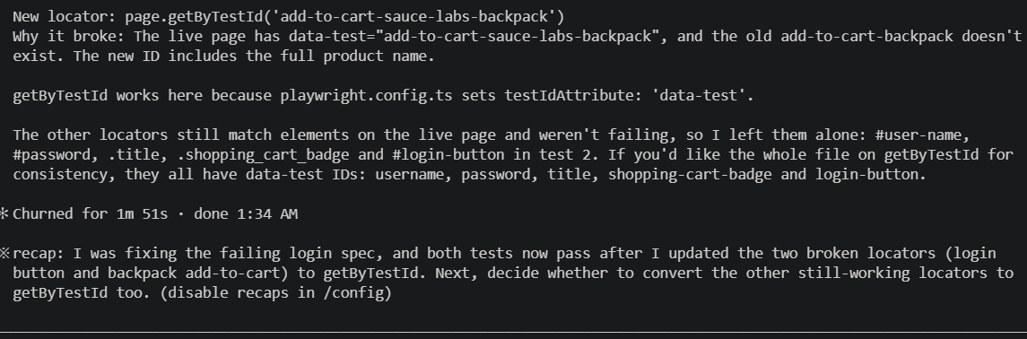
Figure 1. S1, MCP: agent summary. Only the two broken locators were changed, both tests pass.
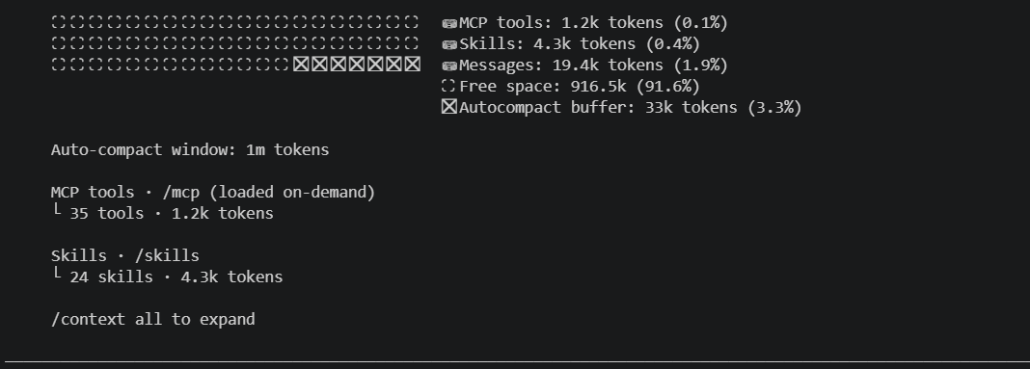
Figure 2. S1, MCP: /context at the end. Playwright MCP tools loaded on demand, 1.2k tokens.
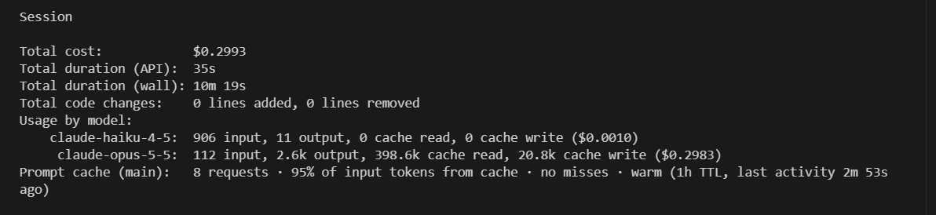
Figure 3. S1, MCP: /cost. 8 requests, $0.2993.

CLI lab
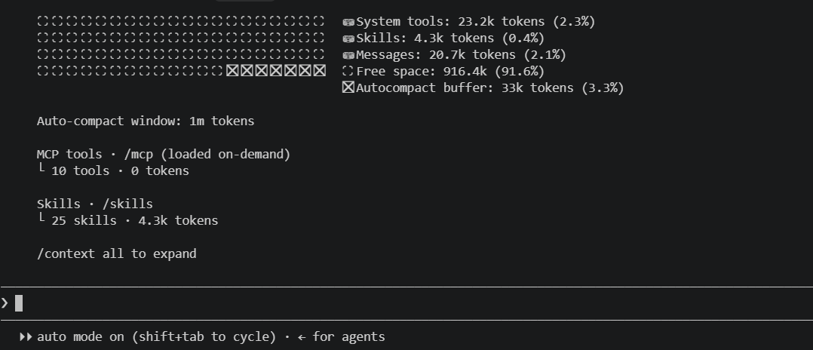
Figure 4. S1, CLI: /context at the end. The 10 global MCP tools were never loaded (0 tokens).
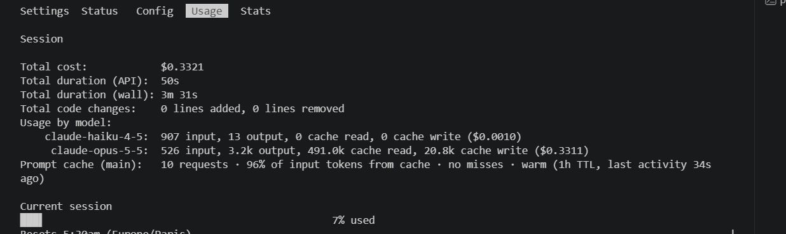
Figure 5. S1, CLI: /cost. 10 requests, $0.3321.

Scenario 2: Exploratory testing
Task: log in as problem_user, explore the buying journey and report every bug with on-page evidence. No automated tests.
Metric | MCP | CLI
Requests | 35 | 28
Cache read | 2.0M | 1.6M
Cache write | 44.1k | 40.2k
Output | 11.8k | 12.9k
Cost | $0.99 | $0.91
API time | 2m 38s | 2m 45s
Messages in context at end | 40.2k | 40.1k
Findings | 8 | 14
The CLI report contains all 8 MCP findings plus 6 more. Three of the extra findings were reached by opening the checkout overview by URL and setting the cart through localStorage, because the last-name bug blocks a real customer; two are in the burger menu, outside the charter. Both reports are in results/s2-mcp and results/s2-cli.

MCP lab
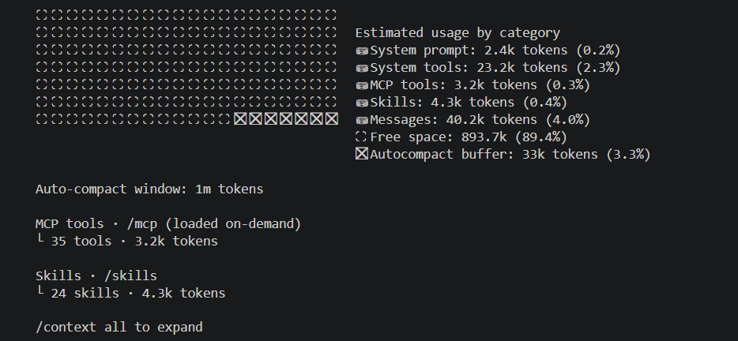
Figure 6. S2, MCP: /context at the end. More MCP tools loaded on demand (3.2k tokens).
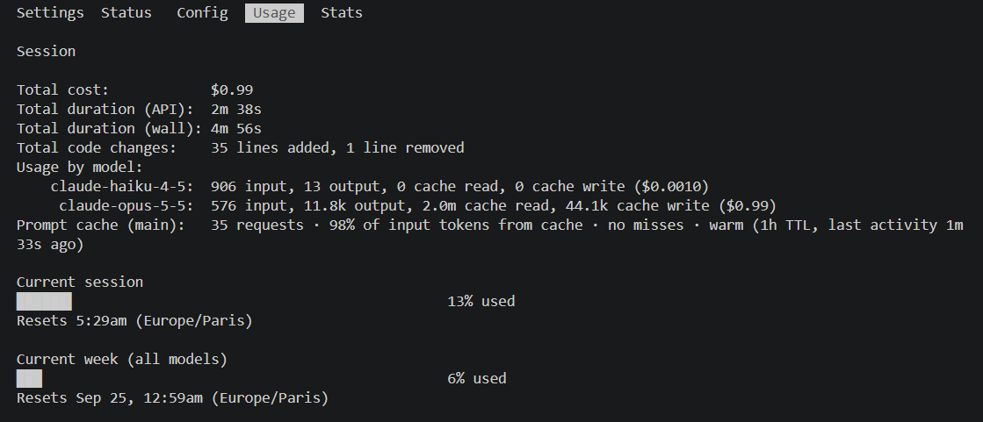
Figure 7. S2, MCP: /cost. 35 requests, $0.99.

CLI lab
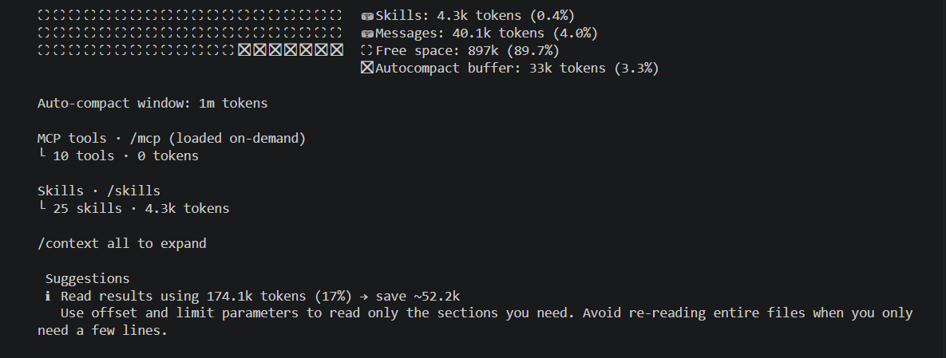
Figure 8. S2, CLI: /context at the end. Claude Code notes that file reads (mainly page snapshots) used 174.1k tokens over the session.
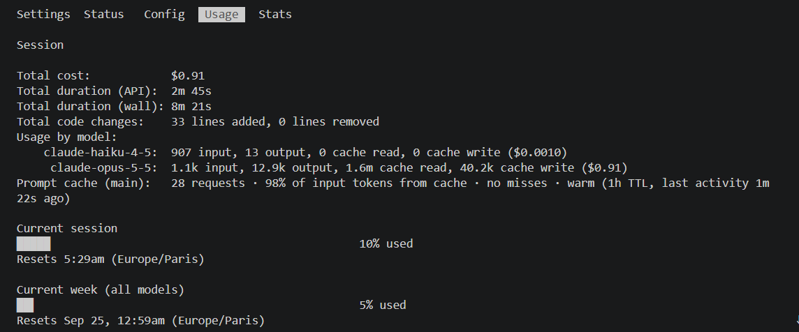
Figure 9. S2, CLI: /cost. 28 requests, $0.91.

Scenario 3: Generating a regression suite
Task: write five tests (login, locked-out user, add to cart, remove from cart, checkout) with a page-object pattern in tests/s3, and keep going until they pass.
Metric | MCP | CLI
Requests | 18 | 12
Cache read | 892.1k | 694.2k
Cache write | 34.8k | 31.7k
Output | 14.2k | 11.4k
Cost | $0.74 | $0.62
API time | 2m 8s | 1m 49s
Context at end | ~65.3k | 61.5k
Tests passing (--repeat-each=3) | 15/15 | 15/15
Locators only in page objects | Yes | Yes
waitForTimeout / test.skip | None | None

MCP lab
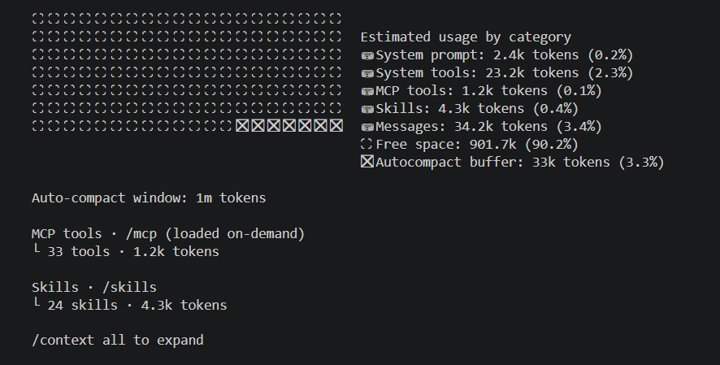
Figure 10. S3, MCP: /context at the end.
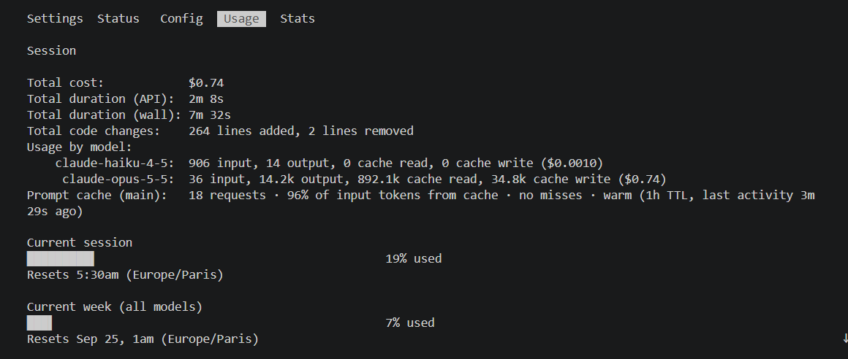
Figure 11. S3, MCP: /cost. 18 requests, $0.74.
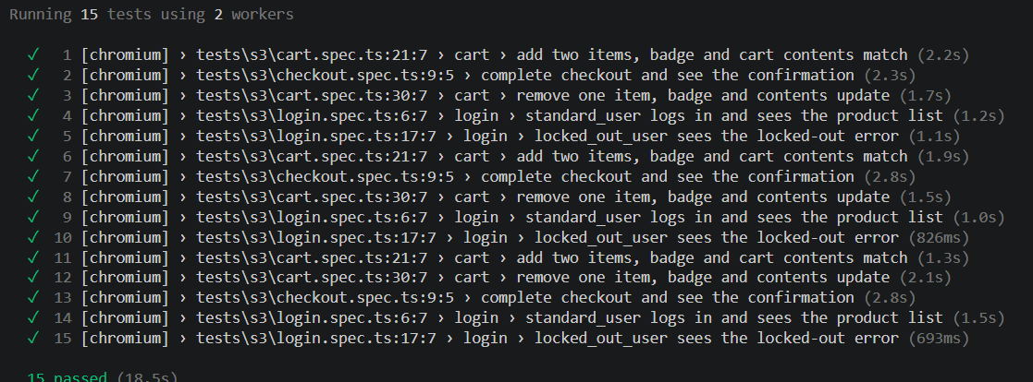
Figure 12. S3, MCP: npx playwright test s3 --repeat-each=3. 15 passed.

CLI lab
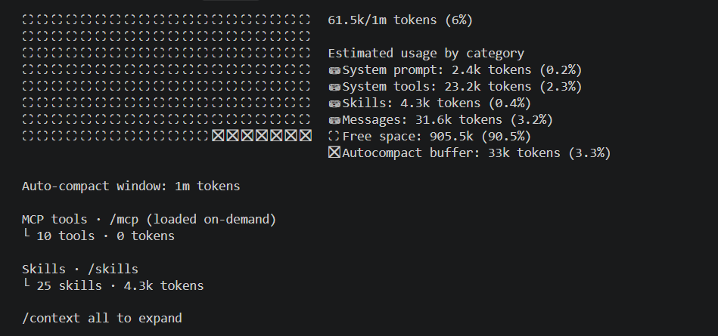
Figure 13. S3, CLI: /context at the end. 61.5k of 1M tokens.
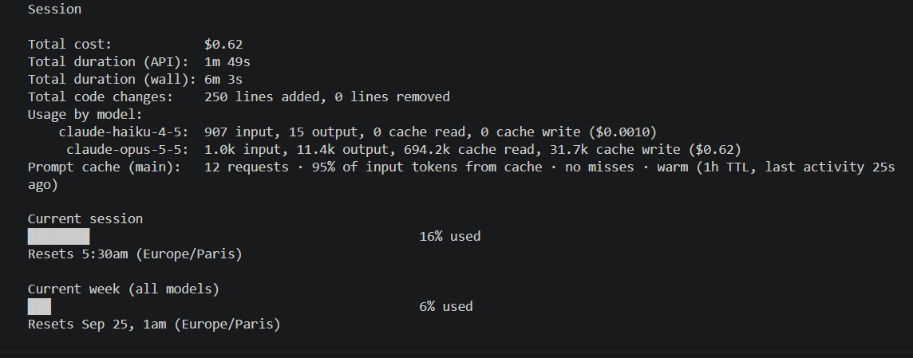
Figure 14. S3, CLI: /cost. 12 requests, $0.62.
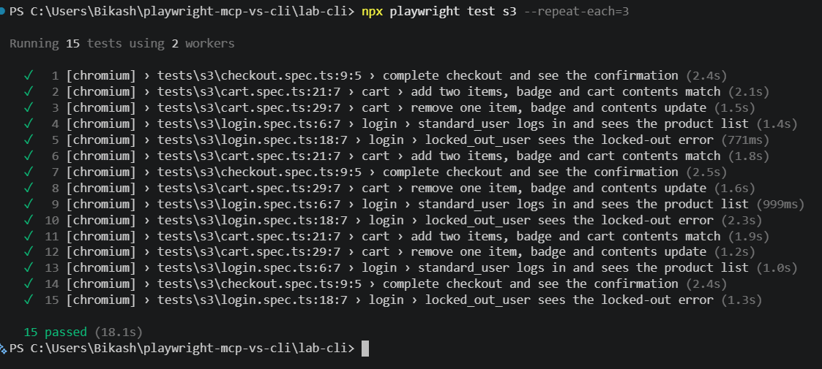
Figure 15. S3, CLI: npx playwright test s3 --repeat-each=3. 15 passed.

Appendix: practice run and run-to-run variation
Before the measured runs I did one practice run of S1 in each lab. It is not part of the results, but it shows how much two runs of the same task can differ. The MCP practice run used 12 requests and cost $0.367; the measured MCP run of the same task used 8 requests and cost $0.299. That is roughly a 20% spread for identical input, which is why small gaps between MCP and CLI should be read as small.
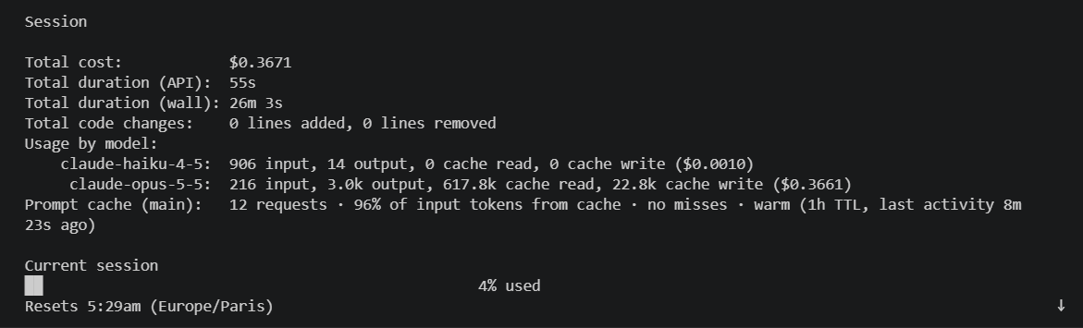
Figure 16. Practice run, S1, MCP: /cost. 12 requests, $0.3671.
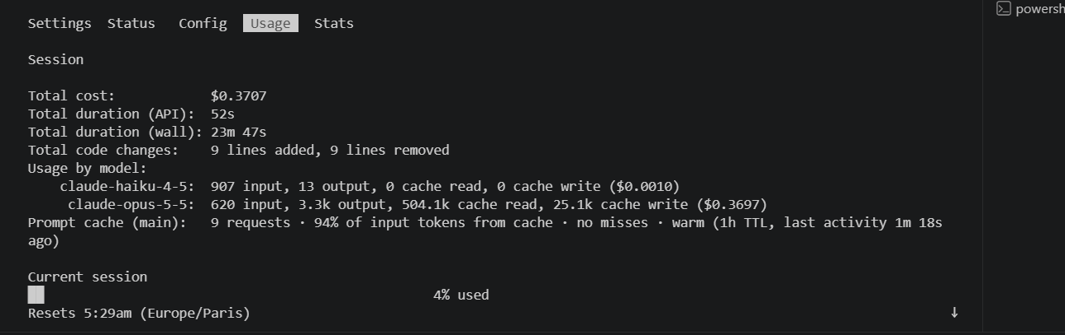
Figure 17. Practice run, S1, CLI: /cost. 9 requests, $0.3707.

