**First name Last name in font size 14**

**MAIN HEADING IN FONT SIZE 16**

**Defining sub-heading if used in font size 14**

**Thesis**

**CENTRIA UNIVERSITY OF APPLIED SCIENCES**

**Degree Programme**

**September 2020**

**ABSTRACT**

|  |  |  |
| --- | --- | --- |
| Centria University  of Applied Sciences | Date  Xxxx 2020 | Author  First name Last name |
| Degree programme  Xxxxxx Xxxxxx | | |
| Name of thesis  MAIN HEADING. Sub-heading if used | | |
| Centria supervisor  First name Last name | | Pages  7 + 2 |
| Instructor representing commissioning institution or company  First name Last name | | |
| The abstract gives a comprehensive picture of the thesis. The abstract is written on its own page in the ready-made template. The text style is declarative, short and the passive voice is used. No abbreviations, symbols or typographical highlights are used in the abstract, neither are references to pictures or tables used.  The abstract is not only a list of sentences, but the text consists of complete, well-organized sentences. The abstract structure is the following:  • information on the commissioner (if the commissioner wants to be anonymous, the phrase “A certain company” or such is used)  • topic and objectives  • main elements of the theoretical framework  • methods  • results and conclusions  Pages for instance: 30 + 3, if page 30 is the last and there are 3 appendices, even though they consist of several pages. Font size 12 pt. | | |
|  | | |
| Key words  Key words are words describing the main contents of the thesis and they are listed in alphabetical order, separated by comma signs and spaces. | | |

**CONCEPT DEFINITIONS**

If there are complex professional terms, jargon or acronyms that require definitions, a separate list with definitions is added. In the concept definitions line spacing 1.5 is used. If you do not need a list of concept definitions, this page can be removed from the Word template.

Examples

**ABS**

(Anti-lock Braking System) is an anti-skid braking system used in vehicles preventing the [wheels](https://en.wikipedia.org/wiki/Wheel) from locking up during [braking](https://en.wikipedia.org/wiki/Brake).

**E.T.A.**

Estimated time of arrival

**ABSTRACT**

**CONCEPT DEFINITIONS**

**CONTENTS**

1 INTRODUCTION 1

2 second main chapter 2

2.1 Sub-heading 2

2.2 Sub-heading 2

2.2.1 Sub-heading of a sub-heading 2

2.2.2 Sub-heading of a sub-heading 3

3 third main chapter 4

4 EXAMPLES OF IN-TEXT REFERENCES 7

**REFERENCES 9**

**APPENDICES**

**FIGURES**

FIGURE 1. Success factors for competitive edge 4

**PICTURES**

PICTURE 1. Motorcycling in Finland´s Winter 5

PICTURE 2. Heading 5

**TABLES**

TABLE 1. Age distribution of the respondents 5

TABLE 2. Heading 5

Update the contents by right click it and selecting:

**Update field > Update entire table > OK**

Write the page numbers of the REFERENCES, FIGURES, PICTURES and TABLES in the contents.

# INTRODUCTION

The introduction is the author’s own introduction to the topic and the contents of the thesis. In the introduction the author introduces the background and the objectives for the thesis report, limits the research, defines the research problem(s) or introduces the development task(s), and presents the main contents of the thesis. In the introduction the author presents his/ her own aims and objectives. Research questions can be presented in the form of questions.

The introduction presents the main source literature used in the report and clarifies the main concepts concisely. The scope of the introduction in a 50-page thesis report is 1.5-3 pages. The first version of the introduction is often drawn up with the research plan, but usually the final version is completed only when the thesis report is otherwise ready.

Break the page by choosing **Insert > Page break** or pressing **Ctrl + Enter**. Do not break the page by pressing **Enter** repeatedly.

# second main chapter

A new main chapter always starts on a new page. In each chapter there must be some text, both under the main heading and under the sub-heading. When numbering the headings, leave one empty space after the last number, and use no full stops. When adding headings, before the first line of text, leave two empty lines after the main headings and leave one empty line after subheadings. A new main chapter always starts on a new page. After the last paragraph of a subchapter, leave two empty lines before starting with a new subheading.

Write main headings in upper case letters, and subheadings in lower case letters. Bold all headings and use font size 12 pt. Notice that if a main heading has subheadings, there must be at least two of them (for example: main heading 5, subheadings 5.1 and 5.2). All headings must be numbered.

## Sub-heading

Two empty lines are inserted above the sub-heading and one empty line below the heading, before the text.

## Sub-heading

The style “Heading 2” is used here in the sub-heading. An automatic numbering is made here using a multi-level list. No full stop is given after the last number, instead a gap similar to a space.

### Sub-heading of a sub-heading

The style ”Heading 3” is used for this sub-heading of the sub-heading.

### Sub-heading of a sub-heading

If sub-chapters are used, there must be at least two of them on each level.

# third main chapter

Figures, tables and pictures are numbered in their own sequence. The word TABLE is written above the table using capital letters. After TABLE, the number of the table is written, followed by a full stop, and last the name of the table follows with no full stop. The word FIGURE or PICTURE is written below the figure or picture in capital letters, followed by the number, a full stop, and the name of the figure or picture. Leave one empty line between the table, figure or picture and the text.

It can sometimes be difficult to tell the difference between a figure and a picture. A figure often includes boxes, arrows, lines, circles, columns or other graphical parts to describe a phenomenon or event. A picture, on the other hand, is for example a photograph of something.

Figures, tables and pictures always have to be referred to and explained in the text using their numbers. All directly quoted figures, tables and pictures must be adapted by the thesis writers themselves, since according to copyright laws, original figures, tables or pictures can be used only with permission from the publisher. After the name of the figure, table or picture, there must be a source reference, with no full stop, and for adapted figures, tables and pictures the expression ‘adapted from’ is added.

A figure can be made for the text using **Insert > Shapes**

A table can be made for the text using **Insert > Table**

A picture can be added to the text using **Insert > Picture** or **Copy/Paste**

Below are some samples of figures, tables and pictures:

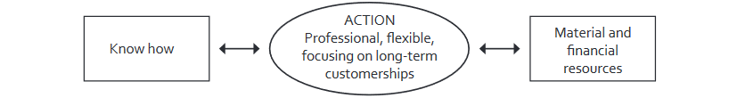

FIGURE 1. Success factors for edge (adapted from Anttila & Iltanen 2001, 27)

If a table continues on the following page, write continues in brackets in the lower right-hand corner of the page. On the next page write the number of the table in the upper left-hand corner and the same word as on the previous page, for example TABLE 16. (continues).

When making an in-text reference to a figure or a table, write the word FIGURE or TABLE all in capital letters and in brackets. Sample 1: There were 37 respondents (TABLE 1). Sample 2: There were 37 respondents. 7 of them were male. (TABLE 1.) When referring to a picture, table or figure within a sentence, use the word figure, table or picture in lower case letters. Sample 3: The results of the questionnaire are presented in table 1.

TABLE 1. Age distribution of the respondents (n = 37)

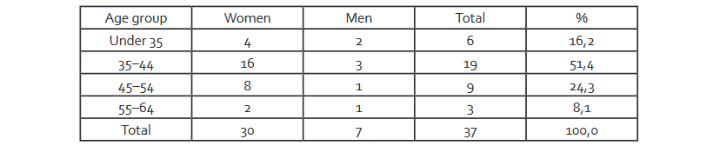

Pictures, tables and figures are not an end in themselves. When used correctly, they give information concisely and descriptively. Conclusions need to be drawn from the pictures, tables and figures in the text and they must be discussed so that the conclusions are not separated from the context. If there are several pictures, tables or figures, they are listed in the table of contents. (See Optima for model: For student > Student’s path > Final thesis and maturity test > Model for a table of contents.)

Below is an example of how to include a picture in the thesis report (PICTURE 1):

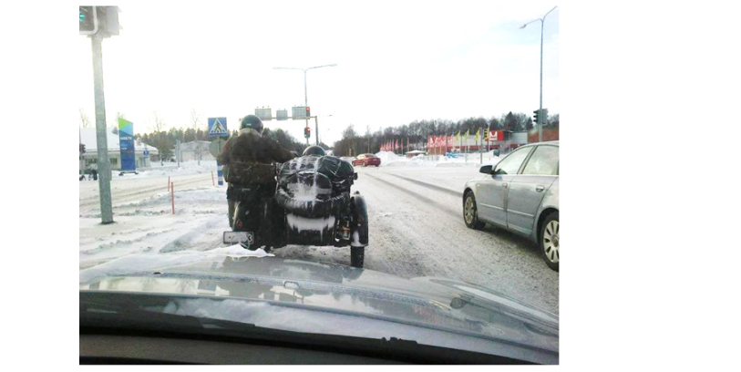

PICTURE 1. Motorcycling in Finnish winter (Aho 2015, 15)

Below is an example of how to include a mathematical formula in the thesis.

In direct-current circuit analysis, the conductance representing the conductivity of a component or circuit is:

G = I / U

where I stands for the current in the component and U stands for the voltage. The unit for conductance is Siemens (S).

# EXAMPLES OF IN-TEXT REFERENCES

In the thesis the sources used are referred to using the **Harvard referencing style** and its name-year system. Through this referencing system the reader can immediately see whose text is referred to, from what year the text is and the page number of the information. An in-text reference is a short reference to the detailed source information found in the list of references.

Examples of in-text references:

Torkki (2007, 106) discusses how the speaker can affect the audience.

A speaker with good rhetorical skills is able to consider the audience (Torkki 2007, 35).

Whenever one refers to a text written by someone else, one must include a reference. The in-text reference written in brackets consists of the author’s last name and the year of publication, followed by a comma and the page number or the pages where the information is taken from. If the entire work is referred to, page numbers are not included. All electronic sources do not have page numbers and in that case, page numbers also are not included in the reference.

Usually the source text is paraphrased in the thesis, i.e. the writer of the thesis rewrites the information in his/ her own words and the in-text reference follows immediately. It must be evident for the reader exactly which part of the text is based on a source. The placement of the full stop in the in-text reference indicates which part of the text is based on a source.

If the in-text reference concerns more than one sentence, the in-text reference is marked in brackets **after** the last full stop of these sentences, almost as if the in-text reference is a sentence of its own. In this case a full stop is also included last inside the brackets. An example of a case where the in-text reference concerns more than one sentence:

The student knows how to refer to sources. He or she is careful and follows the instructions. This ensures that the reader knows which information is based on what source and which part of the text represents the student’s own opinion. (Aro 2015, 21-23.)

If the in-text reference concerns only one sentence, the reference is included **within** that sentence. Thus, the full stop is marked outside of the brackets. An example of a case where the in-text reference concerns only one sentence: This is easy (Aro 2015, 18).

If the source has two authors, the last names of both authors are mentioned when referring to the source. The names are joined using the symbol &. (Lumijärvi & Kela 2014, 5)

If the reference has three or more authors, the last names of all authors are given in the first in-text reference to that source (Lumijärvi, Kiiskinen & Särkilahti 2014, 21–22). However, in later references to the same source, only the last name of the first author is given, followed by the abbreviation et al. meaning “and others”. (Lumijärvi et al. 2014, 23–24).

More examples on referencing are available in chapter 6 References in the Guide for Thesis and Academic Writing.

**REFERENCES**

Aho, H. 2015. *Ajoneuvoja Suomen talvessa*. Kokkola: Kirjakustannus Oy.

Hirsjärvi, S., Remes, P. & Sajavaara, P. 2009. *Tutki ja kirjoita*. 15., new edition. Helsinki: Tammi.

Sieppinen, A. 2011*. Resurssit osana asiakkaan arvonluontia palveluliiketoiminnassa. Pankkien lainapalvelut kuluttajille*. Maisterin tutkinnon tutkielma. Helsinki: Aalto-yliopisto. Available at: http://urn.fi/URN:NBN:fi:aalto-201301151018. Accessed 24.4.2023.

More examples for the list of references are found in chapter 7 Compiling the list of references in the Guide for Thesis and Academic Writing.

APPENDIX 1

**Instructions for appendices**

Appendices consist of e.g. manuals, questionnaires, tables and figures, and other such materials that do not necessarily need to be included in the actual thesis report. Appendices are placed last in the thesis.

Appendices have no page numbering. Instead they are numbered separately: APPENDIX 1, APPENDIX 2 etc. in the top right-hand corner. If an appendix consists of three pages, for example, they are marked: APPENDIX 2/1, APPENDIX 2/2, APPENDIX 2/3.

When referring to appendices in the text, the page number of the appendix is not mentioned, only the number of the appendix (eg. APPENDIX 1). If referring to a figure in an appendix, mention only the appendix and its number, not the figure. For example: In recent years the number of international students in Finland has grown rapidly (APPENDIX 1).

APPENDIX 2/1

Example of the first page of the multi-paged appendix 2.

APPENDIX 2/2

Example of the second page of the multi-paged appendix 2. When referring to this page, a reference to appendix 2 is used (APPENDIX 2).

APPENDIX 2/3

Example of the third page of the multi-paged appendix 2. Also, when referring to this page, a reference to appendix 2 is used (APPENDIX 2).