License Plate Recognition Based On Prior Knowledge
Abstract - In this paper, a new algorithm based on improved BP (back propagation) neural network for Chinese vehicle license plate recognition (LPR) is described. The proposed approach provides a solution for the vehicle license plates (VLP) which were degraded severely. What it remarkably differs from the traditional methods is the application of prior knowledge of license plate to the procedure of location, segmentation and recognition. Color collocation is used to locate the license plate in the image. Dimensions of each character are constant, which is used to segment the character of VLPs. The Layout of the Chinese VLP is an important feature, which is used to construct a classifier for recognizing. The experimental results show that the improved algorithm is effective under the condition that the license plates were degraded severely.

Index Terms - License plate recognition, prior knowledge, vehicle license plates, neural network.

I. INTRODUCTION
Vehicle License-Plate (VLP) recognition is a very interesting but difficult problem. It is important in a number of applications such as weight-and-speed-limit, red traffic infringement, road surveys and park security [1]. VLP recognition system consists of the plate location, the characters segmentation, and the characters recognition. These tasks become more sophisticated when dealing with plate images taken in various inclined angles or under various lighting, weather condition and cleanliness of the plate. Because this problem is usually used in real-time systems, it requires not only accuracy but also fast processing. Most existing VLP recognition methods [2], [3], [4], [5] reduce the complexity and increase the recognition rate by using some specific features of local VLPs and establishing some constrains on the position, distance from the camera to vehicles, and the inclined angles. In addition, neural network was used to increase the recognition rate [6], [7] but the traditional recognition methods seldom consider the prior knowledge of the local VLPs. In this paper, we proposed a new improved learning method of BP algorithm based on specific features of Chinese VLPs. The proposed algorithm overcomes the low speed convergence of BP neural network [8] and remarkable increases the recognition rate especially under the condition that the license plate images were degrade severely.

II. SPECIFIC FEATURES OF CHINESE VLPS

A. Dimensions
According to the guideline for vehicle inspection [9], all license plates must be rectangular and have the dimensions and have all 7 characters written in a single line. Under practical environments, the distance from the camera to vehicles and the inclined angles are constant, so all characters of the license plate have a fixed width, and the distance between the medium axes of two adjoining characters is fixed and the ratio between width and height is nearly constant. Those features can be used to locate the plate and segment the individual character.

B. Color collocation of the plate
There are four kinds of color collocation for the Chinese vehicle license plate .These color collocations are shown in table I.

TABLE I
Category of license plate | Color collocation
small horse power plate | blue background and white characters
motor truck plate | yellow background and black characters
military vehicle and police wagon plate | black background and the white characters
embassy vehicle plate | white background and black characters
Moreover, military vehicle and police wagon plates contain a red character which belongs to a specific character set. This feature can be used to improve the recognition rate.

C. Layout of the Chinese VLPS
The criterion of the vehicle license plate defines the characters layout of Chinese license plate. All standard license plates contain Chinese characters, numbers and letters which are shown in Fig.1. The first one is a Chinese character which is an abbreviation of Chinese provinces. The second one is a letter ranging from A to Z except the letter I. The third and fourth ones are letters or numbers. The fifth to seventh ones are numbers ranging from 0 to 9 only. However the first or the seventh ones may be red characters in special plates (as shown in Fig.1). After segmentation process the individual character is extracted. Taking advantage of the layout and color collocation prior knowledge, the individual character will enter one of the classes: abbreviations of Chinese provinces set, letters set, letters or numbers set, number set, special characters set.
辽BA9083
Chinese
character
character
Letter
Letter or
number
Number
(a)Typical layout
辽BB092警
Chinese
character
character
Letter
Letter or
number
Special red
character
(b) Special character
Fig.1 The layout of the Chinese license plate

III. THE PROPOSED ALGORITHM
This algorithm consists of four modules: VLP location, character segmentation, character classification and character recognition. The main steps of the flowchart of LPR system are shown in Fig. 2.
Firstly the license plate is located in an input image and characters are segmented. Then every individual character image enters the classifier to decide which class it belongs to, and finally the BP network decides which character the character image represents.
Image acquisition
Plate location
Characters segmentation segmentation
classifier
Chinese
character

Letter

Letter or
number

Number

Special character
Characters recognition

Fig.2 The flowchart of LPR system

A. Preprocessing the license plate
1) VLP Location
This process sufficiently utilizes the color feature such as color collocation, color centers and distribution in the plate region, which are described in section II. These color features can be used to eliminate the disturbance of the fake plate’s regions. The flowchart of the plate location is shown in Fig. 3.
Characters edge detection
Binary image segmenting
Candidate image detection
Vehicle plate extraction

Fig.3 The flowchart of the plate location algorithm
The regions which structure and texture similar to the vehicle plate are extracted. The process is described as followed:
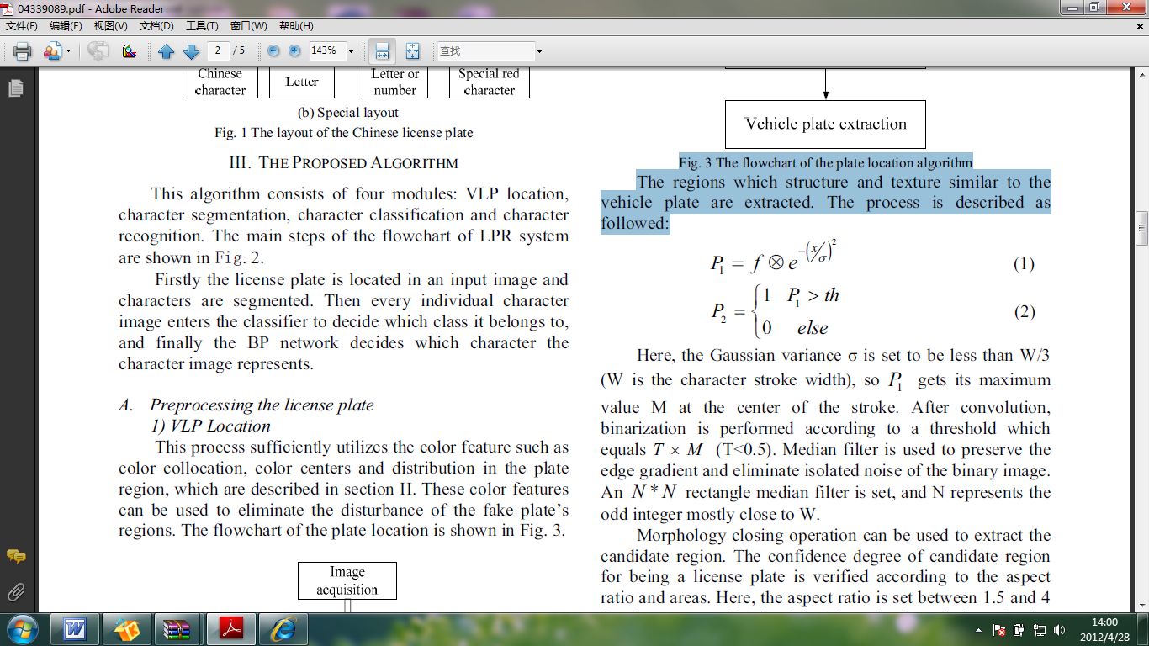 (1)
(2)
Here, the Gaussian variance is set to be less than W/3 (W is the character stroke width), so  gets its maximum value M at the center of the stroke. After convolution, binarization is performed according to a threshold which equals T * M (T<0.5). Median filter is used to preserve the edge gradient and eliminate isolated noise of the binary image. An N * N rectangle median filter is set, and N represents the odd integer mostly close to W.
Morphology closing operation can be used to extract the candidate region. The confidence degree of candidate region for being a license plate is verified according to the aspect ratio and areas. Here, the aspect ratio is set between 1.5 and 4 for the reason of inclination. The prior knowledge of color collocation is used to locate plate region exactly. The locating process of the license plate is shown in Fig. 4.
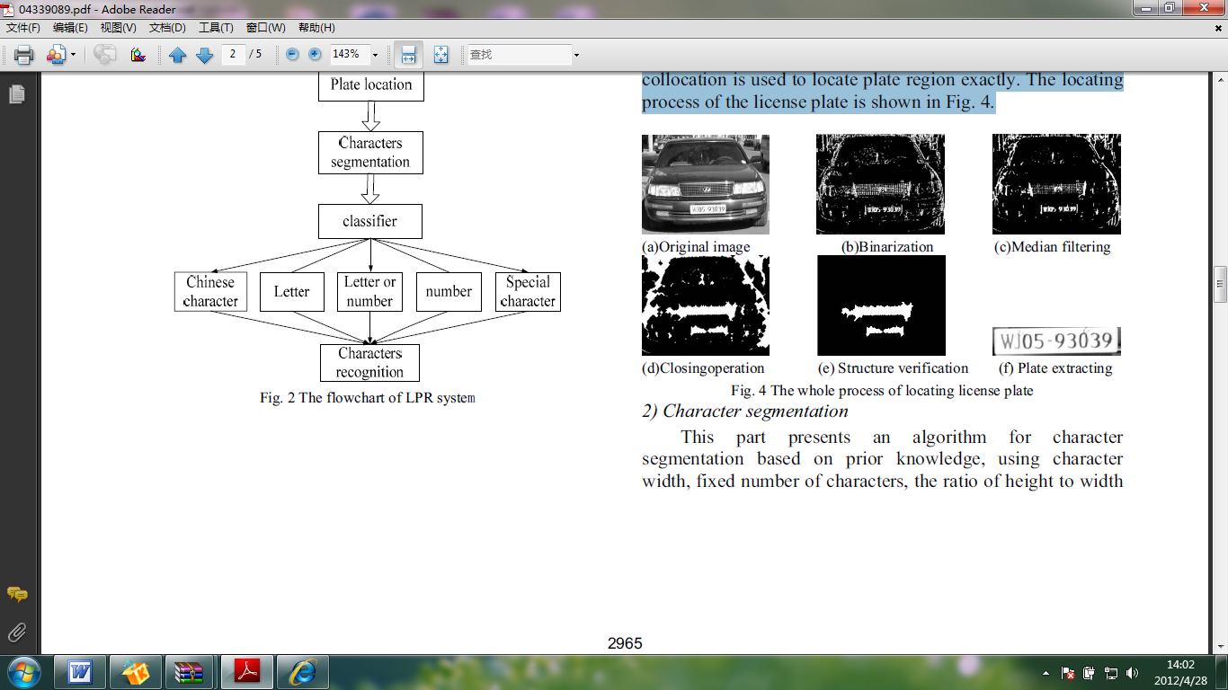

Fig. 4 The whole process of locating license plate
2) Character segmentation
This part presents an algorithm for character segmentation based on prior knowledge, using character width, fixed number of characters, the ratio of height to width of a character, and so on. The flowchart of the character segmentation is shown in Fig. 5.
License plate image

preprocessing

Obtain binary image

Vertical projection
Eliminate space mark
Fig. 5 The flowchart of the character segmentation
Firstly, preprocess the license the plate image, such as uneven illumination correction, contrast enhancement, incline correction and edge enhancement operations; secondly, eliminating space mark which appears between the second character and the third character; thirdly, merging the segmented fragments of the characters. In China, all standard license plates contain only 7 characters (see Fig. 1). If the number of segmented characters is larger than seven, the merging process must be performed. Table II shows the merging process. Finally, extracting the individual character’image based on the number and the width of the character. Fig. 6 shows the segmentation results. (a) The incline and broken plate image, (b) the incline and distort plate image, (c)the serious fade plate image, (d) the smut license plate image.

TABLEII
Get Nf
If NF> MaxF
For each character segments
Calculate the medium point 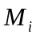
For each two consecutive medium points
Calculate the distance 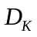
Calculate the minimum distance
Merge the character segment k and the character segment k +1
NF = NF - 1
End of algorithm

where Nf is the number of character segments, MaxF is the number of the license plate, and i is the index of each character segment.
The medium point of each segmented character is determined by:

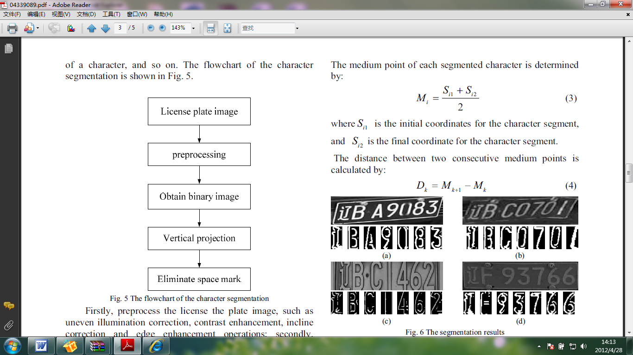 （3）
where 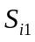 is the initial coordinates for the character segment, and 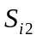 is the final coordinate for the character segment. The distance between two consecutive medium points is calculated by:

（4）
Fig.6 The segmentation results

B. Using specific prior knowledge for recognition
The layout of the Chinese VLP is an important feature (as described in the section II), which can be used to construct a classifier for recognizing. The recognizing procedure adopted conjugate gradient descent fast learning method, which is an improved learning method of BP neural network[10]. Conjugate gradient descent, which employs a series of line searches in weight or parameter space. One picks the first descent direction and moves along that direction until the minimum in error is reached. The second descent direction is then computed: this direction the “conjugate direction” is the one along which the gradient does not change its direction will not “spoil” the contribution from the previous descent iterations. This algorithm adopted topology 625-35-N as shown in Fig. 7. The size of input value is 625 (25*25 ) and initial weights are with random values, desired output values have the same feature with the input values.
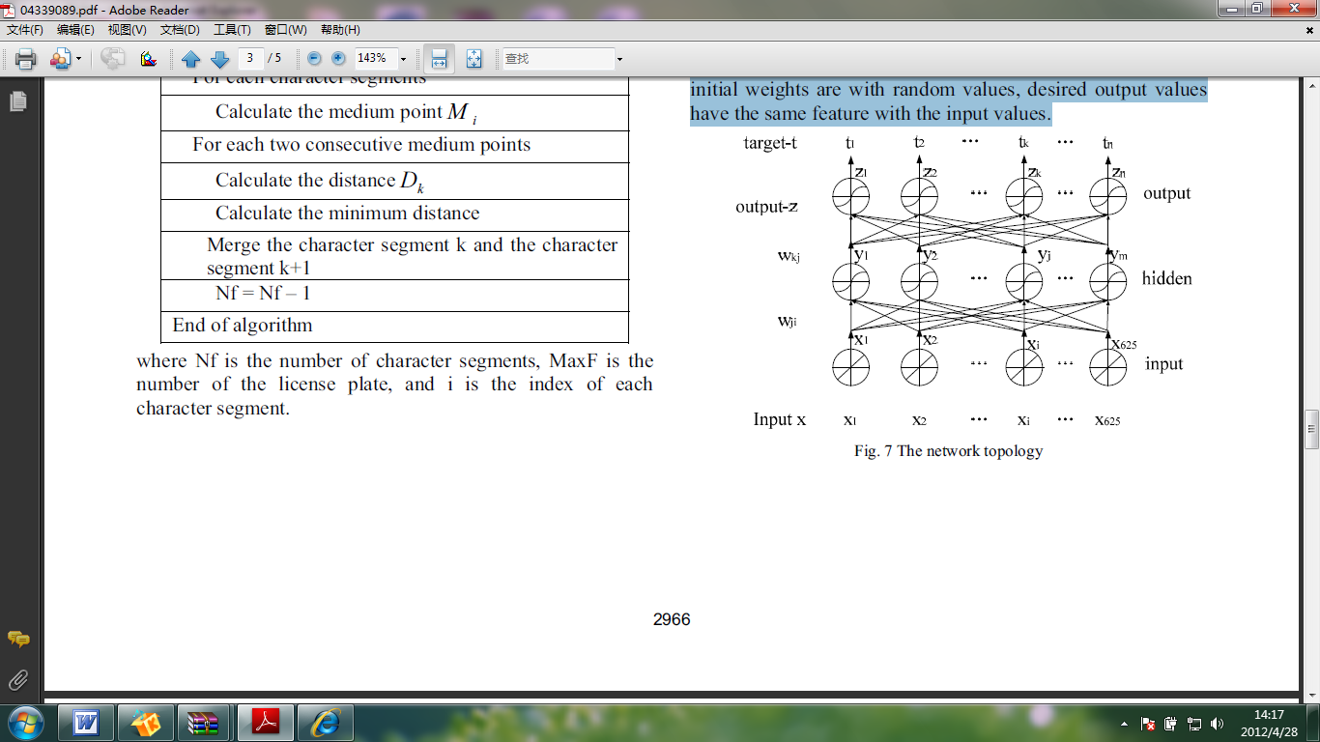

Fig. 7 The network topology
As Fig. 7 shows, there is a three-layer network which contains working signal feed forward operation and reverse propagation of error processes. The target parameter is t and the length of network output vectors is n. Sigmoid is the nonlinear transfer function, weights are initialized with random values, and changed in a direction that will reduce the errors.
The algorithm was trained with 1000 images of different background and illumination most of which were degrade severely. After preprocessing process, the individual characters are stored. All characters used for training and testing have the same size (25*25 ).The integrated process for license plate recognition consists of the following steps:

1) Feature extracting
The feature vectors from separated character images have direct effects on the recognition rate. Many methods can be used to extract feature of the image samples, e.g. statistics of data at vertical direction, edge and shape, framework and all pixels values. Based on extensive experiments, all pixels values method is used to construct feature vectors. Each character was reshaped into a column of 625 rows’ feature vector. These feature vectors are divided into two categories which can be used for training process and testing process.
2) Training model
The layout of the Chinese VLP is an important feature, which can be used to construct a classifier for training, so five categories are divided. The training process of numbers is shown in Fig. 8.
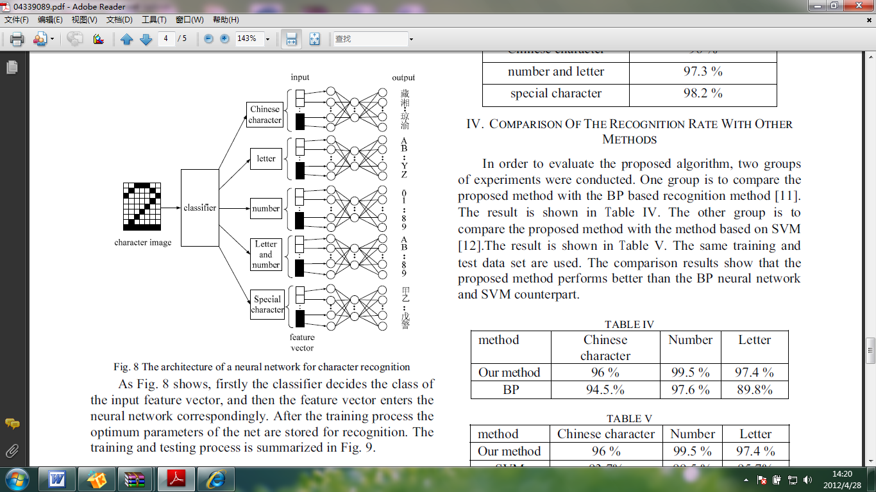
Fig. 8 The architecture of a neural network for character recognition
As Fig. 8 shows, firstly the classifier decides the class of the input feature vector, and then the feature vector enters the neural network correspondingly. After the training process the optimum parameters of the net are stored for recognition. The training and testing process is summarized in Fig. 9.
Input character vector for recognition

特征向量
Neural network
Target output
error
- Training process
Input character vector for recognition

特征向量
Neural network
output
(b)Testing process

Fig.9 The recognition process
3) Recognizing model
After training process there are five nets which were completely trained and the optimum parameters were stored. The untrained feature vectors are used to test the net, the performance of the recognition system is shown in Table III. The license plate recognition system is characterized by the recognition rate which is defined by equation (5).

Recognition rate =(number of correctly read characters)/ (number of found characters) (5)

TABLE III
Class | Recognition
Number | 99.5%
Letter | 97.4%
Chinese character | 96%
Number and letter | 97.3%
Special character | 98.2%

IV. COMPARISON OF THE RECOGNITION RATE WITH OTHER METHODS
In order to evaluate the proposed algorithm, two groups of experiments were conducted. One group is to compare the proposed method with the BP based recognition method [11]. The result is shown in table IV. The other group is to compare the proposed method with the method based on SVM [12].The result is shown in table V. The same training and test data set are used. The comparison results show that the proposed method performs better than the BP neural network and SVM counterpart.

TABLE IV
Method | Chinese character | Number | Letter
Our method | 96% | 99.5% | 97.4%
BP | 94．5% | 97.6% | 89.8%
TABLE V
Method | Chinese character | Number | Letter
Our method | 96% | 99.5% | 97.4%
SVM | 93．7% | 99.5% | 95.7%

V. CONCLUSION
In this paper, we adopt a new improved learning method of BP algorithm based on specific features of Chinese VLPs. Color collocation and dimension are used in the preprocessing procedure, which makes location and segmentation more accurate. The Layout of the Chinese VLP is an important feature, which is used to construct a classifier for recognizing and makes the system performs well on scratch and inclined plate images. Experimental results show that the proposed method reduces the error rate and consumes less time. However, it still has a few errors when dealing with specially bad quality plates and characters similar to others. This often takes place among these characters (especially letter and number):3—8 4—A 8—B D—0. In order to improve the incorrect recognizing problem we try to add template-based model [13] at the end of the neural network.

