Jar of Fireflies Circuit Board
Board design by Ned Konz ned@bike-nomad.com
Design files and code available at http://github.com/bikeNomad/Fireflies
This is Xander Hudson's (jar@synoptic.org) excellent "Jar of Fireflies" project, with some code modifications and a couple of board designs in EAGLE.
The main code modification is the addition of darkness detection (using a photoresistor).
Original project: <http://www.instructables.com/id/Jar-of-Fireflies/>
License: Creative Commons (by)
Please credit Xander Hudson, the original author.

Kit Contents
Quantity | Part
6 | Green LEDs
1 | Photosensor, TEPT-4400
1 | Battery holder 20mm diameter
1 | Ceramic capacitor (0.1uF/100nF)
1 | Battery (CR2016 or CR2032)
1 | Circuit Board, blank
1 | ATtiny45 or ATtiny85 microcontroller, programmed with Jar of Fireflies code
2 | 1/8 or 1/4 watt resistors, 100 to 150 ohms

Assembly
- Identify the top side of the circuit board. This is the side with the white printing.
- Insert (from the top side of the board) and solder the resistors as shown below. Their direction doesn't matter.
- Insert and solder the capacitor. Its direction doesn't matter.
- Insert and solder the 8 pin microcontroller, making sure that the dot that marks pin #1 is above the dot marked on the circuit board.
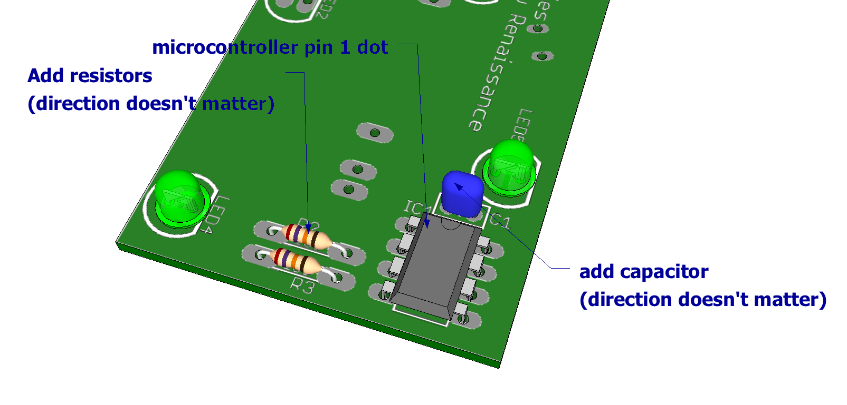
- Insert and solder the six LEDs into the top side of the board (the side with the white printing). The shorter leg of the LEDs goes into the hole nearest the flat side of the flattened circle (see diagram).
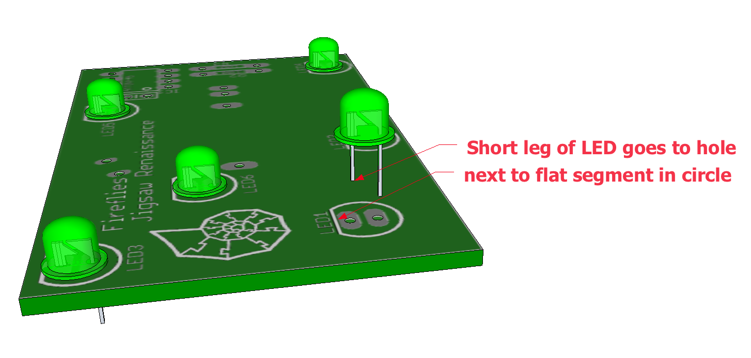
- Turn the board over. Insert and solder the photosensor, inserting the longer leg through the hole nearest the battery holder.
- Cut the plastic pins off the bottom of the battery holder.
- Insert and solder the battery holder, making sure that the + end (the end with the metal clip) is next to the photosensor.
- Insert the battery into the holder, making sure that the side marked + is up and in contact with the metal clip.
- Test the board by covering the light sensor and waiting a bit to see the LEDs flash.

