

Tribhuvan University
Faculty of Humanities and Social Sciences

“ShikshaHub”
A project proposal

Submitted to
Department of Computer Application
Kathmandu Shiksha Campus

In partial fulfilment of the requirements for the Bachelors in Computer Application

Submitted by:
Biken Shrestha
Table of Content
- Introduction…………………………………………………………………4
- Problem Statement………………………………………………………4 &5
- Objectives…………………………………………………………………….5
- Methodology……………………………………………………………….6
- A) Requirement Identification……………………………………….6
- I. Study of Existing Study……………………………………………….6
- II. Requirement Collection…………………………………………….7
- B) Feasibility Study……………………………………………………….7
- I. Technical……………………………………………………………………7
- II. Operational………………………………………………………………8
- III. Economical………………………………………………………………8
- C) High level design of System…………………………………….8
- Gantt Chart………………………………………………………………….11
- Expected Outcome………………………………………………………13
- References………………………………………………………………….14

LIST OF FIGURES

- DFD LEVEL O DIAGRAM…………………………………………………………….9
- DFD LEVEL 1 DIAGRAM…………………………………………………………….10
- Use Case Diagram…………………………………………………………………….11
- Gantt Chart………………………………………………………………………………12

1.INTRODUCTION
In the evolving landscape of education, the need for accessible, organized, and collaborative learning resources is more critical than ever. However, many students and teachers still struggle to find a unified space to efficiently share and access study materials. SikshaHub is a web-based study material sharing platform developed to address this challenge. It will serve as a centralized hub where learners and teachers can upload, discover, and exchange academic resources such as notes, presentations, assignments, and educational videos. By encouraging collaboration and resource sharing, SikshaHub aims to improve learning outcomes, reduce duplication of effort, and helps or develop to connect academic community.
I believe that this project will help students as well as teachers to share their study materials like notes, presentations, assignments as well as read others study materials regarding certain topics which they use to get confusion which will help in removing the confusion. As there are many such platforms already located in the internet like Google classroom, Microsoft one note and ResearchGate but they all have their own limitations. So I want to develop this project so that I can overcome those limitation as it will be easily accessible, community driven and it will be cross institutional as it won’t be limited to one school or organization anybody can access it.

2.PROBLEM STATEMENT
Despite the digital revolution, there is no single unified platform that allows sharing of educational materials across different institutions or peer groups. Existing solutions are either fragmented, lack user engagement, or are limited by institution-specific access like google classroom, Microsoft one note etc which leads to:
- Scattered Resources
Educational content is often shared through informal channels such as WhatsApp, email, or institution-specific platforms. These methods are not only fragmented but also inefficient and hard to manage.

- Duplication of Effort
In the absence of a common repository, students frequently duplicate notes, assignments and projects that may already exist in someone else’s collection. This wastes time, effort, and resources.

- Limited Accessibility
Not all students have access to the same quality of study materials. Those from rural areas or under-resourced institutions may struggle to find relevant content. This widens the academic gap between learners.
- Lack of Collaboration
Traditional learning platforms don’t promote peer-to-peer sharing or collaborative learning. There is no incentive for students to contribute content or help others beyond their own circle.

- Content Disorganization
Even when study materials are shared online, they are rarely tagged, categorized, or easy to search. This leads to information overload and makes it difficult to find what you're looking for.

3.OBJECTIVE
The objective of Shiksha-Hub is to create a centralized, collaborative web platform that:
- To create a user-friendly platform for sharing and accessing study materials and facilitate collaboration between students and teachers: The first goal of our project is to create a user-friendly platform to share and access study materials like assignments, notes and presentations which will help the students for betterment in their studies as well as it will help them to share their learnings. Also, it will help teachers to share their works with other students which they have not teach in life so apparently it will collaborate teachers and students.

- To promote open educational resource (OER) culture in academic settings and ensure resource availability anytime, anywhere: The other goal of our project is to create a open resource so that it will be available at anytime and anywhere for students and teachers so there won’t be any difficult for them to find resources for betterment of their education.

4.METHODOLOGY

- Requirement Identification

- Study of Existing system:
There are some of existing system such as:
- Google classroom: A free learning management system developed by Google. It allows teachers to create and manage classes, share materials and communicate with students.
- Microsoft teams: A collaboration platform that integrates with Microsoft Office tools. Teachers and students can share resources, chat, and hold meetings.
- Study-Lib: A public platform where users can upload and browse study materials like flashcards, notes, and documents.
- Notes-gen: A marketplace for educational notes where students and educators can buy and sell notes.
- Course-hero: A paid learning platform offering study guides, textbook solutions, and tutor services.
After evaluating and researching some of problems that I found in these systema are as follows:
- Some of them are not free accessible like notes-gen and course-hero.
- Some of them are not open accessible like google classroom, Microsoft team, course-hero and notes-gen.
- Less academic quality control; lacks collaboration tools or teacher-student interaction features.
- Some of them are monetized (not fully free), which can limit access for students who cannot afford to pay for content.
- Some of them are not suitable for school- or college-level study materials. Mostly focused on research rather than practical study resources.

- Requirement Collection:

Requirement collection is the process of identifying the needs and expectations of sstudents, teachers, admins for the successful development of the ShikshaHub platform. It involves understanding what functions are necessary to fulfil the platform's goals and how users will interact with the system.
Types of Requirements
A. Functional Requirements (What the system should do)
- User Registration and Login (with roles: student, teacher, admin)
- Uploading various types of materials (PDF, DOC, PPT, video links)
- Search function with filters (by subject, file type, level, etc.)
- Downloading and previewing materials
- Commenting and rating system for feedback
- Admin dashboard for content moderation
- Profile management for users

B. Non-Functional Requirements (How the system should behave)
- Performance: The platform should load quickly even with large files.
- Scalability: It should support thousands of users as it grows.
- Security: User data and uploaded materials must be protected.
- Usability: The UI must be intuitive and easy for all users.
- Accessibility: The platform should work across devices (PC, tablet, mobile).

- Feasibility Study

- Technical:
The project will be technically feasible because we will build the project by using the tools which we have very good knowledge and skills about. We will be using following tools like:
- For Frontend: We will be using HTML, CSS and Java-script.
- For Backend: We will be using PHP.
- For databases: We will be using MySQL.
So, these are the tools that will be in used for the project which is easily supported and different kind features required for the project can also be added by the help of these tools.
Hence, the project is technically feasible.

- Operational:
Operational feasibility assesses whether the proposed system, Shiksha Hub, can be successfully implemented and sustained within the existing academic and technical environment. Shiksha Hub will be designed to be simple, user-friendly, and compatible with the digital habits of its target users like students, teachers, and academic staff. Since most students and educators are already familiar of using digital platforms such as Google Drive, WhatsApp, and email to share study materials, transitioning to a centralized platform like ShikshaHub is expected to be smooth and approvable. The platform enhances the current workflow rather than disrupting it. It allows users to upload, access, and organize academic content without requiring any specialized training or additional infrastructure. Basic internet access and common devices such as smartphones, laptops, or tablets are sufficient for using the platform, making it both accessible and affordable. ShikshaHub is also scalable and easy to maintain. As the user base grows, the system can be upgraded without major technical changes. Considering these factors, ShikshaHub is deemed to be highly operationally feasible and capable of meeting the needs of a modern, connected academic community.

- Economic:
Economic feasibility refers to whether the system can be developed and operated within reasonable financial limits, especially in a project-based academic setting. Since ShikshaHub is a prototype developed for educational purposes, there is no need for commercial hosting, large-scale infrastructure, or paid services. The project can be built using freely available resources such as open-source frameworks, local servers (e.g., XAMPP), and cloud services with free-tier options (GitHub).
All development work is carried out by me, which eliminates labor cost. Tools like Visual Studio Code, GitHub and MySQL used for designing, developing, and testing the system are freely accessible. Therefore, there are no significant financial investments required to complete the project within the academic scope.
Given the minimal costs involved and the valuable learning outcomes it provides, the development of ShikshaHub is considered economically feasible as a student project.

- High Level Design of System:

- Context level DFD (level 0):
A context diagram or level 0 diagram shows the basic overview of the entire system. In Zero level DFD Diagram, it shows an interaction overview with external entities (Students, Teachers and admins) and focuses on the system’s external interfaces and overall data flows. representing different users of the system.

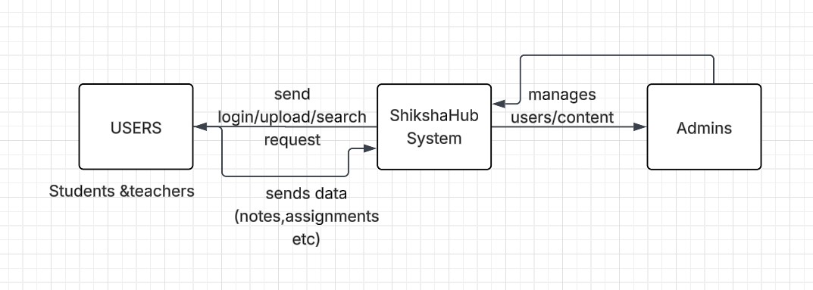

Fig: DFD level 0 diagram of Shiksha Hub

- Level 1 DFD
A Level-1 DFD provides detailed view of the system compared to context diagram. This diagram decomposes the overall system into major functional modules. Here, This Level 1 DFD gives a high-level functional overview of ShikshaHub, showing:
- What key operations the system performs
- How users and admins interact with those operation
- Where data is stored and retrieved during these interactions

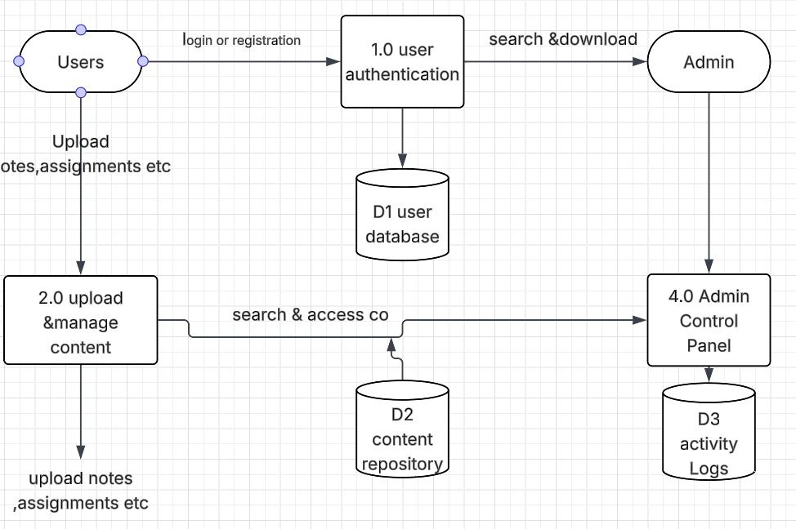

FIG: level 1 DFD of Shikshahub

- Use Case Diagram:
A use-case diagram is a graphical representation used in software engineering and system analysis to depict the functional requirements of a system from the perspective of Its users. The use case diagram helps identify:
- What functionalities are available.
- Who can perform them.
- How the actors relate to system capabilities.

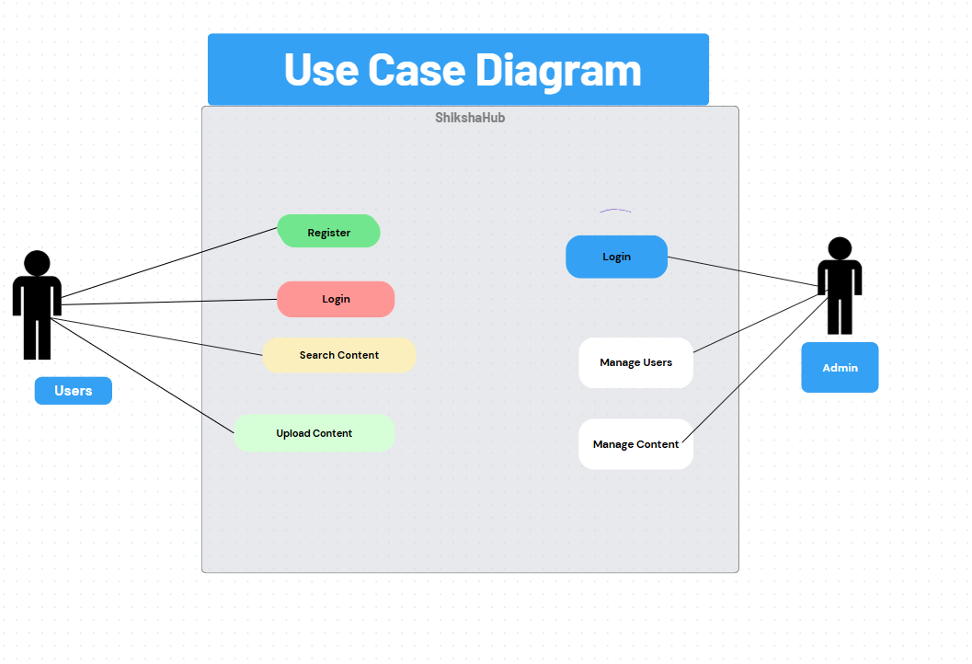
Fig: Use case Diagram

- Gantt Chart
A Gantt chart is a visual tool used to plan and track the progress of a project over time. The Gantt chart for the ShikshaHub project outlines a structured and time-bound development process spanning from the first week of April to the second week of May. The project begins with the Project Plan, scheduled during the first two weeks of April, where the initial objectives, scope, and milestones are defined. Simultaneously, starting from the second week, a feasibility Study is conducted and continues through the third week of April to assess the technical, operational, and financial viability of the proposed platform.
Following this, the Requirement Analysis phase is initiated in the third week of April and extends to the end of the month, focusing on gathering and analysing the needs of the system’s users, including students, teachers, and administrators. Alongside this, the Sample Design phase also runs through the third and fourth weeks of April, during which preliminary designs and system architecture are drafted based on the collected requirements.
As April concludes, attention shifts to the Presentation phase, spanning from the final week of April into the first week of May. During this time, the team prepares and delivers a comprehensive presentation showcasing the progress, system layout, and planned features of ShikshaHub. Concurrently, a major ongoing task throughout the second half of the project is Documentation, which begins in the third week of April and concludes in the second week of May. This involves compiling all relevant project information, including design diagrams, technical explanations, and user documentation.
Overall, the Gantt chart reflects a well-coordinated development schedule with overlapping tasks that allow for efficiency, iteration, and refinement ensuring the ShikshaHub project remains organized and goal-driven throughout its implementation.
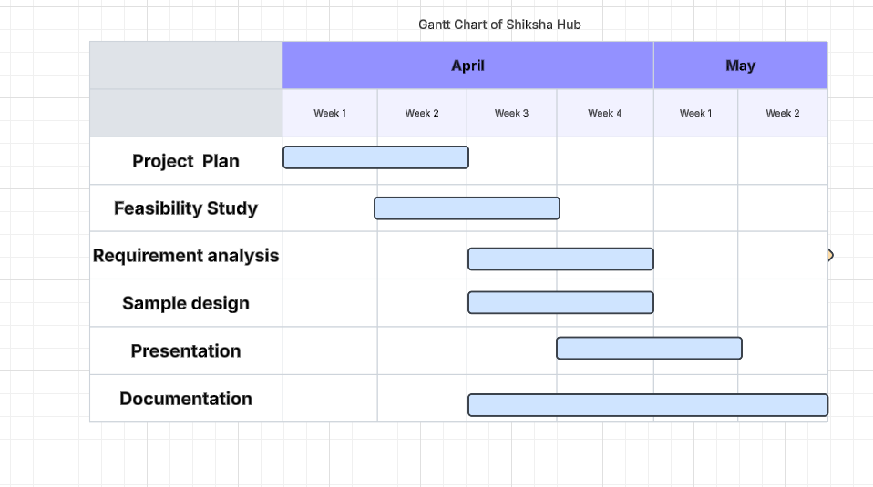

Fig: Gantt Chart

6.Expected Outcomes

The expected outcome of the ShikshaHub project is the successful development and deployment of a user-friendly, web-based platform that enables seamless sharing of study materials among students and teachers. The system aims to streamline the academic content distribution process by allowing users to upload, search for, and download educational resources such as notes, assignments, and previous exam papers. Through role-based access, students and teachers will be able to interact with the platform efficiently, while administrators will have the ability to manage users and moderate content to ensure quality and relevance. By the end of the project, ShikshaHub is expected to provide a centralized, reliable, and secure repository of academic materials that promotes collaborative learning and reduces the dependency on physical handouts or scattered digital sharing. Additionally, the platform will include documentation, diagrams, and technical specifications, making it a well-rounded, functional solution ready for real-world academic environments.

7.REFERENCES
[1] I. Sommerville, Software Engineering, 9th ed. Boston, MA, USA: Pearson Education, 2011.
[2] R. S. Pressman and B. R. Maxim, Software Engineering: A Practitioner’s Approach, 8th ed. New York, NY, USA: McGraw-Hill, 2014.
[3] IEEE, IEEE Recommended Practice for Software Requirements Specifications, IEEE Std 830-1998, 1998.
[4] W3Schools, “HTML, CSS, JavaScript Tutorials,” [Online]. Available: https://www.w3schools.com/. [Accessed: May 15, 2025].
[5] MDN Web Docs, “Web technology documentation,” [Online]. Available: https://developer.mozilla.org/. [Accessed: May 15, 2025].
[6] Oracle, “MySQL 8.0 Reference Manual,” [Online]. Available: https://dev.mysql.com/doc/. [Accessed: May 15, 2025].
[7] Open Source Initiative, “The Open Source Definition,” [Online]. Available: https://opensource.org/. [Accessed: May 15, 2025].
[8] Google Developers, “Web Fundamentals - Performance,” [Online]. Available: https://developers.google.com/web. [Accessed: May 15, 2025].
[9] Tutorials Point, “Software Engineering Tutorial,” [Online]. Available: https://www.tutorialspoint.com/software_engineering/index.htm. [Accessed: May 15, 2025].
[10] Draw.io (diagrams.net), “Diagramming Tool,” [Online]. Available: https://app.diagrams.net/. [Accessed: May 15, 2025].

