Journal Six
User Manual

Table of Contents
Letter to Knitters 1
Requirements 3
Installation 5
Settings 7
Overview 11
Projects 13
Fabric Pieces 15
Form Programmes 19
Stitch Patterns 23
Knit Techniques 27
Image Conversion 31
Sketchbook for Stitch Patterns 43
Overview 44
Tool Modes 45
Drawing Tools 48
Additional Features 49
Sketchbook for Downloadable Charts 51
Overview 52
Tool Modes 53
Drawing Tools 54
Additional Features 55
E6000 Programming and Knitting 57
Additional Resources 63

Letter to Knitters
Dear fellow knitter,
I am a part-time knitter and full-time software developer. Machine knitting has been a satisfying outlet for my creativity and desire to “make things” over the years.
However, I sometimes find frustration in going from ideas to a finished project. Frequent interruptions often mean unfinished projects sit for a month or more before I have a chance to return to them. By that time, my notes have mysteriously disappeared or are indecipherable or, I'm ashamed to admit, never existed in the first place. Perhaps, you can relate.
I wrote Journal Six to address the need for better organization and a more relaxing knitting experience.
Journal Six, your electronic knitting journal for the PASSAP E6000 knitting machine, organizes your projects, stitch patterns, form programmes, and knit techniques in an easy to search database. You may download stitch patterns and card reader techniques to your knitting machine with a standard E6000 download cable or print cards for the card reader. Journal Six also allows you to draw a chart of the shape you want to knit and download it to the console, similar to the old Form 6 software.
Sophisticated image processing techniques convert photos, scans, and original designs from a wide variety of graphics formats into high quality stitch patterns. Journal Six allows you to reduce colors, choose special effects such as stippling or hatching, and apply custom color separations. The sketchbook included with Journal Six allows you to embellish your stitch patterns or create them from scratch using powerful drawing tools optimized specifically for stitch pattern creation.
Your purchase of the Journal Six software license entitles you, and only you, to use the software for the design and knitting of fabric on the PASSAP E6000 knitting machine. I have not burdened Journal Six with any sort of copy protection scheme; there are no tiresome “lives” or other nonsense to deal with. Future development of the software and new features will depend upon whether an adequate market emerges for Journal Six. If your friends are interested in Journal Six, please refer them to http://passappal.com so that they may purchase their own copy.
Yours in knitting,

Jenny

Requirements
You will need the following in order to successfully install and use Journal Six:
- PC or Laptop
  - Windows XP, service pack 2 or better, or Vista
  - 10 MB hard disk space
  - 1 GHz CPU or faster
  - 256 MB RAM or more
  - 1024 x 768 video display or higher
  - Mouse or other pointing device
- PASSAP E6000 Knitting Machine
  - 8K or 32K Console with download capability (optional)
  - E6000 download cable (optional)
It is possible to install Journal Six on a computer with a slower processor or less memory, but performance will be greatly degraded. Journal Six will not run on earlier operating systems.
If your E6000 is not capable of downloading, you may still print stitch patterns and card reader techniques and enter them via the card reader.
If you are unsure of whether your E6000 is capable of downloading, conduct this test:
  - Disconnect the cable that connects the console to the locks.
  - Turn on the E6000 and program your E6000 to the point where “ST.PATT A” is flashing on the console display.
  - Press the unlabeled key (above the CLR key) followed by the 0 key.
  - If error 213 appears, your console is capable of downloading.
  - If you seen any other display appear, your console is not capable of downloading, but you can still use Journal Six to organize your projects and print cards for the card reader.
If you own Creation 6, you probably already have a download cable. If you do not, you may purchase one. They are sometimes available on eBay. Posting a request on http://groups.yahoo.com/group/PASSAPKnits will
quickly put you in touch with someone who will provide you a cable at a reasonable price.
If you are handy with electronics or know someone who is, you may make your own cable. Every attempt has been made to insure accurate instructions, but the author cannot be held responsible for any errors in or interpretation of these instructions. Nor is the author responsible for any damage to equipment. Please proceed with caution:
- Materials
  - 6-pin DIN plug (connects to E6000 )
  - 9-pin D-socket (connects to computer RS-232 serial port)
  - 1K ¼ watt resistor
  - Diode (1N4148)
  - Serial to USB converter (if you do not have a 9 pin serial port on your computer.)
- Assembly
              - Connect pin 3 on the D socket to the resistor and then connect to pin 2 on the DIN plug. This is the data wire.
              - Connect pin 5 on the D socket to pin 6 on the DIN plug. This is the ground wire.
              - Connect pin 6 on the D socket to pin 4 on the DIN plug. This is the control (DSR) wire.
              - Connect pin 2 on the DIN plug to the cathode end of the diode. Connect the anode end of the diode to pin 6 of the DIN plug. [data | diode—ground, E6000 side]
              - If necessary, connect the serial to USB converter to the D socket. Install any drivers needed for the converter on your computer.

Installation
First install your download cable if you are using one:
  - Turn off your E6000 console and computer
  - If you are using a switch box, follow the manufacture's instructions for connecting your download cable.
  - Otherwise, disconnect the DIN plug on your console, which runs to the locks.
  - Connect the DIN plug of download cable to the console.
  - Connect the D socket or USB plug to the serial port (or USB port if you are using an adapter) on your computer.
The Journal Six installation program will install the following on your computer.
- .Net framework from microsoft.com (if not already present)
- Journal Six program files and database
- User manual
Open the JournalSix.zip or JournalSixDemo.zip file that you downloaded. Double click setup.exe. Follow the easy on screen instructions to install the Journal Six files.
Notes:

Settings
Complete the installation of Journal Six by configuring the settings:
- Start Journal Six by double clicking the Journal Six icon located on you desktop.

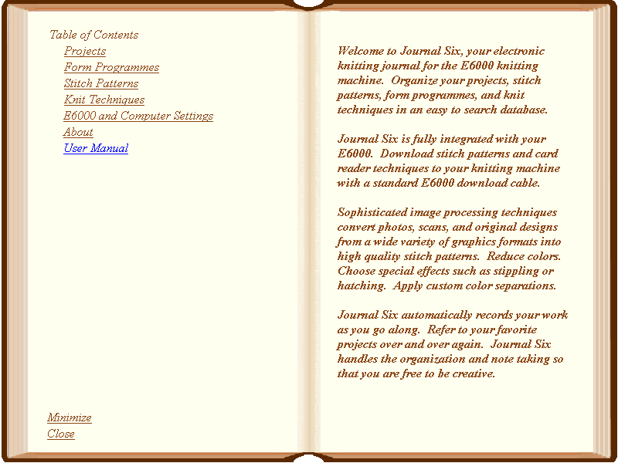
- Click on E6000 and Computer Settings. to turn to the settings page.

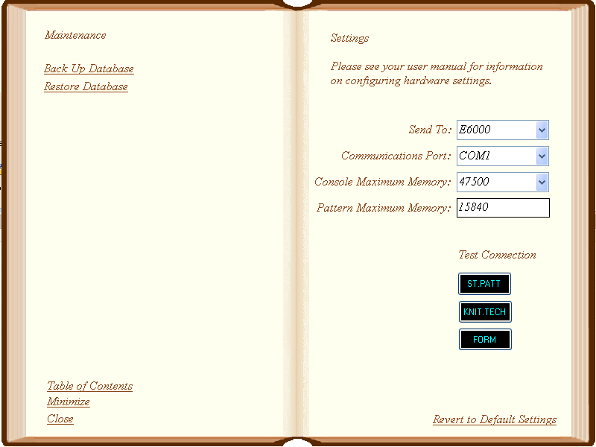
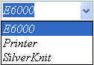
- Send To:
Select “E6000” if you want to send the stitch patterns and card reader techniques to the E6000 console via the download cable. Select “Printer” if you want to print cards for the card reader. Select “SilverKnit” if you want to export stitch patterns to SilverKnit.
- Communizations Port:
Select the Communications port that you have plugged your download cable into. The available COM ports on your computer are listed in the combo box. You may have to experiment a bit if you are unsure of which COM port to use.
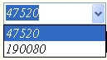
- Console Maximum Memory:
Select 47520 if you have an 8K console; 190080 if you have a 32K Console.
- Pattern Maximum Memory:
It recommend that you leave this value as-is if you plan to download stitch patterns. It represents the maximum pattern size in bytes for downloaded patterns. You can try adjusting upward or downward if you feel a different value should be used.

- Test Connection:
Take some time now to test your connection to the E6000 if you plan to download stitch patterns and card reader techniques.
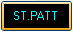
  - Turn on your E6000 console and program it to the point where the console is flashing “ST. PATT A.”
  - Press the “ST.PATT” button in Journal Six to get ready to download the test stitch pattern.
  - Next, press the unlabeled key on the console followed by the zero key. The console will then display PC START.
  - Press the “ST.PATT” button again to send the test stitch pattern to your knitting machine.
If your console successfully accepts the stitch pattern, you have configured the settings correctly. If you have difficulties tries switching COM ports and trying the test again.
  - Continue programming the console until it displays “KNIT.TECH.”
  - Press the “KNIT.TECH” button in Journal Six to get ready to download the test knit technique.
  - Press the unlabeled key on the console followed by the zero key. The console will then display PC START.
  - Press “KNIT.TECH” button again to send this knit technique to your knitting machine.
If your console successfully accepts the knit technique, your console is capable of downloading card reader techniques. Remember, you can always print cards for the card reader if you cannot get the download facility to work with your console.
  - Continue programming the console until it displays “FORM”
  - Press the “FORM” button in Journal Six to get ready to download the test chart.
  - Press the unlabeled key on the console followed by the zero key. The console will then display PC START.
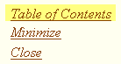
If your console successfully accepts the chart, your E6000 is capable of using downloadable charts.
You are now ready to use Journal Six. Click on Table of Contents to turn to the table of contents.

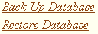
You may make a back up copy of your Journal Six database by clicking on the Back Up Database bookmark.
You may restore the Journal Six database from a back up copy by clicking on the Restore Database bookmark.
It is good practice to back up the database on a regular basis. This feature can also be used to move your projects, stitch patterns, etc., from one machine to another.

Overview
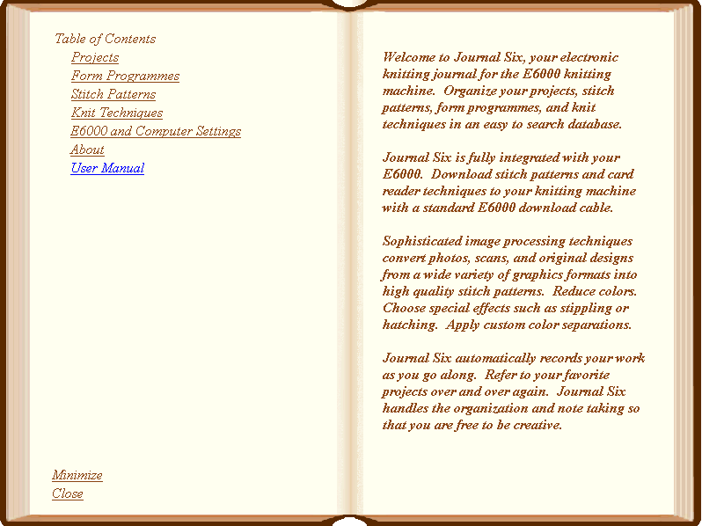
Navigation
Journal Six is laid out like a book. Any underlined text is a bookmark that will open your journal to a different page or create a new page. Click on the bookmarks to move to various chapters and pages of the program.
You may exit Journal Six by clicking the Close bookmark. Journal Six will automatically save all of your work if have purchased the full version. Saving does not occur in the demo version.
You may minimize Journal Six to the Windows task bar by clicking the Minimize bookmark.
The About bookmark will display the licensing agreement, system requirements, and contact information for Journal Six.
Clicking on the User Manual bookmark will open this document.
You may move Journal Six around on you desktop by bringing your cursor to the edge of the book and then clicking and dragging to the desired location.
Organization
Journal Six is typically used in two phases. In the first phase you will enter information about your project. In the second phase, you will use the information you entered to program your E6000 console.
The main organizing concept of Journal Six is the project. The contents of a project is up to you. A project might be as simple as a single swatch or as elaborate as a three-piece suit.
A project is composed of one or more fabric pieces. A fabric piece may have a form programme selected for it and will most likely have one or more stitch patterns and associated knit techniques assigned to it.
Journal Six also has chapters for creating new stitch patterns, techniques, and form programmes that may be used in subsequent projects.
Let's take a look at projects first. Click on the Projects bookmark.

Projects
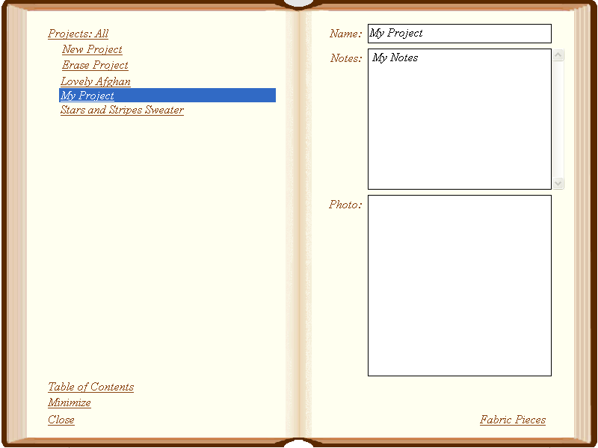
You have turned to the Projects chapter in Journal Six. You may return to the Table of Contents by clicking on the Table of Contents bookmark..
Click on the New Project bookmark to begin a new project. A new project page will be added to the journal.
All projects must have a name. All other fields and choices are optional
The project will automatically be named “My Project.” Change the name to something more meaningful.
Enter any notes on this project that you find useful.
You may add a photograph of your project by clicking on the photo box. You may need to wait until you've actually knitted your creation before you
add a photograph. You can come back at anytime to do so.
If you ever choose to remove a project from your journal, first select the project and then click Erase Project. Your project will be permanently erased.
As you fill your journal with more projects, the project list will become quite extensive and it will be more difficult to find an individual project. You can make the project list more manageable by limiting the list to projects that contain specific key words.
Click on the Projects link at the top of the page. The selection criteria text box will display:
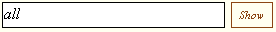
Remove the existing selection criteria and enter your own: For example:

Then click the show button. The project list will be limited to projects that meet the selection criteria. In this example, the project list will be limited to projects that have the words “Tuck” and “Afghan” in the name or in the notes.
You can reset the selection criteria by clicking the Projects link and removing the selection criteria text or replacing it with the word “all.” Then click the show button to restore the entire list.
All projects should have at least one fabric piece associated with it. After all, eventually you will want to knit something, and that something is a fabric piece. Click the Fabric Pieces bookmark to see the fabric pieces associated with the selected project.

Fabric Pieces
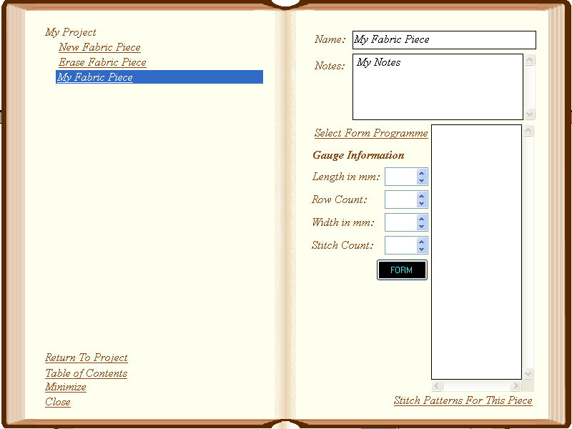
You have turned to the Fabric Pieces chapter. You arrived here from a project page. Click Return To Project to return to the current project page.
Click on the New Fabric Piece bookmark to begin a new fabric piece. A new fabric piece page will be added to your project.
The name of the fabric pieces are listed on the left hand page. The right hand page displays the active fabric piece. To turn to a different fabric piece page, click on the bookmark for the fabric piece you want. You may need to use the scroll bar, which will appear when the fabric piece list becomes extensive, to find the fabric piece you want.
Each fabric piece must have a name. The other fields are optional.
If you choose to remove a fabric piece from your journal, first select the fabric piece and then click Erase Fabric Piece. Your fabric piece will be permanently erased.

The fabric piece will automatically be named “My Fabric Piece.” Change the name to something more meaningful, for example, “Sleeve”
Enter any notes on this fabric piece that you find useful.
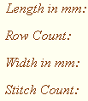
Enter gauge information if you have it. You may need to knit a swatch before you are able to determine the gauge. If you do not have it now, you can always add it a later time.


Click the Select Form Programme bookmark to add a form programme for this fabric piece.
See the Form Programmes and Knitting chapters for more information on using form programmes.

Click the Stitch Patterns For This Piece bookmark to turn to the the stitch patterns page for this fabric piece.
See the Knitting chapter for information on knitting with form programmes and downloading charts.

You have turned to the details page for your fabric piece. You may return to the summary page by clicking the Return to Fabric Pieces.
A cast on has been added for you automatically. You may add additional stitch patterns to the list for your fabric piece by clicking the New Stitch Pattern bookmark.
Click on the Remove Stitch Pattern book mark to remove the selected stitch pattern.
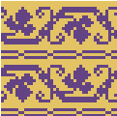
To begin with, the stitch patterns (including cast on) in the list are empty. Click on a stitch pattern in the list to highlight it and turn to the details page for it. You may then add the details for the stitch pattern.
You may add a stitch pattern motif by clicking the Select Stitch Pattern bookmark. See the Stitch Patterns chapter for more information on selecting stitch patterns. If you are knitting without a motif and just using a technique, you may omit selecting a stitch pattern.
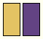
The stitch pattern motif will display on the right hand page. You may use the scroll bars to view sections of the motif if it is larger than the motif layout area.
The color legend beneath the motif indicates the number of colors in the motif and the order in which the colors will be knitted.

You may magnify the motif by moving the slide control to the right. The magnification in no way affects the size of the design as it is knitted; it just allows you to view the detail more easily.
The actual stitch pattern size, stitches by rows, is shown below the motif.
The aspect ratio allows you to get a sense of how the stitch pattern will look when the pattern is knitted. It is calculated by dividing the width of the stitch by its height. Aspect ratios greater than one result in a stitch that is wider than it is longer. Aspect ratios less than one result in a stitch that is longer than it is wide.
The aspect ratio setting in no way affects the pattern that is printed or sent to the console. It is only a visual aid to help you select patterns suitable for your gauge.
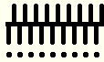
You may associate a knit technique by clicking on the Select Technique bookmark. See the Knit Techniques chapter for more information on selecting knit techniques.
The needle diagram displays the arrangement of needles and pushers for the selected knit technique.
The yarn feeder diagram shows which feeders are in work. A filled circle indicates a yarn feeder in work. A dotted circle indicates a yarn feeder out of work. A few techniques show feeders with a small dot in the center. This indicates that the lock is moved across the carriage with no feeder. An example of this is the drop lace knit technique.
Special instructions for using the knit technique are shown at the bottom of the right hand page.
See the Knitting chapter for information on knitting the selected stitch patterns and techniques

You may return to the summary page for your fabric piece at anytime by clicking the Return to Fabric Pieces.
Once you have finished adding your fabric pieces, you are ready to knit your project. See the Knitting chapter for advice on using Journal Six along side the E6000 console.

Form Programmes
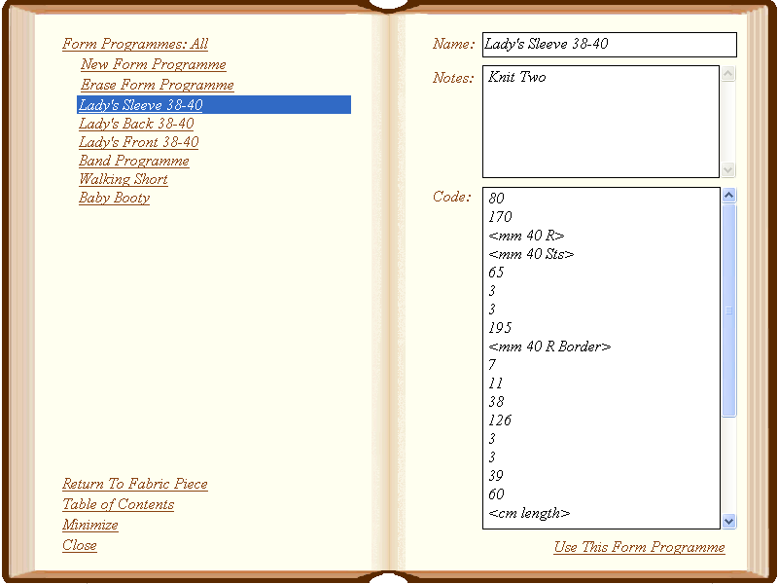
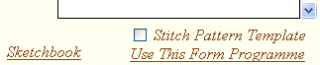
You have turned to the Form Programmes chapter in Journal Six. You may have the arrived here by clicking on the Select Form Programme bookmark on fabric piece page. Or, you may have arrived here from the Form Programmes bookmark on the table of contents.
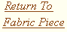
You may return to the current fabric piece without selecting a form by clicking the Return To Fabric Piece bookmark.
You may return to the table of contents by clicking the the Table of Contents

Journal Six does not include any form programmes when you first install it. You will have to add your own. Sources of form programmes include your
E6000 User Manual, knitting magazines, and published books of form programmes. Click on the New Form Programme bookmark to add a new form programme.
All form programmes must have a name. The form programme will initially be named “My Form Programme.” Change it to a more meaningful name.
The notes field is optional. Add any notes that you find useful.
Enter the form programme code (“the numbers”) in the code field. When you program the console, you will enter the codes listed here. Since you hand enter the data into the console, you don't have to worry much about how you format your programme. It is OK to include a few notes in this area as well.
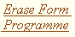
If you ever choose to remove a form programme from your journal, first select the programme and then click Erase Form Programme. Your form programme will be permanently erased.

To associate a form programme with the current fabric piece, select the desired form programme from the list and click Use This Form Programme. You will be returned to the current fabric piece and your chosen form programme will be associated with it.
As you fill your journal with more form programmes, the form programme list will become quite extensive and it will be more difficult to find an individual form programme. You can make the form programme list more manageable by limiting the list to form programmes that contain specific key words.

Click on the Form Programmes link at the top of the page. The selection criteria text box will display:
Remove the existing selection criteria and enter your own: For example:
Then click the show button. The form programme list will be limited to projects that meet the selection criteria. In this example, the list will be limited to form programmes that have the word “Lady” in the name or in the notes.
You can reset the selection criteria by clicking the Form Programmes link and removing the selection criteria text or replacing it with the word “all.” Then click the show button to restore the entire list.
You can open the sketchbook to draw a downloadable chart by clicking on the Sketchbook bookmark. A downloadable chart is an alternative to a standard Form Programme which allows you to sketch the shape of the fabric piece similar to the old Form 6 software. See the chapter on downloadable charts for more information.

If you have created downloadable charts, you may want to use one of them as a transparent background in the stitch pattern sketchbook. To do so, make sure the chart you wish to use is selected and check the Stitch Pattern Template check box.
The next time you open the sketchbook for stitch patterns, you will see a light green transparent shadow in the background of the sketchbook. This is not part of the actual stitch pattern; it merely serves a guide for placing the various design elements of your stitch pattern.
Notes:
Notes:

Stitch Patterns

You have turned to the Stitch Patterns chapter in Journal Six. You may have the arrived here by clicking on the Select Stitch Pattern bookmark from a fabric piece detail page. Or, you may have arrived here from the Stitch Patterns bookmark on the table of contents.
You may return to the current fabric piece without selecting a stitch pattern by clicking the Return To Fabric Piece bookmark.
You may return to the table of contents by clicking the the Table of Contents bookmark.
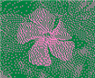
The stitch pattern list shows the list of available stitch patterns. Click on the stitch pattern name to select it. The Stitch pattern box will display the motif for the selected stitch pattern.
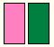
The color legend beneath the motif indicates the number of colors in the motif and the order in which the colors will be knitted.
You may magnify the motif by moving the slide control to the right. The magnification in no way affects the size of the design as it is knitted; it just allows you to view the detail more easily.
The aspect ratio allows you to get a sense of how the stitch pattern will look when the pattern is knitted. It is calculated by dividing the width of the stitch by its height. Aspect ratios greater than one result in a stitch that is wider than it is longer. Aspect ratios less than one result in a stitch that is longer than it is wide.
The aspect ratio setting in no way affects the pattern that is printed or sent to the console. It is only a visual aid to help you select patterns suitable for your gauge.
The stitch pattern size, stitches by rows, is shown below the motif.

To associate a stitch pattern with the current fabric piece, select the desired stitch pattern from the list and click Use This Stitch Pattern. You will be returned to the current fabric piece and your chosen stitch pattern will be associated with it.

If you ever choose to remove a stitch pattern from your journal, first select the stitch pattern from the list and then click Erase Stitch Pattern. Your stitch pattern will be permanently erased.
As you fill your journal with more stitch patterns, the stitch pattern list will become quite extensive and it will be more difficult to find an individual stitch pattern. You may make the stitch pattern list more manageable by limiting the list to stitch patterns that contain specific key words.
Click on the Stitch Patterns link at the top of the page. The selection criteria text box will display:
Remove the existing selection criteria and enter your own: For example:
Then click the show button. The stitch pattern list will be limited to stitch patterns that meet the selection criteria. In this example, the list will be limited to stitch patterns that have the word “Floral” in the name or in the notes.
You may reset the selection criteria by clicking the Stitch Patterns link and removing the selection criteria text or replacing it with the word “all.” Then
click the show button to restore the entire list.


To add a new stitch pattern click the New Stitch Pattern bookmark to turn to the image conversion page. You may also turn to the image conversion page by double clicking a stitch pattern from the stitch pattern list to edit it. See the Image Conversion chapter for more information on creating stitch patterns.
All stitch patterns must have a name. New stitch patterns will initially be named “My Stitch Pattern.” Change it to a more meaningful name.
The notes field is optional. Add any notes that you find useful.

The export button allows you to save a stitch patterns as a Bitmap so that you can use the stitch pattern with another program or share it with friends.
Notes:

Knit Techniques
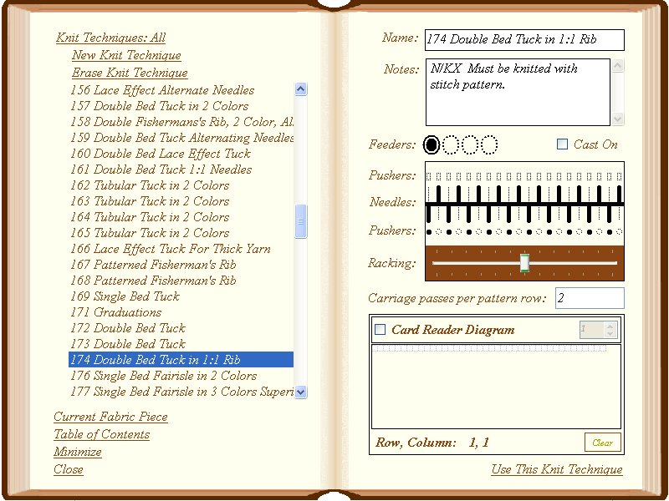
You have turned to the Knit Techniques chapter in Journal Six. You may have the arrived here by clicking on the Select Technique bookmark from a fabric piece details page. Or, you may have arrived here from the Knit Techniques bookmark on the table of contents.
You may return to the current fabric piece without selecting a knit technique by clicking the Return To Fabric Piece bookmark.
You may return to the table of contents by clicking the the Table of Contents bookmark.
The knit technique list shows the list of available knit techniques. Click on the desired knit technique to select it. The right hand page will display the
selected technique.


To associate a knit technique with the current fabric piece, select the desired knit technique from the list and click Use This Knit Technique. You will return to the current fabric piece page and your chosen knit technique will be associated with your fabric piece.

If you ever choose to remove a knit technique from your journal, first select the technique from the list and then click Erase Knit Technique. Your knit technique will be permanently erased.
As you fill your journal with knit techniques, the knit techniques list will become quite extensive and it will be more difficult to find an individual knit technique. You may make the knit technique list more manageable by limiting the list to knit techniques that contain specific key words.
Click on the Knit Techniques link at the top of the page. The selection criteria text box will display:
Remove the existing selection criteria and enter your own: For example:
Then click the show button. The knit technique list will be limited to knit techniques that meet the selection criteria. In this example, the list will be limited to knit techniques that have the word “Rib” in the name or in the notes.
You can reset the selection criteria by clicking the Knit Techniques link and removing the selection criteria text or replacing it with the word “all.” Then click the show button to restore the entire list.

Most knitters will be content to use the existing knit techniques available in the console. However, there are situations where you may find it convenient to add your own knit techniques.
If you sometimes “lie to the console” and choose different lock settings than specified by the console technique, you may find it convenient to create a new technique in Journal Six based on the console technique. Enter the information for the console technique and indicate in the notes field your variations on the technique.
You may also enter the card reader techniques that sometimes accompany published patterns. You will find downloading card reader techniques much easier than marking a card.
To add a new knit technique click the New Knit Technique bookmark.

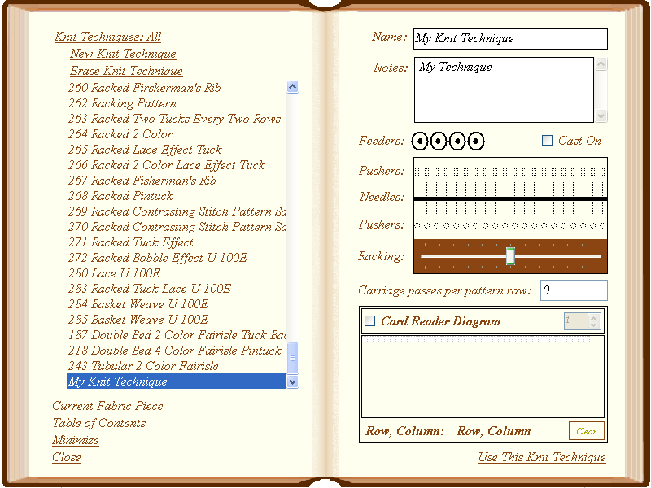
All knit techniques must have a name. New knit techniques will initially be named “My Knit Technique.” Change the name to something more meaningful.
The notes field is optional. Add any notes that you find useful.
Click repeatedly on each yarn feeder to mark it as in-use, ; out-of-use, ; or in-use but empty, .
Check the Cast On box if the technique is a cast on.
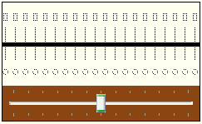
Use the needle diagram to indicate the arrangement of needles and pushers for your technique.
The solid horizontal line indicates the gap between the back and front beds.
The vertical lines represent the needles. They may be marked in-use by clicking on each needle. Clicking a second time will mark them out of use. Right clicking on a needle will set the entire needle bed to in-use or out-of-use.
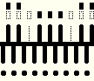
The rectangles along the top of the diagram represent the back bed pushers. They may be marked in-use by clicking on the pushers. The first click will place a pusher in upper working position; the next click will place it in lower working position. Click once more to put the pusher out of work. Right click to change the position of all the back bed pushers at once.
The circles below the front bed needles represent the front bed pushers. Click a pusher to mark it in use. Click again to mark it out of use. Upper and lower working positions are not shown for front bed pushers since the E6000 sets the pusher position automatically.
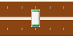
Slide the racking indicator to the left or right to set the relative position of the front bed to the back bed.
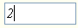
Enter the number of carriage passes required to complete one pattern row in the Carriage Passes Per Pattern Row field. This field optional.
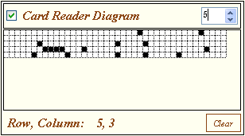
The card reader diagram is used to enter card reader techniques that are sometime included with published patterns and is optional. If you are using a card reader technique, check the Card Reader Diagram check box. Enter the number of rows your diagram requires. In this example 5 rows have been requested. Click on the grid to blacken the squares. A click on a black square will remove the mark. If you want to start over, click the clear button.
Once you have created your knit technique, it is ready for use in your projects.

Image Conversion

You have turned to the Image Conversion chapter in Journal Six. You arrived here by clicking on the New Stitch Pattern bookmark from the stitch patterns page.
You may return to the stitch patterns page without adding a new stitch pattern by clicking the Cancel bookmark.
You may return to the table of contents by clicking the the Table of Contents bookmark.
The image conversion chapter allows you load an image file, choose conversion settings, and transform it into a stitch pattern. Although it is possible to create a “from scratch” stitch pattern in Journal Six, you will typically start with a previously prepared image file. Journal Six allows you convert the most common image file formats: JPG, PNG, BMP, GIF, and CUT.
Sources of image files include digital photographs, scans, and images created in graphics editing software. You may also create a “from scratch” stitch pattern by clicking on the Sketchbook bookmark. Please see the next chapter for information on using the the Sketchbook.

Click the Load Image button to load an image file into Journal Six. The standard Windows “open files” dialog box will open. Supply the name of the image file. The image file will be loaded into the reference image area on the lower left corner of the page.
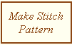
After the image is loaded, a stitch pattern will be generated in the stitch pattern box in the right hand page. This stitch pattern may not be exactly what you had in mind. Typically, you will want adjust the settings to your preference and then click the Make Stitch Pattern button. If you don't like the result, change the settings again and regenerate the stitch pattern.
Journal Six will attempt to guess the correct colors by examining the image. If the image has four or fewer colors, it usually does a good job. If you have many colors in your image file you will want to adjust the color settings.
Select the number of colors you want for you stitch pattern by using the Colors drop down list. The color palette, located at the top of the left hand page, will be limited to the number of colors chosen.

There are several ways to choose colors in the color palette.
To set an individual color in the color palette, double click it. The standard Windows color chooser dialog box will appear. Select the desired color.
You may also use the reference image to choose colors. Single click the color on the palette you wish to change. A thick border will appear around the color. This indicates that the color has been selected. Next, move your cursor to the reference image. When the cross-hair is over the desired color, click. The color on the palette will be updated.
To set the color palette to a gray scale, Click the the Gray Scale Button. Gray scale tends to work very well for photographs.

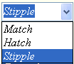
When the colors in the palette are fewer than the total colors in the image Journal Six must approximate the colors not found in the palette using one of several methods: nearest match, cross hatching, or stippling. Choose a color approximation method from the drop down box.
Match will use the nearest color found on the palette. This often creates large solid areas of color suitable for intarsia. Hatch will create a cross hatched appearance similar to the way pictures are printed in newspapers. Stipple will create a stippled appearance, which is quite nice for portraits and natural subjects.

In generating your stitch patterns, you have a choice of overlaying the colors in each row or separating the colors in there own rows.
Selecting Overlay causes each color to appear in the same row. This is the standard way to create a stitch pattern for download.
Some knit techniques require that each color appear as separate row, such as techniques 219-230 and techniques 231-242 . In this case select Separate.
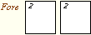
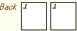
The fore and back color maps are preset for the most common uses. However, you may occasionally choose to adjust them to create special effects. During stitch pattern generation, the colors are first chosen using the selected color approximation method: match, hatch or stipple. A color may then be further manipulated by the color map to arrived at the final color of the stitch in the pattern.
Consider a color map that has a “2” in each of the “fore” color blocks. If, for example, the color approximation method selects the first color in the palette for a stitch, that color is then looked up the color map. In this example that color would be replace with second color in the color palette, because the color block for the first color in the palette has a single “2” in it.
Exactly how the color map is used depends upon how the Overlay/Separate and Expand/Filter options are set. If Separate is chosen, the “Back” as well as the “Fore” color maps are used. If Overlay is chosen then only the “Fore” map is used.

Expand and Filter options also determine how the color maps are used. If expand is chosen, the entire color block in the map is applied to each stitch. This may cause the stitch pattern to expand if more than one color number is entered a block. If filter is used, then an individual color in the color block is applied based on the position of stitch in the pattern, causing the stitch pattern to maintain its specified size.
Color maps may seem strange and confusing, but there are cases where they can help you do some useful things. Most of the time you may safely ignore the color map, since it is preset for you with most useful mappings. The examples section will explain the color map more fully.
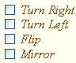
You may change the orientation of the stitch pattern as it relates to the reference image by checking the Turn Right, Turn Left, Flip, and/or Mirror check boxes. You may combine turning, flipping, and mirroring to orient the stitch pattern in any direction.
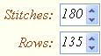
The stitches and rows are preset for you based on the size of the image. The actual image size is used when the width of the image is under 180 pixels. For larger images, Stitches is set to 180 and Rows is set to maintain the aspect ratio from the image. Enter the number of stitches and rows you want in the stitch pattern. Take your gauge into consideration. Depending on the dimensions you choose you may shrink or stretch your stitch pattern in one or both directions.

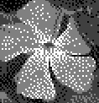
The stitch pattern box is located on the right hand page.
After generating the stitch pattern, you may find that there are few stitches out of place. You may manually change the color of a stitch by clicking on it. Multiple clicks on the same stitch will advance it through the available colors.

The color legend beneath the motif indicates the number of colors in the motif and the order in which the colors will be knitted.
You may magnify the motif by moving the slide control to the right. The magnification in no way affects the size of the design as it is knitted; it just allows you to view the detail more easily.
The stitch pattern size, stitches by rows, is shown below the motif.

The aspect ratio allows you to get a sense of how the stitch pattern will look when the pattern is knitted. It is calculated by dividing the width of the stitch by its height. Aspect ratios greater than one result in a stitch that is wider than it is longer. Aspect ratios less than one result in a stitch that is longer than it is wide.
The aspect ratio setting in no way affects the pattern that is printed or sent to the console. It is only a visual aid to help you select patterns suitable for your gauge.
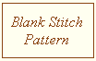
If you want to create a stitch pattern completely by hand, click the Blank Stitch Pattern button to create a blank stitch pattern. You will then need to edit the stitches by hand by clicking on them in the stitch pattern box. This is a very labor intensive way to create a stitch pattern. It is only recommended for small stitch patterns.

Sometimes you may be fairly satisfied with the stitch pattern, but may wish to see how it looks with the yarns you intend to use. For example, you may have converted a photograph using gray scale and want to “colorize” the stitch pattern. After generating the stitch pattern, change the color palette to the colors you prefer. Then click the Change Colors Only button. The colors in your stitch pattern will be updated.

When you are satisfied with the stitch pattern, click the Add To Stitch Patterns bookmark. Your stitch pattern will be added to the stitch pattern list. If your stitch pattern is too large to fit into a console pattern slot, it will be broken down into several patterns so that each may be downloaded separately. If you have opted to print reader cards on the settings page, large
patterns will not be split. The pattern will print as multiple cards.
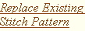
If you have been editing a pre-existing stitch pattern, you may replace it by clicking the Replace Existing Stitch Pattern bookmark. Normally it best to use Add To Stitch Patterns so that you have both the original and edited versions of the stitch pattern.
Examples
The variety of options for creating stitch patterns is sometimes overwhelming. Remember, it is perfectly fine to keep things simple. Most knitters will simply load an image file, set the colors, choose match, hatch or stipple, and click the Make Stitch Pattern button.
The following examples explore additional possibilities for stitch pattern generation.
Let's look at basic 2 color designs first.
Consider the reference image to the right. We will use the following settings, which are the default settings.  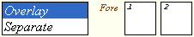 | 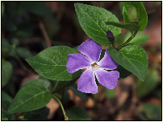
Match will create a solid looking stitch pattern by matching each color in the reference image to the nearest color in the palette, without attempting any shading. | 
Hatch will create a shaded image using cross-hatching to simulate colors in-between the colors on the palette. More detail emerges than in match mode. | 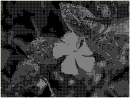
Stipple will create a shaded stitch pattern using stippling to simulate colors in-between the colors on the palette. More detail emerges than in match mode. The stitch pattern has a softer look than a cross-hatched stitch pattern. Stippling is very good for portraits and natural subjects. | 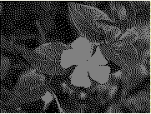

Three and four color stitch patterns suitable for download are just as easily created as two color designs. Just specify the number of colors and the color approximation method. Here is a sampling of some possibilities.

Three Color | Four Color
Match Mode
 | 
Hatch Mode
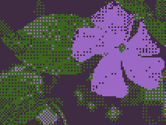 | 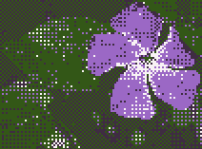
Stipple Mode
 | 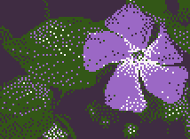

Let's look at stitch patterns where each color is on separate row of the stitch pattern. Colors must be separated for some 3 and 4 color knit techniques, such as techniques 219-230 and techniques 231-242. These techniques are particularly useful if you plan to use the card reader instead of the download cable.
When thinking about color separations, it is helpful to think about how you would mark cards for the card reader. Even though you mark the cards for 3 and 4 color designs, you really only use two colors, black and white. You follow the convention that the black squares of the first row represents color one, the back ground color; the black squares of the second row represents color two, the motif color; the black squares of the third row represents color 3, the second motif color; and so on.
In Journal Six stitch pattern creation, we will use color 2 to represent the black squares and color 1 to represent the white squares. Let's look at converting an image to a 3 color design using color separation.
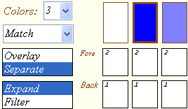  Consider the image to the right.  When Separate is chosen, the color map is pre-filled with the settings for the standard color separation found in your E6000 user manual. Color 2, our “black,” is the Fore color for all three colors in the palette and color 1, our “no mark” color, is the Back color for all three palette colors. | 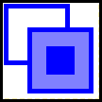
Here is the resulting stitch pattern appropriately marked for knit techniques 219-230.  During stitch pattern generation, each color in the image will be placed on a separate row because Separate was chosen. The actual fore color used in the stitch pattern comes from the color map, in this case color 2 for all three colors. The back color is the color used to indicate an “unblackened” square. In this case, the background color is color 1 for all colors.  Notice that the size of the pattern increases in 3 times in length when you choose separate, even though we specified a 20x20 stitch pattern, the actual diagram is 20x60. This is an effect of choosing to separate colors rather than overlaying them and using Expand. | 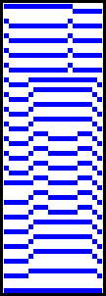
Three and four color stitch patterns on reader cards may also be created by superimposing. Separate cards are created for each of the motif colors in the stitch pattern. In a three color design, a card will be created showing the background and first motif color and a second card showing the background and second motif color. In a four color design an additional card will be created with the background and third motif color.
Consider the image to the right. Let's create separate stitch patterns for the first and second motif colors.
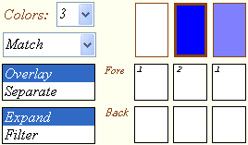  For the first motif color we need to cover up the second motif color by mapping color 3 to the background color, color 1. The resulting stitch pattern is at the right. | 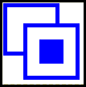
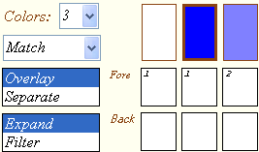  For the second motif color we need to cover up the first motif color by mapping color 2 to the background color, color 1. The resulting stitch pattern is at the right. | 

Let's look more closely at Expand and Filter. Expand substitutes the entire color block in the color map for each pattern stitch generated. This expands the design. Filter applies the color map on top of the stitch pattern. The design does not expand in size.
Let's consider the image at the right, original size 20x20. | 
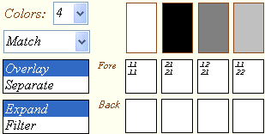  Suppose, instead of three solid rectangles, we wanted to substitute vertical stripes, checks, and horizontal stripes. We map our four colors to the desired  textures using the color numbers. Each individual stitch will be substituted with, in this case, a block of four stitches. The Substitution is made according to the color map below each color in the palette. Our design doubles in size vertically and horizontally since the color blocks are each 2x2 in size. | 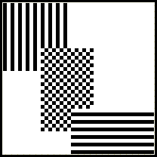
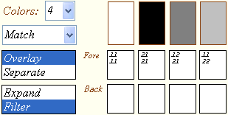  In the above example, the stitch pattern expanded to accommodate the multi-stitch color blocks in the color map. If you want to keep the original size of the stitch  pattern while applying a multi-stitch color map, choose Filter instead. | 

Tips and Techniques
- The Back color blocks on the map are not used if you choose Overlay.

- If you choose Separate, the Back color blocks must be specified on the map and must be the same dimensions at the corresponding Fore block.

- Be careful when working with color maps. Not all resulting stitch patterns will be practical to knit. It is possible that some color maps may generate an error. Review the color map. It is most likely not set up correctly. Look for stray characters and delete them.

- The colors in the palette are automatically chosen from the image up to the first four colors found when the image is loaded. Even if the colors you want have been chosen correctly, be sure to check the order of the colors so that they will be knitted in the correct order.

- If the resulting stitch pattern does not seem to reduce colors in a way that is pleasing to you, try adjusting the colors in the palette to darker or lighter shades. For example instead of a two color palette of black and white, try a palette of dark gray and light gray.

- You will often get the best results converting photograph by using gray scale. However, you may then want to see what your stitch pattern looks like in your selected yarns. After converting your stitch pattern with gray scale, change your color palette to shades representing your yarns. Then click the Change Colors Only button. Your gray scale stitch pattern will be “colorized.”
- If you find are not satisfied with the stitch pattern you generated, it is possible that the image it is based on needs more work. Open the original image in your favorite graphics editing software to revise the image and try again.
- The console stitch patterns will originally display as blank in Journal Six. You may edit these stitch patterns to match the actual stitch patterns or load the corresponding CUT files from Creation 6 if you have them.

Sketchbook for Stitch Patterns

Overview
The sketchbook allows you to create “from scratch” stitch patterns or embellish stitch patterns converted from images.
You open the sketchbook by clicking on the sketchbook bookmark on the image conversion page of the journal.
Prior to opening the sketchbook, you should specify the number colors, colors, and stitches and rows on the image page. If you are embellishing an existing stitch pattern, make sure it is loaded on the image conversion page. The information you provide on the image conversion page will be used as the basis for your sketch.
The stitch pattern appears in the upper left corner of the drawing area. The drawing area itself is 180 stitches by 999 rows. If your stitch pattern is smaller than the maximum drawing area, a turquoise box will appear indicating the extent of the stitch pattern. You may use the drawing area outside of the stitch pattern as a “scratch pad” and later copy sections into the stitch pattern area or select a new area for the stitch pattern.
You can enlarge the sketchbook to full screen by double clicking the spiral binding at the top. Double click it again to return to normal size. You may move the sketchbook around by dragging the spiral binding.
The sketchbook has a variety of drawing tool that are common to many drawing programs. There are also a variety of modes that affect how the tools work.

Tool Modes
You may draw using with either the left or right mouse button. This allows you to have two fill patterns available at all times. The assigned fill patterns are shown in the two small squares at the top of the sketchbook.
You may specify the fill pattern by left or right clicking on a pattern in the color palette area.
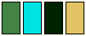
Individual colors may be set as transparent. Click on a color in the legend below the drawing area. The color will disappear. When you draw, the corresponding color in the fill pattern will be transparent. This is very effective when you are overlaying different design elements on top of each other.
You may restore a transparent color by clicking on the corresponding color in the legend to make the color solid again.

You may also use the dropper tool to select a fill pattern based on an area of the sketch. Click the dropper tool to select it. Drag the cursor over the area of the sketch that you want to use as a fill pattern. The pattern will copy to either the left or the right mouse button fill pattern depending on which button was used.



You may specify the layout of the fill pattern by clicking repeatedly on the layout icon. Choices are grid, brick, and half-drop. Grid lays out the repeats of the fill pattern in a grid. Brick staggers the pattern horizontally and half-drop staggers the pattern vertically.


Click the symmetry mode icon to if you wish to draw symmetrically. The draw tools will draw in the symmetry mode you select. The center of symmetry will be the center of the stitch pattern. (You may use the lasso tool, explained later, to move the center of the stitch pattern. It is sometimes convenient to move the stitch pattern center temporarily depending on what you want achieve.)
The following table lists the symmetry options.
 | No symmetry.
 | 2-Way kaleidoscope: Drawing is reflected over a horizontal line
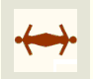 | 2-Way kaleidoscope: Drawing is reflected over a vertical line
 | 2-Way kaleidoscope: Drawing is reflected over a diagonal line extending from the upper right to the lower left.
 | 2-Way kaleidoscope: Drawing is reflected over a diagonal line extending from the upper left corner to the lower right corner
 | 4-Way kaleidoscope: Drawing is reflected horizontally and vertically.
 | 8-Way Kaleidoscope: Drawing is reflected horizontally, vertically, and diagonally.
 | 2-Wing Pinwheel: Drawing is rotated once, 180°.
 | 3-Wing Pinwheel: Drawing is rotated twice, 120°.
 | 4-Wing Pinwheel: Drawing is rotated three times, 90°.
 | 5-Wing Pinwheel: Drawing is rotated 4 times, 72°.
 | 6-Wing Pinwheel: Drawing is rotated 5 times, 60°.
 | 8-Wing Pinwheel: Drawing is rotated 7 times, 45°.

Set the line thickness to your preference. You may set it between 1 and 10 stitches wide.
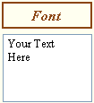
If you plan to use the text tool, select your font by clicking the font button and enter the text you want to add to your stitch pattern in the box below.

Drawing Tools
All drawing tools work similarly. Select your preferred drawing tool. Move your cursor to the drawing area. Press either the left or right mouse button and then drag the cursor to the desired location. Release the mouse button to complete the drawing. The following drawing tools are available:
 | Paintbrush-- Drag across drawing surface to paint individual stitches.
     | Text Tools-- Click the text button repeatedly until the text mode you want is selected. For the horizontal text tool, click in drawing area and drag text to preferred position. For the curved text tool, hold down the mouse button in the center of the circle you want the text to circumscribe. Then drag the mouse to place the text. For the slanted text tool, hold down the mouse button where you want to set the vertex of the text angle and then drag the mouse to set the angle and position the text.
     | Line Tools-- Click in the drawing area to set the starting point. Drag and release to set the end point.
 | Stamp Tool-- Click in the drawing area and drag to the precisely place one instance of the fill pattern. Works best in no-symmetry mode.  You can use the dropper tool along with the stamp tool to do copy and paste operations.
   | Ellipse Tools-- Click in drawing area and drag to size ellipse.
  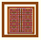 | Rectangle Tools-- Click in drawing area and drag to size rectangle.
 | Flood Fill Tool-- Click in drawing area to replace color under the cursor and surrounding area with your chosen fill pattern.
 | Mirror Tool-- Click in drawing area and drag to select region to mirror. Release mouse button to create mirror image.
   | Turn Tools-- Click in drawing area and drag to select region to turn. Release mouse button to turn 90°. Any “empty” area left behind after turning will fill in with the fill color associated with the mouse button.
 | Flip Tool-- Click in the drawing area and drag to select region to flip. Release mouse button to flip image.

Additional Features

The undo button will undo your drawing to the last action that you took. Ten levels of undo are available. You may click the redo button if you want to undo the “undo.”

Click on the grid icon to display a grid over the drawing area. Clicking on the icon a second time removes the grid.
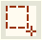
Click on the lasso tool to change the size and location of the stitch pattern on the drawing area. You may wish to temporarily select a new region for the stitch pattern when you are working with various symmetry modes.

Use the magnifier to enlarge the stitches in the drawing area.

Change the aspect ratio to more closely simulate what your stitch pattern will look like knitted. An aspect greater than one will result in stitches that are wider than they are long. An aspect less than one will result in stitches longer than they are wide.
Click Tile View to view the stitch pattern tiled across the surface of the drawing area. Click Sketch Mode to return to drawing.
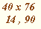
The size of the stitch pattern is shown in the lower right area of the sketchbook. The current cursor position is also displayed.

Click Use This Sketch to save the new stitch pattern to the image conversion page of the journal. The sketchbook will close and you will return to the journal.
Click Cancel and Return to Journal to close the sketchbook and return to the journal without saving.

Notes:

Sketchbook for Downloadable Charts
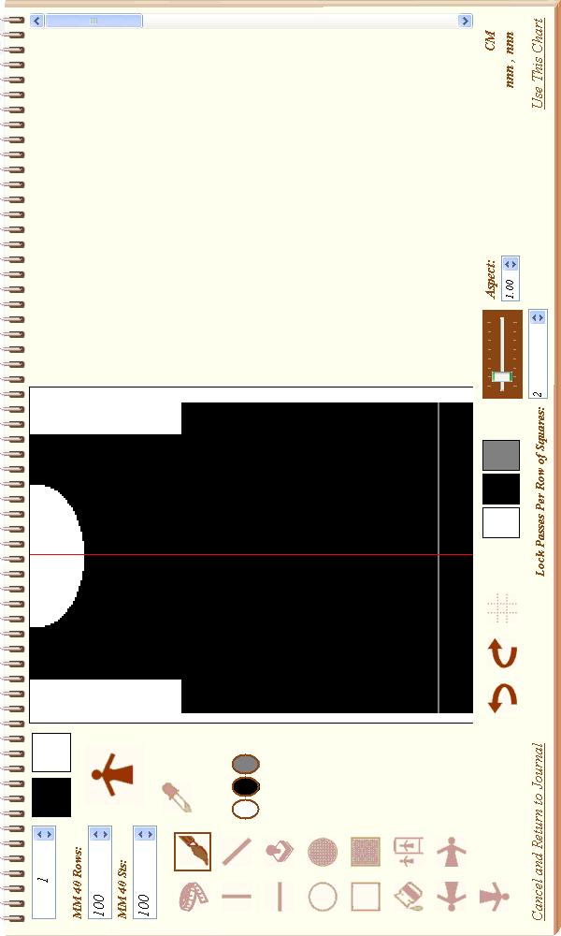

Overview
The sketchbook for downloadable charts allows you to draw a chart of a fabric piece so that it can be downloaded into the console.
Downloadable charts provide much the same functionality as the old PASSAP Form 6 software did. This feature is only available if your console supports downloading from the FORM prompt. If pressing the unlabeled key followed by the zero key does not bring up the PC START prompt then you will not be able to download a chart unless you upgrade the console with the most recent chip set. Please write support@passappal.com if you want a new chip set for your console.
Downloadable charts differ in a number of ways from traditional form programmes. Form programmes provide a great deal of flexibility. One programme can be used to generate multiple lengths and widths of the same base shape. The console determines the stitches and rows to be knitted from the measurements entered. Charts provide more precision and control. With charts, you draw the exact stitches and rows to be knitted. Both methods are similar in that they give the console enough information to display detailed knitting instructions as you knit the piece. Whether you use form programmes or charts is really a matter of personal choice. When you cannot find a form programme to match the shape you want to knit, a downloadable chart is an excellent option.
The preceding page shows a sample chart. When sketching charts keep in mind the following facts:
- You are drawing the exact stitches and rows you want to knit. Needle L90 is the left most square in the sketch area. Needle R90 is the right most square. Each row of square represents 2 or more rows passes of the locks. The number of row passes is dependent on the knit technique you intend to use. For example a 4-color fair-isle pattern may require as many as 8 passes.
- To cast on, draw a horizontal row of stitches over the desired number of needles (squares) anywhere in the sketch area. The cast-on row must be one continuous line of stitches. There must not be any gaps since the console will allow only one cast on.
- The shape must be drawn in solid black with no holes or slits.
- There may only be one neckline since the console will only allow the piece to be divided once.
- The last row drawn must not contain increases or decreases.
- Changes in pattern are represented by a gray horizontal line with a width of one row of squares that crosses the entire piece as show in the example on the preceding page. During knitting, you will receive the ABC prompt for each pattern change specified with a gray line.
- The first gray line represents the change from the cast-on technique to stitch pattern A. A second gray line represents when to switch to stitch pattern B and so on.

Tool Modes
The behavior of the various drawing tools are dependent on the modes selected for them.

You may draw using either the left or right mouse button. This allows you to have two colors available at all times. The assigned colors are shown in the two small squares at the top of the sketchbook.

You may specify the color of each mouse button by left or right clicking on a color in the color palette area. Black represents a stitch; white, no stitch. Gray is used to draw a pattern change line.
You may also use the dropper tool to copy a section of your drawing. Click the dropper tool to select it. Drag the cursor over the area of the sketch that you want to capture. The selection will copy to either the left or the right mouse button fill pattern depending on which button was used. The stamp tool can be used to paste the clipping.
Set the line thickness to your preference. You may set it between 1 and 10 squares wide.
Click the symmetry mode icon to if you wish to draw symmetrically. Anything you draw will be reflected over the red vertical line dividing the “L” needles from the “R” needles. Two-way symmetry is excellent for ensuring that the shaping is identical on both the left and right sides of the garment. Clicking the symmetry mode icon a second time will return the drawing tools to the normal drawing mode.

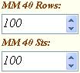
Enter your gauge information in the MM 40 Rows and MM 40 Sts. The gauge information is used in conjunction with the tape measure tool to convert measured squares into centimeters.

Lock Passes Per Rows of Squares indicates how many times you will move the lock for one complete iteration of the knit technique you intend to use. For example, stockinette would require 2 passes. A 3-color fair-isle pattern typically requires 6 passes.

Drawing Tools
All drawing tools work similarly. Select your preferred drawing tool. Move your cursor to the drawing area. Press either the left or right mouse button and then drag the cursor to the desired location. Release the mouse button to complete the drawing. The following drawing tools are available:
 | Tape Measure-- Click in the drawing area to set the starting point. Drag to the location you want to measure. The measurement in centimeters will appear in the lower right corner under the drawing area.
 | Paintbrush-- Drag across drawing surface to paint individual stitches.
 | Line Tools-- Click in the drawing area to set the starting point. Drag and release to set the end point.
 | Ellipse Tools-- Click in drawing area and drag to size ellipse.
 | Rectangle Tools-- Click in drawing area and drag to size rectangle.
Stamp Tool-- Click in the drawing area and drag to the precisely place one instance of the fill pattern. Works best in no-symmetry mode.
You can use the dropper tool along with the stamp tool to do copy and paste operations.
 | Flood Fill Tool-- Click in drawing area to replace color under the cursor and surrounding area with your chosen color.
 | Mirror Tool-- Click in drawing area and drag to select region to mirror. Release mouse button to create mirror image.
 | Turn Tools-- Click in drawing area and drag to select region to turn. Release mouse button to turn 90°. Any “empty” area left behind after turning will fill in with the fill color associated with the mouse button.
 | Flip Tool-- Click in the drawing area and drag to select region to flip. Release mouse button to flip image.

Additional Features
The undo button will undo your drawing to the last action that you took. Ten levels of undo are available. You may click the redo button if you want to undo the “undo.”
Click on the grid icon to display a grid over the drawing area. Clicking on the icon a second time removes the grid.

Use the magnifier to enlarge the stitches in the drawing area.

Change the aspect ratio to more closely simulate what your fabric piece will look like knitted. An aspect greater than one will result in stitches that are wider than they are long. An aspect less than one will result in stitches longer than they are wide.
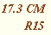
The size in centimeters of the line or shape being drawn is shown in the lower right area of the sketchbook. The current cursor position is also displayed as a left or right needle position.

Click Use This Chart to save the chart to the form programme page of the journal. The sketchbook will close and you will return to the journal.
Click Cancel and Return to Journal to close the sketchbook and return to the journal without saving.
See the chapter on on E6000 Programming and knitting for information on how to download a chart into your console.
Notes:

E6000 Programming and Knitting
Journal Six assists you with stitch patterns, knit techniques, and form programmes when you are programming the E6000 console and when you are knitting.
When you are ready to knit a project follow these steps:
- If you are using the download cable, make sure it is plugged into the E6000 console and your computer.
- Select a project from the project list.

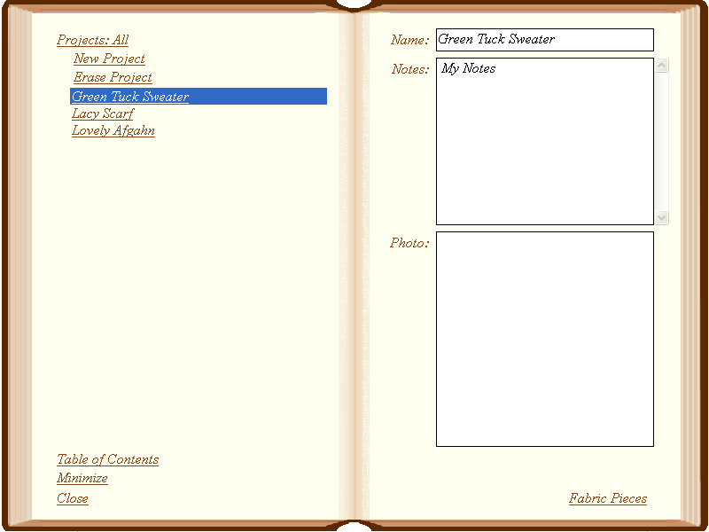

- Double click your project or click the Fabric Pieces bookmark to turn to the fabric pieces page for your project.
- Select a fabric piece from the fabric piece list.
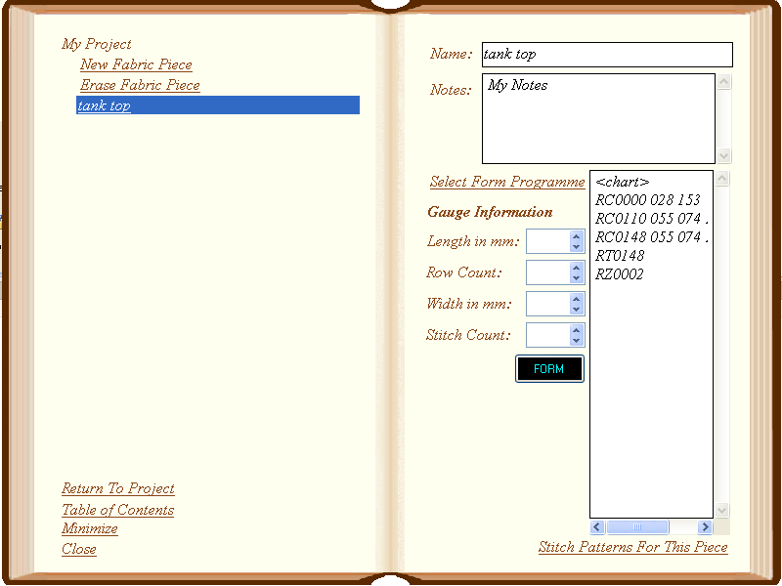

Stitch Patterns
- Double click the fabric piece name or or click Stitch Patterns For This Piece.

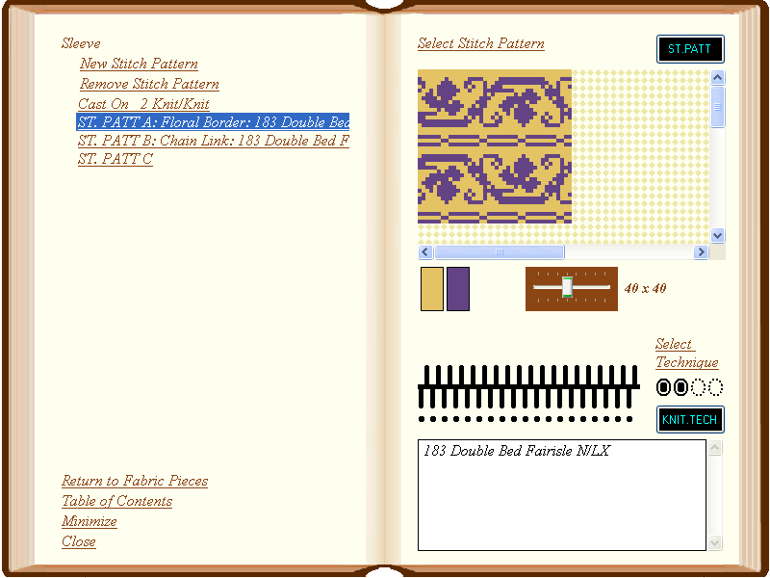
- Select a stitch pattern from the list.
- If you are set up to print cards, (see Settings) click the 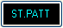 button.
  - The printer dialog box appears. Select your printer and choose either A4 or US LEGAL size.
  - Your stitch pattern will be printed as cards, which you may read into the console using the optical card reader. You will need to trim the cards to fit the reader sleeve. Be sure to align the registration marks carefully.
  - Skip to the next section, Knit Techniques.

- If you are set up to download directly to the console, (see Settings) first make sure your download cable is installed.
  - Program the E6000 console to point where ST.PATT A (or B, C, etc.) is blinking.
  - Press the button in Journal Six. The button will change its appearance to 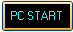.
  - Press the unlabeled key on the console followed by the zero key.
  - The console will display PC START.
  - Press the button in Journal Six. The console display will show WAIT while the stitch pattern is downloaded. Very large stitch patterns may take several minutes to download.

- If you are set up to send stitch patterns to SilverKnit, (see Settings) click the button.
  - SilverKnit will start with your stitch pattern automatically loaded. Consult SilverKnit documentation for more information.
Knit Techniques
- You will be prompted for a knit technique after you download your stitch pattern.
- If you are using standard techniques or “lie to console” techniques, refer to Journal Six and enter the knit technique you have listed for your stitch pattern.
- If you are using a card reader technique, you may either print a reader card or download the technique depending on how you've set up Journal Six.
- To print a card reader technique, press the button.
  - Your technique will print as cards, which you may read into the console using the optical card reader.
- To download a card reader technique,
  - press the button when the E6000 console displays KNIT.TECH . The button will change its appearance to .
  - Next, press the unlabeled key on the console followed by the zero key. The console will then display PC START.
  - Press the button again to send the knit technique to your knitting machine.
Additional Stitch Patterns and Knit Techniques
Repeat the above process to enter additional stitch patterns and knit techniques for your fabric pieces.
Form Programmes
If you are using a form programme to knit your fabric piece, return to the fabric piece summary page by clicking on the Return to Fabric Pieces bookmark.

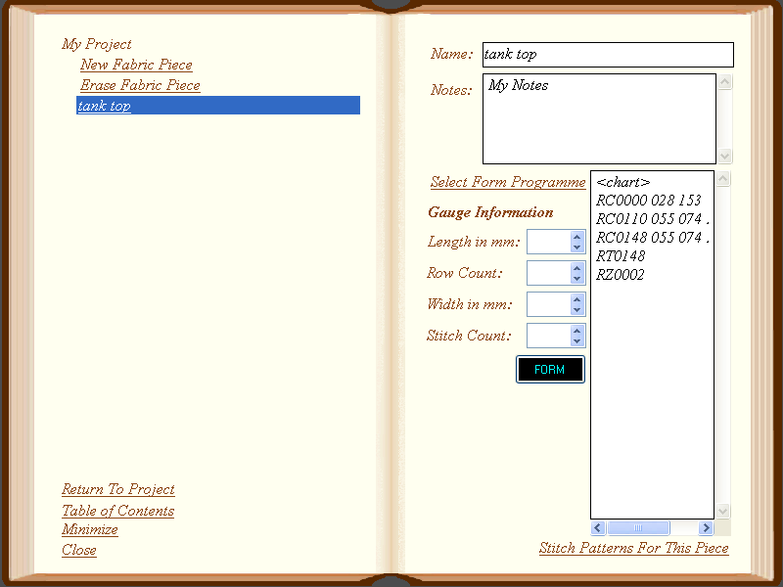

- Traditional Form Programmes: When the E6000 console prompts you for the form programme, enter the form programme codes on the Journal Six fabric piece page.
- Downloadable Charts:
  - When the E6000 console displays FORM, press the form button in Journal Six. The button will change its appearance to .
  - Next, press the unlabeled key on the console followed by the zero key. The console will then display PC START.
  - Press the button again to send the chart to your knitting machine.

Continue programming your console until you receive the the start cast on prompt and are ready to begin knitting.
Knitting
Journal Six assists while you are knitting as well.
- Refer to the knit techniques for the fabric piece when setting up the yarn feeders and needle beds.
- Add notes to Journal Six as you knit so that you may refer to them in future.

Additional Resources
It is my sincere wish that this manual will help you use Journal Six to its fullest.
Registered users of the full version of Journal Six have access to the support group at http://groups.yahoo.com/group/JournalSixSupport/. It's a great place to get your questions about Journal Six answered or just share your discoveries.
Questions sent to support@passappal.com will be answered on a best effort basis. Priority will be given to questions at the support group so that others may learn from your question.
Please refer to your E6000 user manual if you have questions about using your knitting machine.
There are several resources on the web for PASSAP knitters. One of the best is PASSAPKnits user group located at http://groups.yahoo.com/group/PASSAPKnits.
Another group that caters specifically to beginners is: http://groups.yahoo.com/group/PassapClub/.
For information on SilverKnit, a hardware device for downloading stitch patterns to electronic Silver-Reed knitting machines, see http://www.knitandsew.demon.nl/dk/silverknit-en.htm.

Notes:

