**DESIGN AND IMPLEMENTATION**

**OF A “C CLASS” ISP**

*Dissertation Submitted in Partial Fulfilment of the Requirements for the Award of*

*the Degree of*

# MASTER OF COMPUTER APPLICATION

# Submitted by

***TRIDIP SARMA***

***(Roll No. 18MCA18, Regd. No. 18071011)***

*Under the Supervision of*

***Dr. Anindya Halder***

*&****Mr. Bhaskar Baruah***



**Department of Computer Application**

**North-Eastern Hill University**

**Tura Campus, Chasingre, 794002, Meghalaya**

August, 2021



DEPARTMENT OF COMPUTER APPLICATION

**NORTH EASTERN HILL UNIVERSITY**

Chasingre, Tura – 794002

**CERTIFICATE OF APPROVAL**

This is to certify that the MCA 6th Semester major project work “**Design And Implementation of a C Class ISP”** carried out by Tridip Sarma bearing Roll No. *18MCA18* and Registration number *18071011* of 2018-21 under the guidance of [Dr. Anindya](https://nehu.ac.in/faculty/display/354/Dr-Ansuman-Kumar) Halder has been found satisfactory and is approved as a major project work carried out for the requirement of the fulfillment for the 6th Semester Master of Computer Application from Department of Computer Application, North-Eastern Hill University, Meghalaya.

Internal Examiner External Examiner

______________________ _______________________

Date: _____________ Date:_______________



DEPARTMENT OF COMPUTER APPLICATION

**NORTH EASTERN HILL UNIVERSITY**

Chasingre, Tura – 794002

**CERTIFICATE FROM HEAD OF DEPARTMENT**

This is to certify that Tridip Sarma (18MCA18) has prepared the dissertation on a report entitled “**Design and Implementation of a C Class ISP**”. This work was done under supervision and guidance of Dr. Anindya Halder. The dissertation is the result of his effort and endeavors. The dissertation is found worthy of acceptance for the award of the degree of Master of Computer Application in Department of Computer Application, NEHU, Tura Campus.

Date:

**Dr. Anindya Halder**

*Teacher In-charge*

*Department of Computer Application*

*NEHU, Tura Campus*

Place:



DEPARTMENT OF COMPUTER APPLICATION

**NORTH EASTERN HILL UNIVERSITY**

Chasingre, Tura – 794002

**CERTIFICATE FROM SUPERVISOR**

This is to certify that the major project work entitled “Design and Implementation of a C Class ISP**”** is a bona fide work carried out by Tridip Sarma bearing Roll No. 18MCA18 of MCA 6th semester at North Eastern Hill University (NEHU), Tura under my guidance.

**Dr. Anindya Halder**

*Teacher In-charge*

*Department of Computer Application*

*NEHU, Tura Campus*

Date:

Place:



DEPARTMENT OF COMPUTER APPLICATION

**NORTH EASTERN HILL UNIVERSITY**

Chasingre, Tura – 794002

**DECLARATION**

I, **Tridip Sarma**, student of Master of Computer Application hereby declare that an internship report entitled “**Design and Implementation of a C Class ISP”** which is submitted by me to the Department of Application, North Eastern Hill University, Meghalaya, in fulfillment of the requirement of the degree of **Master of Computer Application (MCA)**, is a record of the original bona fide work carried out by me and have not been submitted in part or full to any other university or institute for the award of any degree or diploma.

Date:

**Tridip Sarma**

*Roll No : 18MCA18*

*Reg. No: 18071011*

*MCA (6th Semester)*

*Department of Computer Application*

*NEHU, Tura Campus*

Place:





DEPARTMENT OF COMPUTER APPLICATION

**NORTH EASTERN HILL UNIVERSITY**

Chasingre, Tura – 794002

**ACKNOWLEDGEMENT**

I express my sincere and deep gratitude to my guide *Dr. Anindya Halder* in Department of Computer Application, North-Eastern Hill University (NEHU), Tura Campus, Meghalaya, for the invaluable guidance, support and encouragement. He provided me with all the resources and guidance throughout this project work. I would like to thank all the staff members who were always there at the need of hour and provided with all that help and facilities, which I require for the completion of my project. At last but not the least, I would like to thank the gracious Almighty, my teachers and my parents for all their support.



# **TABLE OF CONTENTS:**

* 1. Introduction…………………………………………………9

1. ISP……………………………………………………….9
2. C Class ISP……………………………………………9
   1. Objective of the Project…………………………………10
   2. Technologies Used & Details…………………………11
3. DSL………………………………………………………11
4. Centralised WIFI…………………………………..12
5. WLC……………………………………………..12
6. NATTING………………………………………………13
7. Static…………………………………………….14
8. Dynamic………………………………………..15
9. DHCP Server………………………………………….16
10. DNS Server……………………………………………17
11. WEB Server…………………………………………...18
12. OSPF……………………………………………………...19

* 1. Simulation Tool Used & Details……………………….20-21
  2. Few Snapshots of the Project………………………….22-27
  3. Future Work………………………………………………….28
  4. Bibliography………………………………………………….29

# **INTRODUCTION:**

1. **ISP:** An ISP (Internet Service Provider) is a company that provides individuals and other companies access to the internet and related services such as web site building and virtual hosting. An ISP has the equipment and the telecommunication line access required to have a point-of-presence on the internet for the geographical area served. In addition to providing access to the Internet, ISPs may also provide software packages (such as browsers), e-mail accounts, and a personal web-sites or home page. ISPs can host Web sites for businesses and can also build the Web sites themselves. ISPs are all connected to each other through network access points, public network facilities on the Internet backbone.
2. **C Class ISP**: Class C (Secondary Switching Area) –This license is for only a particular secondary switching area. A secondary switching area is a government defined territory which could comprise of several small villages, towns or even districts.

# **OBJECTIVE OF THE PROJECT:**

**S**uppose a Network Engineer for the newly established C Class ISP in the state of Assam. They have their HQ in Guwahati and they are permitted to provide triple play services all across Assam. Now, job is to create a network design and implement it with the following consideration:

1. The last mile connectivity can be used both wired and wireless, as some towns have hilly tracks.
2. Every district HQ is connected to the Data Center in Guwahati.
3. The ISP has 2 lease circuits for load balancing and fail over - VSNL and STPI.
4. Home users have B/C Class private IP addresses.
5. Corporates can buy public routable IPs for a premium service.

# **TECHNOLOGIES USED & DETAILS:**

1. **DSL:**

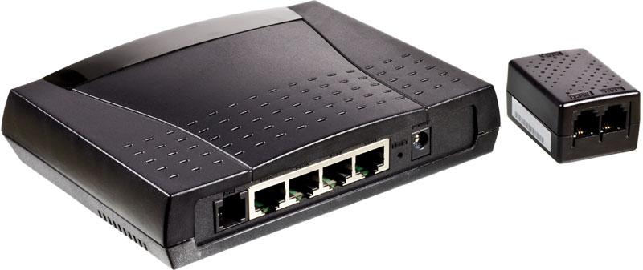DSL (Digital Subscriber Line) is a modem technology that uses existing telephone lines to transport high-bandwidth data, such as multimedia and video, to service subscribers. DSL provides dedicated, point-to-point, public network access. This DSL connection is typically between a network service provider (NSP) central office and the customer site, or on local loops created either within buildings or campuses.

1. 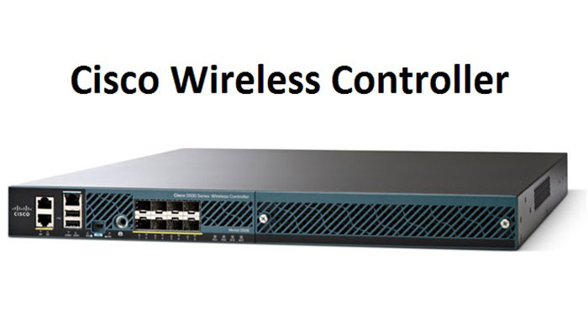**Centralized WIFI**:
2. **WLC:**

The **Cisco Wireless Controller** (WLC) series devices provide a single solution to **configure**, **manage** and **support corporate wireless networks**, regardless of their size and locations. Cisco WLCs have become very popular during the last decade as companies move from **standalone Access Point** (AP) **deployment designs** to a **centralized controller-based design**, reaping the **enhanced functionality**and redundancy benefits that come with controller-based designs.

1. 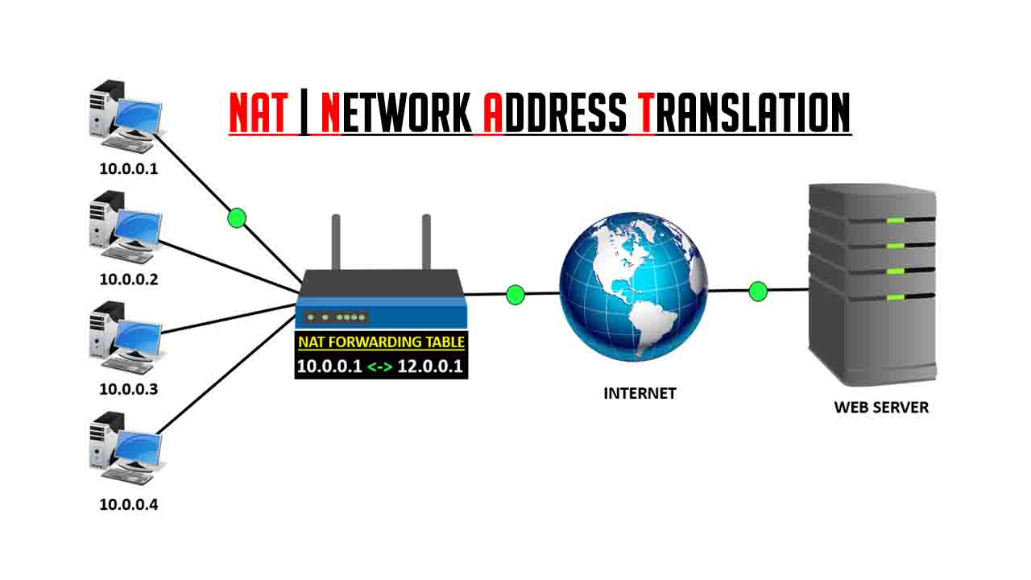**NATTING:**

**Network Address Translation (NAT)** is a process in which one or more local IP address is translated into one or more Global IP address and vice versa in order to provide Internet access to the local hosts. Also, it does the translation of port numbers i.e. masks the port number of the host with another port number, in the packet that will be routed to the destination. It then makes the corresponding entries of IP address and port number in the NAT table. NAT generally operates on a router or firewall.

**Network Address Translation (NAT) working –**   
Generally, the border router is configured for NAT i.e the router which has one interface in the local (inside) network and one interface in the global (outside) network. When a packet traverse outside the local (inside) network, then NAT converts that local (private) IP address to a global (public) IP address. When a packet enters the local network, the global (public) IP address is converted to a local (private) IP address.

If NAT runs out of addresses, i.e., no address is left in the pool configured then the packets will be dropped and an Internet Control Message Protocol (ICMP) host unreachable packet to the destination is sent.

1. **STATIC NAT:**

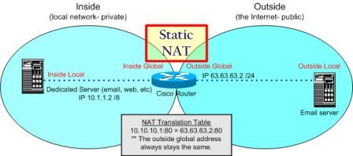Static NAT defines a one-to-one mapping from one IP subnet to another IP subnet. The mapping includes destination. IP address translation in one direction and source IP address translation in the reverse direction. From the NAT device, the original destination address is the virtual host IP address while the mapped-to address is the real host IP address.

Static NAT allows connections to be originated from either side of the network, but translation is limited to one-to-one or between blocks of addresses of the same size. For each private address, a public address must be allocated. No address pools are necessary.

Static NAT also supports the following types of translation:

* To map multiple IP addresses and specified ranges of ports to a same IP address and different range of ports
* To map a specific IP address and port to a different IP address and port.

1. 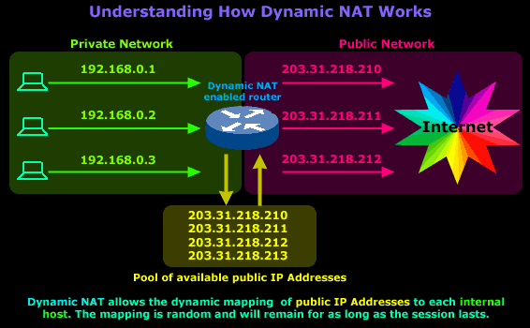**DYNAMIC NAT:**

Dynamic NAT is a many-to-one mapping of a private IP address or subnets inside the SD-WAN network to a public IP address or subnet outside the SD-WAN network. The traffic from different zones and subnets over trusted (inside) IP addresses in the LAN segment is sent over a single public (outside) IP address.

**Dynamic NAT types:**

Dynamic NAT does Port Address Translation (PAT) along with IP address translation. Port numbers are used to distinguish which traffic belongs to which IP address. A single public IP address is used for all internal private IP addresses, but a different port number is assigned to each private IP address. PAT is a cost effective way to allow multiple hosts to connect to the Internet using a single Public IP address.

* **Port Restricted**: Port Restricted NAT uses the same outside port for all translations related to an Inside IP Address and Port pair. This mode is typically used to allow Internet P2P applications.
* **Symmetric**: Symmetric NAT uses the same outside port for all translations related to an Inside IP Address, Inside Port, Outside IP Address, and Outside Port tuple. This mode is typically used to enhance security or expand the maximum number of NAT sessions.

1. **DHCP Server:**



A**DHCP Server** is a network server that automatically provides and assigns IP addresses, default gateways and other network parameters to client devices. It relies on the standard protocol known as Dynamic Host Configuration Protocol or DHCP to respond to broadcast queries by clients.

A DHCP server automatically sends the required network parameters for clients to properly communicate on the network. Without it, the network administrator has to manually set up every client that joins the network, which can be cumbersome, especially in large networks. DHCP servers usually assign each client with a unique dynamic IP address, which changes when the client’s lease for that IP address has expired.

1. **DNS Server:**

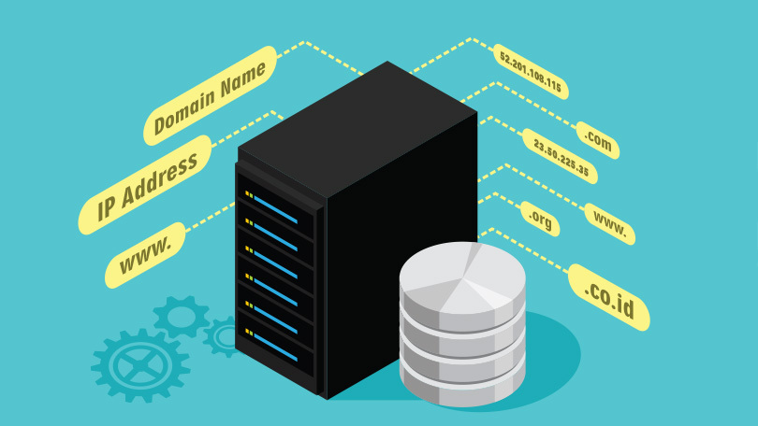The DNS is a system of records of domain names and IP addresses that allows browsers to find the right IP address that corresponds to a hostname URL entered into it. When we try to access a website, we generally type in their domain names, like[cdnetworks.com](https://www.cdnetworks.com/) or[wired.com](https://www.wired.com/) or[nytimes.com](https://www.nytimes.com/), into the web browser. Web browsers however need to know the exact IP addresses to load content for the website. The DNS is what translates the domain names to the IP addresses so that the resources can be loaded from the website’s server.

Sometimes, websites can have numerous IP addresses corresponding to a single domain name. For example, large sites like Google will have users querying a server from distant parts of the world. The server that a computer from Singapore tries to query will likely be different from the one a different computer from say Toronto will try to reach, even if the site name entered in the browser is the same. This is where DNS caching comes in.

1. **Webserver:**

****A web server is a computer that runs websites. It's a computer program that distributes web pages as they are requisitioned. The basic objective of the web server is to store, process and deliver web pages to the users. This intercommunication is done using Hypertext Transfer Protocol (HTTP). These web pages are mostly static content that includes HTML documents, images, style sheets, test etc. Apart from HTTP, a web server also supports SMTP (Simple Mail transfer Protocol) and FTP (File Transfer Protocol) protocol for emailing and for file transfer and storage.  
  
  The main job of a web server is to display the website content. If a web server is not exposed to the public and is used internally, then it is called Intranet Server. When anyone requests for a website by adding the URL or web address on a web browser’s (like Chrome or Firefox) address bar (like www.economictimes.com), the browser sends a request to the Internet for viewing the corresponding web page for that address. A Domain Name Server (DNS) converts this URL to an IP Address (For example 192.168.216.345), which in turn points to a Web Server.

1. **OSPF:**

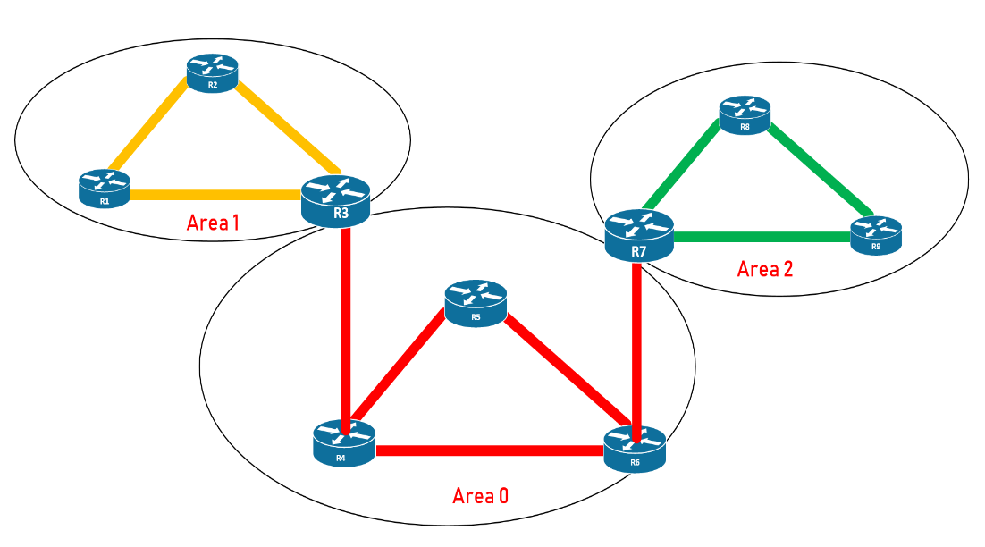

The OSPF (Open Shortest Path First) protocol is one of a family of IP Routing protocols, and is an Interior Gateway Protocol (IGP) for the Internet, used to distribute IP routing information throughout a single Autonomous System (AS) in an IP network.

The OSPF protocol is a link-state routing protocol, which means that the routers exchange topology information with their nearest neighbors. The topology information is flooded throughout the AS, so that every router within the AS has a complete picture of the topology of the AS. This picture is then used to calculate end-to-end paths through the AS, normally using a variant of the Dijkstra algorithm. Therefore, in a link-state routing protocol, the next hop address to which data is forwarded is determined by choosing the best end-to-end path to the eventual destination.

The main advantage of a link state routing protocol like OSPF is that the complete knowledge of topology allows routers to calculate routes that satisfy particular criteria. This can be useful for traffic engineering purposes, where routes can be constrained to meet particular quality of service requirements. The main disadvantage of a link state routing protocol is that it does not scale well as more routers are added to the routing domain. Increasing the number of routers increases the size and frequency of the topology updates, and also the length of time it takes to calculate end-to-end routes. This lack of scalability means that a link state routing protocol is unsuitable for routing across the Internet at large, which is the reason why IGPs only route traffic within a single AS.

1. **SIMULATION TOOL USED & DETAILS:**

**CISCO PACKET TRACER**[**https://www.netacad.com/courses/packet-tracer**](https://www.netacad.com/courses/packet-tracer)

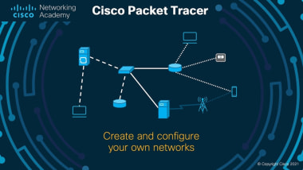

**Cisco Packet Tracer** as the name suggests, is a tool built by Cisco. This tool provides a network simulation to practice simple and complex networks.

The main purpose of Cisco Packet Tracer is to help students learn the principles of networking with hands-on experience as well as develop Cisco technology specific skills. Since the protocols are implemented in software only method, this tool cannot replace the hardware Routers or Switches. Interestingly, this tool does not only include Cisco products but also many more networking devices.

It makes the job easier for Engineers allowing them to add or remove simulated network devices, with a Command line interface and a drag and drop user interface.

**Workspace:**

1. **Logical –**  
   Logical workspace shows the logical network topology of the network the user has built. It represents the placing, connecting and clustering virtual network devices.
2. **Physical –**  
   Physical workspace shows the graphical physical dimension of the logical network. It depicts the scale and placement in how network devices such as routers, switches and hosts would look in a real environment. It also provides geographical representation of networks, including multiple buildings, cities and wiring closets.

**Key Features:**

* Unlimited devices
* E-learning
* Customize single/multi user activities
* Interactive Environment
* Visualizing Networks
* Real-time mode and Simulation mode
* Self-paced
* Supports majority of networking protocols
* International language support
* Cross platform compatibility.

1. **FEW SNAPSHOTS OF THE PROJECT:**

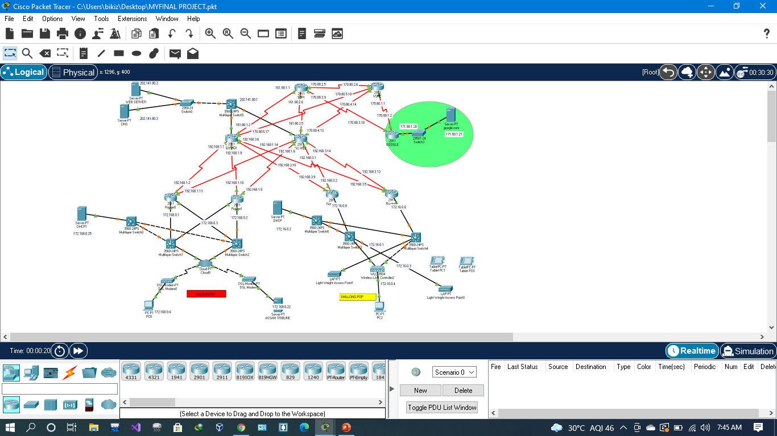

**FEW SNAPSHOTS OF THE PROJECT:**

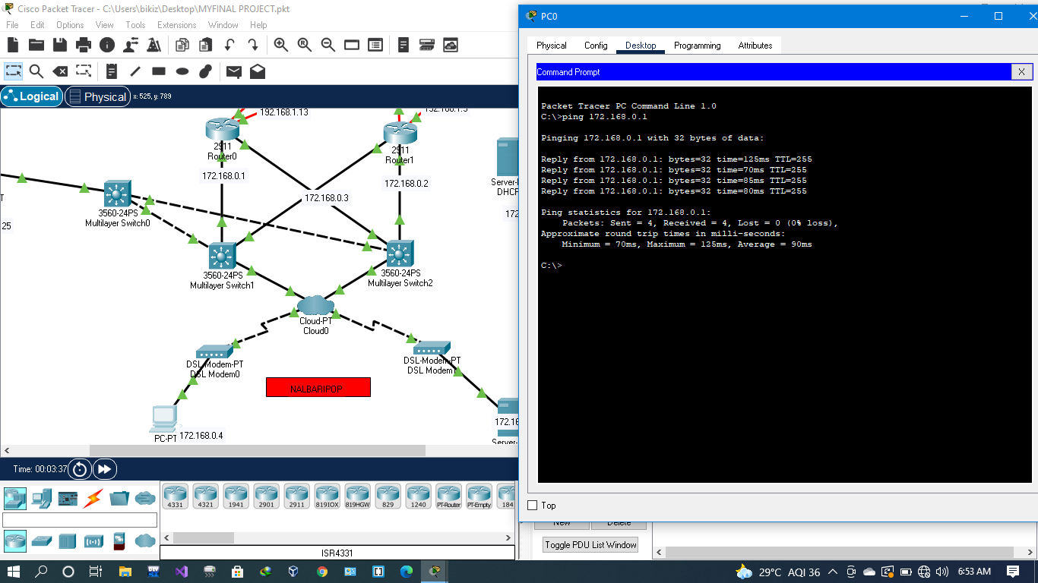

**FEW SNAPSHOTS OF THE PROJECT:**

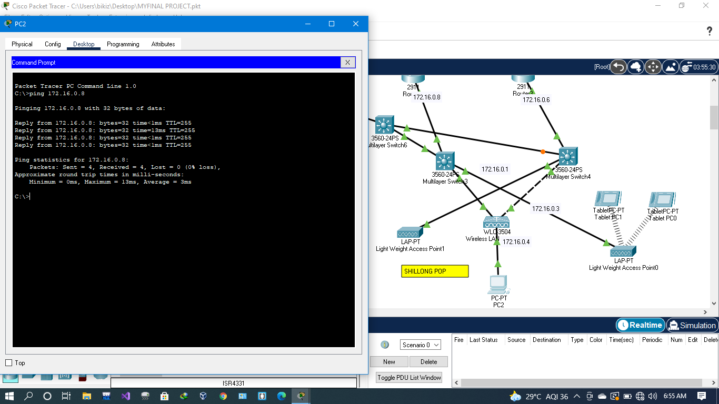

**FEW SNAPSHOTS OF THE PROJECT:**

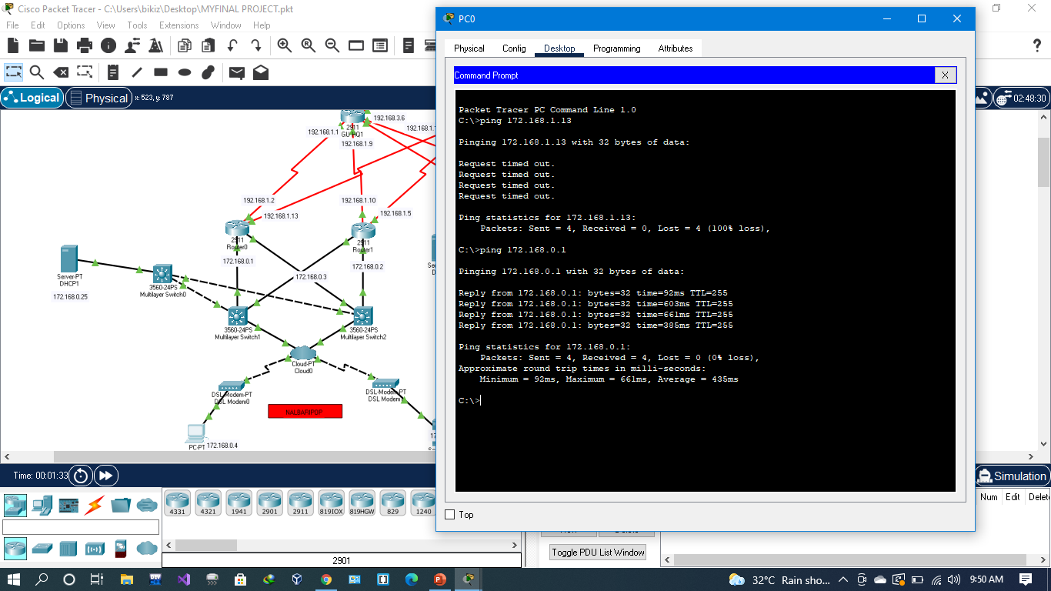

**FEW SNAPSHOTS OF THE PROJECT:**

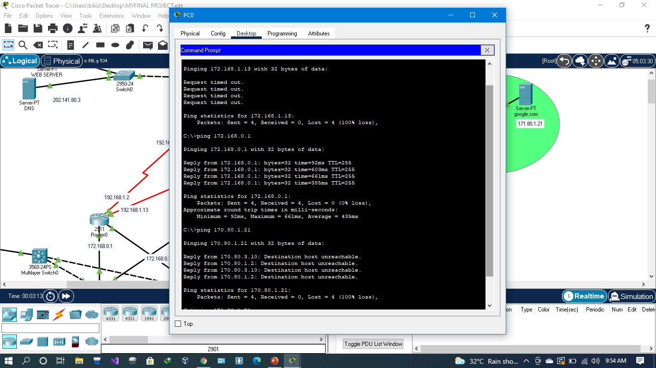

**FEW SNAPSHOTS OF THE PROJECT:**

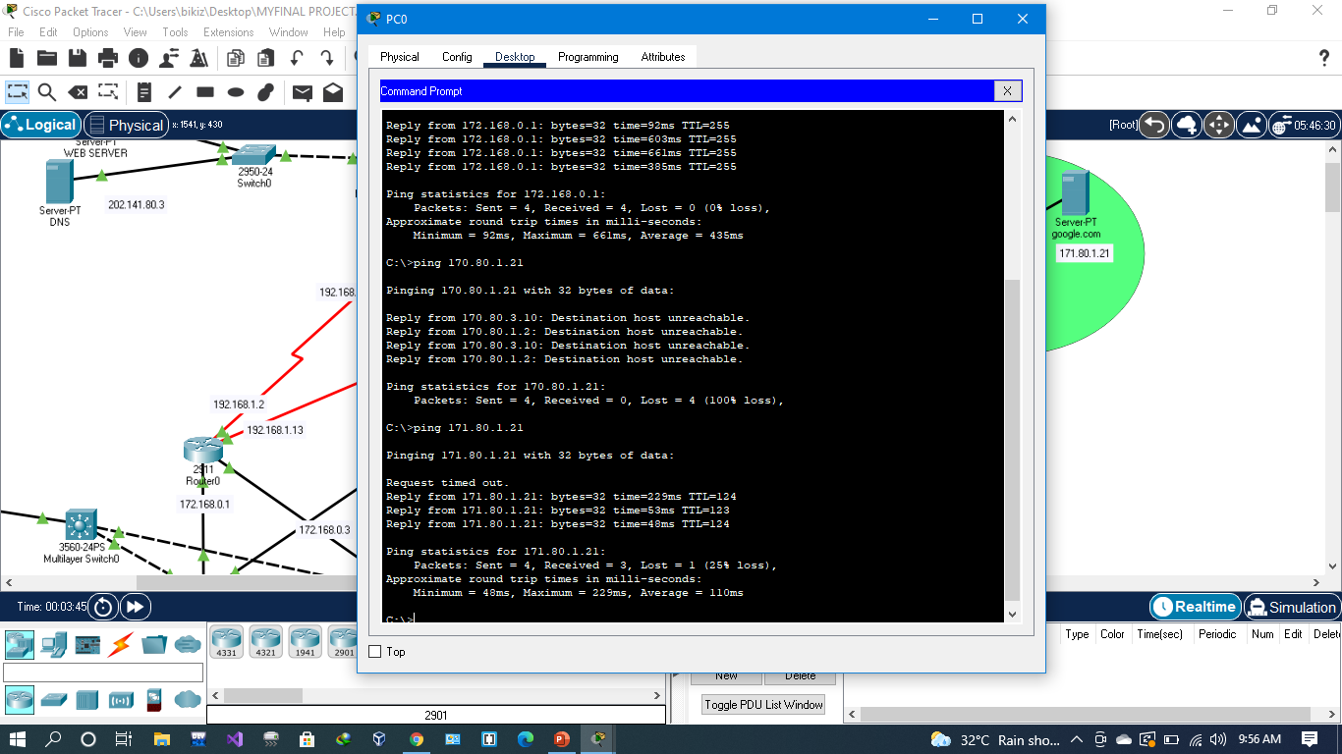

1. **CONCLUSION & FUTURE WORK:**

This project covered the important steps necessary for an ISP to set up its initial router configuration correctly. It discussed the importance of the loopback interface, how to configure interfaces, as well as how to set up in Cisco Packet Tracer.

**We can implement the following steps in future:-**

1. We can allow VPN services to the corporates.
2. QoS to prioritize traffic based on category.
3. Use OSPF as multiple area.
4. **BIBLIOGRAPHY:**
5. Mir, N.F. (2006) Computer and Communication Networks, Prentice Hall.  
   (Order from [amazon](http://www.amazon.com/s/ref=nb_sb_noss?field-keywords=0131747991), order from Barnes and Nobles, compare at bigwords, compare at Campusbooks4less, order from Chegg, or search eFOLLET)
6. Cisco Certified Network Associate Study Guide (640-802)
7. [**https://www.youtube.com/channel/UCmGaNXkRL2IXha8ZN_Uae_Q**](https://www.youtube.com/channel/UCmGaNXkRL2IXha8ZN_Uae_Q)
8. [**https://cybr.com/cybersecurity-fundamentals-archives/project-using-cisco-packet-tracer-to-learn-networking/**](https://cybr.com/cybersecurity-fundamentals-archives/project-using-cisco-packet-tracer-to-learn-networking/)
9. [**www.google.com**](http://www.google.com/)