TEKS Academy • Metric Minds • Mobile App Interaction Data Analysis
MOBILE APP USER ENGAGEMENT
AND SUBSCRIPTION ANALYSIS
DATA ANALYTICS PROJECT DOCUMENTATION
Institution: TEKS Academy
Group: Metric Minds
Team Members
Greeshma
Bhargavi
Rakesh
Project Type: Data Analytics Project
Dataset Source: mobile_app_user_interactions.csv
Environment: Google Colab
Academic Project Documentation

Table of Contents
1. Project Title
2. Project Objective
3. Problem Statement
4. Dataset Information
5. Tools and Technologies Used
6. Data Cleaning
7. Data Analysis / Exploratory Data Analysis
8. Key Insights and Findings
9. Power BI Dashboard
10. Conclusion
11. Future Improvements and Limitations
12. Project Developed By
13. References and Dataset Source

1. Project Title
Mobile App User Engagement and Subscription Analysis

2. Project Objective
The goal of this project was to take raw mobile app interaction data and turn it into insights about how users actually engage with the app. The analysis set out to identify the most frequently used devices and app features, measure session engagement and app performance, compare Android and iOS users, and examine subscription patterns. Python was used throughout for data cleaning, preprocessing, and exploratory data analysis (EDA) to surface insights that can support decisions on engagement, performance, and subscription conversion.

Objective Highlights
- Clean and prepare the raw mobile app interaction dataset for analysis.
- Identify the most frequently used devices, operating systems, and app features.
- Measure session engagement and application performance.
- Compare Android and iOS user behavior.
- Examine subscription patterns among users.
- Surface actionable insights to support decisions on engagement, performance, and conversion.

3. Problem Statement
- Mobile applications generate large amounts of user interaction data — device information, user demographics, session activity, event types, memory usage, battery levels, and subscription status — but on its own, this raw data doesn't reveal much.
- Raw interaction data can be difficult to analyze directly and may contain missing or inconsistent values, making it challenging to identify meaningful patterns.
- It isn't obvious which devices, platforms, or features actually drive engagement without digging into the numbers.
- There's no easy way to tell how Android and iOS users differ, or how subscription status relates to usage, without proper analysis.
- Without proper cleaning and analysis, it's hard to make real use of the data for decision-making — which is exactly what this project set out to fix by uncovering the patterns that matter and turning them into insights the business can act on.

4. Dataset Information
Dataset Attribute | Details
Dataset Name | Mobile App Interaction Dataset
Source File | mobile_app_user_interactions csv
Raw Dataset Shape | 100,000 rows × 21 columns
Cleaned Dataset Shape | 98,656 rows × 21 columns
Row Meaning | Each row represents a single user session/event interaction
Key Columns | date, user_id, session_id, device_os, device_model, event_type, event_target, is_subscribed, session_duration_sec

4.1 Column Overview
Column | Description
date | Date of the user session/event
user_id | Unique identifier for the user
session_id | Unique identifier for the session
ip_address | User's IP address
device_os | Operating system of the device (Android / iOS)
device_os_version | Version of the device operating system
device_model | Model of the device used
screen_resolution | Screen resolution of the device
location_country | Country of the user
location_city | City of the user
app_language | Language setting of the app
network_type | Type of network connection
battery_level | Device battery level at time of interaction
memory_usage_mb | App memory usage in MB
event_type | Type of user interaction event (e.g. click, view, share)
event_target | Target element of the event (e.g. checkout button)
event_value | Numeric value associated with the event
session_duration_sec | Duration of the session in seconds
is_subscribed | Whether the user has an active subscription
user_age | Age of the user
push_enabled | Whether push notifications are enabled

5. Tools and Technologies Used
Tool / Technology | Purpose
Python | Primary programming language for data cleaning, preprocessing, and EDA.
Pandas / NumPy | Used for data manipulation, cleaning, transformation, and analysis of the dataset.
Matplotlib / Seaborn | Used for data visualization — boxplots, count plots, bar charts, pie chart, and heatmap.
Google Colab | Used as the notebook environment to carry out and document the analysis process.
Power BI | Used to build an interactive dashboard for visualizing key engagement and subscription insights.

6. Data Cleaning
Before exploring the data, it was cleaned and validated using Python and Pandas. The raw dataset started out with 100,000 rows and 21 columns.

6.1 Initial Inspection
- Reviewed dataset shape, head/tail rows, data types, and summary statistics.
- Checked for duplicate rows using df.duplicated().sum().
- Checked null values across all 21 columns using df.isnull().sum() — each column had roughly 290–375 missing values.

6.2 Removing Sparse Columns
Columns with more than 50% missing values were dropped using a threshold of len(df) * 0.5 with df.dropna(thresh=threshold, axis=1). No columns in this dataset exceeded that threshold, so all 21 columns were retained.

6.3 Formatting and Type Conversion
- Reviewed unique values for key categorical columns (device_model, device_os, is_subscribed, location_city, network_type, push_enabled, app_language, event_type, event_target, screen_resolution, location_country) to check for inconsistencies.
- Converted the date column from object (string) to datetime using pd.to_datetime(..., errors='coerce').

6.4 Handling Missing Values
- Dropped rows with missing ip_address, session_id, or user_id — these are unique identifier columns where imputing a value would not make sense.
- Grouped remaining columns into categorical and numerical sets using select_dtypes.
- Filled missing values in all categorical columns (including date) with the column mode.
- Temporarily cast device_os_version and session_duration_sec to object type to standardize handling before final conversion.
- For numerical columns without outliers (battery_level, event_value, memory_usage_mb, user_age, session_duration_sec), filled missing values with the column mean.
- For device_os_version, which contains outliers, filled missing values with the column median instead of the mean, since the median is more robust to outliers.
- Converted session_duration_sec and device_os_version back to float after imputation.

6.5 Outlier Detection and Treatment
- Boxplots were generated for all numerical columns to visually inspect outliers. device_os_version showed outliers, while session_duration_sec did not.
- Calculated Q1, Q3, and IQR (Interquartile Range) for device_os_version.
- Defined acceptable bounds as [Q1 − 1.5×IQR, Q3 + 1.5×IQR] and filtered the dataset to keep only rows within these bounds.
- session_duration_sec required no IQR filtering since it had no outliers.
Dataset shape after cleaning: 98,656 rows × 21 columns (reduced from the original 100,000 rows).

6.6 Export
The cleaned dataset was exported to "Mobile app user interaction analysis cleaned.xlsx" for downstream use.

7. Data Analysis / Exploratory Data Analysis
With the data cleaned, Matplotlib and Seaborn were used to explore device and platform usage, subscription patterns, event activity, top-performing devices, top event targets, and correlations among key numerical variables.

7.1 Interactions by Device OS
A count plot compared the number of user interactions across Android and iOS.
Observation: Android has significantly more interactions than iOS, indicating Android users represent the larger share of activity in the dataset.

7.2 Subscription Distribution
A pie chart showed the percentage split between subscribed and non-subscribed users.
Observation: The subscription distribution is almost evenly split, with slightly more than half of the users subscribed — indicating substantial opportunity to convert non-subscribed users.

7.3 Most Frequent Event Types
A horizontal bar chart ranked event types by interaction count.
Observation: Click is the most common interaction, followed by share and view. Event counts are relatively balanced, showing users perform a wide range of interactions rather than relying on a single activity.

7.4 Top 10 Device Models
A horizontal bar chart showed the top 10 device models by number of interactions.
Observation: The Xiaomi Mi 11 has the highest number of interactions among device models, and Android devices dominate the top interaction-generating models.

7.5 Top Event Targets
A horizontal bar chart identified which UI elements/targets received the most interactions.
Observation: The checkout button receives the highest number of interactions, suggesting users frequently reach or engage with the purchasing/conversion area of the app.

7.6 Correlation Analysis
A heatmap visualized correlations between the key numerical variables: battery_level, memory_usage_mb, event_value, session_duration_sec, and user_age.
Observation: The numerical variables have very weak correlations with each other — user age, battery level, event value, and session duration do not appear to have strong linear relationships in this dataset.

8. Key Insights and Findings

8.1 Android Dominates Interaction Volume
Android users account for significantly more interactions than iOS users, making Android the dominant platform by activity in the dataset, led by the Xiaomi Mi 11 as the top device model.

8.2 Subscription Is Nearly Evenly Split
Slightly more than half of users are subscribed, leaving meaningful room for conversion campaigns targeting the remaining non-subscribed base.

8.3 Clicks Drive Engagement
Click is the most common event type, followed by share and view, showing that users engage in a variety of interaction types rather than relying on a single activity.

8.4 Checkout Is a Key Conversion Point
The checkout button is the most-engaged event target, pointing to strong presence in the app's conversion funnel and highlighting it as a priority area for optimization.

8.5 Usage Metrics Are Largely Independent
Battery level, memory usage, event value, session duration, and user age show weak linear relationships with each other, suggesting engagement isn't strongly driven by any single one of these factors in isolation.

8.6 Business Implications
Taken together, these findings support an Android-first platform strategy, continued investment in checkout-flow optimization, and targeted subscription-conversion campaigns aimed at the sizeable non-subscribed user base.

9. Power BI Dashboard
To bring everything together, an interactive Power BI dashboard was built to present the major findings from the analysis in a clear, visual way. Rather than just reading about the results, the dashboard lets you explore them directly — by device, event type, geography, subscription status, and session behavior.
Dashboard Title: Mobile App User Interaction Dashboard

9.1 Dashboard Features — Page 1
- Total Interactions – the overall count of user interactions (99K)
- Average Session Duration – the average duration per session (1.80K)
- Average Memory Usage – the average app memory usage (2.06K)
- Subscription Rate – overall subscription rate indicator
- Interactions by Event Type – compares interaction counts across event types
- Subscription Rate by Country – maps subscribed users across the globe
- Count of Interactions by Device OS – compares Android vs iOS interaction volume
- Top 5 Mobile Models – ranks the leading device models by interactions
- Subscription Rate by Device OS – donut view of subscribed vs non-subscribed users (50K total)
- Top 5 Countries by Mobile Users – ranks countries by user volume
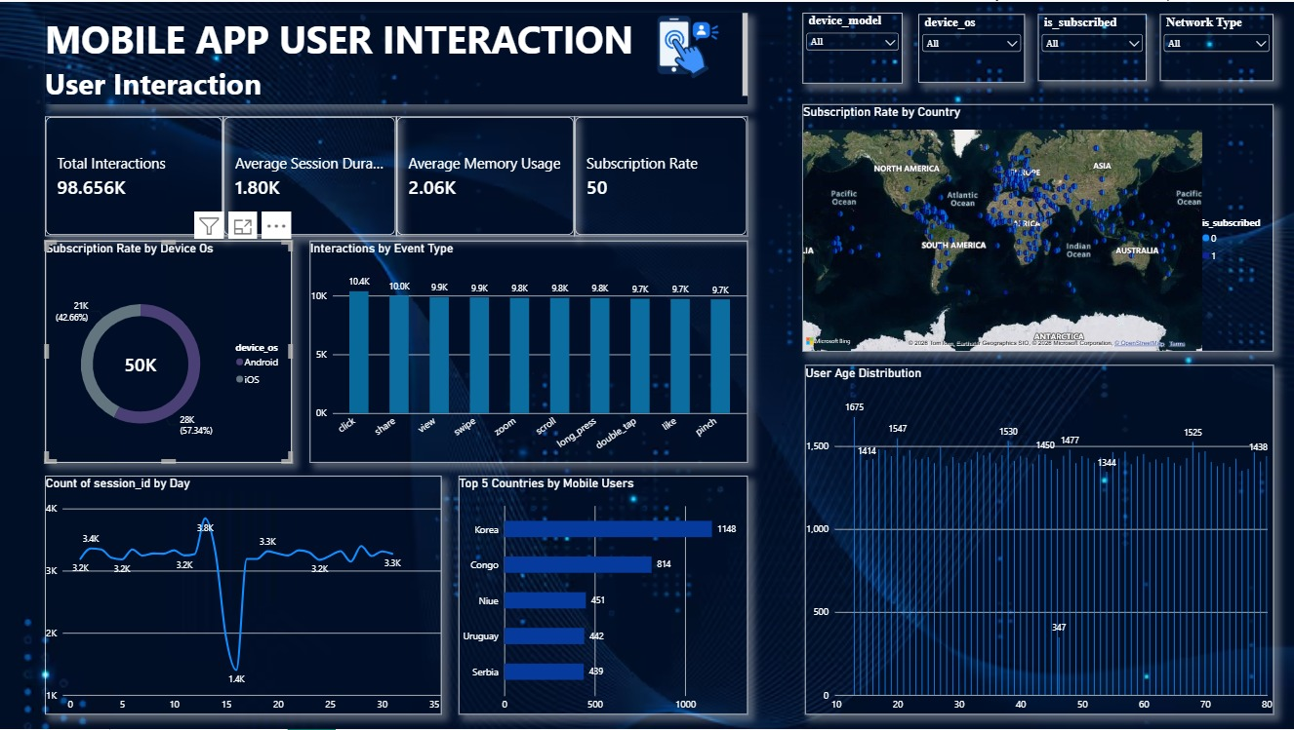
Figure 1: Mobile App User Interaction Dashboard – Page 1

9.2 Dashboard Features — Page 2
- Average Session Duration by Device OS – compares session length between Android and iOS
- Average of Event Value by Event Type – trends event value across interaction types
- Relationship Analysis (scatter) – memory usage vs. session duration by device model
- Average Battery Level by Network Type – battery-level split across 5G, 4G, 3G, and WiFi
- Relationship Analysis (matrix) – event type by event target interaction counts
- Top 5 Device Models by Session Duration – ranks devices by total session time
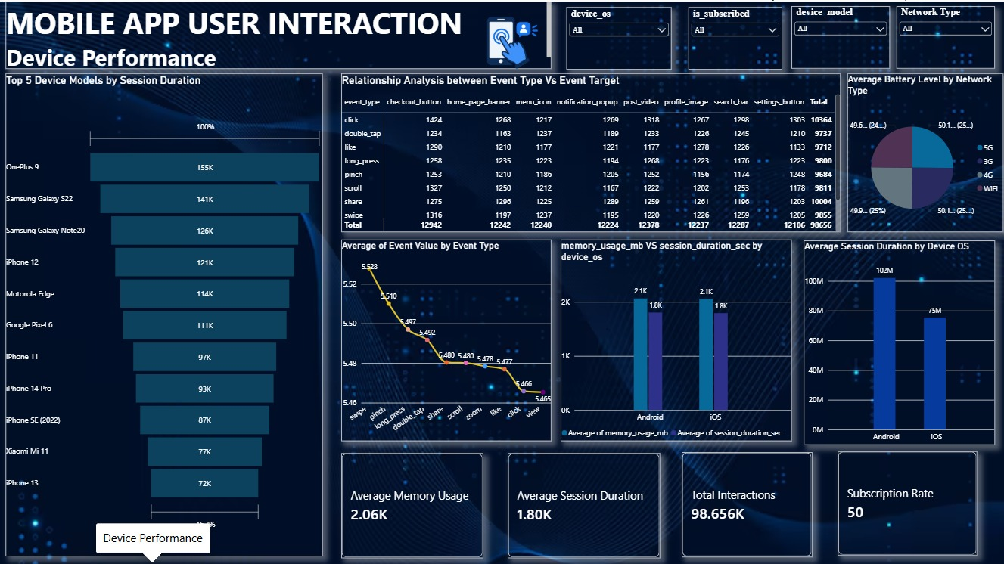
Figure 2: Mobile App User Interaction Dashboard – Page 2

9.3 Dashboard Purpose
The dashboard takes the analytical results and turns them into an interactive, business-friendly view. It makes it easy to quickly see overall engagement volume, compare Android and iOS performance, identify top devices and countries, track subscription rate, and explore how session duration, memory usage, and battery level relate to one another — all in one place.

10. Conclusion
In short, this project cleaned and analyzed 98,656 user interaction records (from an original 100,000) using Python, Pandas, Matplotlib, and Seaborn to uncover what's really driving mobile app engagement. Android emerged as the dominant platform by interaction volume, with the Xiaomi Mi 11 as the leading device model. Clicks are the most frequent user action, and the checkout button is the most-engaged event target, pointing to strong presence in the app's conversion funnel. Subscription status is nearly evenly split, leaving meaningful room for conversion campaigns, while device, session, and usage metrics show weak linear relationships with each other. These insights can guide product decisions around platform prioritization (Android-first), conversion funnel optimization (checkout flow), and subscription growth strategy.

11. Future Improvements and Limitations

11.1 Limitations
- Descriptive Analysis: this project focuses on descriptive and exploratory analysis and doesn't include any predictive modeling.
- Correlation Only: the weak correlations found among numerical variables describe association, not causation — they don't explain why engagement varies.
- Imputation Impact: missing values were filled using mode, mean, and median depending on column type, which can smooth over some natural variability in the data.
- Geographical and Demographic Depth: while location and age fields exist in the dataset, the current dashboard breaks down subscription and users by country but does not yet segment by city or age group.

11.2 Future Improvements
- Enhance the Power BI dashboard with additional business-focused views, such as time-based trends and demographic segmentation.
- Add cohort and time-based analysis to see how engagement and subscription trends evolve over the observed period.
- Segment the analysis by country, city, and user age to uncover geographic and demographic engagement patterns.
- Build subscription-conversion prediction models using engagement and device features.
- Extend the correlation analysis with non-linear techniques, since weak linear correlations don't rule out non-linear relationships.
- Bring in additional datasets such as marketing, campaign, and revenue data to connect engagement metrics to business outcomes.

12. Project Developed By
Details | Information
Project Title | Mobile App User Engagement and Subscription Analysis
Project Type | Data Analytics Project
Group Name | Metric Minds
Team Members | Greeshma, Bhargavi, Rakesh
Course / Program | Data Science
Institution | TEKS Academy
Tools Used | Python, Pandas, NumPy, Matplotlib, Seaborn, Google Colab, Power BI

13. References and Dataset Source

13.1 Dataset Source
The mobile app interaction dataset (mobile_app_user_interactions.csv) was used as the source data for this project.

13.2 Project Resources
- mobile_app_user_interactions.csv – the source interaction dataset used for the project
- Python/Pandas notebook (Google Colab) – used for data cleaning, transformation, validation, and exploratory analysis
- Mobile app user interaction analysis cleaned.xlsx – the cleaned dataset exported for downstream use
- Power BI report – used to build the interactive Mobile App User Interaction Dashboard

13.3 Technologies Referenced
- Python
- Pandas
- NumPy
- Matplotlib
- Seaborn
- Google Colab
- Microsoft Power BI
END OF PROJECT DOCUMENTATION

