**Question 1:**

**package** assignment1;

**import** java.util.Scanner;

**public** **class** PraticeQues1 {

**public** **static** **void** main(String[] args) {

// Create a Scanner object to read input

Scanner scan = **new** Scanner(System.***in***);

System.***out***.print("Enter an integer number: ");

**int** num = scan.nextInt();

// check the number

**if** (num >= 20 && num <= 30)

{

**if** (num % 2 == 0)

{

// if number is even

System.***out***.println("Jerry");

}

**else**

{

// if number is odd

System.***out***.println("Tom");

}

}

}

}

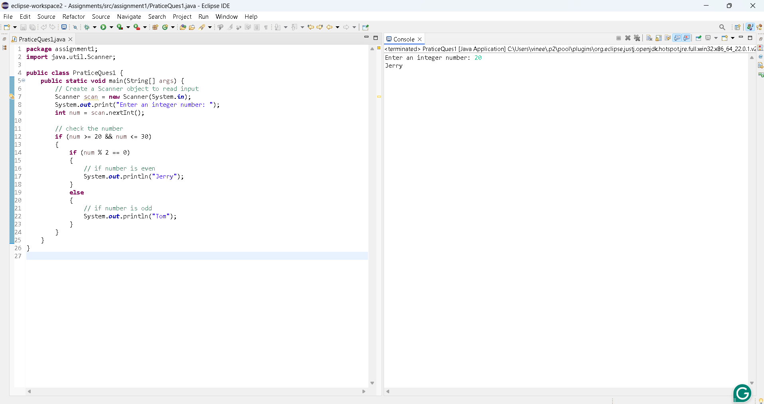

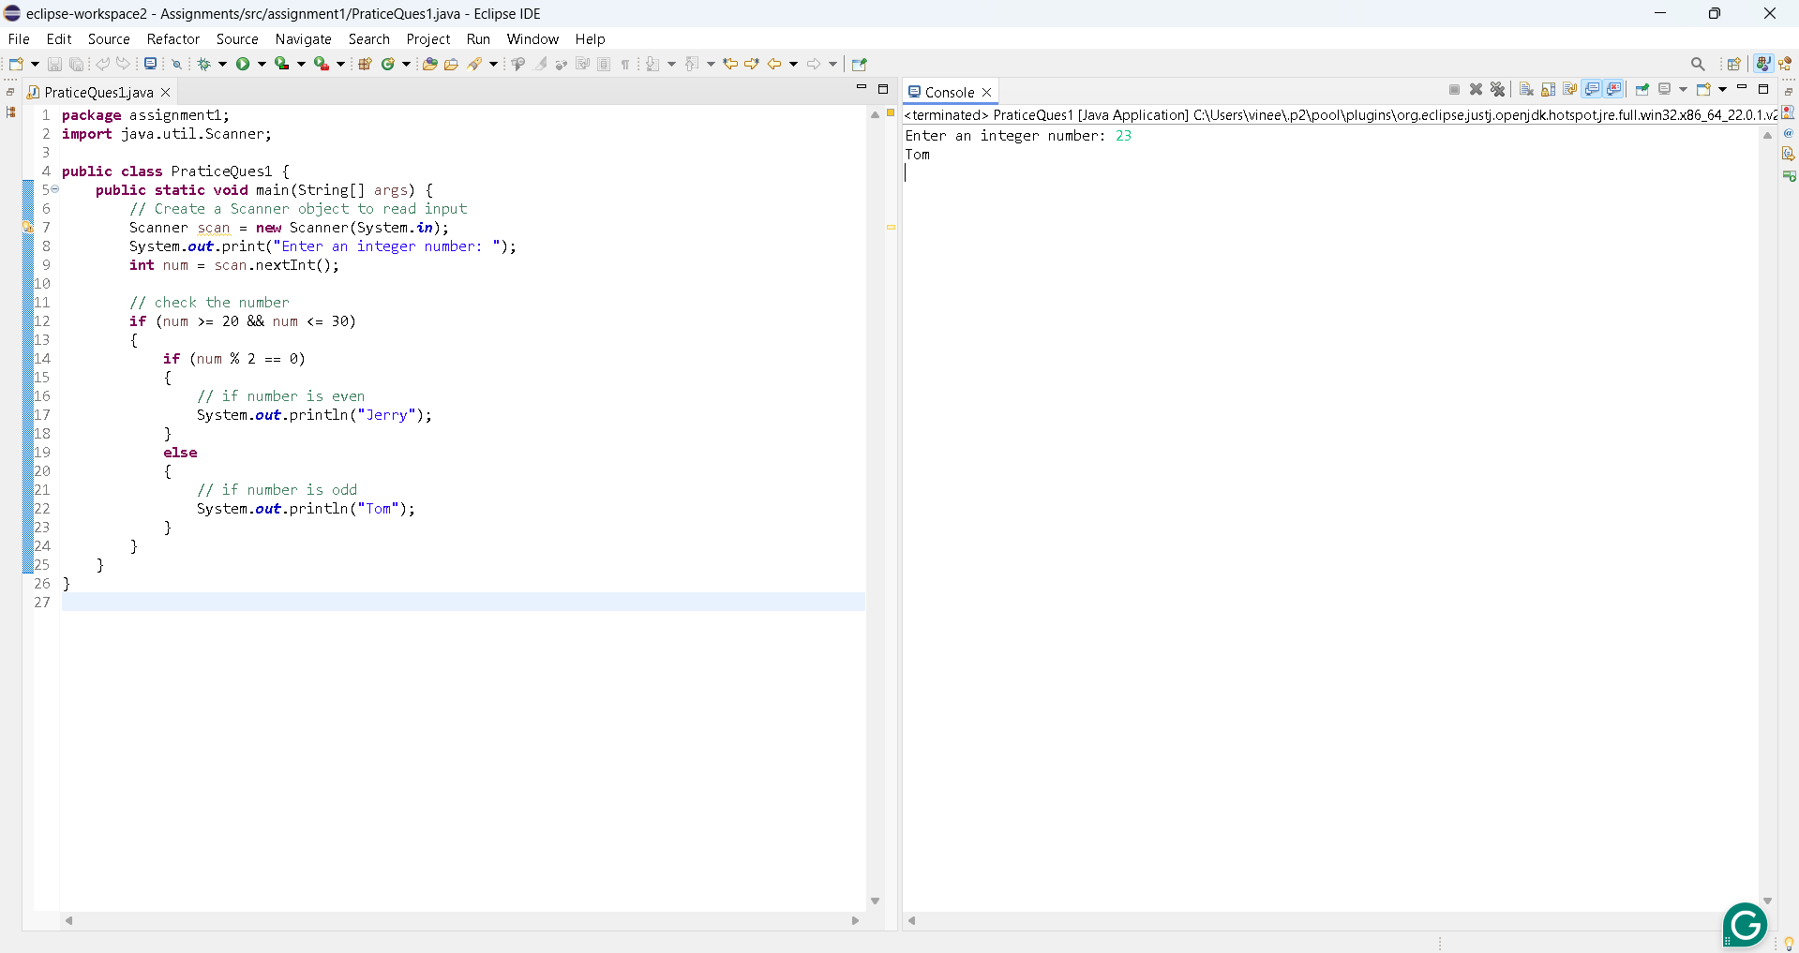

**Question 2:**

**package** assignment1;

**import** java.util.Scanner;

**public** **class** PalindromeCheck {

**public** **static** **void** main(String[] args) {

Scanner scan = **new** Scanner(System.***in***);

System.***out***.print("Enter a number: ");

// take input from the user

**long** originalno = scan.nextLong();

**if** (*isPalindrome*(originalno))

{

//add the all even numbers

**int** sum = 0;

**long** temp=originalno;

**while** (temp != 0)

{

**long** digit = (**int**) (temp % 10);

**if** (digit % 2 == 0)

{

sum += digit;

}

temp /= 10;

}

// check sum of even numbers is greater than 25

**if** (sum > 25)

{

System.***out***.println(originalno + " is palindrome and sum of even numbers is greater than 25");

}

**else**

{

System.***out***.println(originalno + " is palindrome and sum of even numbers is less than 25");

}

}

**else**

{

System.***out***.println(originalno + " is not palindrome.");

}

}

//check the number is palindrome or not

**public** **static** **boolean** isPalindrome(**long** originalno) {

**long** reversednum = 0;

**long** original = originalno;

**while** (originalno != 0) {

**long** digit =originalno % 10;

reversednum = reversednum * 10 + digit;

originalno /= 10;

}

**return** original == reversednum;

}

}

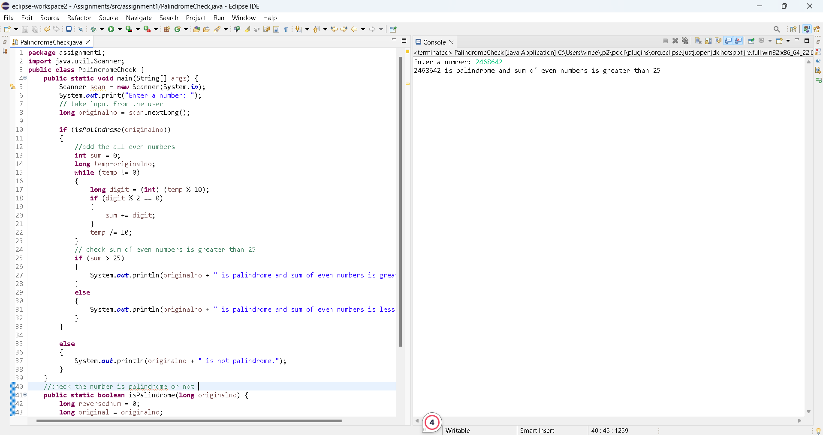

**public** **class** SumIntegersFromString {

**public** **static** **void** main(String[] args) {

Scanner scanner = **new** Scanner(System.***in***);

**int** sum = 0;

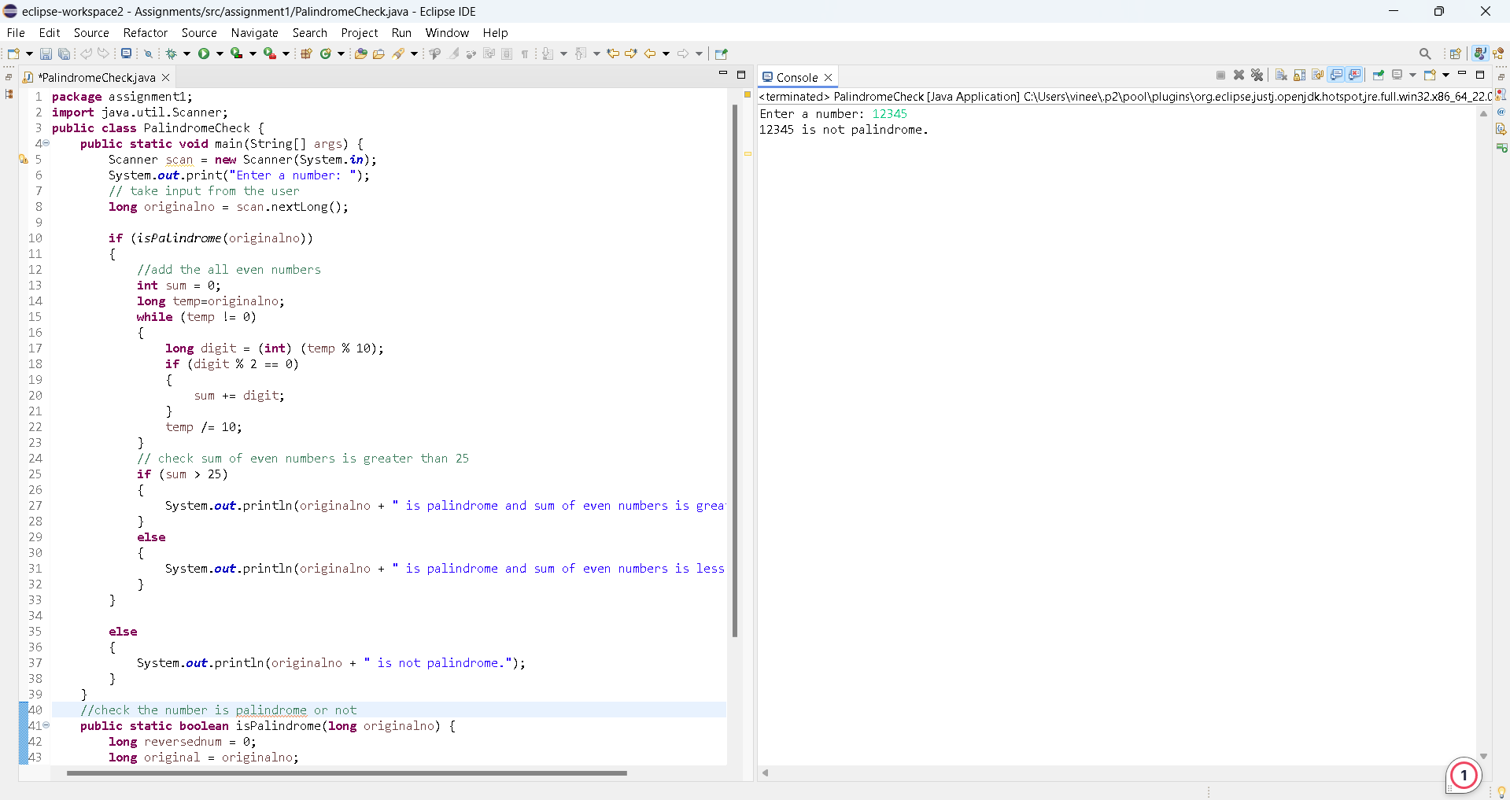

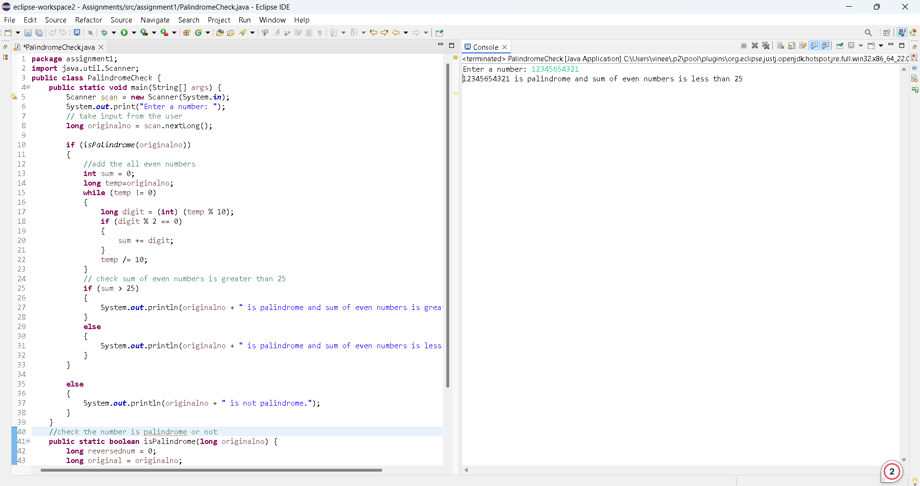

**Question 3:**

**package** assignment1;

**import** java.util.Scanner;

**public** **class** SumOfIntegers {

**public** **static** **void** main(String[] args) {

Scanner scanner = **new** Scanner(System.***in***);

**int** sum = 0;

System.***out***.println("Enter a line of integers separated by spaces:");

String input = scanner.nextLine();

// Split the input string into individual elements

String[] numbers = input.split(" ");

**for** (String num:numbers) {

**int** i = Integer.*parseInt*(num);

sum +=i;

}

// total sum value

System.***out***.println(sum);

}

}

**Question 4:**

**package** assignment1;

**import** java.util.Scanner;

**public** **class** UniqueNumber {

**public** **static** **void** main(String[] args) {

Scanner scan = **new** Scanner(System.***in***);

System.***out***.println("Enter a positive integer: ");

// Get the integer input from the user

**int** input = scan.nextInt();

**int** original = input;

**boolean** isUnique = **true**;

// Extract individual digits by Converting the number to a string

String numberStr = Integer.*toString*(input);

**int** length = numberStr.length();

// Check each digit against every other digit

**for** (**int** i = 0; i < length - 1; i++) {

**char** digit = numberStr.charAt(i);

**for** (**int** j = i + 1; j < length; j++) {

**if** (digit == numberStr.charAt(j)) {

isUnique = **false**;

**break**;

}

}

**if** (!isUnique) {

**break**;

}

}

**if** (isUnique) {

System.***out***.println(original + " is a unique number.");

} **else** {

System.***out***.println(original + " is not a unique number.");

}

}

