**package** assignment3;

**import** java.util.Scanner;

**public** **class** RearrangeArrayElements {

**public** **static** **void** main(String[] args) {

RearrangeArrayElements rearrange = **new** RearrangeArrayElements();

rearrange.inputAcceptor();

}

**public** **void** inputAcceptor() {

Scanner scan = **new** Scanner(System.***in***);

**int** size= scan.nextInt();

**if**(!inputArraySizeValidator(size))

{

displayResult(**null**);

**return**;

}

**int**[] inputArray= **new** **int**[size];

**for**(**int** i=0;i<size; i++)

{

inputArray[i]=scan.nextInt();

}

**if**(!inputArrayValidator(inputArray))

{

displayResult(**null**);

**return**;

}

**int**[] resultArray = computeRearrangedArray(inputArray);

displayResult(resultArray);

}

**public** **boolean** inputArraySizeValidator(**int** size)

{

**return** size > 0;

}

**public** **boolean** inputArrayValidator(**int**[] input) {

**for** (**int** i=1;i<input.length;i++)

{

**if** (input[i]<input[i - 1])

{

**return** **false**;

}

}

**return** **true**;

}

**public** **int**[] computeRearrangedArray(**int**[] inputArray) {

**int**[] resultArray = **new** **int**[inputArray.length];

**int** first = 0;

**int** last = inputArray.length - 1;

**boolean** flag = **true**;

**for** (**int** i = 0; i < inputArray.length; i++) {

**if** (flag) {

resultArray[i] = inputArray[last--];

} **else** {

resultArray[i] = inputArray[first++];

}

flag = !flag;

}

**return** resultArray;

}

**public** **void** displayResult(**int**[] outputArray) {

**if** (outputArray==**null**) {

System.***out***.println("Give proper input");

} **else** {

**for** (**int** i:outputArray) {

System.***out***.print(i + " ");

}

System.***out***.println();

}

}

}

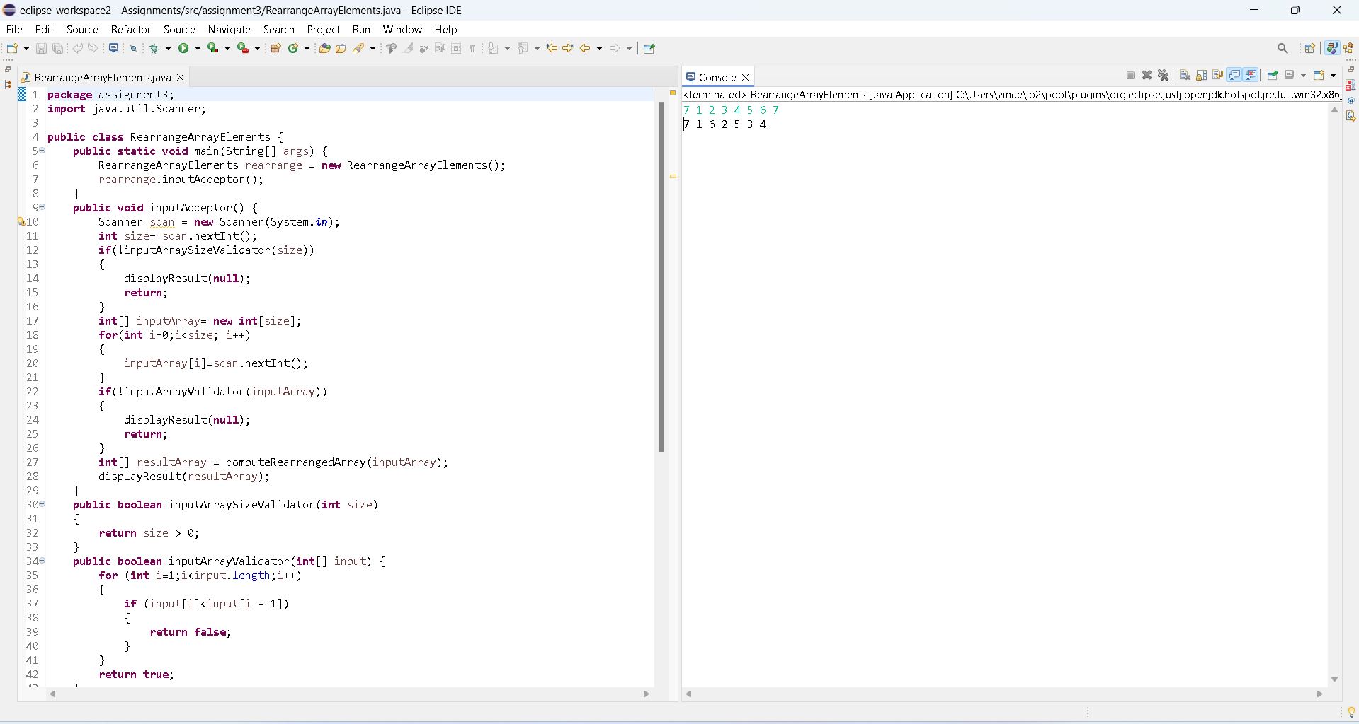

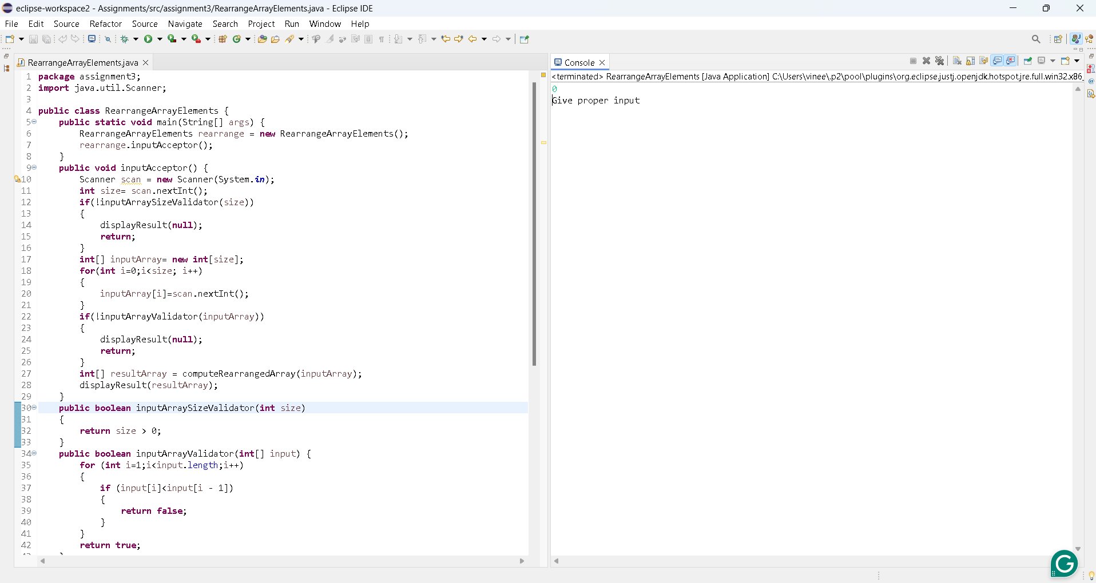

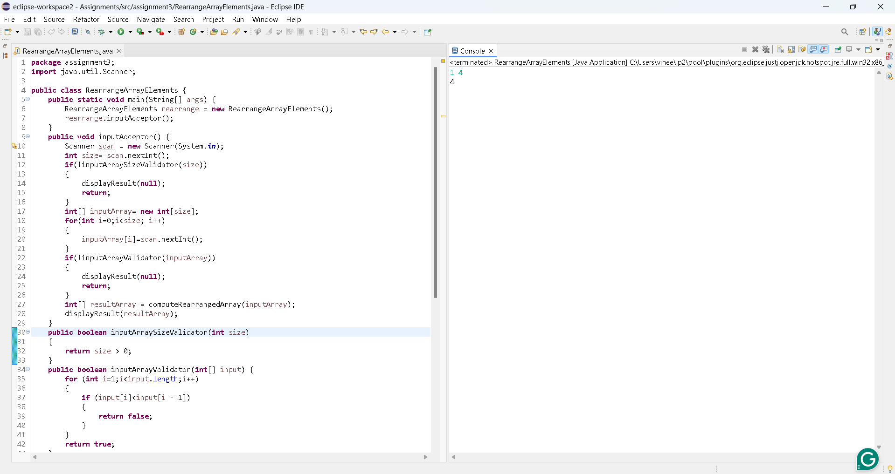P