Project status: Enterprise Day-2 Operations Platform on GCP

Phase 1: Platform foundation (done)
Goal: build the base infrastructure and get AWX running, all from code.
- Bootstrap script: created the Terraform state bucket (gcp-awx-ops-tfstate), the tf-deployer service account, and Workload Identity Federation (github-pool) so GitHub deploys without keys.
- Platform stack (Terraform): VPC and subnet with Cloud NAT, IAP and internal firewalls, a private GKE cluster with Workload Identity, and Cloud SQL Postgres 15 on a private IP. The DB password is generated into Secret Manager.
- AWX stack (Terraform): AWX Operator through Helm, plus the AWX resource with the external database.
- CI/CD: a GitHub Actions pipeline with validate, plan, then apply behind a production approval, and a matrix of platform, awx and fleet stacks.
- Problems fixed: the GKE node-count settings, and the operator image-pull failure (chart 2.19.1 to 3.2.1).
- Result: AWX is reachable and working. You logged in using the generated admin password.

Phase 2: VM fleet, inventory and first playbooks (done)
Goal: give AWX real servers to manage and prove it can operate them.
- SSH key pair: created for AWX. The public key went to a GitHub variable, and the private key went into AWX.
- Fleet stack (Terraform): 6 private Debian 12 VMs with no public IP. Labels (env, role, patch_group, ansible_managed) drive the groups. A startup script creates the ansible user.
- Keyless inventory: the org policy blocked service account keys, so Workload Identity maps the AWX service accounts to the read-only awx-inventory account.
- AWX setup: credential fleet-ssh, project awx-ops-playbooks, inventory gcp-fleet with a dynamic GCE source.
- Three job templates:
  - 00 Connectivity check: 6 hosts answered.
  - 10 Health check: all hosts reported and no failed services were found.
  - 20 Patch Linux (rolling): batches, reboots and a post-patch service check all passed.
- Problems fixed:
  - The inventory filter would have pulled in the GKE node.
  - Check mode broke the patch post-check.
  - The Prompt-on-launch boxes were ticked on the wrong field.

Phase 3: Hardening and quality (not started, optional)
- Build a custom execution environment with the GCP libraries.
- Add ansible-lint and Molecule tests to the CI pipeline.
- Write a CIS hardening role and a template to run it.

Phase 4: AWX configuration as code (next)
- Put credentials, project, inventory and templates into Git (awx.awx collection or infra.aap_configuration).
- Add a workflow that applies the AWX configuration from GitHub.
- Add a workflow that launches jobs from GitHub, such as an ops-trigger.
- Result: AWX can be rebuilt from scratch with no UI clicks.

Phase 5: Patching workflow (not started)
- Create a disk snapshot before patching.
- Add an approval step.
- Patch the dev group, then verify.
- Patch the prod group, then verify, with rollback info available.
- Add a schedule and a survey for the target group.

Phase 6: Self-healing (not started)
- A Cloud Monitoring alert fires on a problem such as a stopped service.
- The alert goes to Pub/Sub, then a Cloud Function.
- The function calls an AWX webhook, and AWX runs the fix playbook.
- Add the provisioning callback so new VMs configure themselves on boot.

Phase 7: Polish and showcase (not started)
- RBAC with teams and permissions, plus notifications.
- A daily health report job.
- Ingress with TLS instead of port-forward.
- Architecture diagrams, all screenshots, a demo video, and the Medium article.
- Tick the Phase 2 box in the README.

Summary
Phase | Status
1. Platform | Done
2. Fleet and playbooks | Done
3. Hardening and quality | Optional
4. Config as code | Next
5. Patching workflow | Pending
6. Self-healing | Pending
7. Polish and article | Pending

===== Cluster and AWX pods =====

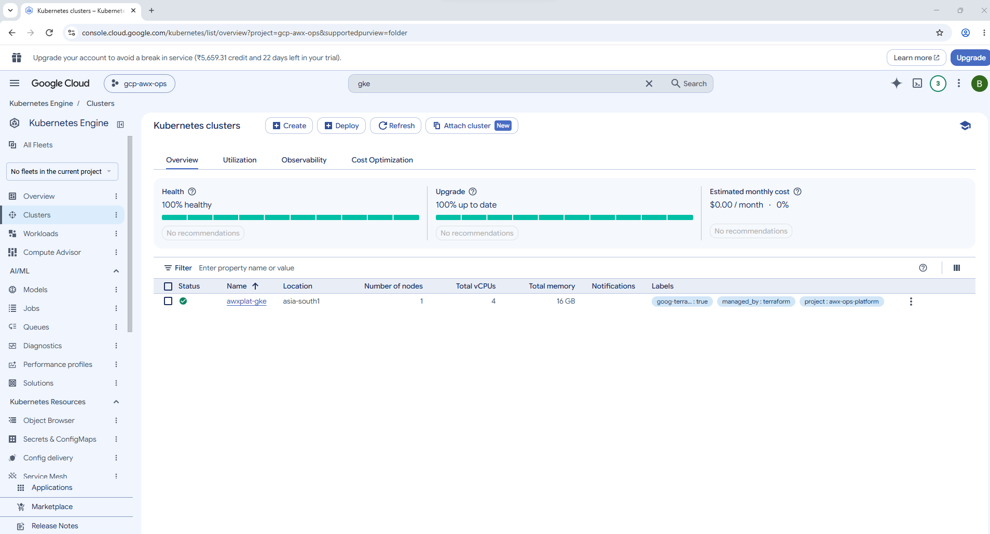
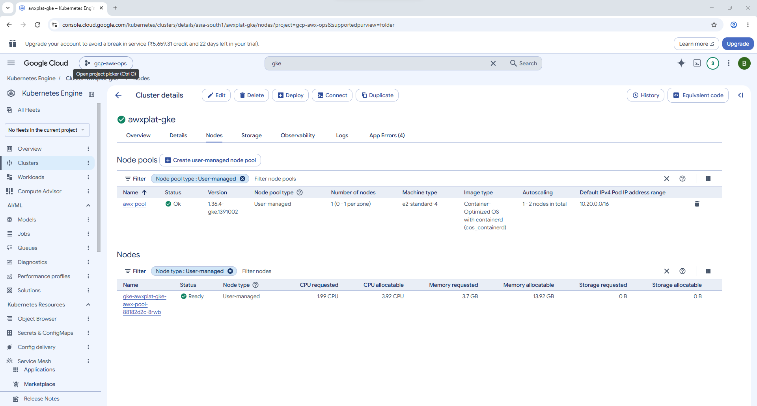
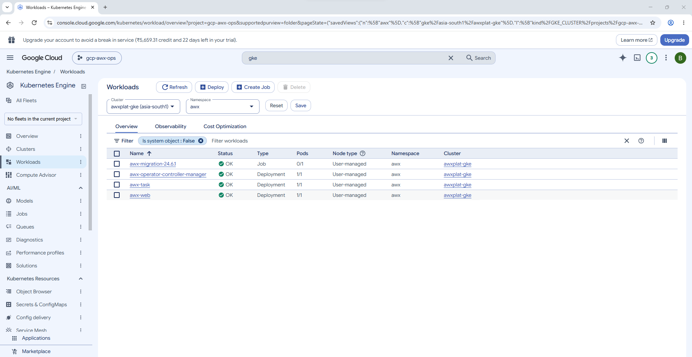
==== Database ====
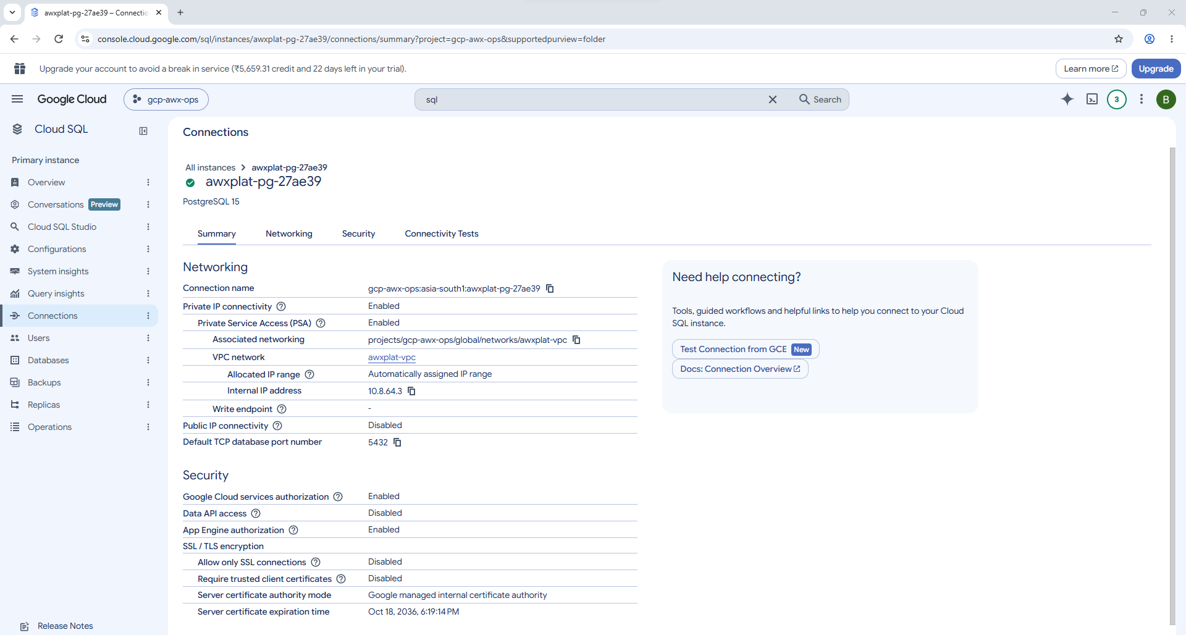
==== Network ====
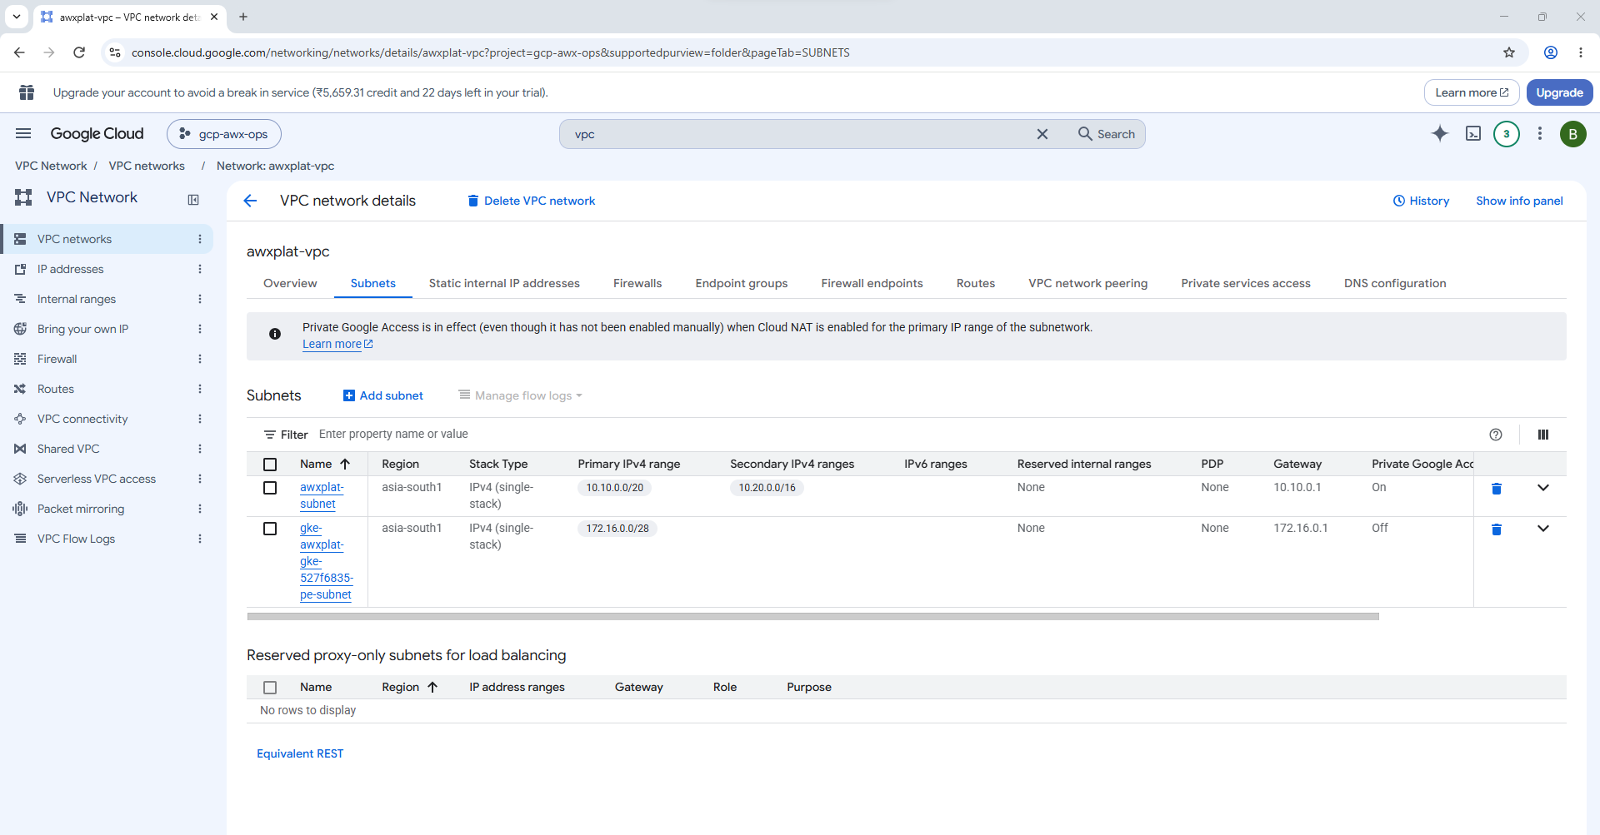
==== Firewall ====
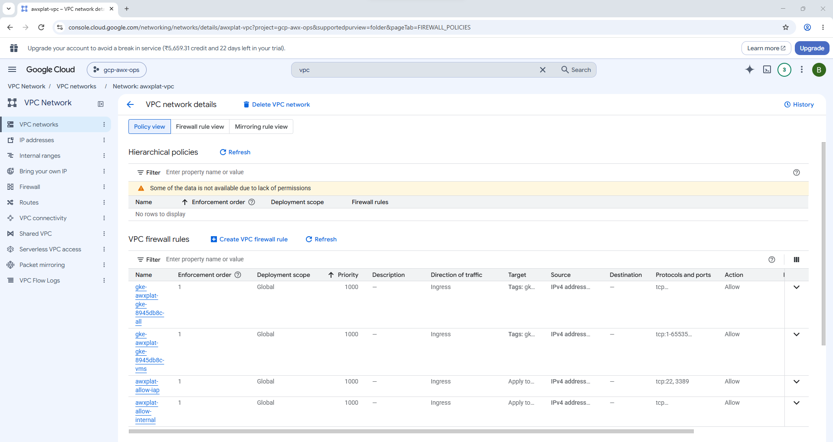
=== Keyless CI
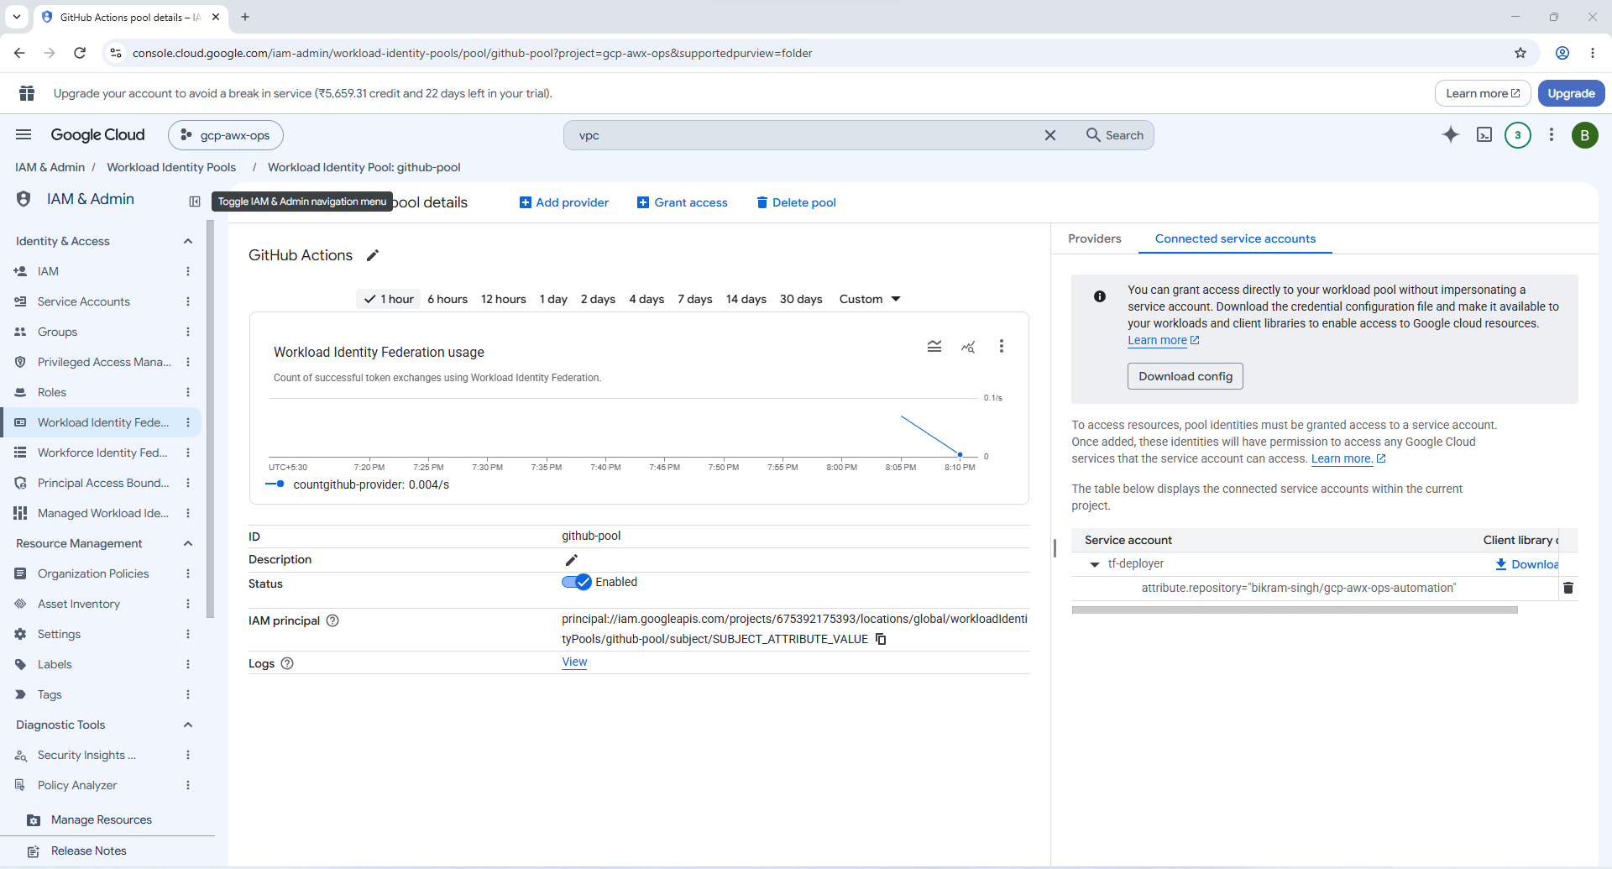
=== Identities
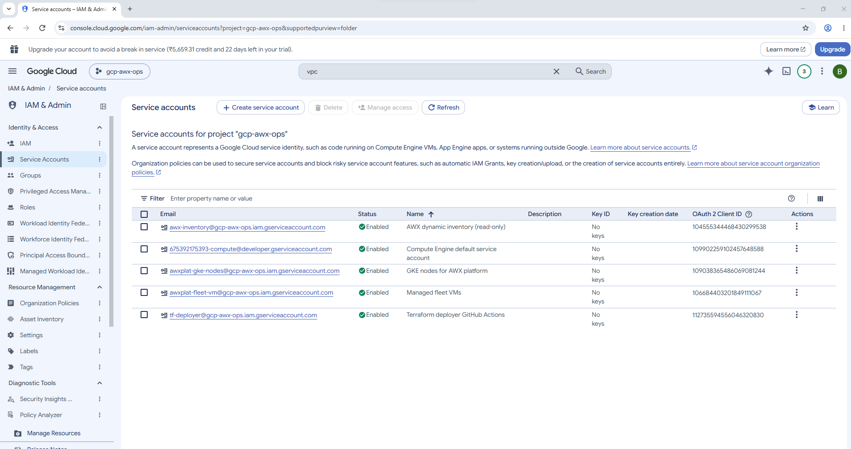
==== Terraform state
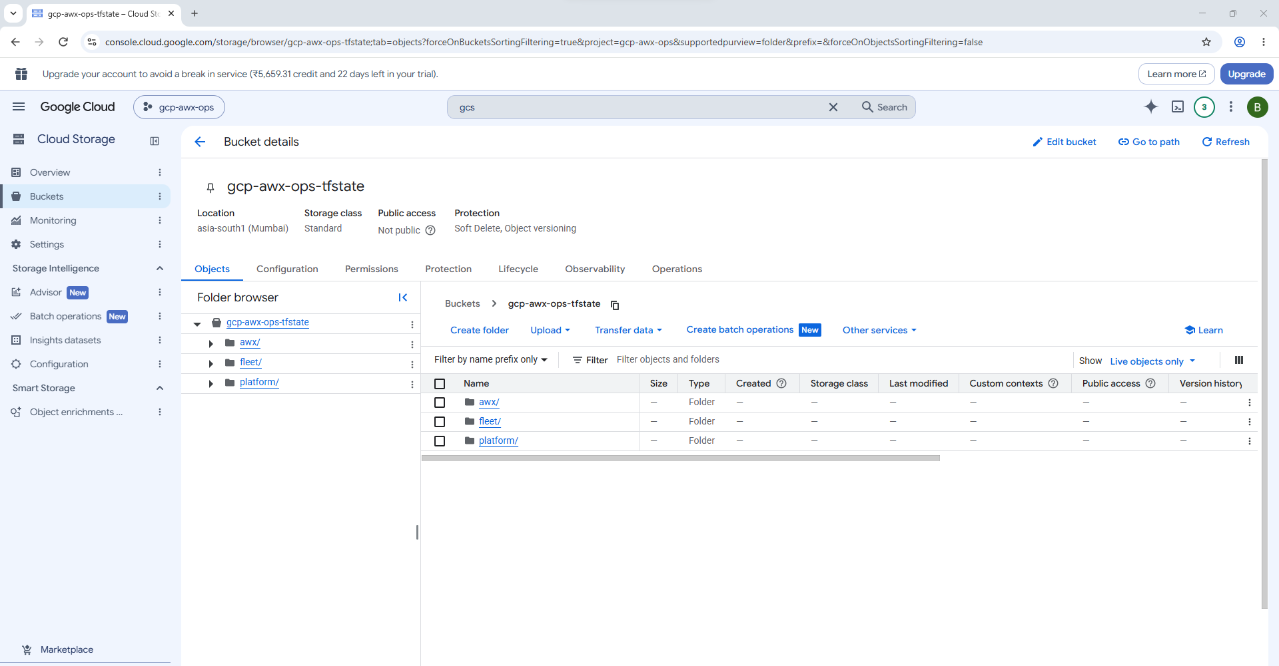
=== Secret
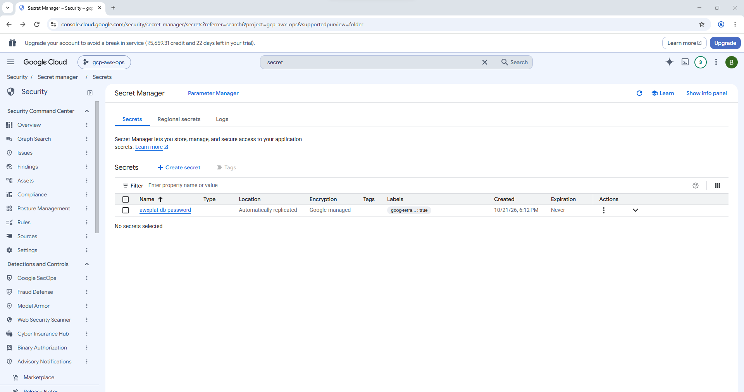
==
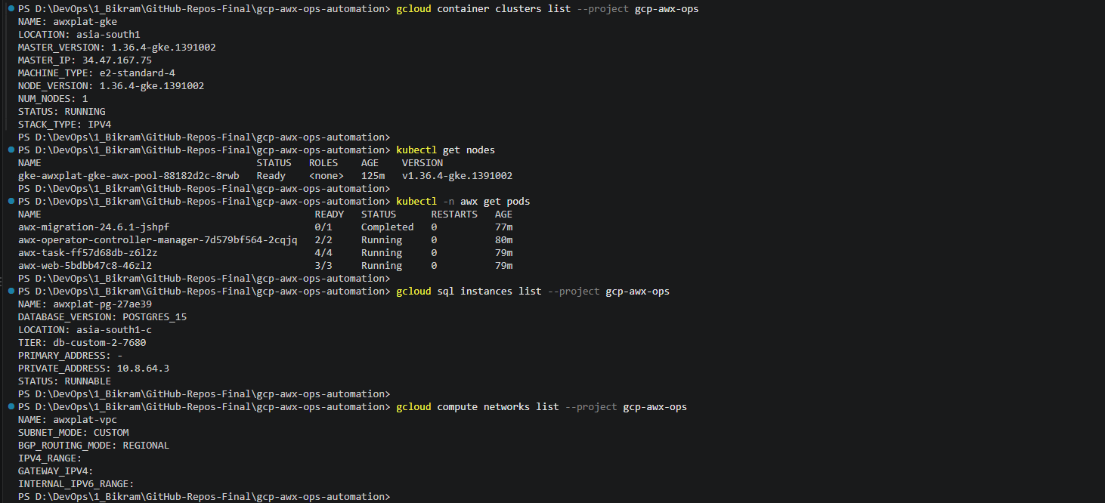
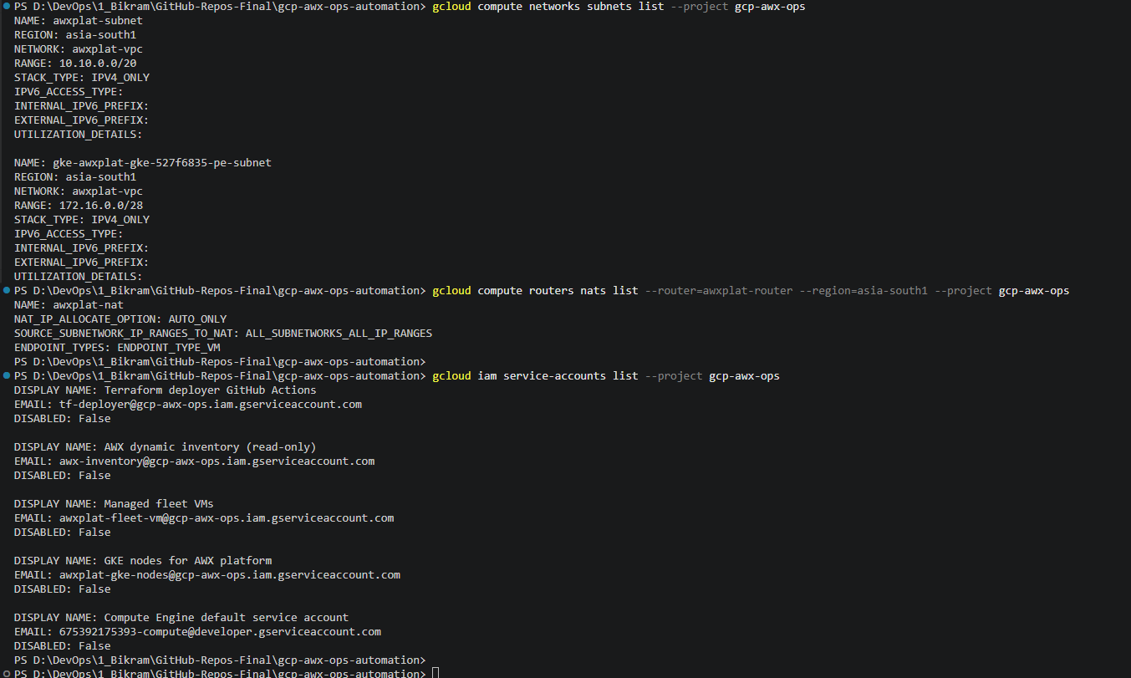
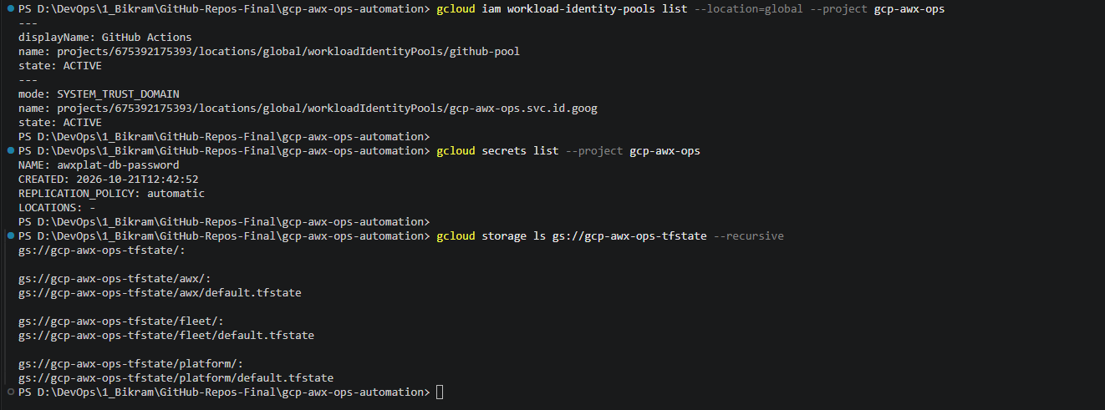

- http://localhost:8080
PS D:\DevOps\1_Bikram\GitHub-Repos-Final\gcp-awx-ops-automation> kubectl -n awx get secret awx-admin-password -o jsonpath='{.data.password}' | ForEach-Object { [Text.Encoding]::UTF8.GetString([Convert]::FromBase64String($_)) }
l9vjNl1WFiYTOrW7XeeCLLOHULxi6lUM
PS D:\DevOps\1_Bikram\GitHub-Repos-Final\gcp-awx-ops-automation>
Username: admin
Password: l9vjNl1WFiYTOrW7XeeCLLOHULxi6lUM
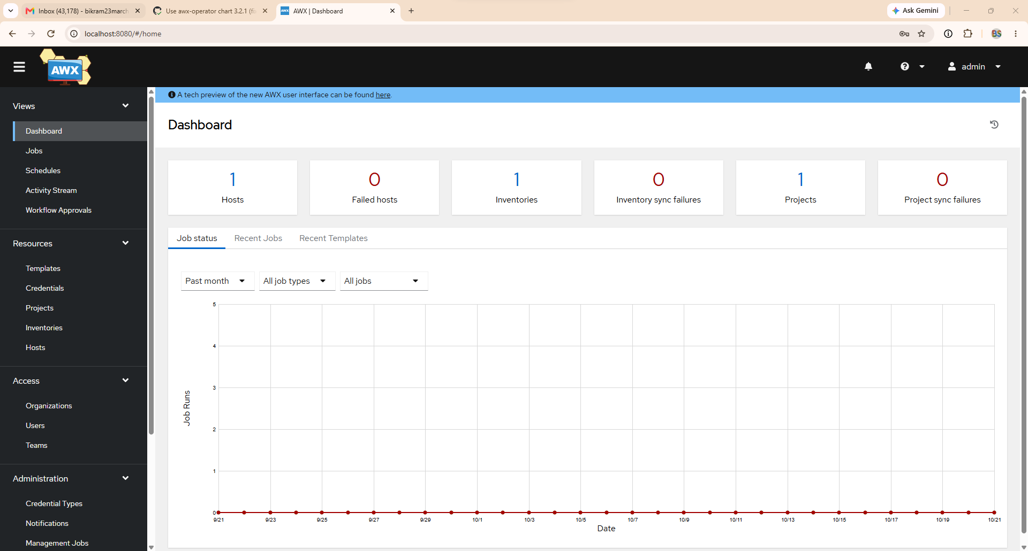
1. Print the private key and copy it
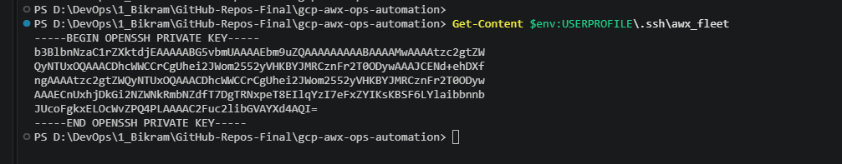
2. Create the credential
Go to Resources → Credentials → Add:
- Name: fleet-ssh
- Credential Type: Machine
- Username: ansible
- SSH Private Key: paste the key
- Leave the password and privilege escalation fields empty, then click Save.
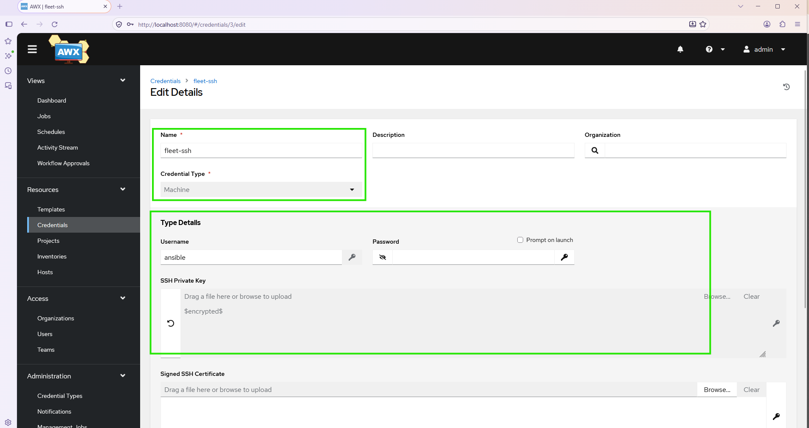
3. Create the project
Go to Resources → Projects → Add:
- Name: awx-ops-playbooks
- Source Control Type: Git
- Source Control URL: https://github.com/bikram-singh/gcp-awx-ops-automation.git
- Source Control Branch: main
- Tick Update Revision on Job Launch, then click Save.
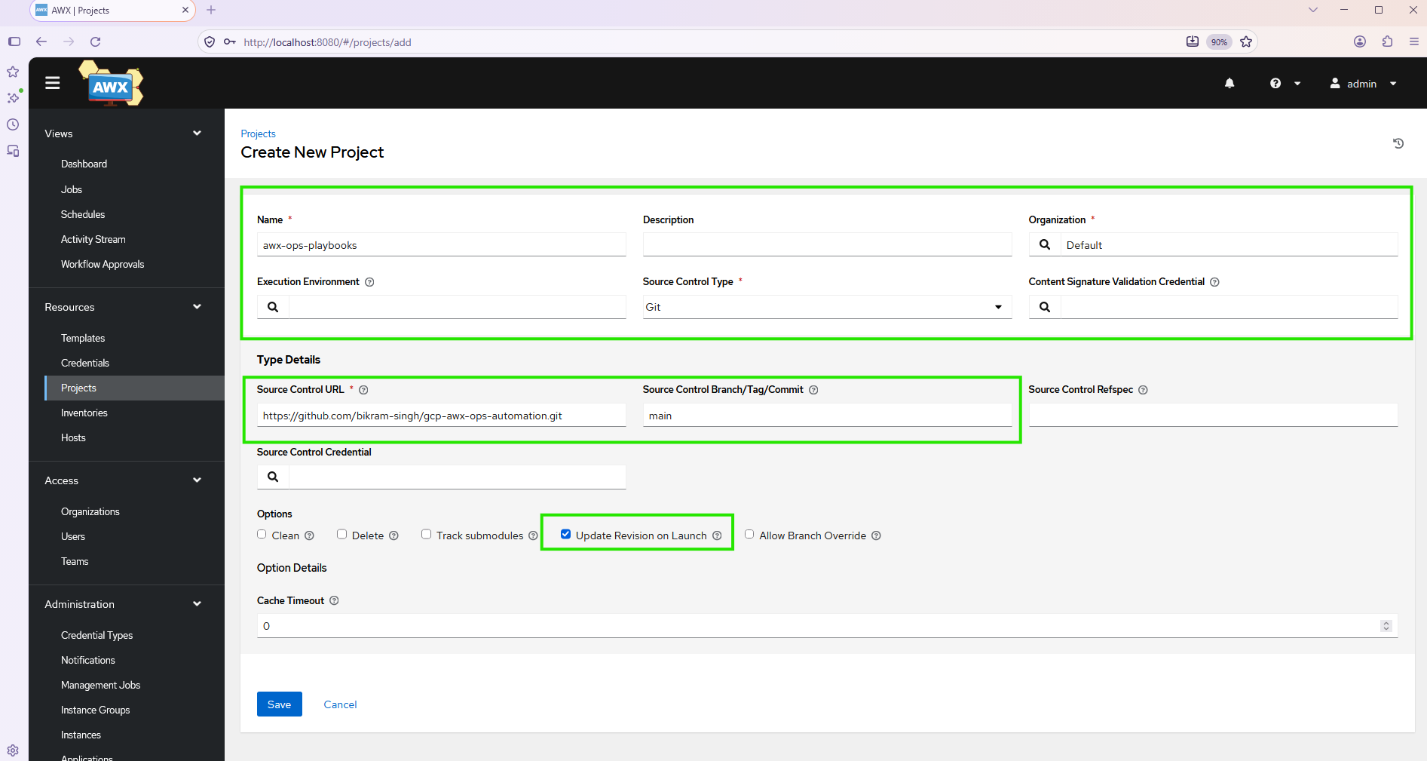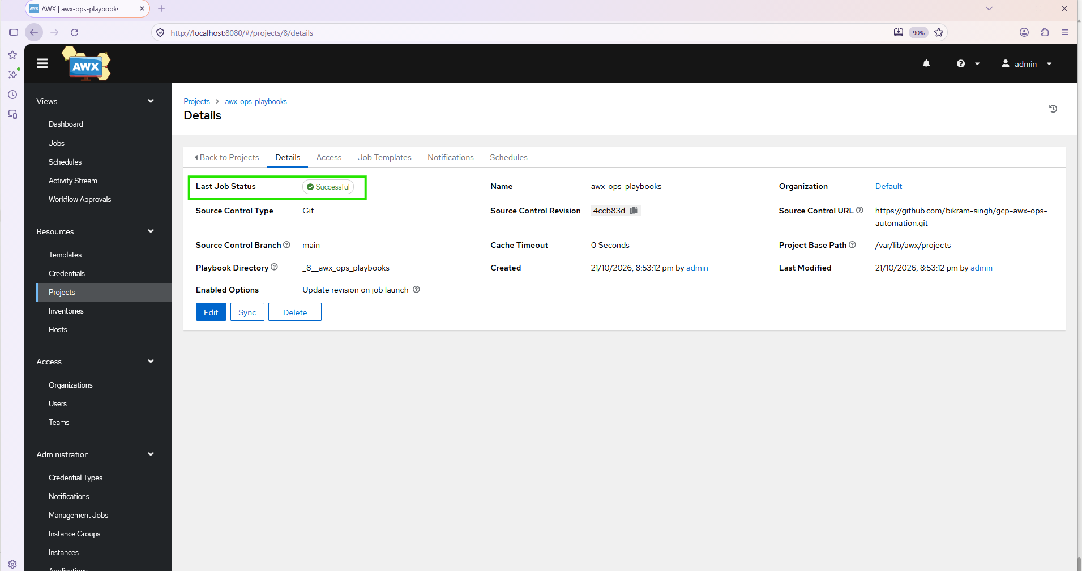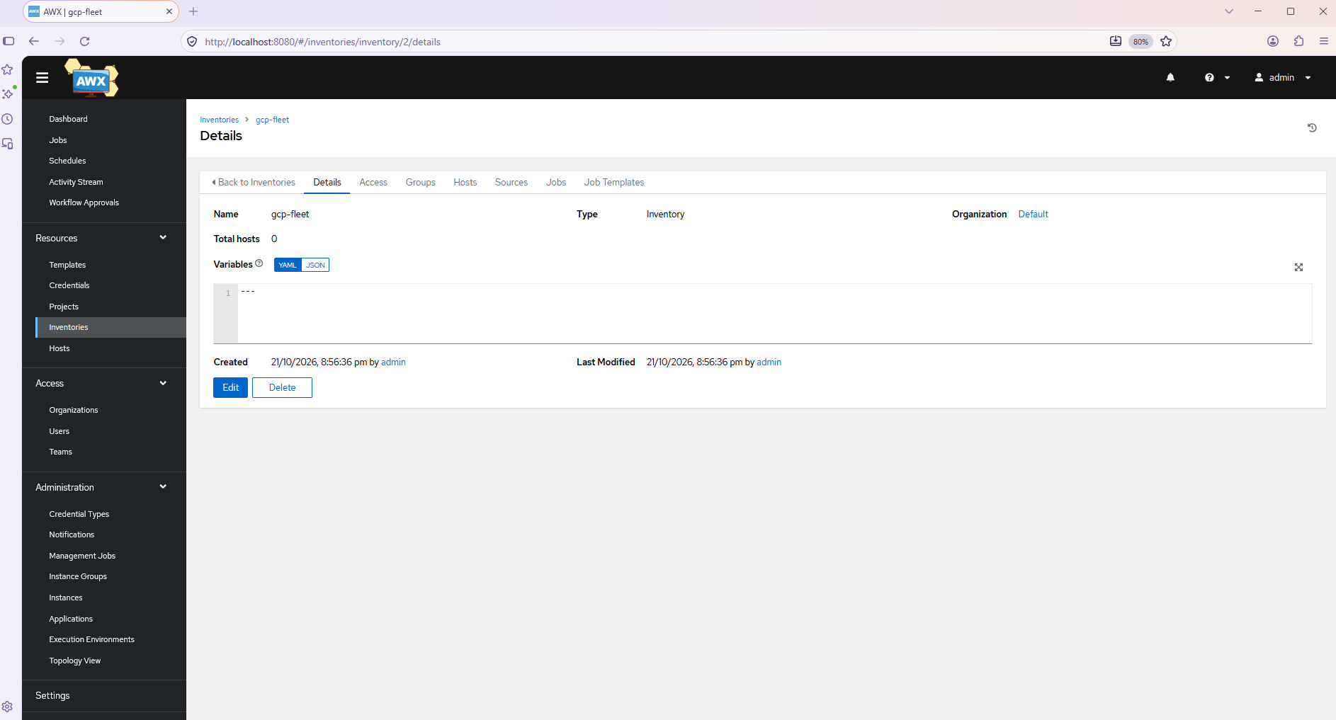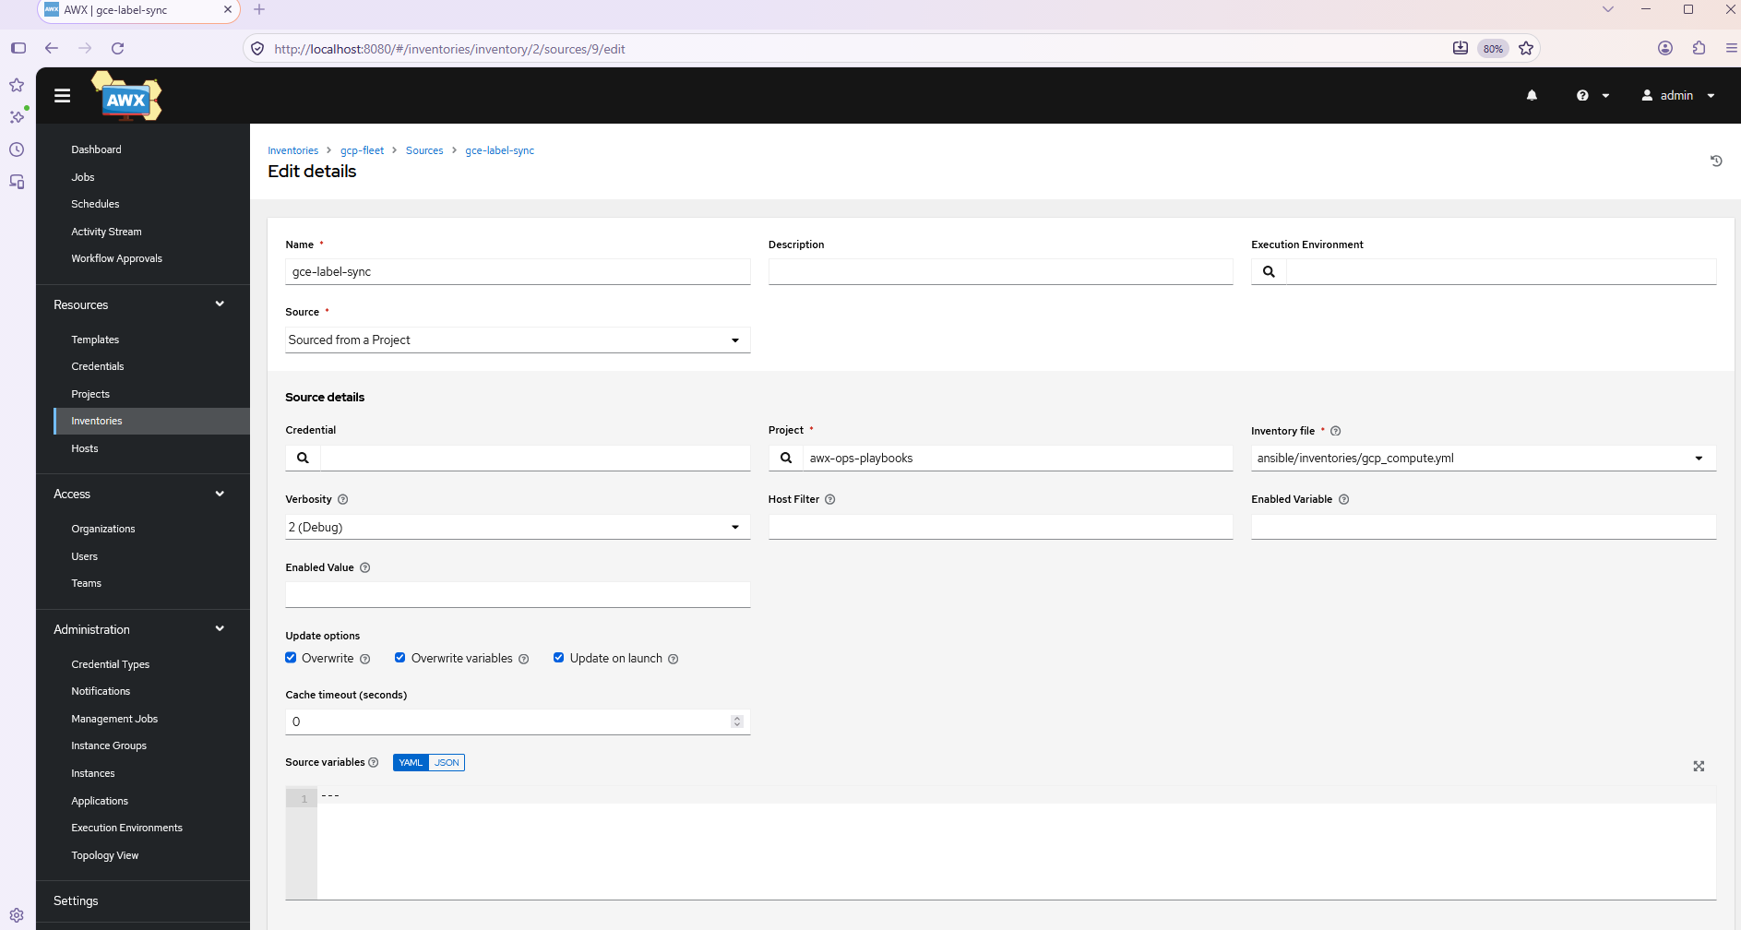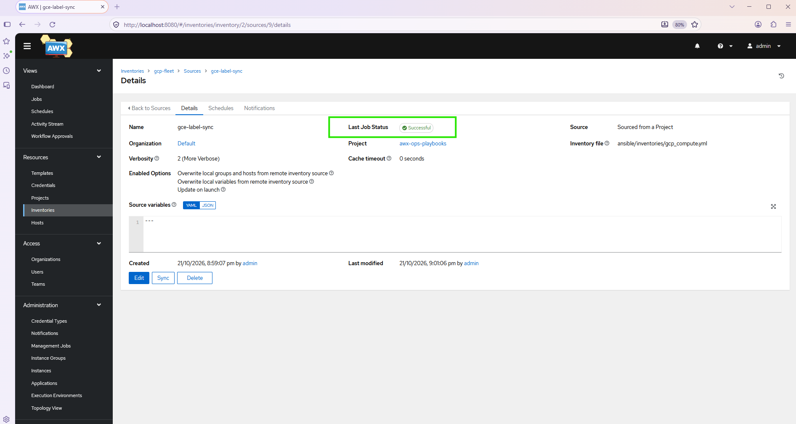

=== Access
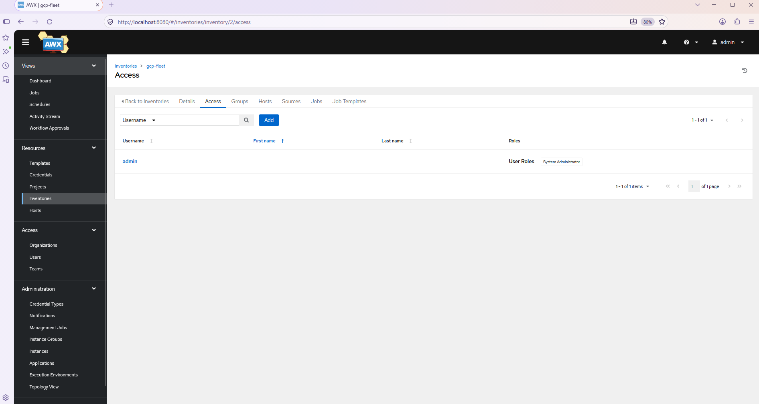
=== Group
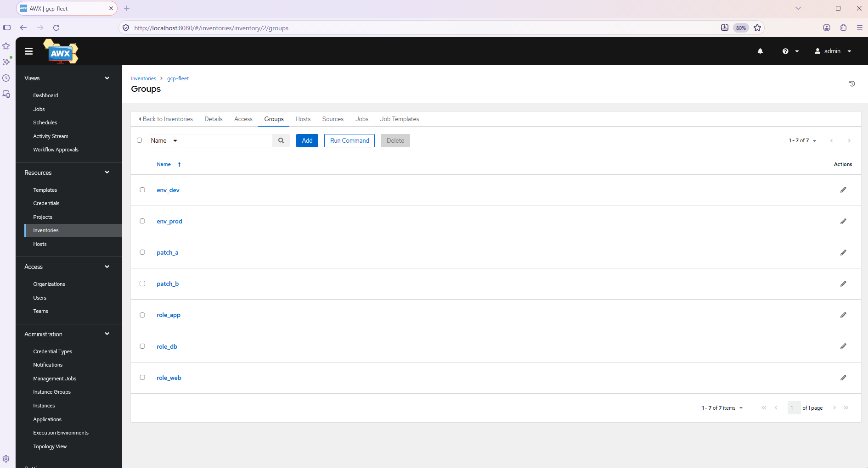
=== Hosts
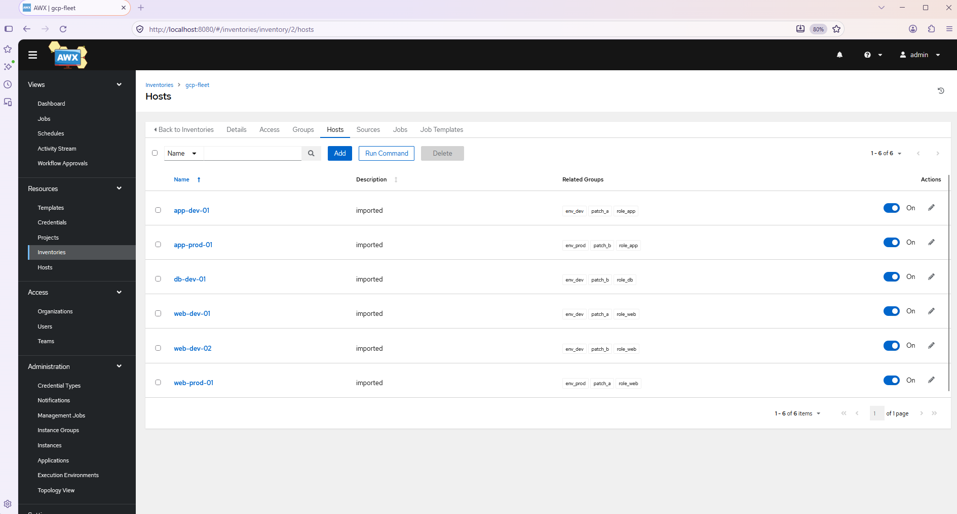
=== 00 Connectivity check Job Template
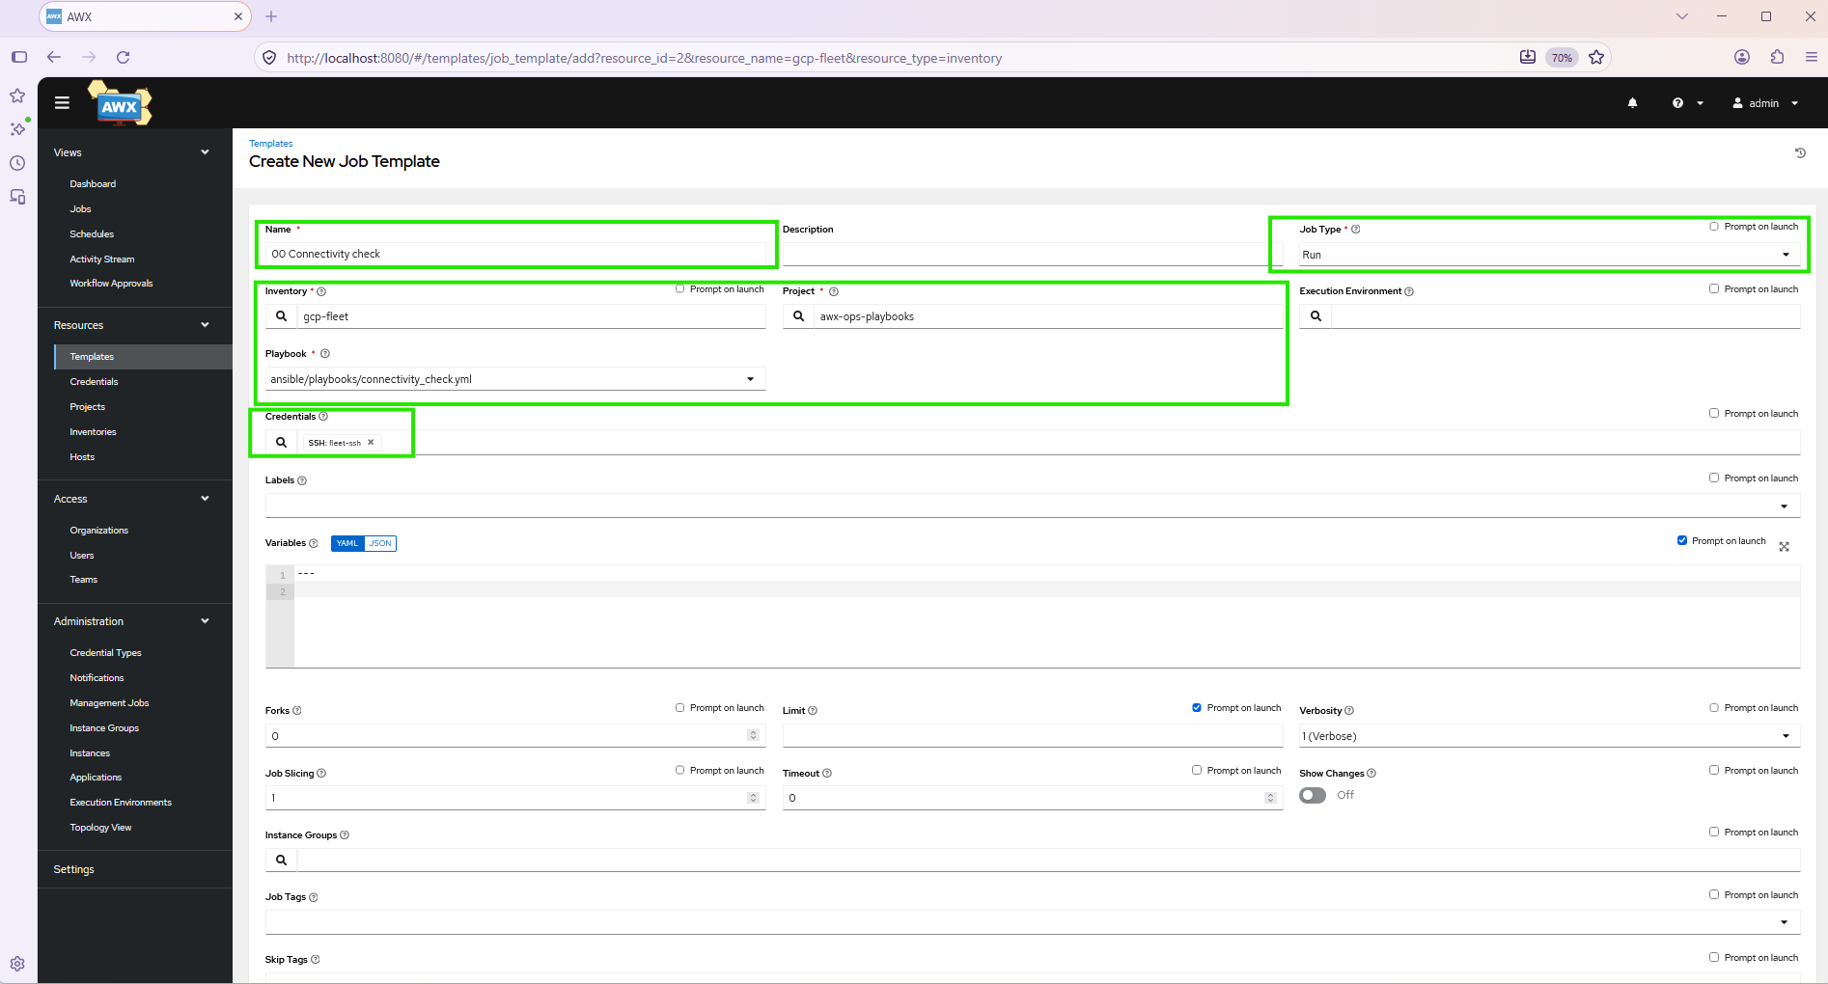
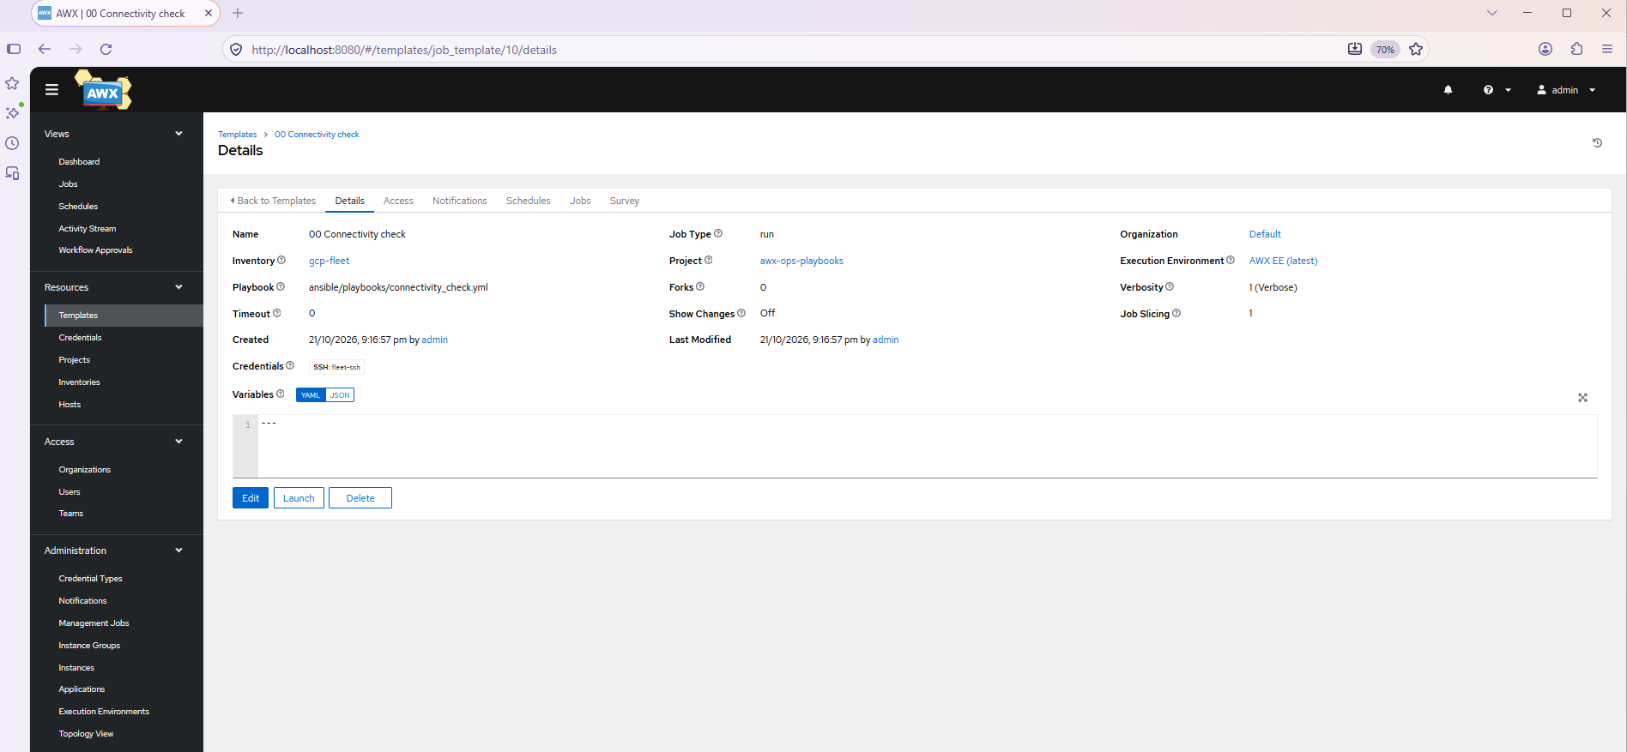
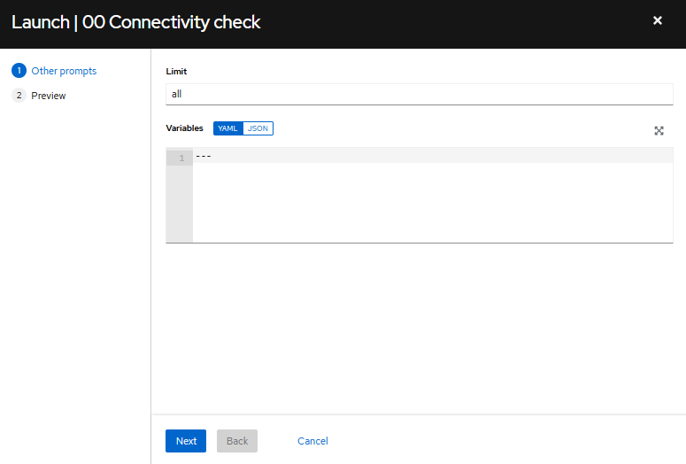
=== 00 Connectivity check Job Status

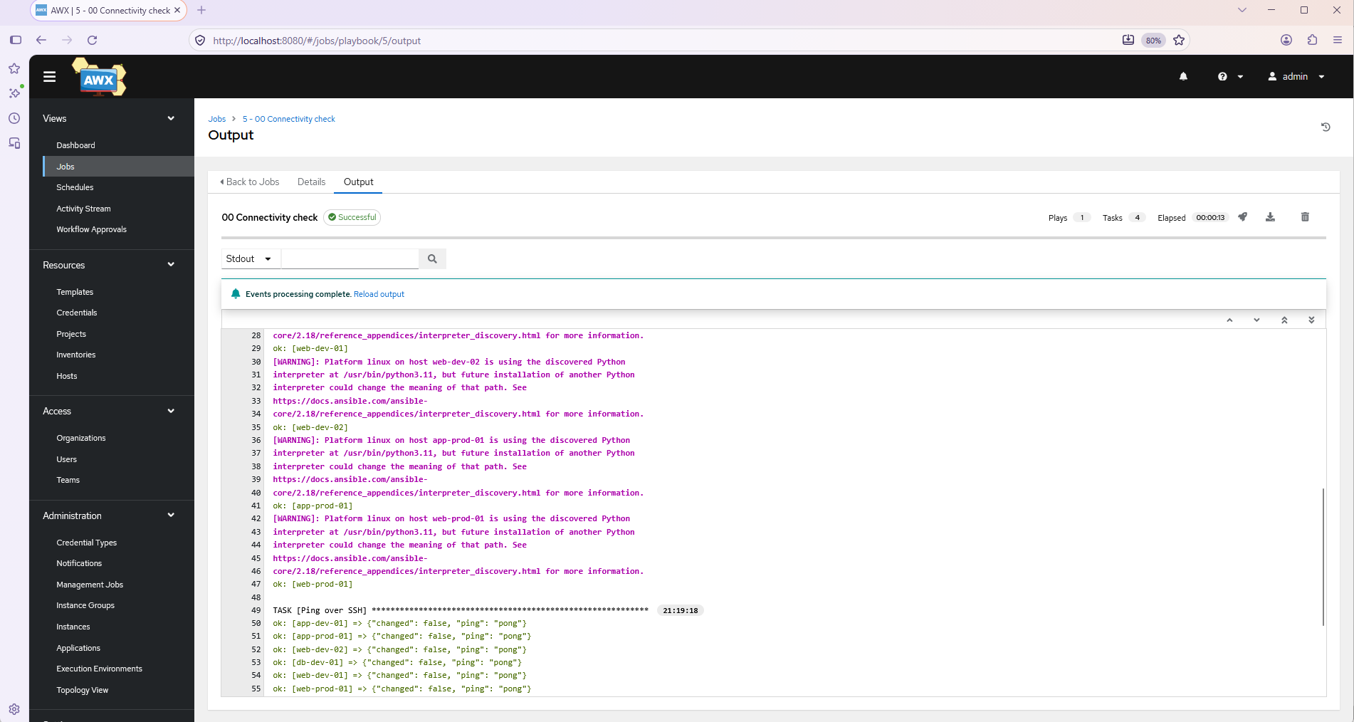
=== 10 Health Check Job Template
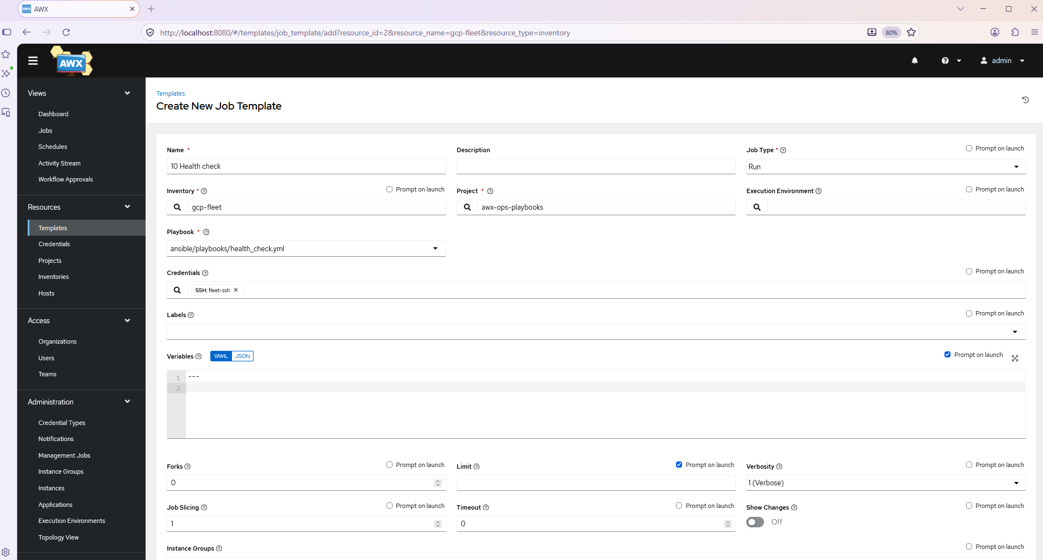
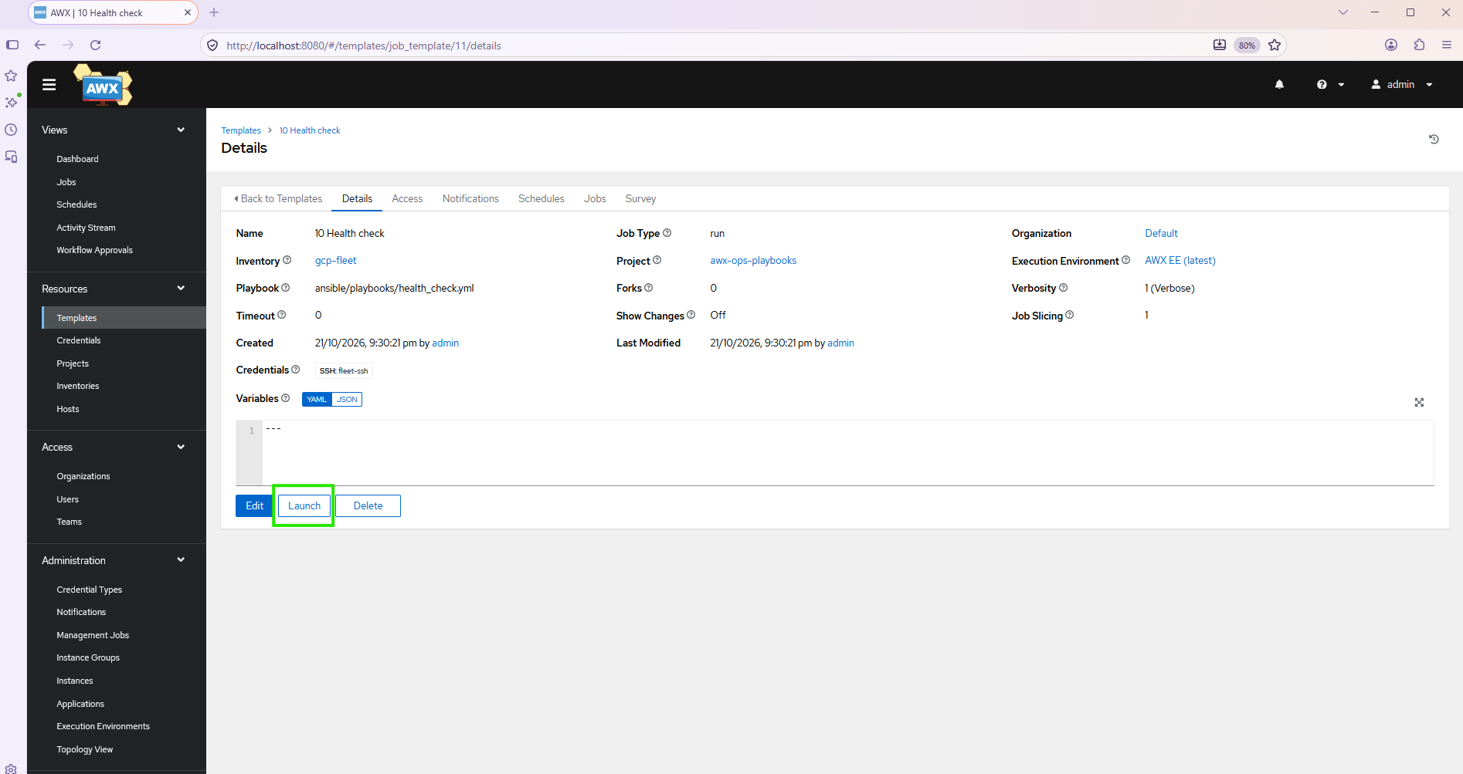
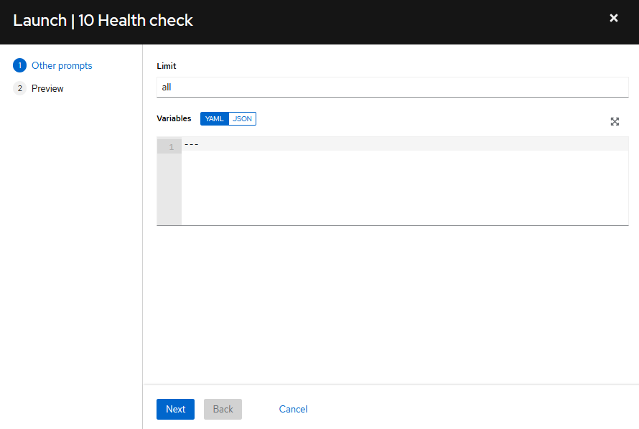
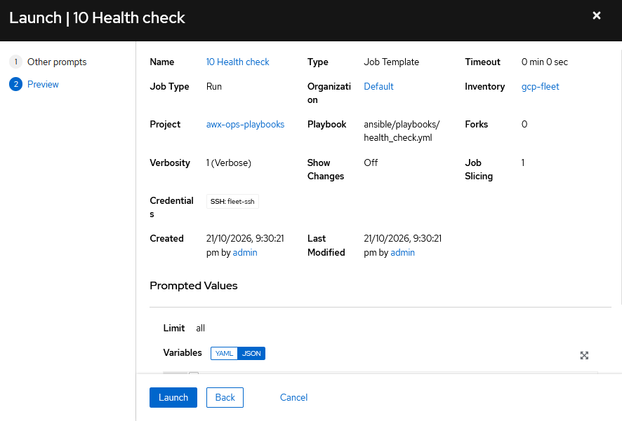
=== 10 Health Check Job Status
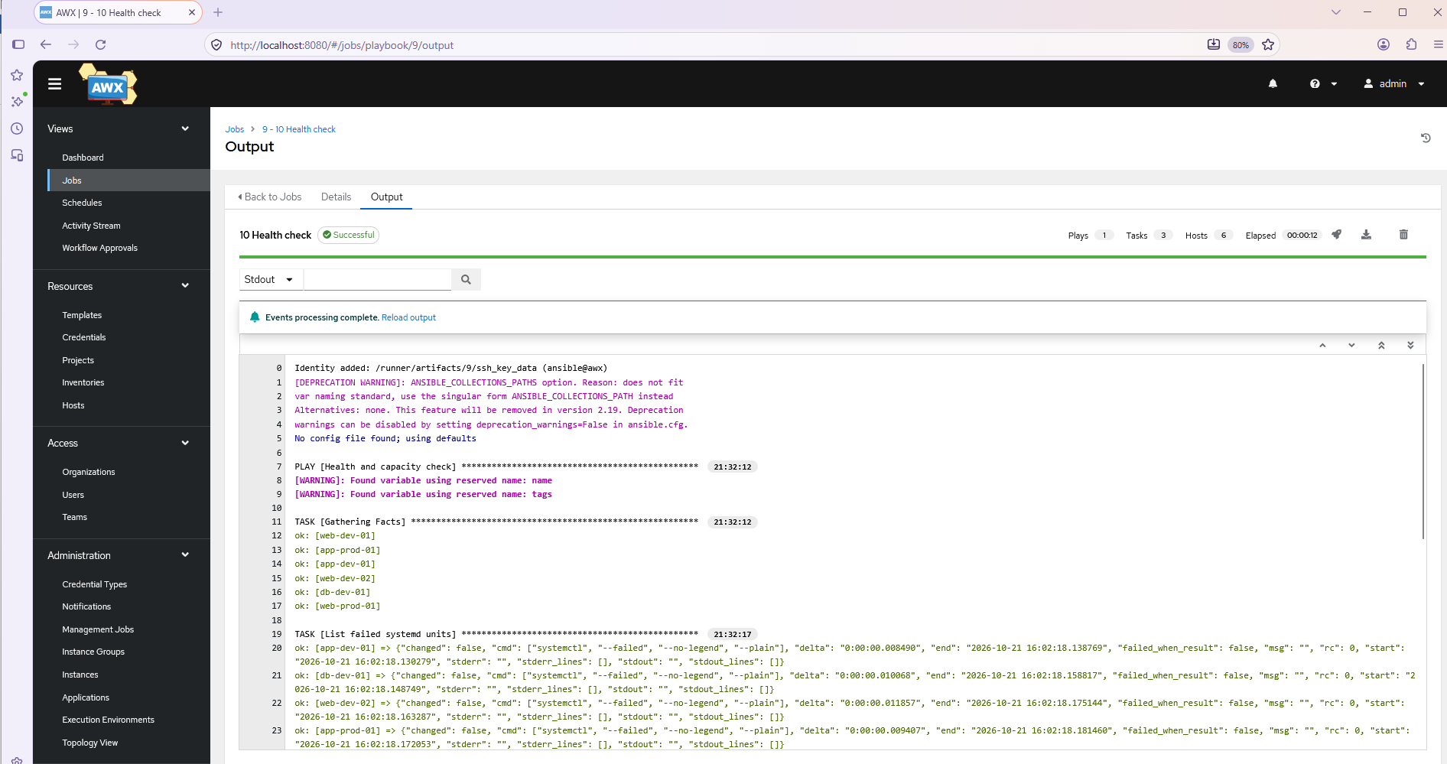
=== 20 Patch Linux (rolling) - Job Template
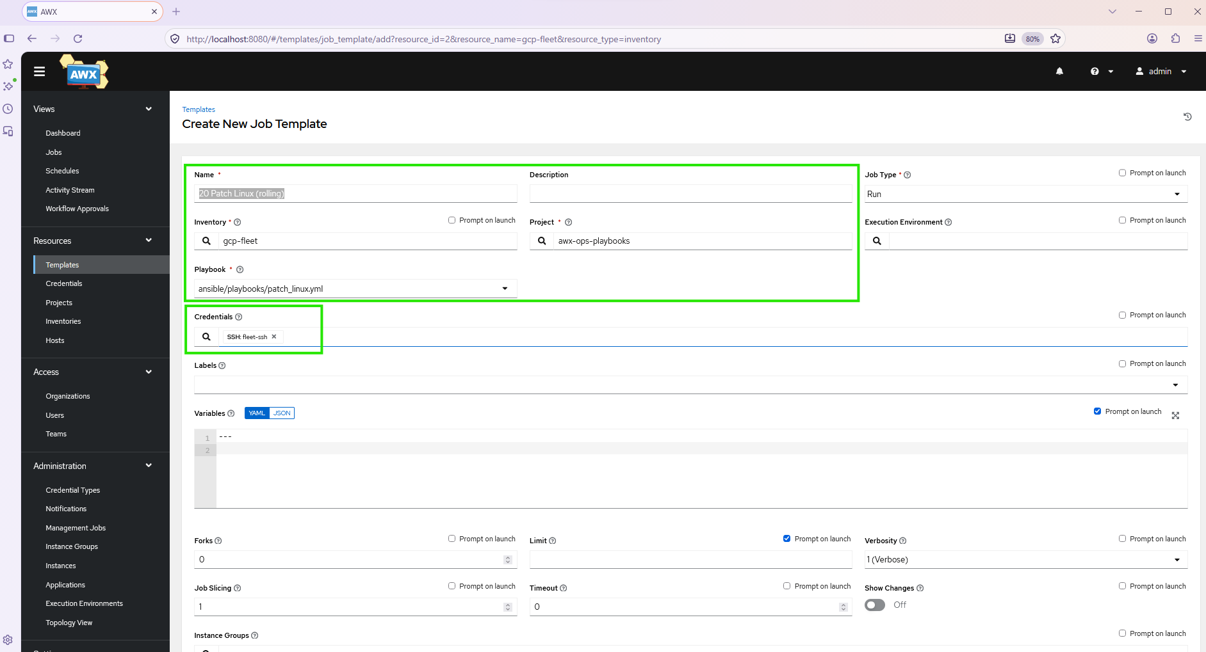
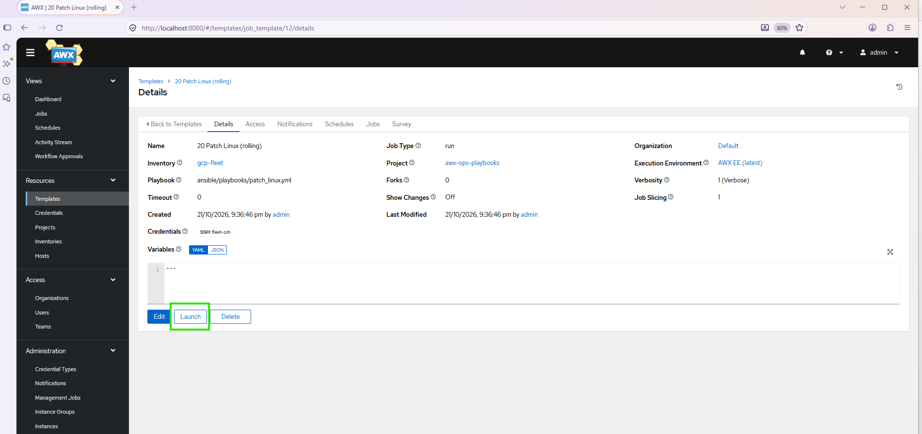
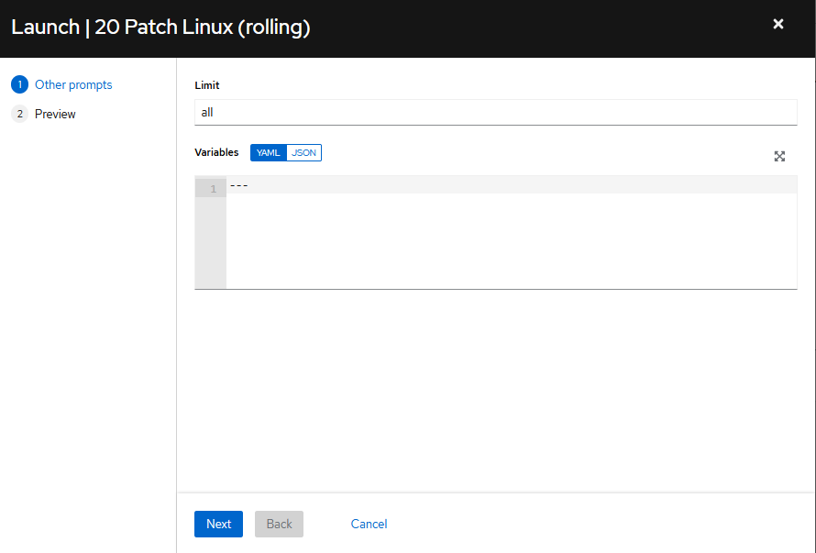
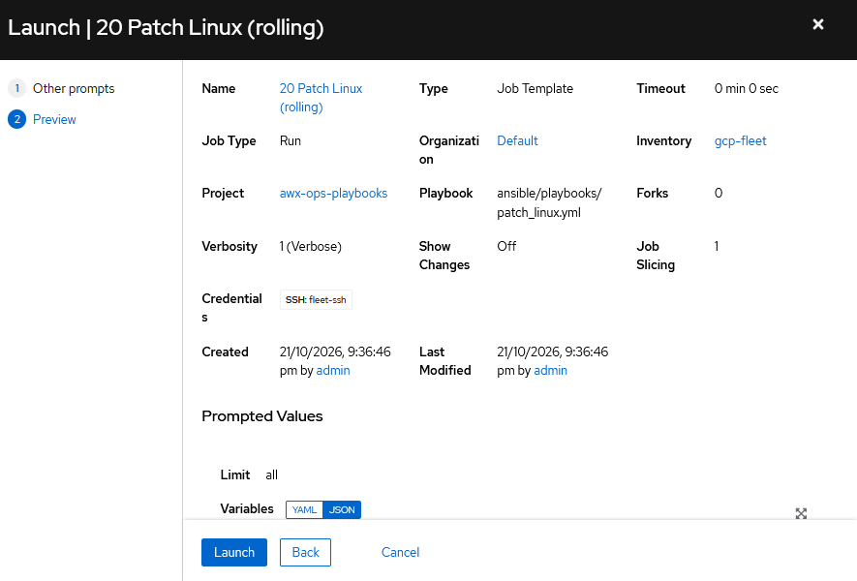
=== 20 Patch Linux (rolling) - Job Status
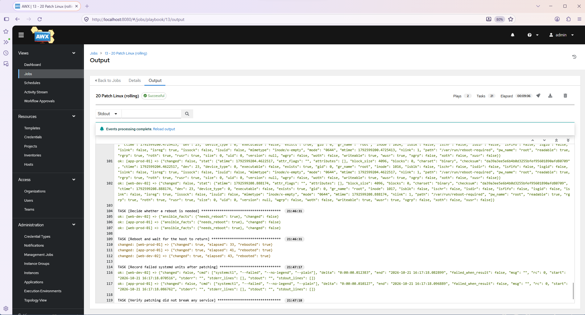
===== ops-trigger testing
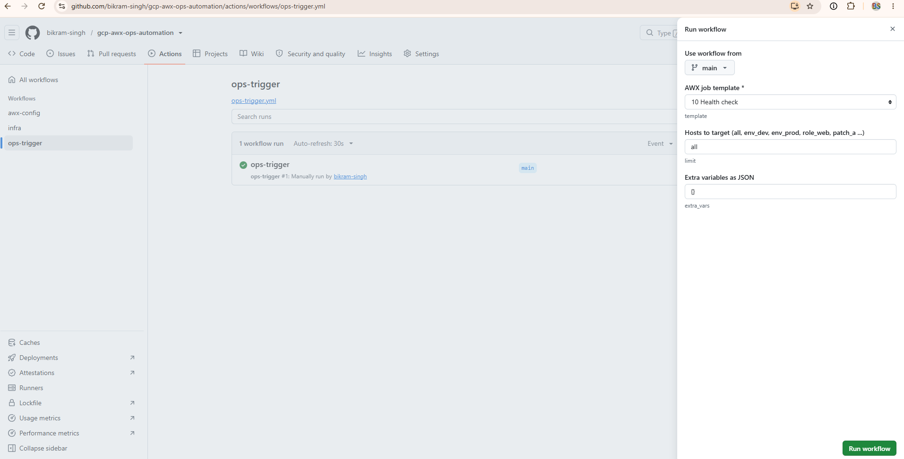
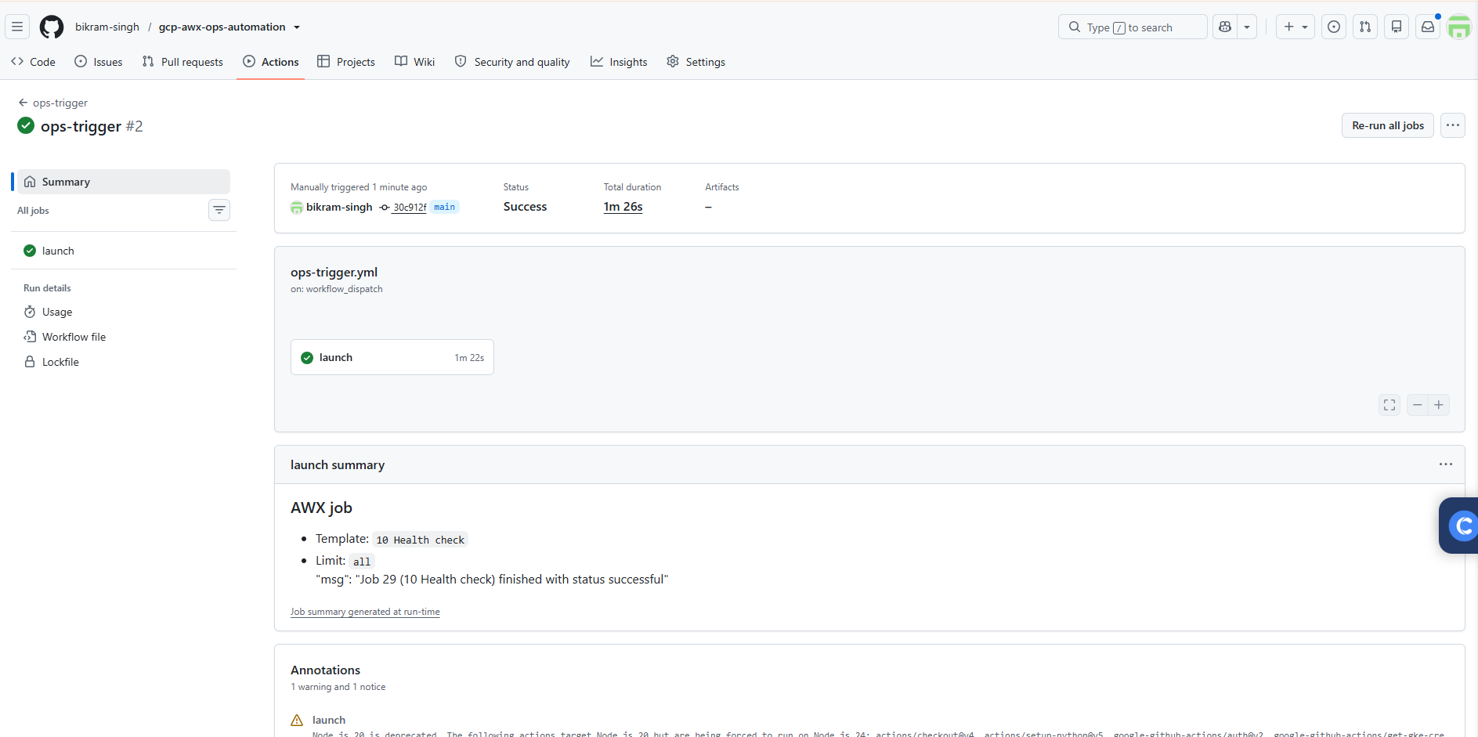
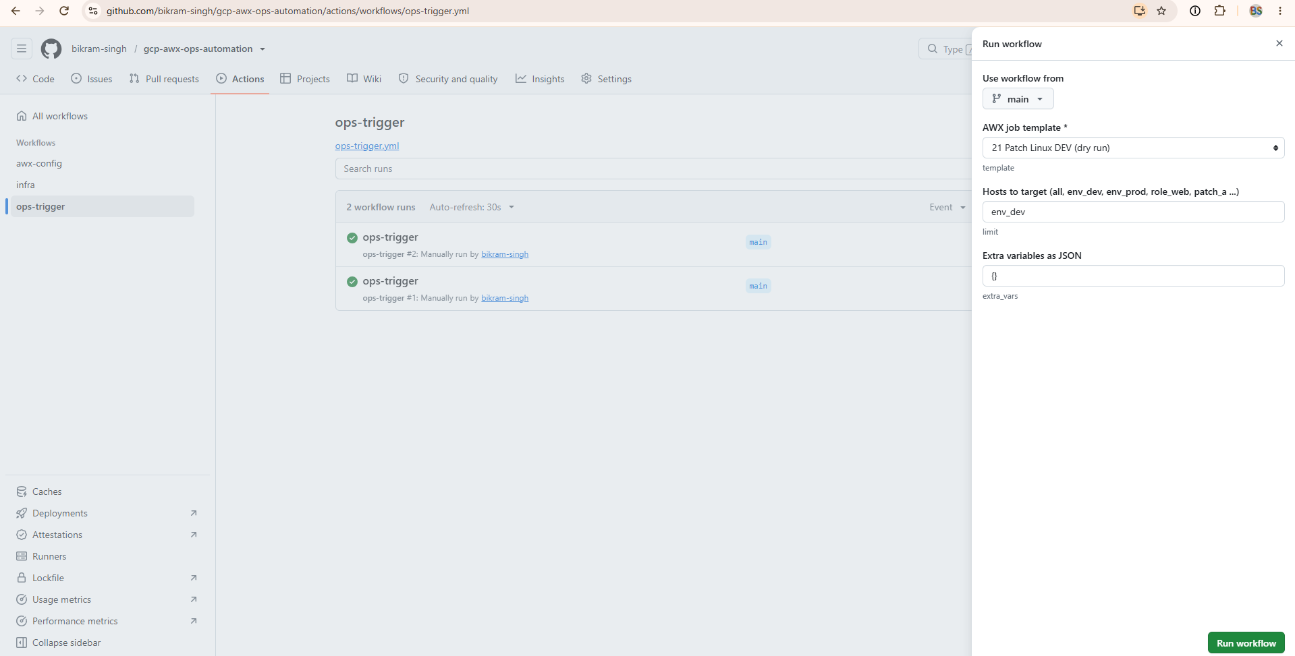
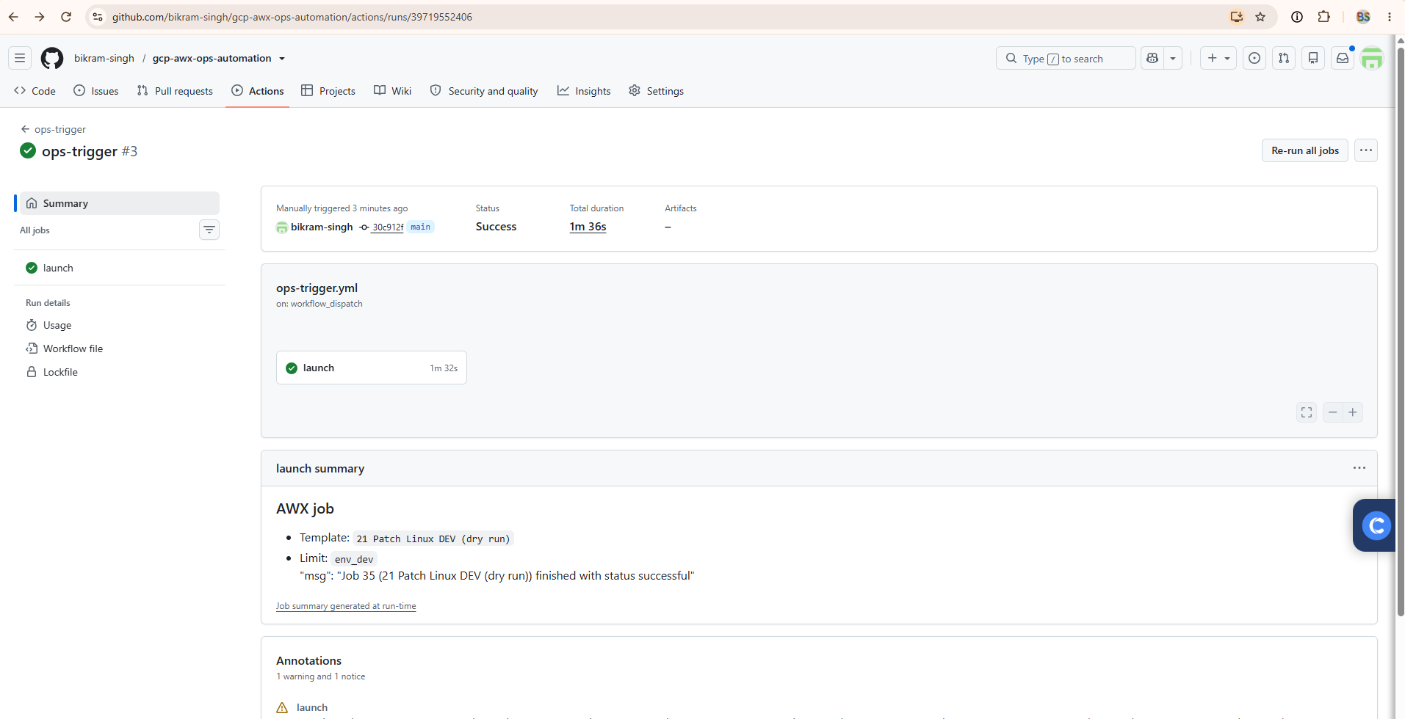

==== Phase 5
ops-trigger test. In Actions, open ops-trigger and click Run workflow with:
- template: 30 Snapshot disks (pre-patch)
- limit: env_dev
- extra vars: {}

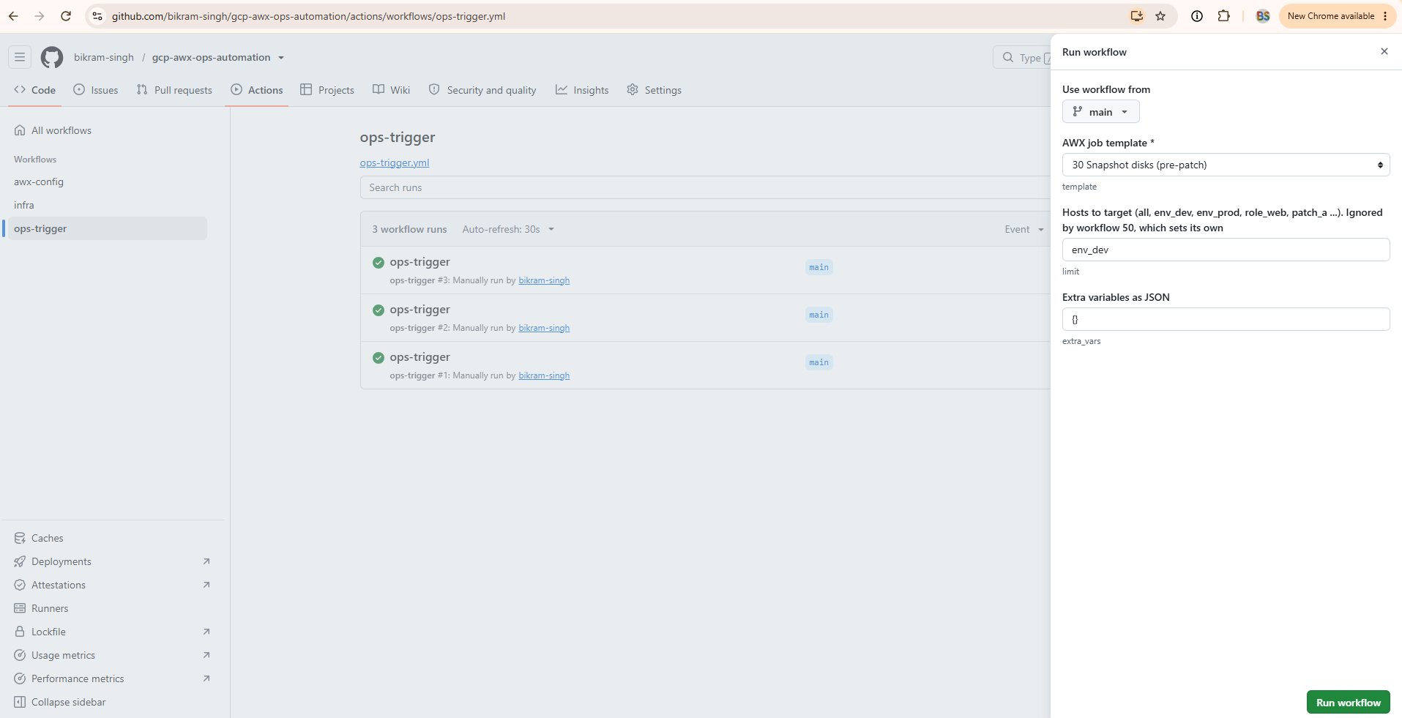
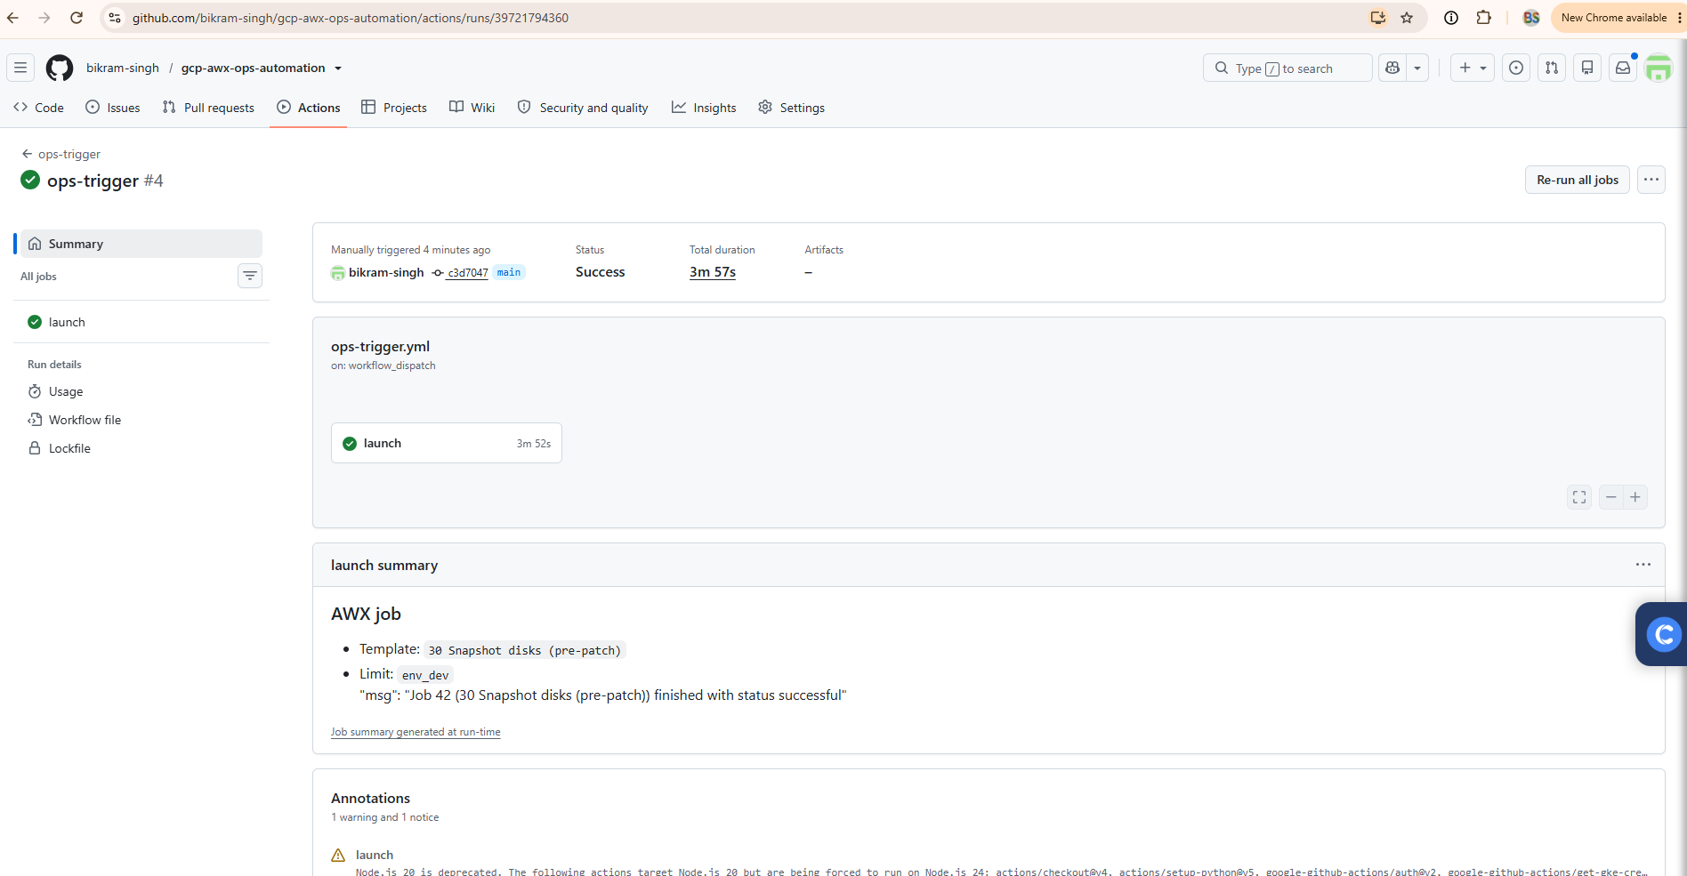
Check the console. In the GCP console, go to Compute Engine → Storage → Snapshots
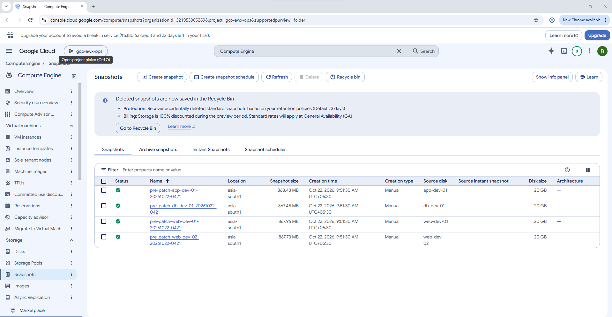
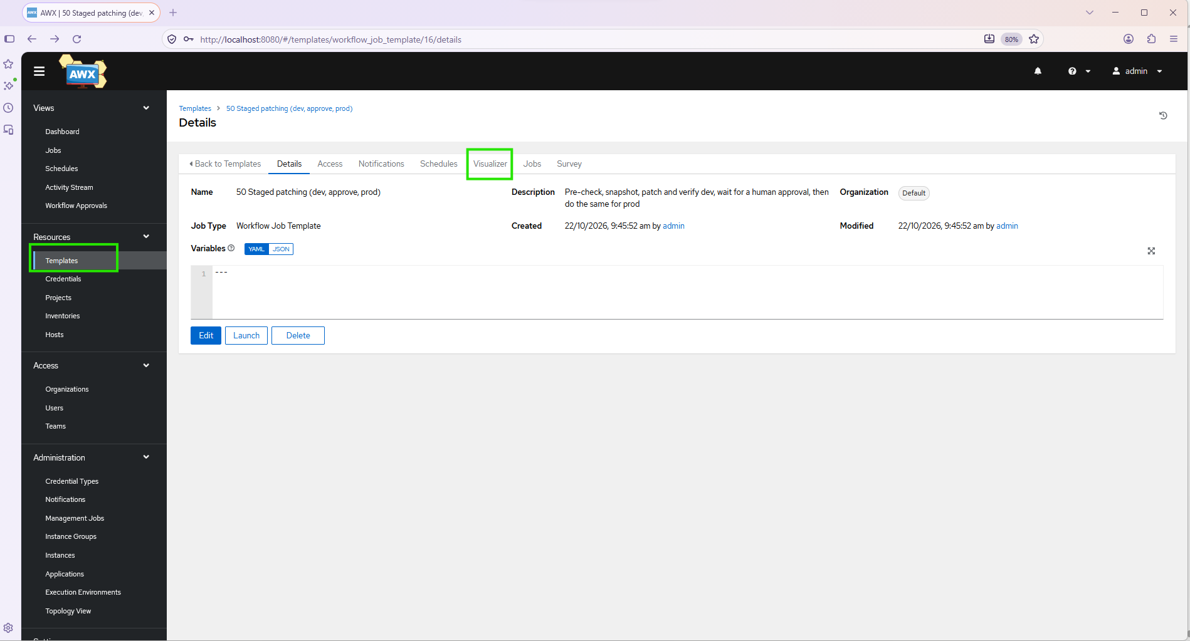
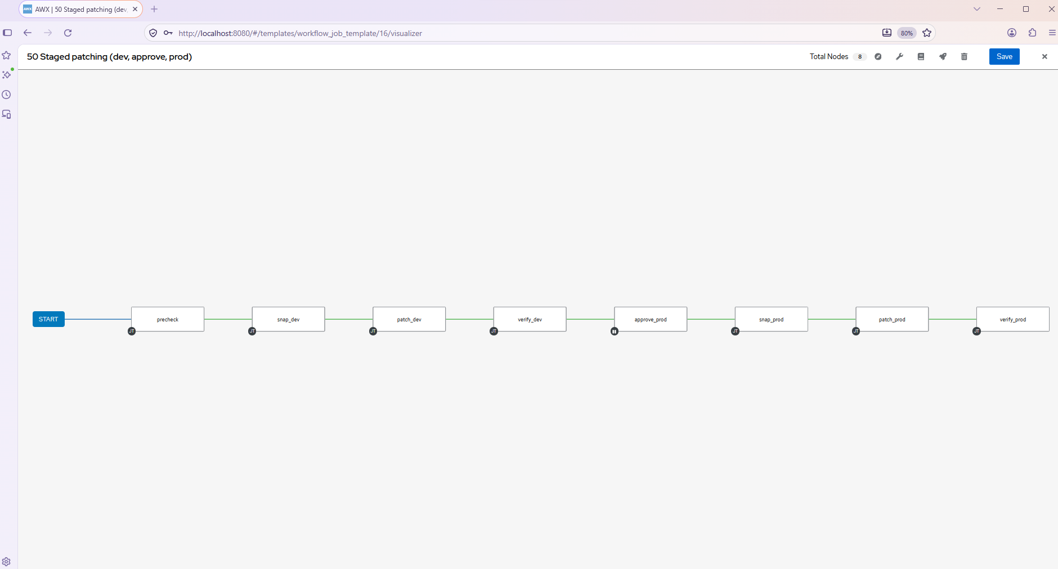
Next, run the full staged workflow:
- In Actions, open ops-trigger and click Run workflow with template 50 Staged patching (dev, approve, prod), any limit, and extra vars {}.
- Approve the production environment when GitHub asks.
- In AWX, open Views → Jobs and watch the workflow job go through precheck, dev snapshot, dev patch and dev verify. Then it pauses at the approval.
- At the pause, take a screenshot of the workflow graph and of Views → Workflow Approvals.
- For the first rehearsal, click Deny. The workflow should end after dev, with prod untouched. Then run it again and click Approve to see the prod stages run.
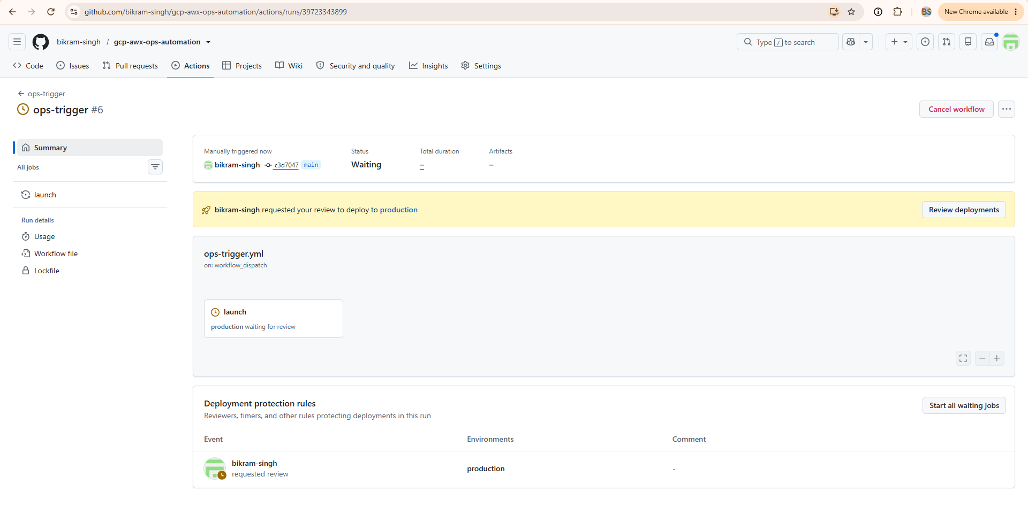
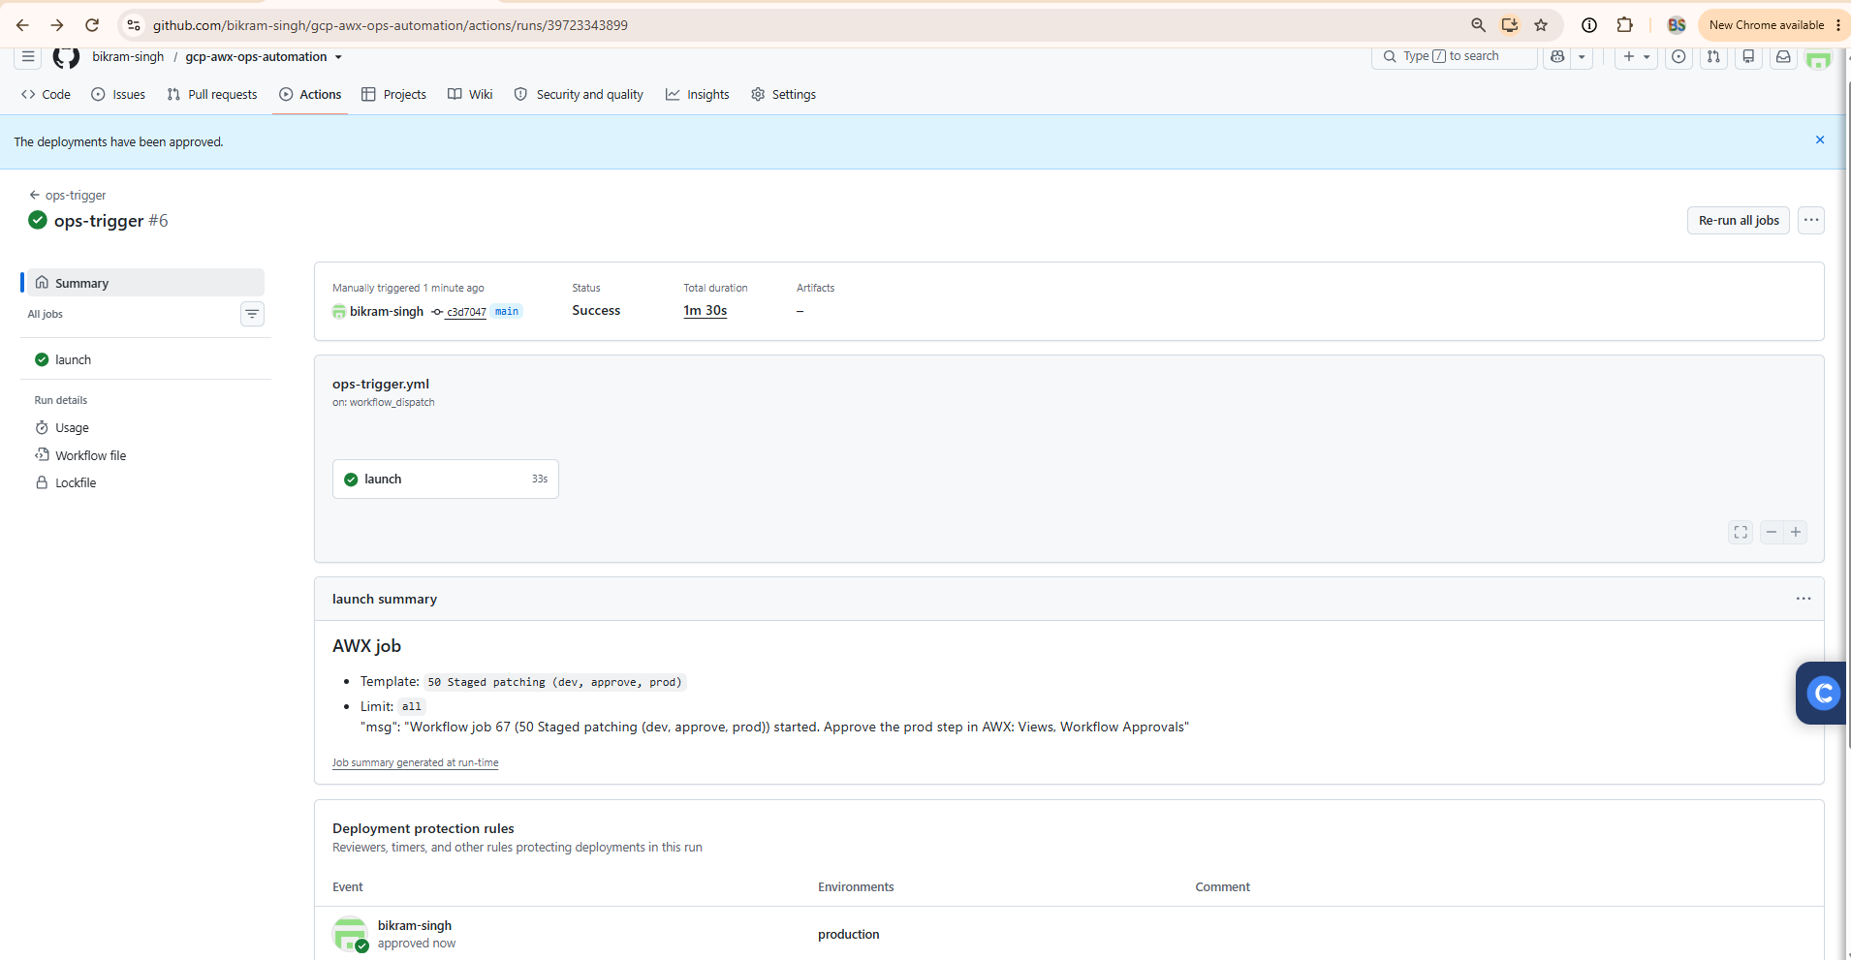
Screenshot this graph. It’s the money shot for the article.
- Open Views → Workflow Approvals. You will see Promote patching to prod? with its description.
- 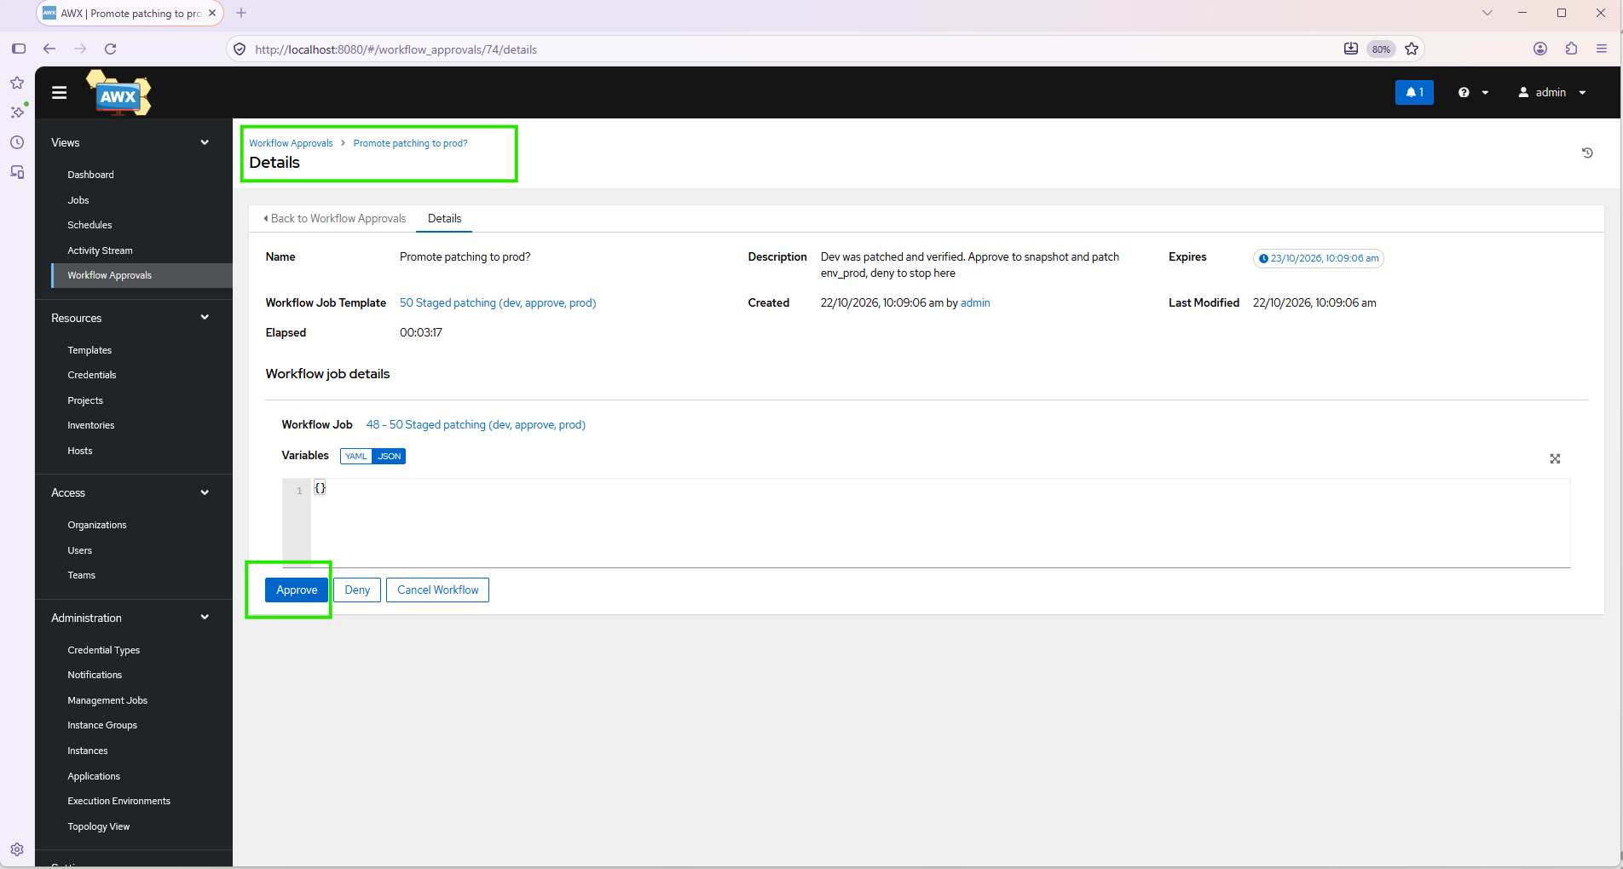
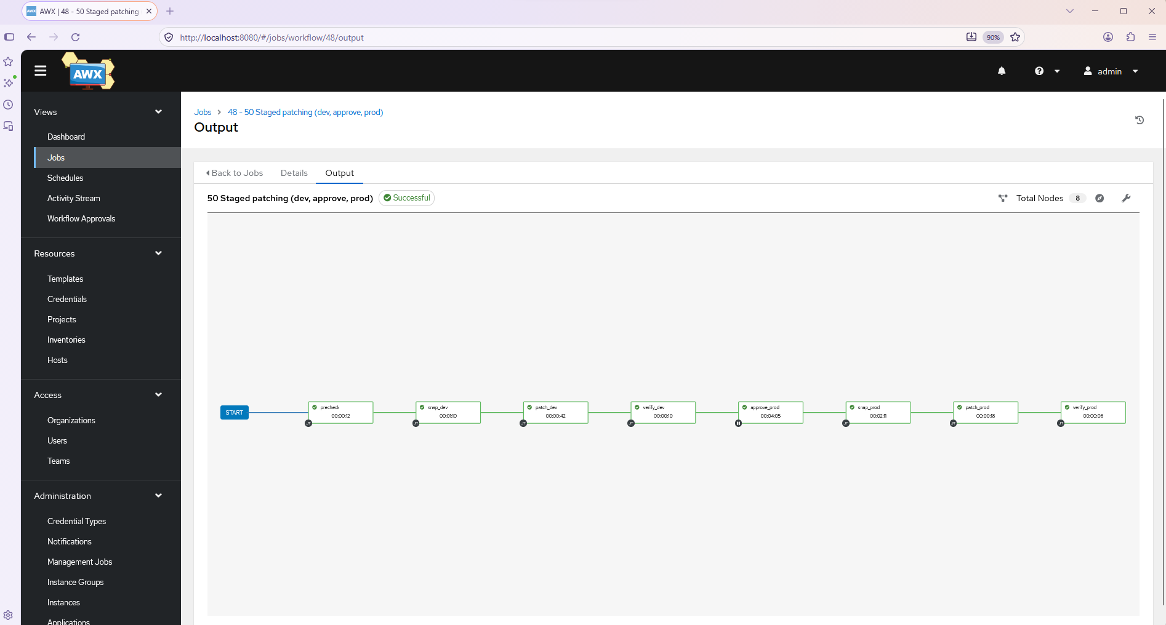
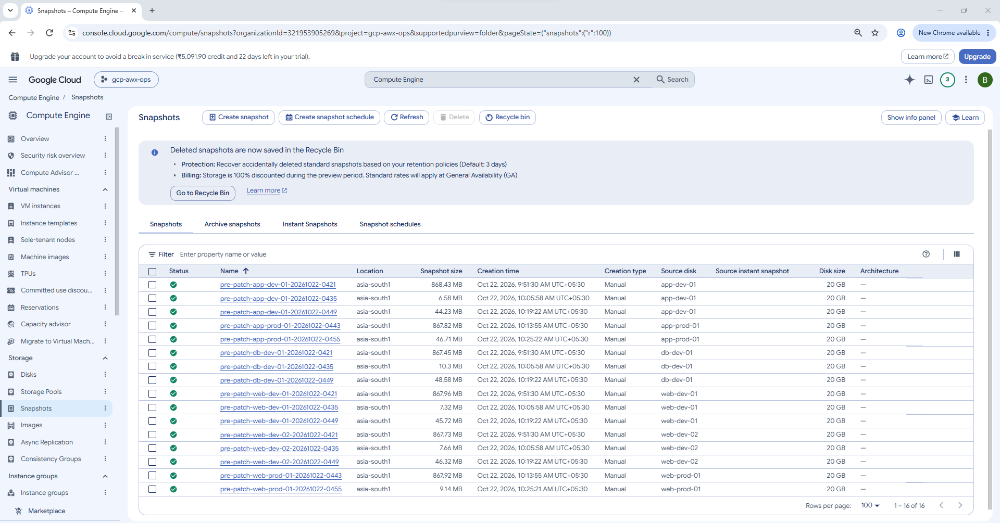
==== Phase 6
Next is Phase 6, self-healing:
- Cloud Monitoring alert fires when a service or VM has a problem.
- Alert goes to Pub/Sub, then a Cloud Function, which calls an AWX webhook.
- AWX runs a fix playbook, for example restarting a stopped service.
- A provisioning callback lets a new VM configure itself on boot.
It needs new Terraform (Pub/Sub, Cloud Function, alert policy), an AWX webhook, and a small “break and heal” demo. Shall I build it?
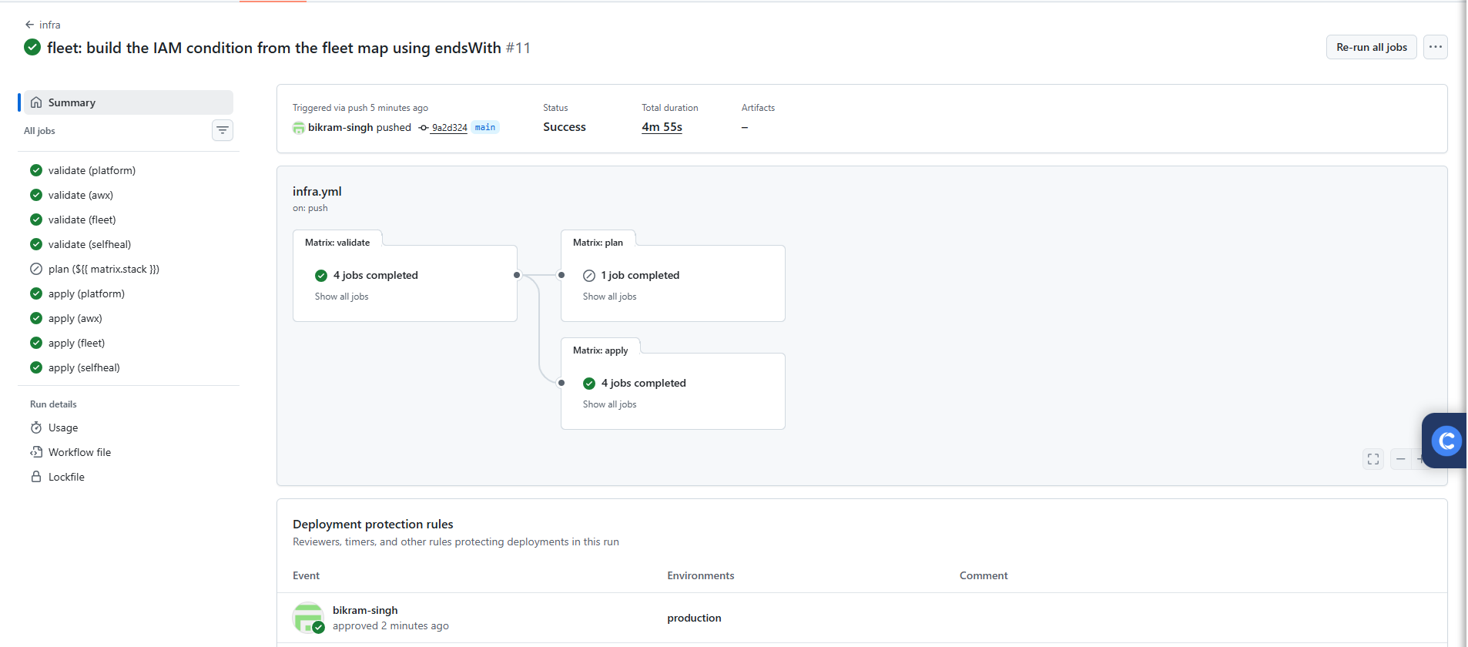
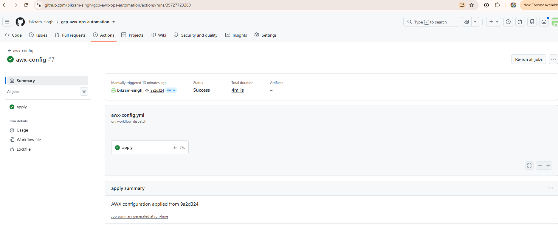
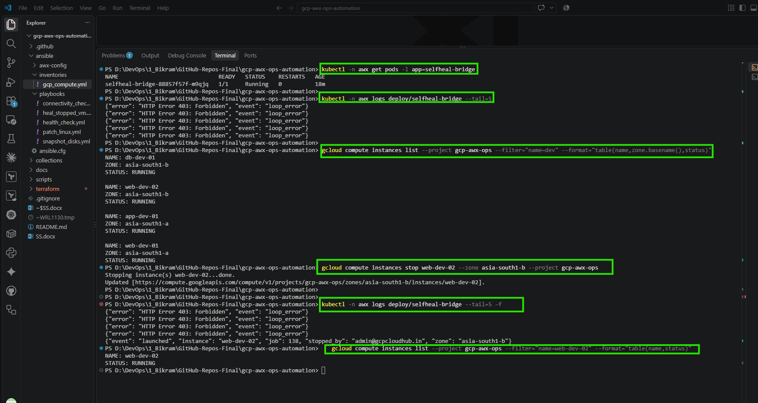
==== Phase 7
==== Phase 8: provisioning callback and notifications
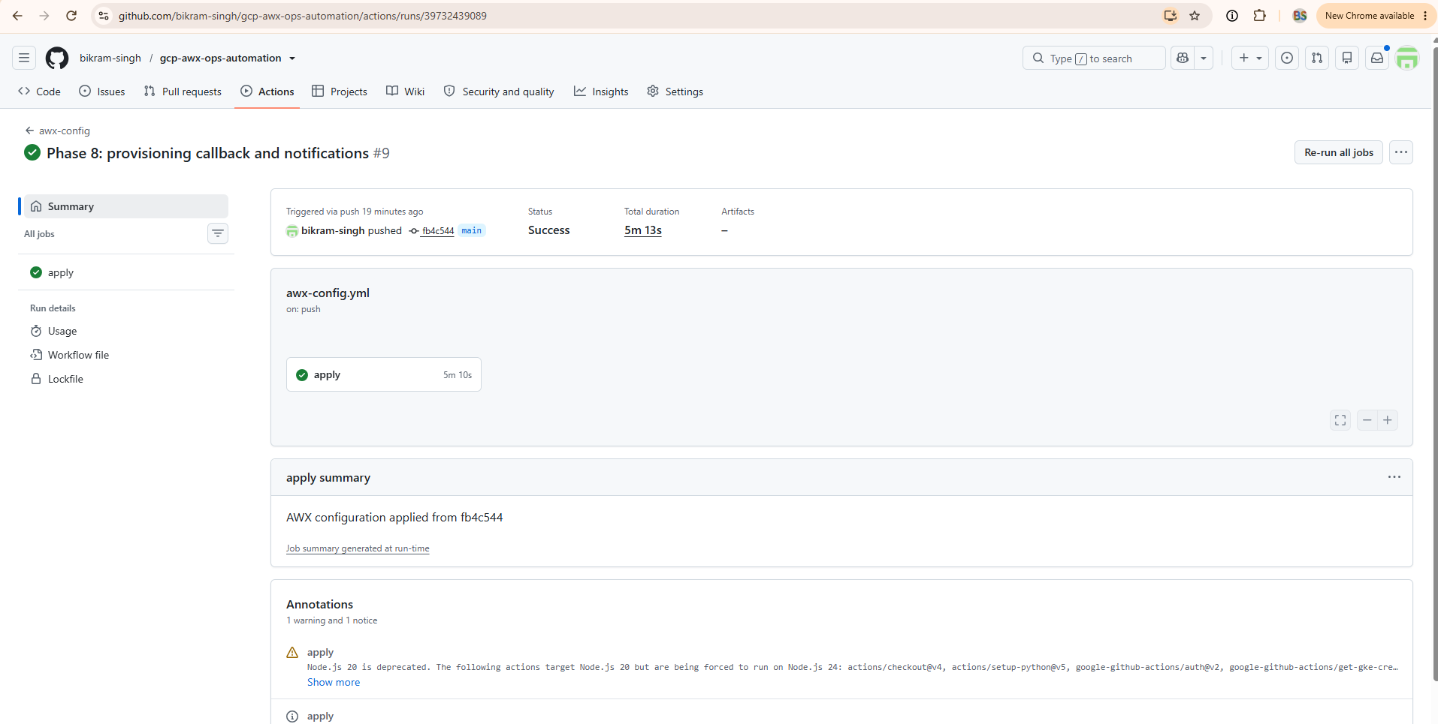
Next is the real test. Add this line inside the default = { ... } block of var.fleet in terraform/fleet/variables.tf, after app-prod-01:
"app-dev-02" = { env = "dev", role = "app", patch_group = "a", zone = "a" }
Then push it:
git add terraform/fleet/variables.tf
git commit -m "Test provisioning callback: add app-dev-02"
git push origin main
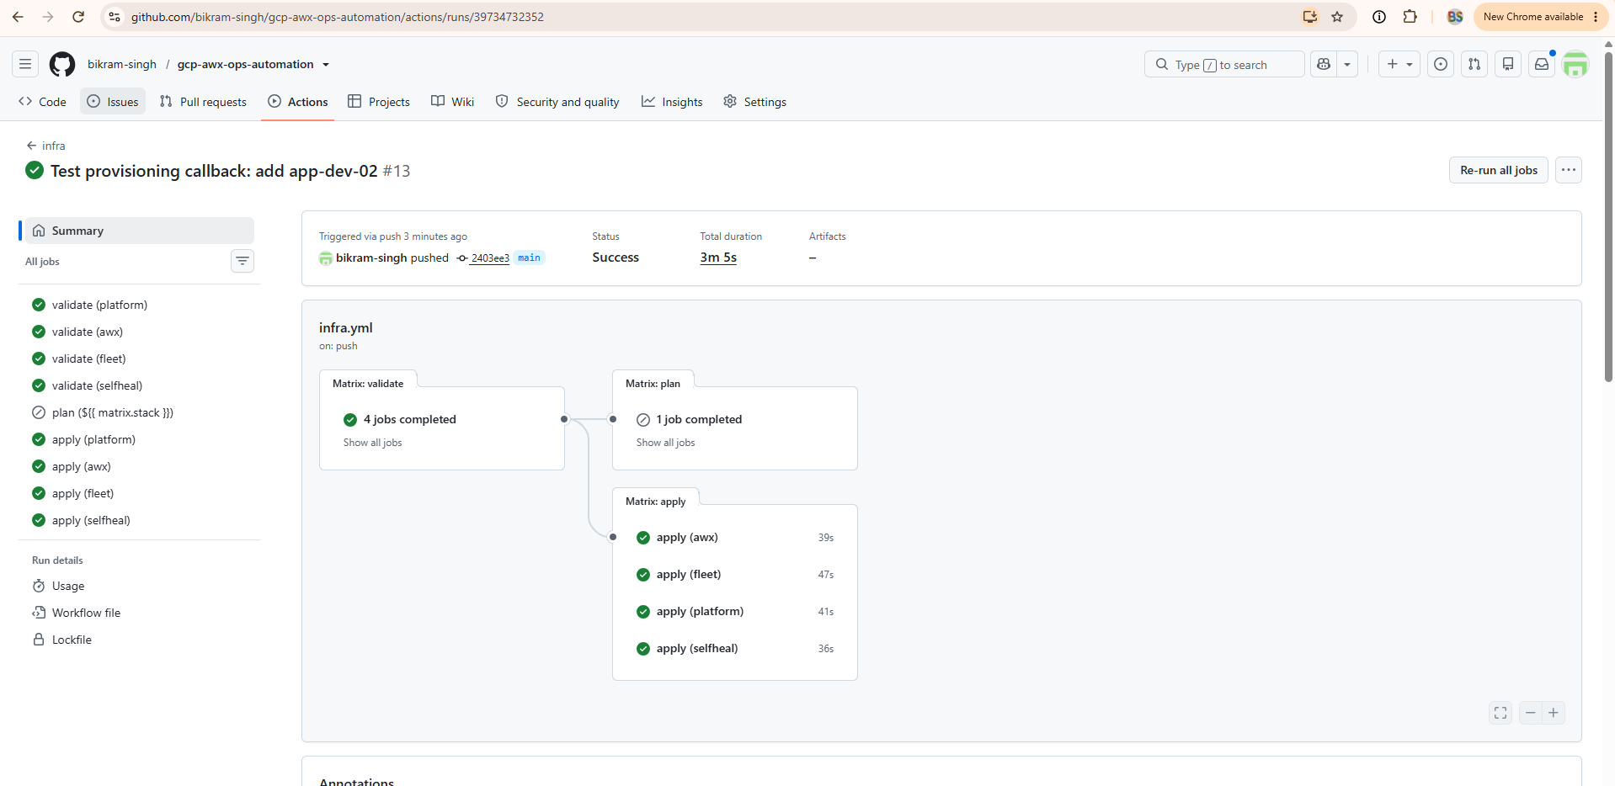
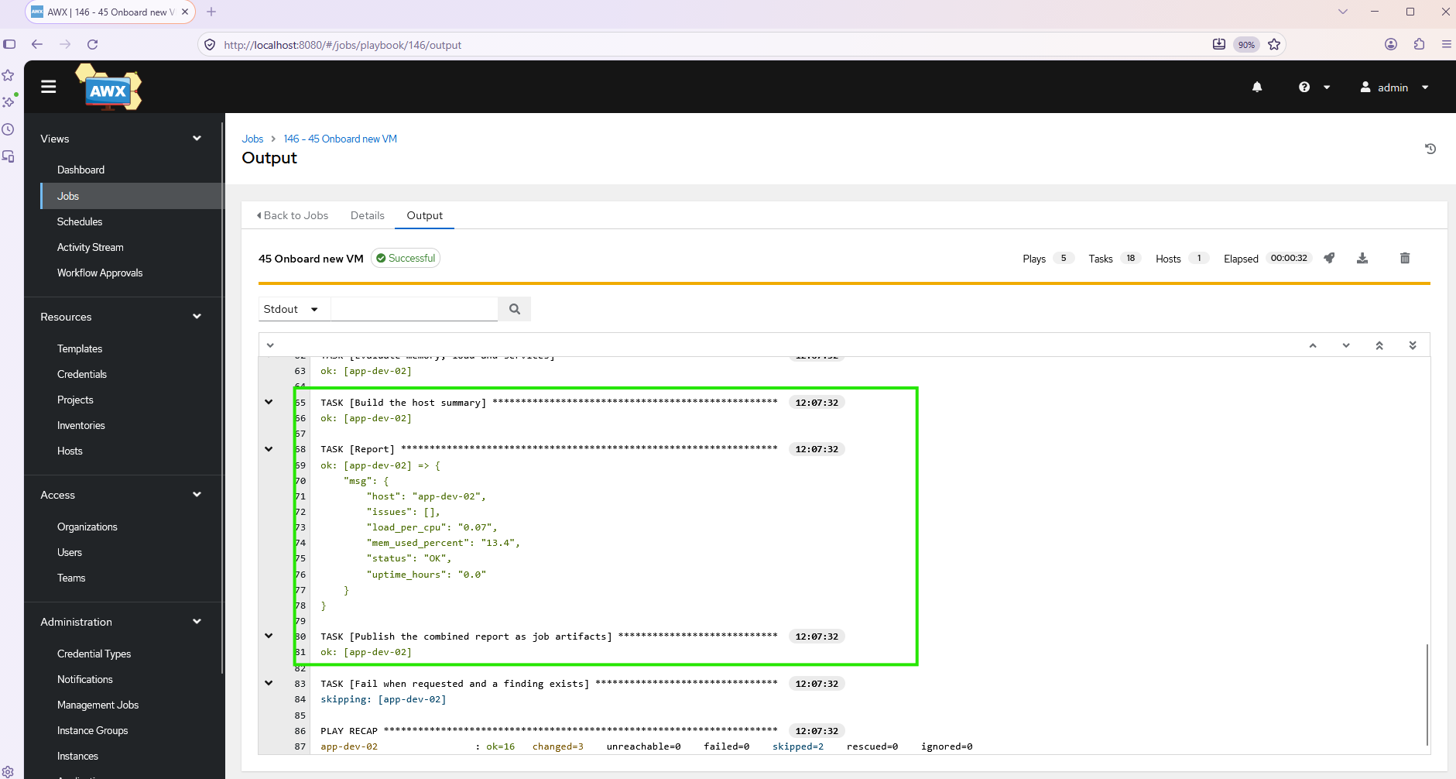

Phase 3a: lint and Molecule CI, CIS hardening role
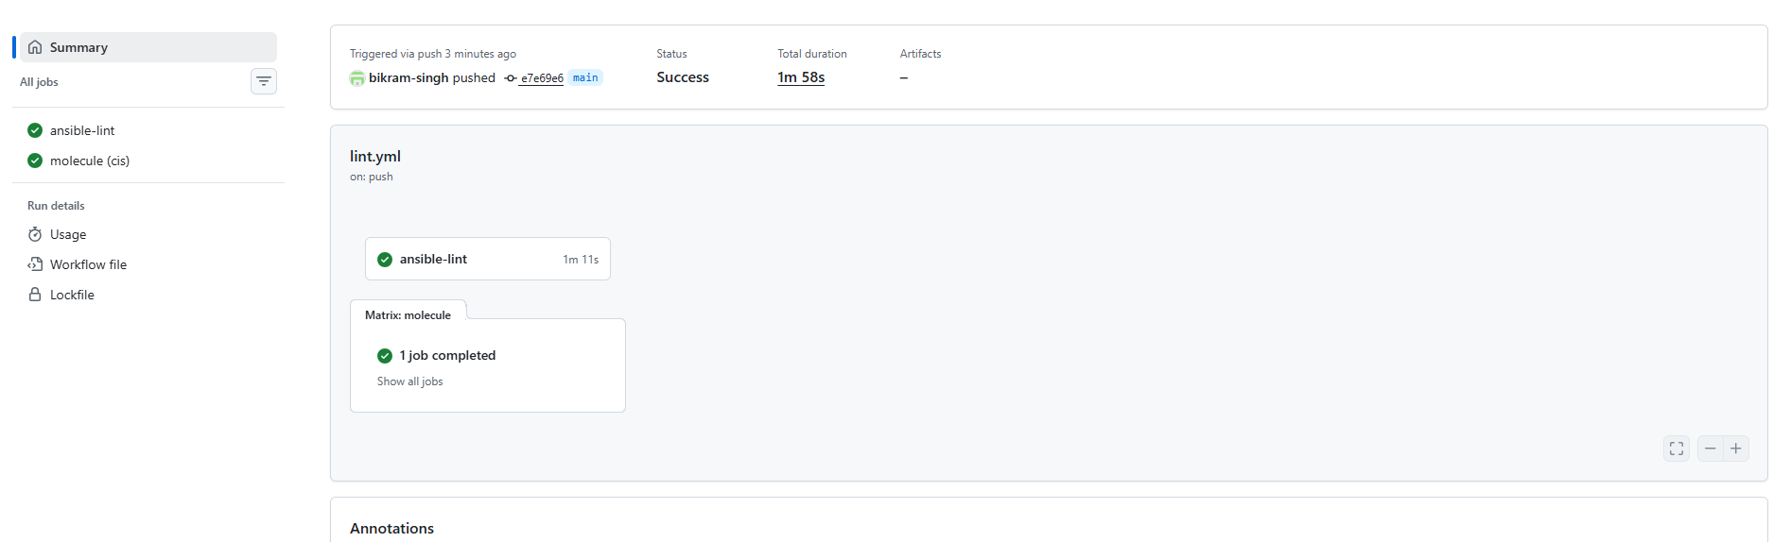
Next, test the hardening on the real VMs:
- Actions → ops-trigger → Run workflow:
  - template: 61 Harden Linux DEV (dry run)
  - limit: env_dev
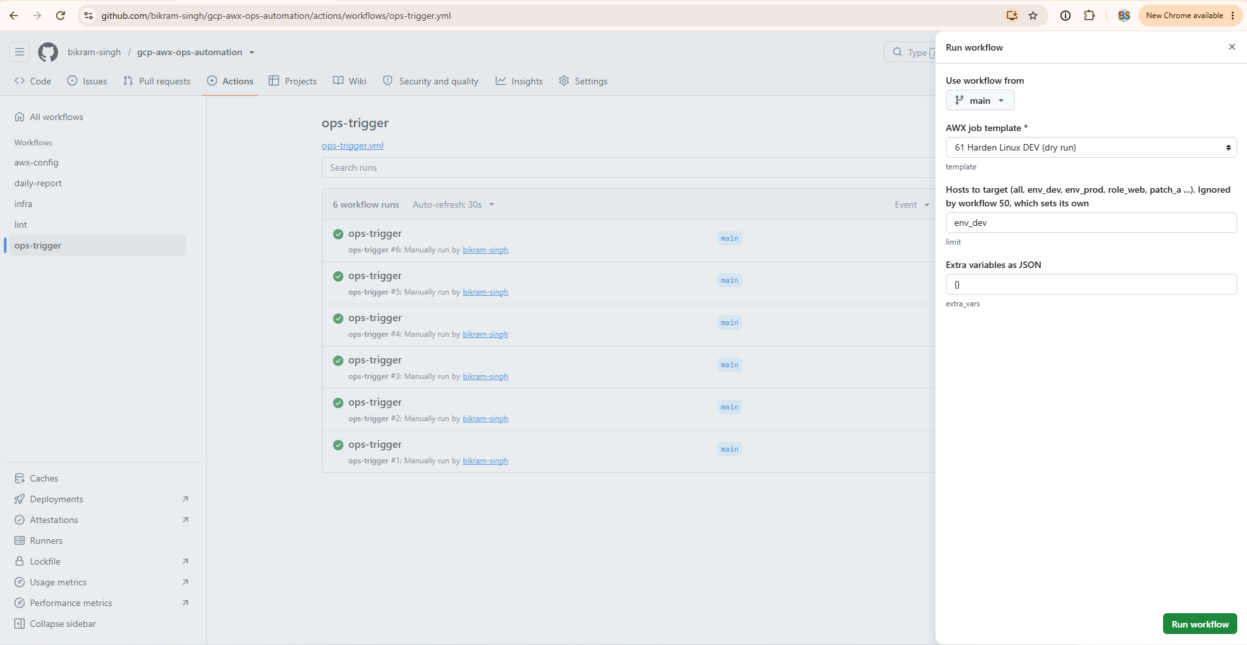

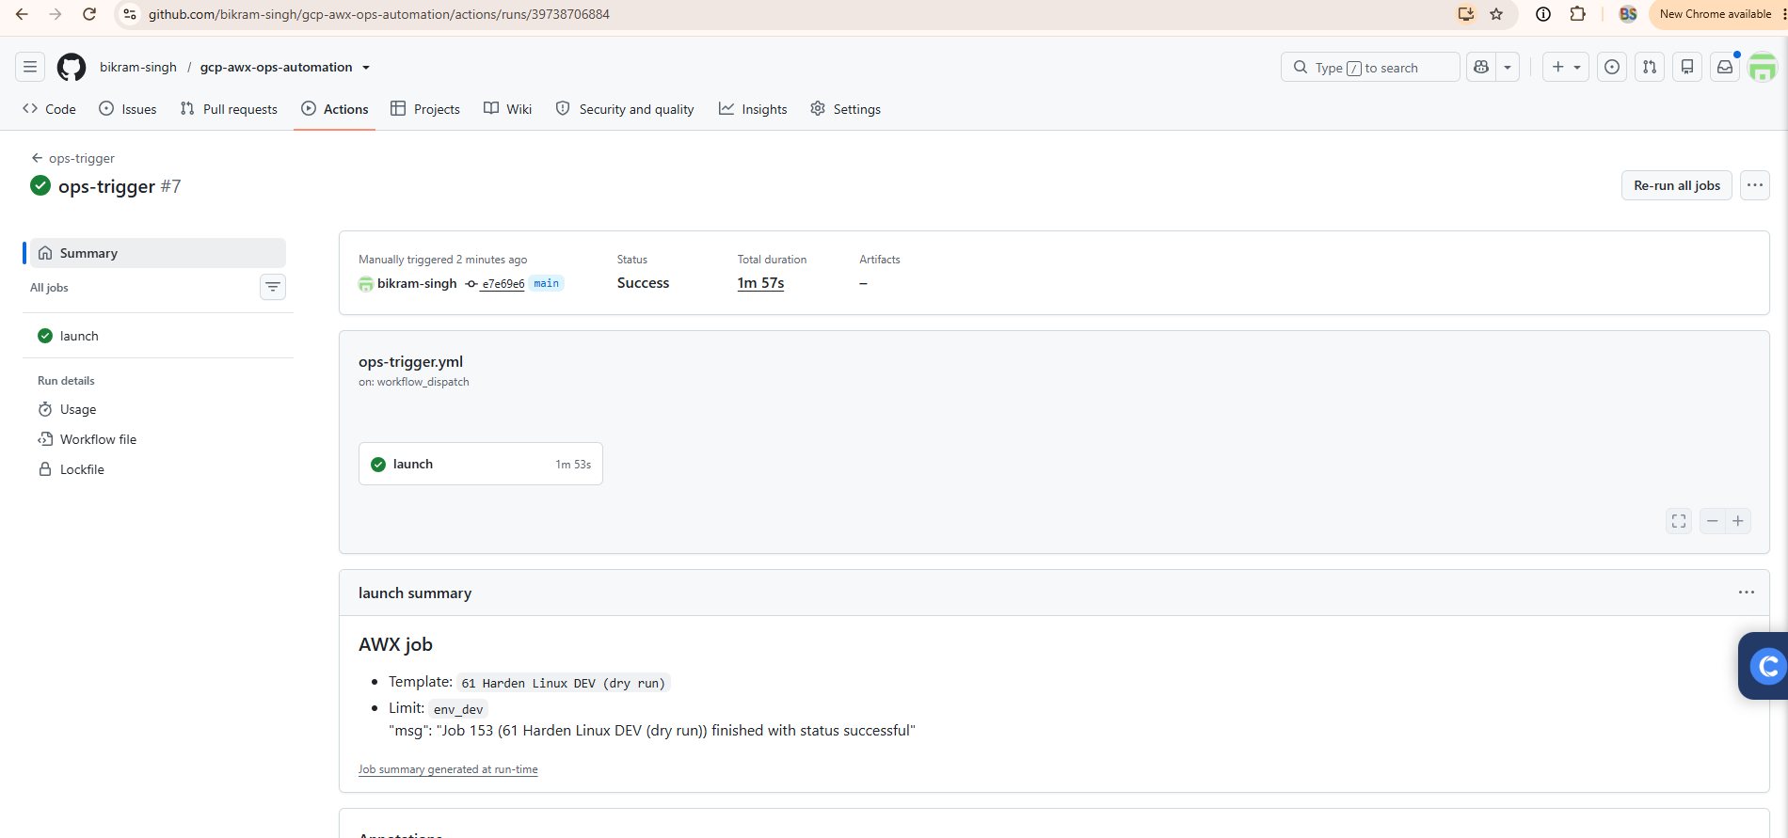
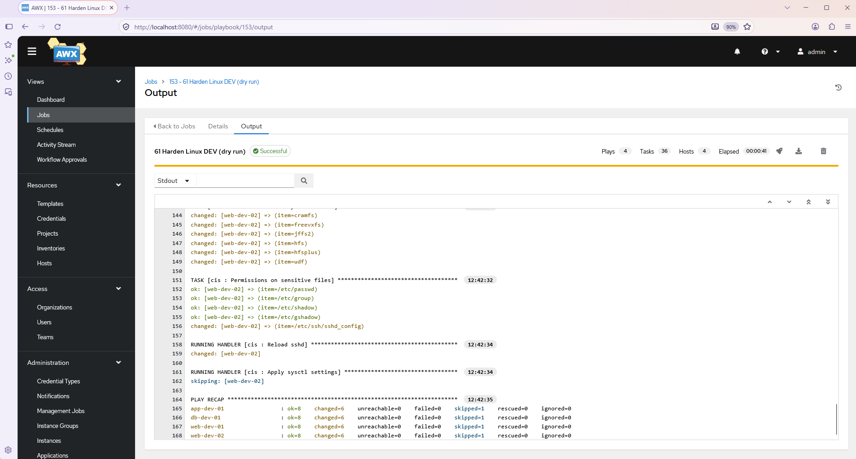
Now apply it for real:
- Actions → ops-trigger → Run workflow, with template 60 Harden Linux (CIS baseline) and limit env_dev. Approve the production environment if it asks.
- When it’s green, run 00 Connectivity check on env_dev to prove AWX can still log in after the hardening.
- Run 60 again on env_dev. Every host should show changed=0.
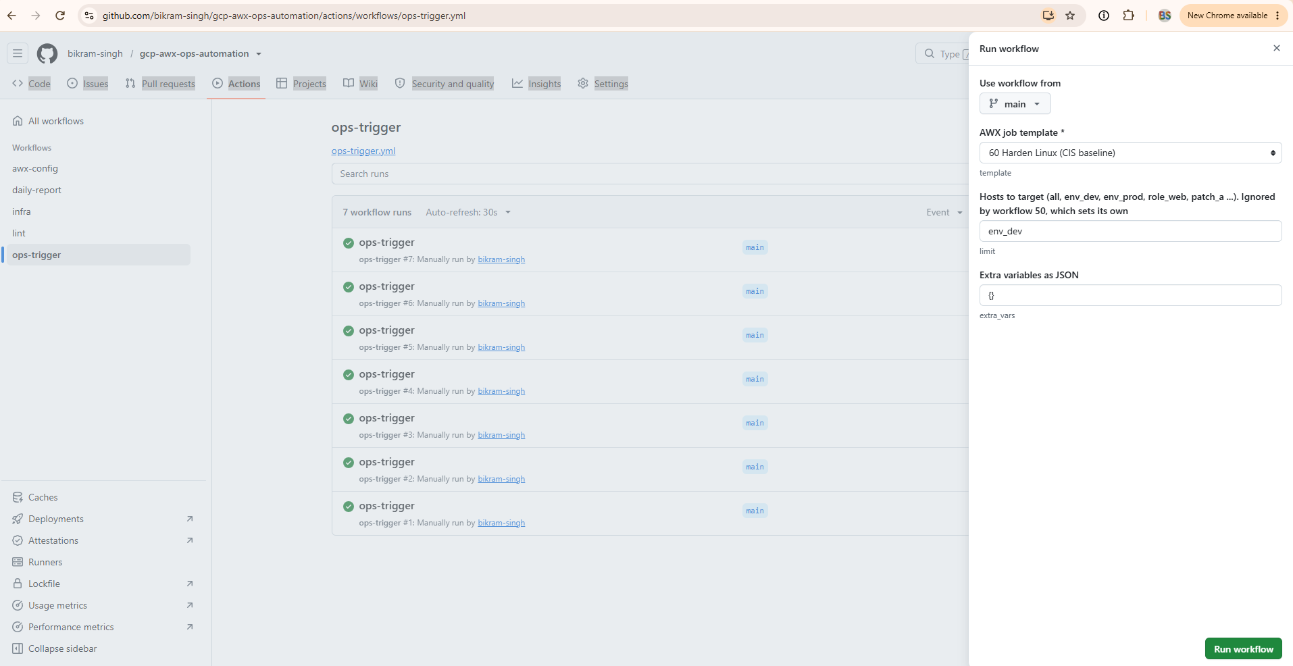
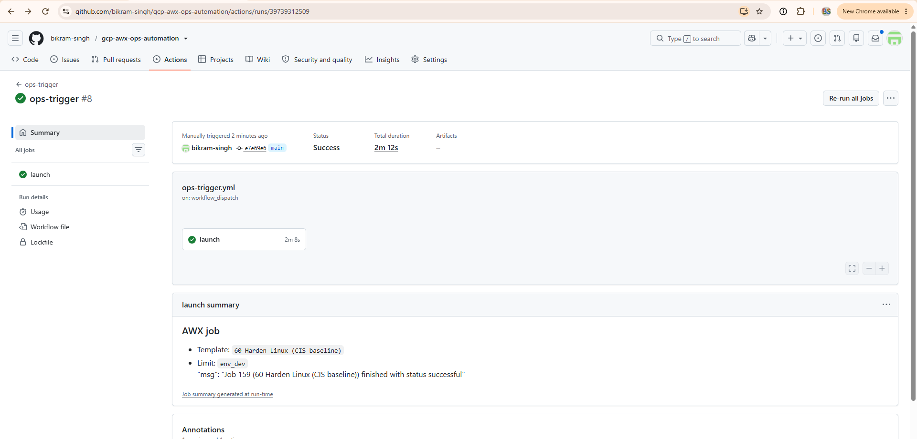
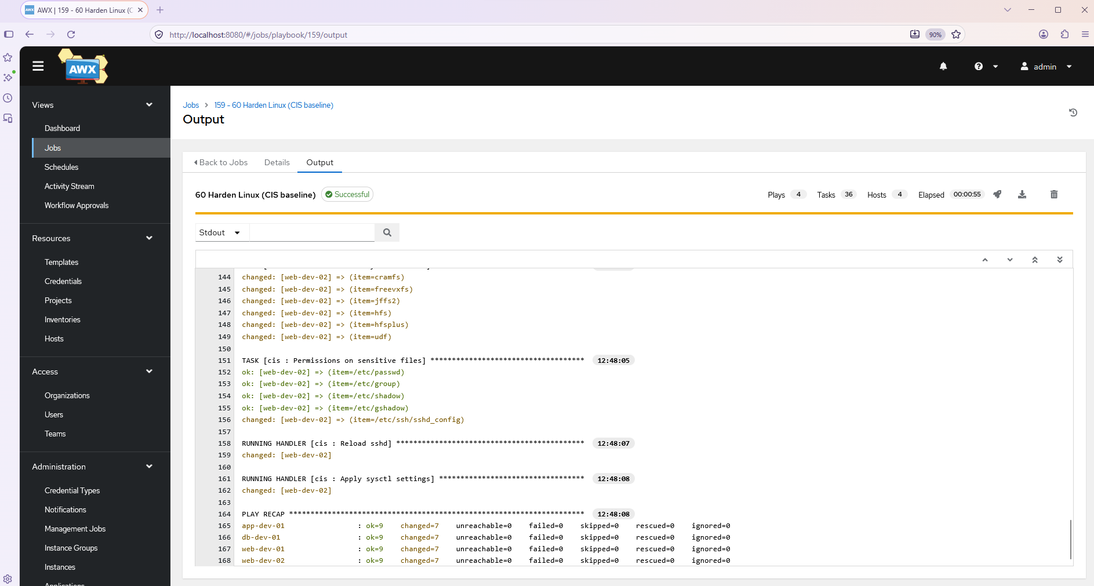
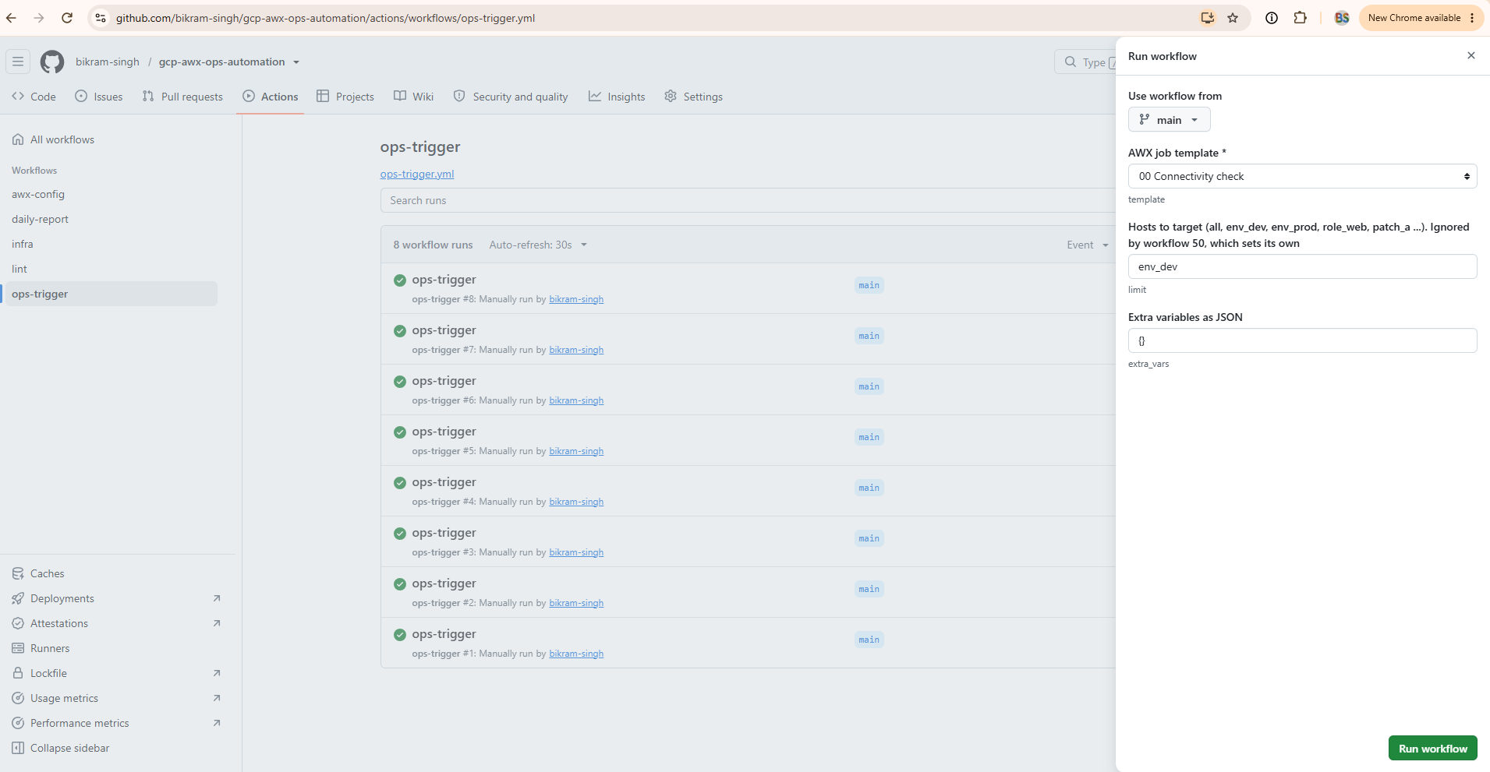
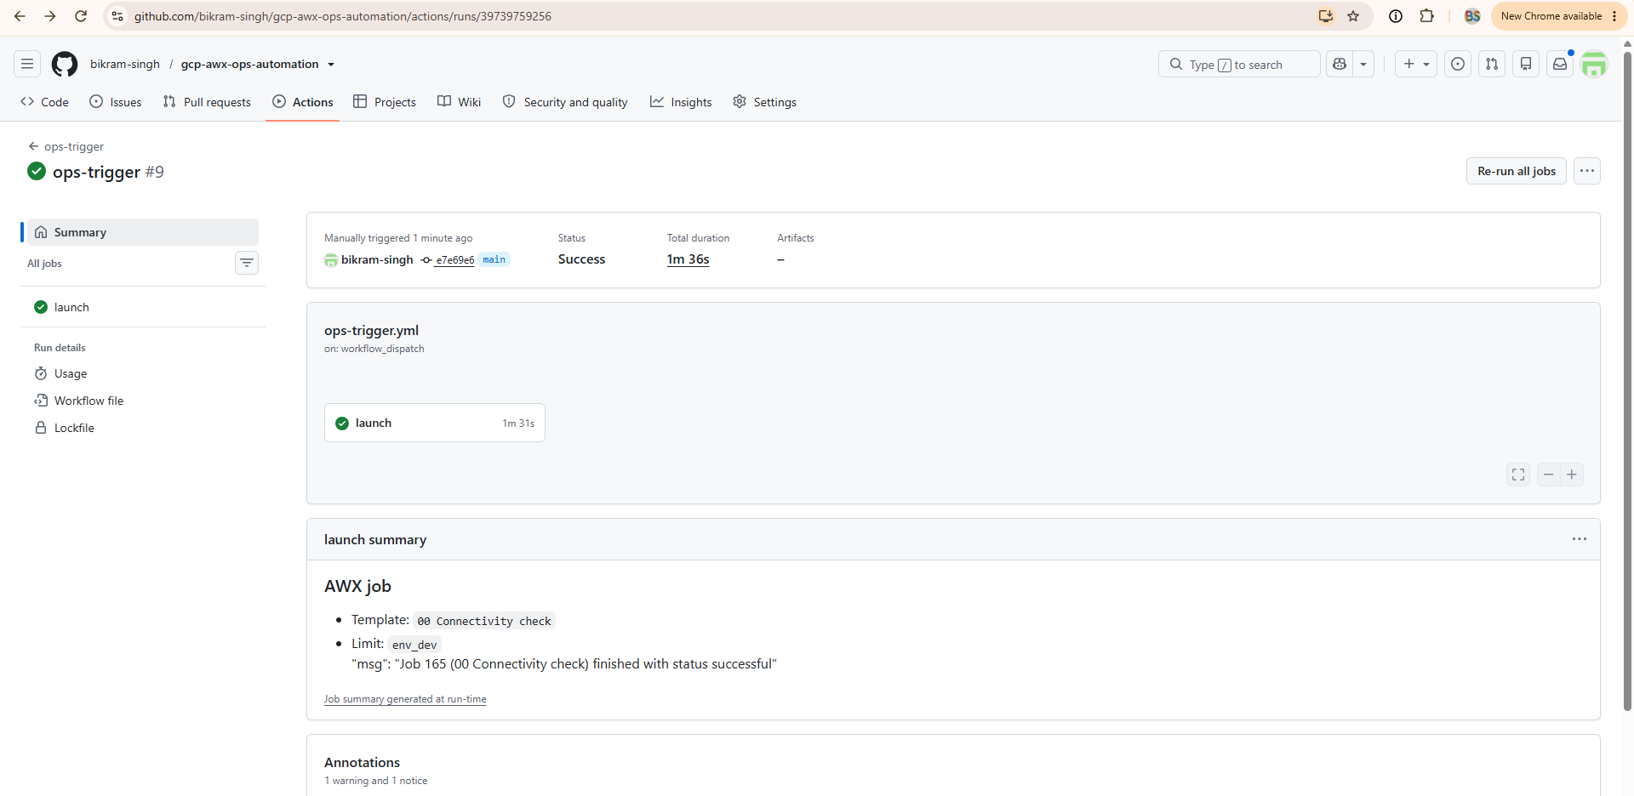
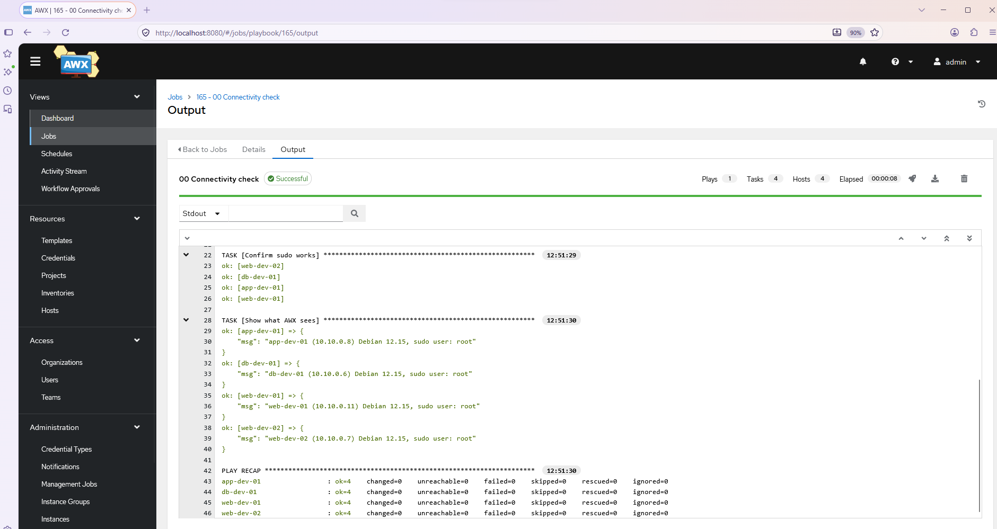
Apply it to prod.
