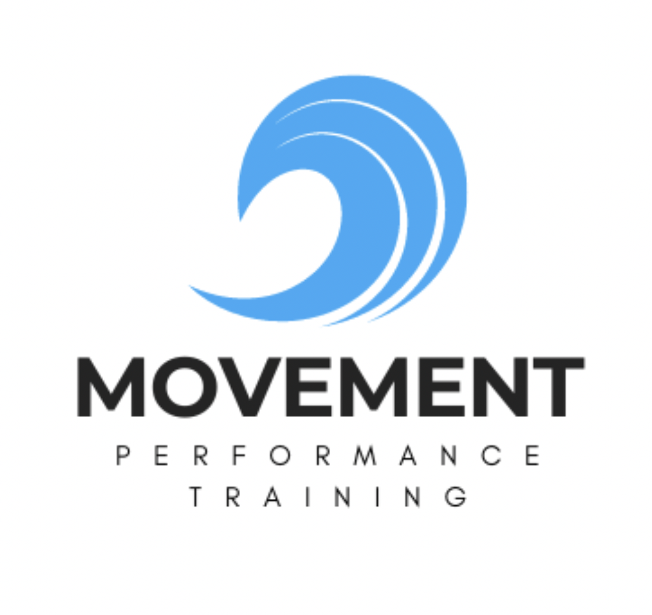

The Windsport Mobility Method

Unlocking Athletic Freedom for Kitesurfers & Wingfoilers

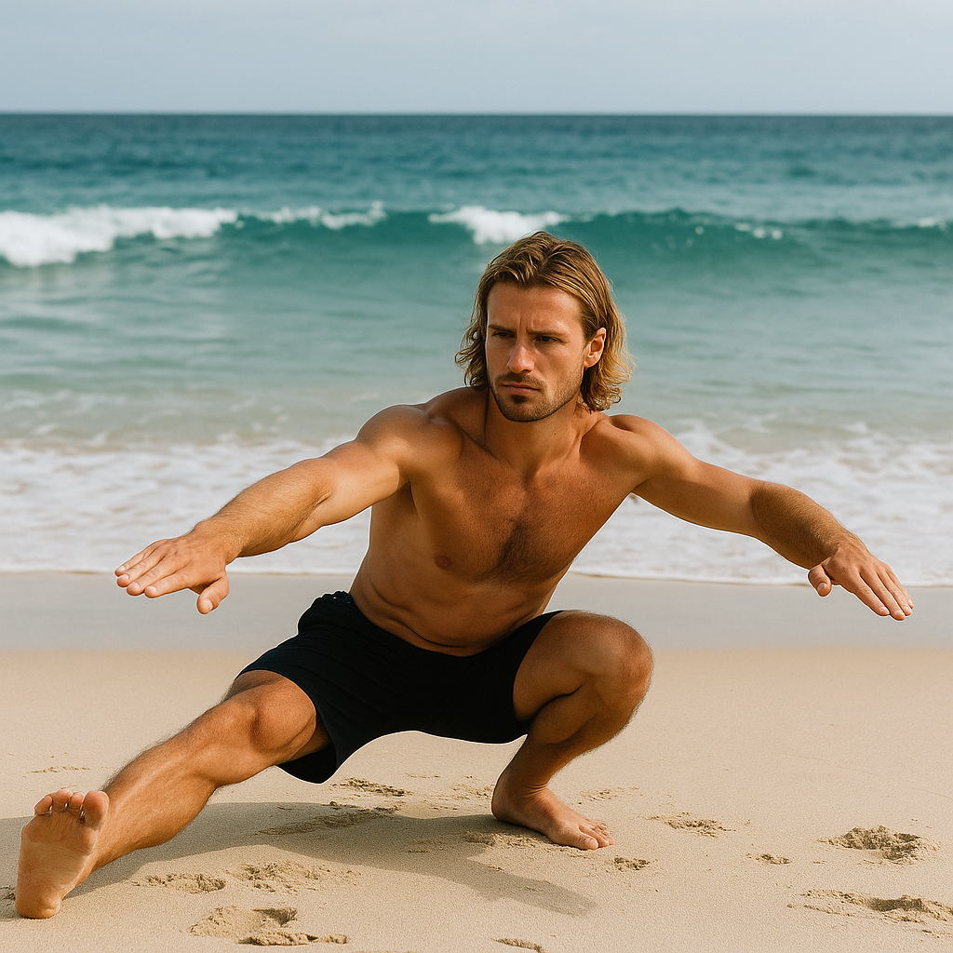
Cossack Squats

INTRODUCTION
- - - - X

Mobility is the foundation of high performance in wind sports like kitesurfing and wing foiling. The dynamic and unpredictable nature of wind and waves demands a body that moves efficiently, recovers quickly, and stays injury resilient. This eBook is designed to help you develop next-level joint mobility, kinetic control, and tissue resilience through science-backed training.
Whether you're carving waves, throwing jumps, or chasing a new trick, your ability to move with strength and freedom determines how far you can push your performance.

“
Your mobility is your access point to performance, power, and play.
Chloe Barret
”

TABLE OF CONTENTS
- - - - X

- Understanding Mobility for Windsports
- Assessment: Where Are You Now?
- The Mobility Training Pyramid
- Mobility for Shoulders & Thoracic Spine
- Hip Function for Rotational Power
- Ankles, Knees & Ground Reaction Control
- Breathwork & Core Integration
- Pre-Session Primers
- Post-Session Recovery Protocols
- 4-Week Windsport Mobility Program
- Strength & Conditioning for Windsport Athletes
- Visual Exercise Guide
- Download the eBook & Join Our Training Community

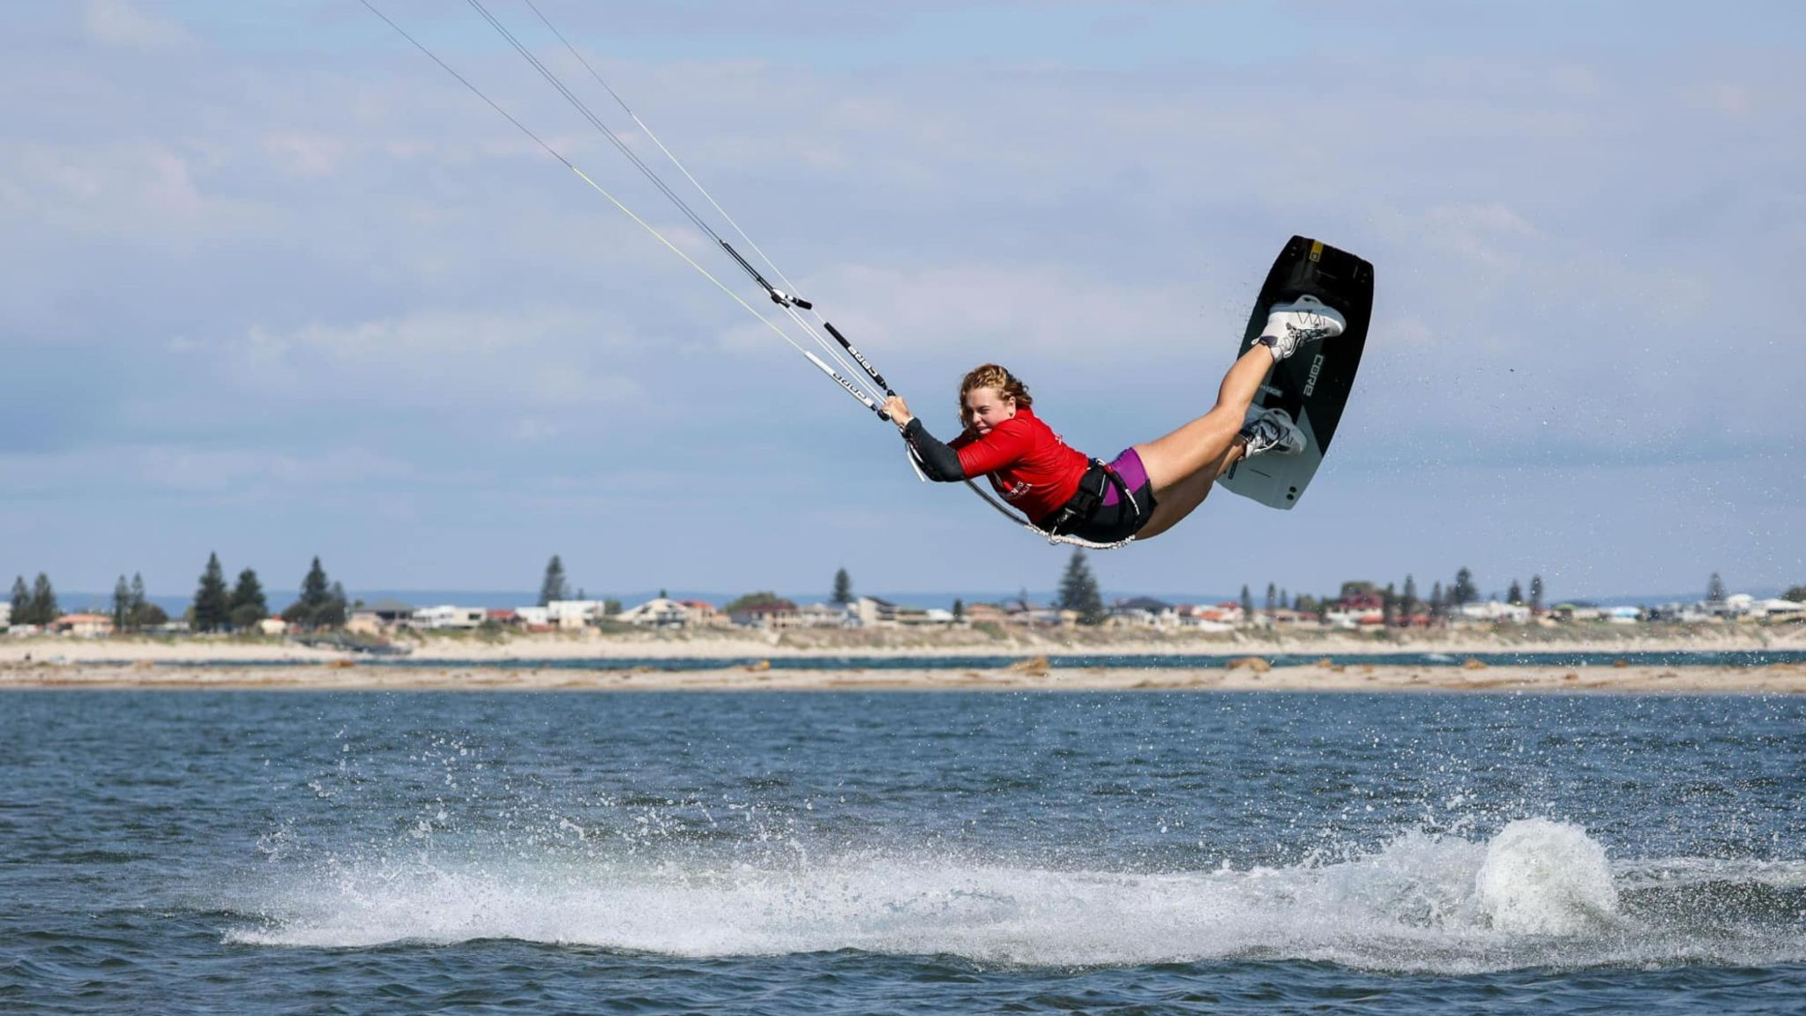
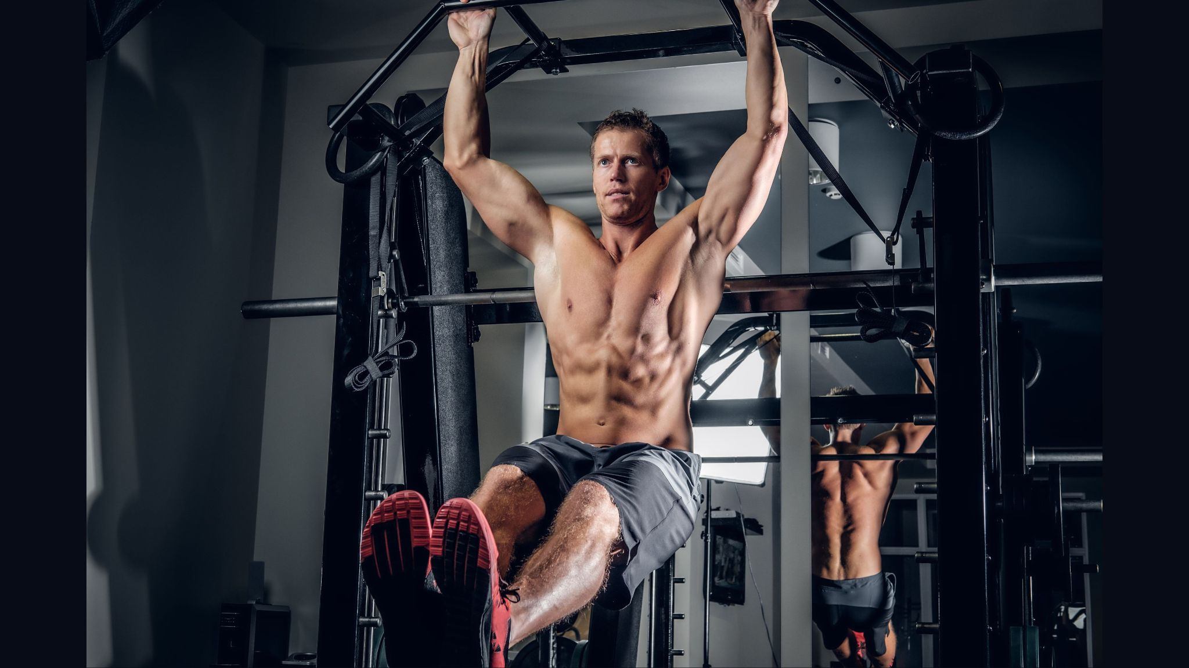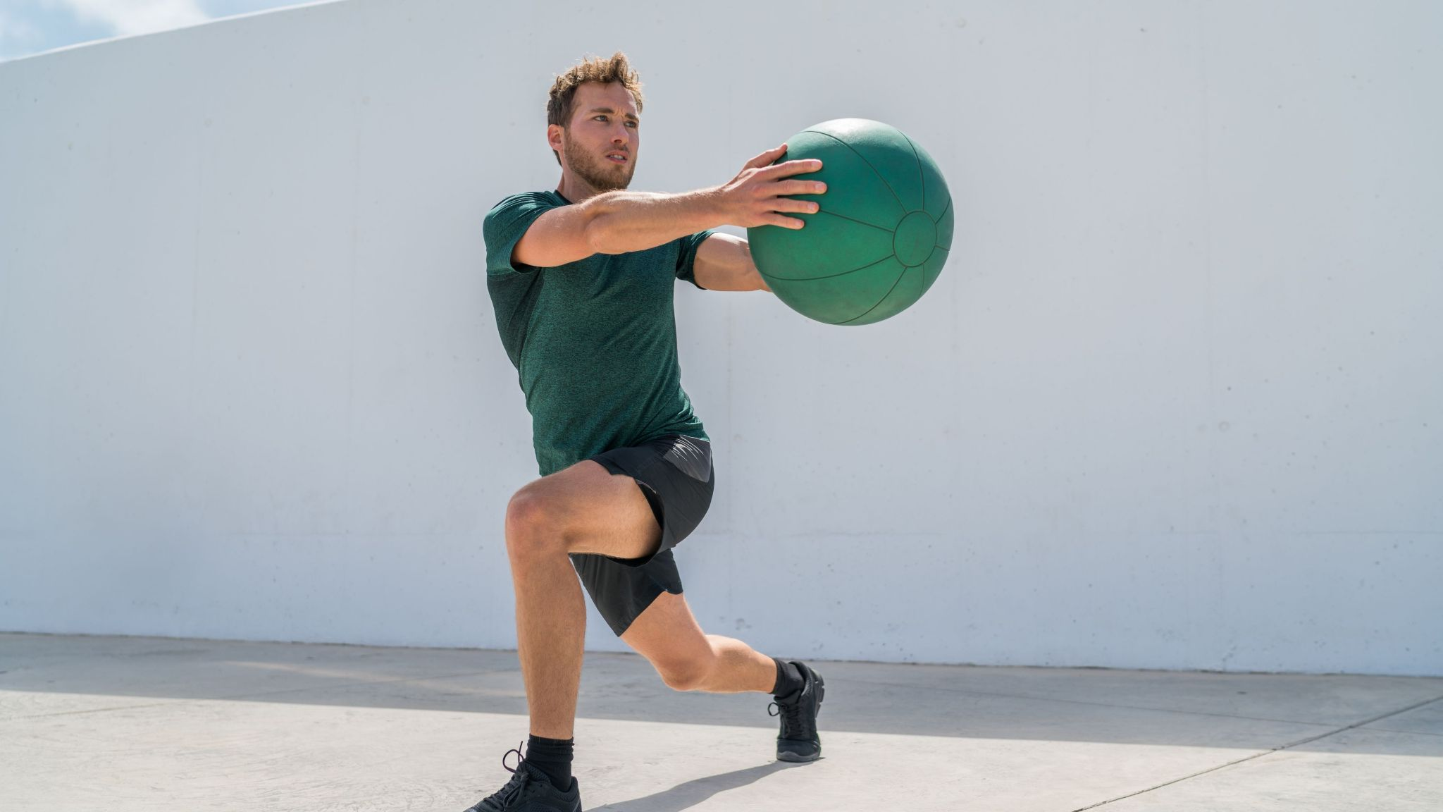
Mobility and strength are the pillars of performance

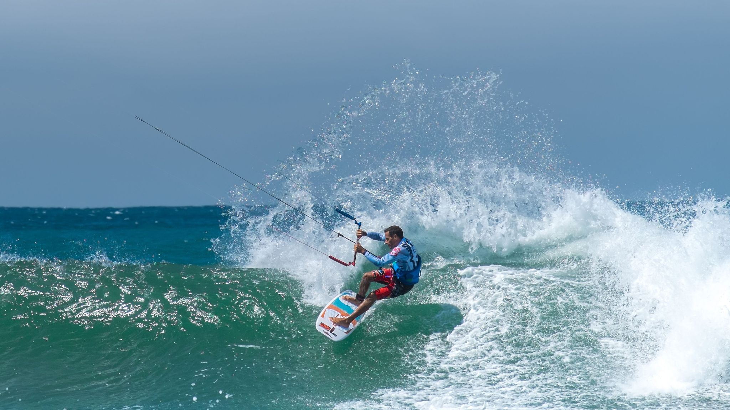
Carving waves on a kite

1. UNDERSTANDING MOBILITY FOR WINDSPORTS
- - - - X

Mobility isn’t just flexibility. It’s active, controlled range of motion—your ability to access and stabilize joints under load or in dynamic movement.
Windsport athletes rely on mobility for:
- Rotational control during jumps and turns
- Shoulder range for kite, wing or paddle control
- Hip and ankle mobility for landing force absorption


Mobility and strength are the pillars of performance
1. ASSESSMENT: WHERE ARE YOU NOW?
Test these key movement patterns:
- Overhead Shoulder Flexion Test
- Seated 90/90 Hip Rotation Test
- Deep Squat with Arms Overhead
Mobility Test Scorecard Template:
Test | Pain (Y/N) | Symmetry (1–5) | Control (1–5) | Restrictions
Shoulder Flexion
90/90 Rotation
Deep Squat
Rate on control, range, and comfort. Retest in Week 4.

3. THE MOBILITY TRAINING PYRAMID
- Tissue Quality – Self-myofascial release
- Joint Range of Motion – Active/passive stretching
- Neuromuscular Control – Patterning and stability
- Integration – Into sport-specific demands

4. MOBILITY FOR SHOULDERS & THORACIC SPINE
Goal: Improve kite handling, reduce shoulder impingement risk.
Exercises & Instructions:
- Bretzel Stretch: Lie on side, top knee to floor, rotate upper back; hold 30s/side.
- Shoulder CARs: Controlled shoulder circles through full ROM, 3 reps/side.
- Wall Slides w/ Band: Back against wall, glide arms up and down with tension.
- Thoracic Extensions: Foam roller under T-spine, extend gently over roller.

5. HIP FUNCTION FOR ROTATIONAL POWER
Goal: Create powerful rotation and landing stability.
- 90/90 Hip Switches: Flow between 90/90 seated positions, 10 reps.
- Copenhagen Stretch: Inner thigh stretch using bench, 30s/side.
- Glute Bridge with March: March from bridge position without dropping hips.
- Rotational Lunge to High Knee: Rotate at hips through lunge → drive knee up.

6. ANKLES, KNEES & GROUND REACTION CONTROL
Goal: Improve shock absorption, single-leg stability.
- Banded Dorsiflexion Glides: Mobilize ankles actively with resistance band.
- Heel-Elevated Squat Hold: Use plate under heels, hold deep squat 30s.
- Lateral Step-Throughs: Side step and drive knee up across body.
- Single-Leg Balance with Rotation: Stand on one leg, rotate arms across body.

7. BREATHWORK & CORE INTEGRATION
Goal: Stabilize trunk for performance and protect the spine.
- Diaphragmatic Breathing: Supine, one hand on chest/abdomen, breathe through diaphragm.
- Deadbugs: Maintain lumbar position, opposite arm/leg extend.
- Bear Crawl w/ Exhale: 90° knees/hips, crawl while exhaling on each move.
- Pallof Press: Press resistance band from chest, hold, control rotation.

8. PRE-SESSION PRIMERS (5–10 min Flow)
- World's Greatest Stretch
- Scapular Push-Ups
- Hip Airplanes
- Dynamic Cossack Squats

9. POST-SESSION RECOVERY
- Foam Rolling: Quads, Lats, Glutes, 1–2 min/area.
- Hip Distractions: Use band to traction joint.
- Box Breathing: 4-4-4-4 rhythm for 3–5 min.
- Legs Up Wall: Parasympathetic reset post-session.

10. 4-WEEK WINDSPORT MOBILITY PROGRAM
Week | Focus | Frequency
1 | Assessment + Fundamentals | 3x/week
2 | Shoulder + Hip Control | 4x/week
3 | Integrated Mobility Flows | 4x/week
4 | Pre/Post + Retest | 3–5x/week
Strength Integration (2x/week)
- Week 1: Goblet Squats, Rows, Bird Dogs
- Week 2: Landmine Rotation, Split Squat, Hollow Hold
- Week 3: Deadlift, Scap Push-Up, Carries
- Week 4: Clean & Press, Step Ups, Anti-Rotation Press

11. STRENGTH & CONDITIONING FOR WINDSPORT ATHLETES
Build usable strength with purpose-driven structure:
S&C Pillars:
- Rotational Power – MB slams, landmine twists
- Unilateral Strength – Bulgarian splits, single-leg RDLs
- Posterior Chain – Deadlifts, glute bridges, Nordic curls
- Shoulder Strength – Bottoms-up press, YTWs
- Plyometrics – Broad jump, pogo hops, bounds
Sample Weekly Flow:
- Mon: Strength (Lower) + Mobility
- Tue: Breath + Recovery
- Wed: Strength (Upper) + Mobility
- Thu: Plyo Flow + Core
- Fri: Sport Session
- Sat: Full Body + Core
- Sun: Off / Breathwork

12. VISUAL EXERCISE GUIDE
(Embed the following images or illustrations):
- 90/90 Hip Switch
- Bretzel Stretch
- Shoulder CARs
- Dynamic Cossack Squat
- Banded Ankle Glides
- Bear Crawl w/ Exhale
- Landmine Rotation
- Single-Leg Deadlift
- Foam Rolling Lats/Glutes/Quads

13. DOWNLOAD + COMMUNITY ACCESS
Get lifetime access to: ✅ Full eBook (PDF/interactive)
✅ Movement tutorial video library
✅ “Surf-Ready Core” & “Rotation Primer” bonus programs
✅ Monthly calendars
✅ Private athlete support group
👉 [Insert Download URL or QR Code Here]

CONCLUSION
The difference between an average session and a personal best often comes down to how well your body moves. Commit to mobility as seriously as you commit to your riding. You’ll ride harder, recover faster, and reduce your injury risk.
Train smart. Move freely. Ride limitless.

