1. Simulations
   1. Initial conditions leading to convergence

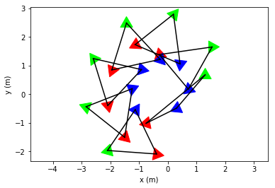

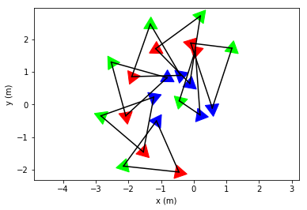

* 1. Initial conditions leading to collision

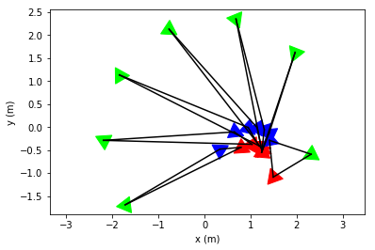

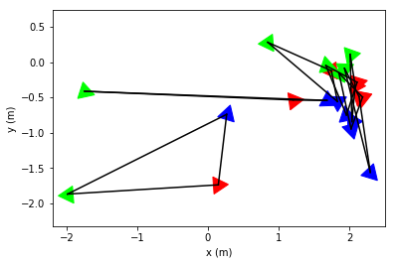

1. Problem Formulation (Formation Tracking)

**Assumption 1(a):** All robots can sense their absolute position w.r.t the global reference frame

**Assumption 1(b):** One robot (leader), can sense its absolute position w.r.t the global reference frame while the others (follower) cannot.

**Assumption 1(c):** No robot can sense its absolute position w.r.t the global reference frame.

**Assumption 2:** Each robot can sense the relative position of its neighboring agents (by means of laser range finder or spherical depth sensor).

**Problem 1:** Suppose assumptions 1(a) and 2 hold true.

**Problem 2:** Suppose assumptions 1(b) and 2 hold true.

**Problem 3:** Suppose assumptions 1(c) and 2 hold true.