Project Report on
OCTAPOD

Submission to the THE ROBOTICS CLUB as a part of INDUCTION'18

TEAM 3


THE ROBOTICS CLUB-SNIST
SREENIDHI INSTITUTE OF SCIENCE AND TECHNOLOGY
(AUTONOMOUS)
(Affiliated to JNT University, Hyderabad)
Yamnampet, Ghatkesar, Hyderabad – 501 301.
2018

CERTIFICATE

This is the project work titled OCTAPOD by N.Sanjana, B.SaiKiran, R.Rahul Reddy, Mohammed Abdulsami Shahid .
As the members of THE ROBOTICS CLUB-SNIST and is a record of the project work carried out by them during the year 2017-2018 as part of INDUCTION under the guidance and supervision of

Mr. Hari krishna Mr. M Tabish
Technical Head Technical Head

Ms. V.Manasa Reddy
The President of THE ROBOTICS CLUB

Dr. A. Purushotham
Technical Advisor
MechanicalDepartment

Declaration

This project work reported in the present thesis titled OCTAPOD is a record work done by Team 3 in THE ROBOTICS CLUB as a part of POST INDUCTION-18.
No part of the thesis is copied from books/ journals/ Internet and wherever the portion is taken, the same has been duly referred in the text. The report is based on the project work done entirely by TEAM 3 and not copied from any other source.

ACKNOWLEDGMENT

This project report is the outcome of the efforts of many people, who have driven our passion to explore into implementation of OCTAPOD. We have received great guidance, encouragement and support from them and have learned a lot because of their willingness to share their knowledge and experience.

We thank our Technical Heads Hari Krishna, M Tabish for being with us till the end of the project completion.
We thank the Executive Body of The Robotics Club for helping us in crucial parts of the project. We are deeply indebted to Ms. V Manasa Reddy, The President of THE ROBOTICS CLUB, Mr. Aditya Gupta, General Secretary of THE ROBOTICS CLUB and Mr. Sai Sandeep, Vice-President of THE ROBOTICS CLUB who spared their most valuable time without any hesitation whenever we wanted.

We also thank our Technical advisor Dr. A. Purushotham, Professor, Mechanical Department, who encouraged us during this project by rendering their help when needed.

Contents
List of figures 6
Abstract 7-8
- Introduction 9-10
  - Aim of the project 9
  - Introduction of the project 9
1.3 Literature survey 9
1.4 Organization of project 10

- Architecture 11-20
Mechanics part
2.1 SG90 Micro Servo motor 11-12
2.2 MG90S Micro servo motor 12-13
2.3 Jumper wires 13-14
2.4 Chassis 14

Electronics part
2.5 Arduino Mega 15-16
2.6 Adafruit PWM shield 16-17
2.7 LM2596 voltage regulator 17
2.8 Lithium polymer battery 18-19
Programming part
2.9 Software description 20

- Implementation and working 21-22
    - Block diagram 21
    - Circuit diagram 21
3.3 Working 22

Chapter 4 Experimental results and conclusion
4.1 Results 25
4.2 Future enhancement 25
4.3 Conclusion 25

Appendix A Source code 23-24
Appendix B Bill 26
List of Figures

Figure No. Description Page No.
Fig 2.1.1 SG90 Micro Servo 11
Fig 2.1.2 SG90 Micro Servo 11
Fig 2.2.1 MG90S Micro Servo 12
Fig 2.2.2 MG90S Micro Servo 13
Fig 2.3.1 Jumper wires 14
Fig 2.4.1 Chassis 14
Fig 2.5.1 Arduino Mega 15
Fig 2.6.1 Adafruit PWM Shield 16
Fig 2.7.1 LM2596 voltage regulator 17
Fig 2.8.1 Lithium Polymer battery 18
Fig 3.1.1 Block diagram 21
Fig 3.2.1 Circuit diagram 21

Abstract
INDUCTION’18
TEAM NO 3
OCTAPOD
ABSTRACT:
This paper introduces a new octapod ,eight legged walking robot which can perform basic functions like crawling forward and backward . Octapods are extension to hexapods which are used where stability and flexibility are demanded . The legs will have three degrees of freedom each. This robot uses the modular design method , PWM to control motor speed ,bus to control motor, gait program to control the robot motion , wireless data transmission to control the robot’s gait. As the robot has six limbs, the robot can be easily programmed to configure many types of gait such as tripod, quadrapod . The robotic locomotion and image acquisition is based on the algorithms fed to the controller.

INTRODUCTION:
Octapod robot is one of the most statically stable and possess a great flexibility while standing or moving due to its movement using eight legs that can be easily manipulated. This robot is biologically inspired from the behaviour of an insect with eight legs(spider).The design process involved in developing the body and arms of the robot has higher level of difficulty. The octapod robot has, by definition eight legs, This gives it the ability to move flexibly across various terrain and does not require any balancing mechanisms to stand upright. However the robot’s static stability margin is not optimum. Nevertheless, a octapod configuration using alternating tripods has been chosen just to try to increase the machine’s speed, slightly jeopardizing stability; legs with powerful micro servomotors are chosen over other types as they can withstand heavy loads.

METHODOLOGY:
Once the robot is powered the Arduino sends signals to the PWM shield to give a go signal for the switching of the motors and the sequence of directional movements is based on the algorithm feed into the microcontroller.

BLOCK DIAGRAM:
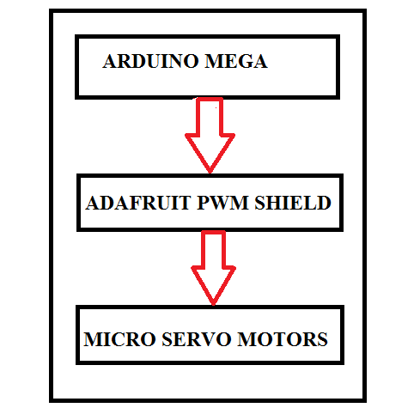
CAD MODEL

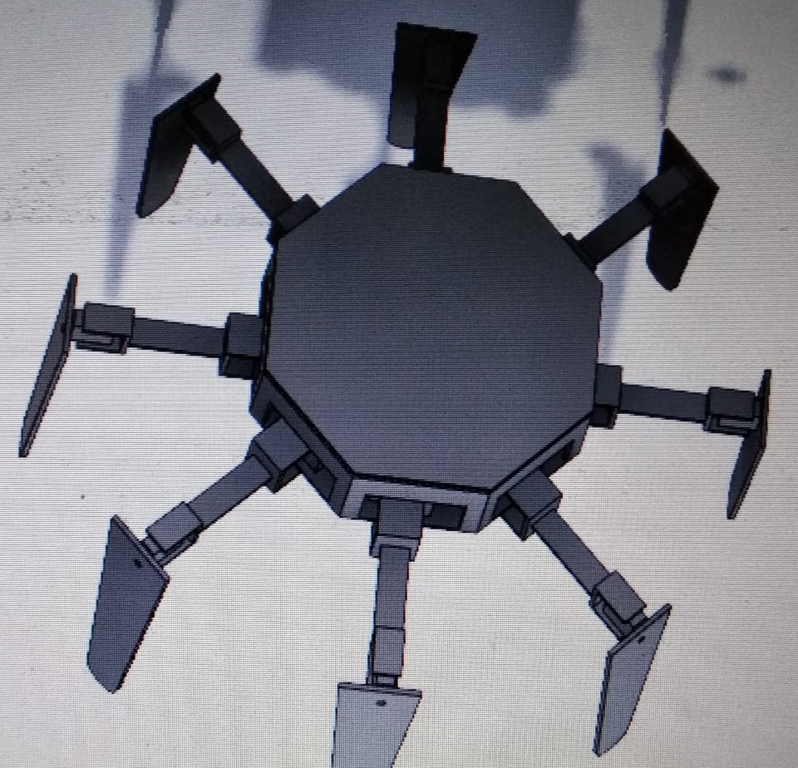

CHAPTER 1
INTRODUCTION

  - AIM OF THE PROJECT:
To make a biomimiced robot named OCTAPOD similar to grounded spider(movement).

  - INTRODUCTION TO PROJECT:
Octapod robot is one of the most statically stable and possess a great flexibility while standing or moving due to its movement using eight legs that can be easily manipulated. This robot is biologically inspired from the behaviour of an insect with eight legs(spider).The design process involved in developing the body and arms of the robot has higher level of difficulty. The octapod robot has, by definition six legs, This gives it the ability to move flexibly across various terrain and does not require any balancing mechanisms to stand upright. However the robot’s static stability margin is not optimum. Nevertheless, a octapod configuration using alternating tripods has been chosen just to try to increase the machine’s speed, slightly jeopardizing stability; legs with powerful micro servomotors are chosen over other types as they can withstand heavy loads.

  - LITERATURE SURVEY:

The idea to make a octapod was inspired from a hexapod which is used in automobile servicing showroom when we visited that place. The name was then derived from the hexa(meaning 6) so named it as octa(meaning 8).The robot has many physical applications and can be modified to use it in many other fields.Two main targets to focus on was that the bot should have surface contact with legs and legs should bear the load of bot. keeping in mind to maintain the minimal weight and flexibility ands maximum density we used the plastic material which was cheap and best for us .
We have selected the modules and parts not to be efficient but to go with the new technology and we also planned it in a minimal budget.

  - ORGANISATION OF THE PROJECT:

The OCTAPOD can be broadly organized by considering 3 major parts of the robot.
1. MECHANICAL PART: It includes all the mechanical components such as the motors, material, Jumper wires.
2. ELECTRONICS PART: It includes electronic IC’s and devices such as Arduino mega, Arduino nano, Adafruit PWM shield,
3. PROGRAMMING PART: It includes the code for interfacing micro servos with PWM shield and that to the Arduino mega .

CHAPTER 2
ARCHITECTURE

MECHANICAL PART:
2.1 SG 90 MICRO SERVO

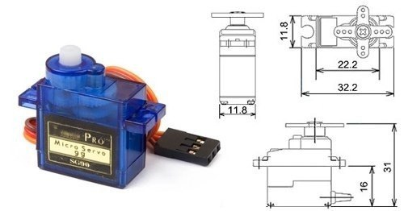
FIG 2.1.1

Tiny and lightweight with high output power. Servo can rotate approximately 180 degrees (90 in each direction), and works just like the standard kinds but smaller. You can use any servo code, hardware or library to control these servos. Good for beginners who want to make stuff move without building a motor controller with feedback & gear box, especially since it will fit in small places. It comes with a 3 horns (arms) and hardware.
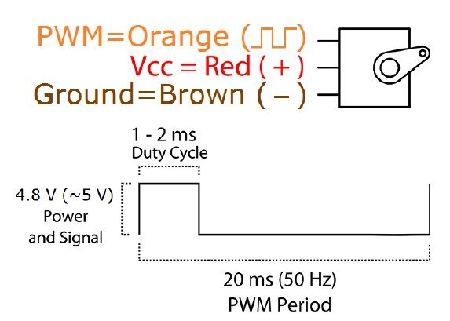

Fig 2.1.2

Specifications
• Weight: 9 g
• Dimension: 22.2 x 11.8 x 31 mm approx.
• Stall torque: 1.8 kgf·cm
• Operating speed: 0.1 s/60 degree
• Operating voltage: 4.8 V (~5V)
• Dead band width: 10 µs
• Temperature range: 0 ºC – 55 ºC

2.2 MG90S MICRO SERVO

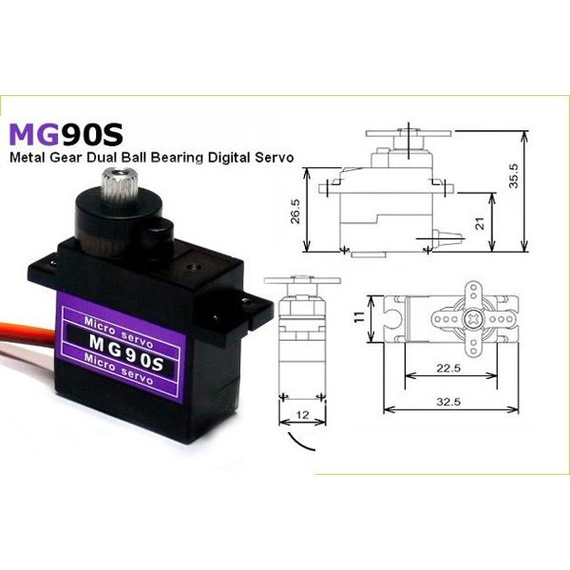
Fig 2.2.1
Tiny and light weight with high output power, this tiny servo is RC airplane, helicopter, quadcopter and robot. This servo has metal gears for added strength and durability.

Servo can rotate approximately 180 degrees ( 90 degrees in each direction), and works just like the standard kinds but smaller. You can use any servo code, hardware or library to control these servos. Good for beginners who want to make stuff move without building a motor controller with feedback & gear box, especially since it will fit in small places. It comes with a 3 horns (arms) and hardware.

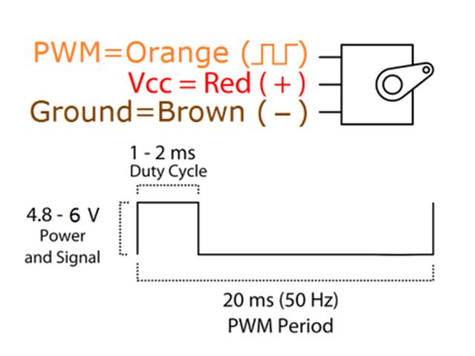

Fig 2.2.2

Specifications
• Weight: 13.4 g
• Dimension: 22.5 x 12 x 35.5 mm approx.
• Stall torque: 1.8 kgf-cm (4.8V), 2.2 kgf-cm(6V)
• Operating speed: 0.1 s/60 degree (4.8 V), 0.08 s/60 degree (6V)
• Operating voltage: 4.8 V – 6V
• Dead band width: 5 µs
• Temperature range: 0 ºC – 55 ºC

2.3 JUMPER WIRES:
A jump wire (also known as jumper, jumper wire, jumper cable, DuPont wire, or DuPont cable – named for one manufacturer of them) is an electrical wire or group of them in a cable with a connector or pin at each end (or sometimes without them – simply "tinned"), which is normally used to interconnect the components of a breadboard or other prototype or test circuit, internally or with other equipment or components, without soldering.
Individual jump wires are fitted by inserting their "end connectors" into the slots provided in a breadboard, the header connectorof a circuit board, or a piece of test equipment.
These jumper wires are used in the connection in the breadboards and generally these wires of three types
1. Male to Male
2. Female to Female
3. Male to Female

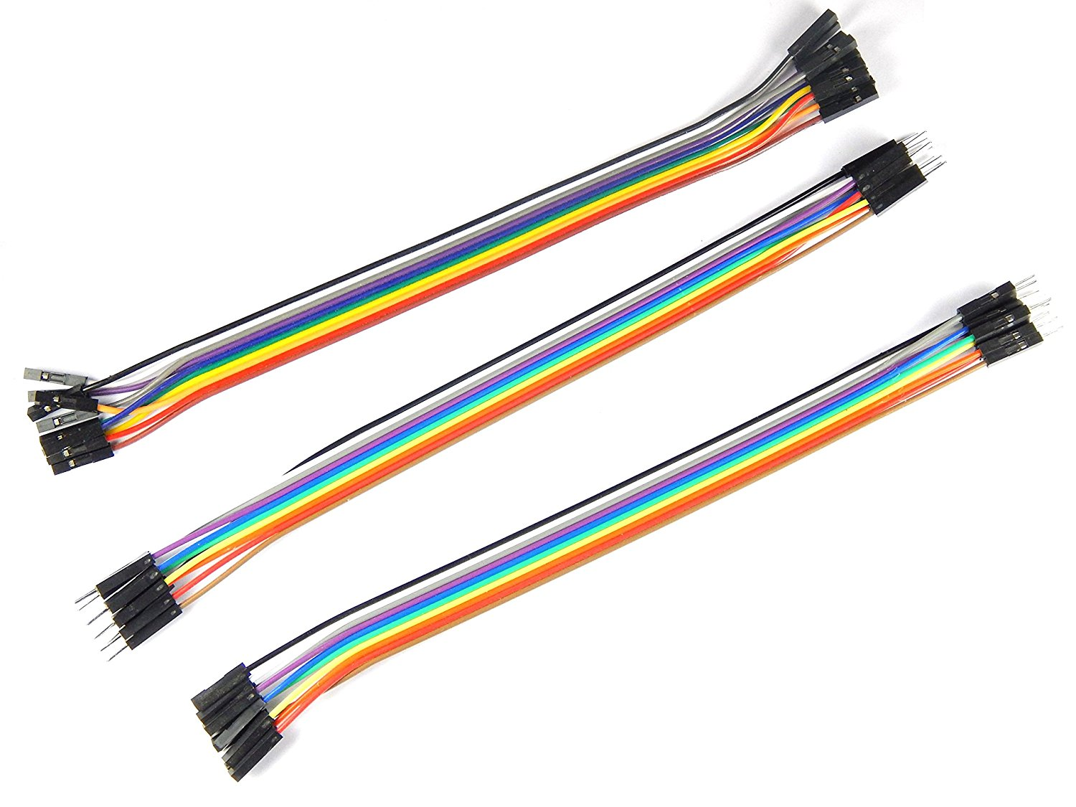
Fig 2.3.1

2.4 CHASSIS:
The framework that supports any robot, analogous to the skeleton of a human body is called chassis.
Made such that weight of the entire robot should be easily balanced and strong enough for the robot to traverse.
It is made up of PLA( plastic) material.

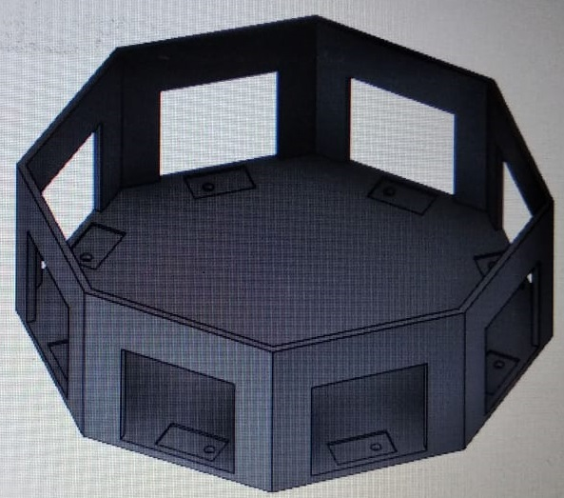
Fig 2.4.1
ELECTRONICS PART:
2.5 ARDUINO MEGA
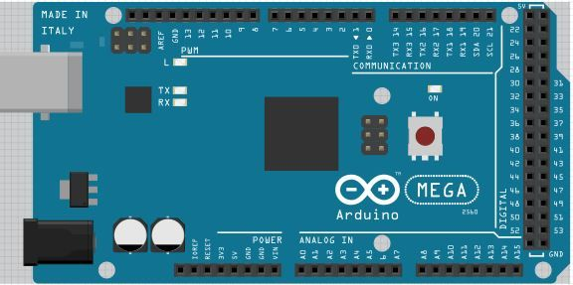
Fig 2.5.1
The Arduino Mega is a microcontroller board based on the ATmega1280 (datasheet). It has 54 digital input/output pins (of which 14 can be used as PWM outputs), 16 analog inputs, 4 UARTs (hardware serial ports), a 16 MHz crystal oscillator, a USB connection, a power jack, an ICSP header, and a reset button. It contains everything needed to support the microcontroller; simply connect it to a computer with a USB cable or power it with a AC-to-DC adapter or battery to get started. The Mega is compatible with most shields designed for the Arduino Duemilanove or Diecimila.

The Arduino Mega can be powered via the USB connection or with an external power supply. The power source is selected automatically. External (non-USB) power can come either from an AC-to-DC adapter (wall-wart) or battery. The adapter can be connected by plugging a 2.1mm center-positive plug into the board's power jack. Leads from a battery can be inserted in the Gnd and Vin pin headers of the POWER connector. The ATmega1280 has 128 KB of flash memory for storing code (of which 4 KB is used for the bootloader), 8 KB of SRAM and 4 KB of EEPROM (which can be read and written with the EEPROM library).

Specifications
Microcontroller | ATmega1280
Operating Voltage | 5V
Input Voltage (recommended) | 7-12V
Input Voltage (limits) | 6-20V
Digital I/O Pins | 54 (of which 15 provide PWM output)
Analog Input Pins | 16
DC Current per I/O Pin | 40 mA
DC Current for 3.3V Pin | 50 mA
Flash Memory | 128 KB of which 4 KB used by bootloader
SRAM | 8 KB
EEPROM | 4 KB
Clock Speed | 16 MHz

2.6 ADAFRUIT 16 CHANNEL PWM SHIELD
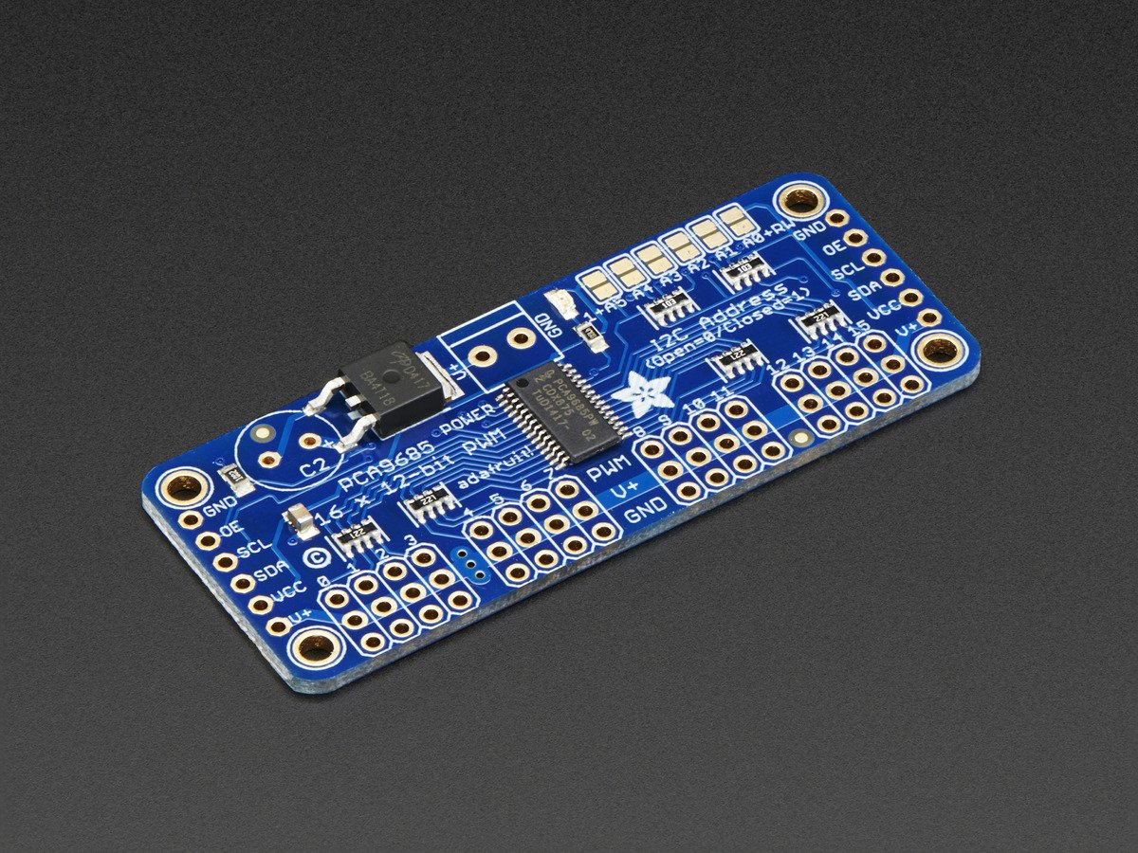
Fig 2.6.1
It is 16 channel 12 bit PWM motor driver/operator/shield.
It's an i2c-controlled PWM driver with a built in clock. That means that, unlike the TLC5940 family, you do not need to continuously send it signal tying up your microcontroller, its completely free running!.It is 5V compliant, which means you can control it from a 3.3V microcontroller and still safely drive up to 6V outputs (this is good for when you want to control white or blue LEDs with 3.4+ forward voltages).6 address select pins so you can wire up to 62 of these on a single i2c bus, a total of 992 outputs - that's a lot of servos or LEDs.Adjustable frequency PWM up to about 1.6 KHz.12-bit resolution for each output - for servos, that means about 4us resolution at 60Hz update rate.Configurable push-pull or open-drain output.Output enable pin to quickly disable all the outputs.
Specifications:
- Dimensions (no headers or terminal block) 2.5" x 1" x 0.1" (62.5mm x 25.4mm x 3mm)
- Weight (no headers or terminal block): 5.5grams
- Weight (with 3x4 headers & terminal block): 9grams
- This board/chip uses I2C 7-bit address between 0x40-0x7F, selectable with jumpers
2.7 LM2596 VOLATGE REGULATOR

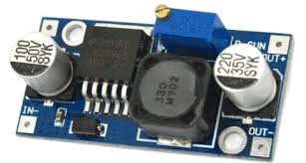
Fig 2.7.1

The LM2596 regulator is monolithic integrated circuit ideally suited for easy and convenient design of a step−down switching regulator (buck converter). It is capable of driving a 3.0 A load with excellent line and load regulation. This device is available in adjustable output version and it is internally compensated to minimize the number of external components to simplify the power supply design. Since LM2596 converter is a switch−mode power supply, its efficiency is significantly higher in comparison with popular three−terminal linear regulators, especially with higher input voltages. The LM2596 operates at a switching frequency of 150 kHz thus allowing smaller sized filter components than what would be needed with lower frequency switching regulators
Specifications

Input voltage: 4.5 – 40 V
Output voltage: 3.3 – 37V
Output current: 3 A
Regulated outputs: 1
Switching frequency: 110 – 173

2.8 LITHIUM POLYMER BATTERY

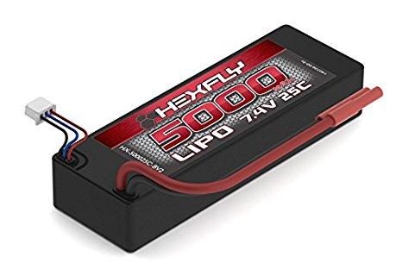

Fig 2.8.1

A lithium polymer battery, or more correctly lithium-ion polymer battery (abbreviated as LiPo, LIP, Li-poly, lithium-poly and others), is a rechargeable batteryof lithium-ion technology using a polymer electrolyte instead of a liquid electrolyte. High conductivity semisolid (gel) polymers form this electrolyte. These batteries provide higher specific energy than other lithium battery types and are used in applications where weight is a critical feature, like tablet computers, cellular telephone handsets and radio-controlled aircraft.

The voltage of a LiPo cell depends on its chemistry and varies from about 2.7-3.0 V (discharged) to about 4.2 V (fully charged), for cells based on lithium-metal-oxides (such as LiCoO₂), and around 1.8-2.0 V (discharged) to 3.6-3.8 V (charged) for those based on lithium-iron-phosphate (LiFePO₄). The exact voltage ratings should be specified in product data sheets, with the understanding that the cells should be protected by an electronic circuit that won't allow them to overcharge nor over-discharge under use. For LiPo battery packs with cells connected in series, a specialised charger may monitor the charge on a per-cell basis so that all cells are brought to the same state of charge (SOC).

Specifications

Voltage | 11.1V Nominal - 12.6V Max
Capacity | 2200mAh
Cell Count | 3
Size | 25 x 34 x 104 mm
Weight | 183 Grams
Max Continuous  Discharge | 30C
Max Continuous  Discharge Current | 66A
Recommended Charge | 1C
Recommended Charge Current | 2.2A
Power Connector | Female T-Connector  (Deans Ultra Plug compatible)
Balance Connector | Standard JST - 4 Pin(.1"/2.54mm)

PROGRAMMING PART:
SOFTWARE DESCRIPTION:
Arduino Software IDE
A program for Arduino may be written in any programming language with compilers that produce binary machine code for the target processor. Atmel provides a development environment for their microcontrollers, AVR Studio and the newer Atmel Studio .A program written with the IDE for Arduino is called a sketch.Sketches are saved on the development computer as text files with the file extension .ino. Arduino Software (IDE) pre-1.0 saved sketches with the extension .pde. The Arduino IDE supports the languages C and C++ using special rules of code structuring. The Arduino IDE supplies a software library from the Wiring project, which provides many common input and output procedures. User-written code only requires two basic functions, for starting the sketch and the main program loop, that are compiled and linked with a program stub main() into an executable cyclic executive program with the GNU toolchain, also included with the IDE distribution. The open-source nature of the Arduino project has facilitated the publication of many free software libraries that other developers use to augment their projects.

CHAPTER 3
IMPLEMENTATION AND WORKING
3.1 BLOCK DIAGRAM
FIG 3.1.1

3.2 GENERAL CIRCUIT DIAGRAM FOR ARDUINO AND PWM SHIELD WITH MICRO SERVOS

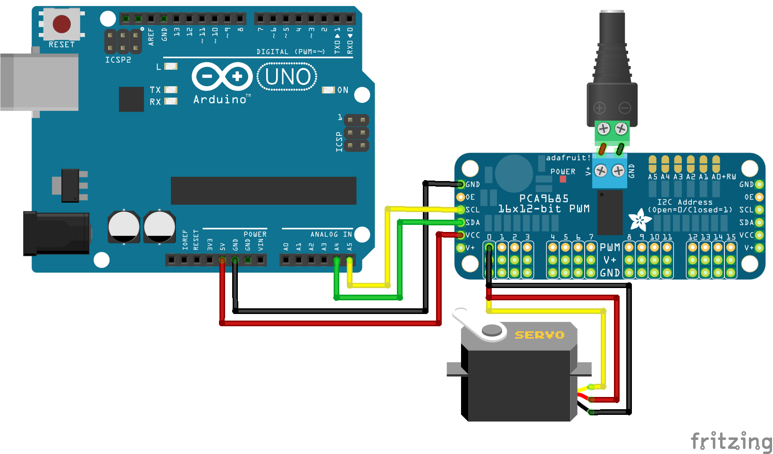
Fig 3.2.1
3.3 WORKING

Octapod robot is one of the most statically stable and possess a great flexibility while standing or moving due to its movement using eight legs that can be easily manipulated. This robot is biologically inspired from the behaviour of an insect with eight legs(spider).The design process involved in developing the body and arms of the robot has higher level of difficulty. The octapod robot has, by definition six legs, This gives it the ability to move flexibly across various terrain and does not require any balancing mechanisms to stand upright. However the robot’s static stability margin is not optimum. Nevertheless, a octapod configuration using alternating tripods has been chosen just to try to increase the machine’s speed, slightly jeopardizing stability; legs with powerful micro servomotors are chosen over other types as they can withstand heavy loads.
Once the robot is powered the Arduino sends signals to the PWM shield to give a go signal for the switching of the motors and the sequence of directional movements is based on the algorithm feed into the microcontroller.

SOURCE CODE

#include <Wire.h>
#include <Adafruit_PWMServoDriver.h>
Adafruit_PWMServoDriver pwm = Adafruit_PWMServoDriver();
#define MIN_PULSE_WIDTH 650
#define MAX_PULSE_WIDTH 2350
#define DEFAULT_PULSE_WIDTH 1500
#define FREQUENCY 50
uint8_t servonum = 0;
void setup()
{
Serial.begin(9600);
Serial.println("16 channel Servo test!");
pwm.begin();
pwm.setPWMFreq(FREQUENCY);
}
int pulseWidth(int angle)
{
int pulse_wide, analog_value;
pulse_wide = map(angle, 0, 180, MIN_PULSE_WIDTH, MAX_PULSE_WIDTH);
analog_value = int(float(pulse_wide) / 1000000 * FREQUENCY * 4096);
Serial.println(analog_value);
return analog_value;
}
void loop() {
pwm.setPWM(8,70, pulseWidth(90));

pwm.setPWM(0,80, pulseWidth(60));
pwm.setPWM(8,90, pulseWidth(70));
delay(1000);
pwm.setPWM(8,90, pulseWidth(100));
pwm.setPWM(0,105, pulseWidth(110));
pwm.setPWM(8,100, pulseWidth(90));
delay(1000);
pwm.setPWM(8,90, pulseWidth(100));
pwm.setPWM(0,110, pulseWidth(115));
pwm.setPWM(8,100, pulseWidth(90));
delay(1000);
pwm.setPWM(8,90, pulseWidth(100));
pwm.setPWM(0,115, pulseWidth(120));
pwm.setPWM(8,100, pulseWidth(90));
delay(1000);
pwm.setPWM(8,90, pulseWidth(100));
pwm.setPWM(0,120, pulseWidth(115));
pwm.setPWM(8,100, pulseWidth(90));
delay(1000);
pwm.setPWM(8,90, pulseWidth(100));
pwm.setPWM(0,115, pulseWidth(110));
pwm.setPWM(8,100, pulseWidth(90));
delay(1000);
pwm.setPWM(8,90, pulseWidth(100));
pwm.setPWM(0,110, pulseWidth(105));
pwm.setPWM(8,100, pulseWidth(90));
delay(1000);
pwm.setPWM(8,100, pulseWidth(90));
pwm.setPWM(0,105, pulseWidth(90));
pwm.setPWM(8,100, pulseWidth(90));
delay(1000);
pwm.setPWM(1,0, pulseWidth(60));
pwm.setPWM(2,0, pulseWidth(120));
pwm.setPWM(3,0,pulseWidth(180));
pwm.setPWM(4,0,pulseWidth(0));
pwm.setPWM(5,0,pulseWidth(150));

}

CHAPTER-04

EXPERIMENTAL RESULTS AND CONCLUSION:

4.1. RESULTS:
The factors that influence the robot’s movements are acceleration, centre of mass centre of gravity, friction. In order to self stabilize itself the legs are made of equal length and differential spacing so that equal load distribution takes place and chassis is always parallel to the ground. The legs provide the movement to the bot and the legs torque and movement are measured by scrutinizing the capacity of the motors provided.

4.2. FUTURE ENHANCEMENT:

As of now ,since the robot only demonstrates the concept of movement on the ground but it can be further developed so as to serve mankind in various aspects. First development should be toughening the physical state of the robot so that it is fire resistant . Such properties make it an efficient terrain robot which can handle the environmental conditions in order to accomplish its objective to surpass surface. We can incorporate a solar panel which makes it self powering so that there won’t be any problem when the battery goes down etc. A camera can be inserted into the head so that the driver can have live video streaming. These both improvements make it very helpful for military and space missions. It can also be used to biomimic and produce an efficient robot which is similar to a spider with all its movement and can be used for spying.

4.3. CONCLUSION:
We’ve built a wireless grounded spider robot(octapod). This mechanism can be further modified and can be used for many major applications like in the military, transportation, space missions etc. A camera along with a solar panel can be incorporated on it so that it can be used as a self powered surveillance robot .

BILL

S No. | Name | Quantity | Cost (in Rs.) | Total Cost (in Rs.)
1 | Arduino Mega | 1 | 750 | 750
2 | Adafruit PWM Shield | 1 | 450 | 450
3 | Jumper Wires | 50 | 2 | 100
4 | SG90 Micro Servo | 8 | 110 | 880
5 | MG90S Micro Servo | 8 | 215 | 1720
6 | 3D Printing- chassis, legs, joints | 1 | 4000 | 4000
7 | Arduino Nano | 1 | 250 | 250
8 | LM2596 | 1 | 100 | 100
9 | Heat Sink | 1 | 20 | 20
10 | 6/4 PCB | 1 | 30 | 30
11 | Adhesive | 10 | 5 | 50
 |  |  | TOTAL | 8350

