**Practical 01**

**Displaying different LED patterns with Raspberry Pi.**

from gpiozero import LED, DistanceSensor

from time import sleep

led = LED(18)

sensor = DistanceSensor(echo=24, trigger=23, max_distance=2.0)

try:

while True:

distance_cm = sensor.distance * 100 # convert to cm

print(f"Distance: {distance_cm:.2f} cm")

if distance_cm <= 10:

led.on()

sleep(0.5)

led.off()

sleep(0.5)

else:

led.off()

sleep(0.1)

except KeyboardInterrupt:

print("Exiting.")

Output:

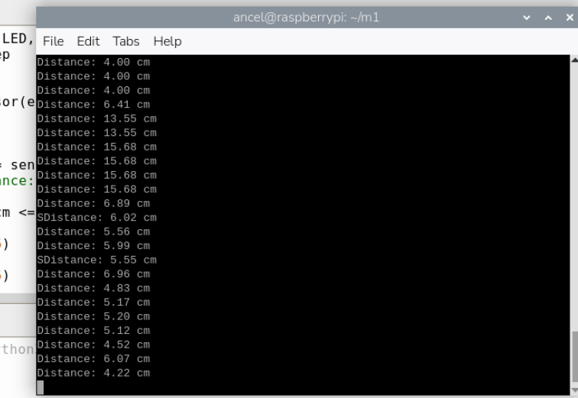

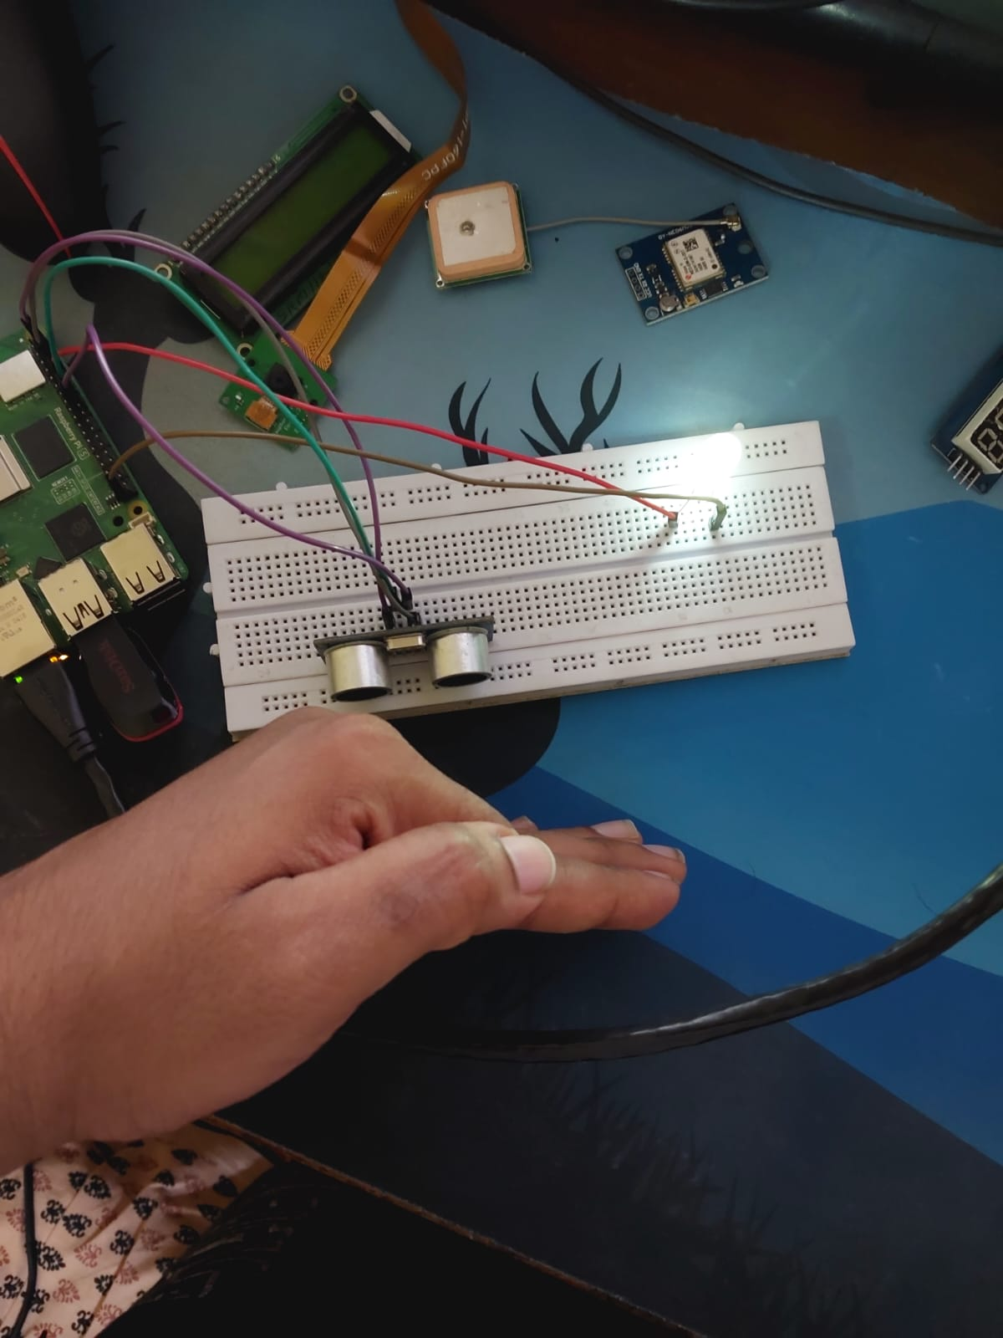

**In proteus :**

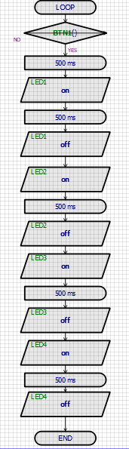

**Output:**

