**Practical 02**

**Displaying Time over 4-Digit 7-Segment Display using Raspberry Pi**

import tm1637

import time

from datetime import datetime

# Initialize TM1637 (CLK, DIO)

tm = tm1637.TM1637(clk=5, dio=4)

colon = True # for blinking the colon

while True:

# Get current time in 12-hour format

now = datetime.now()

hour = int(now.strftime("%I")) # 12-hour format hour

minute = int(now.strftime("%M")) # minute

ampm = now.strftime("%p") # "AM" or "PM"

# Show HH:MM, with colon blinking

tm.numbers(hour, minute, colon)

colon = not colon

# Also print to terminal with AM/PM

print(f"{hour:02d}:{minute:02d} {ampm}")

time.sleep(1)

Output:

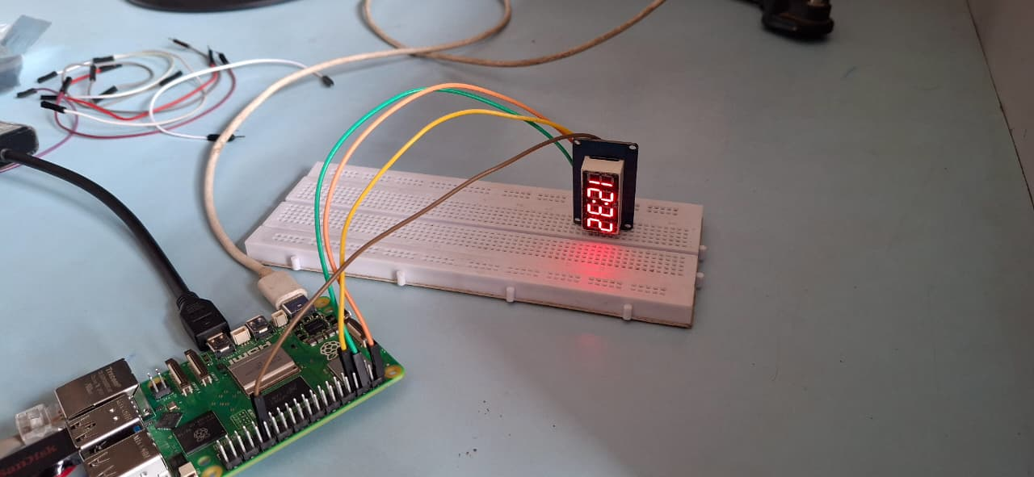

**In proteus :**

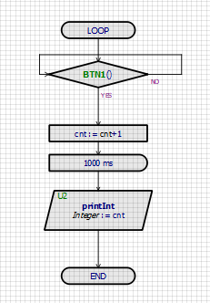

**Output:**

