**Practical 03**

**Interfacing 16X2 LCD with Raspberry Pi to display different messages.**

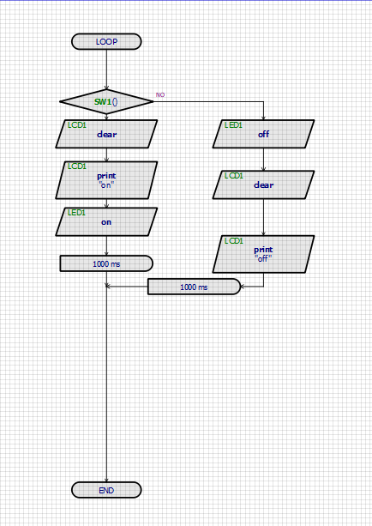

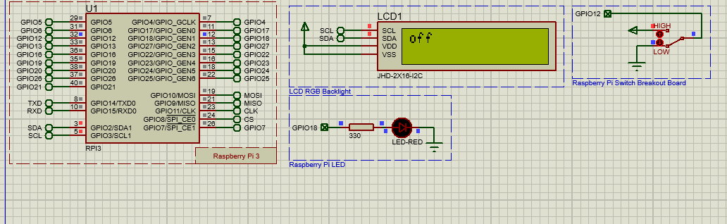**Output:**

