**Practical 06**

**Fingerprint Sensor interfacing with Raspberry Pi**

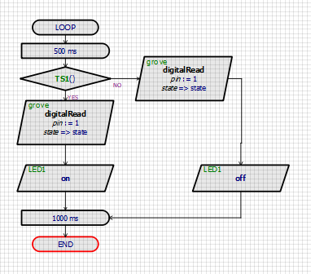

**Output:**

