**Practical 07**

**Gps Sensor interfacing with Raspberry Pi**

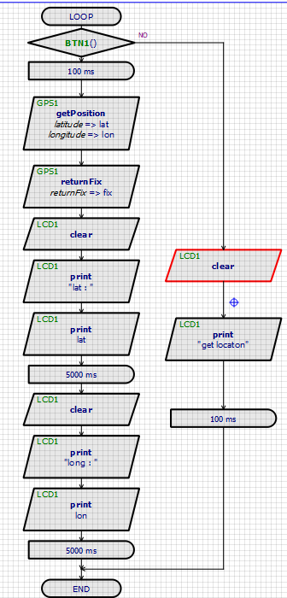

**Output:**