**Practical 10**

**Interfacing Raspberry Pi with RFID.**

**Read RFID**from mfrc522 import SimpleMFRC522

reader = SimpleMFRC522()

while True:

try:

print("Place your RFID tag near the reader")

id, text = reader.read()

print(f"RFID ID: {id}")

print(f"Data on tag: {text}")

finally:

print("Cleaning up GPIO")

**Write RFID**import RPi.GPIO as GPIO

from mfrc522 import SimpleMFRC522

import time

reader = SimpleMFRC522()

try:

# Ask user for data to write

data = input("Enter data to write: ").strip()

print("Now place your RFID tag near the reader to write...")

while True: # Corrected the case of 'while'

reader.write(data)

print("Data written to tag.")

time.sleep(2)

except KeyboardInterrupt:

print("\nProgram stopped by user.")

finally:

GPIO.cleanup()

print("GPIO cleanup done.")

**Output:**

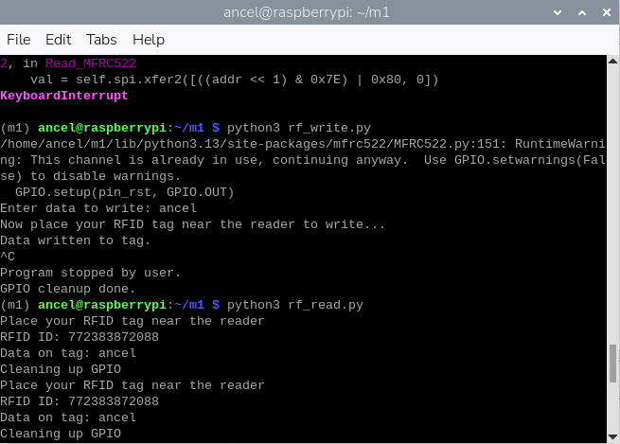

**In Proteus**

