Parallel and Distributed Machine Learning Pipeline
Serial vs Multiprocessing vs MPI on a 2-million-row dataset
Bilal Ahmad
BSIT, University of the Punjab, Lahore
October 2026
DRAFT: add course name, instructor and submission details before handing in.

1. Introduction
Machine learning pipelines spend most of their time on a few heavy steps: reading data, cleaning it, and training models. This project builds one pipeline three ways and measures what parallel computing really buys on an ordinary laptop: a serial baseline, a shared-memory version using Python multiprocessing, and a distributed-memory version using MPI (mpi4py with Open MPI).
The goals were to (1) keep results identical across all versions, so that speedup is never bought with a different answer, (2) measure speedup and efficiency honestly, using repeated runs and medians, and (3) explain where the gains stop and why, using Amdahl's Law and the hardware at hand.

2. Experimental setup

2.1 Hardware and software
Item | Value
CPU | Intel Core i7-1355U laptop processor (2 performance + 8 efficiency cores, 12 hardware threads; WSL2 reports 6 cores x 2 threads)
Memory | 3.6 GiB visible inside WSL2, 1 GiB swap
OS | Ubuntu on WSL2 (on Windows)
Python stack | Python 3.14, NumPy 2.5, pandas 3.0, scikit-learn 1.9
MPI | Open MPI 5.0.10 with mpi4py 4.1.2

2.2 Dataset
A synthetic regression dataset was generated with a Python script: 2,020,000 rows with five numeric features, one categorical column (category) and a numeric target. About 1% duplicate rows and some missing values were injected on purpose, so that cleaning has real work to do. After cleaning, 2,000,000 rows remain. The CSV file is about 219 MB.

2.3 Method
- Every configuration was run several times and the median is reported, because the laptop was noisy (single runs of the same code varied between about 2 s and 11 s in load time).
- Runs were interleaved (1, 2, 4, 8, 12 workers, then again) so that slow drifts in machine speed affect every configuration equally.
- Each process was limited to one BLAS thread, otherwise 12 workers each starting 12 math threads would fight over the same cores.
- Correctness was checked on every run by comparing the test RMSE (data pipeline) or the best model and its RMSE (model selection) with the serial result.

3. Implementations

3.1 Stage 1: data pipeline
The pipeline loads the CSV, drops duplicates and fills missing values with the median, one-hot encodes the category and standardises the numeric features, then trains a linear regression and reports the test RMSE.
- Serial baseline. Plain pandas and scikit-learn LinearRegression, with per-stage timing.
- Multiprocessing. Row hashes are computed by worker processes, duplicates are then found globally and medians come from the full data, so the cleaned data is identical to the serial version. Training computes the partial sums X'X and X'y in each worker, adds them and solves the normal equations, which gives the same linear model. Data is shared with workers by fork (copy-on-write), so nothing is pickled.
- Parallel CSV load (experiment). The file was cut into byte ranges and parsed by several workers. In our measurements it gave no clear gain: any saving in parsing was eaten by sending the parsed data back to the main process, and the machine noise was larger than the effect. The simpler serial load was kept.

3.2 Stage 2: model selection (embarrassingly parallel)
Because the first stage has a large serial part, a heavier and naturally parallel task was added: train 12 random forest models (depth 6, 8, 10, 12 x 20, 40, 60 trees), each on a 50,000-row sample, score them on the same 100,000 held-out rows and pick the best. Each model is an independent job.
- Multiprocessing. A process pool takes models one by one, largest first, which balances the load dynamically.
- MPI. Rank 0 prepares the data, broadcasts the test rows, and sends each other rank only the training rows its models need (point-to-point messages). Models are assigned to ranks by a greedy longest-job-first rule using depth x trees as the cost estimate. Every rank, including rank 0, trains its models, and results are gathered on rank 0. No process other than rank 0 ever holds the full 2M-row table, which matters on a machine with 3.6 GiB of memory.
Both versions use the same seeds and row samples, so they must choose the same best model with the same RMSE.

4. Results

4.1 Correctness
All versions of the data pipeline produced a test RMSE of 5.1424. All model-selection runs, serial and parallel, with any number of workers or MPI processes, selected the same model (depth 12, 60 trees) with RMSE 5.7759. Parallelism therefore changed only the time, not the answer.

4.2 Data pipeline
Table 1 shows median total times over 5 interleaved runs. The serial baseline took 12.04 s.
Workers | Median (s) | Speedup vs serial | Speedup vs 1 worker | Efficiency
Serial | 12.04 | 1.00x | - | -
1 | 5.50 | 2.19x | 1.00x | 100%
2 | 5.38 | 2.24x | 1.02x | 51%
4 | 4.45 | 2.71x | 1.24x | 31%
8 | 4.65 | 2.59x | 1.18x | 15%
12 | 4.66 | 2.58x | 1.18x | 10%
Table 1. Data pipeline, median of 5 runs. Efficiency = speedup vs 1 worker / workers.
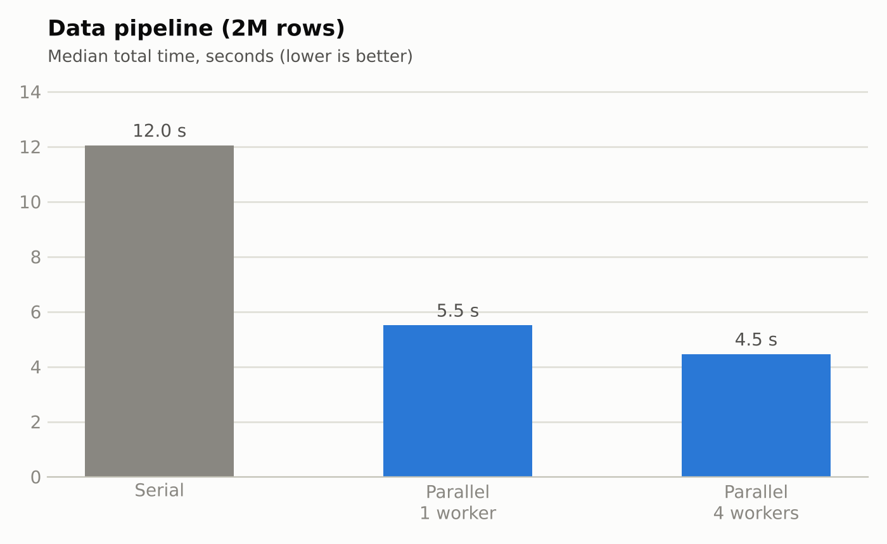
Figure 1. Total time of the data pipeline.
The pipeline is up to 2.7x faster than the serial baseline (4 workers). But the one-worker parallel version is already 2.2x faster, so most of that gain comes from the better algorithm (hash-based duplicate detection and normal equations), not from parallelism. The true parallel gain, measured against the same code with one worker, is only about 1.2x.

4.3 Model selection
Workers | Multiproc. (s) | MPI (s) | Speedup MP | Speedup MPI | MPI comm. (s)
1 | 47.0 | 44.8 | 1.00x | 1.00x | 0.16
2 | 24.8 | 23.9 | 1.90x | 1.87x | 0.26
4 | 14.9 | 13.7 | 3.15x | 3.27x | 0.27
8 | 10.9 | 10.3 | 4.31x | 4.33x | 0.37
12 | 11.6 | 11.6 | 4.04x | 3.88x | 0.61
Table 2. Model selection (12 models), median of 3 runs. Speedups are relative to each method's own 1-worker time.
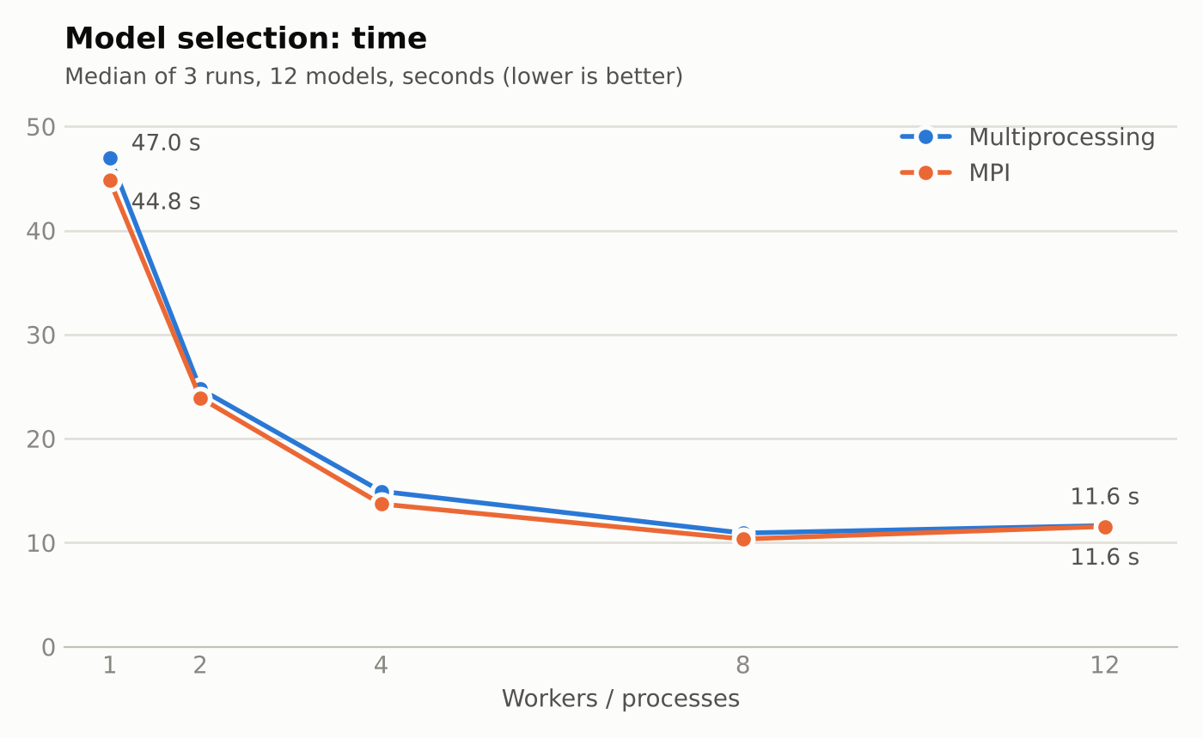
Figure 2. Model selection time vs number of workers.
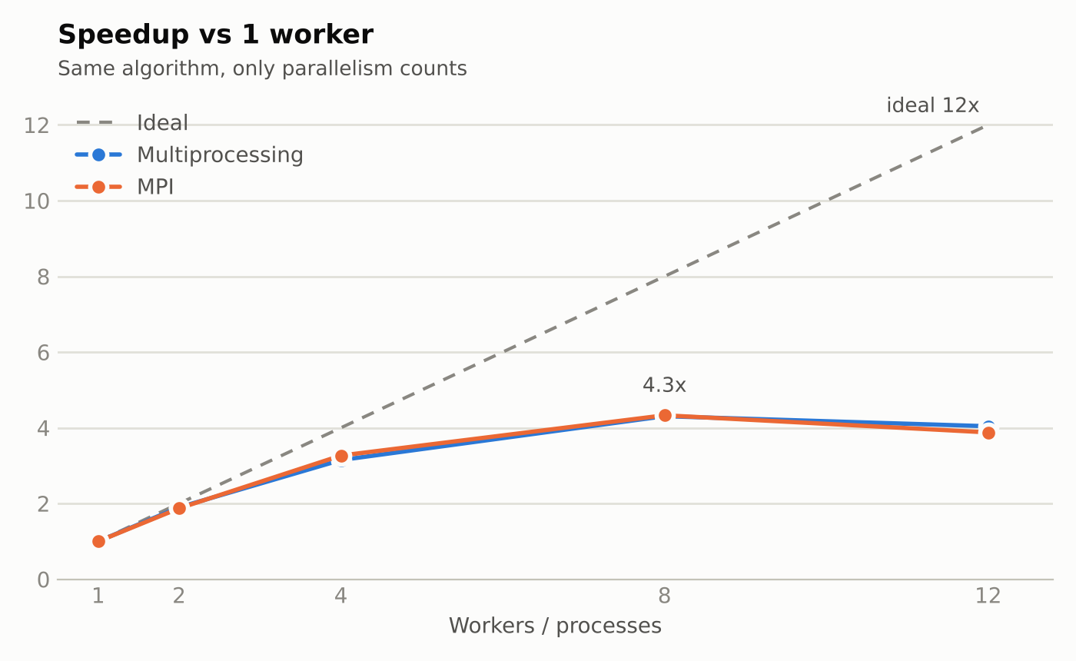
Figure 3. Speedup of model selection compared with the ideal line.
Scaling is nearly ideal up to 2 workers (efficiency 94-95%), still good at 4 (79-82%), and the best result is 4.3x at 8 workers. At 12 workers the time does not improve and is slightly worse. Multiprocessing and MPI perform almost the same.

5. Discussion
- Amdahl's Law in the data pipeline. Loading the CSV (about 2.3 s) is serial and takes more than half of the 4.4 s total once the rest is parallel, so extra workers cannot help beyond a point. This is exactly the serial fraction that Amdahl's Law says limits speedup.
- Granularity in model selection. With only 12 models, 12 workers means one model each, and the total time is set by the largest model (depth 12, 60 trees). More workers cannot split a single model. This load imbalance explains why 8 workers is already as fast as 12.
- Hybrid CPU. The i7-1355U has 2 fast cores and 8 slower efficiency cores. 12 workers are therefore not 12 equal cores, and hyper-threading shares execution units. Efficiency of 54% at 8 workers and 32-34% at 12 is typical for this kind of chip.
- Cost of MPI communication. Sending data to the ranks took 0.16 s with 1 process and 0.61 s with 12, which is between 0.4% and 5% of the selection time. It is small because each rank receives only a few megabytes (its own samples), not the whole table.
- Serial preparation in MPI. In the MPI program rank 0 loads, cleans and engineers features alone, which took about 8.7 s in one run, more than the selection itself at 4 processes. Parallelising this part would be the next big gain, and it is the same Amdahl effect again.
- Algorithm versus parallelism. A better algorithm (2.2x in stage 1) can be worth more than adding cores (1.2x). Parallel results should always be compared with the same code on one worker, as well as with the original baseline.

6. Limitations
- All measurements come from a single laptop under WSL2 with 3.6 GiB of memory. MPI here is shared-memory message passing on one machine, not a real cluster, so network latency is not measured.
- The laptop was noisy (thermal throttling and background load). Medians of 3 to 5 runs reduce this but do not remove it; differences of a few percent between methods are within noise.
- MPI runs with 1, 2 and 4 processes used Open MPI's default process binding, while runs with 8 and 12 processes used --use-hwthread-cpus --bind-to none, because Open MPI by default counts only the 6 physical cores as slots. This may cause small differences.
- The parallel CSV loading experiment was inconclusive because of the noise, and the dataset is synthetic.

7. Conclusion
Both parallel versions reproduced the serial results exactly. The data pipeline became up to 2.7x faster, but only about 1.2x of this is true parallel speedup; the rest comes from a better algorithm, and the serial CSV load limits further gains. For the naturally parallel model-selection task, both multiprocessing and MPI reached about 4.3x with 8 workers (54% efficiency), and MPI's communication cost stayed below about 5% of the run time. The project shows that speedup depends on the size of the serial part, the granularity of the work and the hardware, and that honest measurement (medians, same-code baselines, correctness checks) matters as much as the parallel code.
Possible future work: parallel data preparation inside the MPI program, more models (or cross-validation folds) to improve load balance, and running MPI on several machines to measure real network cost.

Appendix: how to reproduce
Project layout: data/ (generator and dataset), serial/pipeline.py, parallel_multiprocessing/ (pipeline_mp.py, pipeline_select.py), distributed_mpi/pipeline_mpi.py, benchmarks/ (benchmark.py and result files).
python3 data/generate_data.py --rows 2000000 --out data/dataset.csv
python3 serial/pipeline.py --data data/dataset.csv
python3 benchmarks/benchmark.py --reps 5
python3 parallel_multiprocessing/pipeline_select.py --workers 8 --subsample 50000
mpirun --use-hwthread-cpus --bind-to none -n 8 python3 distributed_mpi/pipeline_mpi.py --subsample 50000

