OBJECT-ORIENTED ANALYSIS AND DESIGN · FALL 2026
Study Planner
and Exam Scheduler
Term Project Report
Analysis Document · Design Document · Final Report
INSTRUCTOR
Dr. Yazeed Ghadi
PROJECT TEAM
Ahmed Khaled | 202310947
Ahmad Hamdan | 202310519
Firas Elhag | 202310264
Bilal Feroz Khan | 202310641
November 2026
Contents
PART A — ANALYSIS DOCUMENT (SRS) 3
1. Introduction 3
2. Overall Description 3
3. Functional Requirements 4
4. Non-Functional Requirements 4
5. System Models 4
6. Assumptions and Constraints 9
7. Glossary and References 9
PART B — DESIGN DOCUMENT 10
1. Introduction 10
2. Software Architecture 10
3. Subsystem Services 11
4. Low-Level Design 11
5. UML Models 12
6. Testing Plan 12
PART C — FINAL REPORT FRAMEWORK 13
1. Implementation Summary 13
2. Changes from Design 13
3. Actual Testing Results 13
4. Implementation Status and Limitations 14
5. User Guide 14
6. Group Contributions 15
7. References 15

PART A — ANALYSIS DOCUMENT (SRS)

1. Introduction
The Study Planner and Exam Scheduler is a Java desktop application that helps university students organize courses, assignments, quizzes, exams, and study sessions. It records deadlines, assessment weights, and difficulty levels; generates proposed study sessions; identifies selected scheduling conflicts; tracks completion; displays due-soon and overdue items; and prepares workload reports.

1.1 Purpose
The system provides one place to manage academic tasks and plan study time before deadlines.

1.2 Scope
- Manage courses and instructor information.
- Manage assignments, quizzes, and exams with deadline, weight, and difficulty.
- Generate weekday study sessions before assessment deadlines.
- Detect same-date exams, study sessions overlapping known class times, and days with more than three pending sessions.
- Mark study sessions complete and display due-soon/overdue items.
- Generate weekly progress and per-course assessment workload reports.
- Save data locally in a serialized file.

1.3 Definitions
Assessment: assignment, quiz, or exam. Study session: planned study time interval. Class meeting: recurring weekly class time. Conflict: a scheduling condition that may make the plan impractical.

2. Overall Description

2.1 Product Perspective
The product is a standalone Java desktop application. It uses Swing for the graphical interface and local file serialization for storage. No remote server or online account is required.

2.2 User Class
The primary user is a university student managing their own academic information. The current prototype is single-user.

2.3 Operating Environment
Java 8 or later, NetBeans or another Java IDE, and a desktop operating system supported by Java.

3. Functional Requirements
- FR-01: Add and delete courses with course code, name, and instructor.
- FR-02: Add and delete assessments linked to a course.
- FR-03: Store assessment title, type, deadline, weight percentage, and difficulty.
- FR-04: Generate weekday study sessions before an assessment deadline (never on the deadline day): Hard 5, Medium 3, Easy 2 sessions, spread evenly over the available days.
- FR-05: Offer three one-hour slots per weekday (5:00, 6:00 and 7:00 PM); skip a slot that has already passed, overlaps a known class meeting, or already holds a pending session.
- FR-06: Flag exams that share the same deadline date.
- FR-07: Flag study sessions overlapping entered weekly class meetings.
- FR-08: Flag dates with more than three pending study sessions.
- FR-09: Allow a student to mark a study session complete.
- FR-10: Display course, assessment, pending-session, and completed-session counts.
- FR-11: Display assessments due within seven days and overdue assessments.
- FR-12: Generate a next-seven-days progress summary and per-course assessment workload.
- FR-13: Save and load data from a local file.
- FR-14: Count completed sessions and pending sessions that are still in the future towards an assessment's target, so generating again adds no duplicates; missed sessions are planned again.
- FR-15: If the data file cannot be read, keep it as a .corrupt copy, start with empty data, and warn the user.

4. Non-Functional Requirements
- Usability: clear navigation, readable tables, and consistent styling.
- Performance: normal student workloads should be handled promptly.
- Reliability: successful changes are saved locally through a temporary file; a damaged data file is kept as a .corrupt copy instead of being overwritten.
- Maintainability: model, service, persistence, and UI responsibilities are separated conceptually.
- Portability: run on systems with a compatible Java runtime.
- Privacy: the prototype does not transmit academic data to a server.

5. System Models

5.1 Use Case Model
Primary actor: Student. Use cases: Manage Courses, Manage Assessments, Manage Class Times, Generate Study Plan, Review Conflicts, Track Progress, View Reports, and Save/Load Local Data. Manage Courses, Manage Assessments, Manage Class Times, Generate Study Plan and Track Progress include Save/Load Local Data, because every change is saved automatically (Figure 1).
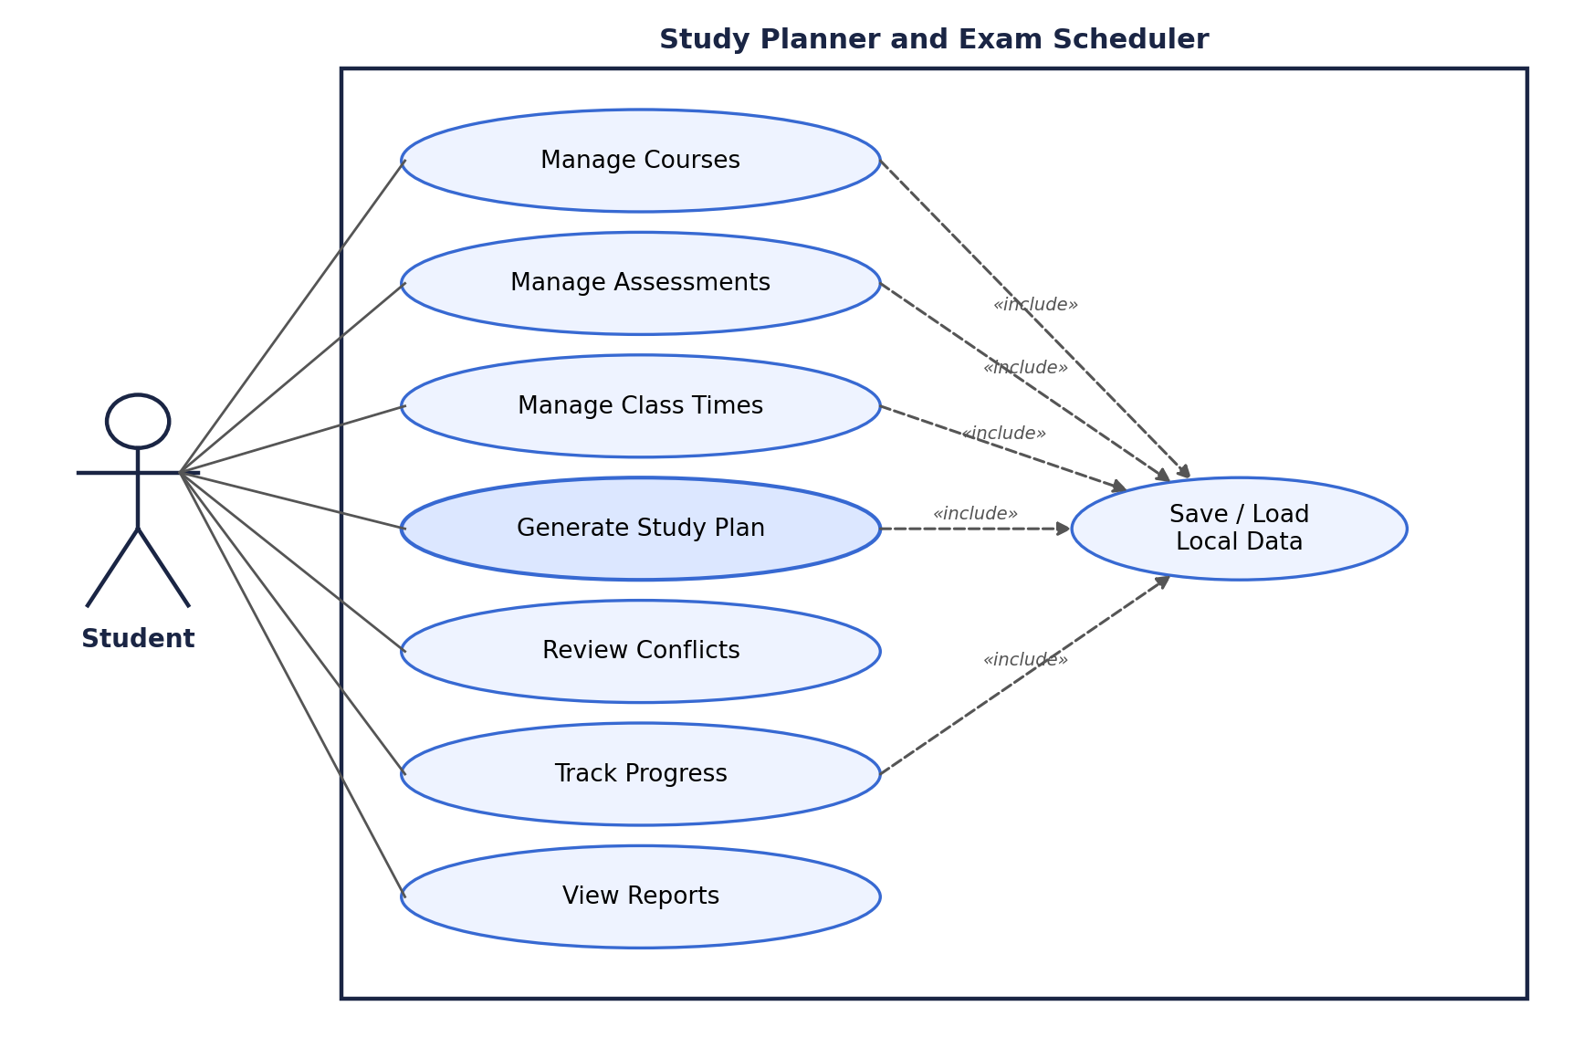
Figure 1 — Use case diagram

Use case specification: Generate Study Plan
Item | Description
Use case | Generate Study Plan
Actor | Student
Precondition | At least one course and one assessment exist.
Trigger | The student selects Generate Study Plan on the Schedule page.
Main flow | 1. For each assessment the system computes the target number of sessions (Hard 5, Medium 3, Easy 2) minus the completed and future pending sessions it already has.  2. It lists the weekdays from today up to the day before the deadline that have a free 5, 6 or 7 PM slot not overlapping a class.  3. It picks evenly spaced days and adds one-hour sessions.  4. It saves the data.  5. It shows how many sessions were created and refreshes the schedule and the warnings.
Alternative flows | A. The deadline is today or in the past: no sessions are created for that assessment.  B. Fewer free slots than needed: fewer sessions are created.  C. The data cannot be saved: a warning dialog is shown.
Postcondition | New pending sessions appear in the schedule; conflicts are checked again and shown on the Dashboard.

5.2 Dynamic Model — Schedule Generation
- Student opens Schedule and selects Generate Study Plan.
- The interface asks the scheduling service to process each assessment.
- The service selects a target number of sessions based on difficulty (Hard 5, Medium 3, Easy 2) and subtracts the completed and future pending sessions the assessment already has.
- It lists the weekdays from today up to the day before the deadline.
- For each day it keeps a one-hour slot (5, 6 or 7 PM) only if the slot is still in the future, does not overlap a known class meeting, and holds no other pending session.
- It picks evenly spaced days (the first slot of each day before any second slot) and adds the sessions to the application data.
- The application saves the data and refreshes the schedule and warnings.
Figure 2 shows the messages between the objects and Figure 3 the activity flow.
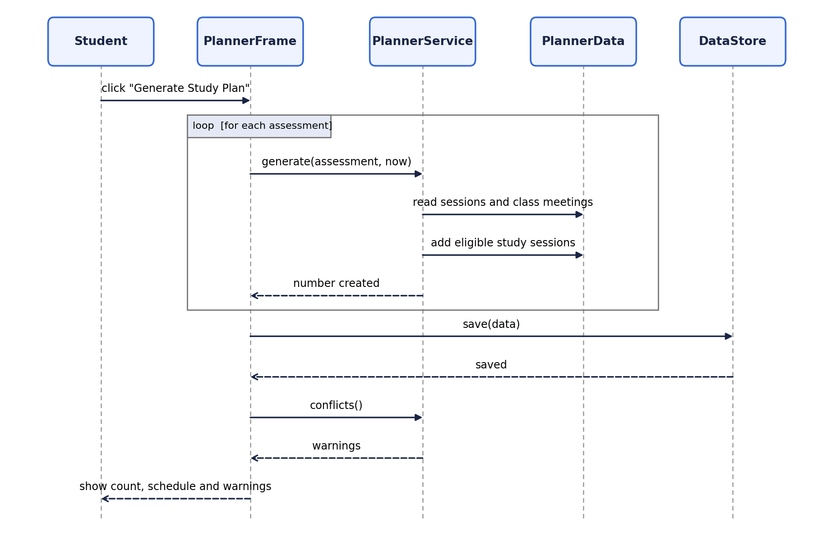
Figure 2 — Sequence diagram: Generate Study Plan
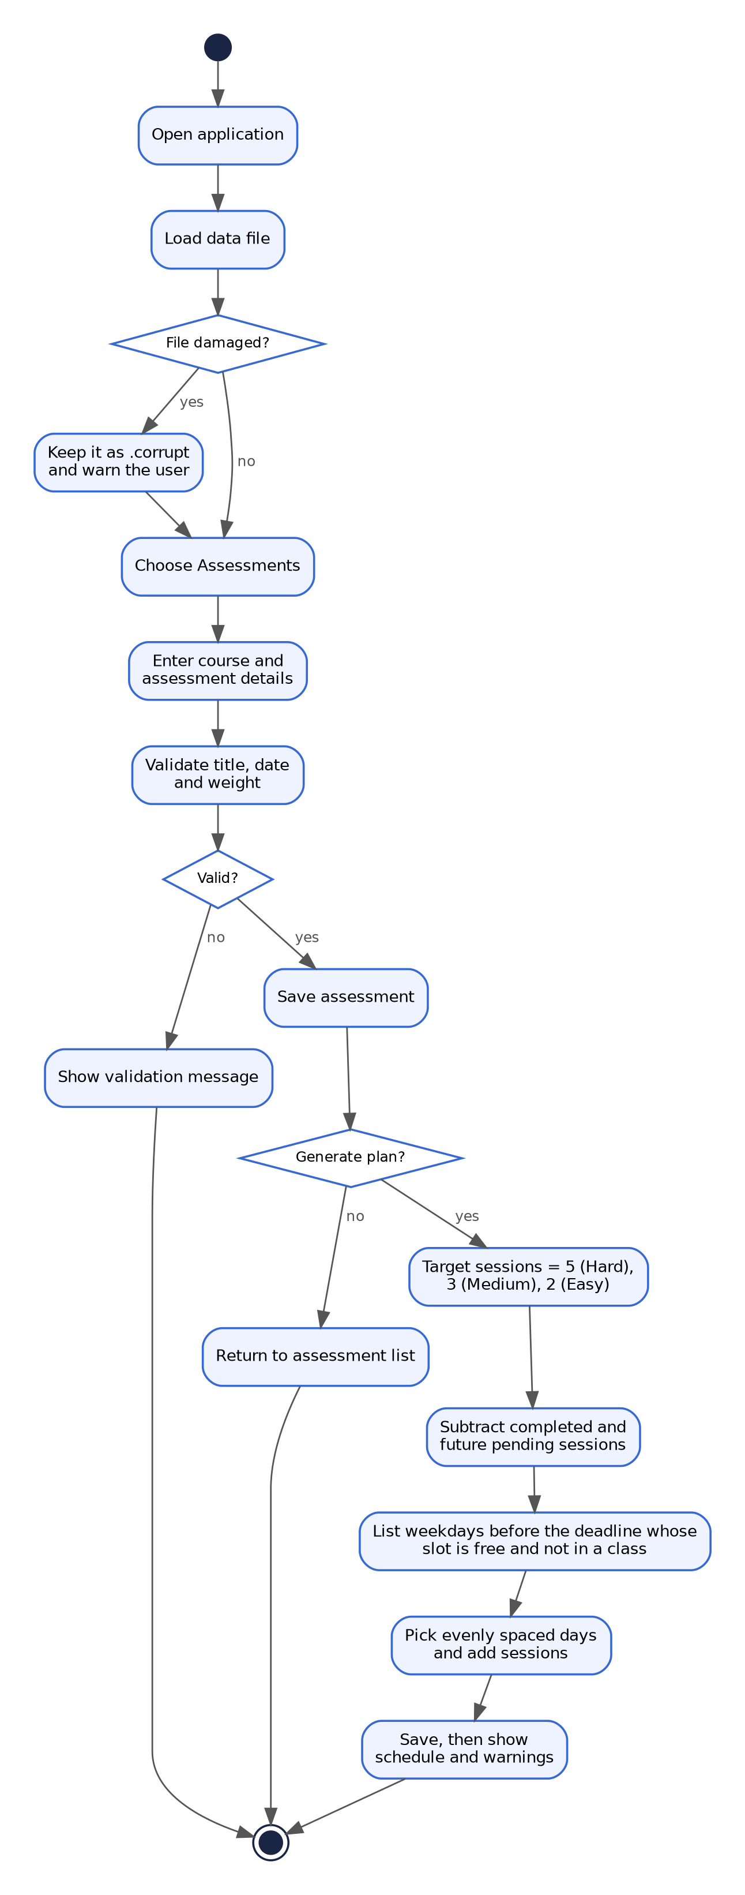
Figure 3 — Activity diagram: from opening the application to a generated plan

5.3 Object and Class Model
Course represents a subject. Assessment represents an assignment, quiz, or exam. StudySession represents a planned interval associated with an assessment. ClassMeeting stores a recurring weekday/time interval. PlannerData aggregates all objects. PlannerService contains scheduling and conflict logic. DataStore handles local persistence. PlannerFrame presents the GUI, and Main starts the program. Objects refer to each other by key, not by Java reference: an Assessment stores its course code, a StudySession stores the assessment ID, and a ClassMeeting stores its course code (Figure 4).
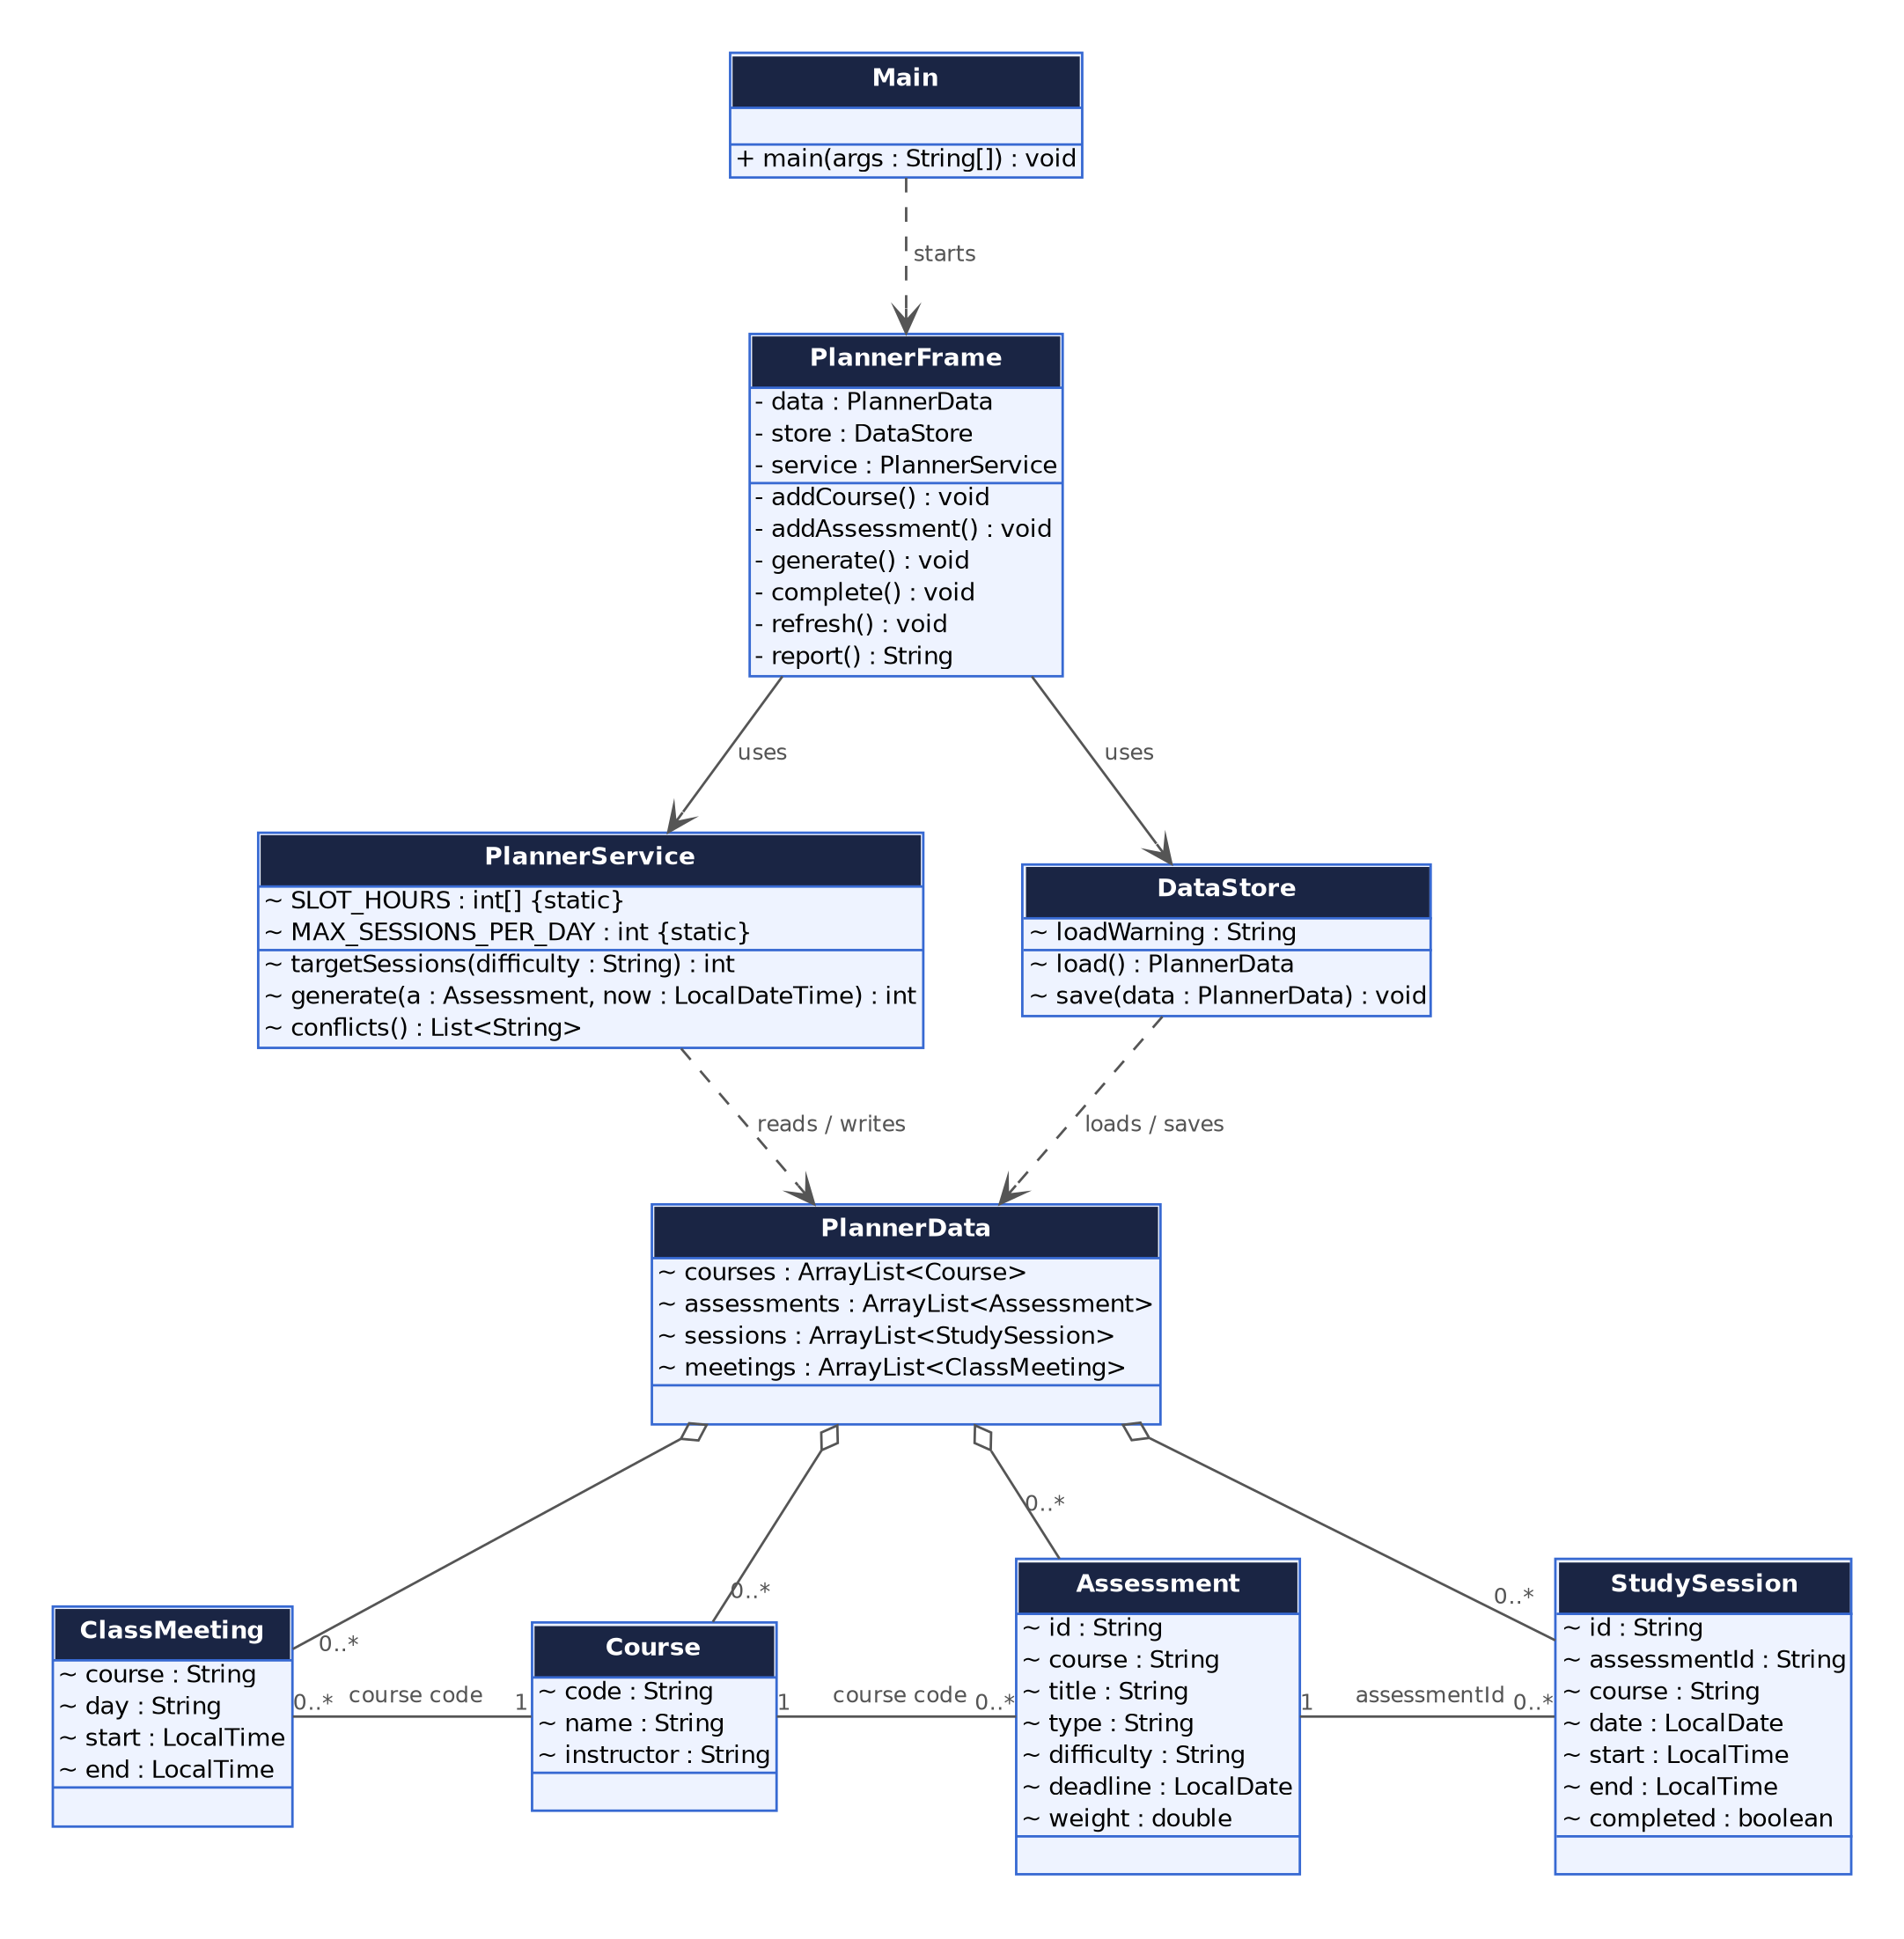
Figure 4 — Class diagram

5.4 User Interface and Navigation
- Dashboard: overview counts, upcoming/overdue assessments, and warnings.
- Courses: add, view, and delete courses.
- Assessments: add, view, and delete assessments.
- Schedule: generate study sessions and mark them complete.
- Class Times: add and delete recurring weekly class meetings.
- Reports: generate weekly progress and per-course workload summaries.

6. Assumptions and Constraints
- Java is used as required by the course brief.
- The interface uses Java Swing and storage uses built-in serialization.
- The scheduler proposes one-hour sessions in three slots (5:00, 6:00 and 7:00 PM) on weekdays, before the deadline day.
- Suggested sessions depend on difficulty: Easy 2, Medium 3, Hard 5, subject to free slots.
- Reminders are visual in-app flags; operating-system notifications are not implemented.
- The prototype is single-user and local.

7. Glossary and References
OOAD: Object-Oriented Analysis and Design. SRS: Software Requirements Specification. UML: Unified Modeling Language. GUI: Graphical User Interface.
Ghadi, Y. (2026). Object-Oriented Analysis and Design Term Projects: Fall 2026 [Course project brief].

PART B — DESIGN DOCUMENT

1. Introduction

1.1 Purpose
This document explains the design and structure of the Study Planner and Exam Scheduler.

1.2 Design Goals
- Separate interface code from business logic and persistence.
- Represent academic concepts with object-oriented classes.
- Keep scheduling logic understandable and testable.
- Use built-in Java technologies to reduce setup.
- Store data locally.

2. Software Architecture
The prototype follows a simple layered structure: presentation (Main and PlannerFrame), service (PlannerService), model (Course, Assessment, StudySession, ClassMeeting, PlannerData), and persistence (DataStore).

2.1 Subsystem Decomposition
- Presentation: dashboard, navigation, forms, tables, and reports.
- Academic data: courses and assessments.
- Scheduling: proposed sessions and conflict detection.
- Progress: completion status and progress counts.
- Persistence: load and save local data.

2.2 Hardware/Software Mapping
The application runs on a student's personal computer using Java. Swing displays the desktop interface. A serialized file is stored in the current user's home directory.

2.3 Persistent Data Management
DataStore uses ObjectOutputStream and ObjectInputStream to store PlannerData in study-planner-data.ser. Persistent model classes implement Serializable. A save is written to a temporary file and then moved over the real file. If the file cannot be read, it is kept as study-planner-data.ser.corrupt, the application starts with empty data and shows a warning. A future production release should add backups and data versioning.

2.4 Access Control and Security
The prototype is single-user and does not provide login or role-based access control. The user should protect access to their computer account and local data file.

2.5 Boundary Conditions
- Dates must be valid ISO dates (YYYY-MM-DD).
- Weight must be between 0 and 100.
- Class meeting end time must be later than start time.
- Assessments whose deadline is today or in the past receive no new study sessions.
- The scheduler offers three one-hour weekday slots (5:00, 6:00 and 7:00 PM); no session is placed on the deadline day.

3. Subsystem Services
- PlannerService.generate(Assessment, LocalDateTime): creates proposed sessions and returns how many were created.
- PlannerService.conflicts(): returns exam, class-time, and overloaded-day warnings.
- DataStore.load(): restores data, or creates an empty model and sets a warning if the file is damaged.
- DataStore.save(PlannerData): writes the data to a temporary file and moves it over the real file.
- PlannerFrame: validates input, handles user actions, calls services, and refreshes views.

4. Low-Level Design

4.1 Object Design Trade-offs
Swing is included with Java and avoids external UI dependencies. Local serialization avoids database setup. The schedule generator is a simple heuristic, not an advanced optimization algorithm. All classes are in one source file (Main.java) so that the NetBeans setup is a single copy; the cost is a long file, and a larger version should split it into packages. This keeps the design understandable while making its limits explicit.

4.2 Final Object Design
- Course: code, name, instructor.
- Assessment: ID, course, title, type, deadline, weight, difficulty.
- StudySession: ID, assessment ID, date, start/end, completion status.
- ClassMeeting: course, weekday, start/end.
- PlannerData: collections of all domain objects.
- PlannerService: schedule generation and conflict detection.
- DataStore: local serialization.
- PlannerFrame: screens and user interactions.

4.3 Packages
All classes are placed in the studyplanner package for simple NetBeans setup. A larger version could split model, service, persistence, and UI into separate packages.

4.4 Class Interfaces
- Course: fields code, name, instructor.
- Assessment: fields ID, course, title, type, deadline, weight, difficulty.
- StudySession: date, start/end, completed status.
- PlannerService: generate(Assessment, LocalDateTime), conflicts(), targetSessions(String).
- DataStore: load(), save(PlannerData).

5. UML Models
The UML diagrams are in Part A, Section 5: Figure 1 (use case), Figure 2 (sequence, schedule generation), Figure 3 (activity) and Figure 4 (class diagram). The same diagrams are provided as PNG files and as PlantUML source in the uml folder, so they can be re-rendered or recreated in a CASE tool.

6. Testing Plan
- Add a course and verify it appears in the table.
- Attempt a duplicate course code and verify validation.
- Add an assessment and verify its fields are displayed.
- Try an invalid date or weight and verify an error appears.
- Add a class meeting and verify it appears in Class Times.
- Generate a study plan and verify sessions are on weekdays before the deadline and never on the deadline day.
- Add two exams on the same date and verify a conflict warning.
- Add a class meeting overlapping 5:00–6:00 PM and verify generation avoids the 5:00 PM slot on that day.
- Mark a session complete and verify status/count changes.
- Restart the application and verify saved data is restored.
- Press Generate Study Plan twice and verify that no duplicate sessions are created.
- Add two assessments with the same title in different courses, delete the second one, and verify that the selected one is removed.
- Damage the data file and start the application: verify the warning and the .corrupt copy.

PART C — FINAL REPORT FRAMEWORK

1. Implementation Summary
The prototype is a Java Swing desktop application with a styled dashboard and sidebar navigation. It supports course and assessment management, class-time entry, basic study-plan generation, completion tracking, selected conflict warnings, deadline flags, reports, and local persistence.

2. Changes from Design
The following changes were made after reviewing the first prototype:
- Generation now counts completed and future pending sessions towards the target, so pressing Generate Study Plan again no longer creates duplicates; missed sessions are planned again.
- Three one-hour slots per weekday replace the single 5:00–6:00 PM slot with one session per day. Before, an assessment created earlier could take every day and leave a nearer deadline without sessions.
- Sessions are spread evenly and stop before the deadline day. Before, they were packed into the earliest days and could be placed on the deadline day itself.
- Deleting an assessment now removes the selected row. Before, it was found by title and could delete the wrong assessment.
- Deleting a course also removes its class times.
- A damaged data file is kept as a .corrupt copy and the user is warned. Before, it was silently replaced by empty data at the next save. Saves now go through a temporary file.
- The source code was formatted and documented with Javadoc comments.
- Design note: because the generator offers at most three slots per day, the overloaded-day check (more than three pending sessions) cannot be triggered by generated sessions; it is a safeguard for data changed in other ways.

3. Actual Testing Results
Automated tests: test/studyplanner/ServiceTest.java checks the service and persistence layers without the GUI: session counts by difficulty, weekdays only, no session on the deadline day, even spreading, no duplicates when generating twice, no starvation of nearer deadlines, avoidance of class times, past and same-day deadlines, planning missed sessions again, the three conflict warnings, and saving, loading and damaged-file recovery. Result of the run on 2026-11-07 (JDK 21, command line): 24 of 24 checks passed. The group should run it again on its own machine.
The GUI itself has not been run by the reviewer. Record the real Pass/Fail result of each manual test below after running it on the group's NetBeans setup; do not mark a test as passed until it has been run.
# | Manual GUI test (Part B, Section 6) | Result
1 | Add a course and verify it appears in the table. | Not run yet
2 | Attempt a duplicate course code and verify validation. | Not run yet
3 | Add an assessment and verify its fields are displayed. | Not run yet
4 | Try an invalid date or weight and verify an error appears. | Not run yet
5 | Add a class meeting and verify it appears in Class Times. | Not run yet
6 | Generate a study plan; verify weekdays before the deadline. | Not run yet
7 | Add two exams on the same date and verify the conflict warning. | Not run yet
8 | Add a class at 5:00–6:00 PM; verify the 5:00 PM slot is avoided. | Not run yet
9 | Mark a session complete and verify status and counts change. | Not run yet
10 | Restart the application and verify the data is restored. | Not run yet
11 | Generate twice; verify there are no duplicate sessions. | Not run yet
12 | Delete one of two assessments with the same title; verify the right one is removed. | Not run yet
13 | Damage the data file; verify the warning and the .corrupt copy. | Not run yet

4. Implementation Status and Limitations
- Implemented in this prototype: add/delete courses; add/delete assessments; add/delete class times; weekday schedule generation (three slots per day, spread before the deadline, no duplicates); mark sessions complete; local save/load with damaged-file recovery; selected conflict checks; dashboard deadline flags; weekly and per-course reports.
- Not implemented: editing existing records; deleting individual study sessions; configurable availability and session duration; advanced workload balancing; operating-system push notifications; multiple user accounts; cross-device synchronization; PDF/Excel report export.

5. User Guide
- Install JDK 8 or later and open NetBeans.
- Create a Java with Ant application named StudyPlannerOOAD.
- Create package studyplanner and copy Main.java from src/studyplanner.
- Set studyplanner.Main as the main class and run.
- Add courses before assessments.
- Add assignments, quizzes, and exams using a valid date (YYYY-MM-DD), weight, and difficulty.
- Add weekly class times to help avoid the study slots.
- Open Schedule and select Generate Study Plan.
- Select a session and choose Mark Complete when finished.
- Use Reports to generate the next-seven-days summary and course workload.
- Data is stored in study-planner-data.ser in the user's home directory.
- To run the automated tests, compile src/studyplanner/Main.java together with test/studyplanner/ServiceTest.java and run studyplanner.ServiceTest.
- The uml folder contains the four diagrams as PNG images and as PlantUML source.

6. Group Contributions
Ahmed Khaled (202310947): [Add actual responsibilities]. Ahmad Hamdan (202310519): [Add actual responsibilities]. Firas Elhag (202310264): [Add actual responsibilities]. Bilal Feroz Khan (202310641): [Add actual responsibilities]. Contributions must reflect work actually completed.

7. References
Ghadi, Y. (2026). Object-Oriented Analysis and Design Term Projects: Fall 2026 [Course project brief].
The UML diagrams were drawn from the PlantUML definitions with Graphviz and the Python library matplotlib.
[Add citations for external images, design inspiration, libraries, or technical sources. Follow the instructor's requirement to credit borrowed ideas/images and obtain consent before reusing third-party libraries or code.]
[Describe how AI assistance was used in this project, as required by the course rules.]

