Study Planner and Exam Scheduler — Analysis Document (SRS)

1. Introduction
University students usually take between four to six courses every semester, and each course comes with its own syllabus, assignments, pop quizzes, and midterms. Most of the time, students just write due dates in a phone calendar or sticky notes, which tells them when something is due, but not when they actually need to start studying for it. Because of this, tasks pile up in the same week and students end up cramming the night before an exam. Existing commercial productivity apps like Notion or Todoist are very flexible, however they require alot of manual setup and do not automatically split up study hours across the days leading up to a deadline unless you pay for complex AI add-ons.

The purpose of this project is to analyze, design, and implement a desktop application in Java called the Study Planner and Exam Scheduler. Following the object-oriented software engineering methodology described by Bruegge and Dutoit (2009), this Analysis Document serves as our Software Requirements Specification (SRS) and acts as a contract between our development team and the instructor (IEEE Computer Society, 1998). Our goal is to build a clean, practical system that helps students organize their coursework without getting bogged down in overly complicated scheduling algorithms or hourly time-slot management.

2. Overview
The Study Planner and Exam Scheduler is a standalone desktop program aimed at college students who want a straightforward way to manage their academic workload. In this system, a student can register their current semester courses and attach different types of graded tasks to each course, specifically assignments, quizzes, and exams. For every task, the student provides a due date and an estimated total number of study hours required to finish or prepare for it.

Instead of forcing the user to drag and drop tasks into specific clock hours like 2:00 PM to 4:00 PM—which students rarely stick to in real life anyway—our system uses a day-based allocation approach. The scheduling engine calculates the number of calendar days left between the current date and the task's due date, and then spreads the estimated study hours evenly across those days using simple division. Furthermore, the application checks for basic scheduling conflicts, such as having two exams on the exact same date or having the combined study hours on a single day go over the student's personal daily limit (for example, more than 5 hours a day). When the user opens the application, a main dashboard highlights overdue and upcoming tasks, lets them check off daily study blocks as they finish them, and displays a course-by-course workload summary. All information is saved locally on the user's machine using either a lightweight SQLite database or a single JSON file so no internet connection or cloud server is needed.

3. Functional Requirements
To keep the project scope realistic for our semester timeline while still demonstrating strong object-oriented analysis and design principles (Larman, 2004; Sommerville, 2016), the functional requirements are organized around five main areas of system behavior.

First, for Course and Task Management (FR1), the system shall allow the student to create, view, edit, and delete courses using a course code (such as CS302) and course title. Under each course, the student shall be able to add, modify, or remove academic items categorized as an Assignment, a Quiz, or an Exam. Each academic item requires a title, a parent course, a due date stored as a calendar date (LocalDate), and an estimated total study hours value.

Second, for Automated Daily Study Distribution (FR2), whenever a task is added or updated, the system shall automatically generate daily study blocks between the start date (defaulting to today) and the due date. The daily study load for a task is calculated by dividing the remaining estimated study hours by the number of available calendar days before the deadline. The system intentionally avoids assigning specific clock times or hourly slots so the schedule stays flexible.

Third, for Conflict Detection and Flagging (FR3), the system shall run basic date checks whenever the schedule is generated or modified. Specifically, the program will flag a conflict warning if two or more Exam items fall on the exact same calendar date, or if the sum of allocated study hours across all tasks on any given day exceeds a user-defined maximum daily study limit (defaulted to 5.0 hours per day).

Fourth, for Progress Tracking and Dashboard Alerts (FR4), the student shall be able to mark individual daily study blocks as completed. Marking a block complete subtracts those hours from the task's remaining hours and updates overall completion status. Upon launching the application, the dashboard shall visually highlight overdue tasks in red and upcoming deadlines (within the next 3 days) in yellow/amber.

Fifth, for Workload Summary and Local Persistence (FR5), the system shall provide a summary screen displaying total completed tasks and remaining study hours grouped by course. All courses, tasks, and daily study blocks shall be automatically saved to and loaded from a local SQLite database file (or a single local JSON file) so that user progress persists after closing the window.

4. Nonfunctional Requirements
The nonfunctional requirements follow standard software quality guidelines (IEEE Computer Society, 1998; Sommerville, 2016) to ensure the application is reliable and maintainable by our group. Regarding Implementation and Portability, the application must be implemented entirely in Java (JDK 17 or higher) using standard object-oriented principles such as inheritance, encapsulation, and polymorphism (Bruegge & Dutoit, 2009). Because it runs on the Java Virtual Machine and uses local storage, it will work across Windows, macOS, and Linux laptops without extra setup.

In terms of Performance and Usability, schedule recalculations and conflict checks has to finish in under one second for a typical semester load of up to 10 courses and 100 academic items. Since the math only involves basic date arithmetic and division over small lists, this is very easy to achieve. The user interface will be built using standard Java GUI components (JavaFX or Swing) with clear visual indicators so a student can understand thier daily workload without reading a manual.

Finally, for Persistence and Maintainability, all user data will be stored locally inside the project directory using either the sqlite-jdbc driver or standard JSON serialization. There are no networking or external server dependencies, which eliminates network latency and privacy risks. The codebase will separate the user interface, business logic, and data storage into distinct packages so team members can work on seperate classes through GitHub without constant merge conflicts.

5. System Models

5.1. Use Case Model
In our initial team brainstorming, our first Use Case Diagram draft only had two use cases (Add Course and Generate Schedule). While that showed the primary actor (Student), it left out several core requirements from our problem statement, such as adding different types of assessments, checking off daily progress, and viewing the course summary.
Following standard UML use case modeling practices (Booch et al., 2005), the Student actor in our improved model interacts with six primary use cases inside the Study Planner System boundary:

Use Case Name | Participating Actor | Brief Description and Relationships
UC1: Manage Courses | Student | Allows the student to add, edit, or delete semester courses (course code and name).
UC2: Manage Academic Items | Student | Allows adding, editing, or deleting Assignments, Quizzes, and Exams with due dates and study hours.
UC3: Generate Study Schedule | Student | Divides study hours evenly across calendar days up to the due date. Includes UC4: Detect Schedule Conflicts («include»).
UC4: Detect Schedule Conflicts | System / Student | Automatically checks for same-day exams and days where total study hours exceed the daily limit.
UC5: Track Daily Study Progress | Student | Marks daily study blocks as done and refreshes the dashboard overdue/upcoming highlights.
UC6: View Workload Summary | Student | Displays a per-course breakdown of completed tasks and remaining study hours.

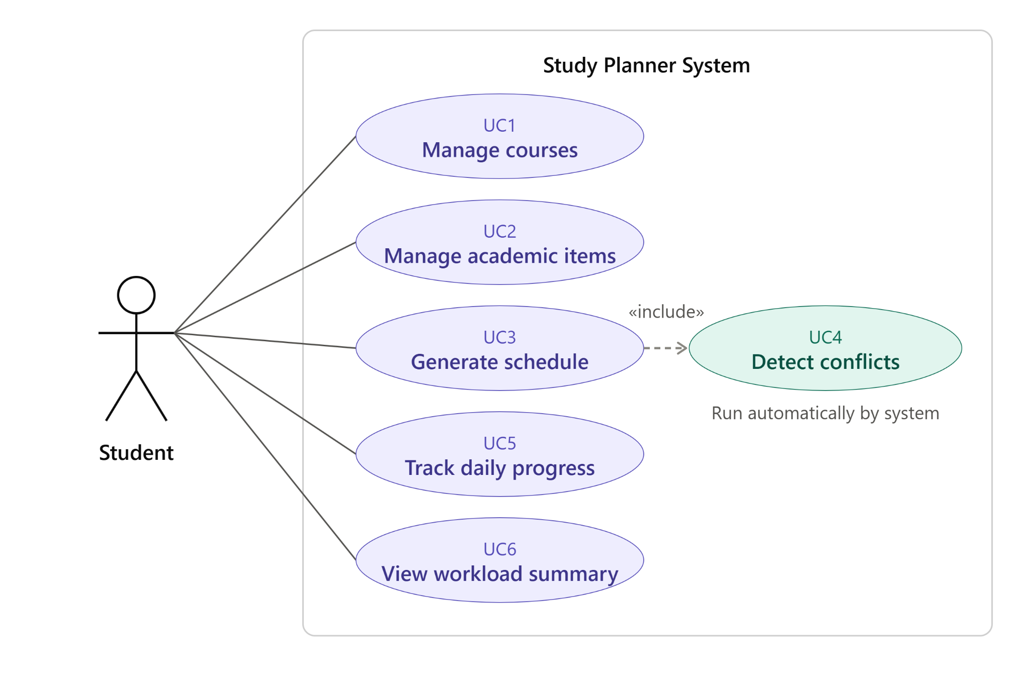
(Above is the Use Case Diagram for our system)

5.2. Dynamic Models
To model how objects interact over time (Booch et al., 2005; Larman, 2004), we analyzed the sequence of events when a student adds coursework and generates their study plan. In our initial sequence diagram draft, addCourse(courseCode) and requestGenerateSchedule() were combined into a single sequence, and the engine called an optimizeSchedule() method. Upon review, we improved this in two ways: first, schedules are generated from AcademicItem tasks rather than empty course codes; second, we replaced the vague optimizeSchedule() call with straightforward date division and conflict checking so the code stays simple to implement.

Sequence 1: Task Creation and Schedule Generation (Lifelines: Student, UI: MainDashboard, Engine: ScheduleEngine, Database: StorageManager)
1. Student calls addAcademicItem(courseCode, title, type, dueDate, estHours) on UI: MainDashboard.
2. UI: MainDashboard calls saveItem(item) on Database: StorageManager, which returns confirmSaved().
3. Student triggers requestGenerateSchedule() on UI: MainDashboard.
4. UI: MainDashboard calls generateSchedule(maxDailyHours) on Engine: ScheduleEngine.
5. Engine: ScheduleEngine calls getCoursesAndTasks() on Database: StorageManager and receives taskList.
6. Engine: ScheduleEngine performs a self-call divideHoursAcrossDays(today, dueDate) to create daily StudyBlock instances.
7. Engine: ScheduleEngine performs a self-call detectDateConflicts(taskList, studyBlocks, maxDailyHours) to flag same-day exams or daily hour overloads.
8. Engine: ScheduleEngine returns studyBlocksAndWarnings to UI: MainDashboard, which calls displayScheduleAndAlerts() for the Student.

Sequence 2: Marking a Daily Study Block CompleteWhen the Student checks off a daily StudyBlock on the dashboard, UI: MainDashboard calls markBlockComplete(blockId) on ScheduleEngine. The engine sets isDone = true on the StudyBlock, subtracts allocatedHours from the parent AcademicItem remaining study hours, calls StorageManager.updateProgress(), and refreshes the dashboard overdue and upcoming highlights.

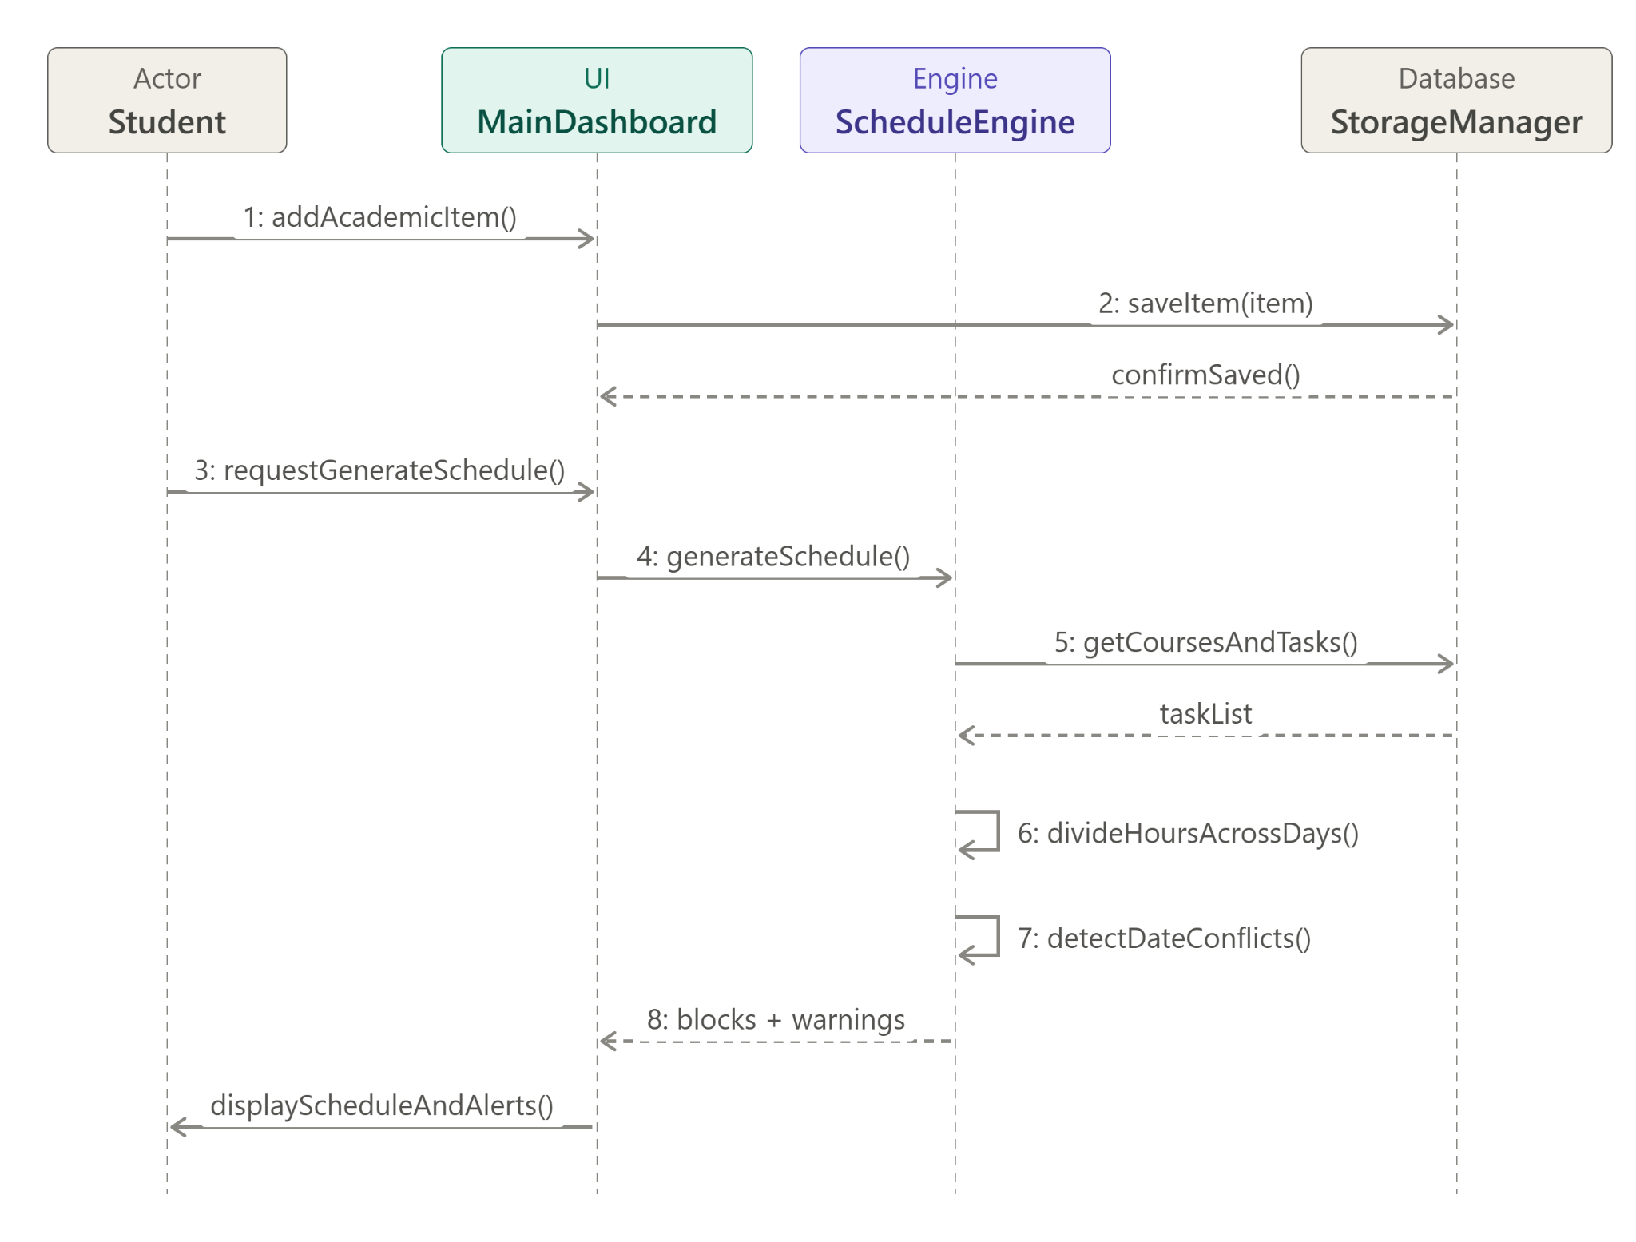
(Above is the Sequence Diagram for our system)

5.3. Object and Class Model
Our initial class diagram draft introduced an abstract AcademicItem superclass with Exam and Assignment subclasses, connected to a ScheduleEngine. Following the entity-boundary-control modeling approach recommended by Bruegge and Dutoit (2009), we improved the Object and Class Model in four specific ways while keeping the Java implementation straightforward:
1. Added a Quiz subclass under AcademicItem so all three required task types (Assignment, Quiz, Exam) use inheritance and polymorphism cleanly.
2. Changed deadline from LocalDateTime to java.time.LocalDate because our system works strictly with calendar days rather than clock times.
3. Added a Course class (1-to-many composition with AcademicItem) and a StudyBlock class (1-to-many association from AcademicItem) to track daily study portions and completion checkboxes.
4. Added StorageManager for local SQLite/JSON persistence and replaced generateMockSchedule() in ScheduleEngine with concrete scheduling and conflict-detection methods.

Class Name | Type / Stereotype | Key Attributes | Key Operations (Methods)
Course | Entity Class | courseCode: String; courseName: String; items: List of AcademicItem | addAcademicItem(item): void; getRemainingCourseHours(): double; getCompletedTaskCount(): int
AcademicItem | «abstract» Superclass | id: String; title: String; dueDate: LocalDate; estimatedHours: double; completedHours: double; isCompleted: boolean | getRemainingHours(): double; calculateDailyHours(today: LocalDate): double; markCompleted(): void; getItemCategory(): String {abstract}
Assignment | Concrete Subclass | complexityLevel: int | getItemCategory(): String; calculateDailyHours(today: LocalDate): double
Quiz | Concrete Subclass | chapterNumber: int | getItemCategory(): String; calculateDailyHours(today: LocalDate): double
Exam | Concrete Subclass | examDurationMinutes: int; weightPercentage: double | getItemCategory(): String; calculateDailyHours(today: LocalDate): double
StudyBlock | Entity Class | blockId: String; assignedDate: LocalDate; allocatedHours: double; isDone: boolean; parentItem: AcademicItem | markBlockDone(): void
ScheduleEngine | Control Class | maxDailyHoursLimit: double | generateDailyBlocks(items): List of StudyBlock; detectConflicts(items, blocks): List of String
StorageManager | Boundary / DAO | dbPathOrJsonFile: String | saveAll(courses): void; loadAll(): List of Course

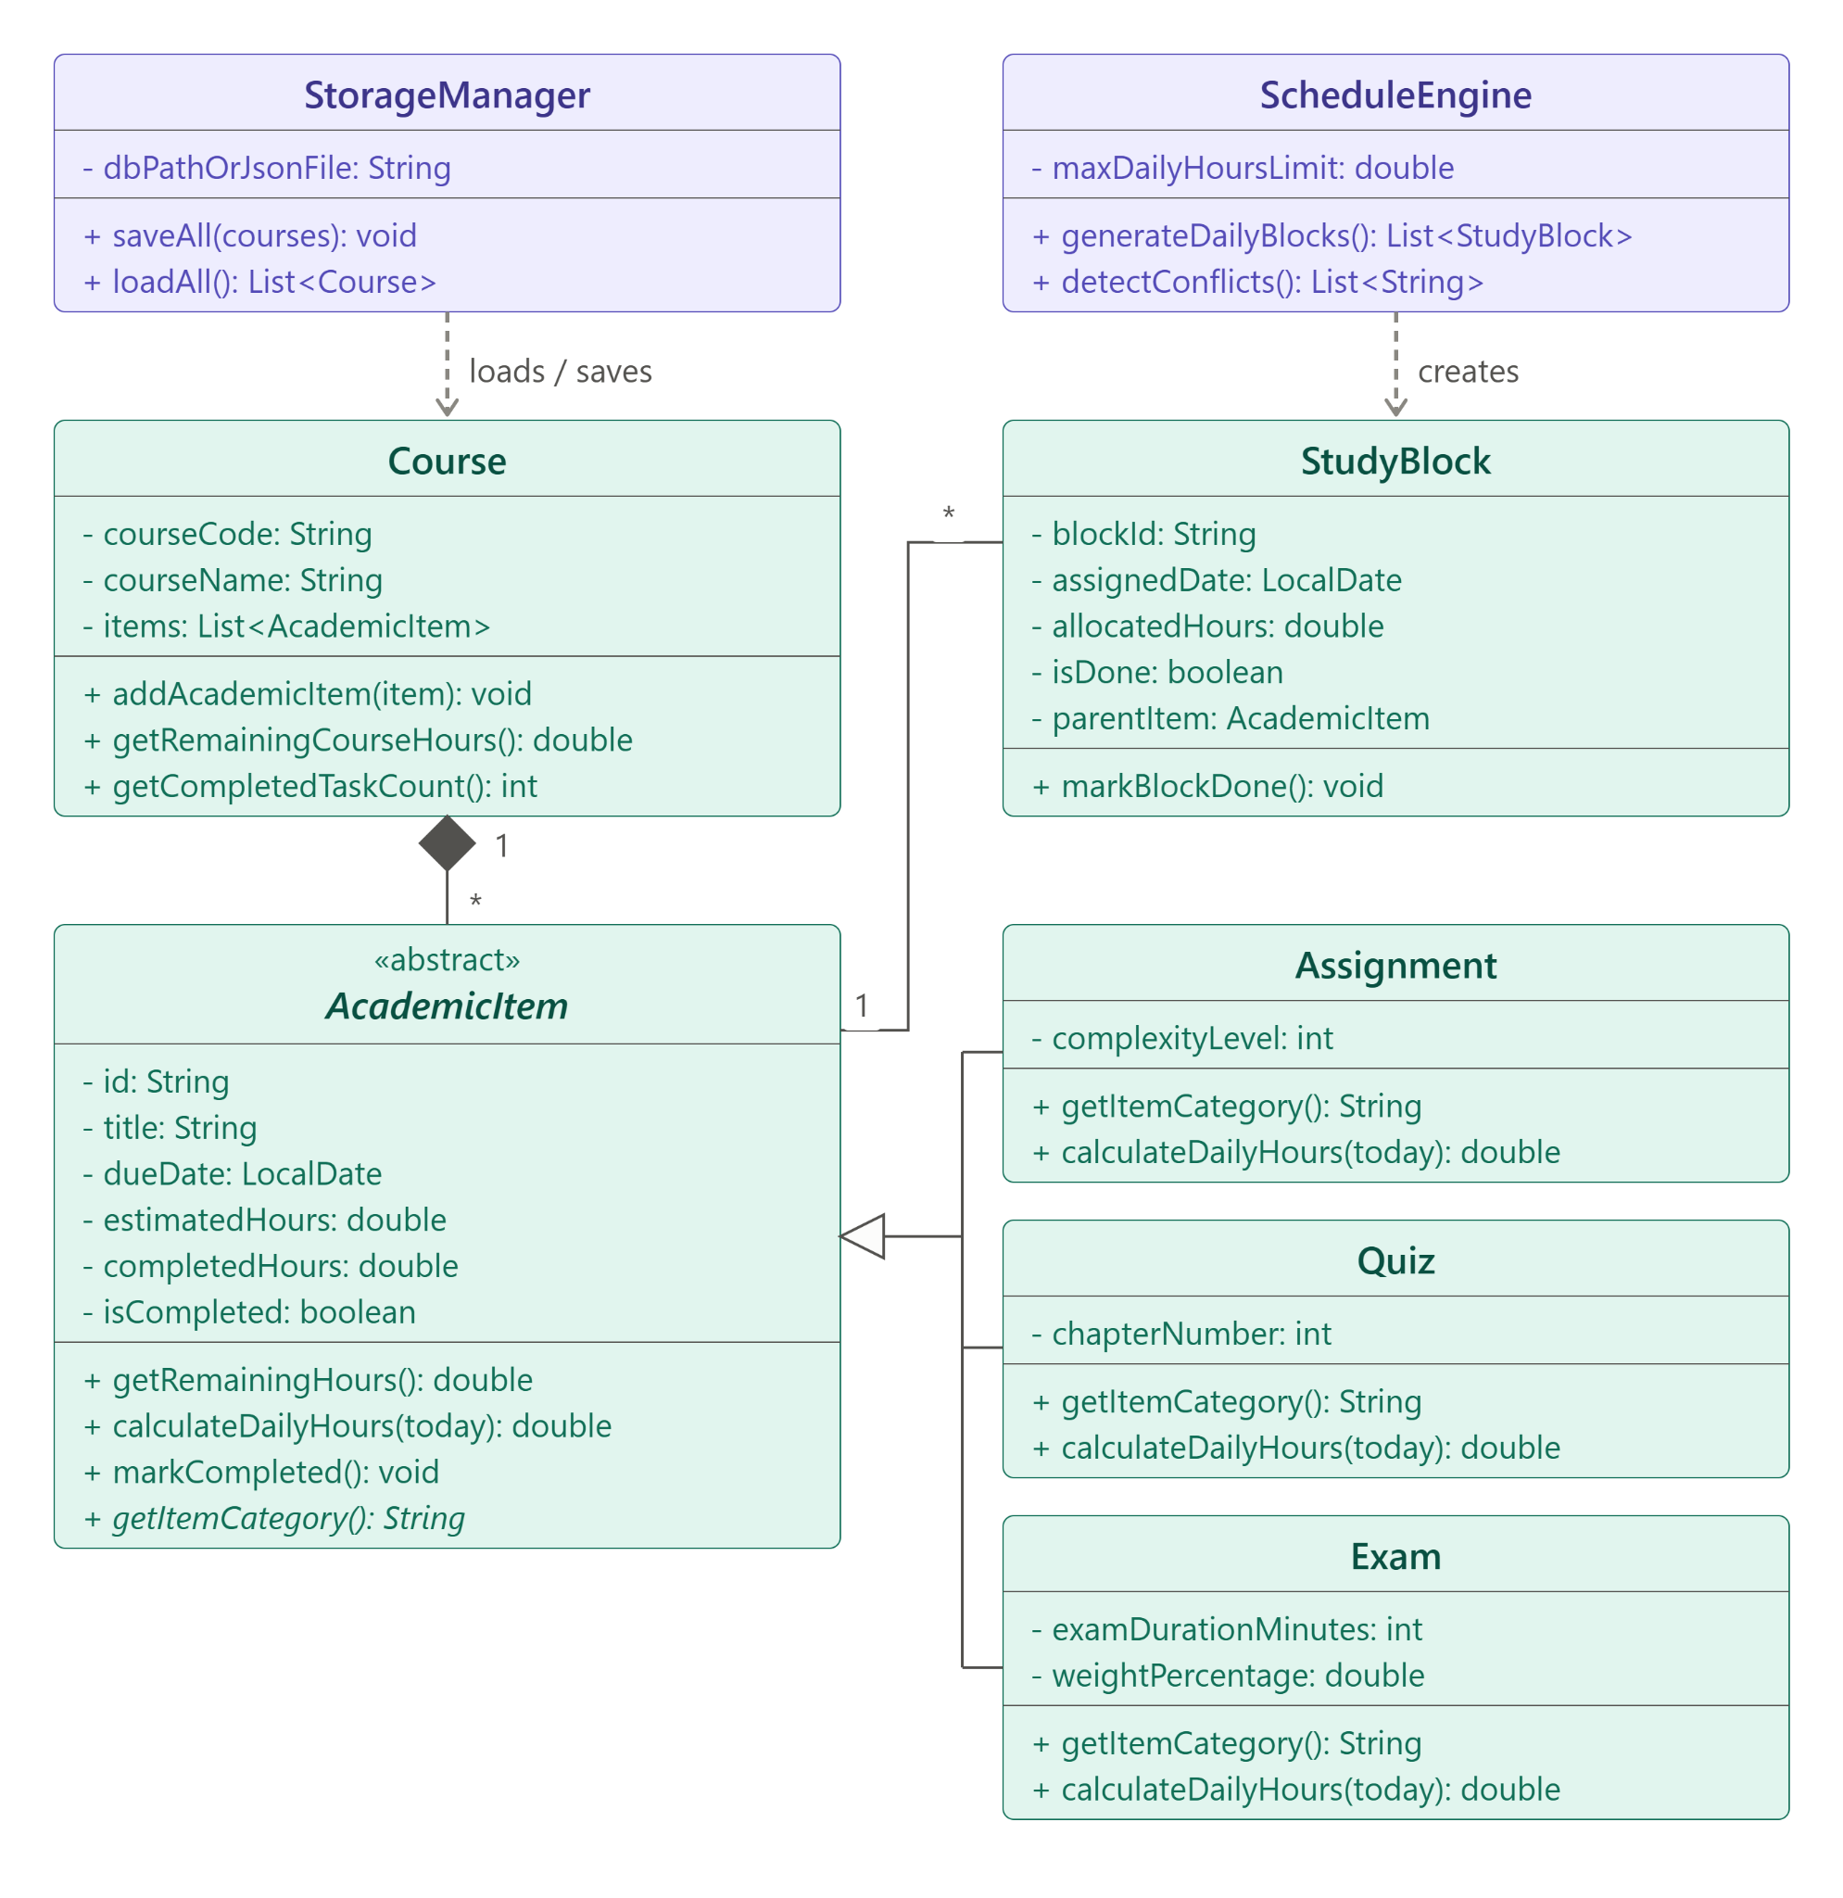
(Above is the Class Diagram for our system)

5.4. User Interface — Navigational Paths and Screen Mock-ups
To keep GUI programming manageable in JavaFX or Swing, the user interface is organized around a single main window with three simple tabs so the user never gets lost in deep pop-up menus:
1. Dashboard and Daily Plan Tab (Home Screen): This is the landing screen when the app opens. At the top, a Conflict and Alert Banner highlights any overdue tasks in red, tasks due within 3 days in yellow, and any conflict warnings (for example, "Conflict Warning: 2 Exams scheduled on 2026-11-20" or "Overload Warning: Nov 18 requires 6.5 hrs, exceeding your 5.0 hr daily limit"). Below that is a table of Today's and Upcoming Study Blocks where each row shows the Date, Course Code, Task Title, Allocated Hours (e.g., 1.5 hrs), and a Mark Complete checkbox.
2. Courses and Tasks Manager Tab: Accessed by clicking the second tab at the top. The left panel shows a list of added courses with an Add Course button. Selecting a course populates the right table with all its Assignments, Quizzes, and Exams, along with a simple input bar at the bottom for Task Title, Type dropdown (Assignment, Quiz, Exam), Due Date picker, and Estimated Total Hours.
3. Workload Summary Tab: Accessed via the third tab. It displays a clean summary table with one row per course, showing Course Code, Total Tasks, Completed Tasks, and Total Remaining Study Hours, plus a numeric field to update the user's Max Daily Study Hours Limit.

6. Glossary and References

Glossary (class definitions and such)
• AcademicItem: The abstract base class representing any graded coursework item (Assignment, Quiz, or Exam) that requires study time before a due date.
• Daily Study Limit: The maximum number of study hours a student wants to work in a single calendar day before the system flags an overload conflict.
• Schedule Conflict: A warning condition triggered either when two or more exams fall on the same date, or when the sum of study blocks on a single day exceeds the Daily Study Limit.
• StudyBlock: A single day's portion of study hours for a specific task, calculated by dividing the task's remaining hours by the number of days left until its deadline.

References (APA 7th Edition)
Booch, G., Rumbaugh, J., & Jacobson, I. (2005). The Unified Modeling Language user guide (2nd ed.). Addison-Wesley Professional. https://www.pearson.com/en-us/subject-catalog/p/unified-modeling-language-user-guide-the/P200000000144/9780134852157

Bruegge, B., & Dutoit, A. H. (2009). Object-oriented software engineering using UML, patterns, and Java (3rd ed.). Prentice Hall. https://www.pearson.com/en-us/subject-catalog/p/object-oriented-software-engineering-using-uml-patterns-and-java/P200000003319/9780133002096

IEEE Computer Society. (1998). IEEE recommended practice for software requirements specifications (IEEE Std 830-1998). Institute of Electrical and Electronics Engineers. https://doi.org/10.1109/IEEESTD.1998.88286

Larman, C. (2004). Applying UML and patterns: An introduction to object-oriented analysis and design and iterative development (3rd ed.). Prentice Hall. https://www.pearson.com/en-us/subject-catalog/p/Larman-Applying-UML-and-Patterns-An-Introduction-to-Object-Oriented-Analysis-and-Design-and-Iterative-Development-3rd-Edition/P200000000422

Sommerville, I. (2016). Software engineering (10th ed.). Pearson Education. https://www.pearson.com/en-us/subject-catalog/p/Sommerville-Software-Engineering-10th-Edition/P200000003258

