Editor(s): Arne Bröring

Date | Version | Comment
25-02-2011 | 0.1 | Initial version, Arne Bröring

Outcome of Ticket 35

Recommendation on EEA Database Model
The EEA has designed a database model for near real time (NRT) data which is so far used for air quality data. In this task, the existing data model is analyzed whether it can be utilized by the SOS Extension for ESRI’s ArcGIS Server. It is investigated if an on-the-fly mapping between the two schemas is feasible or if a new data model optimized for the SOS extension is required. First, an introduction to OGC’s SOS and O&M model is given in Section 1. Then, Section 2 describes the model of the ArcGIS Server SOS Extension. Section 3 analyses the database model of the EEA and tries to map the contents of both models. Finally, Section 4 provides a conclusion and recommends a decision.

Background: OGC’s SOS and O&M
The interface of OGC’s Sensor Observation Service (SOS) supports access to heterogeneous sensor types, stationary as well as mobile sensors, which gather their data in-situ or remotely. The heterogeneous communication protocols and data formats of the associated sensors are hidden by the standardized interface (see Figure 1). To associate the SOS with a sensor, a description of this sensor is uploaded to the SOS via the RegisterSensor operation which can be accessed subsequently by calling the DescribeSensor operation. The InsertObservation operation is responsible for the integration of newly measured data. Those uploaded observations can be requested by calling the GetObservation operation using a combination of temporal, spatial, and thematic filters.

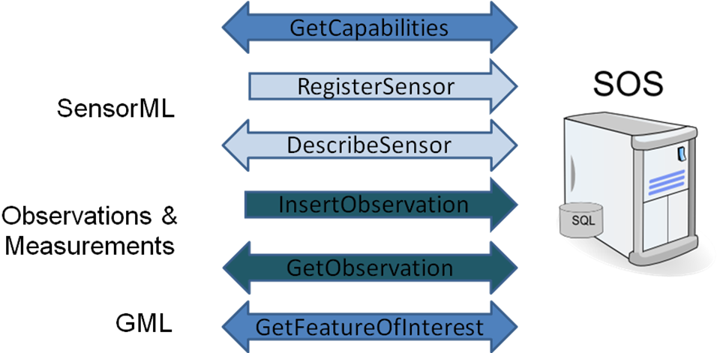
Figure 1 - Overview of the interface of OGC’s SOS.
For the encoding of the data hosted by an SOS, basically three specifications are utilized. First, the Sensor Model Language (SensorML) is used to describe the sensor's metadata. SensorML specifies a model and encoding for processes - while process acts as super type for sensor systems and sensor related processes such as post processing procedures. Physical as well as logical sensors (e.g., simulations) can be modeled. A sensor can be described in detail, including its identification, classification, inputs, outputs, parameters, and characteristics such as a spatial or temporal description.
The two other specifications used by the SOS to encode data are the Geography Markup Language (GML) and its application profile O&M. Thereby, the O&M specification is most important, since it is used to model and encode observed sensor data.
O&M defines an observation as an act of observing a certain phenomenon. The basic observation model is shown in Figure 2. An observation has a relationship to a procedure representing the process which has performed the observation, e.g. a sensor, but may also be a human observer or a computation. The observed property points to a description of the phenomenon which is observed (e.g. 'water temperature' or 'salinity'). This phenomenon has to be a property of the feature of interest. The feature of interest is a real world entity that is the target of an observation. The observation provides a value for this observed property at a certain time, the phenomenon time. The observation value is contained in the result element. In the basic observation model, the result can be of any type, for example a numeric measurement (e.g., 23°C) or a nominal value (e.g., “warm”). Subtypes of the basic observation further define this result type. The result value can be associated with a result quality. This allows for example to define that the measurement of a thermometer has an error interval of 0.03°C.
The feature of interest is encoded in GML and can either be represented by a domain feature or by a sampling feature. A domain feature (e.g. ‘Gulf of Mexico’) is designed for a particular application domain. A sampling feature (e.g. 'Station', 'Trajectory', or 'Scene') is domain independent and purely an artifact of the sampling strategy to produce observations for a domain feature.
The sampling feature links to the domain feature which represents the spatially distributed real world entity. For example, when measuring the water temperature of the Gulf of Mexico at different depths, the concrete locations of the measurements are represented through three dimensional sampling points. Those sampling points reference the feature representation of the Norwegian Sea which carries the water temperature property. This shows that the observed property of an observation can either be a direct or transitive member property of the feature of interest. That means, if the feature of interest is a sampling feature, the observed property has to be either a member of the sampling feature or of the domain feature.

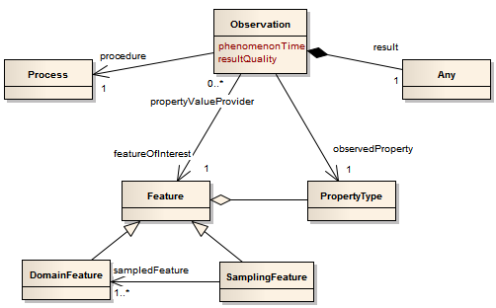
Figure 2 - Excerpt of the basic O&M observation model.
On service level, at the SOS, the observations are grouped by so-called ObservationOfferings. One such offering groups the observations produced by one particular procedure. The offering makes all metadata of this group of observations available. Such metadata are for example the begin- and end-time as well as the overall bounding box of all associated observations.

The Database Model of the ArcGIS SOS Extension
Based on the above described O&M model for representing observations, this section presents the database model of the ArcGIS SOS Extension. This database model is generic in a sense that it is not restricted to a particular use case of observation data. With the flexible O&M model as its foundation, this database model can be applied to various domains, ranging from hydrology over oceanography to air quality monitoring.
Figure 3 depicts the designed database model. To implement this model, each box can be mapped to a database table with the according columns.

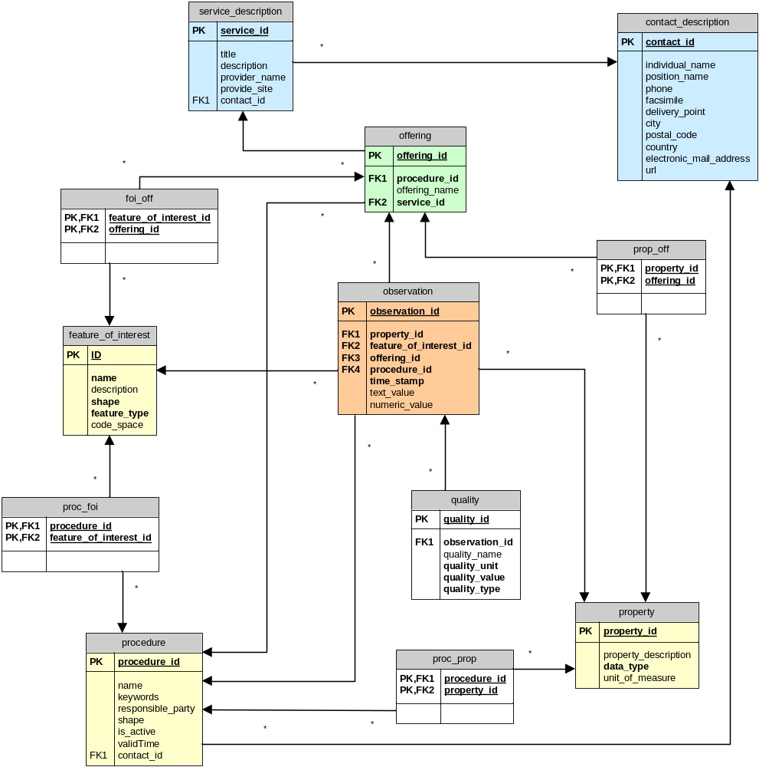
Figure 3 - Generic database model for observations.
The observation type is at the center of the model. It carries a time stamp for storing the phenomenon time and can have a text value OR a numeric value as its result. (Note that this OR relationship cannot be reflected in the model but is applied in the implementation.) Further, the observation has foreign keys to the associated observed property, the feature of interest, and the procedure. Also, the observation is grouped to an observation offering, and has therefore an according foreign key.
To state information about the quality of the result of an observation, the quality type is created. Besides a foreign key to the according observation, it carries the name, unit, type, and value of the quality.
Which unit and data type have to be used to interpret the result is stored in two attributes of the property type. This type also allows storing a description for the observed property. This can also be a link to a more detailed description of the property / phenomenon observed by the sensor. The property type has n:m relationships to the offering, which hosts observations with this particular property, as well as to the procedure, which has this particular property as its output.
The feature of interest type stores the id (and its codespace), name, description, type, and geometry (shape) of the feature. It has n:m relationships with the offering to which it belongs and the procedure which it observes.
The procedure type represents the sensor and contains various metadata to describe a sensor. Besides a service-wide unique id, name, contact information to the responsible party, this type contains the current position (shape) of the sensor. Having such a spatial attribute for the feature of interest as well as for the procedure allows use cases of mobile sensors moving within the extent of a feature (e.g., a PM10 sensor on a bus driving around within the city of San Diego, or a CTD sensor attached to a marine drifter within the Gulf of Mexico). However, in cases of stationary sensors (e.g., thermometer and barometer attached to a weather station), the position of the procedure and of the feature are equivalent. Further attributes of the procedure are its state (is_active) as well as the valid time of its description.

Analysis of the EEA Model for Near Real Time Data
The screenshot below (Figure 4) shows the data model which is currently used by the EEA for the storage of air quality data.

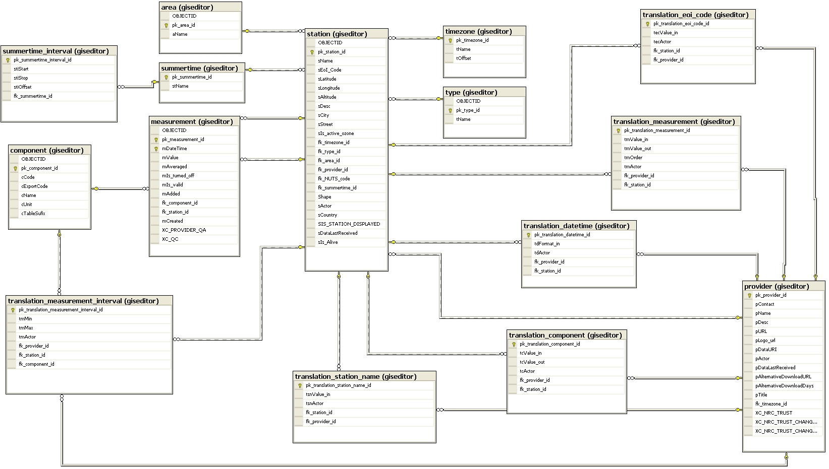
Figure 4 - The current EEA Model for NRT data

In the following, a schema mapping between the model of the ArcGIS Server SOS Extension (Section 2) and the EEA model for near real time data is provided. Thereby, only relevant fields of the EEA model are considered. Not considered are the XC_* fields as well as the translation_* tables. They cannot be mapped to SWE models. Further, the attributes of the tables area and type cannot be mapped to the SWE models. On the other hand, the EEA model lacks corresponding tables for offering and service_description. The information content of the tables summertime, summertime_interval, and timezone can be derived from the time_stamp attribute of the observation table. So, mainly the tables station, provider, measurement, and component of the EEA model are considered.

The table station can be best related to the feature of interest in the O&M model. As shown in Table 1, the attributes id, name, description, and shape of the feature_of_interest table can be mapped to station attributes. However, the code_space attribute cannot be found in the EEA model and the type attribute associated with a station in the EEA model has a different purpose than in the O&M model.
On the other hand, the attributes sIs_active_ozone, sDataLastReceived, and sActor of the EEA model cannot be mapped to SWE concepts.

Table 1 - Mapping between feature of interest and station.
SOS Extension : feature_of_interest | EEA : station
id | pk_station_id  (or: sEoI_Code?)
name | sName
description | sDesc
code_space | not present
shape | Shape  (or: sLatitude, sLongitude, sAltitude?)
feature_type | not present  (the table 'type' has other semantics)
not present | sIs_active_ozone
not present | sDataLastReceived
not present | sActor

Other attributes of the EEA station can be mapped to the procedure in the SOS Extension model (see Table 2). However, not all attributes of the procedure can be found at the station. For example, the individual_name, position_name, and url of the responsible_party of the procedure can be taken from the EEA provider table. Also, some properties of the provider (e.g., pLogo_URL, or pActor) cannot be mapped to the SOS Extension model.

Table 2 - Mapping between procedure and station as well as provider.
SOS Extension : procedure | EEA : station
procedure_id | pk_station_id  (or: sEoI_Code?)
name | not present
keywords | not present
valid_time | not present
shape | station:Shape  (or: sLatitude, sLongitude, sAltitude?)
is_active | sIs_Alive
responsible_party
delivery_point | sStreet
city | sCity
country | sCountry
 | EEA : provider
individual_name | pContact
position_name | pTitle
url | pURL
electronic_mail_address | not present, but not required
administrative_area | not present, but not required
postal_code | not present, but not required
phone | not present, but not required
facsimilie | not present, but not required
not present | pDesc
not present | pLogo_URL
not present | pDataURI
not present | pActor
not present | pDataLastReceived
not present | pAlternativeDownloadURL
not present | pAlternativeDownloadDays

The table property of the SOS Extension relates to the EEA component (see Table 3). Here, the SOS Extension attributes property_id, property_description, and unit_of_measure find their counterparts, while there is no attribute in the EEA model that defines the data_type (e.g., numerical, textual, categorical) of the component.

Table 3 - Mapping between property and component.
SOS Extension : property | EEA : component
property_id | pk_component_id
property_description | cName
unit_of_measure | cUnit
data_type | not present
not present | cCode
not present | cExportCode

The mapping between the observation table and the EEA measurement is shown in Table 4. Since the EEA model only considers numeric values, a field corresponding to text_value is missing. Also, several attributes of the EEA model cannot be mapped to SWE concepts.

Table 4 - Mapping between property and component.
SOS Extension : observation | EEA : measurement
observation_id | pk_measurement_id
time_stamp | mDateTime
text_value | not present, but not required
numeric_value | mValue
not present | mAveraged
not present | mIs_turned_off
not present | mIs_valid
not present | mAdded
not present | mCreated

Conclusion
The analysis and mapping of the two models showed, that there are significant differences and incompatibilities. Key concepts of the O&M and SOS models are not present within the EEA model. For example, the concept of procedure cannot be found and the properties for this type need to be taken from various tables. Hence, an amendment and redesign of the EEA model is recommended for an easier linkage with the SWE models and the database model of the SOS Extension in particular. On the other hand, several attributes of the EEA model do not find correspondence in the model of the SOS Extension. For being able to include that information, also the SOS Extension model needs to be extended for this specific application. Such use case dependent extensions are possible. Besides extending the procedure table to represent some of the missing properties in SensorML, additional tables (e.g., to map the translation_* tables) can be included.

