Sensor Web Enablement

Simplified integration of SWE in ArcGIS Server

May 2010,
European Environment Agency – Jan Bliki, Peter Kjeld
52° North GmbH – Andreas Wytzisk, Simon Jirka

Introduction
Within the last year the demand of near real time environmental data is steadily increasing. Thus, systems for exchanging such data are becoming more and more important.

Since 2006, EEA has been operating “Ozone web” based on ozone in-situ data delivered in near real time by the EU member states. This system is built on proprietary data formats using technology from Microsoft SQL Server, Microsoft BizTalk, ArcIMS and clients developed in Adobe Flash. Recently the data flow has been expanded also to cover other air quality components like PM10, NO_{x} etc., but also bathing water quality samples during the summer. These data are partly exposed to the public, but again based on proprietary data formats. As of January 2010 EEA received data from 62 data providers, divided on 28 European countries.

However, the use of such proprietary data formats has some serious drawbacks:
- Member states’ data provided through proprietary interfaces and data formats makes it difficult for EEA to import the offered data into its applications. Thus, significant work is needed for continuously adjusting existing applications to new (potentially domain-specific) data formats and interfaces. In addition, the flexibility for importing new data sources is limited.
- EEA has no mandate to decide what software is used by the providers. It is therefore of most important to use open standards to allow a basic integration of the providers data flow.
- Due to the heterogeneous means through which member states are providing their environmental data, the process of collecting this data becomes very complex and costly.

Consequently we see a significant need to rely on open standards and a service based architecture for exchanging environmental data within Europe and in particular between EEA and the EU member states. This will on the one hand facilitate the access to environmental data provided by the EEA and on the other hand reduce the workload for collecting data from the different member states.

Sensor Web Enablement
The Sensor Web Enablement (SWE) initiative of the OGC has been active for several years. The SWE activities have lead to a standard based framework comprising data formats for sensor data and metadata as well as web service interfaces (e.g. for accessing sensor data).

Among the SWE standards especially the Sensor Observation Service (SOS) interface and the Observations and Measurements (O&M) data format have already reached a broad acceptance. Whereas the SOS offers an interface for retrieving sensor data and metadata, O&M provides a common encoding for data measured by sensors.

Several pilot projects have successfully evaluated the practical application of SWE, among them several EU funded FP6 and FP7 projects (e.g. SANY (http://www.sany-ip.eu/) OSIRIS (http://www.osiris-fp6.eu/) and GENESIS (http://genesis-fp7.eu/). These positive results have lead in recent years to several SWE based systems that have been deployed for productive use. Examples are the German Indonesian Tsunami Early Warning System (http://www.gitews.de/) or the PEGELONLINE-SOS providing near-real time water level data for all federal waterways in Germany (http://tws01.terranovaws.it/osiris/wwuworkshop/DLZ_IT_BVBS.pdf).

Architecture
Back in 2009, EEA took the initiative of starting up a project to evaluate if SWE would be a future solution for their near real time data flows.
A first step was to expose these data as a Sensor Observation Service (Fig. 1), and hereby being able to provide a standardised interface to the data. This is already a significant improvement compared to the current situation. Currently the data are only available through simple XML files, which lead to a huge overhead of data processing for the data users. The standardized SOS interface in conjunction with the common O&M encoding for sensor data facilitates the access to sensor data drastically.

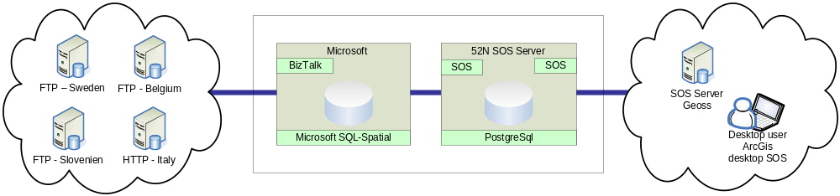
Fig 1: First step: exposing the existing EEA near real time data through a SOS server.

However, as outlined in the introduction section, the access to sensor data by users is only one of two aspects that have to be addressed. At the same time the EEA sees a need to allow member states to deliver their data through the SOS interface. This is the next step that has to be addressed in addition to exposing near real time data through the SOS interface. This will lead to a system as outlined in Fig. 2.

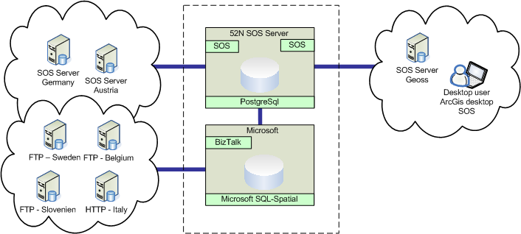
Fig. 2: Receive and expose data using SOS.

However, the approach shown in Fig. 2 would require member stated to install SOS servers in addition to their existing systems and to create bridges between these systems and the SOS servers. Thus, work would be needed to convince member states to install a SOS server and hook it up to their production databases. Besides setting up the server, member states would need components to link their near real time database to SOS instances.

An immediate and complete migration of all member states in the direction of the SOS standard is unlikely as some member states will be interested in moving to SOS, others may be waiting for a “black box” implementation making the move as easy and less costly as possible. Consequently it must be expected that the EEA will still receive data through the existing data flow.
But what happens if existing software is suddenly supporting SOS, software that users are already familiar with and is part of the member state organisation’s IT architecture? What if ArcGIS Server would support SOS, just like it supports various other open standards like WMS and WFS? In that case it will become much simpler for member states to also support SWE in their existing environments (see Fig 3.)

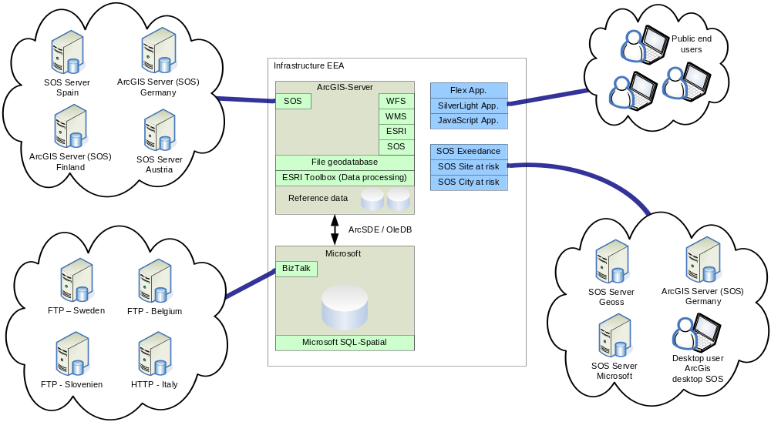
Fig 3: SOS interface available in ArcGIS Server

As shown in Fig 3, data is partly delivered to EEA using the existing file based data delivery into Microsoft BizTalk and a near real time database. However at the same time data also comes in through national or regional SOS servers relying on the built-in SOS interface in ArcGIS Server. All usage of the near real time data by EEA applications and services will then be based on the ArcGIS Server SOS interface.

On top of this solution a number of applications and aggregation services can be built. ArcGIS toolbox and the access to all EEA’s reference data would allow ArcGIS server to geo-process the incoming data; produce new derived products and pass them on to EEA’s global or local partners as new European SOS services. Examples of SOS servers could be a European ozone exeedences service, interpolated maps, health risk areas, etc. (all in near real time). Besides this ArcGIS allows us to re-use all other available services such as WMS, WFS, Google, ESRI, Microsoft Bing Map services or produce final products such as interactive map viewers or dynamic reports.

This architecture will ensure an open access to environmental near real time data based on existing software and existing open standards.

Use cases
To support the suggested architecture, we have described 3 use cases taken from the real world where a SOS interface would be very useful.

Use case 1 – Provide access to near real time data
Air quality data, measured in near real time, covering the whole of Europe is very useful for air quality modelling. One of the GMES services provided by the MACC project (Monitoring Atmospheric Composition and Climate), offers air quality forecasts for Europe. To provide this kind of forecasts timely and relevant data are important. The MACC project uses data from various sources. Thus it is an advance if data can be fetched using standard protocols and data formats, to avoid building and implementing properitary data exchange systems.

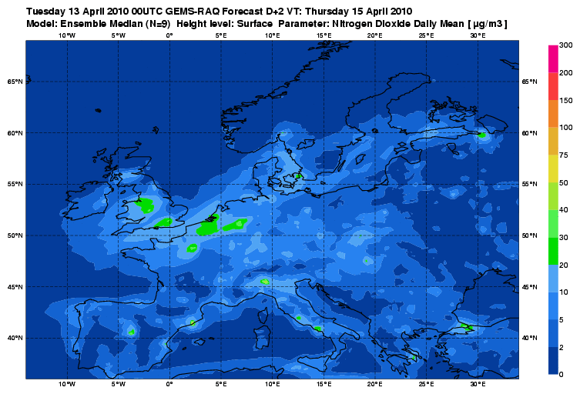
Fig 4: Model output from MACC forecast.

Currently, MACC would has to accept the data files as exposed by EEA, which leads to a significant overhead for processing, filtering and aggregation of redundant air quality data. Although this is not an optimal solution, it is currently the only option.

In our scenario, MACC would get access to the EEA near real time air quality data through a SOS server in their setup which would communicate with the EEA ArcGIS Server, and extract the data which is of interest to MACC. In this case, MACC would probably specify request parameters like air quality components (O₃, NO₂, etc.) and timeframe (last 24 hour data).

Use case 2 – Global exchange of environmental data – EEA and US-EPA
The increasing demand of environmental data is not only regional, national but indeed also global. An initiative between US Environment Protection Agency (US EPA) and EEA is currently discussing how near real time air quality data can be exchanged and used to the benefit of both organisations.

From EEA’s experience it is important that a simplified approach is selected in order to setup a robust and stabile system, and we believe that a SOS interface would provide this. By selected an open standard such as SOS, we will ensure a re-useable system where additional nodes, such as UN Environment Programme (UNEP), would also be able to hook in. By providing our data through the ArcGIS SOS server, we can ensure that our investment in this specific case would also be useful for other initiatives.

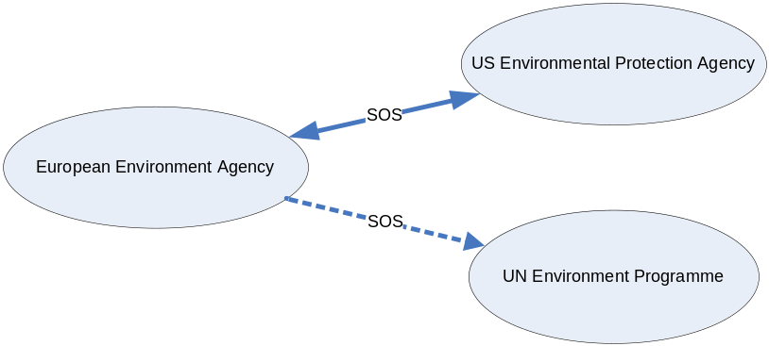
Fig 5: Global data exhange by use of SOS server

Use case 3 - Expose PRTR data
The European Pollutant Register and Transfer Register (E-PRTR) contains point information on chemical exposure in air, water and waste from industry sites around Europe. Currently this dataflow is yearly updated, but it has potential of a higher update frequency. Because of this, offering E-PRTR data through a SOS would lead to significant advantages. For example a SOS would allow the data to be used in various data analysis and applications by external partners. Today these data are available through the EU Commission website (http://eprtr.ec.europa.eu (the website is hosted by EEA and was also developed in close cooperation with EEA)) and is further transferred to the UN for a global picture today as KML.

This example also shows that EEA is becoming a cascaded data provider, where data are collected, harmonized and quality assured before the data are further exposed.

Summary
EEA believes that there is a market for integrating SWE, especially SOS, in existing GIS systems in order to give open access to data as easy and re-useable as possible - an idea supported by SEIS (Shared Environmental Information System), where access to timely and relevant data in the EU member states is a main driver.
The aim of EEA is to establish SWE as a toolbox which member states can use to share data with a strong emphasis on practical and simplified implementation and use. EEA wants to move SWE into production systems.
The benefit of supporting the SOS interface in commercial and well proven GIS systems, like ArcGIS Server, will support a rapid penetration of the SWE standards into the market, for instance to the member states delivering environmental data to the EEA.
Thus, EEA aims at working together with 52° North and ESRI in order to advance the use and support of the SWE standards. This will especially comprise the following aspects:
- Realization of a first stage which comprises the provision of near real time environmental data by EEA through a SOS server (currently ongoing)
- Specifying and documenting how the according SWE standards (i.e. SOS and O&M) shall be used for the provision of data and for delivering data. This will be a straightforward approach that will focus on the core elements of the SWE standards in order to ensure a high performance and low complexity of interfaces and data formats (“Simple SWE”)
- Enabling the SOS support within ArcGIS Server
This approach will help the EEA to improve their ability to offer users an easy access to near real-time environmental data while reducing at the same time the costs for collecting environmental data from member states.

