

Compte rendu Long Lab

Made by :

MESAOURI DEBOUN Bilal

Skander Meziou

Table des matières

I. How to compile & run the project: 3

II. Project architecture : 3

III. Encountered problems : 4

# How to compile & run the project:

* Open terminal
* Change the directory to the folder containing the project
* Execute:
  + javac *.java
  + Java Server
  + Java Client
  + Java Client2
* To add new candidats and users run : java CandidatsInput
* Initial credential for already added users are :
  + Nom : a – mot de passe : a
  + Nom : b – mot de passe : b

# Project architecture :

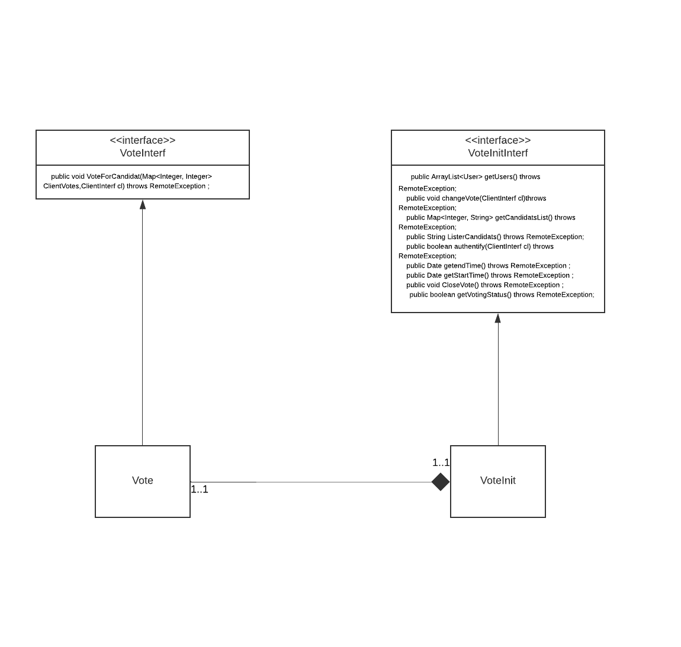

# Encountered problems :

* Passing the stub of the client to the server (we should have put the interface name as parameter type but we did put class name at first then corrected it)
* Package managing when creating project in multiple packages

# Developed features :

* Start vote by typing start on console and closing after a number of days(seconds for testing purposes)
* Changing vote
* adding Candidates and users to vote using the Hard Way
* and other features …