Bilal Wani

bilal.wani.pub@oultook.com

mICROSOFT AZURE

BILAL WANI NOTES

Table of Contents

2 Azure AZ-900 Certification 2

2.1 Course Contents 2

2.1.1 Skills measured 2

2.1.2 Functional groups 2

2.1.3 Describe cloud concepts (25–30%) 2

2.1.4 Describe Azure architecture and services (35–40%) 2

2.1.5 Describe Azure management and governance (30–35%) 3

2.2 Chapter 1 – Cloud Concepts of Azure (25 – 30%) 4

2.2.1 Module 1 – Cloud Computing 4

2.2.2 Module 2 – Benefits of using Cloud Services 4

2.2.3 Module 3 – Cloud Services Types 4

2.3 Chapter 2 – Azure Architecture & Services (35 – 40%) 4

2.3.1 Module 1 – Core Architectural Components of Azure 4

2.3.2 Module 2 – Azure Compute & Networking Services 5

2.3.3 Module 3 – Azure Storage Services 5

2.3.4 Module 4 – azure identity, access, and Security 5

2.4 Chapter 3 – Azure Management & Governance (30 – 35%) 5

2.4.1 Module 1 – Cost Management in Azure 5

2.4.2 Module 2 – feature & Tools in Azure for Governance & Compliance 5

2.4.3 Module 3 – Features & Tools for Managing & Deploying Azure Resources 5

2.4.4 Module 4 – Monitoring Tools in Azure 5

# Azure AZ-900 Certification

## Course Contents

### Skills measured

* Describe cloud concepts (25–30%)
* Describe Azure architecture and services (35–40%)
* Describe Azure management and governance (30–35%)

### Functional groups

### Describe cloud concepts (25–30%)

#### Describe cloud computing

* Define cloud computing
* Describe the shared responsibility model
* Define cloud models, including public, private, and hybrid
* Identify appropriate use cases for each cloud model
* Describe the consumption-based model
* Compare cloud pricing models

#### Describe the benefits of using cloud services

* Describe the benefits of high availability and scalability in the cloud
* Describe the benefits of reliability and predictability in the cloud
* Describe the benefits of security and governance in the cloud
* Describe the benefits of manageability in the cloud

#### Describe cloud service types

* Describe infrastructure as a service (IaaS)
* Describe platform as a service (PaaS)
* Describe software as a service (SaaS)
* Identify appropriate use cases for each cloud service (IaaS, PaaS, SaaS)

### Describe Azure architecture and services (35–40%)

#### Describe the core architectural components of Azure

* Describe Azure regional, regional pairs, and sovereign regions
* Describe availability zones
* Describe Azure datacenters
* Describe Azure resources and resource groups
* Describe subscriptions
* Describe management groups
* Describe the hierarchy of resource groups, subscriptions, and management groups

#### Describe Azure compute and networking services

* Compare compute types, including container instances, virtual machines (VMs), and functions
* Describe VM options, including Azure Virtual Machines, Azure Virtual Machine Scale Sets, availability sets, and Azure Virtual Desktop
* Describe resources required for virtual machines
* Describe application hosting options, including the Web Apps feature of Azure App Service, containers, and virtual machines
* Describe virtual networking, including the purpose of Azure Virtual Networks, Azure virtual subnets, peering, Azure DNS, Azure VPN Gateway, and Azure ExpressRoute
* Define public and private endpoints

#### Describe Azure storage services

* Compare Azure storage services
* Describe storage tiers
* Describe redundancy options
* Describe storage account options and storage types
* Identify options for moving files, including AzCopy, Azure Storage Explorer, and Azure File Sync
* Describe migration options, including Azure Migrate and Azure Data Box

#### Describe Azure identity, access, and security

* Describe directory services in Azure, including Azure Active Directory (Azure AD) and Azure Active Directory Domain Services (Azure AD DS)
* Describe authentication methods in Azure, including single sign-on (SSO), multifactor authentication, and passwordless
* Describe external identities and guest access in Azure
* Describe Azure AD Conditional Access
* Describe Azure role-based access control (RBAC)
* Describe the concept of Zero Trust
* Describe the purpose of the defense in depth model
* Describe the purpose of Microsoft Defender for Cloud

### Describe Azure management and governance (30–35%)

#### Describe cost management in Azure

* Describe factors that can affect costs in Azure
* Compare the Pricing calculator and the Total Cost of Ownership (TCO) calculator
* Describe the Azure Cost Management and Billing tool
* Describe the purpose of tags

#### Describe features and tools in Azure for governance and compliance

* Describe the purpose of Azure Blueprints
* Describe the purpose of Azure Policy
* Describe the purpose of resource locks
* Describe the purpose of the Service Trust Portal

#### Describe features and tools for managing and deploying Azure resources

* Describe the Azure portal
* Describe Azure Cloud Shell, including Azure CLI and Azure PowerShell
* Describe the purpose of Azure Arc
* Describe Azure Resource Manager and Azure Resource Manager templates (ARM templates)

#### Describe monitoring tools in Azure

* Describe the purpose of Azure Advisor
* Describe Azure Service Health
* Describe Azure Monitor, including Log Analytics, Azure Monitor alerts, and Application Insights

## Chapter 1 – Cloud Concepts of Azure (25 – 30%)

### Module 1 – Cloud Computing

### Module 2 – Benefits of using Cloud Services

### Module 3 – Cloud Services Types

## Chapter 2 – Azure Architecture & Services (35 – 40%)

### Module 1 – Core Architectural Components of Azure

Physical architecture of Azure starts with datacentres around the world. The datacentres are grouped in a geographical location to form the **regions** or **availability** **zone**.

Availability zones are physically separate datacenters within an Azure region. Each availability zone is made up of one or more datacenters equipped with independent power, cooling, and networking.

Availability zone are further divided into Zonal Services (Zone specific), Zone-redundant services (automated replicas across zones), Non-regional services (not related to region, services are always available from Azure geographies)

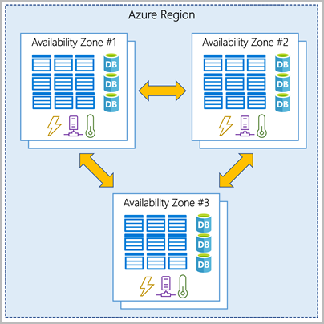

**Azure resources and resource groups**

A resource is the basic building block of Azure. Virtual Machine (VM), virtual networks, databases, storage discs etc are all considered resources within Azure.

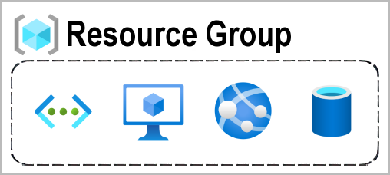

**Resource group** is simple a group of resources. A resource which is part of one resource group, cannot be associated with other resource group. Resource groups cannot be nested. Deleting a resource group will delete all resources within that group.

**Azure Subscription**

In Azure, subscriptions are unit of management, billing, and scale.

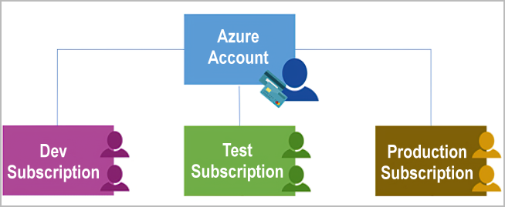  
An account can have multiple subscriptions. The multiple subscription account can have different types of billing requirements. The two types of subscriptions boundaries are:

1. Billing boundary
2. Access control boundary

**Azure management groups**

Resources are gathered into resource groups, and resource groups are gathered into subscriptions. Azure management groups provide level of scope above subscriptions. The subscriptions are grouped into containers called management groups and apply governance conditions to the management groups.

The hierarchy for management groups, subscriptions, and resource groups.

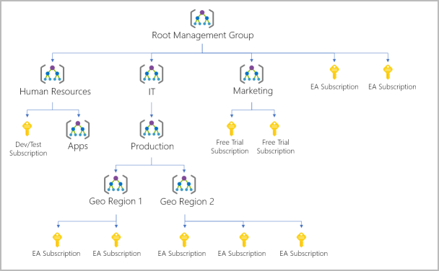

### Module 2 – Azure Compute & Networking Services

For hosting the applications, the Azure offers Virtual Machines (VMs) or containers. The VMs provide maximum control of the hosting environment and allows configuration.  Containers, with the ability to isolate and individually manage different aspects of the hosting solution, can also be a robust and compelling option.

Azure app is also a hosting

**Azure App Service**

App Service enables you to build and host web apps, background jobs, mobile back-ends, and RESTful APIs in the programming language of your choice **without managing infrastructure**. It offers automatic scaling and high availability. App Service supports Windows and Linux. It enables automated deployments from GitHub, Azure DevOps, or any Git repo to support a continuous deployment model.

Azure App Service is an HTTP-based service for hosting web applications, REST APIs, and mobile back ends. It supports multiple languages, including .NET, .NET Core, Java, Ruby, Node.js, PHP, or Python. It also supports both Windows and Linux environments.

With App Service, you can host most common app service styles like:

* Web apps
* API apps
* WebJobs *(WebJobs feature is used to run a program (.exe, Java, PHP, Python, or Node.js) or script (.cmd, .bat, PowerShell, or Bash) in the same context as a web app, API app, or mobile app. They can be scheduled or run by a trigger. WebJobs are often used to run background tasks as part of your application logic.)*
* Mobile apps

**Azure Virtual Networking**

Azure virtual networks and virtual subnets enable Azure resources, such as VMs, web apps, and databases, to communicate with each other, and with users on the internet, and with your on-premises client computers.

Azure virtual networks provide:

1. Isolation and segmentation
2. Internet communications
3. Communicate between Azure resources
4. Rout network traffic
5. Filter network traffic
6. Connect virtual networks

Azure networks support both public and private endpoints. Public endpoints have public IP address and can be accessed from anywhere in the world. Private endpoints exist within the virtual network and have a private IP address from within the address space of that virtual network.

**Communicate with on-premises resources**

Azure virtual networks enable you to link resources together in your on-premises environment and within your Azure subscription. In effect, you can create a network that spans both your local and cloud environments. There are three mechanisms for you to achieve this connectivity:

* Point-to-site virtual private network connections are from a computer outside your organization back into your corporate network. In this case, the client computer initiates an encrypted VPN connection to connect to the Azure virtual network.
* Site-to-site virtual private networks link your on-premises VPN device or gateway to the Azure VPN gateway in a virtual network. In effect, the devices in Azure can appear as being on the local network. The connection is encrypted and works over the internet.
* Azure ExpressRoute provides a dedicated private connectivity to Azure that doesn't travel over the internet. ExpressRoute is useful for environments where you need greater bandwidth and even higher levels of security.

**Azure ExpressRoute**

Azure ExpressRoute lets you extend your on-premises networks into the Microsoft cloud over a private connection, with the help of a connectivity provider. This connection is called an ExpressRoute Circuit. With ExpressRoute, you can establish connections to Microsoft cloud services, such as Microsoft Azure and Microsoft 365. This allows you to connect offices, datacenters, or other facilities to the Microsoft cloud. Each location would have its own ExpressRoute circuit.

ExpressRoute connections don't go over the public Internet. This allows ExpressRoute connections to offer more reliability, faster speeds, consistent latencies, and higher security than typical connections over the Internet. ExpressRoute is a private connection from your on-premises infrastructure to your Azure infrastructure

ExpressRoute enables direct access to the following services in all regions:

* Microsoft Office 365
* Microsoft Dynamics 365
* Azure compute services, such as Azure Virtual Machines
* Azure cloud services, such as Azure Cosmos DB and Azure Storage

ExpressRoute supports four models that you can use to connect your on-premises network to the Microsoft cloud:

* CloudExchange colocation
* Point-to-point Ethernet connection
* Any-to-any connection
* Directly from ExpressRoute sites

**Azure Virtual Networks (VNets)**

Virtual Network is a kind of private network in Azure cloud. Azure VNets enable resources in Azure to securely communicate with each other, the internet, and on-premises networks.

* Communication with the internet
* Communication between Azure resources
* Communication with on-premise resources
* Filtering network traffic – Filter traffic between subsets using any combination of network security groups and network virtual appliances like firewall, gateways, proxies and network address translation (NAT).
* Routing network traffic – Azure routes traffic between subnets, connected to virtual networks, on-premises networks, and the internet, by default. It implements route tables or border gateway protocol (BGP) routes to override the default routes Azure creates.

When creating a VNet, it is recommended that you use the address ranges enumerated in RFC 1918, which have been set aside by the IETF for private, non-routable address spaces:

* 10.0.0.0 - 10.255.255.255 (10/8 prefix)
* 172.16.0.0 - 172.31.255.255 (172.16/12 prefix)
* 192.168.0.0 - 192.168.255.255 (192.168/16 prefix)

In addition, you cannot add the following address ranges:

* 224.0.0.0/4 (Multicast)
* 255.255.255.255/32 (Broadcast)
* 127.0.0.0/8 (Loopback)
* 169.254.0.0/16 (Link-local)
* 168.63.129.16/32 (Internal DNS)

Azure assigns resources in a virtual network a private IP address from the address space that you provision. For example, if you deploy a VM in a VNet with subnet address space 192.168.1.0/24, the VM will be assigned a private IP like 192.168.1.4. Azure reserves the first four and last IP address for a total of 5 IP addresses within each subnet. These are x.x.x.0-x.x.x.3 and the last address of the subnet.

### Module 3 – Azure Storage Services

### Module 4 – azure identity, access, and Security

## Chapter 3 – Azure Management & Governance (30 – 35%)

### Module 1 – Cost Management in Azure

### Module 2 – feature & Tools in Azure for Governance & Compliance

### Module 3 – Features & Tools for Managing & Deploying Azure Resources

### Module 4 – Monitoring Tools in Azure

# References

|  |  |  |
| --- | --- | --- |
| # | Title | Links / URLs |
| 1 | Azure 900 Study Guide | [GitHub - AzureMentor/Azure-AZ-900-Study-Guide: Study Guide for the Microsoft Azure Fundamentals Exam](https://github.com/AzureMentor/Azure-AZ-900-Study-Guide) |
| 2 |  |  |
|  |  |  |
|  |  |  |
|  |  |  |
|  |  |  |