Swizz Point Of Sale Report
SP25-BCS-100, SP25-BCS-087
SP25-BCS-064, SP25-BCS-056

Project Title: Swizz (POS)
Management System Course: Object Oriented Programming (OOP)
Language: Java (Swing & JDBC) Database: MySQL

1. Introduction
The Point of Sale (POS) Management System is a comprehensive software solution designed to streamline the daily operations of a retail business. This project was developed to replace manual bookkeeping with an automated, efficient, and secure digital system. The application allows businesses to manage inventory, process customer sales, and generate sales reports in real-time.

The core objective of this project was to apply Object Oriented Programming (OOP) principles such as Encapsulation, Inheritance,
and Design Patterns (MVC & Singleton) to build a robust and scalable application.

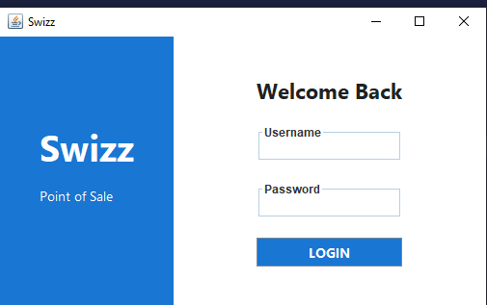

2. Problem Statement
Manual sales processing involves high risks of human error, difficulty in tracking stock levels, and time-consuming calculations for billing.
Without a digital system, store owners lack immediate insight into sales performance and inventory shortages. This project addresses these issues by providing a user-friendly interface for cashiers and a powerful management dashboard for administrators.

3. System Features & Modules
The system is divided into two primary distinct modules based on user roles:

A. Administrator Module

Secure Authentication: Admins log in via a secure gateway.

Inventory Management: The Admin can Add, Update, and Delete products from the database.

Stock Monitoring: View current stock levels to prevent shortages.

Sales Reporting: View historical sales data and receipts to analyze business performance.
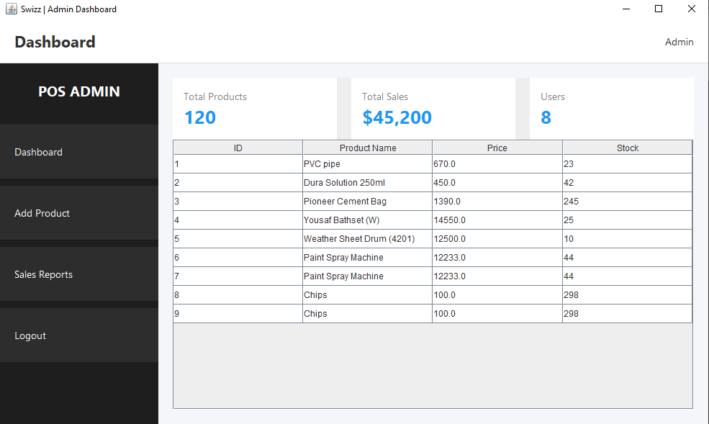

B. Cashier Module

Point of Sale Interface: A visual grid layout allowing cashiers to select products quickly.

Dynamic Cart System: Automatically calculates line totals and the final bill amount.

Stock Validation: The system prevents the sale of items that are out of stock.

Transaction Processing: Commits sales to the database using SQL transactions to ensure data integrity.
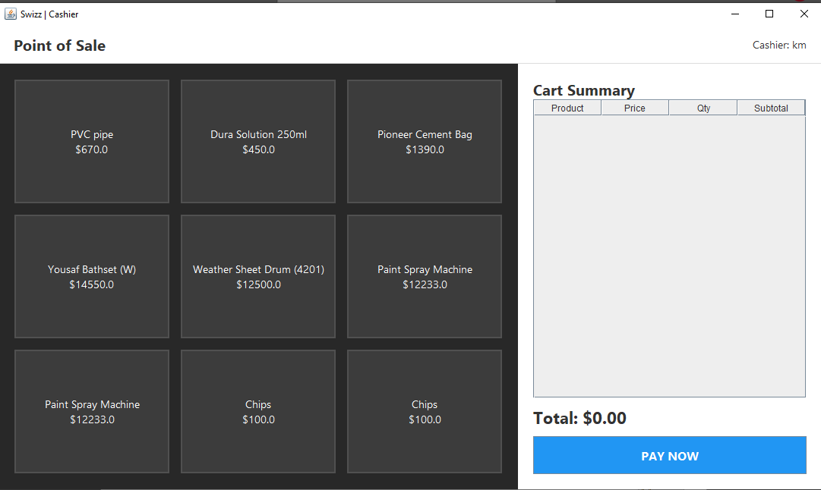

4. Technical Architecture
The project follows the Model-View-Controller (MVC) architectural pattern to separate logic from design:

Frontend (View): Built using Java Swing (JFrame, JPanel, JTable). It provides a responsive graphical user interface for interaction.

Backend (Controller/DAO): The Data Access Object (DAO) pattern is used to handle all database logic. This ensures the frontend never
directly interacts with the database code.

Database (Model): MySQL is used for persistent data storage.

OOP Principles Applied:

Encapsulation: All data models (Product, User, Sale) use private attributes accessed via public getters and setters.

Singleton Pattern: Used in the DBConnection class to ensure only one database connection is created, optimizing performance.

Exception Handling: Comprehensive try-catch blocks to handle SQL errors and input validation.

5. Database Design
The system relies on a relational database with the following key tables:

Users: Stores login credentials and roles (Admin/Cashier).

Products: Stores item details (ID, Name, Price, Stock, Category).

Sales: Records the total sale amount, date, and the cashier responsible.

Sale_Items: Links specific products to a sale ID (normalization).

6. Team Roles and Responsibilities
The development was divided into four distinct functional roles to simulate a professional software development lifecycle:

Frontend Designer: Responsible for the User Interface (UI) and User Experience (UX). This member created the ModernPOSDashboard,
AdminDashboardUI, and LoginPage layouts, ensuring a professional look and feel.

Backend Engineer: Responsible for the Database Schema and the Data Access Layer (DAO). This member wrote the complex SQL queries
and Java logic to handle login security and inventory updates.

System Architect & QA: Responsible for system design and testing. This member created the ConsoleMenu for logic verification and
conducted unit testing to ensure the backend logic connected correctly with the frontend.

Analyst & Reporting: Responsible for data visualization. This member implemented the ReportDAO to fetch sales history and designed
the logic for generating transaction receipts.

7. Conclusion
The POS Management System successfully meets the requirements of a modern retail application. By leveraging Java and MySQL, the
system offers a stable and secure environment for processing transactions. The project demonstrates a practical application of OOP concepts,
effectively solving the problem of manual sales management while providing a scalable foundation for future features.

