
NED University of Engineering & Technology
Department of Computer Science & Information Technology
AIES
Artificial Intelligence & Expert System (CT-361)
Complex Computing Problem (CCP) & Complex Computing Activity (CCA)
Project Title
Rice Variety Classification
Cammeo vs Osmancik using Decision Tree and K-Nearest Neighbours
Submitted by
Student Name | Roll Number
Muhammad Bilal Uddin | CT-24036
Muhammad Usman | CT-24031
Muhammad Mustafa | CT-24038

Abstract
Rice is one of the most important food crops in the world, and different varieties differ in price, cooking quality and market demand. Telling varieties apart by eye is slow and subjective. This project builds a Python-based system that classifies a rice grain as Cammeo or Osmancik from seven numerical morphological measurements (area, perimeter, major axis length, minor axis length, eccentricity, convex area and extent) taken from the UCI Rice (Cammeo and Osmancik) dataset of 3810 grains.
The data were inspected and pre-processed, split 80/20 with stratification, and used to train a Decision Tree and a K-Nearest Neighbours (KNN) model. A majority-class model, a default Decision Tree and a default KNN form the baseline. Both algorithms were then improved with 5-fold cross-validated grid-search hyper-parameter tuning. On the unseen test set the tuned Decision Tree reached 91.86% accuracy (ROC-AUC 0.972) and the tuned KNN reached 90.94% accuracy (ROC-AUC 0.970), compared with 57.22% for the majority-class baseline. A Streamlit interface lets a user enter grain measurements, see predictions with confidence from both models, and inspect the evaluation charts.

Contents
1. Introduction and Problem Statement
2. Problem Description
3. Dataset Description
4. Assumptions and Constraints
5. Methodology
6. Data Pre-processing
7. Models Used
8. Results and Evaluation
9. User Interface
10. Ethics, Privacy and Fairness
11. Challenges and Limitations
12. Conclusion and Future Work
13. References
14. Appendix: Project Structure and How to Run

1. Introduction and Problem Statement

1.1 Background
Rice grains of different varieties look very similar to the human eye, yet they differ in shape, size, cooking time, taste and market value. In rice processing and trading, correct identification of the variety matters: mixing varieties lowers product quality and can cause financial loss and disputes. Traditional identification relies on trained inspectors, which is slow, subjective and hard to scale.
Computer vision systems can photograph grains and extract numerical shape measurements automatically. Once these measurements exist, machine learning can learn the difference between varieties from labelled examples and classify new grains in milliseconds.

1.2 Problem Statement
- The issue being addressed: manual, subjective and slow identification of rice variety. The project automates the decision of whether a grain is Cammeo or Osmancik using only its measured shape features.
- Real-world impact: reliable automatic variety identification supports quality control in rice mills, prevents mixing and fraud in the supply chain, helps fair pricing, and reduces dependence on human experts.
- AI approach applied: supervised predictive modelling (classification). Two classical machine learning algorithms, Decision Tree and K-Nearest Neighbours, are trained, compared with baselines, tuned and evaluated, and presented through a simple interface.

1.3 Objectives
- Define a clear real-world classification problem in the agriculture / smart-systems domain.
- Load, inspect and pre-process the UCI Rice dataset, including checks for noise, missing values and imbalance.
- Implement baseline models and improve them with hyper-parameter tuning.
- Evaluate the models with suitable performance metrics on unseen data.
- Provide a user-friendly interface that makes predictions and results interpretable.
- Discuss ethics, privacy, fairness, transparency and accountability.

2. Problem Description

2.1 Domain and Use Case
Domain: agriculture and food-quality monitoring (a smart-system application). Use case: a camera-based inspection station photographs rice grains; image processing extracts seven shape measurements per grain; the classifier receives these numbers and returns the variety (Cammeo or Osmancik) with a confidence score so that grains can be sorted, verified or flagged for human review.

2.2 Goals of the System
- Accurately predict the variety of a grain from its measurements.
- Show that AI can turn raw measurements into automated decisions better than a naive baseline.
- Keep the model transparent: a Decision Tree gives readable rules and feature importance.
- Present results in an interpretable way through charts and a prediction interface.

2.3 Inputs and Outputs
Table 1: Inputs and outputs of the system
Item | Description
Input | Seven numeric features of one rice grain: Area, Perimeter, Major_Axis_Length, Minor_Axis_Length, Eccentricity, Convex_Area, Extent
Output | Predicted class: Cammeo or Osmancik, with the probability of each class
Task type | Binary classification (supervised learning)
Learning data | 3810 labelled grains (1630 Cammeo, 2180 Osmancik)

2.4 Alternative Solution Strategies Considered
Several strategies can solve this problem. A rule-based expert system could encode expert thresholds, but such thresholds are hard to obtain manually and the two varieties overlap. Deep learning on raw images needs far more data and computing power. Because the features are already extracted and the dataset is of moderate size, classical machine learning is an effective and efficient choice. Decision Tree was selected because it is interpretable and produces if-then rules close to an expert system, and KNN was selected because it is a simple, distance-based method with a very different working principle, which makes the comparison between the two meaningful.

3. Dataset Description

3.1 Source and Relevance
The project uses the Rice (Cammeo and Osmancik) dataset from the UCI Machine Learning Repository, donated in 2019 by Cinar and Koklu of Selcuk University, Turkey. Images of 3810 rice grains of two certified varieties grown in Turkey were captured, processed, and seven morphological features were extracted for each grain. The dataset is released under the CC BY 4.0 licence. It is directly relevant because it contains exactly the measurements an automated inspection system would produce, together with expert-assigned labels. The dataset has 3810 samples, which is large enough for a reliable train/test split and cross-validation.

3.2 Features
Table 2: Dataset features
Feature | Type | Meaning
Area | Integer | Number of pixels inside the grain boundary
Perimeter | Continuous | Length of the grain boundary in pixels
Major_Axis_Length | Continuous | Longest line that can be drawn across the grain
Minor_Axis_Length | Continuous | Shortest line that can be drawn across the grain
Eccentricity | Continuous | How round the ellipse with the same moments as the grain is
Convex_Area | Integer | Pixel count of the smallest convex shell around the grain
Extent | Continuous | Ratio of the grain region to its bounding box
Class (target) | Binary | Cammeo or Osmancik

3.3 Class Distribution
The dataset contains 2180 Osmancik grains (57.2%) and 1630 Cammeo grains (42.8%). The classes are mildly imbalanced, so a model that always predicts Osmancik would already be right 57.22% of the time. This is why the majority-class model is used as the lowest baseline and why precision, recall, F1 and ROC-AUC are reported in addition to accuracy.
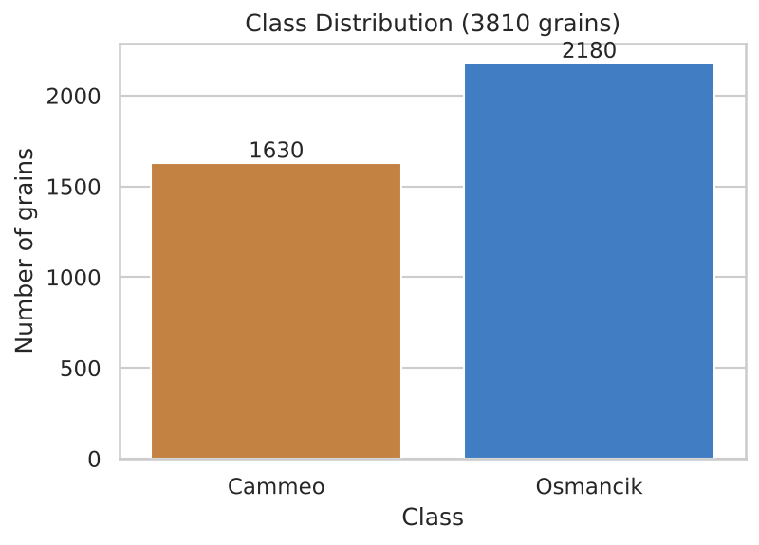
Figure 1: Class distribution of the dataset

3.4 Exploratory Data Analysis
The feature histograms show that the two varieties overlap, but Cammeo grains are generally larger and longer (greater area, perimeter and major axis length), while Osmancik grains are smaller and rounder. Because of this overlap, perfect classification is not expected.
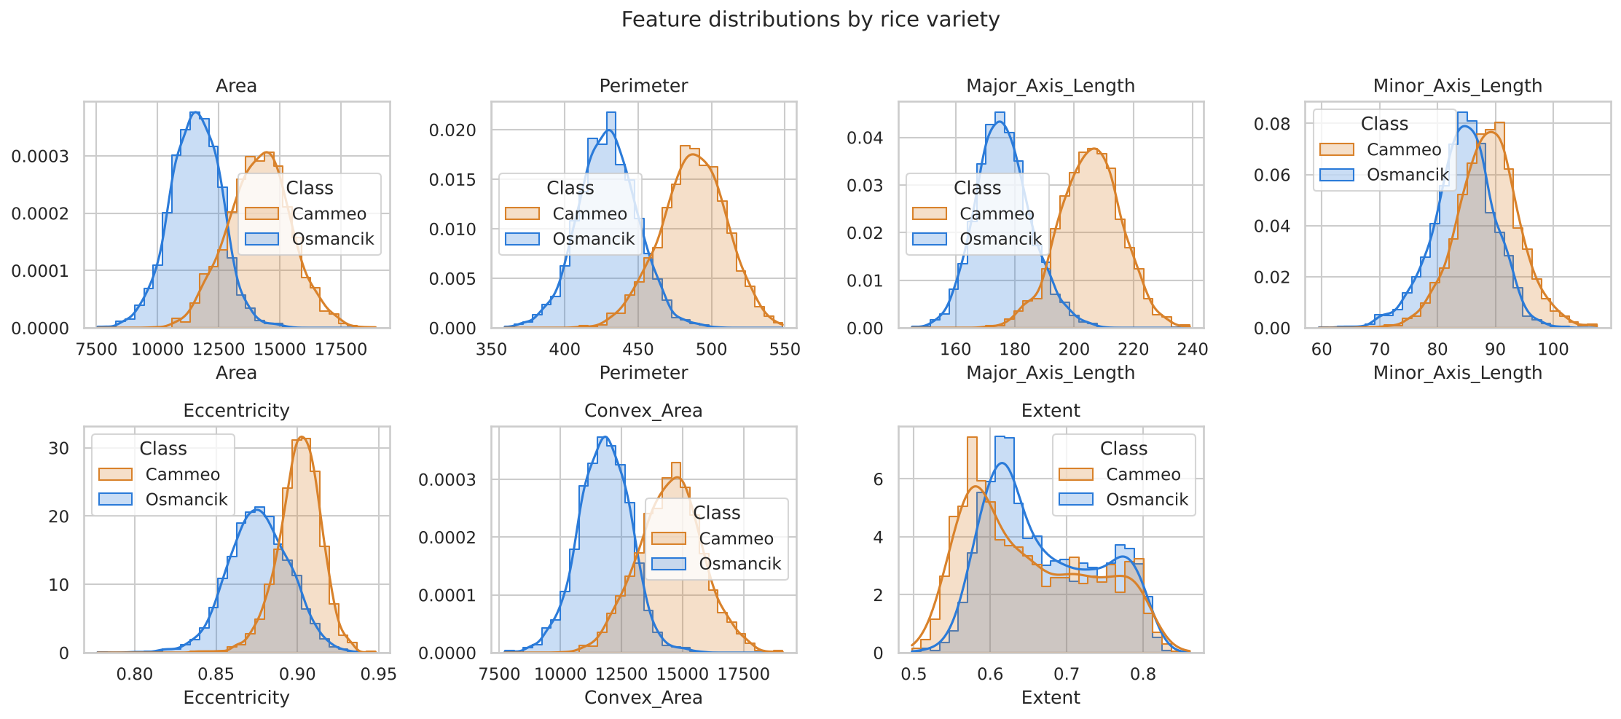
Figure 2: Distribution of each feature by variety
The correlation matrix shows very strong correlation between Area, Perimeter, Convex Area and Major Axis Length, since all of them grow with grain size. This redundancy has no effect on a Decision Tree but is one reason feature scaling matters for the distance-based KNN model.
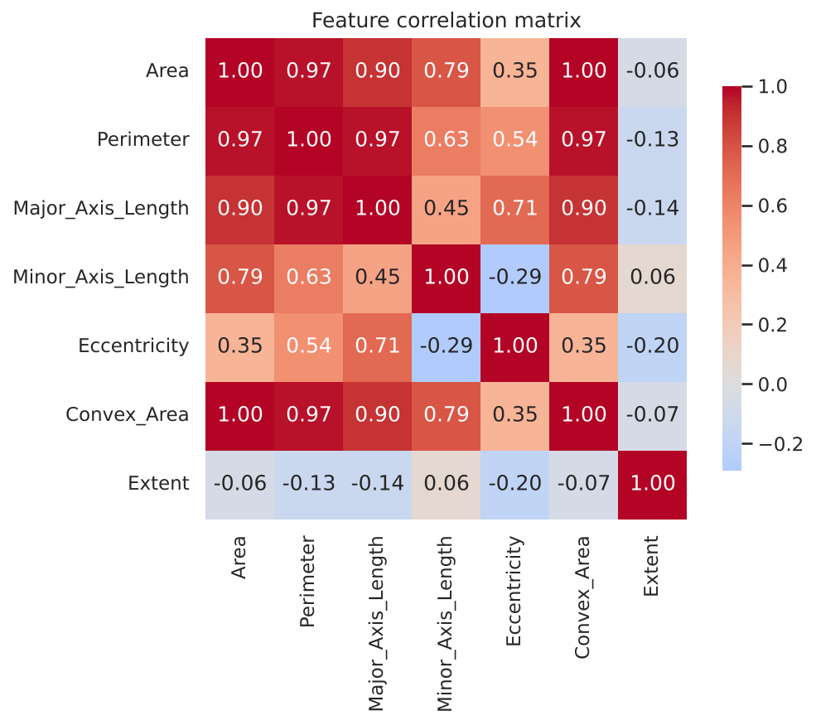
Figure 3: Correlation between features

3.5 Data Quality Findings
Table 3: Data quality summary
Check | Result
Missing values | 0
Duplicate rows | 0
IQR outliers: Area / Convex_Area | 4 / 3
IQR outliers: Minor_Axis_Length / Eccentricity | 65 / 21
IQR outliers: Perimeter / Major_Axis / Extent | 0 / 0 / 0

The dataset has no missing values and no duplicates. A small number of statistical outliers exist (mainly in minor axis length and eccentricity). They were kept because they are genuine measurements of unusually shaped grains, not recording errors, and removing them would make the system fail on real unusual grains. Tree-based models are not sensitive to outliers, and KNN is protected by feature scaling.
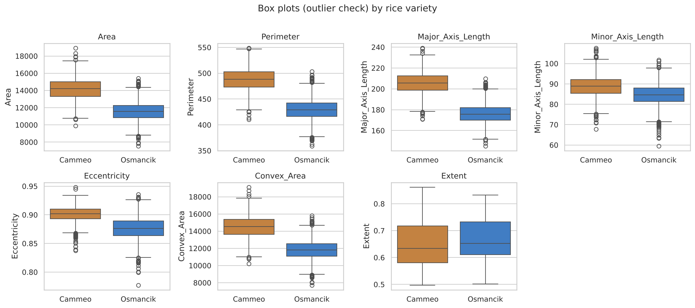
Figure 4: Box plots of the features by variety (outlier check)

4. Assumptions and Constraints
The following table lists each project requirement and how it is handled in this work.
Table 4: Requirements and how they are addressed
Requirement / constraint | How it is addressed
Completed in a group | Developed by a group of three students (see cover page).
Suitable dataset(s) | One sufficiently large and suitable dataset is used: UCI Rice (Cammeo and Osmancik), 3810 samples, as permitted by the activity description.
Noise, missing values, inconsistencies, imbalance | Data checked for missing values, duplicates and outliers; median imputer included in every pipeline; class imbalance handled by stratified splitting, class-weight tuning and imbalance-aware metrics.
Diverse data types | All inputs are numeric. The pipeline handles integer and continuous values and encodes the text label into 0/1.
External factors | Lighting, camera and grain placement can change measured values; the system assumes measurements come from a consistent imaging setup (see Section 11).
Data privacy | The data contain only physical grain measurements; no personal or sensitive data are collected or stored.
Ethics: fairness, transparency, accountability | Discussed in Section 10; the Decision Tree is interpretable and confidence is always shown.
Baseline model | Majority-class model, default Decision Tree and default KNN are implemented first.
Improvement with multiple approaches | Hyper-parameter tuning with GridSearchCV is applied to both Decision Tree and KNN and compared with the baselines.
Real-time monitoring depends on network | The model runs locally on the user's computer, so predictions do not need a network connection.

4.1 Assumptions
- The labels in the dataset are correct (assigned by the dataset authors).
- The seven features are measured in the same way for new grains as in the training data.
- Only the two varieties in the dataset are present; grains of any other variety are out of scope.
- The train and test samples come from the same distribution.

5. Methodology
The solution follows a standard supervised machine learning workflow. Figure 5 shows the methodology diagram of the complete system, from the raw dataset to the final interface.
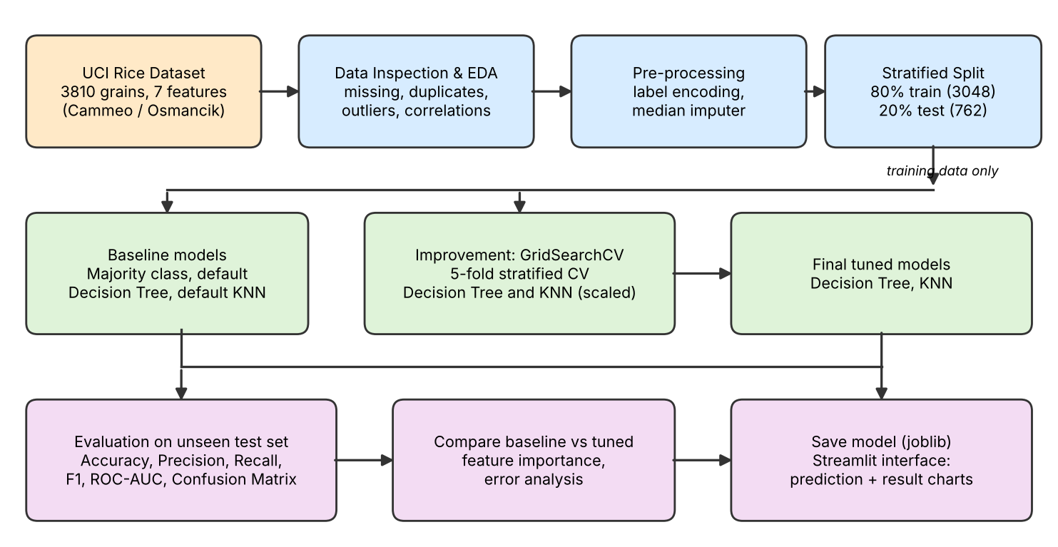
Figure 5: Methodology diagram of the Rice Variety Classifier
The main stages are:
- Data loading and inspection: read the CSV file, check shape, types, missing values, duplicates, outliers and class balance.
- Pre-processing: encode the label, split into training and test sets, impute (if needed) and scale (for KNN).
- Baseline modelling: train the majority-class model, a default Decision Tree and a default KNN.
- Improvement: tune the hyper-parameters of both algorithms with 5-fold stratified cross-validation, using the training data only.
- Evaluation: measure all models on the unseen test set with several metrics and plots.
- Deployment: save the trained models and present them through a Streamlit interface.

6. Data Pre-processing
- Duplicate removal: duplicate rows would be dropped; 0 were found.
- Label encoding: Cammeo = 0 and Osmancik = 1.
- Stratified train/test split: 80% training (3048 grains) and 20% test (762 grains) with a fixed random seed (42) for reproducibility. Stratification keeps the class ratio the same in both sets.
- Missing-value handling: a median imputer is the first step of every model pipeline. No values are missing in this dataset, but the pipeline remains robust if a measurement is missing.
- Feature scaling: StandardScaler (zero mean, unit variance) is applied inside the KNN pipeline because KNN uses distances and Area (about 12,000) would otherwise dominate Eccentricity (about 0.9). Decision Trees split on single features and do not need scaling.
- Prevention of data leakage: the imputer and scaler are fitted only on training folds because they are part of a scikit-learn Pipeline. The test set is never used for tuning.

7. Models Used

7.1 Decision Tree
A Decision Tree repeatedly splits the data using a threshold on one feature, choosing the split that best separates the classes (Gini impurity or entropy). The result is a tree of if-then rules that a human can read, which makes the model transparent and close in spirit to a rule-based expert system. Its weakness is over-fitting: a very deep tree memorises the training data. Limiting depth and leaf size controls this.

7.2 K-Nearest Neighbours (KNN)
KNN classifies a new grain by looking at the k most similar training grains (smallest distance in scaled feature space) and taking a majority vote. It makes no assumption about the shape of the decision boundary, but it is sensitive to feature scale and to the choice of k: a small k is noisy, a large k blurs the boundary.

7.3 Baseline Models
- Majority-class (Dummy) model: always predicts the most common class. It shows the accuracy that can be obtained without any learning.
- Decision Tree with default settings (no depth limit).
- KNN with k = 5 and scaled features.

7.4 Performance Improvement: Hyper-parameter Tuning
GridSearchCV with 5-fold stratified cross-validation (accuracy as the scoring metric) was run on the training set. The Decision Tree grid had 448 combinations and the KNN grid had 64 combinations.
Table 5: Hyper-parameter search spaces and best values
Model | Hyper-parameters searched | Best values found
Decision Tree | criterion {gini, entropy}; max_depth {3,4,5,6,8,10,None}; min_samples_split {2,5,10,20}; min_samples_leaf {1,2,5,10}; class_weight {None, balanced} | criterion = gini; max_depth = 4; min_samples_split = 2; min_samples_leaf = 10; class_weight = balanced
KNN | n_neighbors {1,3,...,31}; weights {uniform, distance}; metric {euclidean, manhattan} | n_neighbors = 25; weights = uniform; metric = euclidean

The tuned Decision Tree is shallow (maximum depth 4) with a minimum of 10 grains per leaf, which prevents over-fitting. The tuned KNN uses a large neighbourhood (k = 25), which smooths out noise in the overlapping region between the two varieties.

8. Results and Evaluation

8.1 Evaluation Metrics
- Accuracy: share of grains classified correctly.
- Precision, Recall, F1-score: macro-averaged over both classes so that each variety counts equally.
- ROC-AUC: ability to separate the classes across all thresholds (1.0 is perfect, 0.5 is random).
- Confusion matrix: shows exactly which grains are confused.
- Cross-validated accuracy: mean and standard deviation over 5 folds of the training data, a check on stability.

8.2 Overall Comparison
Table 6: Test-set performance of all models
Model | Accuracy | Precision | Recall | F1 | ROC-AUC | CV accuracy
Majority Class (Dummy) | 0.5722 | 0.2861 | 0.5000 | 0.3639 | 0.5000 | 0.5722 ± 0.0005
Decision Tree (Baseline) | 0.8976 | 0.8960 | 0.8947 | 0.8953 | 0.8947 | 0.8868 ± 0.0089
Decision Tree (Tuned) | 0.9186 | 0.9181 | 0.9154 | 0.9166 | 0.9715 | 0.9308 ± 0.0125
KNN (Baseline) | 0.9094 | 0.9089 | 0.9058 | 0.9072 | 0.9490 | 0.9265 ± 0.0066
KNN (Tuned) | 0.9094 | 0.9096 | 0.9050 | 0.9070 | 0.9699 | 0.9308 ± 0.0093

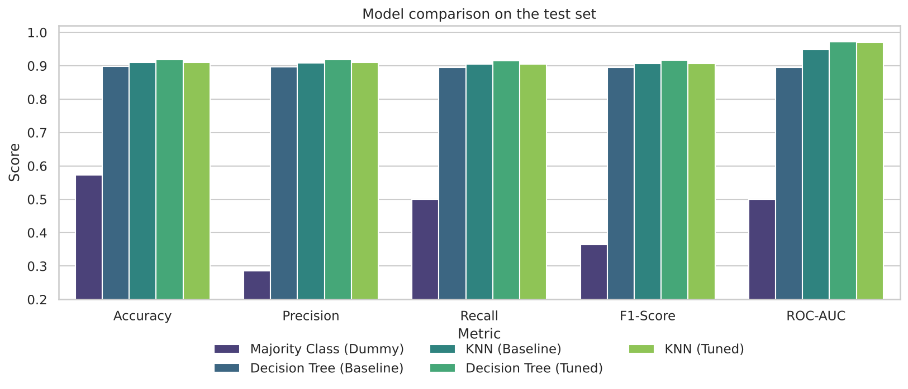
Figure 6: Comparison of all models on the test set
All learning models are far better than the majority-class baseline (57.22%). Tuning improved the Decision Tree clearly: accuracy rose from 89.76% to 91.86%, F1 from 0.8953 to 0.9166 and ROC-AUC from 0.8947 to 0.9715. For KNN, the test accuracy stayed at 90.94%, but ROC-AUC improved from 0.9490 to 0.9699 and the cross-validated accuracy from 0.9265 to 0.9308. The baseline KNN was already strong, so tuning gave it better-calibrated probabilities rather than more correct labels on this particular test split.
The test set holds 762 grains, so one percentage point equals roughly eight grains. The difference between the tuned Decision Tree and the tuned KNN is therefore small and should not be over-interpreted; both models perform at a similar level, in line with accuracies of roughly 92 to 94 percent reported by other studies on this dataset.

8.3 Confusion Matrices
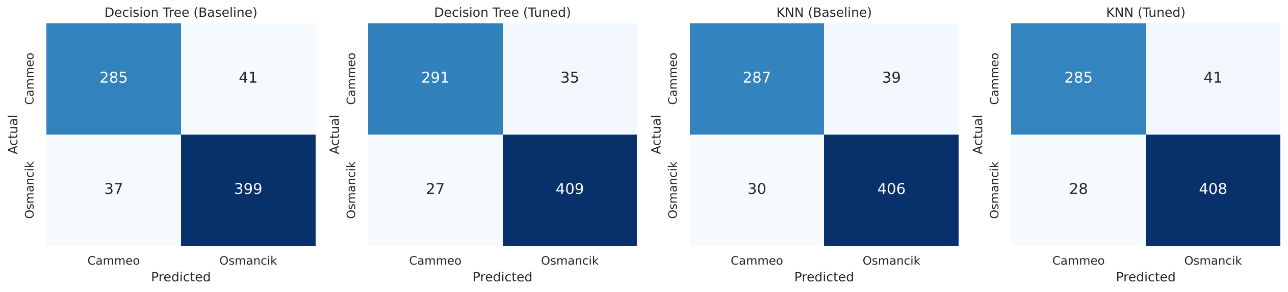
Figure 7: Confusion matrices of baseline and tuned models
For the tuned Decision Tree, 291 Cammeo and 409 Osmancik grains were classified correctly, 35 Cammeo grains were wrongly labelled Osmancik and 27 Osmancik grains were wrongly labelled Cammeo. The tuned KNN made 41 and 28 errors of the two kinds respectively. Errors occur mostly for grains whose size lies in the overlapping region of the two varieties.

8.4 ROC Curves
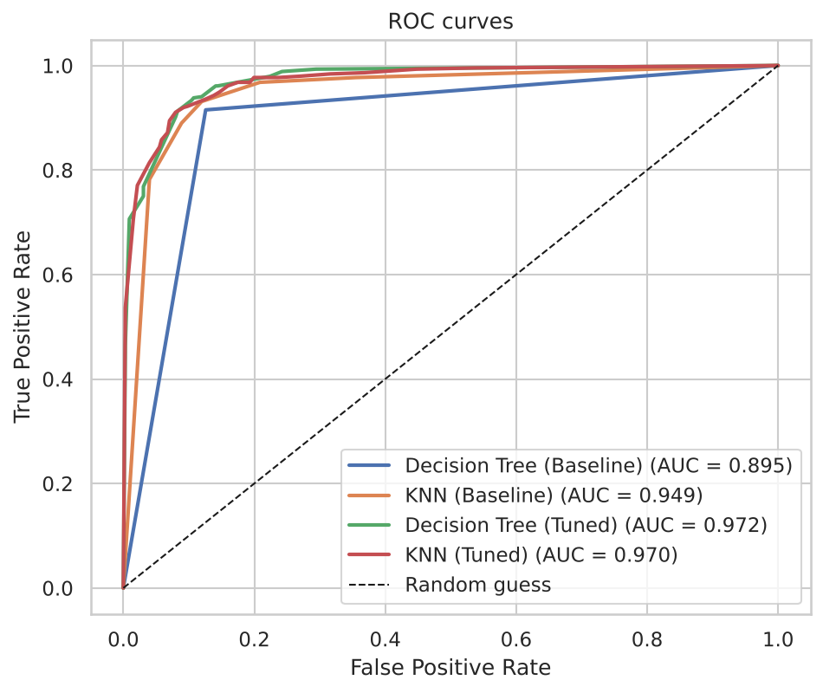
Figure 8: ROC curves of the models
The curves of the tuned models lie close to the top-left corner, confirming that the two varieties are well separable from the seven features. The tuned models have visibly higher AUC than the baselines.

8.5 Feature Importance
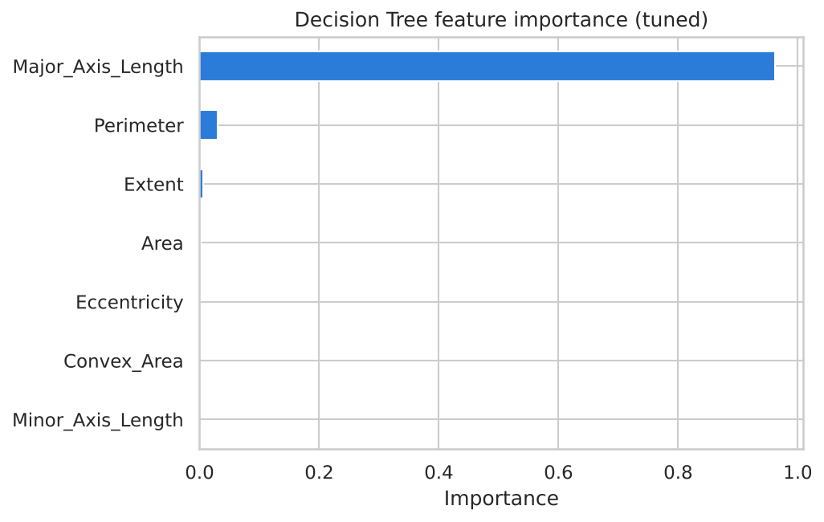
Figure 9: Feature importance of the tuned Decision Tree
The tuned Decision Tree relies mostly on Major Axis Length (importance 0.96), followed by Perimeter (0.03). Because Area, Perimeter and Convex Area are strongly correlated with each other, the tree uses one of them and the others receive a low score; a low importance does not mean that the feature is unrelated to the variety. The result agrees with the exploratory analysis: grain length is the most informative difference between Cammeo and Osmancik.

8.6 Effect of Hyper-parameters
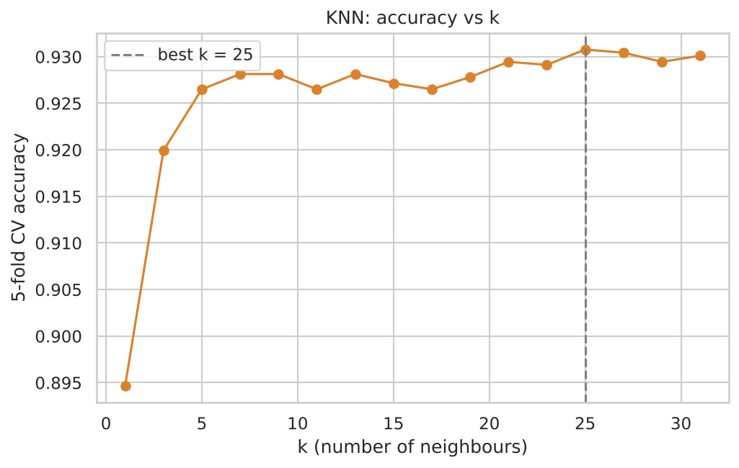
Figure 10: KNN cross-validated accuracy for different values of k
Accuracy rises as k grows from 1, because a single nearest neighbour is sensitive to noisy grains, and then levels off at moderate values of k.
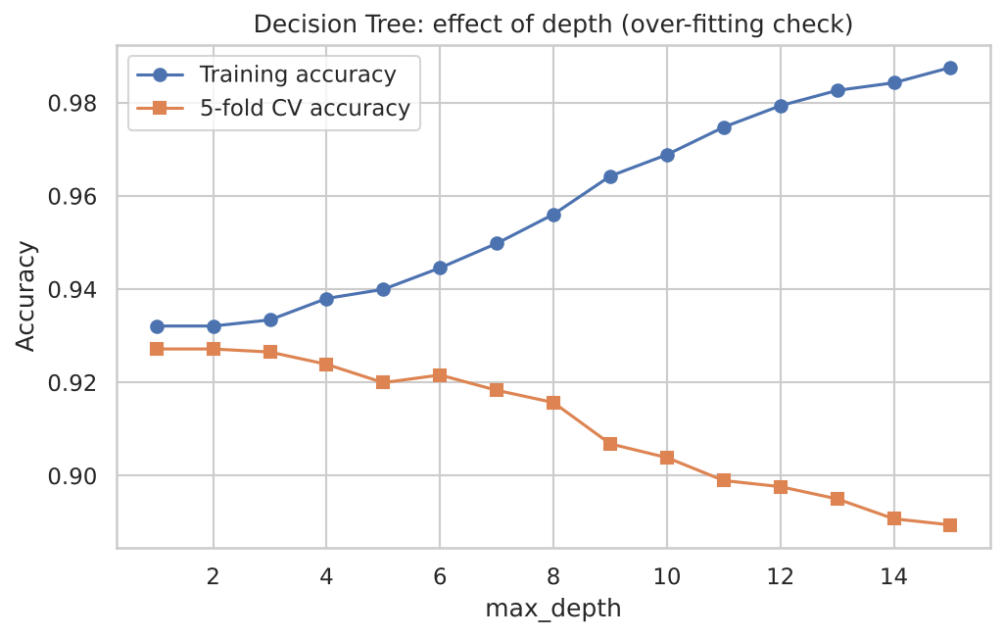
Figure 11: Decision Tree accuracy for different depths
The training accuracy of the Decision Tree keeps increasing with depth while the cross-validated accuracy stops improving after a shallow depth. The growing gap is over-fitting, which is why a shallow tuned tree generalises better than the unrestricted baseline tree.

8.7 Model Transparency
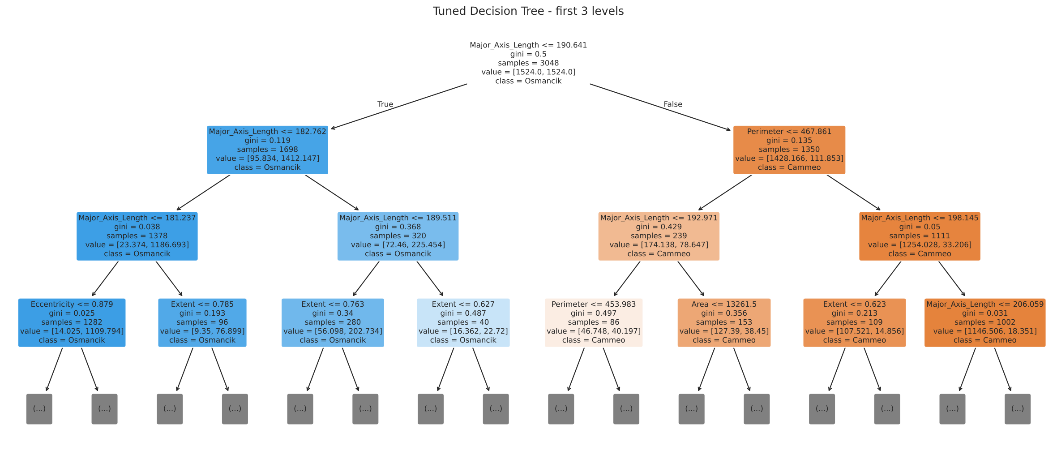
Figure 12: First levels of the tuned Decision Tree
The first levels of the tuned tree can be read as simple rules on grain measurements. This transparency allows a domain expert to check whether the model's reasoning is sensible.

9. User Interface
A web-based interface was built with Streamlit (file app.py) and runs locally in the browser with the command: streamlit run app.py. It has four tabs:
- Predict: sliders for the seven grain measurements (limited to the range seen in the dataset), starting values for a typical Cammeo grain, a typical Osmancik grain or the dataset average, and the choice of Decision Tree, KNN or both. The predicted variety is shown with a confidence percentage and a probability bar chart.
- Model Results: the table of baseline versus tuned metrics, best hyper-parameters, the model comparison chart and the confusion matrices.
- Charts: ROC curves, feature importance, KNN accuracy versus k, Decision Tree depth curve and the top of the tree.
- Dataset: a preview of the data, class-wise averages, feature distributions and the correlation heatmap.
Showing both models side by side with their confidence helps users judge how reliable a prediction is: if the two models disagree or the confidence is low, the grain can be sent for manual inspection.

10. Ethics, Privacy and Fairness
- Data privacy: the dataset contains only physical measurements of rice grains. It has no personal or sensitive information, so no anonymisation is necessary. If the system were extended with farmer or supplier data, such data would have to be anonymised.
- Fairness: the classes are imbalanced (about 57% and 43%). To avoid a model that favours the larger class, a stratified split, class-weight tuning and per-class metrics (macro precision, recall, F1) and confusion matrices were used. The model is not used to decide anything about people.
- Transparency: the Decision Tree is human-readable, feature importance is reported, and the interface displays a probability with every prediction instead of a bare label.
- Accountability: all results are reproducible (fixed random seed, saved code and model). Predictions are decision support; a human inspector remains responsible for final quality decisions, especially for low-confidence predictions.
- Appropriate use: the model should only be used for the two varieties and imaging conditions it was trained on, and it should not be presented as perfectly accurate.

11. Challenges and Limitations
- Overlapping classes: the two varieties overlap in size, so some grains are misclassified by every model and accuracy saturates at about 91 to 93 percent.
- Correlated features: Area, Perimeter and Convex Area carry almost the same information, which makes feature-importance values harder to interpret and makes scaling essential for KNN.
- Over-fitting: the unrestricted Decision Tree memorises training data; this was controlled by limiting depth and leaf size with cross-validated tuning.
- Class imbalance: mild imbalance can hide errors in accuracy alone; extra metrics were used.
- Small test set: with 762 test grains, differences below about one percentage point are not reliable.
- External factors: measurements depend on camera, lighting, resolution and grain placement. A system deployed in another factory would need a similar imaging set-up or re-calibration.
- Scope: only two varieties are covered; a grain of any other variety would still be forced into one of the two classes.
- Network dependence: the model is run locally, so predictions do not depend on network availability; only a future cloud-based monitoring deployment would.

12. Conclusion and Future Work
This project built a complete AI solution for classifying rice grains as Cammeo or Osmancik. After inspecting and pre-processing the 3810-grain UCI dataset, a Decision Tree and a KNN model were trained, compared with baselines and tuned with cross-validation. The tuned Decision Tree achieved 91.86% accuracy and the tuned KNN 90.94%, both far above the 57.22% majority-class baseline, with ROC-AUC values near 0.97. Grain length (major axis length) proved the most informative feature. A Streamlit interface makes the predictions and evaluation results easy to use and interpret.
Possible future work includes testing further algorithms and ensembles, adding more rice varieties, collecting images from different cameras to test robustness, and connecting the classifier directly to a camera-based sorting line.

References
[1] Cinar, I. and Koklu, M. (2019). Classification of Rice Varieties Using Artificial Intelligence Methods. International Journal of Intelligent Systems and Applications in Engineering, 7(3), 188-194. doi:10.18201/ijisae.2019355381
[2] Cinar, I. and Koklu, M. Rice (Cammeo and Osmancik) [Dataset]. UCI Machine Learning Repository (2019). doi:10.24432/C5MW4Z
[3] Pedregosa, F. et al. (2011). Scikit-learn: Machine Learning in Python. Journal of Machine Learning Research, 12, 2825-2830.
[4] Streamlit documentation: https://docs.streamlit.io
[5] Course material: CT-361 Artificial Intelligence & Expert System, NED University of Engineering and Technology.

Appendix: Project Structure and How to Run
Table 7: Project files
File / folder | Purpose
train_model.py | Full pipeline: load, pre-process, baselines, tuning, evaluation, saves model and figures
app.py | Streamlit interface
data/Rice_Cammeo_Osmancik.csv | UCI Rice dataset (3810 rows)
models/rice_models.joblib | Saved tuned Decision Tree and KNN pipelines
outputs/ | metrics.json, results_table.csv and all figures
report/ | This report and its build script
requirements.txt | Python packages needed
README_Roman_Urdu.txt | Roman Urdu explanation of the whole project

Steps: (1) pip install -r requirements.txt (2) python train_model.py (3) streamlit run app.py

