**Lab 1**

**Introduction to Machine Learning**

**Objectives:**

· Understand what Machine Learning is and its applications.

· Install and configure the Python environment for ML development.

· Create and activate a virtual environment.

· Install essential ML libraries like numpy, pandas, scikit-learn, and matplotlib.

**Lab Setup**

· Python (recommended version: 3.10+)

Jupyter Notebook

· Git (optional)

· Internet connection

**Step By Step Procedure:**

1. Open cmd command

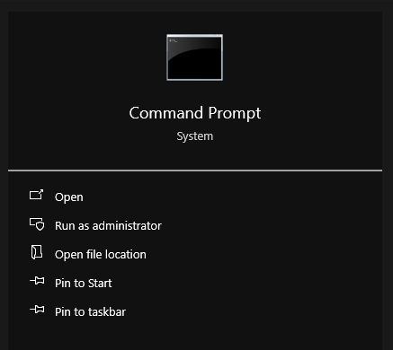

1. Verify Python Installation

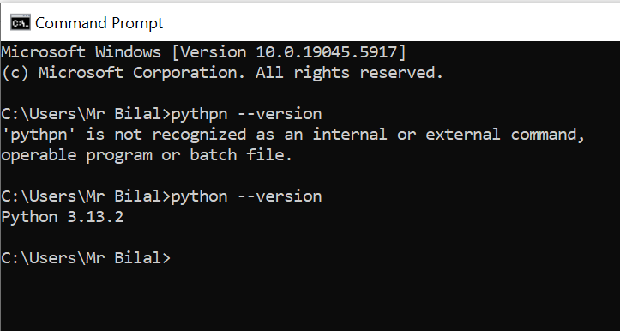

1. Create a Virtual Environment

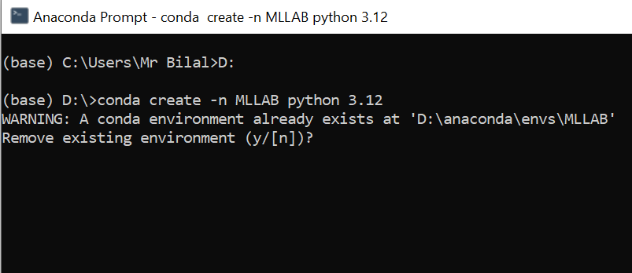

1. Activate the Virtual Environment

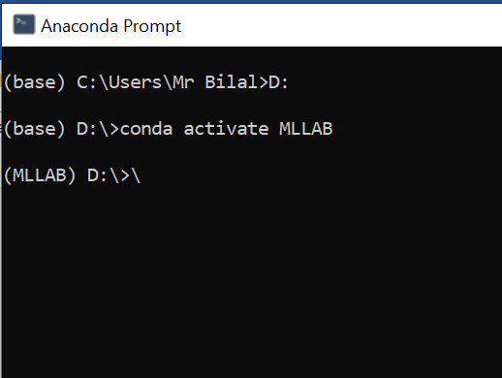

1. Path of virtual environment

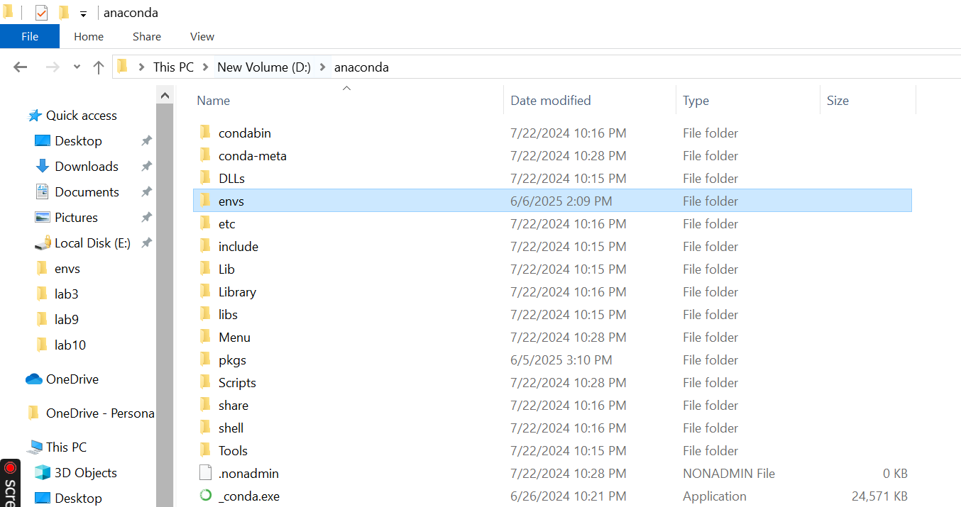

### ****Conclusion:****

In this lab, we successfully introduced the fundamentals of Machine Learning and understood its major types and real-world applications. We then proceeded to set up a Python-based development environment using a virtual environment, which ensures project dependencies are isolated and managed effectively. By installing essential ML libraries such as numpy, pandas, matplotlib, and scikit-learn, we established a solid foundation for building and testing machine learning models. This setup prepares us for future labs involving data preprocessing, modeling, training, and evaluation using various machine learning techniques.