Thanh Huynh – 2688093

Bilal Butt – 2688700

Michel Clerger – 2694646

Zirui Song - 2652528

Design document

GROUP MEMBERS:

Contents

INTRODUCTION: 2

CLASS DIAGRAM 3

CLASS DIAGRAM 3

DESCRIPTION OF THE CLASSES AND THEIR MEMBERS 3

HARDWARE RELATED CLASSES 4

IMMEDIATE CLASSES 9

INTELLIGENCE CLASSES 17

STATE DIAGRAMS 17

SEQUENCE DIAGRAMS 18

PIN CONFIGURATIONS 18

# INTRODUCTION:

This document is the design document for building an application that programs the simulation of a washing machine.

In the first section of this document, the class diagram of the application is presented in the form of diagrams along with their descriptions. The descriptions are divided into 3 sub-parts: hardware related class, immediate class which implementation the working logics of each hardware components the main classes for executions.

The second section presents some states diagrams for some of the important controlling processes.

The third section presents selected sequence diagrams for some of the more complex and important methods related to various classes.

The four section presents some configurations description of the pins.

# CLASS DIAGRAM

## Class diagram



Figure - Class diagram

## Description of the classes and their members

By default, all of the member variables of classes are private and their methods are public. If it is not the case, the visibilities of these properties and methods will be indicated. The class diagram is still subject to refinement and will be amended as deemed necessary.

The classes as depicted in the class diagram are based on the notion of how the Arduino itself operates. Since the Arduino does not have an operating system instead it operates by consistently running a main loop that continues indefinitely. Therefore in the class hierarchy the LaundryMachine class plays the role of the class that contains the main loop.

The loop of the LaundryMachine class is constantly polling the ProgramSelect and CoinWallet classes to see if they have received any input from the user indicated by changes in their respective member variables. Once it has been determined if the program selected and the relevant payment has been completed and the user has indicated that he wants to begin the washing program, the ProgramExecutor will be called.

The ProgramExecutor executes the complete washing program for the washing program setting initially identified by the user. The interface classes are implemented in the HardwareControl class and are responsible for implementing functions that have to do with manipulating the actual hardware.

## HARDWARE RELATED CLASSES

#### ICOIN

ICoin is the interface class containing the virtual functions relating which is implemented in the hardware class.

|  |  |
| --- | --- |
| ICOIN | |
| Functions | Description |
| *virtual boolean GetCoin10Button() = 0;* | This is used for getting the status of “Coin 10” button which indicates that a coin of value 10 is put into the machine. Return true if button is pressed, if not false is returned |
| *virtual boolean GetCoin50Button() = 0;* | This is used for getting the status of “Coin 50” button which indicates that a coin of value 50 is put into the machine. Return true if button is pressed, if not false is returned |
| *virtual boolean GetCoin200Button() = 0;* | This is used for getting the status of “Coin 200” button which indicates that a coin of value 200 is put into the machine. Return true if button is pressed, if not false is returned |
| *virtual void SetCoin10(byte led) = 0;* | This is used for setting the LED (#coin10) corresponding to the given led parameter is put into the machine.  For example, if we call SetCoin10(B00000010), the second LED will turn on.  It also can use to set more than one LEDs and clear the LEDs.  For example, if we call SetCoin10(0xB00000111), all three LEDs will be turn on. And if we call SetCoin10(0x00) all the LEDs corresponding to #coin10 are off. |
| *virtual void SetCoin50(byte led) = 0;* | This is used for setting the LED (#coin50) corresponding to the given led parameter is put into the machine.  Working principles are similar to SetCoin10. |
| *virtual void SetCoin200(byte led) = 0;* | This is used for setting the LED (#coin200) corresponding to the given led parameter is put into the machine.  Working principles are similar to SetCoin10. |
| *virtual boolean GetClearButton() = 0;* | This is used for detecting that the Clear button is pressed or not. Return true if button is pressed, if not, false is returned. |
| Remarks:  All functions are implemented and working well | |

#### IPROGRAM

IProgram is the interface class containing the virtual functions relating which is implemented in the hardware class.

|  |  |
| --- | --- |
| IPROGRAM | |
| Functions | Description |
| *virtual boolean GetStartButton() = 0;* | This is used for getting the status of start button. Return true if button is pressed, if not false is returned |
| *virtual boolean GetProgramButton() = 0;* | This is used for getting the status of program button. Return true if button is pressed, if not false is returned |
| *virtual void SetProgramIndicator(int programIndicator) = 0;* | This is used for setting on of 3 LEDS which are indicating the program A, B or C. We can SetProgramIndicator(B00000001) for selecting program A.  SetProgramIndicator(B00000010) for selecting program B.  SetProgramIndicator(B00000100) for selecting program C. |
| Remarks:  All function are implemented and working well | |

#### ILOCK

ILock is the interface class containing virtual functions which are implemented in the hardware class.

|  |  |
| --- | --- |
| ILOCK | |
| Functions | Description |
| *virtual boolean GetLockStatus() = 0;* | This is used for getting the status of the switch belonging to the Door Lock on the simulator board. It returns a true if switch is turned on else it returns a false. It will only yield meaningful return values when keyselect is low. |
| *void SetLockStatus(boolean lock)* | This function is used for setting the lock related LED on or off depending on the Boolean lock passed to the function. |
| Remarks: | |

#### ISOAP

ISoap is the interface class containing virtual functions which are implemented in the hardware class.

|  |  |
| --- | --- |
| ISOAP | |
| Functions | Description |
| *virtual boolean GetSoap1() = 0;* | This is used for getting the status of the switch belonging to the Soap 1 on the simulator board. It returns a true if switch is turned on else it returns a false. It will only yield meaningful return values when keyselect is low. |
| *virtual boolean GetSoap2() = 0;* | This is used for getting the status of the switch belonging to the Soap 2 on the simulator board. It returns a true if switch is turned on else it returns a false. It will only yield meaningful return values when keyselect is low. |
| *virtual void SetSoap1(boolean On) = 0;* | Will turn on the LED labelled Soap 1 on the simulation board if given argument true. Otherwise it will turn off LED for Soap 1 if given argument false. |
| *virtual void SetSoap2(boolean On) = 0;* | Will turn on the LED labelled Soap 2 on the simulation board if given argument true. Otherwise it will turn off LED for Soap 2 if given argument false. |
| Remarks: Function SetSoap2 still has some glitches because it is intended to be turned on by setting particular bits for Data and Group. However it seems to not be working despite using the prescribed method of deactivating and activating strobe in order to turn on or off the Soap 2 LED in question. | |

#### IWATER

IWATER is the interface class containing the virtual functions relating which is implemented in the hardware class.

|  |  |
| --- | --- |
| IWATER | |
| Functions | Description |
| *virtual void SetWaterLevel(int level) = 0;* | The purpose of this function will be to set the appropriate water lever for the washing process. It takes one parameter for the level that we want to check. |
| *virtual boolean CheckWaterLevel(int level) = 0;* | The purpose of this function will be to check if the washing machine has reached the desired water level. It takes one parameter for the level that we want to check. |
| *virtual void SinkWater() = 0;* | The purpose of this function will be to |
| Remarks: This interface is complete. All the functions are implemented.  To discuss: I just wonder if we need any more functions for this interface or are those 3 enough? | |

#### IMOTOR

IMOTOR is the interface class containing the virtual functions relating which is implemented in the hardware class.

|  |  |
| --- | --- |
| IMOTOR | |
| Functions | Description |
| *virtual void SetDirection(char dir) = 0;* | The purpose of this function will be to indicate the direction of the washing machine. It takes one parameter to allow us to indicate the direction that we want to set. |
| *virtual void SetSpeed(int level) = 0;* | The purpose of this function will be to indicate the speed of the washing machine. It takes one parameter to allow us to indicate the speed that we want to set. |
| *virtual void StopMotor() = 0;* | The purpose of this function will be to stop the motor. |
| *virtual void StartMotor() = 0* | The purpose of this function will be to start the motor at an initial state assuming that all the prerequisites are handled properly within the IProgram interface. |
| *virtual void CheckLoadingLevel(int level) = 0;* | The purpose of this function will be to check le loading level of the washing machine. It takes one parameter for the level that we want to check. |
| Remarks: This interface is complete. All the functions are implemented.  To discuss: To start the motor can we just set the initial speed, or we also should consider some other states? Should we take care of the prerequisites in this function of in the IProgram interface? | |

#### Itemperature

ITemperature is the interface class containing the virtual functions relating which is implemented in the hardware class.

|  |  |
| --- | --- |
| ITEMPERATURE | |
| Functions | Description |
| *virtual void SetHeater(bool sw1tch) = 0;* | To set the heater on or off. |
| *virtual int GetTemperature() = 0;* | To get the current temperature. |
| Remarks:  “sw1tch” is to avoid conflict with C “switch” statement | |

#### IBuzzer

IBuzzer is the interface class containing the virtual functions relating which is implemented in the hardware class.

|  |  |
| --- | --- |
| IBUZZER | |
| Functions | Description |
| *virtual void SetBuzzer(int ms) = 0;* | To let the buzzer make noise for a period of milliseconds. |
| Remarks:  None | |

#### HARDWARE CLASS

Hardware class implements all functions from interface classes. However, it also has its own functions which are describe as following functions.

|  |  |
| --- | --- |
| HARDWARE | |
| Functions | Description |
| *void SetKeySelect(int value);* | Setting keyselect to 0 or 1 |
| *void SetGroup(int group);* | Setting value for all combinations value from group pins. This function is used in implications of setting output for coin indicators or program indicators. |
| *void SetData(int data);* | Setting value for all combinations value from data pins. This function is used in implications of setting output for coin indicators or program indicators. |
| *void Strobe();* | Inactive stroke for 100ms and then active for 15ms. |
| Remarks: | |

## immediate CLASSES

#### COINWALLET CLASS

CoinWallet is the class contains the functions and variables for handling coins and the amount of money that users put into the machine

|  |  |  |
| --- | --- | --- |
| Properties | | |
| nrOfCoin10 | Integer | This is a instance variable to indicate how many coin of value 10 which is put by users |
| nrOfCoin50 | Integer | This is a instance variable to indicate how many coin of value 50 which is put by users |
| nrOfCoin200 | Integer | This is a instance variable to indicate how many coin of value 200 which is put by users |
| balance | Integer | The current amount of money in the wallet |
| mCoin | ICoin * | An pointer with point to an ICoin object. It is used to reference to methods related to coin functionalities in hardware class |
| Operations | | |
| CoinWallet(ICoin *) : *constructor of the class* | | |
| mappingCoin(char nrofCoin) : char  *This is used to map the nrOfCoinX variable to become a level of bits for hardware class is able to handle it* | | |
| Withdraw(int amount): Boolean  *This is used to for withdrawing the amount of money indicated by given parameters. If the amount is less than or equal the balance, the amount of money is withdrawn and this functions return true. Otherwise, false is return.* | | |
| AddCoin10(): void  *Is called in the poll function to always detect weather the button to put coin 10 is pressed or not. If it is, increase the nrOfCoin10 by 1 (only allow it up to 3) and turn on the corresponding LED to indicate the coin is successfully put.* | | |
| AddCoin50() : void  *Is called in the poll function to always detect weather the button to put coin 50 is pressed or not. If it is, increase the nrOfCoin50 by 1 (only allow it up to 3) and turn on the corresponding LED to indicate the coin is successfully put.* | | |
| AddCoin200() : void  *Is called in the poll function to always detect weather the button to put coin 200 is pressed or not. If it is, increase the nrOfCoin200 by 1 (only allow it up to 2) and turn on the corresponding LED to indicate the coin is successfully put.* | | |
| WithdrawAll() : void  *Withdraw all of the current money in the wallet. Then the balance is set into 0.* | | |
| GetAmount() : int  *Return the current balance in the coin wallet.* | | |
| Poll(): void  *This function is called in the main loop for polling all functions related to coin mentioned above.* | | |
| Remarks:  All functions are implemented.  This class is tested with google test.  ReturnChange is added comparing with the previous version | | |

#### programselect CLASS

ProgramSelect is the class contains the functions and variables for handling program select.

|  |  |  |
| --- | --- | --- |
| Properties | | |
| currentProgram | Integer | This is an instance variable to indicate the current program |
| mProgram | IProgram * | An pointer with point to an IProgram object. It is used to reference to methods related to coin functionalities in hardware class |
| (* mStartHandler)() | void | Function pointer which points to the start function in program executor class. |
| Operations | | |
| ProgramSelect(): *constructor of the class. In the constructor, currentProgam is initialized as 1 for washing program A.* | | |
| ProgramSelect (IProgram *): *constructor of the class with IProgram as a input parameter.* | | |
| GetProgramType(): char  *This is used to get the type of the program selected by detecting the program select button.* | | |
| InstallStartHandler(void (* handler)()) : void  *This is used to pass the address of function pointer “handler” to the “mStartHandler” pointer.* | | |
| setProgramInterface(int value): void  *This is used to control the hardware to change the program* | | |
| Poll(): void  *This function is called in the main loop for polling all the time which program is currently selected and call the function that “mStartHandler” point to and execute it.* | | |
| Remarks:  All functions are implemented.  This  In the final implementation, the InstallStartHandler is not called from ProgramExecutor, but it is still kept their for the possibility of another scenario. | | |

#### LOCK CLASS

The Lock class contains the functions and variables for handling the lock interface and its associated hardware controls

|  |  |  |
| --- | --- | --- |
| Properties | | |
| iLock | ILock * | iLock is a pointer to a ILock type interface which is implemented in the HardwareControl class. The iLock will essentially point to a HardwareControl object which it can use to interact with the hardware IO. |
| lock | Boolean | The lock is a Boolean property that describes the status of the lock switch on the board and needs to be otherwise true in order to run a washing program. |
| Operations | | |
| Lock(): *default constructor of the class* | | |
| Lock(ILock *) : *constructor of the class which takes an ILock pointer and assigns it to iLock* | | |
| lockMachine() : void  *This is the polling function to check what the lock switch status is and will turn on or turn off the lock.* | | |
| checkLock(): Boolean  *Returns status of lock switch on the board.* | | |
| setLock(Boolean ): void  *Is the setter function for lock property.* | | |
| setInterface(ILock *) : void  *Assigns the pointer to ILock object(actually HardwareControl object) in its argument to the iLock property.* | | |
| Remarks:  All functions are implemented. The classes are yet to be tested. | | |

#### SOAP CLASS

The Lock class contains the functions and variables for handling the lock interface and its associated hardware controls

|  |  |  |
| --- | --- | --- |
| Properties | | |
| iSoap | ISoap * | iSoap is a pointer to an ISoap type interface which is implemented in the HardwareControl class. The iSoap will essentially point to a HardwareControl object which it can use to interact with the hardware IO. |
| soapCpt1 | Boolean | The soapCpt1 is a Boolean property that describes the status of the soap compartment 1 switch on the board and needs to be otherwise true in order to run a washing program. |
| soapCpt2 |  | The soapCpt2 is a Boolean property that describes the status of the soap compartment 2 switch on the board and needs to be otherwise true in order to run a washing program. |
| Operations | | |
| Soap(): *default constructor of the class* | | |
| Soap(ISoap *) : *constructor of the class which takes an ISoap pointer and assigns it to iSoap* | | |
| checkCpt1() : boolean  *This is the polling function that will check if soap switch 1 is turned on and will turn on soap 1 LED accordingly.* | | |
| checkCpt2() : boolean  *This is the polling function that will check if soap switch 2 is turned on and will turn on soap 2 LED accordingly.* | | |
| lockCpt1(Boolean ): void  *Is the setter function for soapCpt1 property, and will turn the soap 1 LED on or off according to the Boolean argument provided.* | | |
| lockCpt2(Boolean ): void  *Is the setter function for soapCpt2 property, and will turn the soap 2 LED on or off according to the Boolean argument provided.* | | |
| setInterface(ISoap *) : void  *Assigns the pointer to ISoap object(actually HardwareControl object) in its argument to the iSoap property.* | | |
| Remarks:  All functions are implemented. The classes are yet to be tested. | | |

#### Water CLASS

Water is the class that contains the functions and variables for the water system of the washing system.

|  |  |  |
| --- | --- | --- |
| Properties | | |
| Full | Constant Integer | Constant integer which will be used to indicate the full level of the water contained in the washing machine. |
| Medium_water | Constant Integer | Constant integer which will be used to indicate the medium level of the water contained in the washing machine. |
| Low_water | Constant Integer | Constant integer which will be used to indicate the low level of the water contained in the washing machine. |
| Empty | Constant Integer | Constant integer which will be used to indicate the empty level of the water contained in the washing machine. |
| CurrentLevel | Integer | Current level of the water |
| DesiredLevel | Integer | Desired level of the water |
| oWater | IWater * | A pointer with point to an IWater object. It is used to reference to methods related to water functionalities in hardware class |
| Operations | | |
| Water (IWater *): *constructor of the class* | | |
| CheckLevel(): int  *This function is used to check the current level of the water in the washing machine* | | |
| SetLevel(int level): void  *This function is used to set the water level at a certain level. We can pass the desired level as the value of the parameter of that function, to be set as the water level.* | | |
| SetSink(boolean state):void  *This function is used to set the state of the Sink whether ON of OFF. We can pass the desired state as the value of the parameter of that function, to be set as the state of the Sink.* | | |
| SetDrain(boolean state): void  *This function is used to set the state of the Drain whether ON of OFF. We can pass the desired state as the value of the parameter of that function, to be set as the state of the Drain.* | | |
| ~Water()  *This is the destructor of the object.* | | |
| Remarks:  All functions are implemented. The unit test environment and implementation of the unit test are setting up | | |

#### Motor CLASS

Motor is the class that contains the functions and variables for the motor of the washing system.

|  |  |  |
| --- | --- | --- |
| Properties | | |
| High | Constant Integer | Constant integer which will be used to indicate the high speed of the motor of the washing machine. |
| Medium | Constant Integer | Constant integer which will be used to indicate the medium speed of the motor of the washing machine. |
| Low | Constant Integer | Constant integer which will be used to indicate the low speed of the motor of the washing machine. |
| OFF | Constant Integer | Constant integer which will be used to indicate when we want to stop the motor. Therefore, the speed is 0 at that time. |
| Speed | Integer | Current speed of the motor. |
| Direction | Boolean | Boolean which we be used to set the direction of the washing machine. Left will be for 0 and Right will be for 1. |
| oMotor | IMotor * | A pointer with point to an IMotor object. It is used to reference to methods related to motor functionalities in hardware class |
| Operations | | |
| Motor (IMotor *): *constructor of the class* | | |
| Start(int s): void  *This function is used to set the speed of the Motor. We can pass the desired speed as the value of the parameter of that function, to be set as the current speed of the motor.* | | |
| Stop():void  *This function is used to stop the motor.* | | |
| SetDirection(boolean dir): void  *This function is used to set the direction of the washing machine. We can pass the desired direction of the wash as the parameter of that function, to be set as the direction of the washing machine.* | | |
| ~Motor()  *This is the destructor of the object.* | | |
| Remarks:  All functions are implemented. The unit test environment and implementation of the unit test are setting up | | |

#### Buzzer CLASS

Buzzer is the class contains the functions and variables for handling the buzzer.

|  |  |  |
| --- | --- | --- |
| Properties | | |
| buzzer | IBuzzer * | An pointer with point to an IBuzzer object. It is used to reference to methods related to buzzer functionalities in hardware class |
| Operations | | |
| Buzzer(IBuzzer *) : *constructor of the class* | | |
| SingleBuzzer(int duration) : void  *This is used to let buzzer beep once for a specific duration (in ms).* | | |
| MultipleBuzzer(int duration) : void  *This is used to let buzzer beep for specific times, each beep in specific duration (in ms) and pauses in same duration between every two beeps.* | | |
| Remarks:  All functions are implemented. The unit test environment and implementation of the unit test are setting up | | |

#### temperature CLASS

Temperature is the class contains the functions and variables for handling heater and the temperature of the water in the machine

|  |  |  |
| --- | --- | --- |
| Properties | | |
| currentTemperature | Integer | This is an instance variable to indicate the current temperature inside |
| desiredTemperature | Integer | This is an instance variable to indicate the temperature that the program desires |
| temp | ITemperature * | An pointer with point to an ITemperature object. It is used to reference to methods related to coin functionalities in hardware class |
| Operations | | |
| Temperature(ITemperature *) : *constructor of the class* | | |
| GetDesired() : int  *This is used to get the desired temperature* | | |
| CheckTemperature() : int  *This is used to get the current temperature* | | |
| SetTemperature(int value): void  *This is used to control the heater to set and keep the temperature to the desired value* | | |
| Poll(): void  *This function is called in the main loop for polling all functions related to coin mentioned above.* | | |
| Remarks:  All functions are implemented. The unit test environment and implementation of the unit test are setting up | | |

# intelligence CLASSES

#### PROGRAMSETTING CLASS

ProgramSetting is the class contains the functions and variables for handling the setting for washing programs

|  |  |  |
| --- | --- | --- |
| Properties | | |
| type | char | A char to indicate the program |
| cost | Int | The cost of each program |
| Operations | | |
| ProgramSettings(char) : *constructor of the class* | | |
| GetProgramType() : char  *This is used to get the type of the program* | | |
| GetProgramCost() : int  *This is used to get the cost of the program* | | |
| ToString() : String  *This is used to transfer the object to string* | | |
| Remarks:  All functions are implemented. | | |

# STATE DIAGRAMs

It will be updated later.

# SEQUENCE DIAGRAMS

It will be updated later.

# UNIT TEST

## Problems and solution for environment setup using CodeBlock:

### Problem of installing and configuring the compiler:

First, trying to install GCC complier with MinGW package from following link <http://www.mingw.org/category/wiki/download> for Codeblocks and do the following set up as Figure 2. MinGW includes a port of the GNU Compiler Collection (GCC), including C, C++ for Window environment.

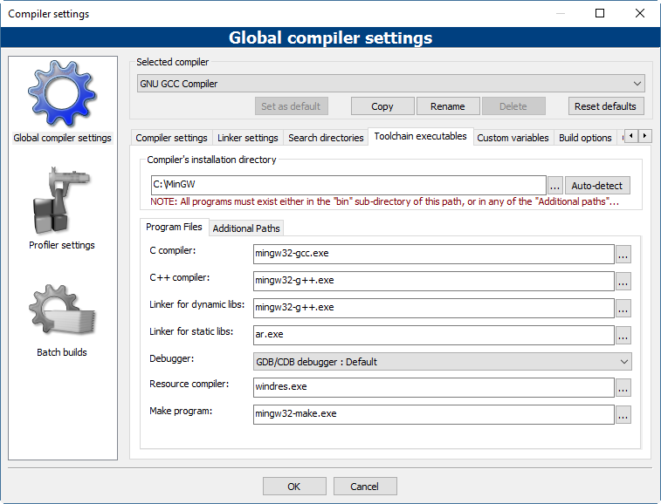

Figure - Compiler setting with MinGW

This setting turned out some following errors on the gtest-port.h

* *Error: ‘fileno’ was not declared in this scope*
* *Erorr: _stricmp is not declared in this scope*

To get rid of these errors, one of the suggested solution is changing the -std=c*** flag -std=gnu++0x should fix your problem. In Codeblocks, it is done by adding new compiler flags. It is done by going to the ***compiler Flags*** tag then right click on the area that the Fag will be added and choose “New flag”, then give the flag’s information. For more details, it can be done by reference on this link: <http://stackoverflow.com/questions/31171979/enabling-std-c14-flag-in-codeblocks>

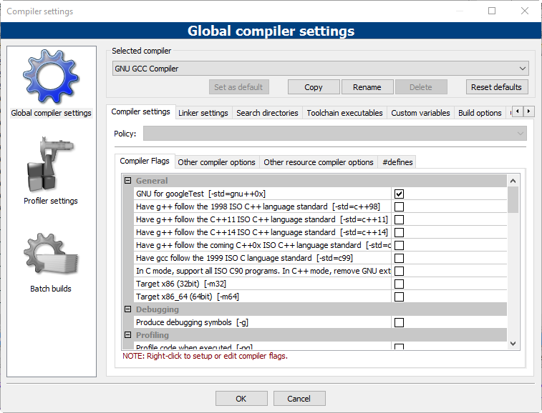

Figure - New flag is added

However, this above solution still left the error with *_stricmp which is indicated as following*

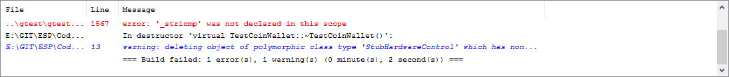

Figure - _strcmp error

It could be the configuration for minGW was not correct. However, we cannot indicated what is going wrong, since the minGW provided many options to install the compiler. Then, an alternative solution was tried. Besides minGW, one of the tutorial (<http://wiki.codeblocks.org/index.php/MinGW_installation>) of Codeblocks guides us to use TDM-GCC which is the easier way to set up a working compiler is to install a recent GCC release targeting the MinGW compiler system. The following settings (Figure 5) for the compiler on Codeblocks worked.

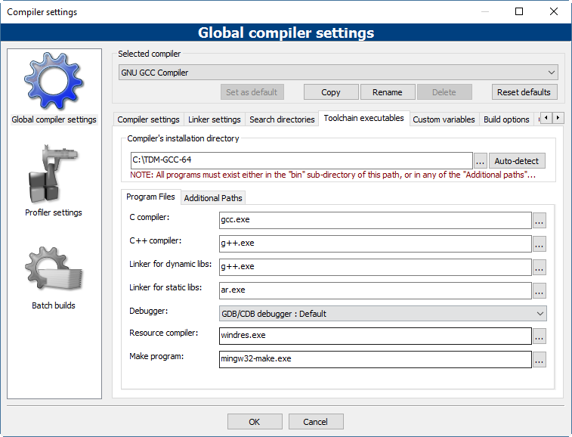

Figure - Configuration of CodeBlock compiler with TDM-GCC

### Problem with the data types for cross-complier the source code

When the code was implemented on Arduino platform, we did use the Byte data type which is only work on this platform but not for the others one. This leads to a problem when we would like to implement the test for google test, it did not work properly. Since, CodeBlock or Linux environment required some extra libraries to make it complies and currently, CodeBlock does not support the cross-complier for Arduino platform. One of the possibilities is used “typedef” to define the type Byte as a trick to make it compile in CodeBlock as well as Linux environment. However, changing the Byte type to one of the standard types of C++ such as unsigned char is an implemented solution.

After changing the data type back to the C++ standard types, the classes can be run in both Codeblock and Linux environments.

### STUBHARDWARE CLASS

Stubhardware is stub of the class HardwareControl which simulates the behaviors of the real Hardware class. This class contains all the functions that the HardwareControll class has. However, the Stubharware’s functions only return value or have the empty body in term of void function. These functions are used to make sure that the test can work in the condition of all hardware components work well. It also turns out that if any errors occur, it will be the problem of the upper class (CoinWallet or PropramSelect) and it is easier to maintain and debug the errors.

### TESTCOINWALLET CLASS

Testcoinwallet class is the implementation of unit tests for class CoinWallet. This contains 17 tests which mainly check for the amount of the money when users put the number of coins into the laundry machine. It also check for the balance when one of washing programs is executed and the corresponding amount of money is subtracted. The following table lists these tests in detail.

|  |  |
| --- | --- |
| Tests | Explanations |
| test_getBalance | Test the getBalance method in the term of the wallet does not have any coins and the expected balance is 0 |
| test_coin10_one | Test the balance of the coin wallet when 1 coin of 10 is added, the expected balance is 10 |
| test_coin10_two | Test the balance of the coin wallet when 2 coins of 10 are added, the expected balance is 20 |
| test_coin10_three | Test the balance of the coin wallet when 3 coins of 10 are added, the expected balance is 30 |
| test_coin10_four | Test the balance of the coin wallet when 4 coins of 10 are added. Since the machine only allows 3 coins of 10 are put. Then when the fourth one is put, in real situation, it is returned back to the user and the expected balance is 30 |
| test_coin50_one | Test the balance of the coin wallet when 1 coin of 50 is added, the expected balance is 50 |
| test_coin50_two | Test the balance of the coin wallet when 2 coins of 50 are added, the expected balance is 100 |
| test_coin50_three | Test the balance of the coin wallet when 3 coins of 50 are added, the expected balance is 150 |
| test_coin50_four | Test the balance of the coin wallet when 4 coins of 50 are added. Since the machine only allows 3 coins of 50. Then when the fourth one is put, in real situation, it is returned back to the user and the expected balance is 150 |
| test_coin200_one | Test the balance of the coin wallet when 1 coin of 200 is added, the expected balance is 200 |
| test_coin200_two | Test the balance of the coin wallet when 2 coins of 200 are added, the expected balance is 400 |
| test_coin200_three | Test the balance of the coin wallet when 3 coins of 200 are added. Since the machine only allows 2 coins of 200. Then when the fourth one is put, in real situation, it is returned back to the user and the expected balance is 400 |
| test_balance_programA | Test the balance of 360, which is the price for program A, by adding 1 coin of 200, 3 coins of 50 and 1 coin 10. The expected balance is 360. |
| test_balance_programB | Test the balance of 480, which is the price for program B, by adding 2 coins of 200, 1 coin of 50 and 3 coins of 10. The expected balance is 480. |
| test_balance_programC | Test the balance of 510, which is the price for program C, by adding 2 coins of 200, 1 coin of 50 and 3 coins of 10. The expected balance is 510. |
| test_withdraw_all | Test for calling the WithDrawAll function in the CoinWallet class. The expected balance is 0. |
| test_withdraw | Test for calling the WithDraw function in the CoinWallet class, which the given amount of withdraw money is 510 and the balance is 550. Then, the expected balance is 40. |

### TEstpgrogramSELECT CLASS

Testcoinwallet class is the implementation of unit tests for class ProgramSelect. This contains 6 tests which mainly check for which washing program is selected when the program button is pressed.

|  |  |
| --- | --- |
| Tests | Explanations |
| getProgramA | By default, the selected program is A. This test called the GetProgramType of ProgramSelectClass and expected result is washing program “A”. |
| getProgramB | This test calls the Poll function of the ProgramSelectClass. The StubHardware class is built based on the assumption that all the reading input from buttons, when they are called, will return true. It means that, when the Poll function called the program button is pressed. Calling the Poll function one time means that the button is pressed one time and the expected result is washing program “B”. |
| getProgramC | The testing concept of this test is similar to getProgramB. However, the Poll function is called twice and the expected result is washing program “C”. |
| getProgram_backtoA | This test applied the same concept as getProgramB and getProgramC. However, after we get “C”, the new circle is started and back again to “A” if the poll function is called 3 times and expected result is washing program “A”. |
| getProgram_backtoB | This test applied the same concept as getProgram_backtoA. However, the poll function is called 4 times and the expected result is washing program “B” |
| getProgram_backtoC | The same concept as getProgram_backtoA and getProgram_backtoB is applied. In this case, the poll function is called 5 time and the expected result is washing program “C”. |

# PIN CONFIGURATIONS

From our independent investigations we tried to determine which buttons correspond to which exact input descriptors. In the hardware control class the constants used for each of the corresponding buttons and switches were as follows:

Keyselect must be HIGH in order to read button inputs.

Button 1: IN_IN0 and IN_IN3, pressing button 1 raises IN0 and IN3 to high  
Button 2: IN_IN0, pressing button 2 raises IN0 to high  
Button 3: IN_IN3, pressing button 3 raises IN3 to high  
Button 4: IN_IN2, pressing button 3 raises IN2 to high  
Button 5: IN_IN1, pressing button 3 raises IN1 to high  
Button 6: IN_IN1, IN_IN2 and IN_IN3, pressing button 1 raises IN1, IN2 and IN3 to high

Keyselect must be LOW in order to read switch inputs.

Switch 2: IN_IN0, pulling up switch 2 raises IN0 to high  
Switch 3: IN_IN3, pulling up switch 3 raises IN3 to high  
Switch 4: IN_IN1, pulling up switch 4 raises IN1 to high  
Switch 5: IN_IN2, pulling up switch 5 raises IN2 to high

*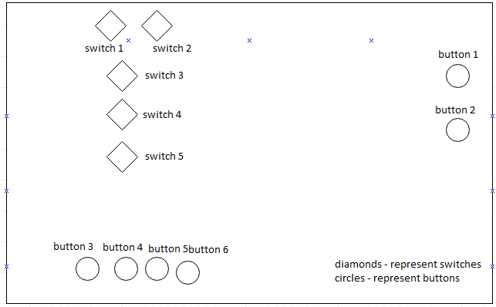Figure 1: Buttons and Switches on Laundry Machine*