ITA2 CASE

ISNL – WEBSITE for international students in nertherlands

NGOC KIEU THANH HUYNH - 2688093

Bilal Butt - 2688700

2015

Contents

DELIVERABLE B 2

DELIVERABLE C 4

ITA1 – Sitemap and wireframe: 4

Site-map, ITA1 - version: 4

Wireframes, ITA1 –versions: 5

Site-map for ITA2 website: 22

Updated old wireframes and wireframes for new pages: 23

Overview of PHP files 25

# DELIVERABLE B

|  |  |  |
| --- | --- | --- |
| ReqID | Functional Requirement | Where on your original website it will appear, and what kind of information it will show/ask? |
| MUST | | |
| 1 | A visitor of your site will be able to register as a new user (creating new user account)   Information is processed by PHP script and stored in database | Homepage will have login/sign up feature to allow users to register. This could be place in the right corner of the website.  SignUp Info Requirements: user’s name, email and password  Login Info: user email and password  User information will be kept and stored in MySql database. |
| 2 | One or more pages will only be visible to logged in users (Describe what kind of page?) | Users will have a personal page with their personal information and a list of events on the website that they have shown an interest in. |
| 3 | The pages only visible to logged in users, should be accessible by menu items. These items become visible when user logged in successful. | When user logs in the ‘search for event page’ will be visible. |
| 4 | Specific information about a visitor is shown when he returns to the site, whether logged in or not. e.g. Name of visitor, number of visits  (Functionality implemented with ‘Cookies’) | In the personal page the user gets a welcome message with his/her name, the last time he/she visited the website and the date they signed up. |
| 5 | A visitor of your site can post information to your server that is stored in a database. (describe what kind of info)  e.g. forum, feedback on your site | The visitor can leave comments in the contact page that are sent to the database. Information in that section will be related to feedback for the website as well as the events they visit. |
| SHOULD | | |
| 6 | A user can enter information on one page which is taken over to another page.  e.g. If you order a product and go to the shopping basket, the product is still there  In this case ‘Session’ technique is used to persist the data. | User’s information about their favorite events for them will remain in their personal/favorite events page. That data for each user will be stored in the database. |
| 7 | When a user has registered successful a confirmation e-mail is sent to the provided e-mail address. | Will send email to users when they register to confirm their registration. |
| 8 | Information that was sent to your server and stored in the database can be changed or deleted (describe also what kind of info you are acting on) | Information related to user’s favorite events and personal information. |
| 10 | Dynamic update of menu with JQuery after login. | After user login, the left corner of the website’s header will be changed into the icon of logged in user. |
| 11 | A logged in visitor can Upload file(s) to server via a form | No |
| 11 | A logged in visitor can Download files which were uploaded to the server. | No |
| 12 | Our proposals idea: website can store information in database about the number of people interested in the different events in order to help future organizers of events with managing the capacity of their events. | The database could keep track the number of visitors interesting with different events. This figure can be calculate by how many visitors choose these events as their favorite events. |
| 13 | The visitors can search for events in case of providing location and the time. | The search for event page can be implemented and only the login user can see it. |

# DELIVERABLE C

## ITA1 – Sitemap and wireframe:

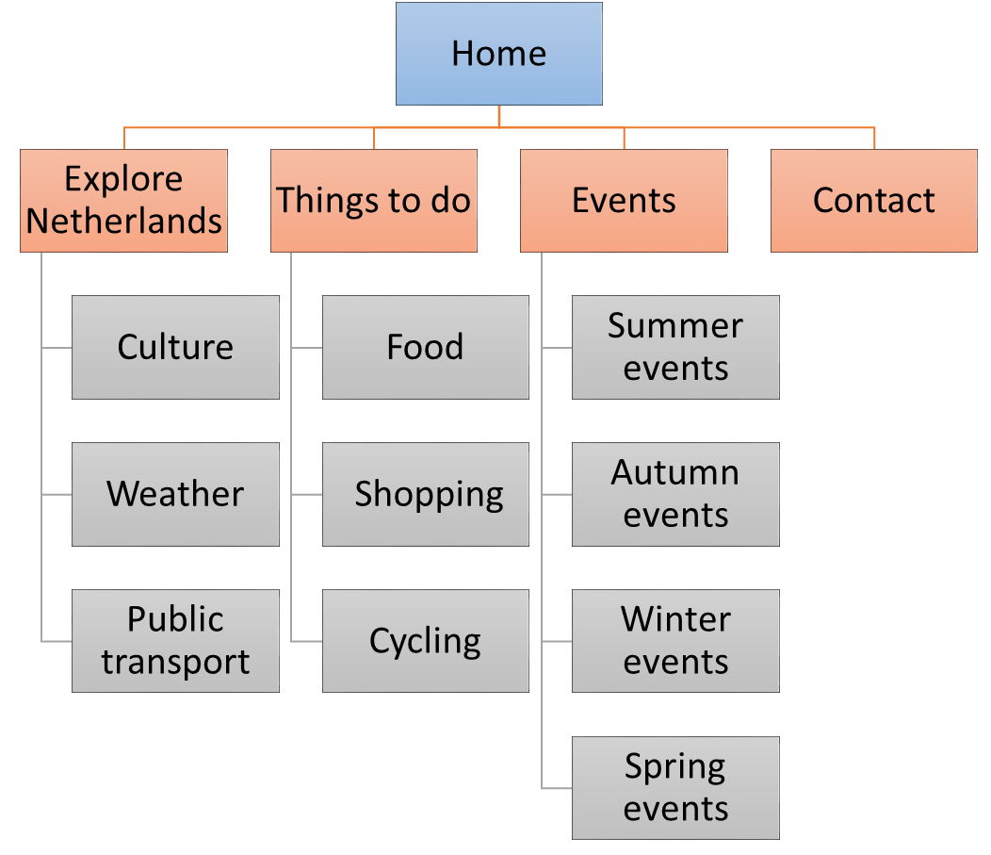

### Site-map, ITA1 - version:

* Home page: contain general information about website and navigate visitors to another pages.
* Explore Netherlands is the menu that contains 3 main information about this country, which we think necessary for an internal students when they come here: Culture, Weather and Public transport
* Things to do: some reminding things for new students when they came to Netherlands:
  + Food is able to provide them some information about where they could drink and eating out
  + Shopping: Some advised or recommend supermarket or some places they could go for food or for their clothes
  + Cycling: Information about how to buy a good bicycle in Netherlands, and some traffic rules with bike.
* Events: the main part of the website
  + Give information about the oncoming events, organize by season
  + Search for events: user could leave out some information about their places, time they are available. Website could suggest for them some suitable events.
* Contact page: allow the visitors contact with the owner’s website by sending forms.

### Wireframes, ITA1 –versions:

#### Home page

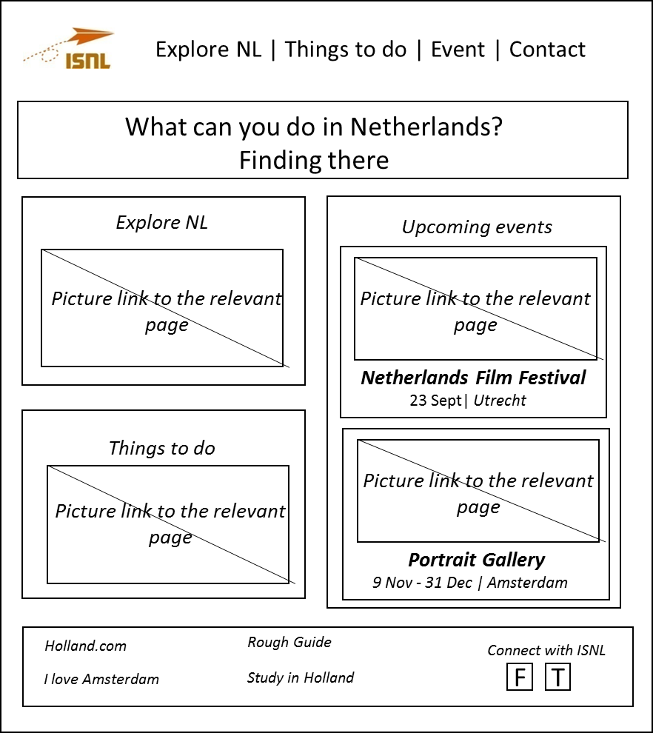

#### Explore NL page

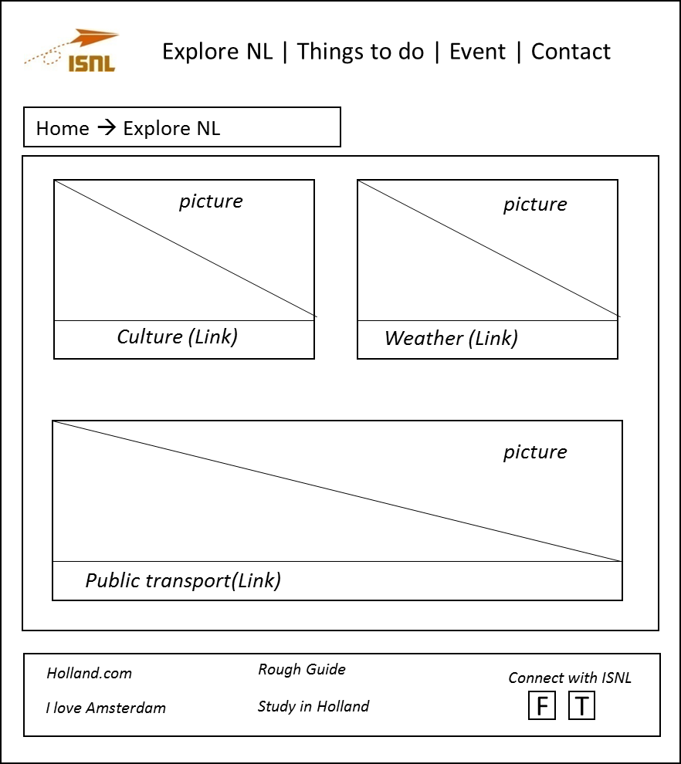

From this page, visitors are able to link to 3 sub-pages:

##### Culture page:

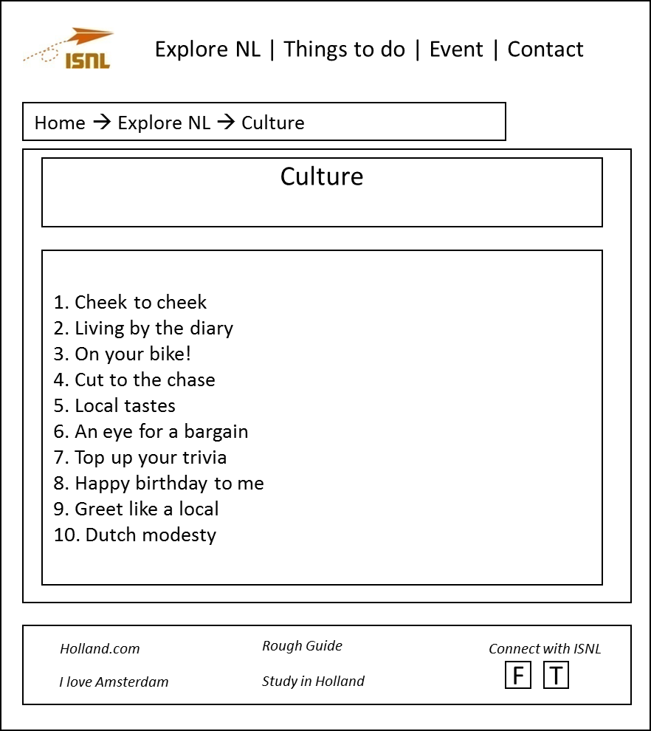

##### Weather page:

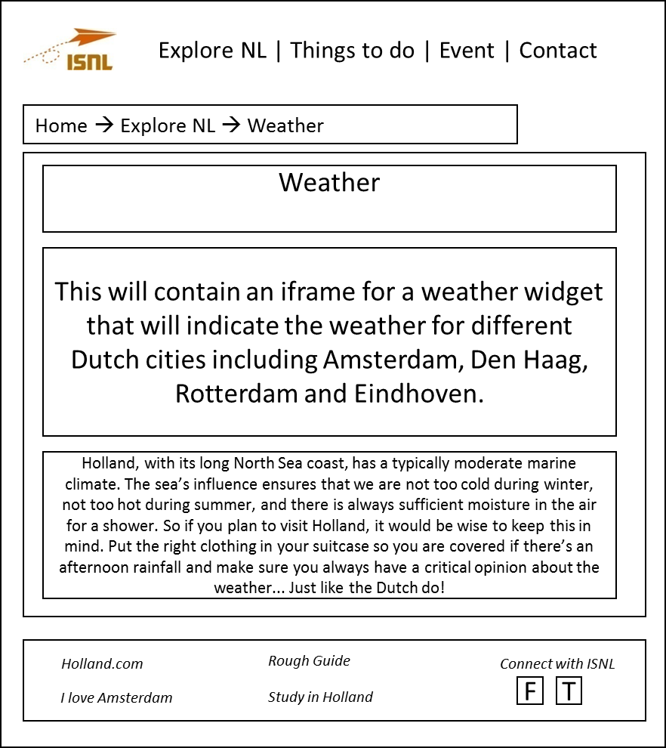

##### Public transport page:

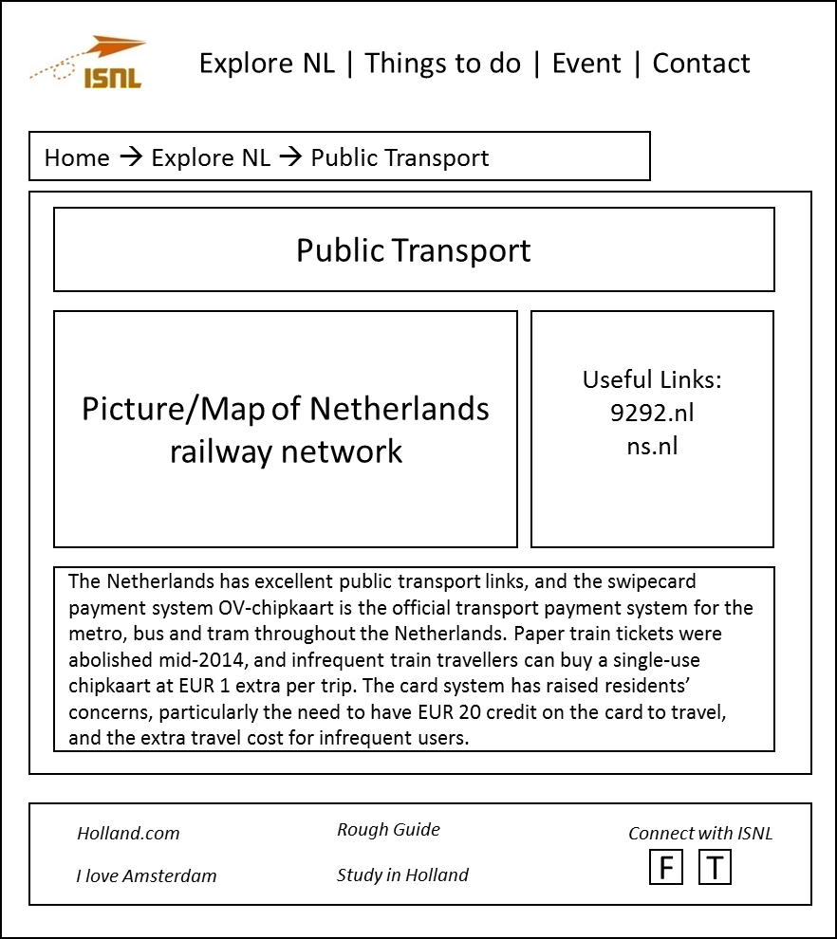

##### Things to do

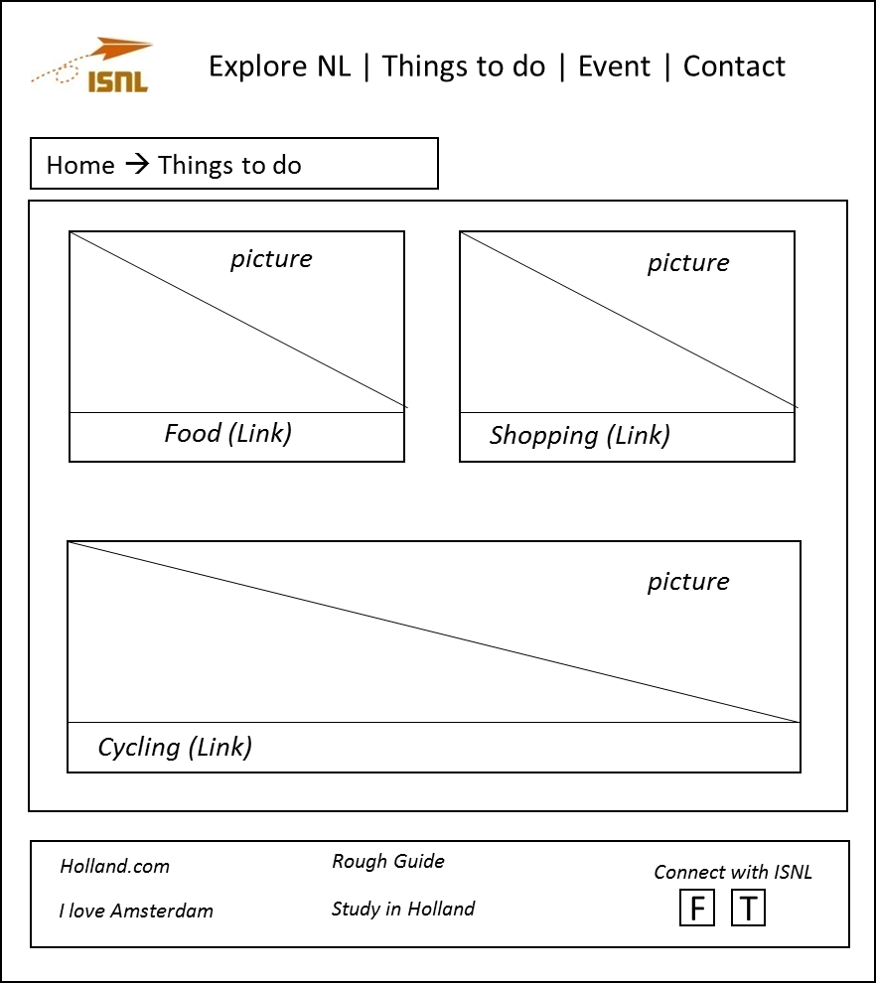

From this page, visitors are able to link to 3 sub-pages:

##### Food

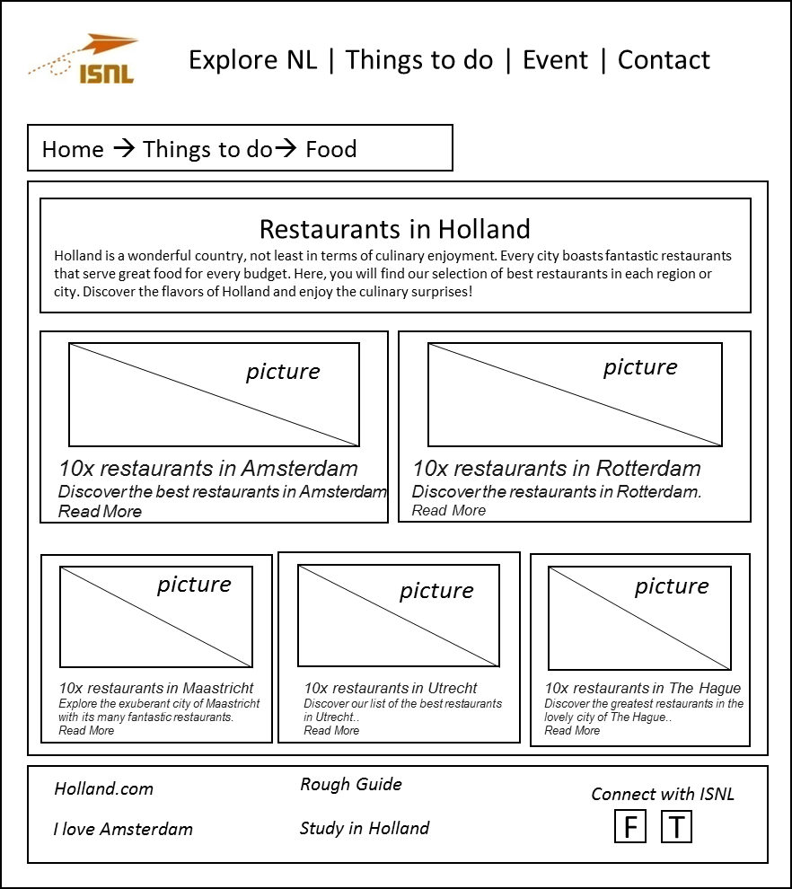

This page will link to pages introducing about top restaurant in 5 cities:

|  |  |
| --- | --- |
| Pages & Link | Link |
| 10x restaurants in Amsterdam | [Amsterdam](http://www.holland.com/us/tourism/interests/food-6/restaurants-in-holland/restaurants-in-amsterdam-2.htm) |
| 10x restaurants in Rotterdam | [Rotterdam](http://www.holland.com/us/tourism/interests/food-6/restaurants-in-holland/restaurants-in-rotterdam.htm) |
| 10x restaurants in Maastricht | [Maastricht](http://www.holland.com/us/tourism/interests/food-6/restaurants-in-holland/restaurants-in-maastricht-2.htm) |
| 10x restaurants in Utrecht | [Utrecht](http://www.holland.com/us/tourism/interests/food-6/restaurants-in-holland/restaurants-in-utrecht-2.htm) |
| 10x restaurants in the Hague | [Hague](http://www.holland.com/us/tourism/interests/food-6/restaurants-in-holland/restaurants-in-den-haag-2.htm) |

##### Shopping

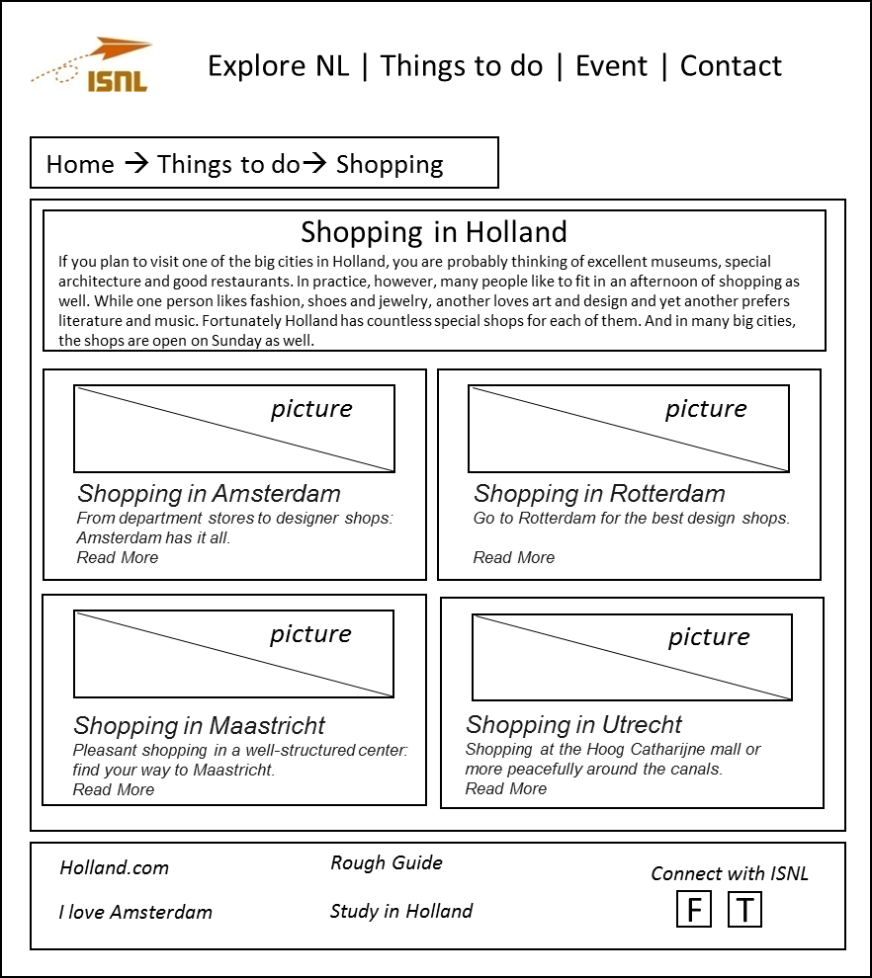

This page will link to pages introducing recommended shops in 4 cities:

|  |  |
| --- | --- |
| Pages & Link | Link |
| Shopping in Amsterdam | [Amsterdam](http://www.holland.com/us/tourism/cities/amsterdam/shopping-in-amsterdam-2.htm) |
| Shopping in Rotterdam | [Rotterdam](http://www.holland.com/us/tourism/cities/rotterdam-1/shopping-in-rotterdam-1.htm) |
| Shopping in Maastricht | [Maastricht](http://www.holland.com/us/tourism/cities/maastricht-1/shopping-in-maastricht-2.htm) |
| Shopping in Utrecht | [Utrecht](http://www.holland.com/us/tourism/cities-in-holland/utrecht-1/shopping-in-utrecht-1.htm) |

##### Cycling

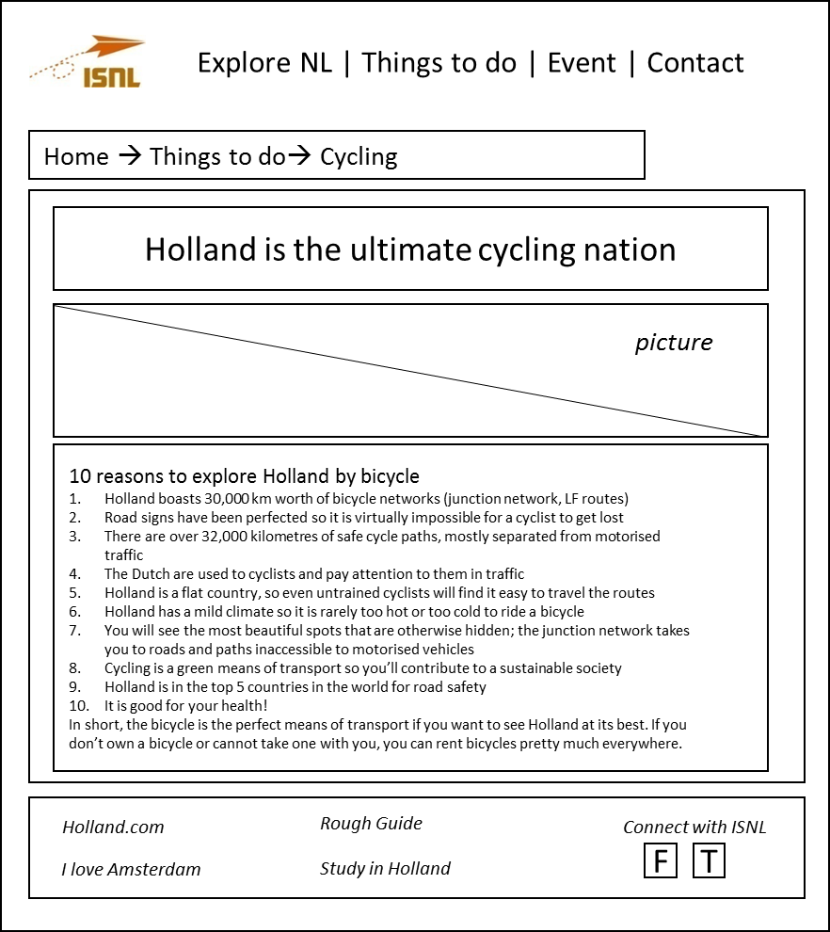

##### Events page

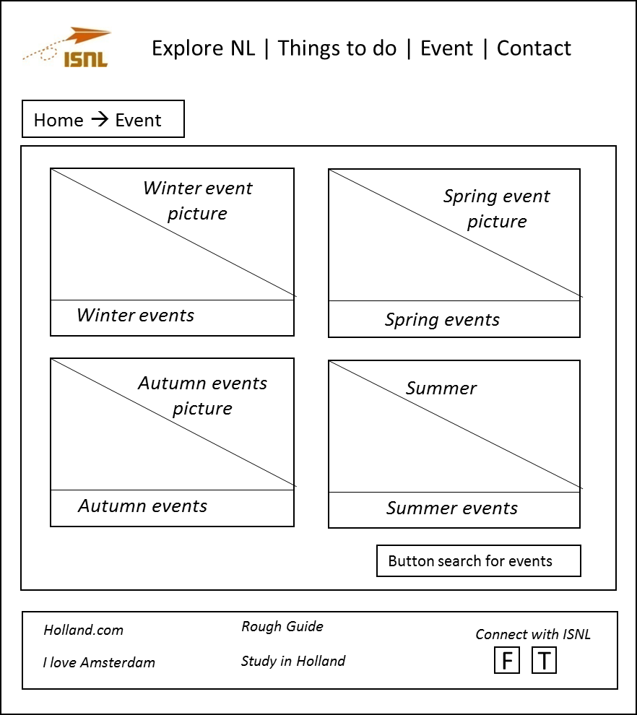

Visitors are able to search for events following the search for event pages by clicking the button search for events:

##### Search for event pages

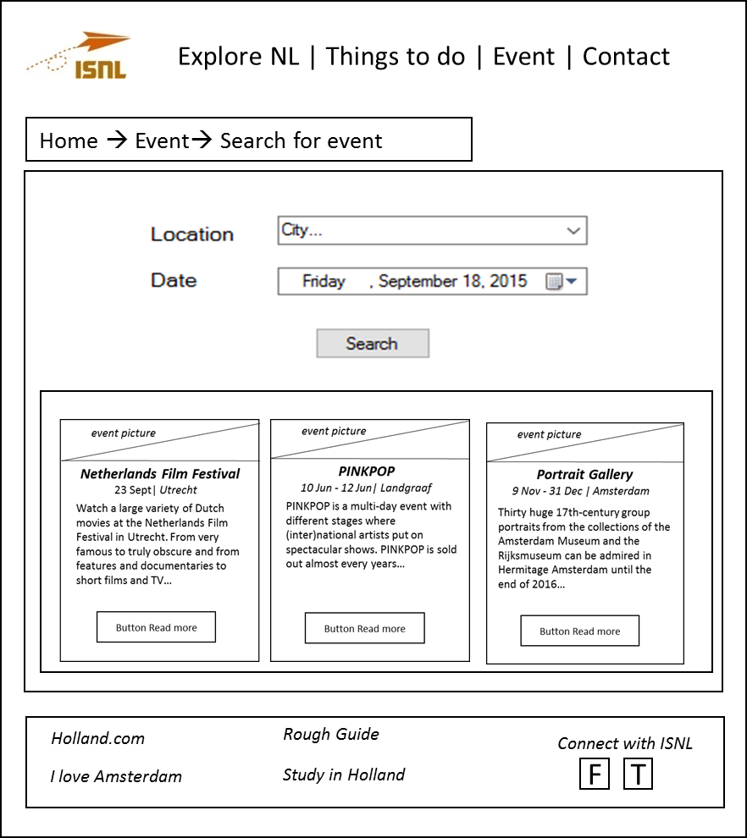

##### Summer events page

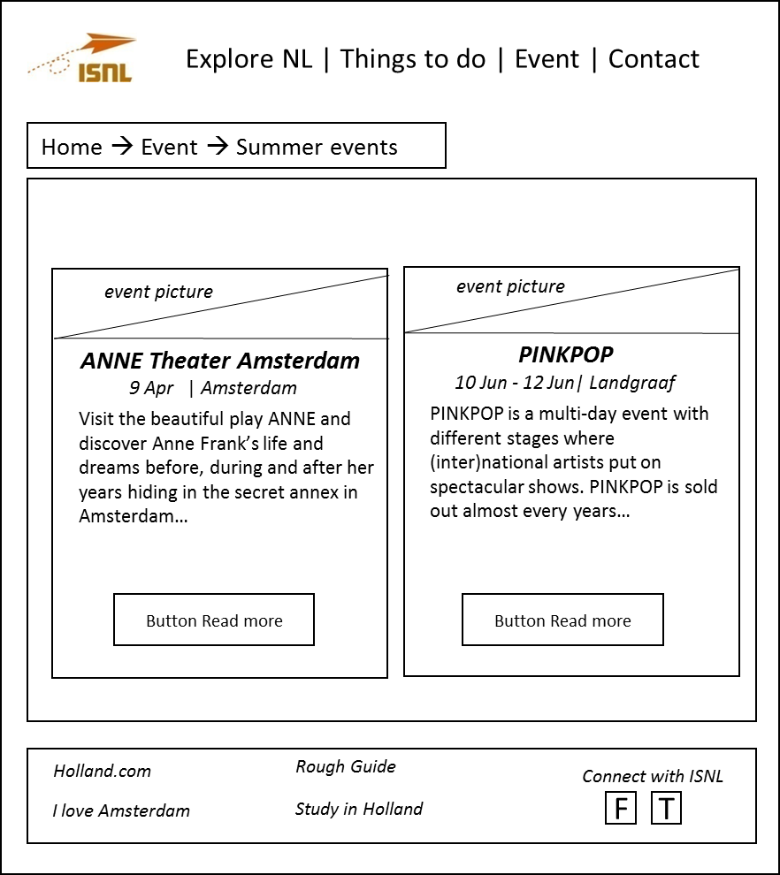

##### Autumn events page

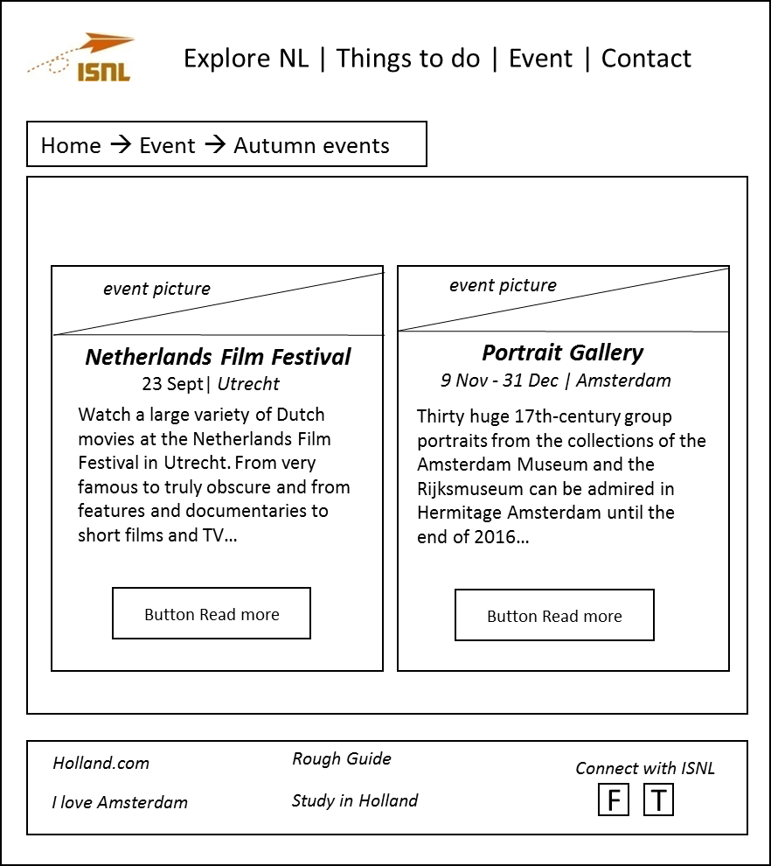

##### Winter events page

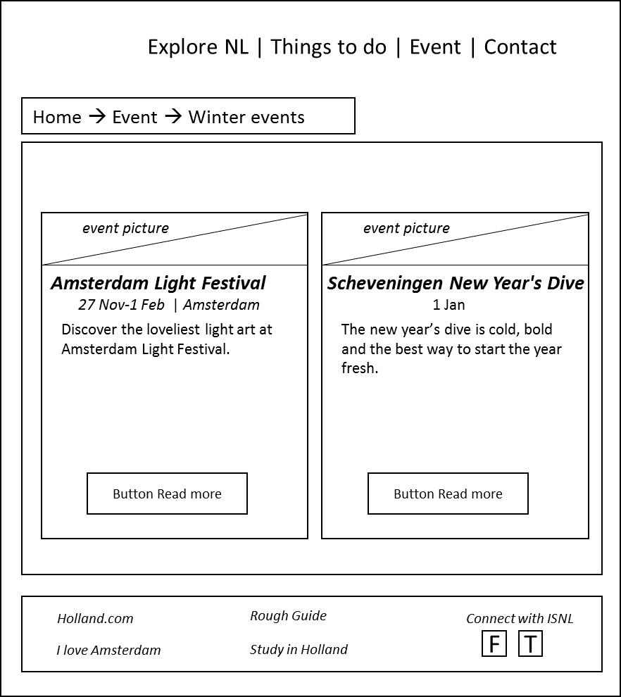

##### Spring events page

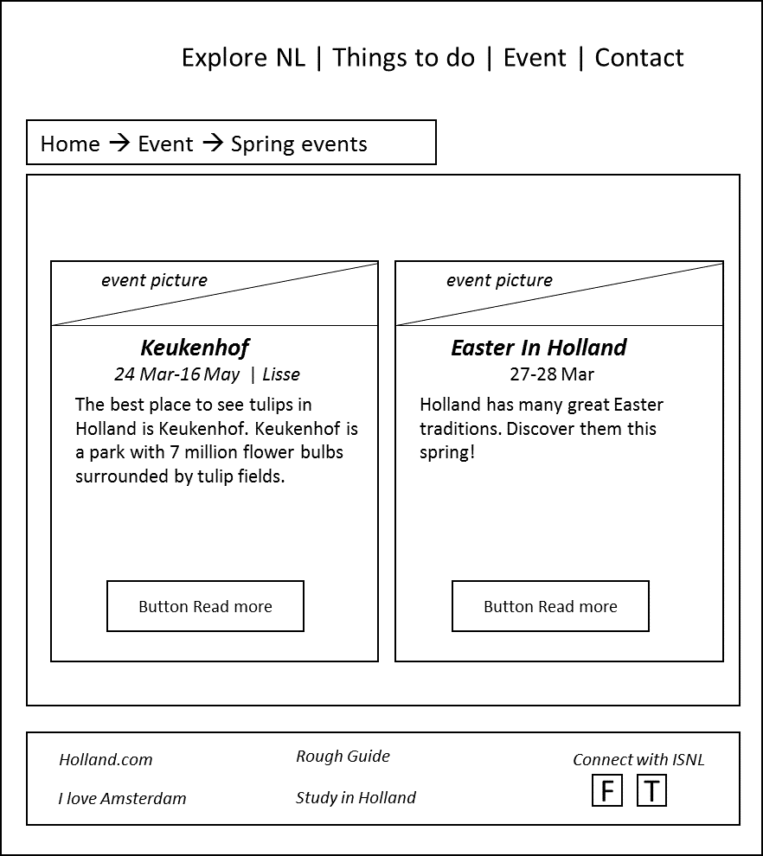

For each event, visitors could read more about full information following by this structure

##### Specific event page

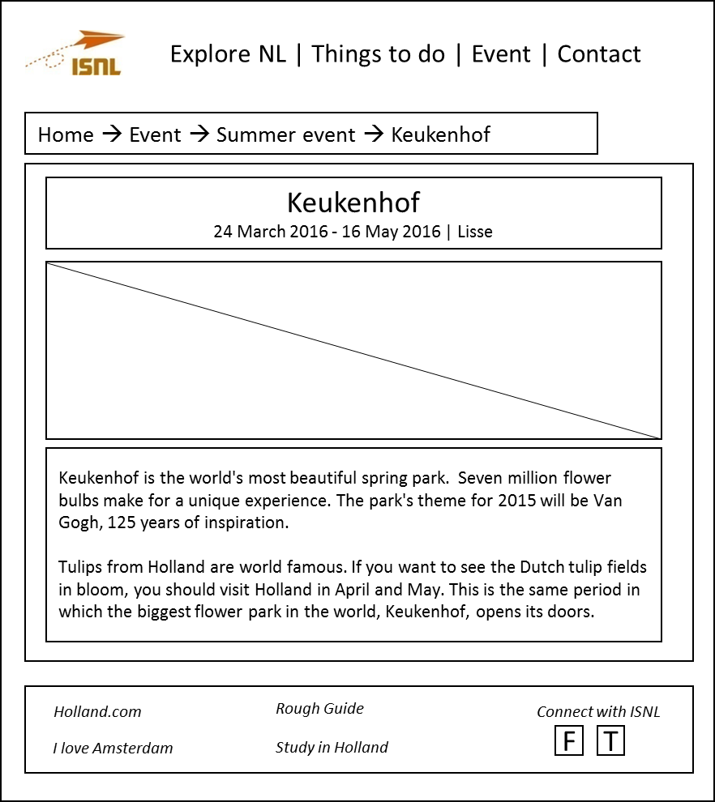

##### Contact

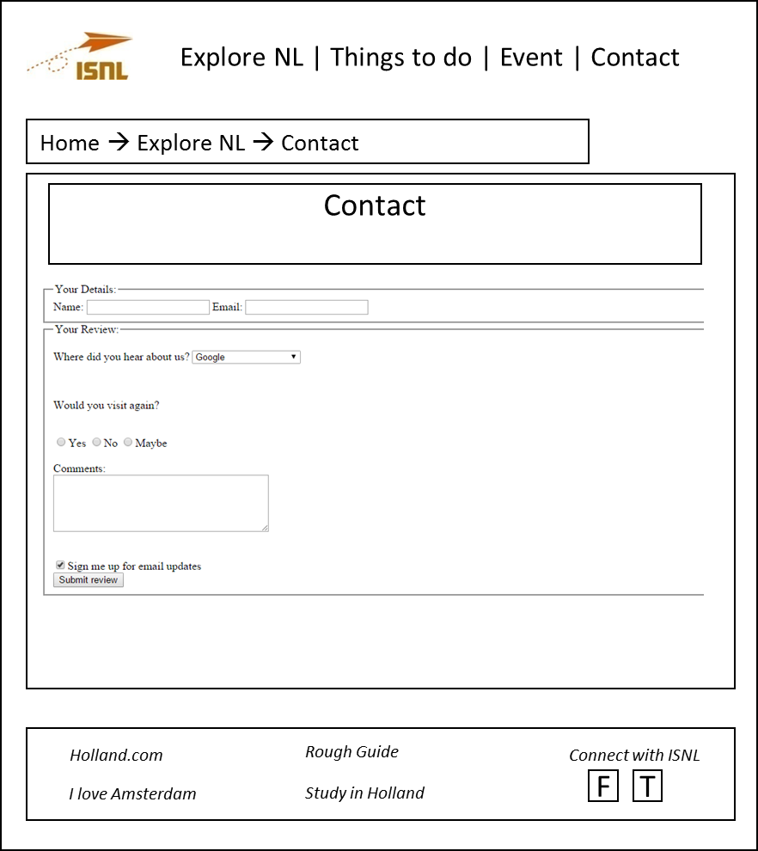

## Site-map for ITA2 website:

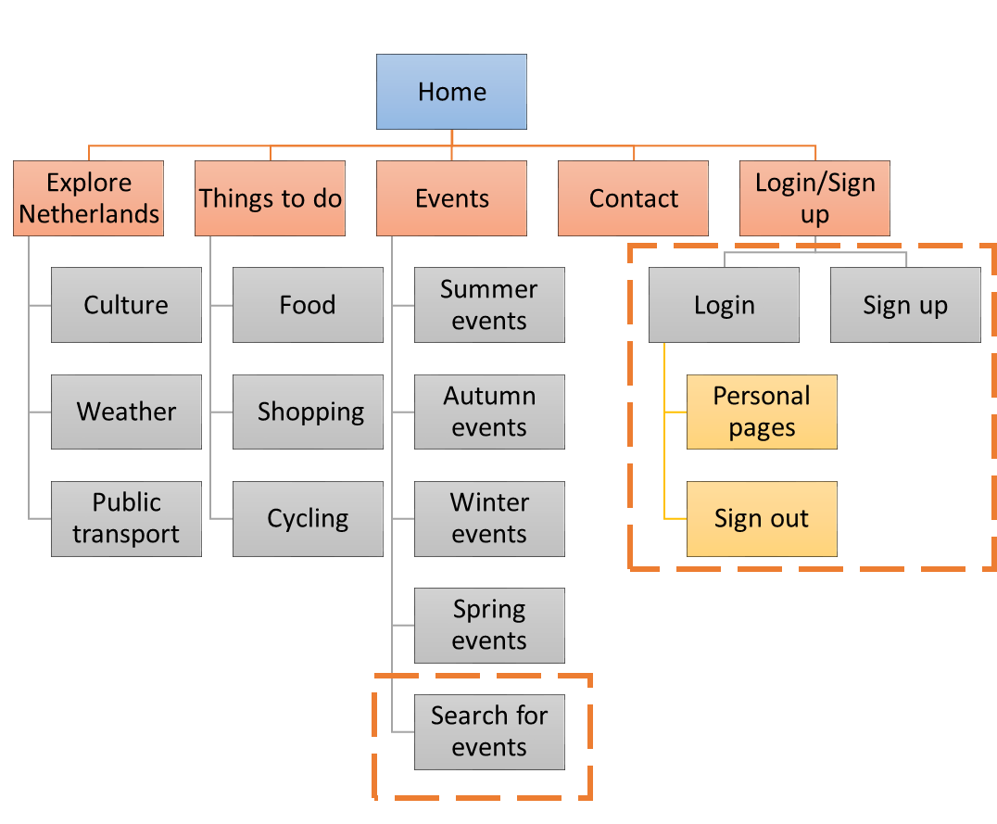

Comparing with the old site-map in ITA1 – website, the Login and sign up pages will be added. Users after sign up and have their own account. They will be provide a personal page. Besides, only login-users have a chance to visit the search for events page.

## Updated old wireframes and wireframes for new pages:

1. The header of old pages will be added 2 buttons ‘Log in’ and ‘Sign up’, to allow users sign up an account or log in in to their account. The changes are indicated by the red color.

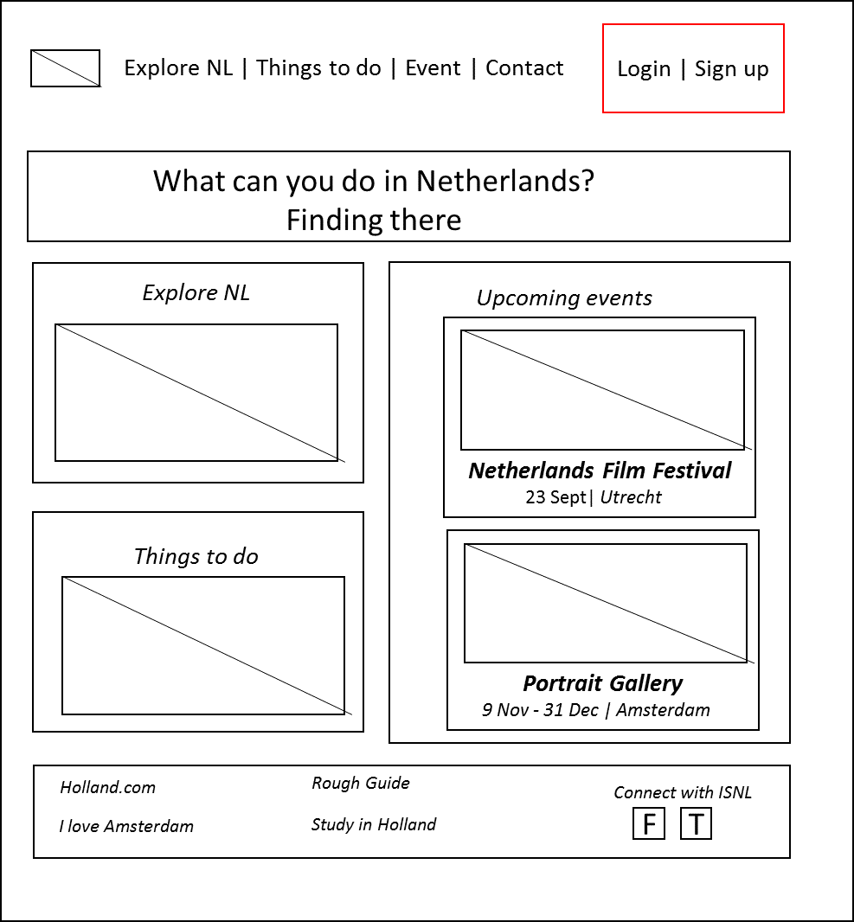

1. Login page:

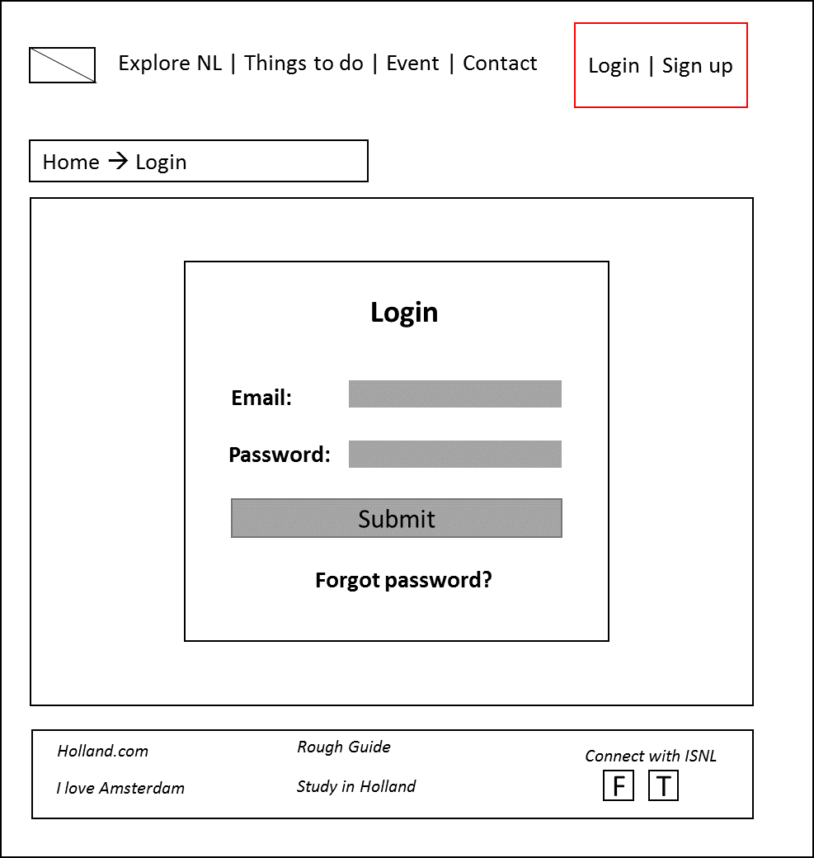

1. Sign up page:

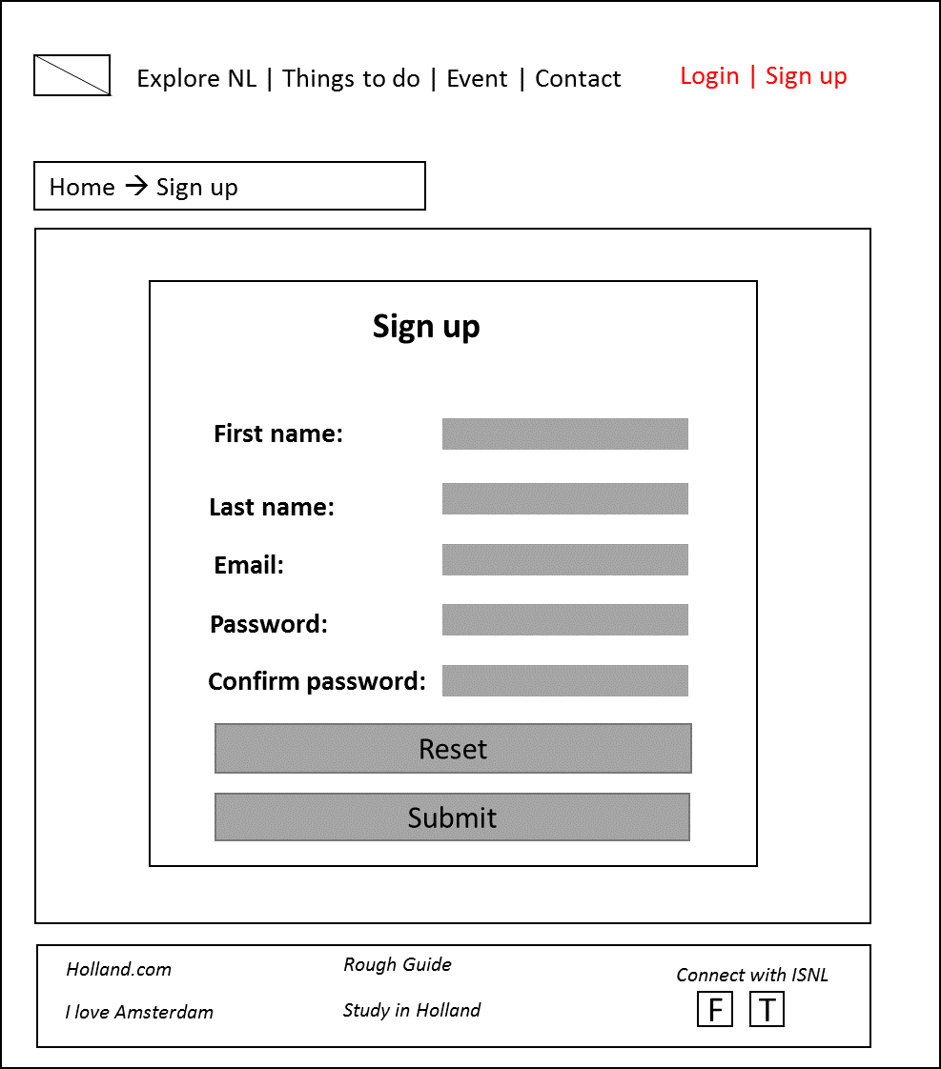

1. Personal page: this page will show information about users and keep track their favorite event. When users log in, they allow to access this page by the drop down menu in the left side of their name on the header.

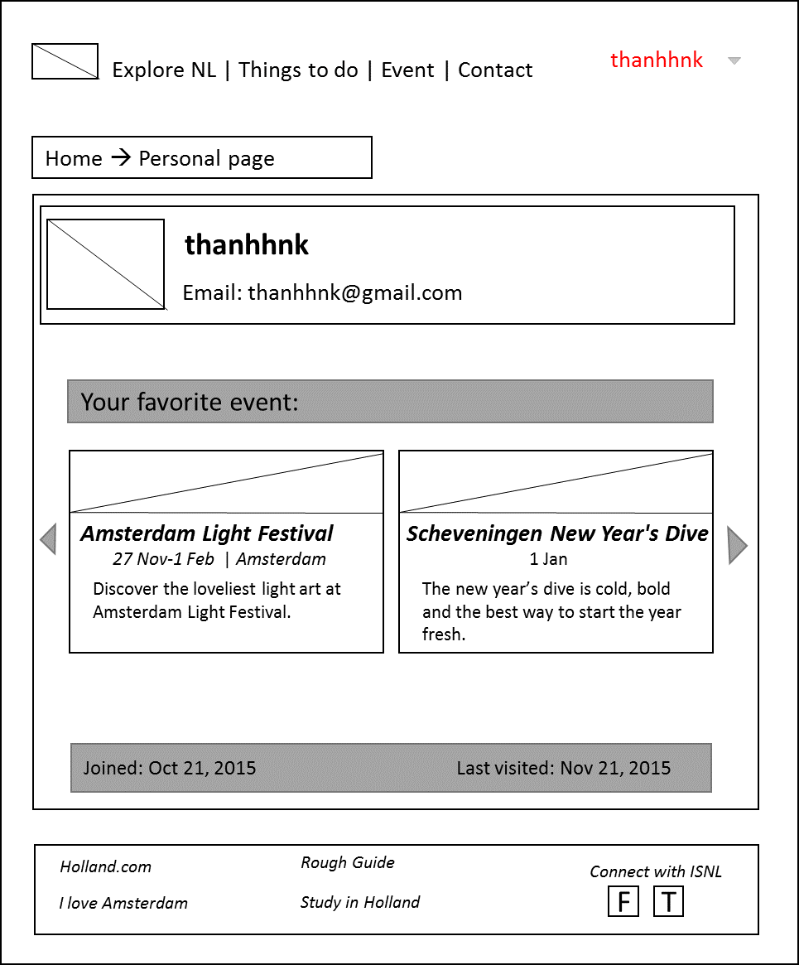

## Overview of PHP files

|  |  |  |  |
| --- | --- | --- | --- |
| Files’ name | visualization | processing | infrastructure |
| signIn.view.php | X |  |  |
| signIn.php |  | X |  |
| signUp.view.php | X |  |  |
| signUp.php |  | X |  |
| Users.class.php |  |  | X |
| Users.DAO.php |  |  | X |
| events.class.php |  |  | X |
| events.DAO.php |  |  | X |
| personalPage.view.php | X |  |  |
| pesronalPage.php |  | X |  |
| searchForEvent.view.php | X |  |  |
| searchForEvent.php |  | X |  |
| DBConnection.php |  |  | X |
| config.php |  |  | X |
| header.inc.php | X |  |  |
| footer.inc.php | X |  |  |
| headTag.inc.php | X |  |  |
| home.php | X |  |  |
| thingstodo.php | X |  |  |
| explorenl.php | X |  |  |
| events.php | X |  |  |
| contact.php | X |  |  |
| culture.php | X |  |  |
| publicTransport.php | X |  |  |
| weather.php | X |  |  |
| food.php | X |  |  |
| shopping.php | X |  |  |
| cycling.php | X |  |  |
| summerEvent.php | X |  |  |
| springEvent.php | X |  |  |
| autumnEvent.php | X |  |  |
| winterEvent.php | x |  |  |

# DELIVERABLE D

## UML sequence diagrams:

### Register a user account:

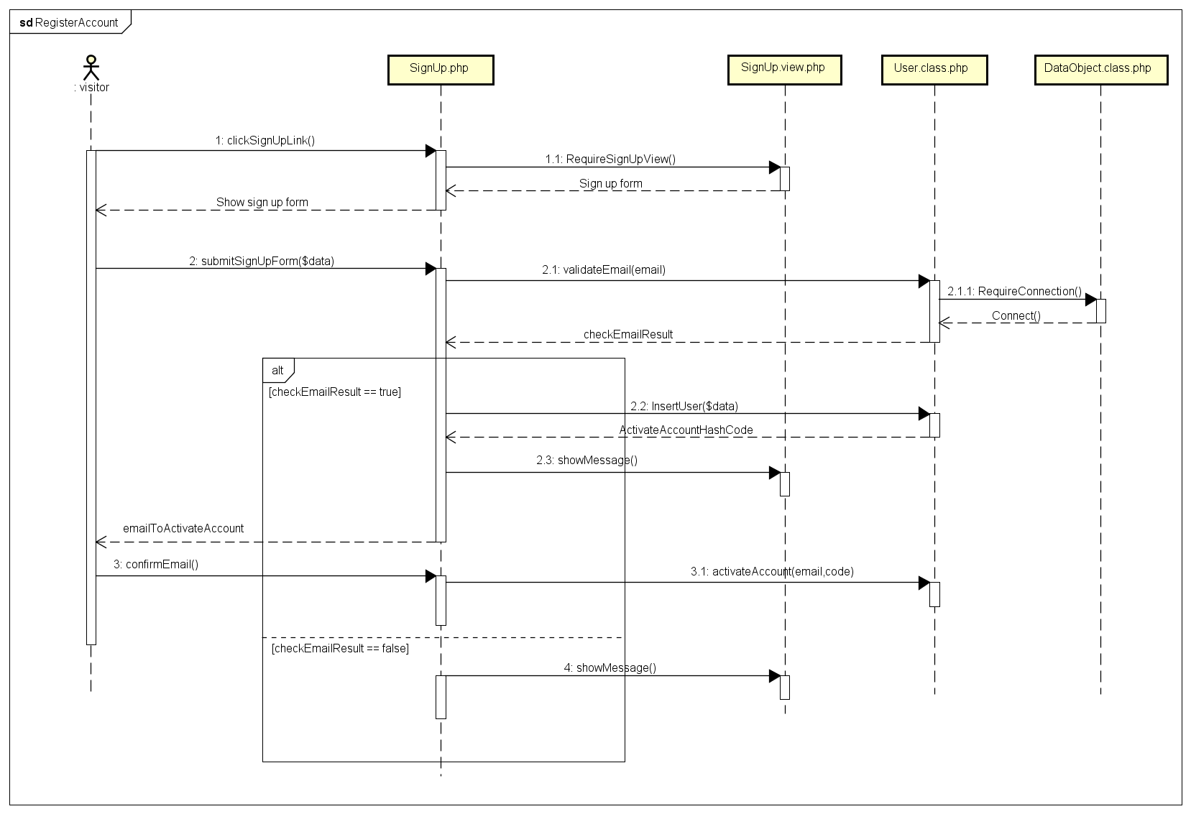

### Sign in:

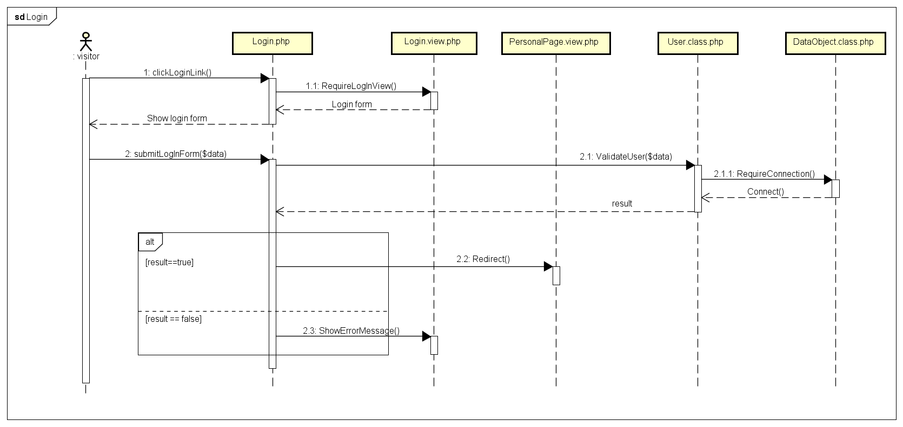

### Add favorite event into personal pages:

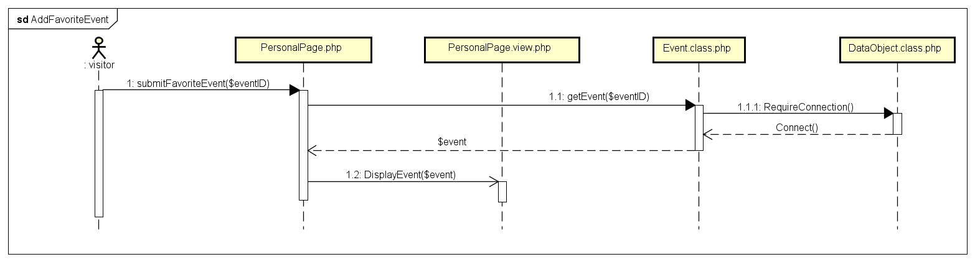

## Updating overview PHP Files:

|  |  |  |  |
| --- | --- | --- | --- |
| Files’ name | visualization | processing | infrastructure |
| signIn.view.php | X |  |  |
| signIn.php |  | X |  |
| signUp.view.php | X |  |  |
| signUp.php |  | X |  |
| Users.class.php |  |  | X |
| events.class.php |  |  | X |
| personalPage.view.php | X |  |  |
| pesronalPage.php |  | X |  |
| searchForEvent.view.php | X |  |  |
| searchForEvent.php |  | X |  |
| DataObject.class.php |  |  | X |
| config.php |  |  | X |
| common.inc.php | X |  |  |
| home.php | X |  |  |
| thingstodo.php | X |  |  |
| explorenl.php | X |  |  |
| events.php | X |  |  |
| contact.php | X |  |  |
| culture.php | X |  |  |
| publicTransport.php | X |  |  |
| weather.php | X |  |  |
| food.php | X |  |  |
| shopping.php | X |  |  |
| cycling.php | X |  |  |
| summerEvent.php | X |  |  |
| springEvent.php | X |  |  |
| autumnEvent.php | X |  |  |
| winterEvent.php | x |  |  |