ngOC KIEU THANH huYNH – 2688093

Bilal Butt – 2688700

Raima khan –2692686

Armin ROSHAN- 2487128

Design document

GROUP MEMBERS:

Contents

INTRODUCTION 2

CLASS DIAGRAM 3

Class diagram 3

Description of the classes and their members 3

SEQUENCE DIAGRAMs 5

Draw a component 5

Draw a PIPELINE 6

# INTRODUCTION

This document is the design document for building a flow network application.

In the first section of this document, the class diagram of application are represented by diagrams and their brief description. The second section presents some sequence diagrams.

# CLASS DIAGRAM

## Class diagram

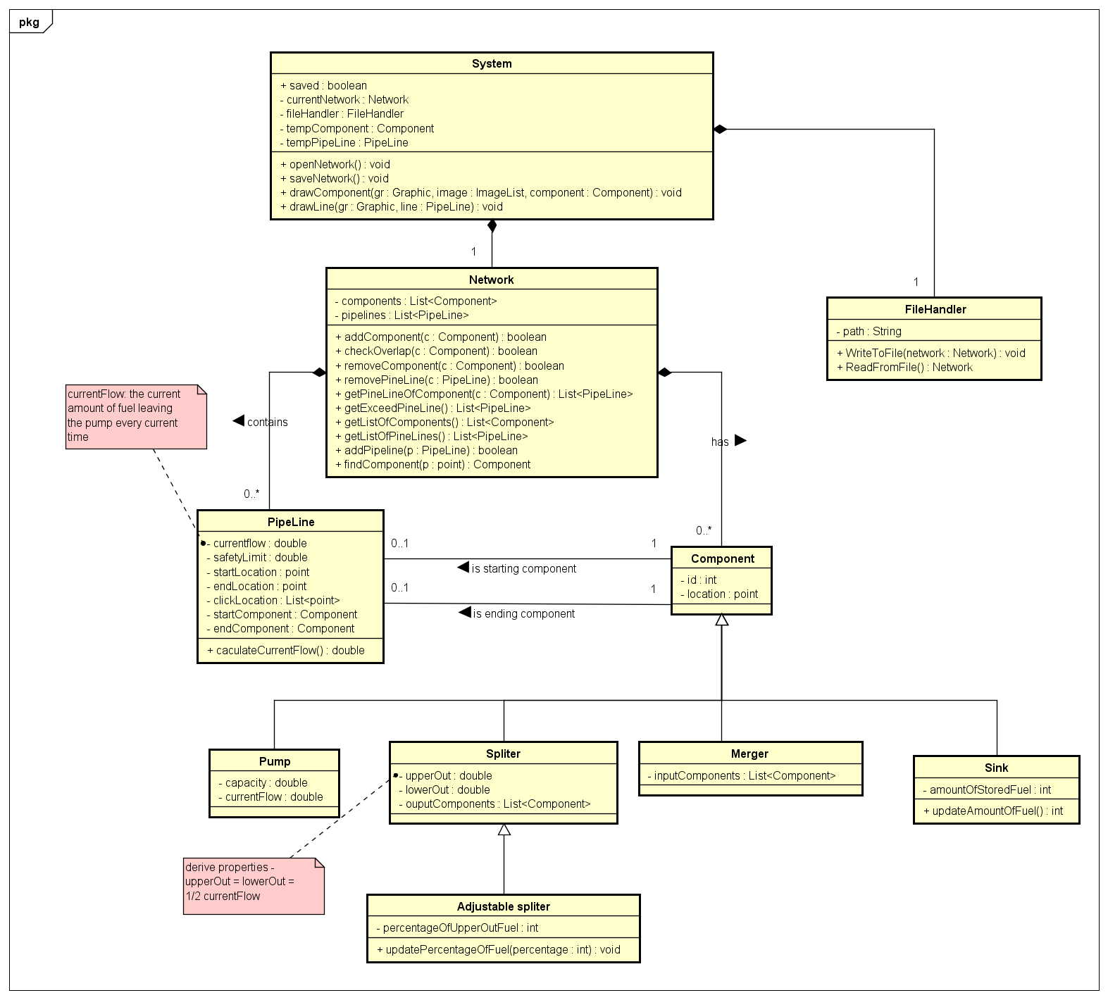

## Description of the classes and their members

#### COMPONENT CLASS

|  |  |  |
| --- | --- | --- |
| Properties | | |
| ID | Integer | This is unique number to indicate the components of each network drawing. It is increased automatically when the component is added |
| Location | Point | Representing an ordered pair of integer x- and y-coordinates that defines a location of components on the screen |
| Operations | | |
| Component(id: int, location: Point): *constructor of the class* | | |

#### PIPELINE CLASS

|  |  |  |
| --- | --- | --- |
| Properties | | |
| currentFlow | Double | Representing the current flow of the pipeline |
| saftyLimit | Double | Representing the maximum safety limit of the pipeline |
| startLocation | Point | Indicating the starting location of the pipeline |
| endLocation | Point | Indicating the ending location of the pipeline |
| clickLocation | List<Point> | Indicating the points in the middle of the pipeline |
| startComponent | Component | The component containing the starting location |
| endComponent | Component | The component containing the ending location |
| Pipeline(currentflow: double, limit: double, startLocation: Point, endLocation: Point, clickLocation :List<Point>) : *constructor of the class* | | |
| caculateCurrentFlow(): double  *This method is used to calculated and update the current flow of the pipeline whenever the other pipelines are added. Base on the startCompnent and endComponent, it’s possible to calculate the values of currentflow and update it.* | | |

#### NETWORK CLASS

|  |  |  |
| --- | --- | --- |
| Properties | | |
| components | List<Component> | A list of Component objects, private and are accessible through getListOfComponent() methods |
| pipeLines | List<Pipeline> | A list of Pipeline objects, private and are accessible through getListOfPipeLine() methods |
| Network(components : List<Component>, pipeLines: List<PineLine>) : *constructor* | | |
| + addComponent(c : Component) : boolean  *This method is used to calculated and update the current flow of the pipeline whenever the other pipelines are added. Base on the startCompnent and endComponent, it’s possible to calculate the values of currentflow and update it.* | | |
| checkOverlap(c : Component) : Boolean  *Check whether the given component c is overlap any other components in the list of components* | | |
| removeComponent(c : Component) : Boolean  *Find the given component c and remove it from the list of componets. When c is removed, the connected pipeline of c also have to be removed.*  *Return true if c is found and removed* | | |
| removePineLine(c : PipeLine) : Boolean  *Find the given pipeline from parameter list and remove it.*  *Return true if c is found and removed* | | |
| getPineLineOfComponent(c : Component) : List<PipeLine>  *Get the list of pipeline connected to the given component c.*  *Return the list of pipeline* | | |
| getExceedPineLine() : List<PipeLine>  *Check for the exceed pipelines (if the currentflow > safetylimit) and return into a list of pipelines* | | |
| getListOfComponents() : List<Component>  *Return the private object components* | | |
| getListOfPineLines() : List<PipeLine>  *Return the private object pinelines* | | |
| addPipeline(p : PipeLine) : Boolean  *Add a given pipeline p into the list of pipelines, which is represented by object pipelines.*  *P is added if and only if the location of p is not overlapped other components in the list. Method checkOverlap is called for this check. If it is not overlap, it is added into the list and this method return true.* | | |
| findComponent(p : point) : Component  *Find that weather there are a component having the location which contain s the given point or not. If it is true, return the found component. Otherwise, return null.* | | |

# SEQUENCE DIAGRAMs

## Draw a component



Description:

This sequence diagram describe how a component to the drawing screen and add that component to the list of components belonging to the object currentNetwork. The drawComponent method has three argument parameters which include objects of type Graphic, ImageList and Component. The Graphic object can come from the Form's PaintEventArgs or otherwise by creating the Graphic object of the form or a control. The ImageList consists of the images for each of the images for the components that the user would like to place on the drawing screen.

The component object comes from the temComponent property of the System class. This property changes its reference to a new Component object whenever the user clicks on a button for different components on the toolbox. Clicking on a specific component button would create a Component of that type and change the tempComponents reference to that newly created Component object. The component argument in the method is then used to call the method addComponent on the currentNetwork property of the static System class.

The method addComponent takes an argument of type Component which would be the same as tempComponent in this case. The method addComponent then adds the Component to the List of Components property of Network class. However when the addComponent method is called there is another method call within this method to the method for checkOverlap method which would return a boolean. If the return value is true then the component would be successfully added to the list of components.

Once the component is successfully added to the list of components the Graphic object of the method will use the location property of the component to draw the image from the ImageList corresponding to the component that needs to be drawn on the drawing screen.

## Draw a PIPELINE



This sequence diagram for drawing a pipeline. The drawPipeLine method takes two argument parameters, a Graphics object type and a PipeLine object. The PipeLine object is created whenever the click on pipe-line button in form event is raised. In this event the tempPipeLine property of System class is assigned a new PipeLine object without that PipeLine object having any start and end Component properties assigned.

The next time whenever the user clicks on the screen the event for screeen click goes through various checks that first include to check if the tempPipeLine is empty and if not the nested statements check for the following: whether the startComponent of the tempPipeLine is null and assigns a startComponent to it via the method findComponent, if startComponent is not null and endComponent is null and calling the method findComponent returns a null then the point from the EventArgs is added to that tempPipeLines list of clickLocations and finally if startComponent is not null and endComponent is null and calling the method findComponent returns a non-null value then the startComponent is assigned whichever component is returned by findComponent function unless that component is the same as the startComponent.

Once the PipeLine object given in the drawPipeLines argument is complete in that it at least has a start and end Components that are non-null, then the Graphic object is used to draw the PipeLine according to the startComponent and endComponent locations as well as the locations given in the list of clickLocations of the PipeLine object from the parameter.