ngOC KIEU THANH huYNH – 2688093

Bilal Butt – 2688700

Raima khan –2692686

Armin ROSHAN- 2487128

Design document

GROUP MEMBERS:

Contents

INTRODUCTION 2

CLASS DIAGRAM 3

Class diagram 3

Description of the classes and their members 3

SEQUENCE DIAGRAMs 9

Draw a component 9

Draw a PIPELINE 10

Remove a pipeline : 12

Remove a Component : 12

Remove a Component : 14

# INTRODUCTION

This document is the design document for building an application that simulates an oil pipe-line network. The functionalities and user requirement of this application are indicated in the User Requirement Specifications document.

In the first section of this document, the class diagram of the application is presented in the form of diagrams along with their brief descriptions. The second section presents selected sequence diagrams for some of the more complex and important methods related to various classes.

# CLASS DIAGRAM

## Class diagram

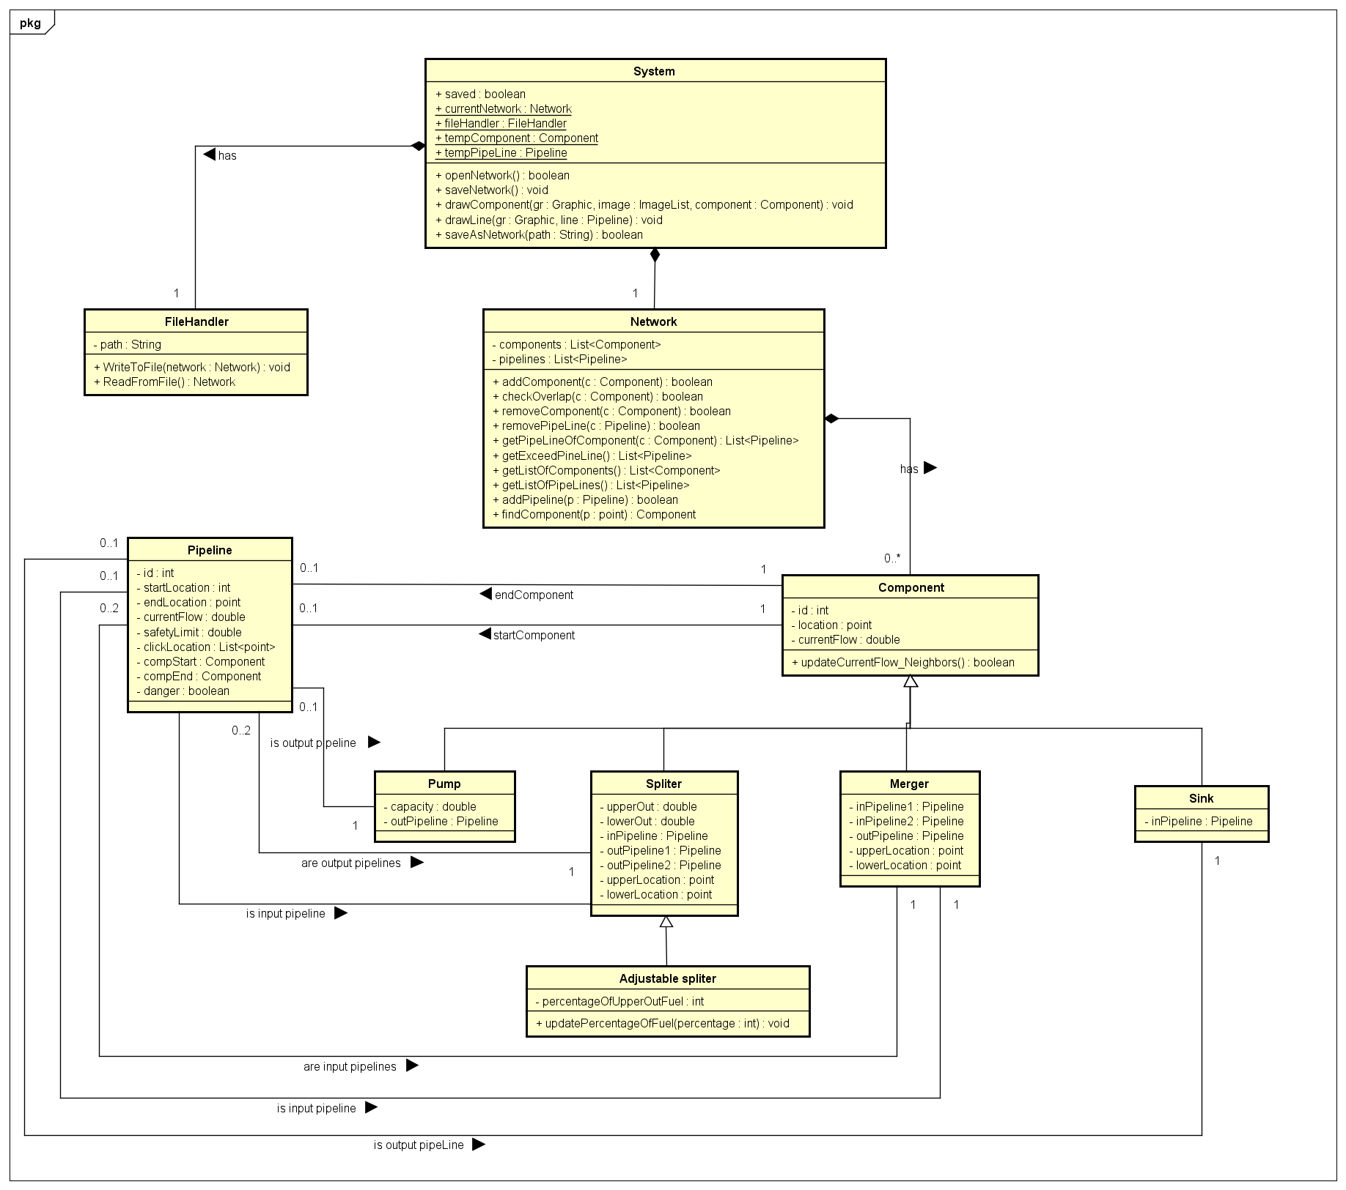

## Description of the classes and their members

By default, all of the properties of classes are private and methods of them are public. If it is not the case, the visibilities of these properties and methods will be indicated.

#### COMPONENT CLASS

Component class is the parent class, representing the generic properties for all type of components.

|  |  |  |
| --- | --- | --- |
| Properties | | |
| iD | Integer | This is unique number to indicate the components of each network drawing. It is increased automatically when the pipeline is added. |
| location | Point | Representing an ordered pair of integer x- and y-coordinates that defines a location of components on the screen |
| currentFlow | Double | The current flow of this component. |
| Operations | | |
| Component(location: Point): *constructor of the class* | | |
| updateCurrentFlow_Neighbors() : boolean  *This methods can be an abstract method which is used to update the current flow of itself and their neighbors’ components. Its implementation can be different corresponding to what kind of components of the subclasses.* | | |

#### PUMP CLASS

Pump class is the child class of Component class. It has the following characteristics:

|  |  |  |
| --- | --- | --- |
| Properties | | |
| capacity | double | A value of ‘Capacity’ indicates the capacity of Pump’s flow. |
| outPipeline | PipeLine | The output pipeline of the pump. |
| Operations | | |
| Pump(location: point, capacity: double, currentflow: double*): constructor of the class*  *The outPipeLine property is NULL when the constructor is called. It is updated when there are a pipeline connecting this pump to the other component.* | | |

#### Sink CLASS

Sink class is the child class of Component class. It has the following characteristics:

|  |  |  |
| --- | --- | --- |
| Properties | | |
| inPipeline | PipeLine | The input pipeline of the sink |
| Operations | | |
| Sink(location: point*): constructor of the class*  *The input pipeline and the current flow are initialized by NULL and 0 respectively. They are updated when the pipeline is added.* | | |

#### Merger CLASS

Merger class is the child class of Component class. It has the following characteristics:

|  |  |  |
| --- | --- | --- |
| Properties | | |
| inPipeline1 | Component | The first input pipeline of the merger |
| inPipeline2 | Component | The second input pipeline of the merger |
| outPipeline | Component | The output pipeline of the merger |
| upperLocation | Point | The location of the first output pipeline |
| lowerLocation | Point | The location of the second output pipeline |
| Operations | | |
| Merger (location: point): *constructor of the class*  *Properties* inPipeline1*,* inPipeline2*,* outPipeline, upperLocation, lowerLocation *are NULL when the constructor is called and updated when the merger has connected pipelines.* | | |

#### SPLITTER CLASS

Splitter class is the child class of Component class. And parent class of Adjustable Splitter class. It has the following characteristics:

|  |  |  |
| --- | --- | --- |
| Properties | | |
| upperOut | double | The value of this field indicates the flow of splitter’s upper terminal. |
| lowerOut | double | The value of this field indicates the flow of splitter’s lower terminal. |
| inPipeline | Pipeline | The input pipeline of the splitter class |
| outPipeline1 | Pipeline | The first output pipeline of the splitter |
| outPipeline2 | Pipeline | The second output pipeline of the splitter |
| Operations | | |
| Component(location: point): constructor of the class  *Properties inPipeline, outPipeline1, outPipeline2 are NULL when the constructor is called and updated when the merger has connected pipelines.* | | |

#### Adjustable SPLITTER CLASS

Adjustable Splitter class is the child class of Splitter class. It has the following characteristics:

|  |  |  |
| --- | --- | --- |
| Properties | | |
| PercentageOfUpperOutFuel | integer | A value of this field indicates the percentage of splitter’s upper flow. |
| Operations | | |
| UpdatePercentageOfFuel(int percentage) | void | This method updates the percentage of splitter’s flow on lower terminal. |
| Component(location: point, perUpper: int): *constructor of the class* | | |

#### PIPELINE CLASS

|  |  |  |
| --- | --- | --- |
| Properties | | |
| iD | Integer | This is unique number to indicate the components of each network drawing. It is increased automatically when the pipeline is added. This is used to distinguish the pipeline when they directly connect the splitter to the merger. At that point, the compStart and compEnd of these two pipelines are the same. |
| startLocation | Point | Indicating the starting location of the pipeline |
| endLocation | Point | Indicating the ending location of the pipeline |
| currentFlow | Double | Indicating the current flow of the pipeline |
| safeLimit | Double | Representing the maximum safety limit of the pipeline |
| clickLocation | List<Point> | Indicating the points in the middle of the pipeline |
| compStart | Component | The component containing the starting location |
| compEnd | Component | The component containing the ending location |
| Pipeline(limit: double, startLocation: Point, endLocation: Point, clickLocation :List<Point>) : *constructor of the class*  *The location of the component class is consider as the start location of the pipeline.* | | |
| caculateCurrentFlow(): double  *This method is used to calculated and update the current flow of the pipeline whenever the other pipelines are added. Basing on the startCompnent and endComponent, it’s possible to calculate the values of currentflow and update it.* | | |

#### NETWORK CLASS

The Network class in the class hold main objects of the application.

|  |  |  |
| --- | --- | --- |
| Properties | | |
| components | List<Component> | A list of Component objects, private and are accessible through getListOfComponent() methods |
| pipeLines | List<Pipeline> | A list of Pipeline objects, private and are accessible through getListOfPipeLine() methods |
| Network() : *constructor* | | |
| + addComponent(c : Component) : boolean  *This method is used to calculated and update the current flow of the pipeline whenever the other pipelines are added. Base on the startCompnent and endComponent, it’s possible to calculate the values of currentflow and update it.* | | |
| checkOverlap(c : Component) : Boolean  *Checks whether the given component c overlaps any other components in the list of components. Returns true if the component is overlapping some other components. Otherwise, it returns false.* | | |
| removeComponent(c : Component) : Boolean  *Finds the given component c and remove it from the list of componets. When c is removed, the connected pipeline of c also have to be removed.*  *Returns true if c is found and removed* | | |
| removePipeLine(c : PipeLine) : Boolean  *Find the given pipeline from parameter list and remove it.*  *Return true if c is found and removed* | | |
| getPipeLineOfComponent(c : Component) : List<PipeLine>  *Get the list of pipelines connected to the given component c.*  *Return the list of pipelines* | | |
| getExceedPipeLine() : List<PipeLine>  *Check for the exceed pipelines (if the currentflow > safetylimit) and return into a list of pipelines* | | |
| getListOfComponents() : List<Component>  *Return the private object components* | | |
| getListOfPipeLines() : List<PipeLine>  *Return the private object PipeLines* | | |
| addPipeline(p : PipeLine) : Boolean  *Add a given pipeline p into the list of pipelines, which is represented by object pipelines.*  *P is added if and only if the location of p is not overlapped other components in the list. Method checkOverlap is called for this check. If it is not overlap, it is added into the list and this method return true.* | | |
| findComponent(p : point) : Component  *Find out whether there is a component having the location which contains the given point or not. If it is true, return the found component. Otherwise, return null.* | | |

#### SYSTEM CLASS

The System class is the main class in our class heirarchy, which is a static class and has two properties of type Network and FileHandler. This class is the main class in our application and uses the two objects in its property.

|  |  |  |
| --- | --- | --- |
| Properties | | |
| saved | Boolean | Keep track the state of the current network drawing.  Saved is true if there are not any new changes. Otherwise, it is false. |
| currentNework | Network | The object of network class, indicating the current network that the user are working on. |
| fileHandler | FileHandler | Handling functions relating to save, open network drawing |
| tempComponent | Component | These two properties help the System verify and know which component the user is trying todraw or whether the user is trying to draw a pipe-line. |
| tempPipeline | Pipeline |
| openNetwork() : void  *Open the network drawing from the text file based on fileHandler.path and fileHandler.ReadFromFile()* | | |
| saveNetwork() : void  *Save the network drawing into the text file based on fileHandler.path and fileHandler.ReadFromFile()* | | |
| saveAsNetwork(path : String) : void  *Save as the network into a text file for the first time working with it. The path is indicated by the users and assigns to fileHandler.path* | | |
| drawComponent(gr : Graphic, image : ImageList, component : Component) : void  *Draw the given component on the drawing screen depending on which button from the toolbox the user has selected* | | |
| drawLine(gr : Graphic, line : PipeLine) : void  *Draw the given pipeline on the drawing screen.* | | |

#### FILEHANDLer class

The FileHandler Class is one of the most important classes in the application. It handles functionalities relating to files.

|  |  |  |
| --- | --- | --- |
| Properties | | |
| Path | String | The path property indicates the file path where the text file storing the Network objects related information is stored. |
| WriteToFile(network : Network) : void  *The WriteToFile takes a Network object as a parameter,* *writes the list of components and pipe-lines from the lists of the given Network object to a text file in a pre-determined convention for writing such objects to file.* | | |
| ReadFromFile() : Network  *The ReadFromFile method reads a text file that has components and pipelines written to it in a pre-determined convention and then takes those components and pipe-lines and assigns them to a Network object which it returns.* | | |

# SEQUENCE DIAGRAMs

## Draw a component



This sequence diagram describe how a component to the drawing screen and add that component to the list of components belonging to the object currentNetwork. The drawComponent method has three argument parameters which include objects of type Graphic, ImageList and Component. The Graphic object can come from the Form's PaintEventArgs or otherwise by creating the Graphic object of the form or a control. The ImageList consists of the images for each of the images for the components that the user would like to place on the drawing screen.

The component object comes from the temComponent property of the System class. This property changes its reference to a new Component object whenever the user clicks on a button for different components on the toolbox. Clicking on a specific component button would create a Component of that type and change the tempComponents reference to that newly created Component object. The component argument in the method is then used to call the method addComponent on the currentNetwork property of the static System class.

The method addComponent takes an argument of type Component which would be the same as tempComponent in this case. The method addComponent then adds the Component to the List of Components property of Network class. However when the addComponent method is called there is another method call within this method to the method for checkOverlap method which would return a boolean. If the return value is true then the component would be successfully added to the list of components.

Once the component is successfully added to the list of components the Graphic object of the method will use the location property of the component to draw the image from the ImageList corresponding to the component that needs to be drawn on the drawing screen.

## Draw a PIPELINE



This sequence diagram for drawing a pipeline. The drawPipeLine method takes two argument parameters, a Graphics object type and a PipeLine object. The PipeLine object is created whenever the click on pipe-line button in form event is raised. In this event the tempPipeLine property of System class is assigned a new PipeLine object without that PipeLine object having any start and end Component properties assigned.

The next time whenever the user clicks on the screen the event for screeen click goes through various checks that first include to check if the tempPipeLine is empty and if not the nested statements check for the following: whether the startComponent of the tempPipeLine is null and assigns a startComponent to it via the method findComponent, if startComponent is not null and endComponent is null and calling the method findComponent returns a null then the point from the EventArgs is added to that tempPipeLines list of clickLocations and finally if startComponent is not null and endComponent is null and calling the method findComponent returns a non-null value then the startComponent is assigned whichever component is returned by findComponent function unless that component is the same as the startComponent.

Once the PipeLine object given in the drawPipeLines argument is complete in that it at least has a start and end Components that are non-null, then the Graphic object is used to draw the PipeLine according to the startComponent and endComponent locations as well as the locations given in the list of clickLocations of the PipeLine object from the parameter.

## Remove a pipeline :



This sequence diagram is for removing a pipeline. First of all user will click at the pipeline that he wants to remove .So now there will be a point p(x,y) of click of user, but still its harder to find, that p(x,y) belongs to which pipeline, in the network. For this we need to call “FindComponent (point p)” method, by means of which we can find pipeline that have point p(x,y) . This method will return object of pipeline. After pipeline is selected click on Remove_component button in form event will be raised (in order to remove it), which will immediately call “removePipeline” method. The method “removePipeline” takes one argument that is an object of pipeline that user is going to remove. As we know user is removing pipeline from network, which means that the current flow of neighbor components of that pipeline will be affected .As a result of this once selected pipeline is removed there will be a call for “UpdateCurrentFlow_ Neighbors” method. This method will prompt neighbor components of pipeline to update their own CurrentFlow as well as current flow of their neighbor components. Finally user can see pipeline will be removed from the network.

## Remove a Component :



This sequence diagram is for removing a component. User will click at the component that he wants to remove. “FindComponent(point p)” method takes that point as parameter where user clicked .This method will help us to find component with the clicked point. After component is selected click on Remove_Component button in form event will be raised (in order to remove it). It will call method “removeComponent” that takes one argument that is an object of component. If user will remove any component then system will also removes all pipelines connected to that component. So “removeComponent” method will take service of “getPipelineOfComponet” method to find pipelines connected to component. It will returns the list of pipelines connected to component. Then “RemovePipeline” method will remove all pipelines connected to that component. Finally “removeComponent” method will return true which means that component with its pipeline has been successfully removed. As we know user is removing pipeline from network, which means that the current flow of neighbor components of that pipeline will be affected .As a result of this once selected pipeline is removed there will be a call for “UpdateCurrentFlow_ Neighbors” method. This method will prompt neighbor components of pipeline to update their own CurrentFlow as well as current flow of their neighbor components. Finally user can see pipeline will be removed from the network.

## Remove a Component :

