ngOC KIEU THANH huYNH – 2688093

Bilal Butt – 2688700

Raima khan –2692686

Armin ROSHAN- 2487128

USER requirements specification

GROUP MEMBERS:

Contents

INTRODUCTION 2

USER INTERFACE 3

FUNCTIONAL REQUIREMENTS (USE-CASES) 6

USE CASE: ADD COMPONENTS 6

USE CASE: ADD A PUMP 6

USE CASE: ADD AN ADJUSTABLE SPLITTER 7

USE CASE: ADD PIPELINE BETWEEN TWO COMPONENTS 7

USE CASE: REMOVE PIPELINE. 8

USE CASE: REMOVE COMPONENT 8

USE CASE: CREATE A NEW NETWORK DRAWING FILE 9

USE CASE: OPEN A NETWORK DRAWING FILE 9

USE CASE: SAVE AS A NETWORK DRAWING FILE 9

USE CASE: SAVE A FILE WHICH THE NAME ALREADY EXISTS 10

USE CASE: SAVE A NETWORK DRAWING FILE 10

USE CASE: CLOSE A NETWORK DRAWING FILE 11

USE CASE: EXIT APPLICATION 11

NON-FUNCTIONAL REQUIREMENTS (OTHER REQUIREMENTS) 12

# INTRODUCTION

This document is the user requirements specification for building a flow network application. This application allows the user to make a drawing sketch of a network for a fuel transportation system. This application allows the user to simulate a network containing components including pump, sink, splitter, adjustable splitter and merger.

Each of the components have their own attributes and functionalities and are meant to give a true representation of components in an actual fuel transportation system. The pump represents the source for such a system and has a maximum capacity and the currently utilized capacity set by the user in her simulation for the system. The sink similarly acts as a consumption point for the fuel network. The other two remaining components are the splitter and merger. The splitter has two types, the adjustable splitter and the regular splitter. The splitter acts as an objects that divides the flow in two separate directions in the system. Whereas the regular splitter divides the flow evenly between two directions, the adjustable splitter allows the user to assign the fraction of the total flow in each direction. The merger on the other hand combines the flow of two different pipelines into one single pipeline.

Together the components and their associated pipelines would allow the user to create a simulation for a network for the transportation of fuel. The application will help users connect and manage the amount of fuel of every pipeline. The application will give constant feedback on the flow of the system for each pipeline, including checks on occurrences of overflow.

In the first section of this document, user interface design of application are represented by diagrams and their brief description. The second section presents functional requirements using the user cases. The last section introduces some non-functional requirements of this application.

# User Interface

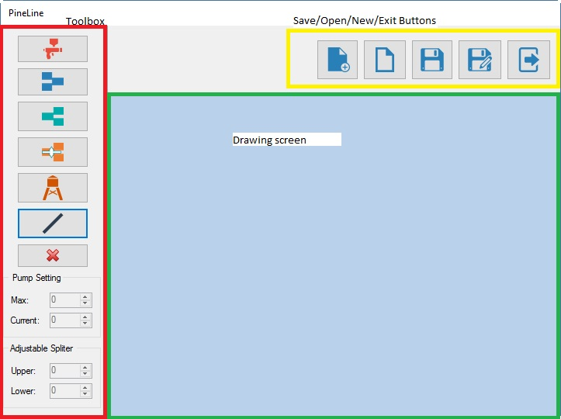

* On the left hand side of the form (the red area) is the toolbox containing seven button and two group boxes. Their functionalities are explained in table 1.
* On the top right corner of the form, is a group of buttons which are related to file management. Their functionalities are explained in table 1.
* The light blue area is the drawing screen.
* Every button contains the tool tip indicating its name. The tooltip is shown up when the user hovers the mouse on it, which allows the user to easily get the meaning of its function.

#### Table 1: Form’s components and their meaning

|  |  |
| --- | --- |
| Form’s components | Meaning |
|  | Add a pump |
|  | Add a merger |
|  | Add a splitter |
|  | Add adjustable splitter |
|  | Add a sink |
|  | Add a pipeline |
|  | Remove a component |
|  | Pump setting group box, which allows user to input the maximum flow (the capacity) and current flow of a pump. It’s only visible when the pump is added or selected.  The max value and current value must be non-negative and current value cannot exceed the max value. |
|  | Adjustable splitter group box, which allows user to input the upper and lower output flow. It’s only visible when the adjustable splitter is add or selected. |
|  | Add a new network drawing. |
|  | Open a network drawing. |
|  | Save a network drawing. |
|  | Save as a new network drawing. |
|  | Exit application |

# Functional Requirements (use-cases)

All use cases have the system user as the only actor involved. Furthermore, if it is not mentioned, all the use cases are of the sea-level.

## USE CASE: ADD COMPONENTS

**Pre-condition:** The user has the main form for the GUI of the pipeline app open on his/her PC.

**Trigger:** User clicks on one of the button representing the component, which user would like to add.

**MSS:**

1. User picks the component they want to place from the list of components in the toolbox on the left side of the form (from the users’ point of view).
2. System makes the selected component as the actively chosen component.
3. User clicks on the position he wishes to place the component on in the drawing screen.
4. System draws a copy of the selected component on the drawing screen at the position chosen by the user.

**Extensions:**

1.a. The component chosen is a pump.

1. Reference to use case “Add a pump”.
2. Continue from step 2 in MSS.

1.b. The component chosen is an adjustable splitter.

1. Reference to use case “Add an adjustable splitter”.
2. Continue from step 2 in MSS.

3.a. The component overlapped another component

1. System prompts user for warning that components cannot overlap each other.
2. User chooses another position to place the component.
3. Go back to step 4 of MSS.

## USE CASE: ADD A PUMP

**Pre-condition:** The user has the main form for the GUI of the pipeline app open on his/her PC.

**Trigger:** User clicks on the button add a pump

**MSS:**

1. System prompts user for max flow and current flow to assign to the pump and enable the textboxes for max flow and current flow.
2. User assigns values for max and current flow.
3. Continue from step 2 in MSS of use case “Add component”.

**Extensions:**

2.a. The value of current flow larger the value of max flow or either of them has a negative value.

1. Systems prompts the warning message and requires user to assign other values.
   1. User presses OK. They can proceed to step 2.
   2. User presses Cancel. They can stop this use case.
2. Continue from step 2 in MSS.

## USE CASE: ADD An adjustable splitter

**Pre-condition:** The user has the main form for the GUI of the pipeline app open on his/her PC.

**Trigger:** User clicks on the button add an adjustable splitter.

**MSS:**

1. System prompts user for upper output flow to be assigned to the adjustable splitter and enable the numeric up/down for upper.
2. System updates the lower flow according to the changes made by user to the upper output flow.
3. Continue from step 2 in MSS of use case “Add component”.

## USE CASE: ADD PIPELINE BETWEEN TWO COMPONENTS

**Pre-condition**: There exist at least two components. There exists at least one component whose input is not connected and there exists at least one component whose output is not connected.

1. User clicks on starting component for the pipeline on the drawing screen.
2. System chooses the selected component as the starting point of pipeline.
3. User may click on one or more points on the drawing screen that do not have a component on them.
4. System draws lines connecting each point on the screen clicked with the previous point clicked.
5. User ends pipeline by clicking on the final component on the drawing screen.
6. System selects the final component as ending point of the pipeline and labels the line with the current flow going through it.
7. System re-calculates all pipeline flow values relating to the added pipeline and displays the new values on each of the respective labels

## USE CASE: REMOVE PIPELINE.

**Pre-Condition:** The drawing screen must have at least two components with at least one pipeline connecting the components.

**MSS:**

1. User selects remove pipeline button on the toolbox on the right side of the form.
2. System goes into delete pipeline mode.
3. User selects the pipeline he/she wants to delete from the drawing screen.
4. *System prompts user asking if he/she wants to delete the selected pipeline.*
5. System removes the selected pipeline.
6. System re-calculates all pipeline flow values relating to the removed pipeline and displays the new values on each of the respective labels

**Extensions:**

4.a User do not want to remove the pipeline

.1: At this point, end of this use case.

## USE CASE: REMOVE COMPONENT

**Pre-condition:** There are at least one component located on the drawing screen.

**MSS:**

1. User selects remove component button from the toolbox on the right side of the form.
2. System goes into delete component mode.
3. User selects the component to delete from the drawing screen.
4. System prompts user asking if he/she wants to delete the component and gives warning that deleting the component will also remove all connected pipelines.
5. User confirms that they want to delete the selected components.
6. System removes the component and its connected pipelines from the drawing screen.
7. System re-calculates all pipeline flow values relating to the removed component and displays the new values on each of the respective labels

**Extensions:**

4.a User does not want to remove the component and its connected pipelines.

.1: At this point, end of this use case.

## USE CASE: CREATE A NEW NETWORK DRAWING FILE

**Pre-condition:** The user has the main form for the GUI of the pipeline app open on his/her PC.

**Trigger**: User clicks on the button add new network drawing.

**MSS:**

1. System shows the new drawing screen.

**Extensions:**

1.a There exists network drawing already open

.1: Reference to use case close network drawing file.

## Use Case: OPEN A NETWORK DRAWING FILE

**Pre-condition:** The user has the main form for the GUI of the pipeline app open on his/her PC.

**Trigger**: User clicks on the button open network drawing.

**MSS:**

1. System shows the file dialog
2. User chooses the location of the file or types the name of required file.
3. System loads the file and shows it in drawing screen.

**Extensions:**

1.a There is existing file already open and there are new changes which are made

.1: Reference to user case close file.

1.b There is existing file already open and there are not new changes which are made

.1: The existing file is closed directly.

.2: Return to MSS of this use case.

## Use Case: SAVE As A NETWORK DRAWING FILE

**Pre-condition:** The user has the main form for the GUI of the pipeline app open on his/her PC and the current network drawing has not saved yet.

**Trigger**: User clicks on the button save as network drawing.

**MSS:**

1. System opens the file dialog
2. User chooses the location to save the file
3. User gives the file’s name
4. System save the file in the chosen directory

**Extensions:**

3.a The file’s name already exists.

.1: Reference to use case save a file which the name already exists.

## USE case: save a file which the name already exists

**Level: Fish level**

**Trigger:** user saves as a file with a name already exists.

**MSS:**

1. System notifies user that name already exist and prompts user asking if he/she would like to overwrite or cancel it.
2. User confirms that they want to overwrite it.
3. Return to MSS of use case save as at step 4.

**Extensions:**

2.a User want to cancel

.1: At that point, end of save as use case.

## Use Case: SAVE A NETWORK DRAWING FILE

**Pre-condition:** The user has the current network drawing saved already as a file and makes the new changes on it.

**Trigger**: User clicks on the button save network drawing.

**MSS:**

1. System saves the new changes.
2. System informs the user about saved changes.

## Use Case: CLOSE A NETWORK DRAWING FILE

**Level: Fish level**

**Trigger:** users open the new network drawing and need to close the current one or exit the application.

**MSS:**

1. System prompts user asking if he/she wants to close the current network drawing or not.
2. User confirms that they want to close it.

**Extensions:**

1.a User has not save the file yet

.1: System prompts user asking if he/she wants to save the current network drawing or not

a) If the user chooses YES, reference to the use case save.

b) If the user chooses NO, back to the MSS of the use case referencing to this use case.

1.b User confirms that they do not want to close the current network drawing, they cancel their request .

1. At that point, end of this use case.

## Use Case: EXIT APPLICATION

**Pre-condition:** The user has the main form for the GUI of the pipeline app open on his/her PC.

**Trigger**: User clicks on the button exit button or click on the close button of the main form.

**MSS:**

1. System prompts users for saving the file
2. Use confirms that they want to save that file.
3. System closes the application.

**Extensions:**

1.a User saved the file previously

.1: Go directly to MSS at step 3

2.a User would like to save the file

.1: Reference to the use case save

# Non-functional Requirements (other requirements)

* Application should work optimally in Windows environment.
* It should be user friendly. It incorporates elements of good user interface design.
* It should quickly response to users input.

fsadf