ngOC KIEU THANH huYNH – 2688093

Bilal Butt – 2688700

Raima khan –2692686

Armin ROSHAN-

USER requirements specification

GROUP MEMBERS:

Contents

INTRODUCTION 2

USER INTERFACE 3

FUNCTIONAL REQUIREMENTS (USE-CASES) 4

USE CASE: ADD COMPONENTS 4

USE CASE: ADD A PUMP 4

USE CASE: ADD A PUMP 5

USE CASE: ADD PIPELINE BETWEEN TWO COMPONENTS 5

USE CASE: REMOVE PIPELINE. 6

USE CASE: REMOVE COMPONENT 6

USE CASE: CREATE A NEW NETWORK DRAWING FILE 7

USE CASE: OPEN A NETWORK DRAWING FILE 7

USE CASE: SAVE AS A NETWORK DRAWING FILE 7

USE CASE: SAVE A FILE WHICH THE NAME ALREADY EXISTS 8

USE CASE: SAVE A NETWORK DRAWING FILE 8

USE CASE: CLOSE A NETWORK DRAWING FILE 9

USE CASE: EXIT APPLICATION 9

NON-FUNCTIONAL REQUIREMENTS (OTHER REQUIREMENTS) 10

# INTRODUCTION

This document is the user requirements specification for building a flow network application. This application allows the user to make a drawing sketch of a network for fuel transportation system. This application allows the user to simulate a network containing components including pump, sink, splitter, adjustable splitter and merger.

Each of the components have their own attributes and functionalities and are meant to give a true representation of components in an actual fuel transportation system. The pump represents the source for such a system and has a maximum capacity and the currently utilized capacity set by the user in her simulation for the system. The sink similarly acts as a consumption point for the fuel network. The other two remaining components are the splitter and merger. The splitter has two types, the adjustable splitter and the regular splitter. The splitter acts as an objects that divides the flow in two separate directions in the system. Whereas the regular splitter divides the flow evenly between two directions the adjustable splitter allow the user to assign the fraction of the total flow in each direction. The merger on the other hand combines the flow of two different pipelines into one single pipeline.

Together the components and their associated pipelines would allow the user to create a simulation for a network for the transportation of fuel. The application will help users connect and manage the amount of fuel of every pipeline. The application will give constant feedback on the flow of the system for each pipeline, including checks on occurrences of overflow.

In the first section of this document, the functional requirements are represented by use-cases. The second section indicated user interface design of application. The last section introduces some non-functional requirements of this application.

# User Interface

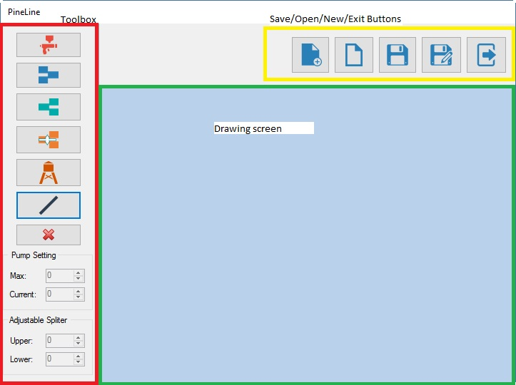

# Functional Requirements (use-cases)

All use cases have the system user as the only actor involved. Furthermore, if it is not mentioned, all the use cases are of the sea-level.

## USE CASE: ADD COMPONENTS

**Pre-condition:** The user has the main form for the GUI of the pipeline app open on his/her PC.

**Trigger:** User clicks on one of the button representing the component, which user would like to add.

**MSS:**

1. User picks the component they want to place from the list of components in the toolbox on the left side of the form (from the users’ point of view).
2. System makes the selected component as the actively chosen component.
3. User clicks on the position he wishes to place the component on in the drawing screen.
4. System draws a copy of the selected component on the drawing screen at the position chosen by the user.

**Extensions:**

1.a. The component chosen is a pump.

1. Reference to use case “Add a pump”.
2. Continue from step 2 in MSS.

1.b. The component chosen is an adjustable splitter.

1. Reference to use case “Add an adjustable splitter”.
2. Continue from step 2 in MSS.

1.c. The component overlapped another component

1. System prompts user for warning that components cannot overlap each other.
2. User chooses another position to place the component or stop use case.

## USE CASE: ADD A PUMP

**Pre-condition:** The user has the main form for the GUI of the pipeline app open on his/her PC.

**Trigger:** User clicks on the button add a pump

**MSS:**

1. System prompts user for max flow and current flow to assign to the pump and enable the textboxes for max flow and current flow.
2. User assigns values for max and current flow.
3. Continue from step 2 in MSS of use case “Add component”.

**Extensions:**

2.a. The value of current flow larger the value of max flow or either of them has a negative value.

1. Systems prompts the waring message and requires user to assign other values.
2. Continue from step 3 in MSS.

## USE CASE: ADD A PUMP

**Pre-condition:** The user has the main form for the GUI of the pipeline app open on his/her PC.

**Trigger:** User clicks on the button add an adjustable splitter.

**MSS:**

1. System prompts user for upper and lower output flows to be assigned to the adjustable splitter and enable the textboxes for upper and lower output flows.
2. User assigns values for upper and lower output flow.
3. Continue from step 2 in MSS of use case “Add component”.

**Extensions:**

2.a. The sum of upper flow value and the lower one is larger than 100% of the input flow

1. Systems prompts the waring message and requires user to assign other values.
2. Continue from step 3 in MSS.

## USE CASE: ADD PIPELINE BETWEEN TWO COMPONENTS

**Pre-condition**: If there exist at least two components. There exists at least one component whose input is not connected and there exists at least one component whose output is not connected.

1. User clicks on starting component for the pipeline.
2. System chooses the selected component as the starting point of pipeline.
3. User may click on one or more points on the drawing screen that do not have a component on them.
4. System draws lines connecting each point on the screen clicked with the previous point clicked.
5. User ends pipeline by clicking on the final component on the drawing screen.
6. System selects the final component as ending point of the pipeline and labels the line with the current flow going through it.
7. System re-calculates all pipeline flow value relating to the added pipeline and display the new values on each of the respective labels

## USE CASE: REMOVE PIPELINE.

**Pre-Condition:** The drawing screen must have at least two components with at least one pipeline connecting the components.

**MSS:**

1. User selects remove pipeline button on the toolbox on the right side of the form.
2. System goes into delete pipeline mode.
3. User selects the pipeline he/she wants to delete from the drawing screen.
4. *System prompts user asking if he/she wants to delete the selected pipeline.*
5. System removes the selected pipeline.
6. System re-calculates all pipeline flow value relating to the removed pipeline and display the new values on each of the respective labels

**Extensions:**

5.a User do not want to remove the pipeline

.1: At this point, end of this use case.

## USE CASE: REMOVE COMPONENT

**Pre-condition:** There are at least one component located on the drawing screen.

**MSS:**

1. User selects remove component button from the toolbox on the right side of the form.
2. System goes into delete component mode.
3. User selects the component to delete from the drawing screen.
4. System prompts user asking if he/she wants to delete the component and gives warning that deleting the component will also remove all connected pipelines.
5. User confirms that they want to delete the selected components.
6. System removes the component and its connected pipelines from the drawing screen.
7. System re-calculates all pipeline flow value relating to the removed component and display the new values on each of the respective labels

**Extensions:**

5.a User do not want to remove the component and its connected pipelines.

.1: At this point, end of this use case.

## USE CASE: CREATE A NEW NETWORK DRAWING FILE

**Pre-condition:** The user has the main form for the GUI of the pipeline app open on his/her PC.

**Trigger**: User clicks on the button add new network drawing.

**MSS:**

1. System shows the new drawing screen.

**Extensions:**

1.a There is existing network drawing already open

.1: Reference to user case close network drawing file.

## Use Case: OPEN A NETWORK DRAWING FILE

**Pre-condition:** The user has the main form for the GUI of the pipeline app open on his/her PC.

**Trigger**: User clicks on the button open network drawing.

**MSS:**

1. System shows the file dialog
2. User chooses the location of the file or types the name of required file.
3. System loads the file and shows it in drawing screen.

**Extensions:**

1.b There is existing file already open

.1: Reference to user case close file.

## Use Case: SAVE As A NETWORK DRAWING FILE

**Pre-condition:** The user has the main form for the GUI of the pipeline app open on his/her PC and the current network drawing has not saved yet.

**Trigger**: User clicks on the button save as network drawing.

**MSS:**

1. System opens the file dialog
2. User chooses the location to save the file
3. User gives the file’s name
4. System save the file in the chosen directory

**Extensions:**

3.a The file’s name is already existing.

.1: Reference to use case save a file which the name already exists.

## USE case: save a file which the name already exists

**Level: Fish level**

**Trigger:** user saves as a file with a name already exists.

**MSS:**

1. System notifies user that name already exist and prompts user asking if he/she would like to overwrite or cancel it.
2. User confirms that they want to overwrite it.
3. Return to MSS of use case save as at step 4.

**Extensions:**

2.a User want to cancel

.1: At that point, end of this use case.

## Use Case: SAVE A NETWORK DRAWING FILE

**Pre-condition:** The user has the current network drawing saved already as a file.

**Trigger**: User clicks on the button save network drawing.

**MSS:**

1. System prompts user asking if he/she wants to save the current network drawing or not.
2. User confirms that they want to save it.

**Extensions:**

2.a User does not want to save the current network drawing

.1: At that point, end of use case.

## Use Case: CLOSE A NETWORK DRAWING FILE

**Level: Fish level**

**Trigger:** users open the new network drawing and need to close the current one or exit the application.

**MSS:**

1. System prompts user asking if he/she wants to close the current network drawing or not.
2. User confirms that they want to close it.

**Extensions:**

1.a User has not save the file yet

.1: Reference to the use case save

1.b User confirms that they do not want to close the current network drawing, they cancel their request .

1. At that point, end of this use case.

## Use Case: EXIT APPLICATION

**Pre-condition:** The user has the main form for the GUI of the pipeline app open on his/her PC.

**Trigger**: User clicks on the button exit button or click on the close button of the main form.

**MSS:**

1. System prompts users for saving the file
2. Use confirms that they want to save that file.
3. System closes the application.

**Extensions:**

1.a User saved the file previously

.1: Go directly to MSS at step 3

2.a User would like to save the file

.1: Reference to the use case save

# Non-functional Requirements (other requirements)

* Application should work optimally in Windows environment.
* It should be user friendly. It incorporates elements of good user interface design.
* It should quickly response to users input.