A SYSTEM FOR ORGANIZE A SOCIAL EVENT

Project Plan

Course: ProP

Date: 09-08-2015

Group : E

Students: Ngoc Kieu Thanh Huynh – 2688093

Bilal Butt – 2688700

Michel Clerger – 2694646

Roman Siabro – 2224489

Table of Contents

Project Statement 3

Formal Client 3

Project Leader 3

Requirement from client 3

Project goal 3

Project Deliverables and Non-Deliverables 4

Project Constraints 4

Project Risks 5

Project Phasing 6

Phase 1: Initiation 7

Phase 2: Design and build stage 1 7

Phase 3: Design and build stage 2 7

Phase 4: Test 8

Phase 5: Deliver 8

# Project Statement

In this chapter we state why our project, project is started and what we will achieve. The following topics will be described: the client, the project leader, the initial situation, the problem description, the goal of our project, the deliverables and non-deliverables, the constraints and the risks.

## Formal Client

Mr. Emin Thaqi

Contact information

Emin Thaqi

Rachelsmolen 1, Eindhoven

e.thaqi@fontys.nl

## Project Leader

Mr. Bilal Butt and Mr. Roman Siabro are the project leader.

Contact information

Mr. Bilal

b.butt@student.fontys.nl

## Requirement from client

The organization of jazz music event would like to have a system to manage their event. This system have to satisfy these requirements:

* Containing a website such that joiners can visit this website before the event takes place to get information and make reservations for the entrances and the camping spot. All of payment can be done online.
* An application be able to manage:
  + The entrance of the joiner by some kind of identification to visitor tools like QR code.
  + The entrance of the camping area.
  + The sales of food and drink during the event as well as the loan of camping materials.
  + The leaving of the visitors at the ending of the events.
  + The status of the event when it finished

## Project goal

Base on the requirements from client. The goal of this project is to develop a system for organize the music even, which contains two main parts:

The first one is the website, which has 3 main functionalities:

1. Giving the general information about the event to:
   * advertise the event among the audience
   * provide contact information for users of website if they need more information
2. Allowing participants to register and pay for the entrance of the event
3. Allowing participants, if they wish to rent a camping ground, to sign up and pay for a designated camping area on the festival grounds

The second one is the C# application, which has 5 main functionalities:

1. For the entrance of the events, it is necessary to have a functionalities used to
   * Check whether if visitor is allowed to join the event or not
   * Check the payment status of the joiners
   * Use QR-code, barcode or an arm brace with a n RFID-chip for the identification of visitors and their event-account
2. For the entrance of the camping, the application have an ability to
   * Check the position and the bill for the payments group are paid or not.
3. This application are able to
   * Manage the sale receipt of food and drink during the events
   * Rent the material for camping
4. At the end of the event, it is important to have an functionality to
   * Check the balance of visitor’s event-account
   * The hire of some material status (returned or not)
5. Finally, the functionality to allow the organization to see the status of the event
   * The amount of visitor and the amount of visitor in group like (will visited, already in the event, left)
   * The information about the payment in general
   * The amount of camping slot are booked and free
   * The amount of money could be earn from the shops

## Project Deliverables and Non-Deliverables

* In this project the deliverables are:
  + An website
  + An application contains all of functionalities required by client and describe in the project gold
  + A database for the system
* We will not deliver:
  + Prototype created by our company.
  + Source code of the system

## Project Constraints

***Constraint 1: Time***

**The project must be completed within 19 weeks.**

***Constraint 2: Deliver the website in three versions***

* **Version 1 - is a front-end website**
* **Version 2 - has the possibility to make reservations**
* **Version 3 – have an ability to place tweets during events.**

***Constraint 3: Database could be use the Oracle database or MySQL database***

***Constraint 4: Windows application should use in an object oriented language.***

## Project Risks

**Risk 1: The method is chosen (QR-Code, RFIP-chip or barcode) for identification is not suitable or cannot built up**

Probability: Medium

Impact on project: High

Steps to prevent: Try to find the method and the tool as soon as possible

Clean up action: Change the methods to the new once.

**Risk 2: The client would like to change the GUI design of the website when it already implemented**

Probability: Medium

Impact on project: Low

Steps to prevent: Giving the GUI of the website in design phrase for the client before implement

Clean up action: Built up the structure of the CSS file and relating implementation of the website in the flexible way and easy to change.

# Project Phasing

In this chapter we describe the phases of our project, with the activities and milestones. In figure 1 a visual overview of the activities, their dependencies and the milestones is given. The total project will take 19 weeks to complete.

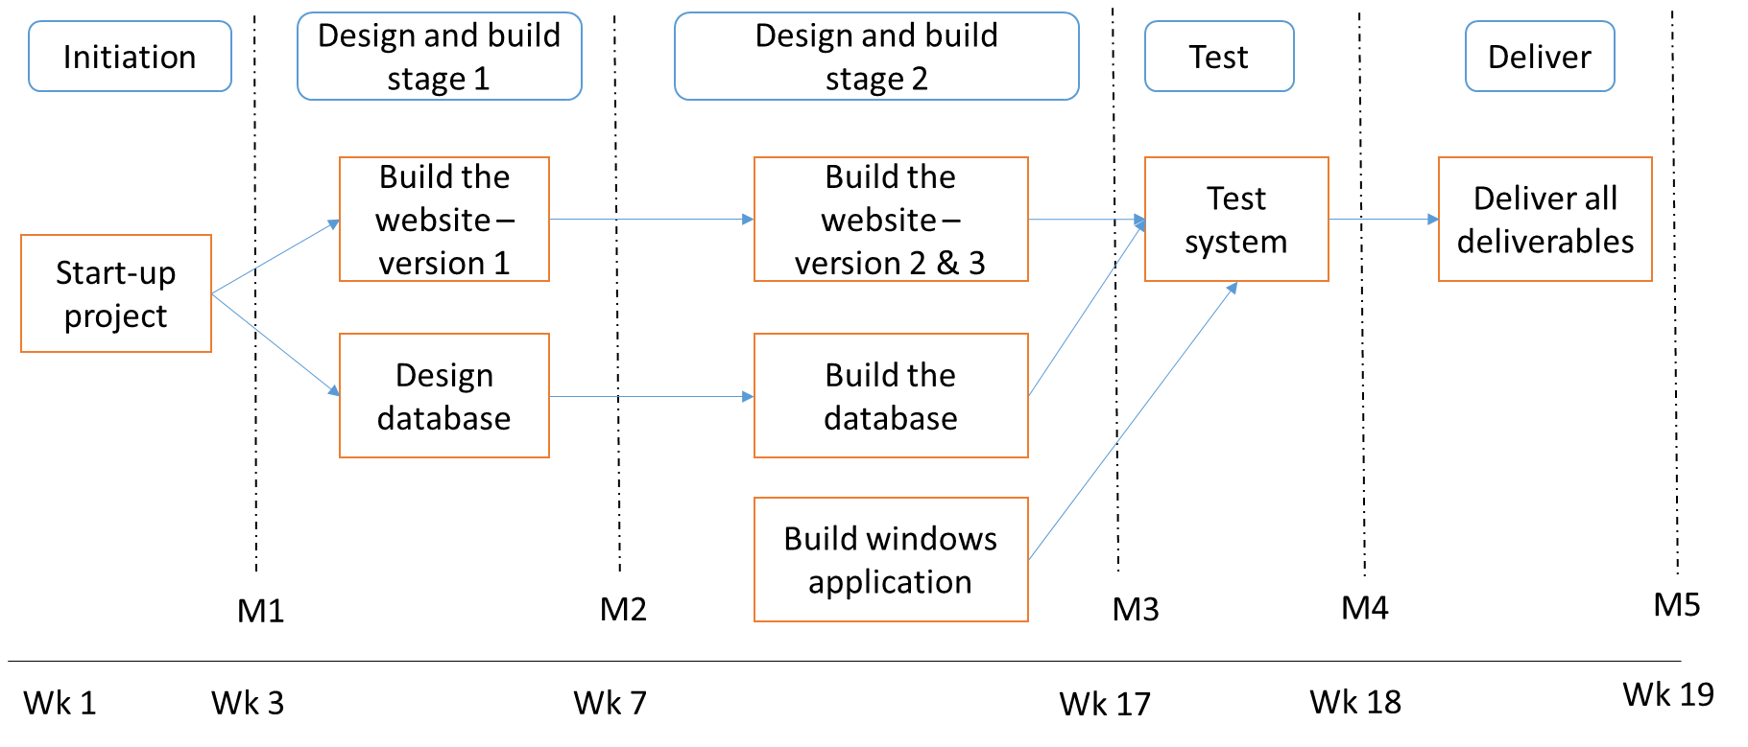

Figure 1. The activities and milestones.

## Phase 1: Initiation

The initiation phase has only one activity, called “Start-up project”.

Activity: Start-up the project

Tasks for the activity are:

* Kick-off meeting
* Work on project plan
* Work on setup document
* Investigate what kind of identification like barcode, QR-code or an arm brace with RFID-chip are suitable for this kind of project.

Estimated duration is 3 weeks and 30 hours

Deliverables for milestone **M1** are:

* Set-up document
* The project plan

## Phase 2: Design and build stage 1

The design and build stage 1 phase has 2 activities. The first activity focus on building the version 1 of the website and the second once relating to design the database of the system

Activity: Make a first version of the website

* 1. Research more on CSS, HTML and JavaScript for implementation
  2. Built up the website base on the design in setup document

Estimated duration is 4 week and 30 hours.

Activity: Make a design for the database

* 1. Consider all of necessary data need to store in database
  2. Make an ERD diagram for database

Estimated duration is 1 weeks and 15 hours.

Deliverables for milestone **M2** are:

* The website – version 1
* A design for database

## Phase 3: Design and build stage 2

This phase focus on built the ultimate website, built up the database and the windows application for the system. This phase is the most important one of the project.

Activity: Build the website version 2 and 3

1. Built the website version 2, which have an ability to connect to the database
2. Built the website version 3, which is able to connect with the social network, place the tweets during the event.

Estimated duration is 5 weeks and 40 hours.

Activity: Build the database

1. Specify the DBMS can be used
2. Implement the database in DBMS
3. Modify the design and implementation in case of necessary

Estimated duration is 1 weeks and 5 hours.

Activity: Build the windows application

1. Built the functionalities for the application base on the setup document
2. Testing along the way and build again if there are any problems

Estimated duration is 7 weeks and 60 hours.

Deliverables for milestone **M3** are:

* Website version 2 and 3
* Widows application

## Phase 4: Test

Activity: Test system

Tasks for the activity are:

* Connect the windows application, website and database into a system
* Make test plan
* Discuss test plan with client
* Execute test plan
* Document all succeeded tests, all failed tests and a list of improvements

Estimated duration is 1 weeks and 10 hours.

Deliverables for milestone **M4** are:

* Test report including all succeeded tests, all failed tests and a list of improvements.

## Phase 5: Deliver

The deliver phase has only one activity, called “deliver system”.

Activity: Deliver system

Tasks for the activity are:

* Make the presentation to introduce the systems

Estimated duration is 1 week and 5 hours.

Deliverables for milestone **M5** are:

* The completed system
* All of the documentation relating to the system

# Responsibility Assignment Matrix

In this project, RACI matrix is used to describe the participation of group’s member in completing tasks.

|  |  |  |  |  |
| --- | --- | --- | --- | --- |
| Task | Thanh | Bilal | Michel | Roman |
| Project plan | R | A | C | C |
| Setup Documents | R | A | I | I |
| Process Report | R | A | I | I |
| Design functionality for website | C | A | R | R |
| Implement website version 1 | R | R | R | R,A |
| Implement website version 2,3 | R | R | R | R,A |
| Design database | R | A,C | C | C |
| Implement database | R | A | R | I |
| Design functionality for windows application | R,A | R,C | I | I |
| Implement windows application | R,A | R,C | R | R |

***R – Responsible, A – Accountable, C – Consulted, I - Informed***