Kommunikationsphase

*Prof. Dr. Elmar Wings*

## Yahya Fakhet:7012464 Faissal Hammouda:7012301



**WS/2021**

**Inhalt**

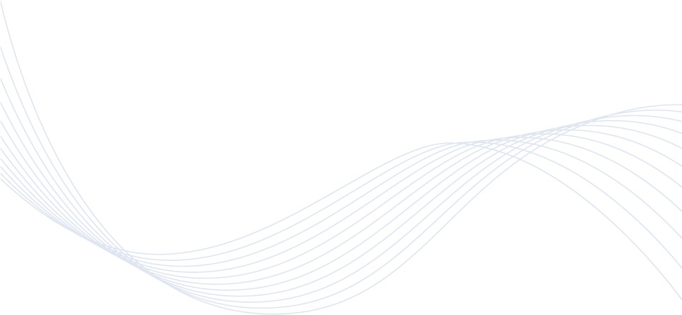



# *Kommunikationsphase*

* ***Kommunikations-Test***
* ***Applikationsvorschlag***

**2**

## Thank you for using [www.freepdfconvert.com](http://www.freepdfconvert.com/) service!

Only two pages are converted. Please Sign Up to convert all pages. <https://www.freepdfconvert.com/membership>