Part 1:
Introduction: This is a report documenting the work done in relationship with the last assignment and final project in the problem solving with scripting subject matter in oslo metropolitan university of Oslo as part of the Applied Computer and Information Technology (ACIT) master with specialization in cloud based services and operations. The work is done by student Bilal Sahli. The objective of this work is to demonstrate capabilities in problem solving with scripting leaned during the class and in order to have an opportunity to practice those skills. This work is also a fine way to showcase scripting, programming and problem solving skills to future employers.
Chose av naming convention: In python the naming convention for naming domain models is PascalCase. However modules, methodes, and other things should be lower case, separated by lowercase.
2. I created a virtual environment. Visual studio code suggested to do it for me. Because of that I skipped to do it manually. However I still need to activate it by '.\.venv\Scripts\activate'. In mac it will have been 'mac activate command'
3. as mentioned in the lectures __init__.py is not necessary in python 3.x but it is a good practice to include it. And So I did in this project.
4. although creditcard number and customer number will be presented to the user as numbers but I chose to have them as a string. This is because we are not going to do any arithmetic operations on those numbers.
5. in the design I hade not a state attribute in the address entity, in the development phase I added this entity because it is mandatory by the shipping agencies like posten or postnord. And in norshipping it is also required.
It was tricky first time to read a csv file because the reader could not read the chars that excel created into the file. Deleting the file and creating a new solved the problem.
6.in validation methods I used generic functions that can be used widely in the system. For example, in order to validate priority enum I created a versatile function that takes in a raw value represented as a string and compares it against possible values of an enum class. This is better than to create a function that only checks if a value is within the range of the priority enum because this will allow us to reuse this function to match against other enum classes and will help us achieving a good SE practice of not repeating our selves.
7- We Assume that start longitude and latitude is predefined by the user. We assume also that the stop longitude and latitude is also defined by the user. Like if the courier starts from nordexpress office address.
8- 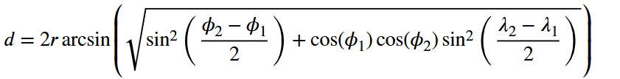
This is the Haversine formula used to calculate the great-circle distance between two points on a sphere like earth their longitudes and latitudes.( what is Haversine formula - Google Search)
9- I used env variables bcz it makes code easy to maintain and more readable. I used the dotenv library and I use the env.load() method in the beginning of my program.
Sources:
algorithm - Calculate distance between two latitude-longitude points? (Haversine formula) - Stack Overflow
validate against an enum python - Google Search
regex longitude AND lATITUDE python - Google Search
what is Haversine formula - Google Search

