**SECTION 1: HTML**

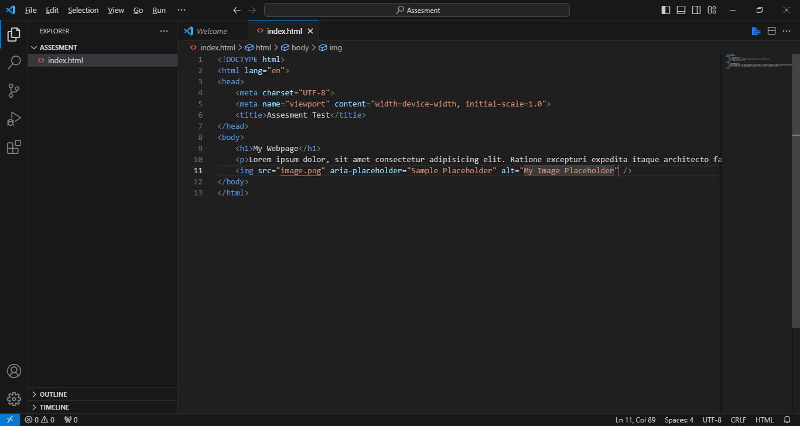

**SECTION 2: CSS**

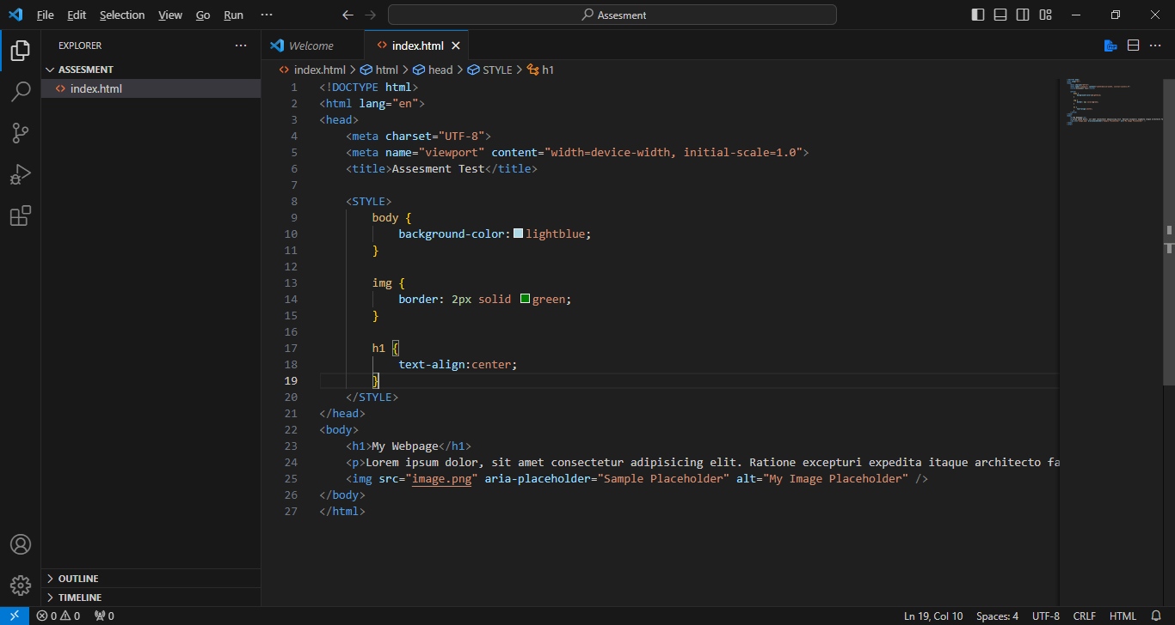

**SECTION 3: JAVASCRIPT**

1. 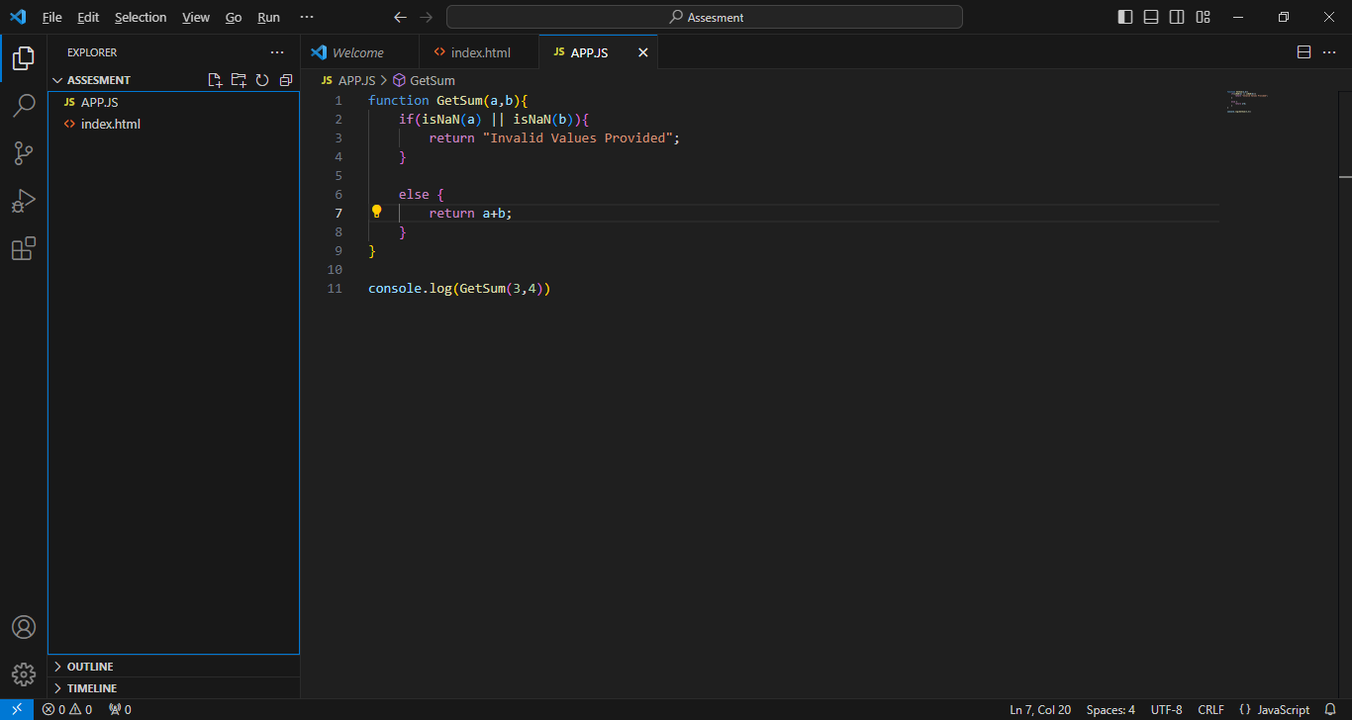
2. 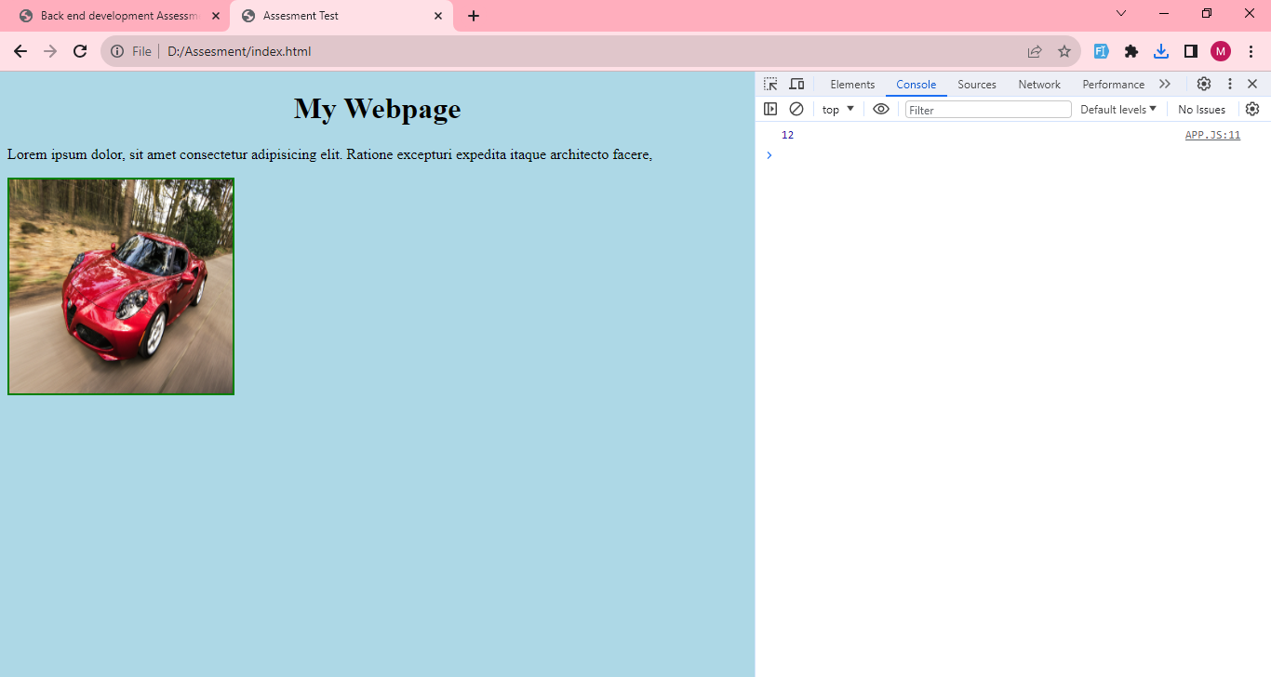

**SECTION 4: DIFFERENCE BETWEEN HTTPS AND HTTP?**

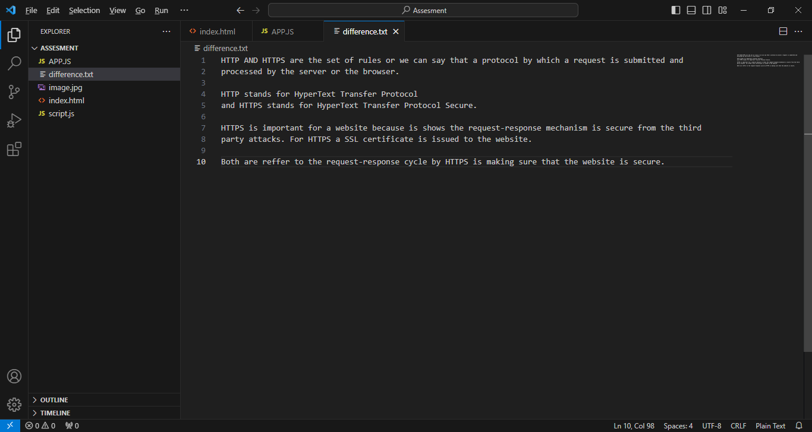

**SECTION 4: RESPONSIVE WEB LAYOUT?**

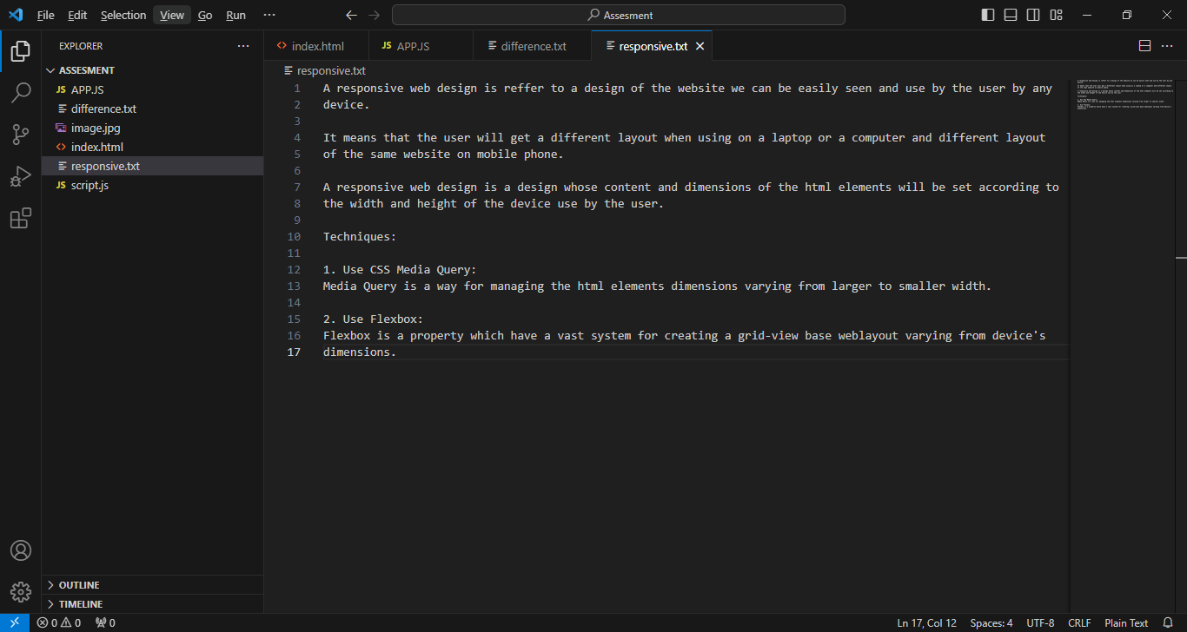

**SECTION 5: JS TO GET LARGEST NUMBER FROM THE ARRAY.**

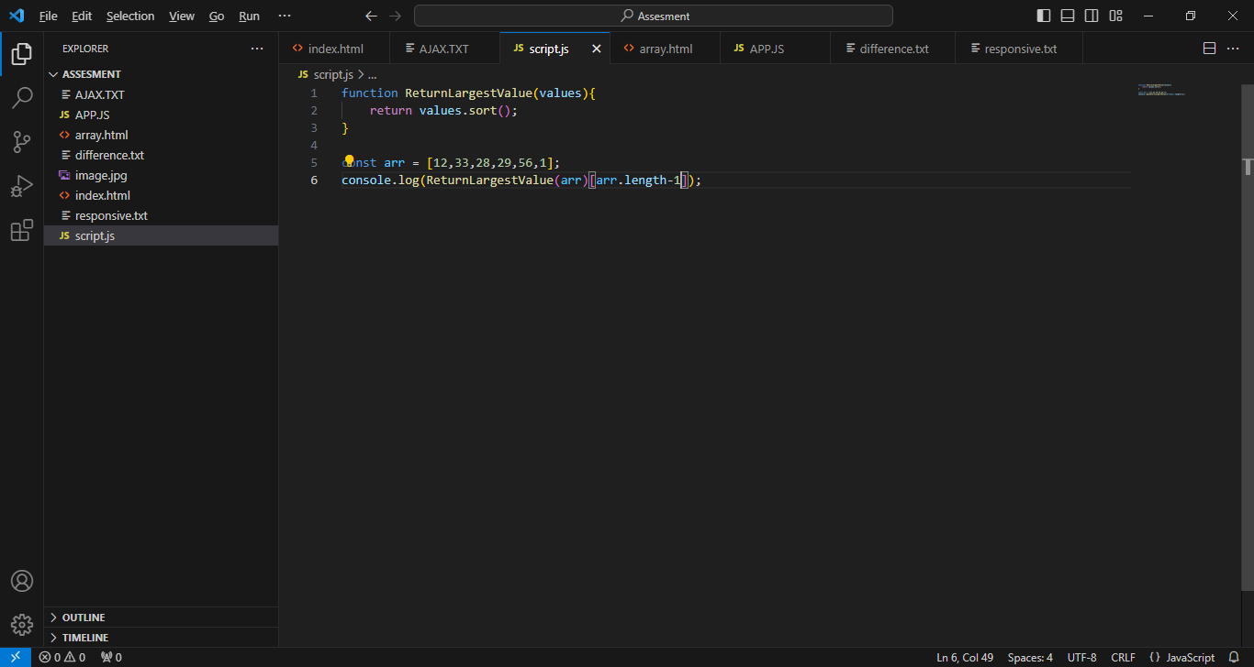

**SECTION 5: AJAX AND ITS USAGE?**