**Add Job:**

1.Role:3d vendor and 3d designer only

2.Show respective categories as per role

3. File Upload

4. Location is not required

5. payment method ---> online payment  
  
  
Job Tab List view:  
 1. Show Applicant Count for individual Job.  
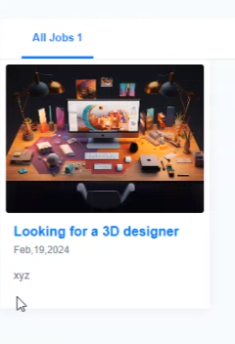  
  
Popular Service:  
1. For the designer   
2. For the vendor  
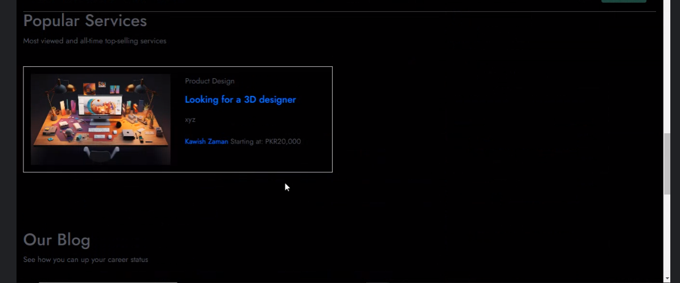  
  
**Remove Blog.**

**Remove dummy data  
add postjob button on header.**

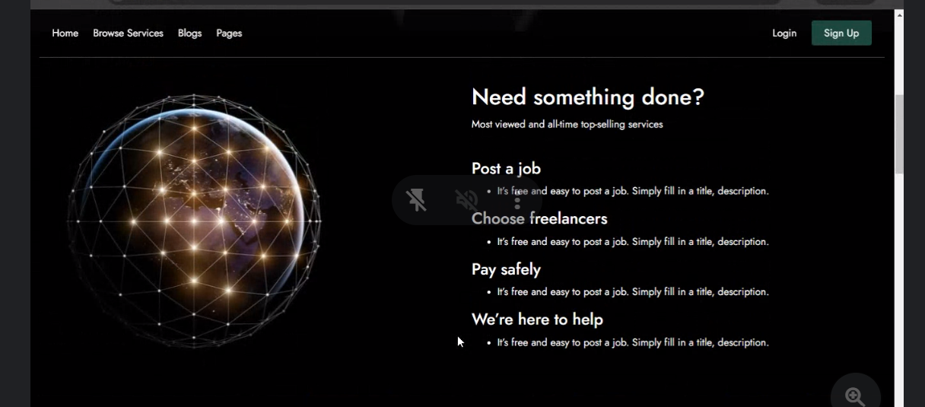  
  
remove dummy data  
button should be Apply NOW

Open Chat option:  
Hire Now Button Functionality   
  
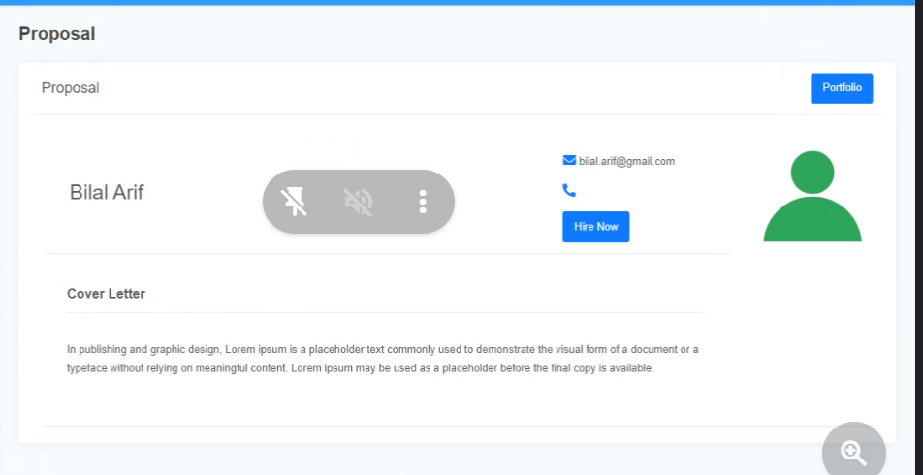  
Specify the job title:  
  
  
