Website Proposal

# 1. Introduction

This proposal outlines the plan to create a new website inspired by 'The Brokerage Inc.' The objective is to design a user-friendly and informative platform that caters to our client's needs. The website will be developed on WordPress, allowing for easy content management and scalability, and Laravel as the backend development of dashboard features and functionality. Our approach will ensure a blend of aesthetic appeal and functionality, aimed at enhancing user engagement and satisfaction.

# 2. Project Scope

The website will consist of the following pages and features, each designed to offer specific information and services to the users: Home, Our Company, What We Offer, Testimonials, Resources, Contact Us, Privacy Policy, Staff Resources, Webinars & Events, and Articles & Podcasts, Blogs and the inner pages of the website. Frontend pages will be developed with a focus on user experience, and backend pages will cater to administrative functionalities.

# 3. Development Timeline

The frontend development is scheduled over 1 month, and the backend development will extend to 1.5 months to include dashboard functionalities.

# 4. Implementation Plan

**Development:** The frontend of the website will be built on WordPress, utilizing themes and plugins for customization. The backend will be developed using Laravel for robust data management and administrative functions.

*Note: As I mentioned above in introduction section the pages below are not the final designed pages, however we are inspired by this website and the layout for the development of your website.*

# 1. Frontend Pages

# Home

Introduction to the company, including a brief overview of services and unique value propositions.

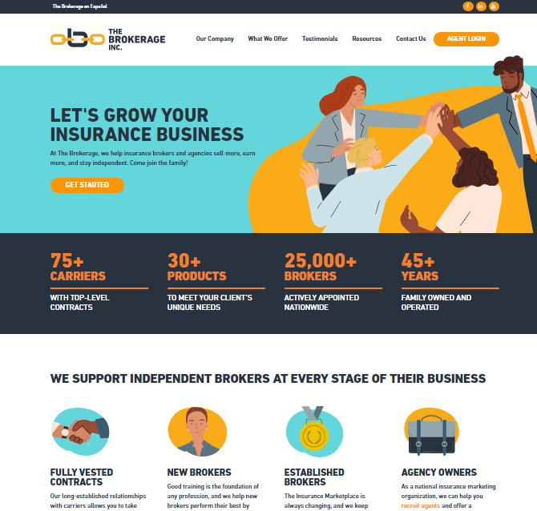

# Our Company

Detailed background information on the company, its history, mission, and vision.

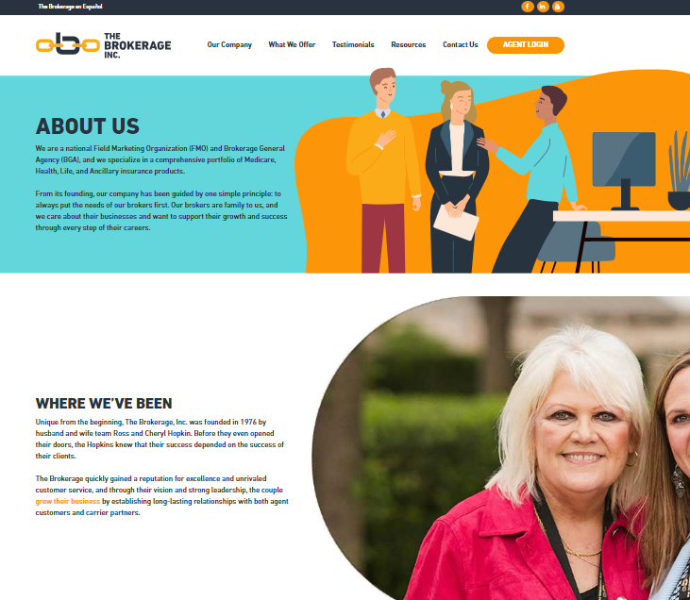

# What We Offer

Comprehensive details on services and products offered, including any specializations.

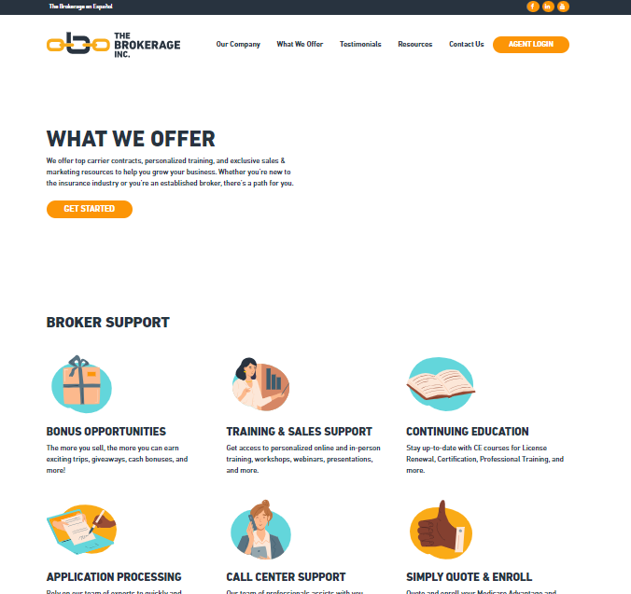

# Testimonials

Client testimonials and case studies showcasing the impact of the company's work.

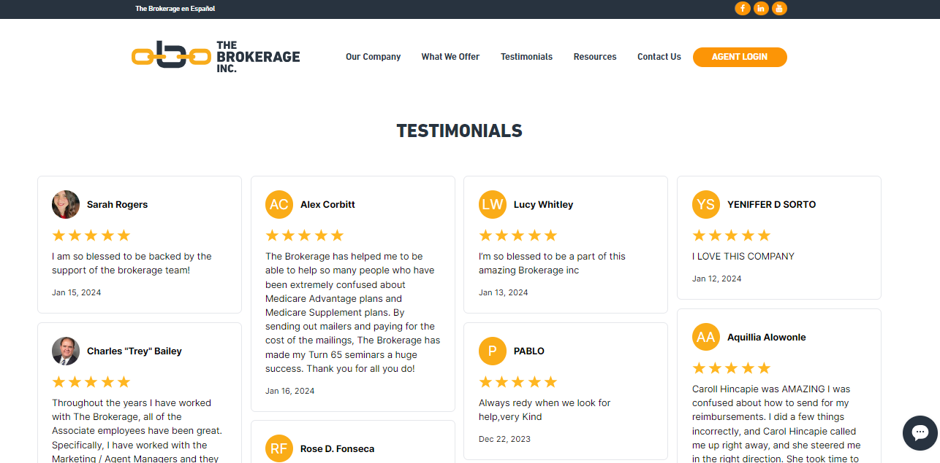

# Resources

A repository of downloadable resources, guides, articles, and tools for clients.

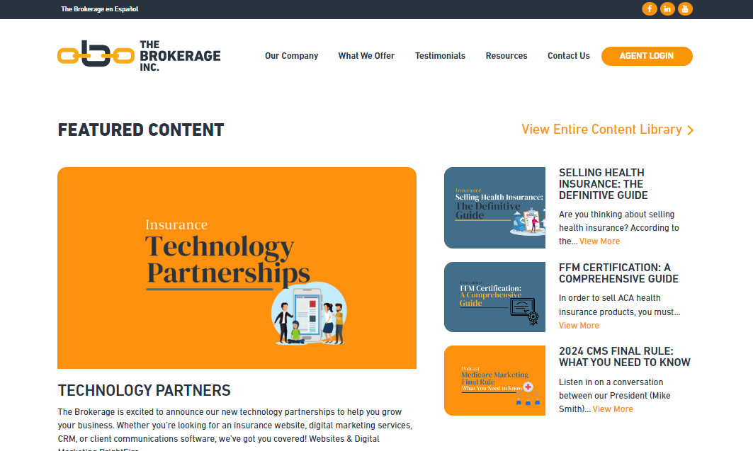

# Contact Us

Contact information, including an inquiry form, map, and directions to company locations.

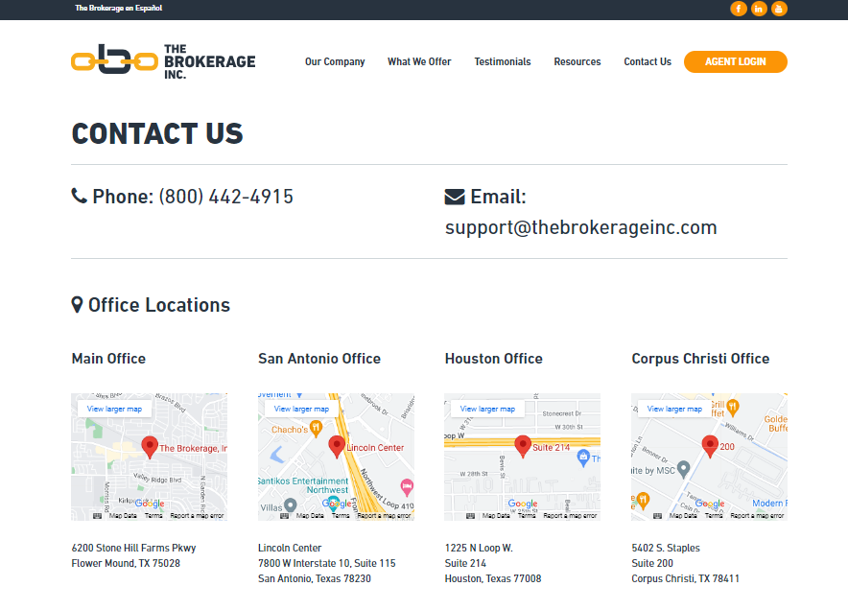

# Privacy Policy

Explanation of the website's data handling practices and user privacy protections.

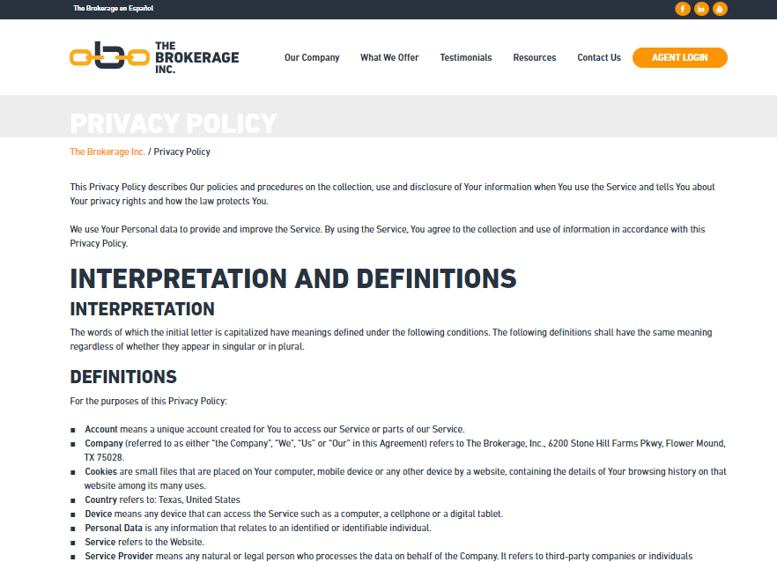

# Careers

The 'Careers' page will be dedicated to showcasing current job openings and providing a detailed overview of the benefits of working with our company

# 

# Articles & Podcasts

Educational content aimed at providing value and engaging the website's target audience.

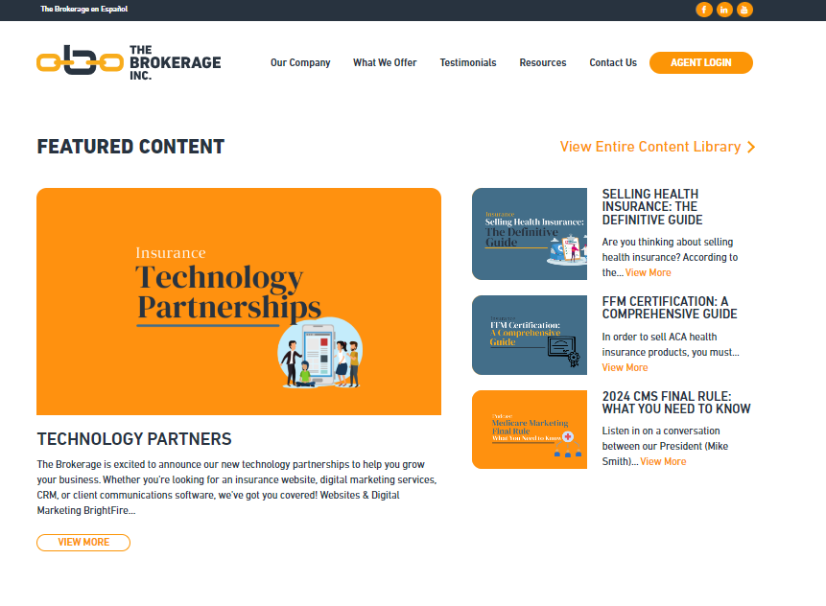

# 2. Backend Pages

# Staff Resources

A secure page for staff to access organizational resources, documents, and tools.

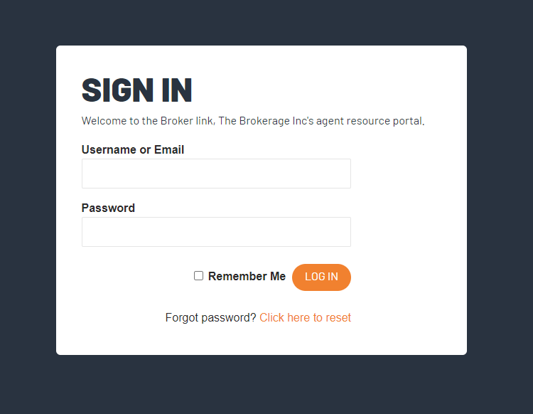

# Registration

A portal for new users to register, including staff, with custom fields to capture necessary information.

