SQL

Intro to SQL
Relational Databases: is a database that organizes information into one or more tables.
- Is a store of data organized in tables made of columns and rows, and the relationship between those tables
- Software that controls a relational database is called a relational database management system (RDBMS) and typically allows management and updates to the database through an implementation of the structured query language (SQL).
Structure of a Relational Database –
- Most tables are defined with a key column that holds a unique value for every row.
  - That column is called a primary key.
- Columns in a table that reference primary keys in other tables are called foreign keys.
- Data in different tables are related to each other via matching values in the key columns in those tables.
- Rows in each table are also called records.
- Columns can also be called fields or attributes
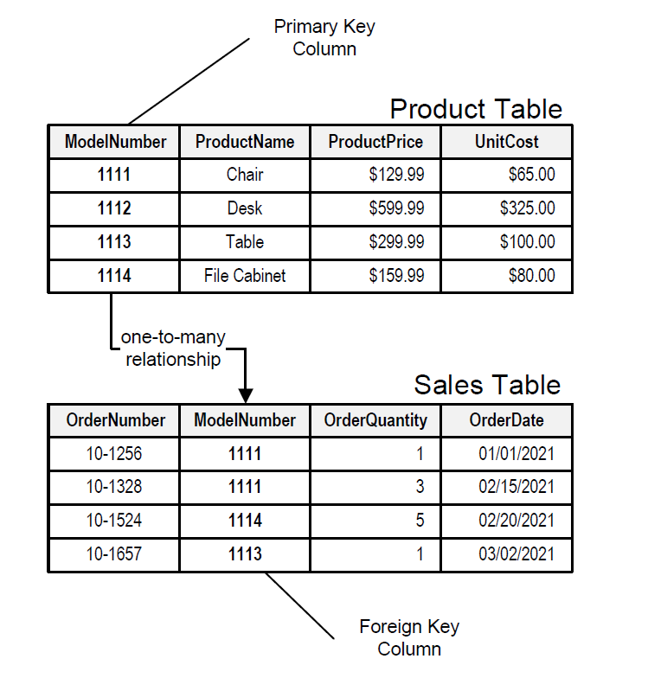

Database: is a collection of structured information stored so it can be easily accessed and updated.
- Relational databases
- Object databases
- Object-related databases
- NoSQL databases

Table: is a collection of data organized into rows and columns.
- Sometimes referred to as relations
Column: is a set of data values of a particular type
Row: is a single record in a table

All data stored in a relational database is of a certain data type.
Common data types:
- Integer, a positive or negative whole number
- Text, a text string
- Date, the date formatted as YYYY-MM-DD
- Real, a decimal value

Statement: is text that the database recognizes as a valid command, they always end in a semicolon (;)
EX:
CREATE TABLE
table_name (
column_1 data_type,
column_2 data_type,
column_3 data_type,
);
- CREATE TABLE is a clause. Clauses perform specific tasks in SQL. By convention, clauses are written in capital letters. Clauses can also be referred to as commands.
- table_name refers to the name of the table that the command is applied to
- (column_1 data_type,
column_2 data_type,
column_3 data_type );
is a parameter. A parameter is a list of columns, data types, or values that are passed to a clause as an argument. Here the parameter is a list of column names and the associated data type.

The structure of SQL statements vary. The number of lines used does not matter. A statement can be written all on one line or split up across multiple lines if it makes it easier to read.
CREATE TABLE celebs (
Id INTEGER,
name TEXT,
age INTEGER,
);
- CREATE TABLE is a clause that tells SQL you want to create a new table
- Celebs is the name of the table
- (id INTEGER, name TEXT, age INTEGER) is a list of parameters defining each column, or attribute in the table and its data type:
  - Id is the first column in the table. It stores values of data type INTEGER.
  - Name is the second column in the table. It stores values of data type TEXT.
  - Age is the third

Insert: the insert statement inserts a new row into a table.
- Use it to add new records
- Statement below enters a record for Justin Bieber into celebs table

INSERT INTO celebs (id, name, age)
VALUES (1, ‘Justin Bieber’, 22);
- INSERT INTO is a clause that adds the specified row or rows
- Celebs is the table the row is added to
- (id, name, age) is a parameter identifying the columns that data will be inserted into
- VALUES is a clause that indicates the data is being inserted
- (1, ‘Justin Bieber’, 22) is a parameter identifying the values being inserted
  - 1: an integer that will be added to id column
  - ‘Justin Bieber’: text that will be added to name column
  - 22: an integer that will be added to age column

Manipulation
SELECT: statements are used to fetch data from a database.
- In the statement below, SELECT returns all data in the name column of the celebs table.
SELECT name FROM celebs;
- SELECT is a clause that indicates that the statement is a query. You will use SELECT every time you query data from a database.
- Name specifies the column to query data from.
- FROM celebs specifies the name of the table to query data from. In this statement, data is queried from the celebs table
You can also query data from all columns in a table with SELECT, for example:
SELECT * FROM celebs;
* is a special wildcard character that we have been using. It allows you to select every column in a table without having to name each one individually. Here, the result set contains every column in the celebs table.
SELECT statements always return a new table called the result set.

ALTER
The ALTER TABLE statement adds a new column to a table.
- Use when you want to add columns to a table
- The statement below adds a new column, for example:

ALTER TABLE celebs
ADD COLUMN twitter_handle TEXT;
- ALTER TABLE is a clause that lets you make the specified changes
- celebs is the name of the table that is being changed
- ADD COLUMN is a clause that lets you add a new column to a table:
  - twitter_handle is the name of the new column being added
  - TEXT is the data type for the new column
- NULL is a special value in SQL that represents missing or unknown data. Here the rows that existed before the column was added have NULL (∅) values for twitter_handle

UPDATE
UPDATE: the UPDATE statement edits a row in a table
- Can use the UPDATE statement when you want to change existing records.
- The statement below updates the record with an id value of 4 to have the twitter_handle @taylorswift13

UPDATE celebs
SET twitter_handle = ‘@taylorswift13’
WHERE id = 4;
- UPDATE is a clause that edits a row in the table
- celebs is the name of the table
- SET is a clause that indicates the column to edit
  - twitter_handle is the name of the column that is going to be updated
  - @taylorswift13 is the new value that is going to be inserted into the twitter_handle column
- WHERE is a clause that indicates which row(s) to update with the new column value. Here the row with a 4 in the id column is the row that will have the twitter_handle updated to @taylorwift13

DELETE
DELETE FROM: statement that deletes one or more rows from a table.
- Can use the statement when you want to delete existing records
- The statement below deleted all records in the celebs table with no twitter_handle:

DELETE FROM celebs
WHERE twitter_handle IS NULL;
- DELETE FROM is a clause that lets you delete rows from a table
- Celebs is the name of the table we want to delete rows from
- WHERE is a clause that lets you select which rows you want to delete. Here we want to delete all of the rows where the twitter_handle column IS NULL
- IS NULL is a condition in SQL that returns true when the value is NULL and false otherwise

To delete a table completely, use the DROP TABLE statement:
DROP TABLE celebs;

CONSTRAINTS
Constraints: add information about how a column can be used are invoked after specifying the data type for a column
- Can be used to tell the database to reject inserted data that does not adhere to a certain restriction
- The statement below sets constraints on the celebs table

CREATE TABLE celebs (
id INTEGER PRIMARY KEY,
name TEXT UNIQUE,
date_of_birth TEXT NOT NULL,
date_of_death TEXT DEFAULT ‘Not Applicable’
);
- PRIMARY KEY columns can be used to uniquely identify the row. Attempts to insert a row with an identical value to a row already in the table will result in a constraint violation which will not allow you to insert the new row
- UNIQUE columns have a different value for every row. This is similar to PRIMARY KEY except a table can have many different UNIQUE columns
- NOT NULL columns must have a value. Attempts to insert a row without a value for a NOT NULL column will result in a constraint violation and the new row will not be inserted
- DEFAULT columns take an additional argument that will be the assumed value for an inserted row if the new row does not specify a value for that column.

AS is a key word in SQL that allows you to rename a column or table using an alias.
- Can be anything as long as it is in single quotes
- An alias only exists for the duration of that query
- The statement below is an example:

SELECT name AS ‘Titles’
FROM movies;
In this example we renamed the name column as Titles
When using AS, the columns are not being renamed in the table. The aliases only appear in the result

DISTINCT
When we are examining data in a table, it can be helpful to know what distinct values exist in a particular column.
DUSTINCT is used to return unique values in the output
- It filters out all duplicate values in the specified column(s)
For example
SELECT tools FROM inventory;
Might produce:
tools
Hammer
Nails
Nails
Nails
Nails
By adding DISTINCT before the column name,
SELECT DISTINCT tools FROM inventory;
The result would now be:
tools
Hammer
Nails

WHERE
We can restrict our query results using the WHERE clause in order to obtain only the information we want.
For example, writing a statement that only includes movies with a rating higher than 8:
SELECT * FROM movies
WHERE imdb_rating > 8;
- The WHERE clause filters the result set to only include rows where the following condition is true
- Imdb_rating > 8 is the condition. Here, only rows with a value greater than 8 In the imdb_rating column will be returned
The > is an operator.
Operators create a condition that can be evaluated as either true or false
Comparison operators used with the WHERE clause are:
- = equal to
- != not equal to
- <> not equal to
- > greater than
- < less than
- >= greater than or equal to
- <= less than or equal to

LIKE 1
LIKE can be a useful operator when you want to compare similar values.
For example:
SELECT * FROM movies
WHERE name LIKE ‘Se_en’;
This selects all movies that start with ‘Se’ and end with ‘en’ and have exactly one character in the middle.
- LIKE is a special operator used with the WHERE clause to search for a specific pattern in a column
- name LIKE ‘Se_en’ is a condition evaluating the name column for a specific pattern
- Se_en represents a pattern with a wildcard character
The _ means you can substitute any individual character here without breaking the pattern.
The names Seven and Se7en both match this pattern.

LIKE 2
The percentage sign % is another wildcard character that can be used with LIKE
The statement below filters the result set to only include movies with names that begin with the letter ‘A’:
SELECT * FROM movies WHERE name LIKE ‘A%’;
% is a wildcard character that matches zero or more missing letters in the pattern For example:
- A% matches all movies with names that begin with letter ‘A’
- %a matches all movies that end with ‘a’
We can also use % both before and after a pattern for example:
SELECT * FROM movies
WHERE name LIKE ‘%man%’;
Here, any movie that contains the word ‘man’ in its name will be returned in the result
LIKE is not case sensitive.
‘Batman’ and ‘Man of Steel’ will both appear in the result of the query above

IS NULL
Unknown values are indicated by NULL
It is not possible to test for NULL values with comparison operators, such as = or !=
Instead, we will have to use these operators:
- IS NULL
- IS NOT NULL
The statement below filters all movies with an IMDb rating:
SELECT name
FROM movies
WHERE imdb_rating IS NOT NULL;

BETWEEN
The BETWEEN operator is used in a WHERE clause to filter the result set within a certain range.
- It accepts two values that are either numbers, text, or dates
For example, this statement filters the result set to only include movies with year from 1990 up to and including 1999
SELECT * FROM movies
WHERE year BETWEEN 1990 and 1999;

When the values are text, BETWEEN filters the result set for within the alphabetical range.
In this next statement, BETWEEN filters the result set to only include movies with names that begin with the letter ‘A’ up to, but not including ones that begin with ‘J’.
SELECT * FROM movies
WHERE name BETWEEN ‘A’ and ‘J’;
However, if a movie has a name of simply ‘J’, it would actually match. This is because BETWEEN goes up to the second value – up to ‘J’. So the movie named ‘J’ would be included in the result set but not ‘Jaws’.

NOT BEWTEEN
Returns all records outside the given range, for example:
SELECT * FROM movies
WHERE year NOT BETWEEN 1990 and 1999;

BETWEEN with IN
The following SQL statement selects all products with a price between 10 and 20. In addition, the CategoryID must be either 1,2, or 3.
SELECT * FROM Products
WHERE Price BETWEEN 10 AND 20
AND CategoryID IN (1,2,3);

BETWEEN Dates
The following SQL statement selects all orders with and OrderDate between ’01-July-1996’ and ’31-July-1996’:
SELECT * FROM Orders
WHERE OrderDate BETWEEN ‘1996-07-01’ AND ‘1996-07-31’:

AND
Sometimes we want to combine multiple conditions in a WHERE clause to make the result set more specific and useful.
One way of doing this is to use the AND operator.
In the statement below, we use the AND operator to only return 90’s romance movies.
SELECT * FROM movies
WHERE year BETWEEN 1990 AND 1999
AND genre = ‘romance’;
- year BEWTEEN 1990 AND 1999 is the 1st condition
- genre = ‘romance’ is the 2nd condition
- AND combines the two conditions
With AND, both conditions must be true for the row to be included in the result

OR
Similar to AND, the OR operator can also be used to combine multiple conditions in WHERE, but there is a fundamental difference:
- AND operator displays a row if all the conditions are true
- OR operator display a row if any condition is true
The below statement checks out a new movie or something action packed
SELECT * FROM movies
WHERE year > 2014
OR genre = ‘action’;
- year > 2014 is the 1st condition
- genre = ‘action’ is the 2nd condition
- OR combines the two conditions
With OR, if any of the conditions are true, then the row is added to the result.

ORDER BY
It is often useful to list the data in our result set in a particular order
We can sort the results using ORDER BY, either alphabetically or numerically.
- Sorting the results often makes the data more useful and easier to analyze
For example, if we want to sort everything by the movie’s title form A through Z:
SELECT * FROM movies
ORDER by name;
- ORDER BY is a clause that indicates you want to sort the result set by a particular column
- name is the specified column
Sometimes we want to sort things in a decreasing order.
For example, if we want to select all of the well-received movies, sorted from highest to lowest by their year:
SELECT * FROM movies
WHERE imdb_rating > 8
ORDER BY year DESC;
- DESC is a keyword used in ORDER BY to sort the results in descending order (high to low or Z to A).
- ASC is a keyword used in ORDER BY to sort the results in ascending order (low to high or A to Z).
The column that we ORDER BY doesn’t even have to be one of the columns that we’re displaying
Note: ORDER BY always goes after WHERE (if WHERE is present)
When ordering by more than one column, it will first order that data in the first column, then, keeping the previous column order, it will order the next column, and so on.
The statement below uses LIMIT and ORDER BY to write a query that return the top 3 highest rated movies:
SELECT * FROM movies
ORDER BY imdb_rating DESC
LIMIT 3
LIMIT
Most SQL tables contain hundreds of thousands of records.
- Becomes important to cap the number of rows in the result
For example, imagine we just want to see a few examples of records:
SELCT * FROM movies
LIMIT 10;
LIMIT is a clause that lets you specify the maximum number of rows the result set will have.
- Saves space on our screen and makes our queries run faster
Here, we specify that the result set can’t have more than 10 rows.
LIMIT always goes at the very end of the query
- Also, it is not supported in all SQL databases
The statement below uses LIMIT and ORDER BY to write a query that return the top 3 highest rated movies:
SELECT * FROM movies
ORDER BY imdb_rating DESC
LIMIT 3

CASE
A CASE statement allows us to create different outputs (usually in the SELECT statement).
- It is SQL’s way of handling the if-then logic
Suppose we want to condense the ratings in movies to three levels:
- If the rating is above 8, then it is fantastic
- If the rating is above 6, then it is poorly received
- Else, Avoid at All Costs

SELECT name,
CASE
WHEN imdb_rating > 8 THEN ‘Fantastic’
WHEN imdb_rating > 6 THEN ‘Poorly Received’
ELSE ‘Avoid at All Costs’
END AS ‘Review’
FROM movies
- Each WHEN tests a condition and the following THEN gives use the string if the condition is true
- The ELSE gives us the string if all the above conditions are false
- The CASE statement must end with END
- END AS ‘Review’ shortens the columns name to review

Aggregate Functions
COUNT(): count the number of rows
SUM(): the sum of the values in a column
MAX(): the largest value
MIN(): the smallest value
AVG(): the average of the values in a column
ROUND(): round the values in the column

Count
The fastest way to calculate how many rows are in a table is to use the COUNT() function
- Is a function that takes the name of a column as an argument and counts the number of non-empty values in that column

SELECT COUNT(*)
FROM table_name;
- Here we want to count every row, so we pass * as an argument inside the parenthesis
When using the COUNT() function on a column in SQL, it will include duplicate values by default
- Counts all rows for which there is a value in the column
- If you want to count only the unique values in a column, then you can utilize the DISTINCT clause withing the COUNT() function.
- The COUNT function will only count non-NULL values when a specific column is selected

EXAMPLE:
/* This will return the number of distinct category values. */
SELECT COUNT(DISTINCT category)
FORM fake_apps;

Sum
SUM(), is a function that takes the name of a column as an argument and returns the sum of all the values in that column

SELECT SUM(downloads)
FROM fake_apps;
This adds all values in the downloads column.

Max / Min
The MAX() AND MIN() functions return the highest and lowest values in a column, respectively

SELECT MAX(downloads)
FROM fake_apps;
- This statement shows the app with the most downloads or in other words the most popular app
- Here we returned the largest value in the downloads column
- MIN() does the exact opposite
When you have more than one row that contains the minimum or maximum value in a column, the topmost row containing that value will be returned in the result.
The below statement shows all the rows that contain the maximum price, instead of just the topmost one.
SELECT name, price FROM fake_apps
WHERE price = (SELECT max(price) FROM fake_apps);

Average
SQL uses the AVG() function to quickly calculate the average value of a particular column
The statement below returns the average number of downloads for an app in the database:
SELECT AVG(downloads)
FROM fake_apps;
- The AVG() function works by taking a column name as an argument and returns the average value for that column
How can we get the average of only the unique values of a column?
- To run the AVG() function on a column such that it only averages the unique values in the column, we could use the DISTINCT clause right before the column name, for example:

SELECT AVG(DISTINCT price)
From fake_apps;

Round
By default, SQL tries to be as precise as possible without rounding.
ROUND() function takes two arguments inside the parenthesis:
- A column name
- An integer
It rounds the values in the column to the number of decimal places specified by the integer
SELECT ROUND(price, 0)
FROM fake_apps;
- Here, we pass the column price and integer 0 as arguments
- SQL rounds the values in the column to 0 decimal places in the output
The following statement rounds an average of a column to 2 decimal places:
SELECT ROUND(AVG(PRICE), 2)
FROM fake_apps;

Group By 1
Oftentimes, we will want to calculate an aggregate for data with certain characteristics.
For instance, we might want to know the mean IMDb ratings for all movies each year.
We could calculate each number by a series of queries with different WHERE statements, like so:
SELECT AVG(imdb_rating)
FROM movies
WHERE year = 1999;

SELECT AVG(imdb_rating)
FROM movies
WHERE year = 2000;

SELECT AVG(imdb_rating)
FROM movies
WHERE year = 2001;
*/ and so on /*
There is a better way to do this.
We can use GROUP BY to do this in a single step:
SELECT year,
AVG(imdb_rating)
FROM movies
GROUP BY year
ORDER BY year;
GROUP BY clause in SQL that is used with aggregate function.
- It is used in collaboration with the SELECT statement to arrange identical data into groups
The GROUP BY statement comes after any WHERE statements, but before the ORDER BY or LIMIT.

SELECT price, COUNT(*)
FROM fake_apps
GROUP BY price;
Here, our aggregate function is COUNT() and we arranged price into groups.

When using the GROUP BY clause, do we always have to group by one of the selected columns listed after SELECT?
- No, you can GROUP BY a column that was not included in the SELECT statement.
- For example, this query does not list the price column in the SELECT statement, but it does group the data by that column.

SELECT name, downloads
FROM fake_apps
GROUP BY price;
However, usually we do include the grouped by column in the SELECT for the sake of clarity, so that it’s easier to see what rows belong to which group.

Group By 2
Sometimes, we want to GROUP BY a calculation done on a column.
For instance, we might want to know how many movies have IMDb ratings that round to 1, 2, 3, 4, 5.
We could do this using the following syntax:
SELECT ROUND(imdb_rating), COUNT(name)
FROM movies
GROUP BY ROUND(imdb_rating)
ORDER BY ROUND(imdb_rating);
*However, this query may be time-consuming to write and more prone to error
SQL lets us use column reference(s) in our GROUP BY that will make our lives easier.
- 1 is the first column selected
- 2 is the second column selected
- 3 is the second column selected
and so on
The following query is equivalent to the one above:
SELECT ROUND(imdb_rating), COUNT(name)
FROM movies
GROUP BY 1
ORDER BY 1;
Here, the 1 refers to the first column in our SELECT statement, ROUND(imdb_rating).

Having
In addition to being able to group data using GROUP BY, SQL also allows you to filter which groups to include and which to exclude.
For instance, imagine that we want to see how many movies of different genres were produced each year, but we only care about years and genres with at least 10 movies.
We can’t use the WHERE here because we don’t want to filter the rows; we want to filter groups.
This is where HAVING comes in.
HAVING is very similar to WHERE.
- In fact, all types of WHERE clauses we learned thus far can be used with HAVING.
We can use the following for the problem:
SELECT year, genre, COUNT(name)
FROM movies
GROUP BY 1, 2
HAVING COUNT(NAME) > 10;
- When we want to limit the results of a query based on values of the individual rows, use WHERE.
- When we want to limit the results of a query based on an aggregate property, use HAVING
HAVING statement always comes after GROUP BY, but before ORDER BY and LIMIT.
Suppose we have the query below:
SELECT price, ROUND(AVG(downloads)), COUNT(*)
FROM fake_apps
GROUP BY price
HAVING COUNT(*) > 10;
It returns the average downloads (rounded) and the number of apps – at each price point.
However, certain price points don’t have very many apps, so their average downloads are less meaningful.
Adding the HAVING clause restrict the query to price points that have more than 10 apps
COUNT(*) > 10 is the condition.
- Because the condition has an aggregate function in it, we have to use HAVING instead of WHERE.
Can a WHERE clause be applied with a HAVING statement in the same query?
YES, when you apply a WHERE clause in the same query, it must always be before any GROUP BY, which in turn must be before any HAVING.
- As a result, the data is essentially filtered on the WHERE condition first. Then, from this filtered data, it is grouped by specified columns and then further filtered based on the HAVING condition.

Multiple Tables:
In order to efficiently store data, we often spread related information across multiple tables.
For instance, imagine that we’re running a magazine company where users can have different types of subscriptions to different products. Different subscriptions might have many different properties. Each customer would also have lots of associated information.
We could have one table with all of the following information:
- Order_id
- Customer_id
- Customer_name
- customer_address
- subscription_id
- subscription_description
- subscription_montly_price
- subscription_length
- purchase_date
However, a lot of this information would be repeated. If the same customer has multiple subscriptions, that customer’s name and address will be reported multiple times. If the same subscription type is ordered by multiple customers, then the subscription price and subscription description will be repeated. This will make out table bug and unmanageable.

So instead, we can split our data into three tables:
- orders would contain just the information necessary to describe what was ordered:
  - order_id. customer_id, subscription_id, purchase_date
- subscriptions would contain the information to describe each type of subscription:
  - subscription_id, description, price_per_month, subscription_length
- customer would contain the information for each customer:
  - customer_id, customer_name, address
Combining Tables with SQL
Combining tables manually is time-consuming. Luckily, SQL gives us an easy sequence for this: it’s called a JOIN
If we want to combine orders and customers, we would type:
SELECT *
FROM orders
JOIN customers
ON orders.customer_id = customers.customer_id;
- The first line selects all columns from the combined table. If we only want to select certain columns, we can specify which ones we want.
- The second line specifies the first tables that we want to look in, orders
- The third line uses JOIN to say that we want to combine information from orders with customers.
- The fourth line tells us how to combine the two tables. We want to match orders table’s customer_id column with customers table’s customer_id column.
Because column names are often repeated across multiple tables, we use the syntax table_name.column_name to be sure that our requests for columns are unambiguous. In our example, we use this syntax in the ON statement, but we will also use it in the SELECT or any other statement where we refer to column names.
For example: instead of selecting all the columns using *, if we only wanted to select orders table’s order_id column and customers table’s customer_name column, we could use the following query:
SELECT orders.order_id, cutomers.customer_name
FROM orders
JOIN customers
ON orders.customer_id = customers.cutomer_id

Inner Joins
Let’s revisit how we joined orders and customers. For every possible value of customer_id in orders, there was a corresponding row of customers with the same customer_id.
What if that wasn’t true?
For instance, we imagine that our customers table was out of date, and was missing any information on customer 11. If that customer had an order in orders, what would happen when we joined the tables?
When we perform a simple JOIN (often called an inner join) our result only includes rows that match our ON condition.
Consider the following animation, which illustrates an inner join of two tables on table1.c2 = table2.c2:
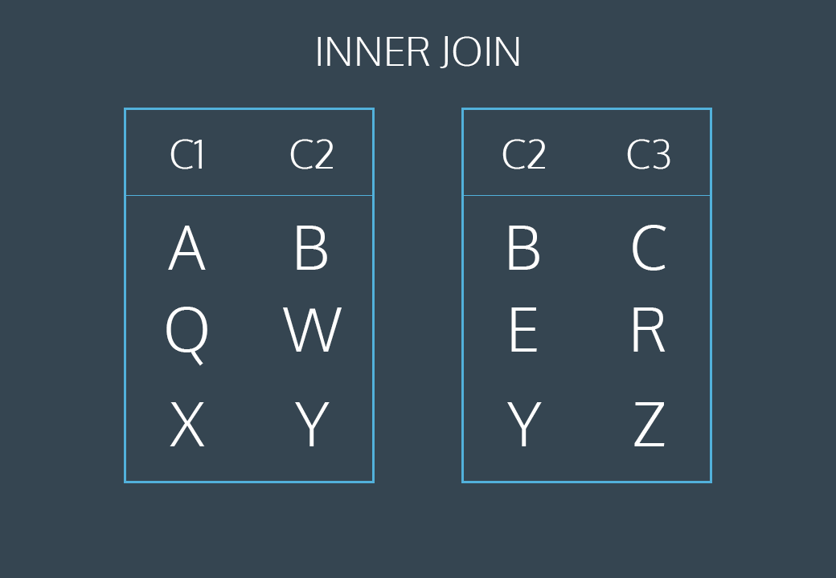
The first and last rows have matching values of c2. The middle rows do not match. The final result has all values from the first and last rows but does not include the non-matching middle row.

When we write a JOIN query, does the order we specify the tables matter? For example:
FROM table1 JOIN table2 vs FROM table2 JOIN table1
Generally, no, the order of the tables in the JOIN will not affect the overall results of the query.
As long as you specify what columns to select, the results should appear essentially the same, just that the rows will be ordered according to the appearance in the first table.
However, if you do not specify specific columns, then the order of columns will be different depending on the order of the tables. Without specifying columns in your SELECT, by using just SLEECT *, the result query will order the columns by the first table’s columns followed by the second table’s columns.
For example, say we had two table:
orders, with the columns order_id, customer_id and customers, with the columns customer id, address.
If we run the following query:
SELECT * FROM orders
JOIN customers
ON orders.customer_id = customers.cutomer_id;
The columns in this query’s results will be order from left to right as:
Order_id, customer_id, customer_id, address

Left Joins
What if we want to combine two tables and keep some of the un-matched rows?
SQL lets us do this through a command called LEFT JOIN. A left join will keep all rows from the first table, regardless of whether there is a matching row in the second table.
Consider the following animation:
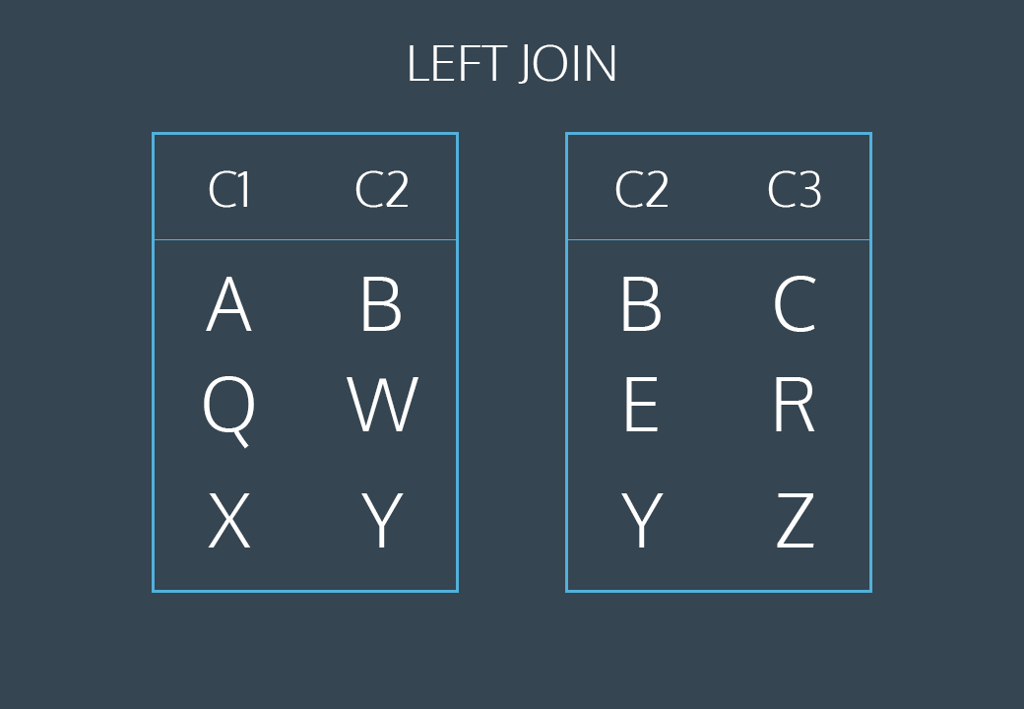
The first and last rows have matching values of c2. The middle rows do not match. The final result will keep all rows of the first table but will omit the un-matched row from the second table.
This animation represents a table operation produced by the following command:
SLEECT *
FROM table1
LEFT JOIN table2
ON table1.c2 = table2.c2;
- The first line selects all columns from both tables
- The second line selects table1 (the “left” table)
- The third line performs a LEFT JOIN on table2 (the “right” table)
- The fourth line tell SQL how to perform the join (by looking for matching values in column c2)
When should I use INNER JOIN instead of LEFT JOIN?
Depending on how we want to select the combined data, it can determine whether to use an INNER JOIN or LEFT JOIN.
Generally, we use INNER JOIN when we want to select only rows that match an ON condition. If no rows match the ON condition, then it will not return any results. This can be somewhat stricter than using a LEFT JOIN.
We use a LEFT JOIN when we want every row from the first table, regardless of whether there is a matching row from the second table. This is similar to saying,
“Return all the data from the first table no matter what. If there are any matches with the second table, provide that information as well, but if not, just fill the missing data with NULL values.”
In a way, LEFT JOIN is less strict than INNER JOIN. Furthermore, the results of a LEFT JOIN will actually include all results that an INNER JOIN would have provided for the same given condition.

Right Joins
The RIGHT JOIN keyword returns all records from the right table (table2), and the matching records from the left table (table1). The result is 0 records from the left side if there is no match.
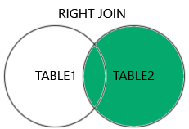
The following SQL statement will return all employees, and any order they might have placed:
SELECT Orders.OrderID, Employees.LastName, Employees.FirstName
FROM Orders
RIGHT JOIN Employees ON Orders.EmployeeID = Employees.EmployeeID
ORDER BY Orders.OrderID;

Full Join
SQL FULL OUTER JOIN Keyword
The FULL OUTER JOIN keyword returns all records when there is a match in left (table1) or right (table2) table records.
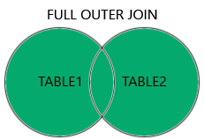
FULL OUTER JOIN and FULL JOIN are the same.

FULL OUTER JOIN Syntax:
SELECT column_name(s)
FROM table1
FULL OUTER JOIN table2
ON table1.column_name = table2.column_name
WHERE condition;
NOTE: The FULL OUTER JOIN keyword returns all matching records from both tables whether the other table matches or not. So, if there are rows in “Customers” that do not have matches in “Orders”, or if there are rows in “Orders” that do not have matches in “Customers”, those rows will be listed as well.

Primary Key vs Foreign Key
Let’s return to our example of the magazine subscriptions. Recall that we had three tables: orders, subscriptions, and customers.
Each of these tables has a column that uniquely identifies each row of that table:
- order_id for orders
- subscription_id for subscriptions
- customer_id for customers
These special columns are called primary keys.
Primary keys: special columns used to uniquely identify each row of a table in SQL
Primary keys have a few requirements:
- none of the values can be NULL
- each value must be unique (i.e. you can’t have two customers with the same customer_id in the customers table).
- A table can not have more than one primary key column.
Let’s reexamine the orders table:
order_id | customer_id | subscription_id | Purchase_date
1 | 2 | 3 | 2017-01-01
2 | 2 | 2 | 2017-01-01
3 | 3 | 1 | 2017-01-01

Note that customer_id (the primary key for customers) and subscription_id (the primary key for subscriptions) both appear in this.
When the primary key for one table appears in a different table, it is called a foreign key.
So, customer_id is a primary key when it appears in customers, but a foreign key when it appears in orders.
In this example, our primary keys all had somewhat descriptive names. Generally, the primary key will just be called id. Foreign keys will have more descriptive names.
Why is this important? The most common types of joins will be joining a foreign key from one table with the primary key from another table. For instance, when we join orders and customers, we join customer_id, which is a foreign key in orders and the primary key in customers.

Is it possible for a table to have more than one unique identifier column, like an id column?
Yes, it is possible for a table to have more than one column which can uniquely identify a row of data. A column that can uniquely identify a record of data is known as a "Candidate Key". Tables can have multiple "Candidate Keys,” each of which could potentially be the "Primary Key", but there must only be one "Primary Key" per table. Usually, the column chosen as the "Primary Key" follows the naming convention like customer_id or product_id.
For example, say that we had a table of employee records, with the columns employee_id and phone_number. Every employee has a unique employee_id value, and a unique phone_number value. Both of these columns can be unique identifiers for a row, so they are "Candidate keys", but the "Primary Key" would most likely be set to employee_id.

Self Join
A self join is a regular join, but the table is joined with itself.
Self Join Syntax:
SELECT column_name(s)
FROM table1 T1, table1 T2
WHERE condition;

*T1 and T2 are different table aliases for the same table

Cross Joins
The CROSS JOIN clause is used to combine each row from one table with each row from another in the result set. The JOIN is helpful for creating all possible combinations for the records (rows) in two tables.
So far, we’ve focused on matching rows that have some information in common.
Sometimes, we just want to combine all rows of one table with all rows of another table.
For instance, if we had a table of shirts and a table of pants, we might want to know all the possible combinations to create different outfits.
Our code might look like this:
SELECT shirts.shirt_color, pants.pants_color
FROM shirts
CROSS JOIN pants;
- The first lines select the columns shirt_color and pants_color.
- The second line pulls data from the table shirts
- The fourth line performs a CROSS JOIN with pants
Notice that cross joins don’t require an ON statement. You’re not really joining on any columns.
If we have 3 different shirts (white, grey, and olive) and 2 different pants (light denim and black), the results might look like this:

shirt_color | pants_color
White | Light denim
White | Black
Grey | Light denim
Grey | Black
Olive | Light denim
Olive | Black

3 shirts x 2 pants = 6 combinations
This clothing example is not very practically useful.
A more common usage of CROSS JOIN is when we need to compare each row of a table to a list of values.
Let’s return to our newspaper subscriptions. This table contains two columns that we haven’t discussed yet:
- start_month: the first month where the customer subscribed to the print newspaper (I.e. 2 for February)
- end_month: the final month where the customer subscribed to the print newspaper
Suppose we wanted to know how many users were subscribed during each month of the year. For each month (1, 2, 3) we would need to know if a user was subscribed. Follow the steps below to see how we can use a CROSS JOIN to solve this problem.
Instructions:
- Eventually, we’ll use a cross join to help us, but first, let’s try a simpler problem.
Let’s start by counting the number of customers who were subscribed to the newspaper during March.
Use COUNT(*) to count the number of rows and a WHERE clause to restrict to two conditions:
  - start_month <= 3
  - end_month >= 3

SELECT COUNT(*)
FROM NEWSPAPER
WHERE start_month <= 3 AND end_month >= 3;
Answer: 13

- The previous query lets us investigate one month at a time. In order to check across all the months, we’re going to need to use a cross join.

The database contains another table called months which contains the numbers between 1 and 12.

Select all columns from the cross join of newspaper and months.

SELECT * FROM newspaper
CROSS JOIN months;
Each customer is CROSS JOIN’ed with each month

- Create a third query where you add a WHERE statement to your cross join to restrict to two conditions:
  - start_month <= month
  - end_month >= month

This will select all months where a user was subscribed

SELECT * FROM newspaper
CROSS JOIN months
WHERE start_month <= month AND end_month >= month;
Filters from the previous CROSS JOIN

- Create a final query where you aggregate over each month to count the number of subscribers

SELECT month, COUNT(*) AS ‘subscribers’
FROM newspaper
CROSS JOIN months
WHERE start_month <= month AND end_month >= month
GROUP BY month;

Union
The UNION clause is used to combine results that appear from multiple SELECT statements and filter duplicates.
Sometimes we just want to stack one dataset on top of the other. Well, the UNION operator allows us to do that.
Suppose we have two tables, and they have the same columns.
table1:
Pokémon | Type
Bulbasaur | Grass
Charmander | Fire
Squirtle | Water

table2:
Pokémon | Type
Snorlax | Normal

If we combine these too with UNION:
SELECT * FROM table1
UNION
SELECT * FROM table2;
The result would be:
Pokémon | Type
Bulbasaur | Grass
Charmander | Fire
Squirtle | Water
Snorlax | Normal

SQL has strict rules for appending data:
- Tables must have the same number of columns.
- The columns must have the same data types in the same order as the first table

What happens if the tables we perform UNION on have duplicate rows?
When you combine tables with UNION, duplicate rows will be excluded.
To explain why this is the case, recall a Venn Diagram, which shows the relations between sets. If we perform UNION on two sets of data (tables), say A and B, them the data returned in the result will essentially be
A + B – (A intersect B)
In the first part,
A + B
will add together all the rows of both tables, including duplicates
The second part,
- (A intersect B)
will remove every duplicate, which is where A and B intersected
If however, you wanted to include duplicates, certain versions of SQL provides the UNION ALL operator.

With
The WITH clause stores the result of a query in a temporary table using an alias.
Often times, we want to combine two tables, but one of the tables is the result of another calculation.
Let’s return to our magazine order example. Our marketing department might want to know a bit more about our customers. For instance, they might want to know how many magazines each customer subscribes to. We can easily calculate this using our orders table:
SELECT customer_id, COUNT(subscription_id) AS ‘subscriptions’
FROM orders
GROUP BY customer_id;
This query is good, but a customer_id isn’t terribly useful for our marketing department, they probably want to know the customer’s name.
We want to be able to join the results of this query with our customers table, which will tell us the name of each customer. We can do this by using a WITH clause.
WITH previous_query AS (
SELECT customer_id, COUNT(subscription_id) AS ‘subscriptions’
FROM orders
GROUP BY customer_id
)
SELECT customers.cutomer_name, previous_query.subscriptions
FROM previous_query
JOIN customers
ON previous_query.customer_id = customers.customer_id;
- The WITH statement allows us to perform a separate query (such as aggregating customer’s subscriptions)
- previous_query is the alias that is used to reference any columns from the query inside of the WITH clause
Essentially, we are putting a whole first query inside the parentheses () and giving it a name. After that, we can use this name as if it’s a table and write a new query using the first query.
Do not include ; inside of the () of the WITH statement.

Can we use WITH for more than one nested query in SQL?
Yes, you can use WITH for more than one nested query. You can do so by listing each query using commas after the WITH.
For example,
WITH
Query1 AS (SELECT column1 FROM table1 WHERE condition1),
Query2 AS (SELECT column2 FROM table2 WHERE condition2)
…

Review
- JOIN will combine rows from different tables if the join condition is true.
- LEFT JOIN will return every row in the left table, and if the join condition is not met, NULL values are used to fill in the columns from the right table.
- Primary key is a column that serves a unique identifier for the rows in the table.
- Foreign key is a column that contains the primary key to another table.
- CROSS JOIN lets us combine all rows of one table with all rows of another table.
- UNION stacks one dataset on top of another.
- WITH allows us to define one or more temporary tables that can be used in the final query.

Extra Review:
- IN is used to check whether an attribute value matches a value contained with a (sub)set of listed values.
- EXISTS is used to check whether an attribute has a value
- LIKE is used to check for similar character strings
- NOT negates an expression
- # qualifies dates
- ‘text’ qualifies text
- DAY() returns today’s date
- YEAR() returns only the year from a date field
- & ‘ ‘ & to combine two attributes into a single column

Some of The Most Important SQL Commands
- SELECT - extracts data from a database
- UPDATE - updates data in a database
- DELETE - deletes data from a database
- INSERT INTO - inserts new data into a database
- CREATE DATABASE - creates a new database
- ALTER DATABASE - modifies a database
- CREATE TABLE - creates a new table
- ALTER TABLE - modifies a table
- DROP TABLE - deletes a table
- CREATE INDEX - creates an index (search key)
- DROP INDEX - deletes an index

Extra Notes:
The NOT operator is used in combination with other operators to give the opposite result, also called the negative result.
In the select statement below we want to return all customers that are NOT from Spain:
SELECT * FROM Customers
WHERE NOT Country = ‘Spain’;
In the example above, the NOT operator is used in combination with the = operator, but it can be used in combination with other comparison and/or logical operators.
The next statement returns customers that do not start with the letter ‘A’:
SELECT * FROM Customers
WHERE CustomerName NOT LIKE ‘A%’;

This next statement returns customers with a customerID not between 10 and 60:
SELECT * FROM Customers
WHERE CustomerID NOT BETWEEN 10 AND 60;

This next statement returns customers that are not from Paris or London:
SELECT * FROM Customers
WHERE City NOT IN (‘Paris’, ‘London’);

This next statement returns customers with a CustomerID not greater than 50:
SELECT * FROM Customers
WHERE NOT CustomerID > 50;
Note: There is a not-greater-than operator: !> that would give you the same result.

This next statement returns customers with a CustomerID not less than 50:
SELECT * FROM Customers
WHERE NOT CustomerID < 50;
Note: There is a not-less-than operator: !< that would give u the same result.

INSERT INTO:
The INSERT INTO statement is used to insert new records in a table
It is possible to write the INSERT INTO statement in two ways:
  - Specify both the column names and the values to be inserted:
INSERT INTO table_name (column1, column2, column3, …)
VALUES (value1, value2, value3, …);

  - If you are adding values for all the columns of the table, you do not need to specify the column names in the SQL query. However, make sure the order of the values is in the same order as the columns in the table. Here, the INERT INTO syntax would be as follows:
INSERT INTO table_name
VALUES (value1, value2, value3, …);
The following statement inserts a new record in the “Customers” table:
INSERT INTO Customers (CustomerName, ContactName, Address, City, PostalCode, Country)
VALUES (‘Cardinal’, ‘Tom B. Erichsen’, ‘Skagen 21’, ‘Stavanger’, ‘4006’, ‘Norway’);

It is also possible to only insert data in specific columns.
The following statement will insert a new record, but only insert data in the “CustomerName”, “City”, and “Country” columns (CustomerID will be updated automatically):
INSERT INTO Customers (CustomerName, City, Country)
VALUES ('Cardinal', 'Stavanger', 'Norway');

It is also possible to insert multiple rows in one statement.
To insert multiple rows of data, we use the same INSERT INTO statement, but with multiple values:
INSERT INTO Customers (CustomerName, ContactName, Address, City, PostalCode, Country)
VALUES
('Cardinal', 'Tom B. Erichsen', 'Skagen 21', 'Stavanger', '4006', 'Norway'),
('Greasy Burger', 'Per Olsen', 'Gateveien 15', 'Sandnes', '4306', 'Norway'),
('Tasty Tee', 'Finn Egan', 'Streetroad 19B', 'Liverpool', 'L1 0AA', 'UK');
*make sure to separate each set of values with a comma

NULL Values:
A field with no value is null value.
If a field in a table is optional, it is possible to insert a new record or update a record without adding a value to this field. Then, the field will be saved with a NULL value.
Note: A Null value is different from a zero value or a field that contains spaces. A field with a NULL value is one that has been left blank during record creation.
How to test for NULL values?
It is not possible to test for NULL values with comparison operators, such as =, <, 0r <>.
- We will have to use the IS NULL and IS NOT NULL operators instead.
The IS NULL operator us used to test for empty values (NULL values).
The following SQL lists all customers with a NULL value in the “Address” field:
SELECT CustomerName, ContactName, Address
FROM Customers
WHERE Address IS NULL;
Always use IS NULL to look for NULL values.

The IS NOT NULL operator use used to test for non-empty values (NOT NULL Values).
The following SQL lists all customers with a value in the “Address” field:
SELECT CustomerName, ContactName, Address
FROM Customers
WHERE Address IS NOT NULL;
SELECT TOP Clause: (Alternate to MySQL LIMIT clause)
The SELECT TOP clause is used to specify the number of records to return.
- Useful on large tables with thousands of records Returning a large number of records can impact performance
This next statement selects only the first 3 records of the Customers table:
SELECT TOP 3 * FROM Customers;
The following SQL statement selects the first three records from the “Customers” table, where the country is “Germany” (for SQL Server/MS Access)
SELECT TOP 3 * FROM Customers
WHERE Country = ‘Germany’;

The following query sorts the top 3 results reverse alphabetically by CustomerName:
SELECT TOP 3 * FROM Customers
ORDER BY CustomerName DESC;

WILDCARDS:
The % wildcard represents any number of characters, even zero characters.
The following statement returns all customers from a city that contains the letter ‘L’:
SELECT * FROM Customers
WHERE city LIKE ‘%L%’;

Next Statement returns all customers that starts with ‘La’:
SELECT * FROM Customers
WHERE CustomerName LIKE ‘La%’;
*You can also combine any number of conditions using AND or OR operators.

Wildcard Characters:
A wildcard character is used to substitute one or more characters in a string.
The LIKE operators is used in a WHERE clause to search for a specified pattern in a column.
% | Represents zero or more characters
_ | Represents a single character
[] | Represents any single character within the brackets (not supported in PostgreSQL and MySQL databases)
^ | Represents any character not in the brackets (not supported in PostgreSQL and MySQL databases)
- | Represents any single character within the specified range (not supported in PostgreSQL and MySQL databases)
{} | Represents any escaped character (only in Oracle databases)

IN
The IN operator allows you to specify multiple values in a WHERE clause
The IN operator is a shorthand for multiple OR conditions.
Ex:
SELECT * FROM Customers
WHERE Country IN (‘Germany’, ‘France’, ‘UK’);

By using the NOT keyword in front of the IN operator, you return all records that are NOT any of the values in the list.
Ex:
SELECT * FROM Customers
WHERE Country NOT IN (‘Germany’, ‘France’, ‘UK’);

You an also use IN with a subquery in the WHERE clause
With a subquery you can return all records from the main query that are present in the result of the subquery.
Ex:
SELECT * FROM Customers
WHERE CustomerID IN (SELECT CustomerID FROM Orders);
Returns all customers that have an order in the Orders table.

This next statement will return all customers that have NOT placed any orders in the Orders table:
SELCT * FROM Customers
WHERE CustomerID NOT IN (SELECT CustomerID FROM Orders);

EXISTS
The EXISTS operator is used to test for the existence of any record in a subquery.
The EXISTS operator returns TRUE if the subquery returns one or more records.
EXISTS Syntax:
SELECT column_name(s)
FROM table_name
WHERE EXISTS
(SELECT column_name FROM table_name WHERE condition);
The following SQL statement returns TRUE and lists the suppliers with a product price less than 20:
SELECT SupplierName
FROM Suppliers
WHERE EXISTS (SELECT ProductName FROM Products WHERE Products.SupplierID = Suppliers.supplierID AND Price < 20);

CONCAT() Function
Used to concatenate two or more strings together. It’s often used to combine columns, literals, or expressions into a single string.
Syntax: CONCAT(string1, string2, …)
How it works:
- Concatenation: It takes multiple strings and concatenates them together into a single string.
- NULL handling: If any of the input values is NULL, ‘CONCAT’ returns NULL. In databases that support it, like MySQL, you can use ‘CONCAT_WS’ function (where ‘WS’ stands for “with separator”) to handle NULLs differently.
Examples:
SELECT CONCAT(‘Hello’, ‘ ‘, ‘World’) As Result;
// prints out ‘Hello World’ as Result
SELECT CONCAT(First_Name. ‘_’, Last_Name) AS Full_Name
FROM EMPLOYEES;
//---------------------------------------------------------------------------------------------
SELECT CONCAT(‘EMPLOYEE_ID: ‘ Employee_ID) AS ID_Description
FROM Employees;
// ------------------------------------------------------------------------------------------------
SELECT CONCAT(‘Name: ‘, First_Name, ‘_’, Last_Name) AS Full_Name
FROM Employees
// if First_Name is ‘John’ and Last_Name is NULL, the result would be “Name: John”
// -------------------------------------------------------------------------------------------------
SELECT CONCAT(‘User: ‘, UPPER(User_Name), ‘, Email: ‘, Email_ AS User_Info
FROM Users;
// If User_Name is “johndoe” and Email is john@example.com, the result would be “User: JOHNDOE, Email: john@example.com”.
// -----------------------------------------------------------------------------------------------------
SELECT CONCAT(‘Total: $’, ROUND(Price, 2)) AS Total_Price
FROM Products
// If Price is 25.5543, the result would be “Total: $25.55”
The CONCAT() function is quite versatile and allows you to easily combine strings and values in various way within SQL queries

LEFT() and RIGHT() Functions
The LEFT() function returns a specified number of characters from the left side of a string.
Syntax: LEFT(string, length)
Parameters:
- String: the input string
- Length: the number of characters to extract from the left side of the string.
Examples:
SELECT LEFT(‘Hello World’, 5) AS Left_Part
// output would be ‘Hello’
// ----------------------------------------------------------------------------------------------
SELECT LEFT(Product_Name, 3) AS Short_Name
FROM Products;
// if Product name is “Apple Iphone”, the result would be”App”.

The RIGHT() function returns a specified number of characters from the right side of a string.
Same syntax and parameters as LEFT()

ROW_NUMBER() Function
In MySQL, the ROW_NUMBER() function assigns a unique sequential integer to each row in the result set based on the specified ordering.
- This function is particularly useful for tasks such as ranking, pagination, and identifying duplicates
Syntax:
ROW_NUMBER() OVER (PARTITION BY column_name ORDER BY column_name)
- PARTITION BY: Optional, divides the result set into partitions to which the row number is applied independently. If omitted, the function treats the entire result set as a single partition.
- ORDER BY: Mandatory, specifies the order in which the rows are numbered.

Examples of ROW_NUMBER():
/* let’s say we have a table named employees and we want to assign a row number to each employee based on their salary*/
SELECT
employeeID, FirstName, LastName, Salary,
ROW_NUMBER() OVER (ORDER BY Salary DESC) AS row_num
FROM employees
/* This query will return each employee’s ID, name, salary, and a row number indicating their rank based on salary, with the highest salary being assigned row number 1.
// ------------------------------------------------------------------------------------
/* If we want to assign row numbers within each department based on salary, we can partition the result set by the department*/
SELECT
employeeID, FirstName, LastName, Salary
ROW_NUMBER() OVER (PARTITION BY departmentID ORDER BY Salary DESC) AS row_num
FROM employees;
/* This query will give each employee within a department a row number based on their salary, with 1 being the highest salary within each department*/
// --------------------------------------------------------------------------------------
/* Row numbers are often used for pagination. Suppose we want to retrieve employees ranked 11-20 by salary*/
SELECT
employeeID, FirstName, LastName, Salary
FROM (
SELECT

employeeID, FirstName, LastName, Salary
ROW_NUMBER() OVER (ORDER BY Salary DESC) AS row_num
FROM employees) AS ranked_employees
WHERE row_num BETWEEN 11 AND 20;
/* This query first assigns row numbers to all employees based on salary, then retrieves rows with row numbers 11 to 20.
// ---------------------------------------------------------------------------------
/* Row numbers can also be used to identify duplicate rows*/
SELECT
employeeID, FirstName, LastName, departmentID, Salary
ROW_NUMBER() OVER (PARTITION BY employeeID ORDER by departmentID) AS row_num
FROM employees;
/* In this query, if there are any duplicate employeeID’s, the row_num will be greater than 1, allowing you to identify and handle duplicates.

FLOOR() Function
The FLOOR() function in SQL is used to round a numeric value down to the nearest integer that is less than or equal to the original values.
- It essentially truncates the decimal part of the number and returns the integer part.
Syntax: FLOOR(number)
Examples:
// basic usage
SELECT FLOOR(5.7); -- Returns 5
SELECT FLOOR(-3.2) – Returns -4
// Negative numbers are rounded towards negative infinity
SELECT FLOOR(10.999); -- Returns 10
SELECT FLOOR(NULL); -- Returns NULL
SELECT * FROM products WHERE FLOOR(PRICE) = 20;
// This selects all products whose price rounded down is 20.
Use Cases:
- Pricing: For various pricing calculations where you need to deal with integers, FLOOR() can be helpful to ensure you’re using the correct whole number.
- Quantities: When dealing with quantities that shouldn’t be fractional, rounding down ensures you work with whole units.
- Aging: In come data analytics or financial calculations, you might want to round down a date to the nearest day or month
Notes on FLOOR():
- FLOOR() always returns a value of the same data type as the input. If the input is an integer, the result is also an integer.
- If the input is already an integer, FLOOR() returns the same value.
- Be cautious when using FLOOR() with negative numbers, as it rounds towards negative infinity

CEILING() Function
The CEILING() function in MySQL is used to round a numeric value up to the nearest integer that is greater than or equal to the original value.
- It essentially rounds the number towards positive infinity, opposite of FLOOR() function.

REPLACE() Function
The Replace() function in MySQL is used to replace all occurrences of a substring within a string with another substring.
- It searches for a specified substring within a string and replaces it with another substring wherever it finds it.
Syntax:
REPLACE(original_string, string_to_replace, replacement_string)
Examples:
SELECT REPLACE(‘hello world’, ‘world’, ‘universe’); -- Returns ‘hello universe’
SELECT REPLACE(‘hello world’, ‘ ‘, ‘’); -- Removes spaces and Returns ‘helloworld’
SELECT * FROM products WHERE REPLACE(name, ‘ ‘, ‘_’) = ‘product_name’;
--This last one selects all products whose names, with spaces replaced by underscores, match ‘product_name’
Use Cases:
- Data Cleaning: Removing or replacing unwanted characters or substrings
- Data Transformation: Changing the format of strings to fit specific requirements
- Normalization: Standardizing data by replacing variations with a common format
Notes:
- The function is case sensitive
- All occurrences of string_to_replace are replaced unless you specify a start position
- If string_to_replace is an empty string, the function inserts replacement_string at every character position in the original string, effectively duplicating it
- If any of the parameters are NULL, the function returns NULL
- The function returns the same data type as the original string

OFFSET Clause:
The OFFSET clause in SQL is used to specify the number of rows to skip before starting to return rows from a query.
- It is often used in combination with the LIMIT clause to paginate results or to get a specific subset of rows from a larger result set.
- Cannot be used within subquery in mysql
Syntax: LIMIT <number> OFFSET >number>
- LIMIT <number> specifies the maximum number of rows to return
- OFFSET <number> specifies the number of rows to skip before starting to return rows
Examples:
/*Consider a table, Employees, with 10 rows. If you want to get rows 6 to 10, you would skip the first 5 rows*/
SELECT * FROM EMPLOYEES
LIMIT 5 OFFSET 5;
--OFFSET 5 skips first 5 rows
--LIMIT 5 returns the next 5 rows

/*if you have a query that returns results in pages of 10 rows each and you want the second page*/
SELECT FROM EMPLOYEES
LIMIT 10 OFFSET 10;
--OFFSET 10 skips first 10 rows
--LIMIT 10 returns rows 11 to 20

SET Clause:
The SET clause is used to assign values to variables.
- It is commonly used to set session variables, user variables, or system variables within a session.
- The SET clause allows you to initialize, modify, or update the value of a variable
Syntax: SET variable_name = value;
- variable_name: the name of the variable to be assigned
- value: the value to be assigned to the variable
The SET clause is particularly useful for initializing session variables or for performing calculations or operations where you need to temporarily store a value.
Examples:
SET @my_var := 10;
--this initializes a session variable @my_var with the value 10

SET @my_var := @my_var + 5;
--updates the value of @my_var by adding 5 to its current value

SELECT COUNT(*) INTO @num_rows FROM table;
--this assigns the count of rows from table to the session variable @num_rows

SET @my_string := ‘Hello, World!’;
--this assigns the string ‘Hello, World!’ to the session variable @my_string

SET @result := (SELECT column1 + column2 FROM a_table WHERE id = 1);
--this assigns the result of the calculation to the session variable @result
The SET command is also used with UPDATE to specify which columns and values that should be updated in a table.
The following query updates the first customer (CustomerID = 1) with a new ContactName and a new City:
UPDATE Customers
SET ContactName = ‘John Smith’, City = ‘Boston’
WHERE CustomerID = 1;

MySQL SELF JOINS
SELF JOIN – joining another copy of a table to itself
- used to compare rows of the same table
- helps display a hierarchy of data

With Clause
The WITH clause in MySQL, also known as Common Table Expressions (CTEs), allows you to define a temporary result set that can be referenced within a SELECT, INSERT, UPDATE, or DELETE statement.
CTEs improve the readability and maintainability of complex queries by breaking them down into simple, more manageable parts. They can be recursive and non-recursive.
Key feature of the WITH clause:
- Temporary Result Set: The CTE is only available for the duration of the single query it is part of.
- Improved Readability: By breaking down complex queries into smaller parts, CTEs make queries easier to read and understand.
- Modularity: CTEs allow you to separate different parts of a query, making it easier to debug and maintain.
- Recursive Queries: CTEs can be recursive, which is particularly useful for hierarchal data or traversing graph structures.

Syntax:
WITH cte_name (column1, column2, …) AS (
--- CTE query
SELECT …
)
SELECT * FROM cte_name;

Example:
Non-recursive CTE
Let’s consider a simple example where we have an employees table and we want to find the average salary of employees by department then find employees whose salary is above the department average.
WITH dept_avg_salary AS (
SELECT department, AVG(salary) AS avg_salary
FROM employees
GROUP BY department
)
SELECT e.name, e.department, e.salary, e.avg_salary
FROM employees e
JOIN dept_avg_salary d ON e.department = d.department
WHERE e.salary > d.avg_salary;
In this example:
- We define a CTE ‘dept_avg_salary’ that calculates the average salary for each department
- We then use this CTE in the main query to find employees whose salary is above the department average.
Recursive CTE
Recursive CTEs are useful for querying hierarchal data, such as organizational charts or tree structures. Here’s an example with a ‘categories’ table representing a product hierarchy.
WITH RECURSIVE category_hierarchy AS (
--Anchor member
SELECT id, name, parent_id, 1 AS level
FROM categories
WHERE parent_id IS NULL
UNION ALL

--Recursive member
SELECT c.id, c.name, c.parent_id, ch.level + 1
FROM categories c
INNER JOIN category_hierarchy ch ON c.parent_id = ch.id
)
SELECT id, name, parent_id, level
FROM category_hierarchy;
In this example:
- The anchor member of the recursive CTE select the root categories (where parent_id is NULL)
- The recursive member joins the categories table with the category_hierarchy CTE to find child categories and increment the level by 1.
- The final SELECT statement retrieves the hierarchal structure of categories

Practical Considerations on WITH clause:
- Performance: While CTEs can simplify complex queries, they may sometimes impact performance. Analyzing the execution plan and optimizing the CTE or the underlying query may be necessary.
- Nesting and Reuse: CTEs can be nested or referenced multiple times within the same query, providing flexibility in query design.
- Temporary Nature: Remember that CTEs are temporary and only exist for the duration of the query. They are not stored in the database like views or tables.

