**Analysis and Visualization of S&P 500 Companies and Index through ETL Pipeline**

**1. Introduction**

The S&P 500, a key financial benchmark managed by S&P Dow Jones Indices, tracks the performance of 500 major U.S. companies across various industries, providing a comprehensive measure of the stock market's health and the economy. As of December 31, 2020, over $5.4 trillion was invested in assets linked to the index (Reference: [Link](https://jcl.law.uiowa.edu/sites/jcl.law.uiowa.edu/files/2023-07/Sharfman_Online.pdf)), which includes big companies like Apple, NVIDIA, Microsoft, and Tesla. Despite its name, the index comprises 505 stocks due to multiple share classes, such as Alphabet's Class A (GOOGL) and Class C (GOOG). The goal of this project is to analyse S&P 500 companies and index data to retrieve insights to support data-driven decision making. For this purpose, the objective of this project is to build an ETL pipeline to extract the data, analyse it to uncover trends and patterns within the S&P 500 to equips investors and financial strategists with data-driven insights to support informed decisions on investments, portfolio management, and risk assessment in the U.S. stock market.

**Main Question**

What sectors demonstrate the highest market capitalization and revenue growth in the S&P 500, and how do they compare in terms of EBITDA and employee count?

**2. ETL Pipeline and Final Data**

The data pipeline is developed to extract data from Kaggle using the Kaggle API and store it in an SQLite database. Upon execution, the pipeline creates two tables: one for S&P 500 companies and another for the S&P 500 index. This pipeline operates on a batch basis, updating the data daily, ensuring it remains current and reflective of changes in the data source. The pipeline's design is robust enough to handle variations in the source data, ensuring consistent performance and reliability.

|  |  |  |  |  |
| --- | --- | --- | --- | --- |
| **Datasets** | **License** | **Data Format** | **Descriptive Columns** | **Numerical Columns** |
| Dataset - 1  S&P 500 Companies data | [CC0 1.0: Public Domain](https://creativecommons.org/publicdomain/zero/1.0/) | CSV | Exchange, Symbol, Shortname, Long name, Sector, Industry, City, State, Country, Longbusinesssummary | Currentprice, Marketcap, Ebitda, Revenue growth, Fulltime employees, Weight |
| Dataset - 2  S&P 500 Index data | [CC0 1.0: Public Domain](https://creativecommons.org/publicdomain/zero/1.0/) | CSV | Date | Open, High, Low, Close, Volume |

**3. Analysis and Visualizations of S&P 500 Companies**

A comprehensive analysis is conducted to address the primary question and related questions. Key aspects include the distribution of companies across sectors to identify trends, the top companies by market capitalization to highlight market dominance, revenue growth by sector to uncover high-growth areas, and comparisons of EBITDA and employee count. The results are visualized through clear charts, provide actionable insights and performance of the S&P 500, equipping stakeholders with valuable data for informed decision-making.

**3.1.1 Distribution of Companies Across Sectors and Companies Market Capitalization:**

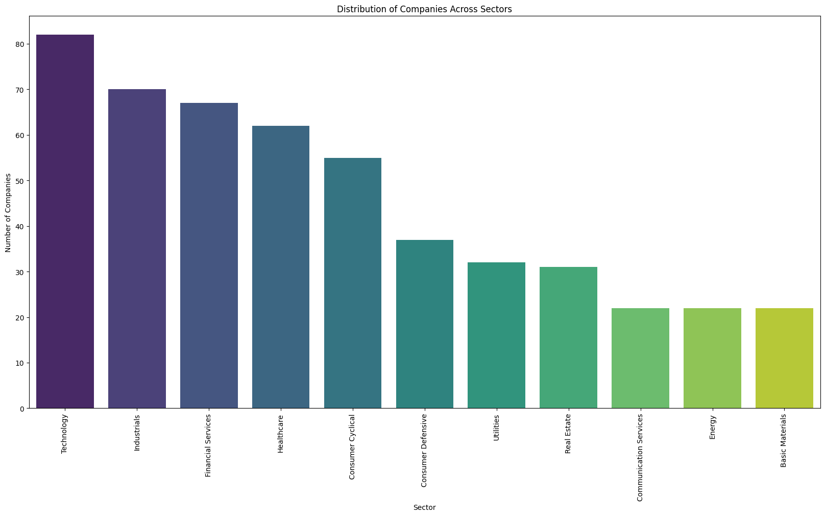 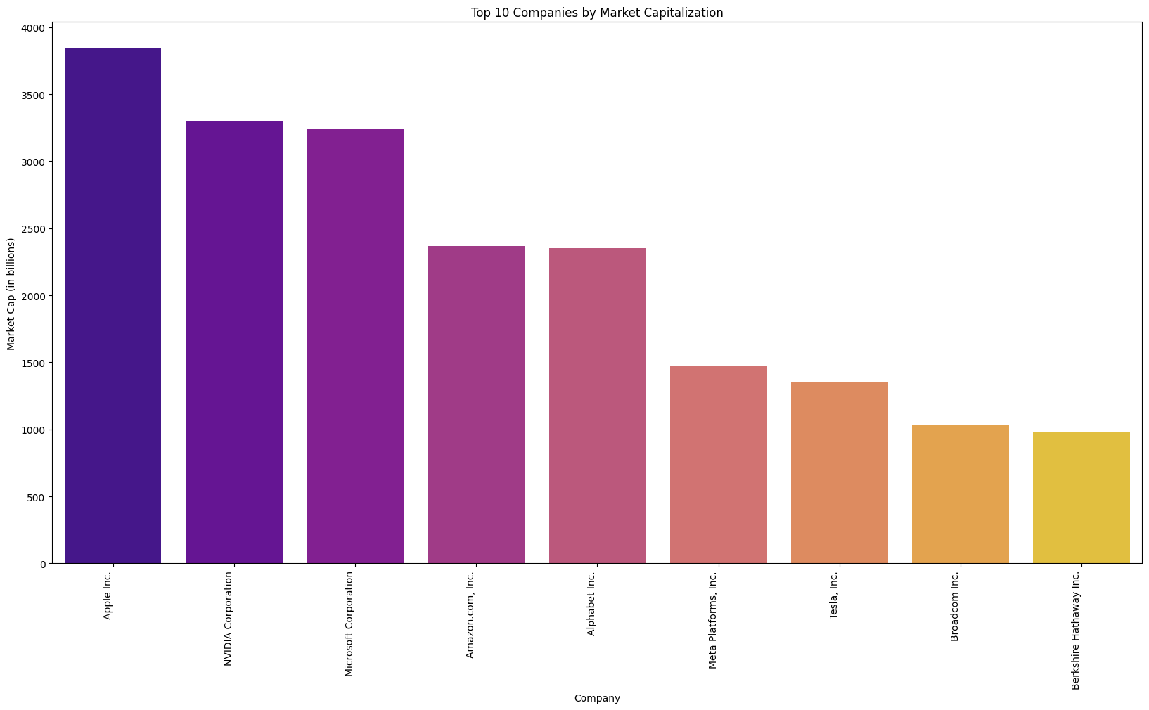Distribution of companies across sectors highlights the representation of companies in various industries, with the **Technology sector** contains **82 companies (16.33%)**, underscoring its pivotal role in driving innovation and the digital economy. The **Industrials sector** follows closely, with **70 companies (13.94%)**, reflecting its contribution to manufacturing and infrastructure. The **Financial Services sector**, with **67 companies (13.35%)**, shows its critical role in economic stability and growth. Meanwhile, the **Healthcare sector** features **62 companies (12.35%)**, showcasing the increasing importance of medical and biotechnological advancements, and the **Consumer Cyclical sector**, with **55 companies (10.96%)**, highlights consumer-driven market resilience. The remaining sectors collectively represent **166 companies (33.07%)**, highlighting the diverse but less concentrated industrial presence.

Top companies by market capitalization, shows the economic clout of leading global firms. **Apple Inc.** dominates with a market capitalization of **$3,846.82 billion**, followed by **NVIDIA Corporation** and **Microsoft Corporation** at **$3,298.80 billion** and **$3,246.07 billion**, respectively. **Amazon.com, Inc.** and **Alphabet Inc.** feature prominently, with **Alphabet’s** dual stock structure reflecting market caps of **$2,351.63 billion** and **$2,351.62 billion**. Notable entries also include **Meta Platforms, Inc. ($1,477.46 billion)**, **Tesla, Inc. ($1,351.63 billion)**, **Broadcom Inc. ($1,031.22 billion)**, and **Berkshire Hathaway Inc. ($978.78 billion)**. These figures illustrate the dominant presence of technology and consumer-driven companies in shaping global market dynamics.

**3.1.2 Sector-Wise Analysis of Revenue Growth and Workforce Distribution:**

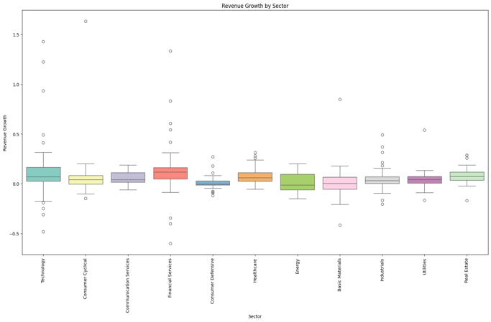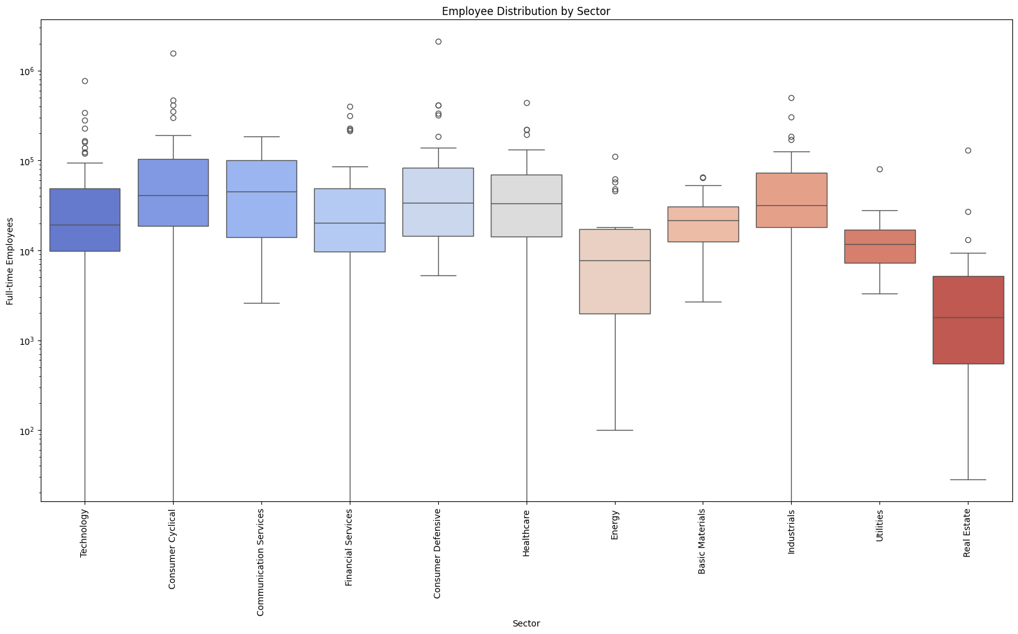

Revenue Growth by sector highlighting the variability and central tendencies within each sector. The **Financial Services** sector stands out with the highest average revenue growth at **12.30%**, reaching a maximum of **133.4%**, showcasing significant variability and high-performing entities. Similarly, the **Technology** sector, with an average growth of **11.58%**, demonstrates its dynamic potential and adaptability. On the other hand, sectors like **Energy (0.77% average)** and **Consumer Defensive (1.03% average)** exhibit lower and more stable growth rates, reflecting their steady, less volatile nature. This analysis underscores the diversity in growth potential and performance across industries, providing valuable insights into sector-specific dynamics.

Employee Distribution by Sector displayed on a logarithmic scale to accommodate wide variations. The **Consumer Defensive** sector with an average of **132,277 employees**, emphasizing its labour-intensive nature in industries like retail and food production. The **Consumer** **Cyclical** sector, averaging **111,910 employees**, also reflects workforce scalability. In contrast, sectors like **Real Estate (7,723 employees)** and **Utilities (14,603 employees)** have relatively smaller workforce requirements, consistent with their focused operations. Outliers in sectors such as **Consumer Defensive** and **Cyclical** highlight the presence of some of the largest global employers, shows the diverse workforce dynamics across industries.

**3.1.3 Sector-Wise Correlation Analysis of Market Cap and EBITDA:**

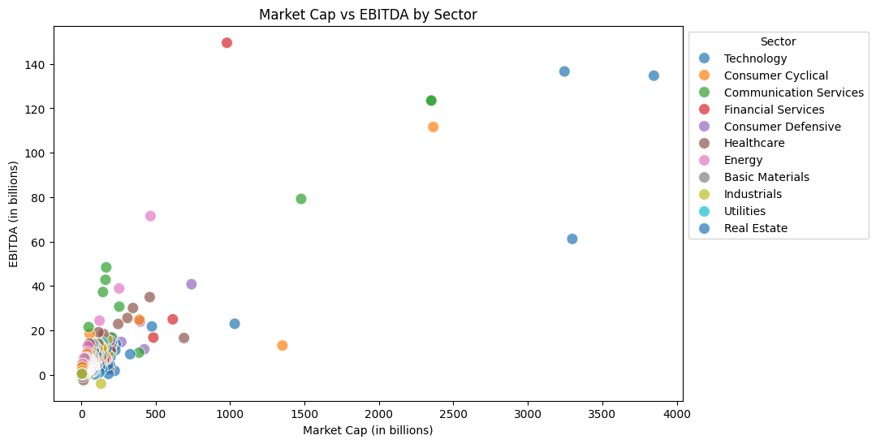

The **Communication Services** sector with average market capitalization **($354.73 billion)** maintains a strong **EBITDA ($25.51 billion)**, reflecting the dominance of companies in media, telecommunications, and online services. The **Technology** sector, with an average market cap of **$210.82 billion** and an **EBITDA** of **$7.65 billion**, underscores its critical role in innovation and profitability. Sectors like **Energy** and **Financial Services** show robust **EBITDA** values **($11.70 billion and $8.87 billion, respectively)**, emphasizing their stable cash flow despite comparatively lower average market caps.

In contrast, **Real Estate** exhibits the lowest average market cap **($34.89 billion)** and **EBITDA ($2.31 billion)**, consistent with its narrower operational focus. This scatter plot effectively illustrates the financial dynamics and profitability patterns across sectors, aiding in identifying industry-specific trends and outliers.

**3.1.4 Sector-Wise Analysis of Market Capitalization, Revenue Growth, and Workforce Distribution (Main Question):**

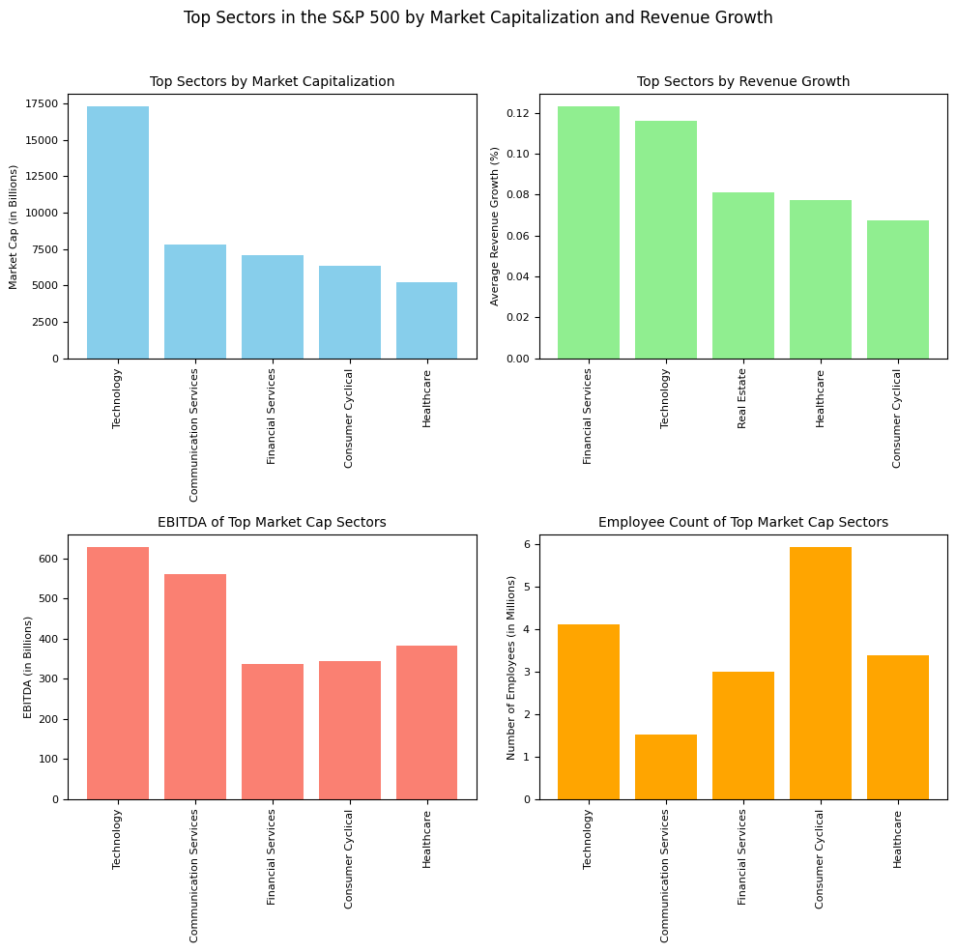

These above visuals address the central question of the project by analysing the top-performing sectors in the S&P 500 across key financial and operational metrics: **market capitalization, revenue growth, EBITDA, and employee count.**

The first visual highlights the **Technology sector** as the leader in market capitalization, with a total value of **$17,287 billion**, significantly ahead of **Communication Services ($7,804 billion)** and **Financial Services ($7,108 billion)**. This dominance reflects the pivotal role of technology in shaping modern economies. Similarly, in terms of revenue growth, the **Financial Services** sector leads with an average growth rate of **12.30%**, closely followed by **Technology** at **11.58%**, emphasizing their strong adaptability and strategic growth in a competitive landscape. Other notable sectors like **Real** **Estate** and **Healthcare** exhibit moderate but stable growth, reflecting their consistent market performance.

The subsequent visuals further analyse the operational metrics. The **Technology** **sector** also dominates in **EBITDA**, with total earnings of **$627 billion**, showcasing its profitability and operational efficiency, followed by **Communication** **Services** **($561 billion)** and **Healthcare ($382 billion)**. From an employment perspective, the **Consumer** **Cyclical** sector stands out as the largest employer, with **5.93 million full-time employees**, driven by labour-intensive industries like retail and services. The **Technology** **sector**, with **4.11 million employees**, highlights its substantial workforce requirements to sustain innovation and global reach. These insights provide a comprehensive view of the top sectors’ financial strength and operational scale, aligning with the project’s goal of identifying key industry trends and economic drivers.

**3.2 S&P 500 Index Historical Performance and Market Dynamics: Trends, Distributions, and Correlations**

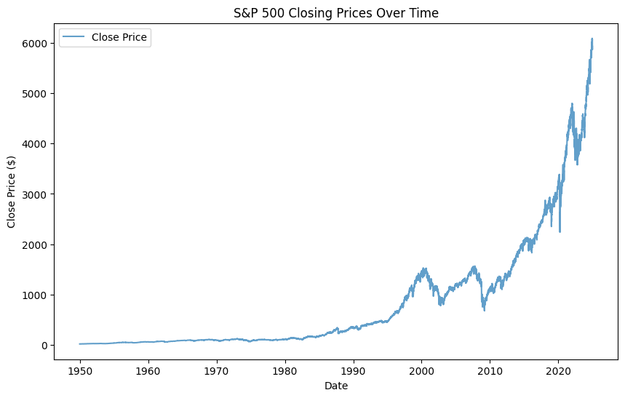 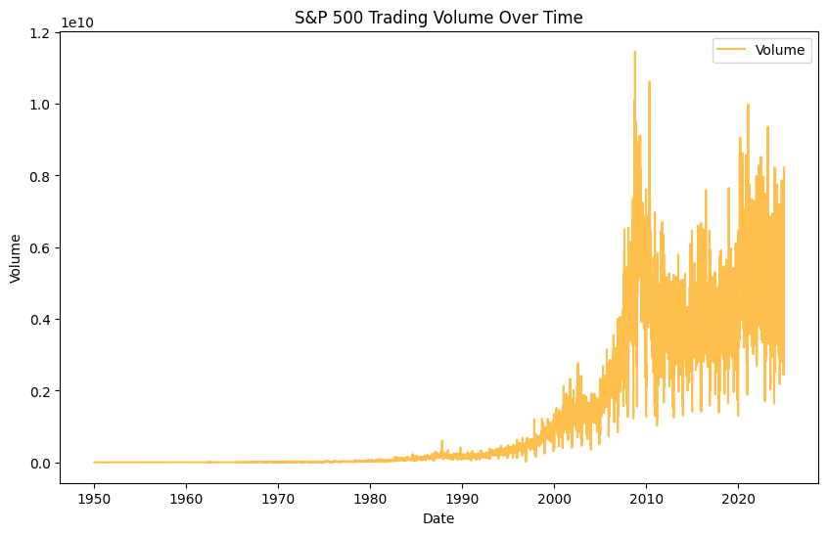

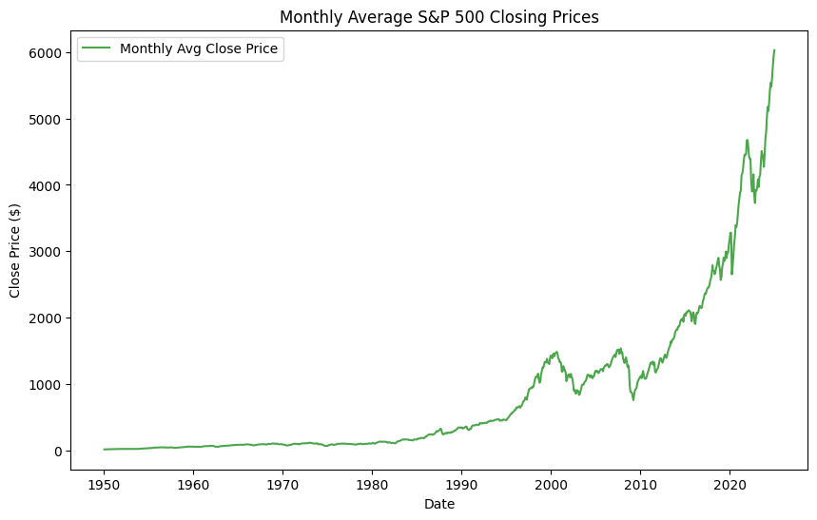 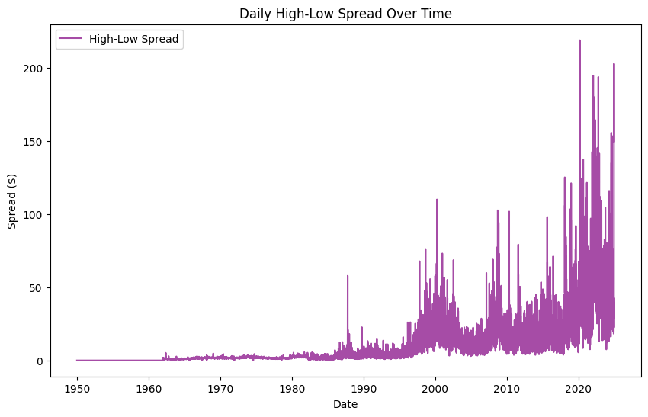

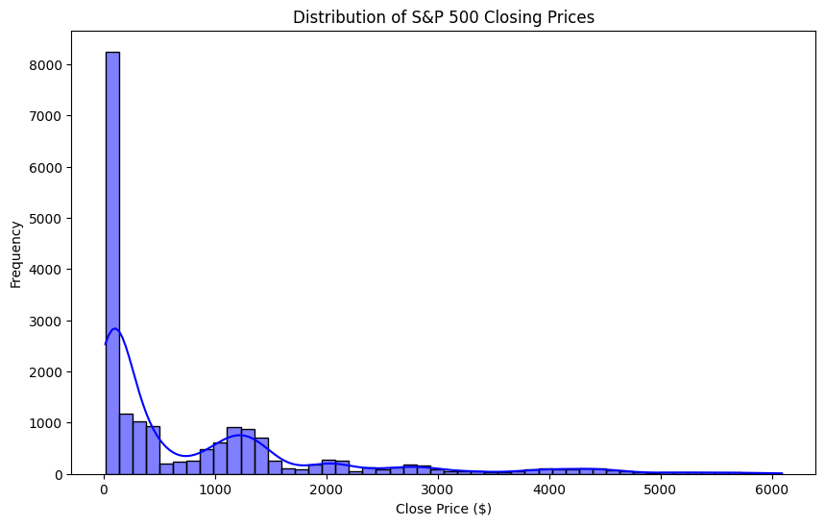 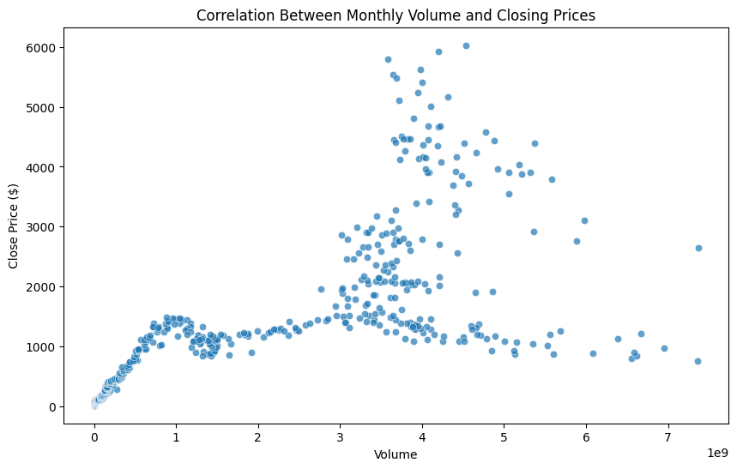

The analysis of the S&P 500 from **1950-01-03 to 2024-12-20** reveals a remarkable upward trajectory in closing prices, growing from **$16.66 to $5930.85**, reflecting a staggering increase of approximately **35,499%.** This consistent growth highlights the resilience and value-generation capability of financial markets over decades, supported by economic expansion and inflation-adjusted performance. Similarly, the monthly average closing prices echo this trend, rising from **$16.88 to $6027.86**, with a comparable growth percentage of **35,619%,** further reinforcing the index’s long-term stability and profitability despite short-term market volatility.

Trading volumes also show significant evolution, with the highest volume of **11.46 billion** shares recorded on **2008-10-10**, during the financial crisis, and the lowest of **680,000** shares on **1951-12-24**, reflecting early market activity. The correlation between monthly trading volume and closing prices, with a coefficient of **0.79**, indicates a strong relationship, suggesting that higher trading activity is often associated with bullish market conditions. Additionally, the daily high-low spread, averaging **$10.14** and peaking at **$218.96** during the COVID-19 crisis on **2020-03-13**, showcases market volatility during significant economic events.

The distribution of closing prices, with a **mean of** **$844.50**, **a median of** **$261.33**, and a **standard deviation of** **$1164.97**, highlights the right-skewed nature of the data, reflecting the concentration of lower values in the earlier decades and the growth trajectory of the index. Together, these analyses provide a comprehensive picture of the S&P 500’s historical performance, market activity, and its role as a key indicator of economic growth and market sentiment.

**4. Discussion and Conclusion**

The report offers a comprehensive analysis of the S&P 500, combining sectoral insights with historical index trends to uncover key market dynamics. By examining financial performance, workforce distribution, and long-term growth patterns, it highlights the evolution of the market. These findings provide valuable perspectives for informed decision-making and a deeper understanding of economic and market behaviour.