Understanding K-means Clustering

Student Name: Bilal Ahmad Cheema
Student ID: 24160235
Module: Machine Learning and Neural Networks

Learning outcomes
• Explain what K-means optimises and why initialisation and scaling matter.
• Use elbow, silhouette and Davies-Bouldin evidence together when comparing candidate values of K.
• Interpret cluster plots and centroid profiles in plain language using the real columns in Iris.csv.
• Recognise why the “best” K can depend on whether the goal is compact separation or practical interpretability.
1. Technique and focus
Clustering is an unsupervised learning task where the algorithm must find structure on its own after receiving input features but no target labels. K-means remains one of the most widely used clustering methods because it is computationally efficient, easy to explain and straightforward to scale to larger numeric datasets (Xu and Wunsch, 2005; Jain, 2010). It is employed in document grouping, image compression, customer segmentation, and exploratory scientific analysis.
One practical question is the main focus of this tutorial: how should we determine the number of clusters, K? This decision determines whether different groups are combined, divided too finely, or portrayed in a way that is truly helpful to another analyst. Instead of using K as a guess, the tutorial demonstrates how to compare multiple K values on the same dataset and provide evidence to support the final decision.
2. What K-means is optimising
K-means partitions observations into K groups by minimising the within-cluster sum of squares, often called inertia in software libraries. In practice, it repeatedly assigns each observation to the nearest centroid and then updates each centroid to the mean of the observations currently assigned to it (MacQueen, 1967; Lloyd, 1982). The method is simple, but its objective is non-convex, so different starting centroids can lead to different local minima.
That is why careful initialisation matters. K-means++ spreads out the initial centroids and generally improves stability compared with naive random seeding (Arthur and Vassilvitskii, 2007). In order to avoid a single lucky or unlucky run, it is also advisable to use multiple restarts. Feature scaling is equally crucial because the method uses Euclidean distance; if variables with larger units are not standardised, they may dominate the outcome.
3. Dataset and preprocessing
The case study uses the supplied file Iris.csv, derived from Fisher’s classic Iris data (Fisher, 1936). The file has 150 rows and six columns: Id, SepalLengthCm SepalWidthCm PetalLengthCm PetalWidthCm and Species. We do not use the Id column for clustering because it is a name, for each item. The Species names are also not used when we are trying to group the flowers. This is because we want to see if the computer can group the flowers on its own without any help. The computer only looks at the measurements of the flowers, which're SepalLengthCm SepalWidthCm, PetalLengthCm and PetalWidthCm to decide how to group them together.
Before fitting, the four numeric features are standardised to zero mean and unit variance. This step is essential because K-means is distance-based and would otherwise weight larger-scale variables more heavily (scikit-learn, 2025). The notebook should also include information about missing values and other basic data quality issues. The major pedagogical advantage of this dataset is that it is small, simple, and can be visualized, but at the same time, it has enough overlap to show that choosing K is not a simple task.
4. How to compare candidate values of K
An ideal tutorial should not rely on only one measure. Here, K is being compared based on three different approaches, inertia, silhouette coefficient, and Davies-Bouldin index. The inertia measure will always decrease with an increase in K, as the number of centroids will increase, fitting the data better. The elbow method tries to find where the rate of decrease starts to slow. While the method is useful, the elbow points are not very clear on their own..
Silhouette analysis measures how similar each point is to its own cluster relative to the nearest alternative cluster; higher average values indicate clearer separation (Rousseeuw, 1987). The Davies-Bouldin index moves in the opposite direction: lower values indicate compact clusters that are well separated from one another (Davies and Bouldin, 1979). Using these measures together is more defensible than choosing the first K that “looks right”.
5. Results on Iris.csv
Figure 1 illustrates the elbow curve for K = 2 to K = 7. The descent in the curve from K = 2 to K = 3 is significant. After that point, the curve starts to become flatter. Hence, the elbow point is around K = 3. Figure 2 includes the other validation parameters. In this case, the average silhouette score is maximized when K = 2 and drops as K increases. The Davies-Bouldin index is also minimized when K = 2 (around 0.60), meaning that the most compact and separated clusters are when K = 2.
This is not an error, but rather points to an important characteristic of the data. One iris type is very distinct, while the other two are much more similar. A purely unsupervised approach to validation supports K = 2. However, the objective of the tutorial is not simply to achieve the best possible performance. Rather, it is to illustrate how changing the value of K affects the utility of the result. Figure 3 plots the PCA for K=2, K=3, and K=5. K=2 groups the similar species into one large group. K=5 has smaller groups, which are less intuitive. K=3 is an optimal value for the tutorial because it reveals the detailed distinctions expected for the iris data, even though the raw validation data is not as good as K=2.
6. Interpreting the clusters
While selecting K is only half the battle, an effective clustering must also be understood. Figure 4 displays the standardised centroid profiles of the K=3 solution using the actual column names of Iris.csv. We can see that one of these clusters has smaller petal measurements, while the other two differ in petal length and petal width. This type of visualization is useful because it moves beyond abstract centroids to provide a story that another student might find useful in their own project.
The hidden species column can be used afterward as a post-hoc sense check. This does not make the technique a supervised one. It simply helps the reader understand why K = 2 does best in terms of compactness and separation, and K = 3 is still included for educational purposes because it is more relevant to the actual composition of the dataset. This is precisely the kind of subtlety that a good tutorial should be able to convey to the reader: the best K is partially dependent on the purpose.
7. Strengths, limitations and alternatives
K-means is fast, scalable and easy to reproduce, which makes it a strong introductory technique and a sensible baseline for many practical tasks (Jain, 2010). With data that has somewhat compact clusters, it can perform extremely well. One of the reasons this algorithm is easy to teach is that it is simple. The algorithm, code, and validation can all be easily described within a short tutorial.
The limitations should also be clearly stated. K-means clustering requires the user to specify the value of K and is also sensitive to initialization, outliers, feature scaling, and cluster shapes. K-means clustering also performs poorly in the presence of highly irregularly shaped clusters, especially if the data contains clusters of different densities. In these cases, other clustering techniques like hierarchical clustering, DBSCAN, and Gaussian mixture models might be more appropriate, as these techniques violate one or more of the K-means clustering assumptions. Clearly stating the limitations of the technique also makes the tutorial more credible.
9. Conclusion
In the Iris.csv file, the results of the K-means algorithm do not yield a single, correct answer for the choice of K. The validation criteria all prefer the choice of K = 2, as it is the most compact and separate of all the solutions. However, the choice of K = 3 is also a reasonable choice for teaching, as more information can be extracted from the results. This, in essence, is the real lesson of this tutorial: the proper use of the K-means algorithm involves choosing multiple values of K, explaining the trade-off between the two, and then defending the final choice of K in simple terms.
Figures
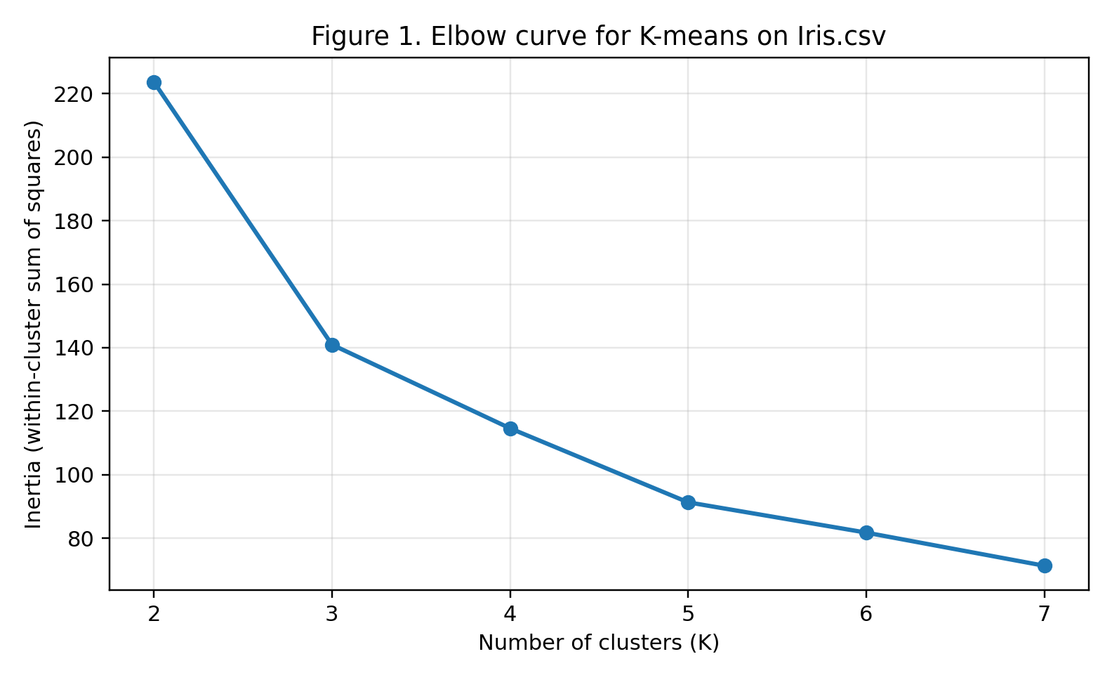
Figure 1. Elbow curve for K-means on Iris.csv. Inertia decreases as K increases, so the key question is where the rate of improvement begins to slow.
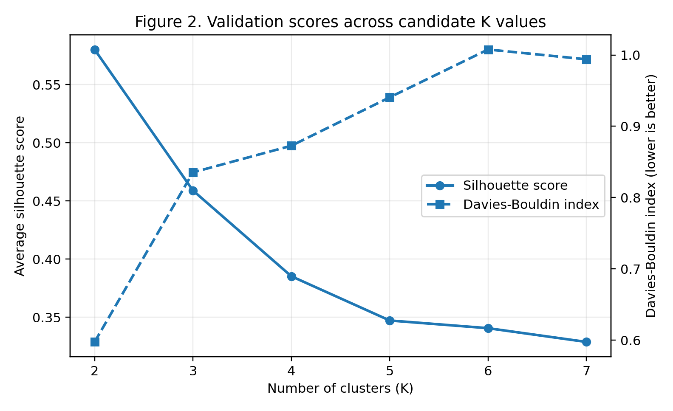
Figure 2. Silhouette score and Davies-Bouldin index across candidate K values. On this dataset both measures favour K = 2, showing that the most compact-and-separated partition is not always the most pedagogically useful one.
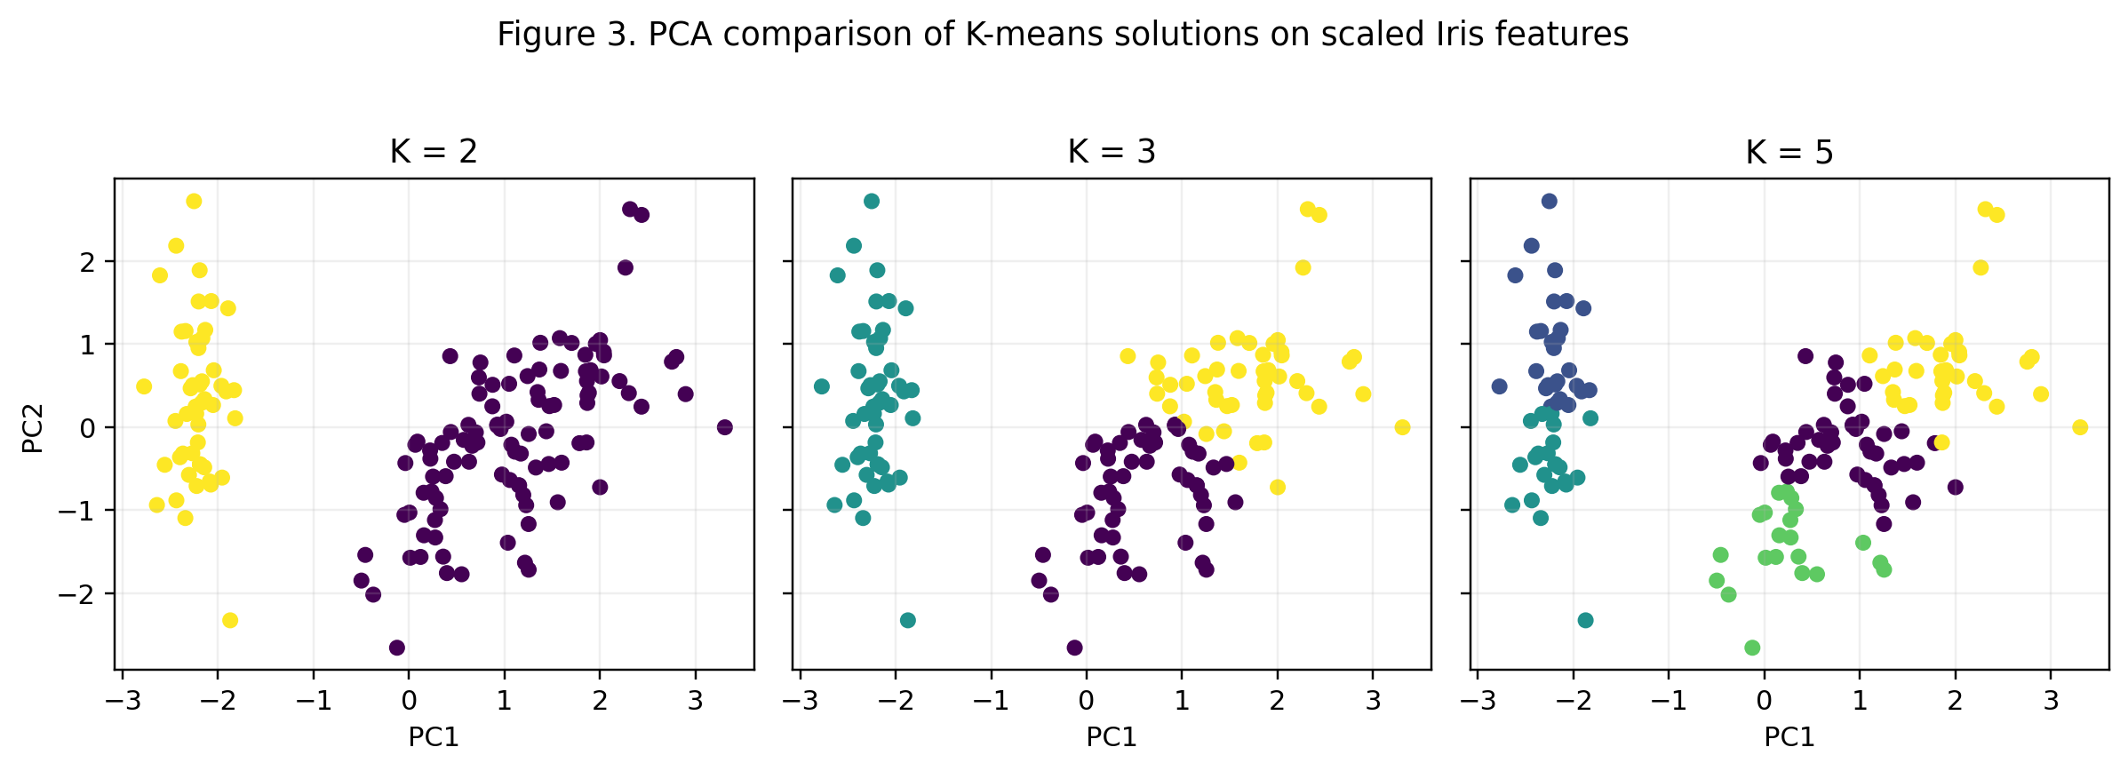
Figure 3. PCA comparison of K = 2, K = 3 and K = 5. The visual contrast helps explain how smaller K values merge structure while larger K values can over-fragment it.
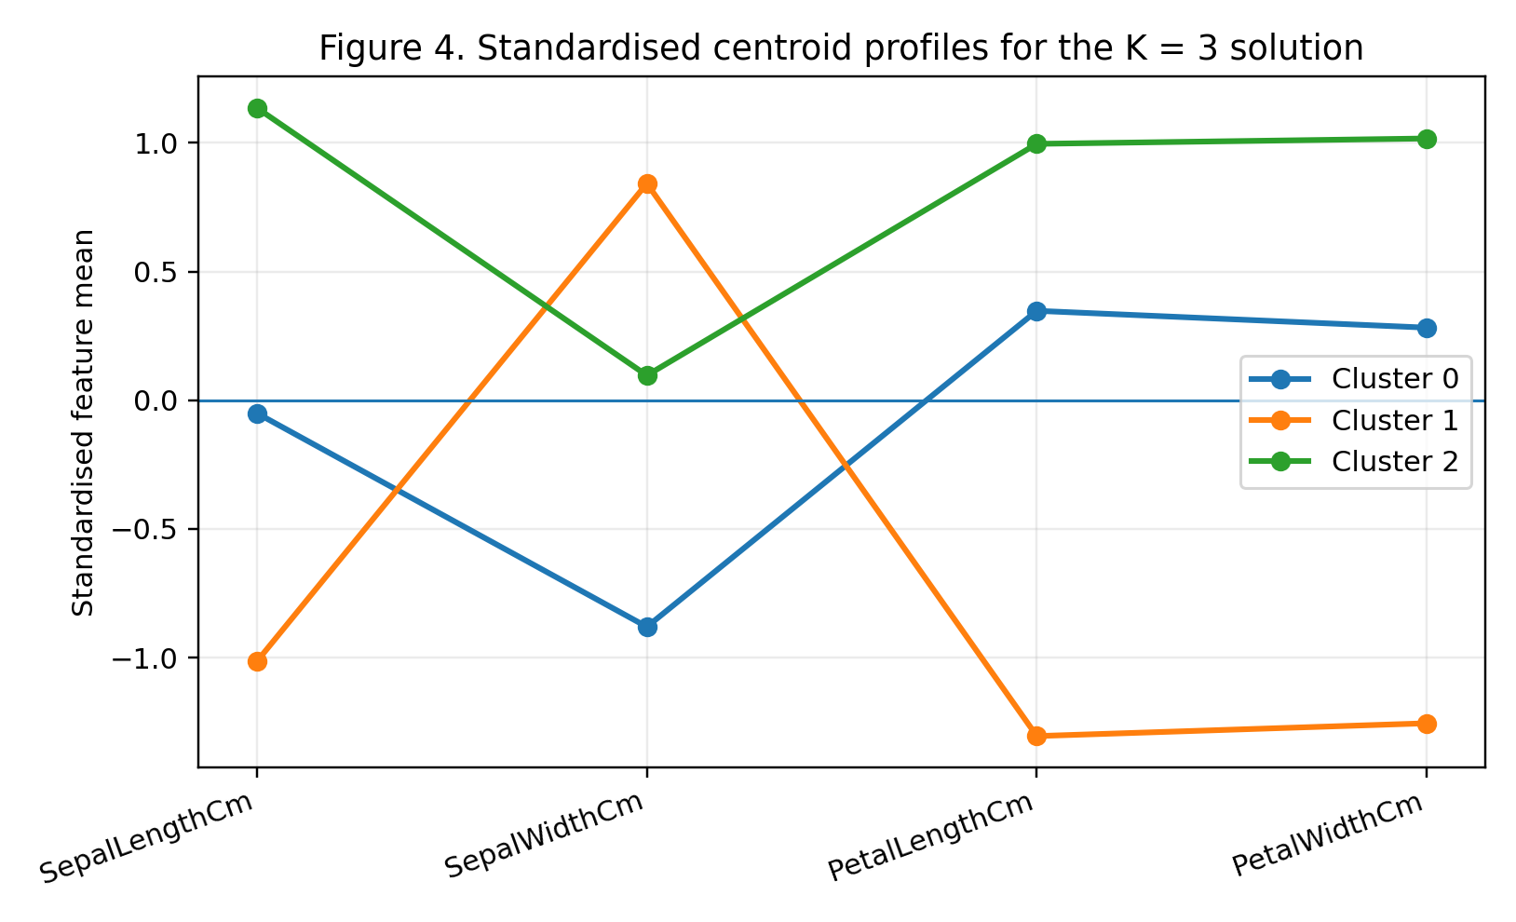
Figure 4. Standardised centroid profiles for the K = 3 solution. Using the real Iris.csv column names makes the clusters interpretable in feature terms rather than only as coloured points on a plot.
References
Arthur, D. and Vassilvitskii, S. (2007) ‘k-means++: the advantages of careful seeding’, Proceedings of the Eighteenth Annual ACM-SIAM Symposium on Discrete Algorithms, pp. 1027–1035.
Davies, D.L. and Bouldin, D.W. (1979) ‘A cluster separation measure’, IEEE Transactions on Pattern Analysis and Machine Intelligence, 1(2), pp. 224–227.
Fisher, R.A. (1936) ‘The use of multiple measurements in taxonomic problems’, Annals of Eugenics, 7(2), pp. 179–188.
Jain, A.K. (2010) ‘Data clustering: 50 years beyond K-means’, Pattern Recognition Letters, 31(8), pp. 651–666.
Lloyd, S. (1982) ‘Least squares quantization in PCM’, IEEE Transactions on Information Theory, 28(2), pp. 129–137.
MacQueen, J. (1967) ‘Some methods for classification and analysis of multivariate observations’, Proceedings of the Fifth Berkeley Symposium on Mathematical Statistics and Probability, 1, pp. 281–297.
Rousseeuw, P.J. (1987) ‘Silhouettes: a graphical aid to the interpretation and validation of cluster analysis’, Journal of Computational and Applied Mathematics, 20, pp. 53–65.
scikit-learn (2025) Clustering and KMeans documentation. Available at: https://scikit-learn.org/ (Accessed: 26 March 2026).
Xu, R. and Wunsch, D. (2005) ‘Survey of clustering algorithms’, IEEE Transactions on Neural Networks, 16(3), pp. 645–678.
Approximate word count (tutorial narrative only): about 1,700 words.

