

**Project Report**

**Title: Clustering**

Data Mining and Warehousing

Hafiz Bilal Ahmed (B18101036)

**Source:**

https://www.kaggle.com/code/tonzowonzo/simple-k-means-clustering-on-the-iris-dataset/data

Column Description:

1. SepalLengthCm Length of the sepal (in cm)
2. SepalWidthCm Width of the sepal (in cm)
3. PetalLengthCm Length of the petal (in cm)
4. PetalWidthCm Width of the petal (in cm)

# Set Number of Clusters that is 3

**K Mean Clustering:**

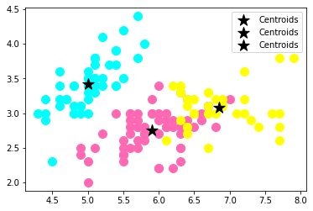

**Agglomerative Clustering :**

**Dendrogram:**

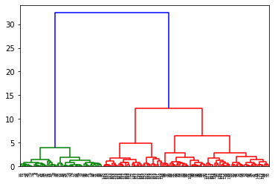

**Clustering Graph:**

