FAST – National University of Computer and Emerging Sciences, Islamabad
Edge Computing & Intelligent Systems
Assignment 03 – Technical Report
Model Optimization for the Edge: PTQ, QAT, Unstructured and Structured Pruning, and ONNX Deployment

Field | Detail
Student | Bilal Aleem
Roll number | i221866
Section | DS-A
Program | BS Data Science
Deadline | 13 November 2026, 11:59 PM
Dataset / Model | CIFAR-10 / ResNet-18 (PyTorch)

1. Overview
This report documents a complete PyTorch model-compression pipeline for CIFAR-10 image classification. A ResNet-18 baseline is trained and then compressed with four techniques: Post-Training Static Quantization (PTQ), Quantization-Aware Training (QAT), iterative unstructured magnitude pruning, and structured channel pruning with architecture reconstruction. All five models are exported, run through a unified inference pipeline, benchmarked automatically on the full 10,000-image test set, and exported to ONNX for CPU inference with ONNX Runtime.

1.1 Headline results
- PTQ INT8 keeps accuracy (83.53% vs 83.54% FP32) with a 3.69x smaller checkpoint and a 3.27x faster single-image CPU latency.
- QAT INT8 reaches 83.93%, the best INT8 accuracy, at the same size and speed as PTQ.
- Unstructured pruning removes 80% of conv/FC weights with no accuracy loss (83.96%), but gives no dense-CPU speed-up because zeros are still stored and multiplied.
- Structured pruning physically halves the compute (17.94M vs 35.05M MACs) and parameters (357,690 vs 701,466), at a cost of 0.55 accuracy points.

1.2 Environment and honest scope notes
- Hardware: all training and benchmarking ran on a single CPU core (no GPU), PyTorch 2.14, ONNX Runtime 1.31. Latencies are single-thread CPU numbers on this machine, not on a phone or microcontroller.
- Model width: to make training feasible on one core, the ResNet-18 keeps the standard topology (3x3 stem, four stages of two BasicBlocks, 18 weight layers) but uses a base width of 16 channels instead of 64 (0.70M parameters, 35.05M MACs). The baseline was trained for 10 epochs, so absolute accuracy (83.5%) is lower than a fully trained full-width ResNet-18 (about 93-95%). The compression comparisons are still valid because every method starts from the same baseline.
- Dataset: the official CIFAR-10 download host was not reachable from the build environment, so a public GitHub mirror of the same 60,000 images (50,000 train / 10,000 test, class-balanced) was used. The mirror stores the images as JPEG files, so small accuracy differences from the original lossless dataset are possible.
- Seeds and timing: seed 42 is used everywhere. Latency has run-to-run noise of a few percent; differences below that should not be over-interpreted.

2. Project structure and reproducible pipeline
Every stage is a separate script; run_all.sh executes them in order and writes logs to logs/.
src/common.py data loading, ResNet-18 (quantization-ready), resumable training loop, MAC counter
src/prepare_data.py converts the CIFAR-10 image folders to compact .npz arrays
src/train_baseline.py trains and saves the FP32 baseline
src/ptq.py Post-Training Static Quantization (fusion, calibration, convert)
src/qat.py Quantization-Aware Training (fake-quant, fine-tune, convert)
src/prune_unstructured.py iterative global magnitude pruning + fine-tuning + make permanent
src/prune_structured.py channel pruning + architecture reconstruction + fine-tuning
src/inference.py unified inference for all five PyTorch models
src/benchmark.py automated benchmark -> results/*.csv
src/export_onnx.py ONNX export (FP32, pruned, PTQ-INT8, QAT-INT8)
src/onnx_inference.py ONNX Runtime CPU inference + benchmark

3. Baseline FP32 model
The network is a CIFAR-style ResNet-18: a 3x3 convolution stem, four stages with 2 BasicBlocks each (channel widths 16, 32, 64, 128 with stride-2 downsampling at the start of stages 2-4), global average pooling and a 10-way linear layer. The residual addition is implemented with FloatFunctional so it can be quantized later; ReLU modules are not shared, which eager-mode quantization requires.
Training: SGD with Nesterov momentum 0.9, weight decay 5e-4, one-cycle learning-rate schedule (peak 0.1), batch size 128, 10 epochs, random-crop (padding 4) and horizontal-flip augmentation. Final test accuracy is 83.54%. The checkpoint is saved as models/resnet18_fp32.pth (2.86 MB).
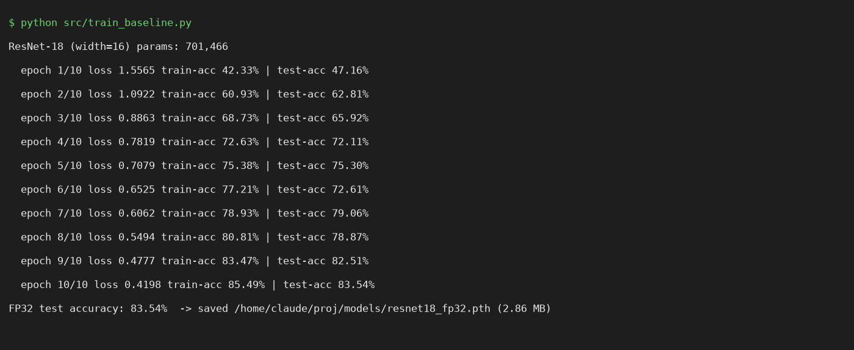
Figure 1 – Baseline training output.

4. Post-Training Static Quantization (PTQ)
Implemented in src/ptq.py with PyTorch eager-mode quantization:
- Fusion: Conv+BN+ReLU and Conv+BN (including the 1x1 downsample branches) are fused so each runs as a single INT8 kernel.
- Backend: torch.backends.quantized.engine = "fbgemm" (x86); the default fbgemm qconfig uses per-channel INT8 weights and UINT8 activations.
- Calibration: 2,000 randomly chosen training images (no augmentation) are passed through the observer-instrumented model to estimate activation ranges.
- Convert and deploy: torch.ao.quantization.convert produces the INT8 model, which is saved as a TorchScript file (models/resnet18_ptq_int8.pt, 0.77 MB) that loads without the Python class definition.
Result: 83.53% accuracy (-0.01 points), 3.7x smaller file, and 3.27x lower batch-1 latency.
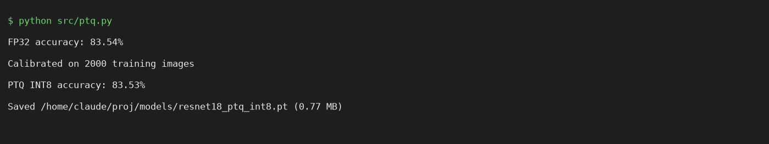
Figure 2 – PTQ execution output.

5. Quantization-Aware Training (QAT)
Implemented in src/qat.py. The pretrained FP32 weights initialise the model, which is fused (QAT-style, BatchNorm kept trainable) and prepared with get_default_qat_qconfig("fbgemm"). This inserts 51 FakeQuantize modules that simulate INT8 rounding in the forward pass while gradients flow through a straight-through estimator.
Fine-tuning: 3 epochs, SGD lr 0.01 with cosine decay, weight decay 1e-4. In the last epoch the observers and BatchNorm statistics are frozen so the quantization ranges stabilise. The model is then converted to a real INT8 model and exported as TorchScript (models/resnet18_qat_int8.pt, 0.77 MB).
Result: the fake-quantized model scores 84.12% and the converted INT8 model 83.93%, which is +0.39 points over FP32. Part of this gain comes from the additional 3 epochs of fine-tuning, so it should not be read as quantization improving accuracy by itself. Compared with PTQ, QAT is 0.40 points better at identical size and speed.
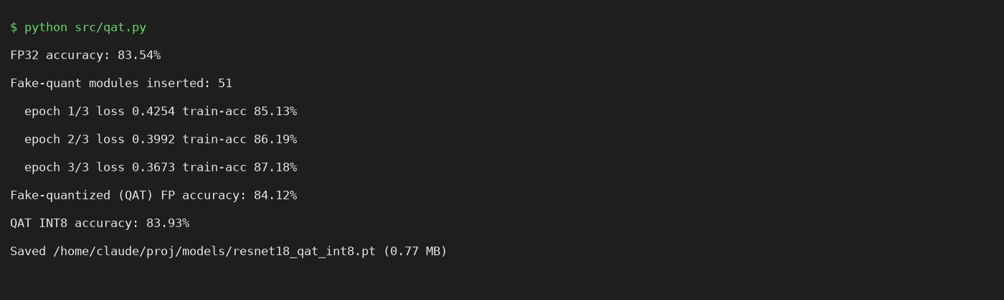
Figure 3 – QAT execution output.

6. Unstructured pruning
Implemented in src/prune_unstructured.py with torch.nn.utils.prune. All Conv2d and Linear weights are pruned jointly by global L1 magnitude (smallest absolute weights are removed anywhere in the network) in 5 iterations with a cubic sparsity schedule towards 80%. After every iteration the model is fine-tuned (1 epoch, 2 on the last iteration) while the masks stay applied (weight = weight_orig x weight_mask). At the end prune.remove folds the masks into the weights, making the pruning permanent.
Iteration | Sparsity (measured) | Accuracy after fine-tune
1 | 39.04% | 83.55%
2 | 62.72% | 83.38%
3 | 74.88% | 83.61%
4 | 79.36% | 83.65%
5 (final) | 80.00% | 83.96%

Final model: 142,221 of 701,466 weights are non-zero (80.0% sparsity), 83.96% accuracy. The dense checkpoint is still 2.86 MB because zeros are stored; gzip compresses it to 0.77 MB, showing the storage potential of sparse formats. Important limitation: standard dense CPU kernels do not skip zeros, so latency does not improve (see Section 9). Speed-ups need sparse-aware runtimes or hardware.
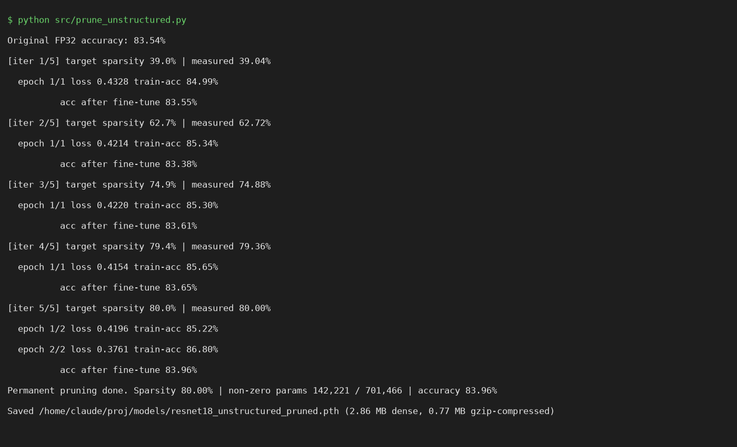
Figure 4 – Iterative unstructured pruning output (restarts caused by resumable training are de-duplicated).

7. Structured channel pruning
Implemented in src/prune_structured.py. Residual connections require every block output to keep the width of its skip path, so pruning the block outputs would force matching changes across stages. We therefore prune the internal channels of every BasicBlock: the output filters of conv1 are exactly the input channels of conv2, which keeps all tensor dimensions valid.
- Importance: each conv1 filter is ranked by its L1 norm; the lowest 50% are removed in every block (kept widths per block: 8, 8, 16, 16, 32, 32, 64, 64).
- Reconstruction: a new, physically smaller ResNet-18 is built (BasicBlock with a smaller mid width). Surviving conv1 filters, the matching BatchNorm parameters/statistics and the matching conv2 input channels are copied over, so the network contains no masked zero channels.
- Fine-tuning: 3 epochs, SGD lr 0.03, one-cycle schedule.
Accuracy right after pruning (before fine-tuning) collapses to 25.20%, which shows the cut is aggressive; fine-tuning recovers it to 82.99%. Parameters drop from 701,466 to 357,690 (51.0%) and MACs from 35.05M to 17.94M (51.2%). The checkpoint stores the kept widths with the weights so inference can rebuild the architecture (models/resnet18_structured_pruned.pth, 1.48 MB).
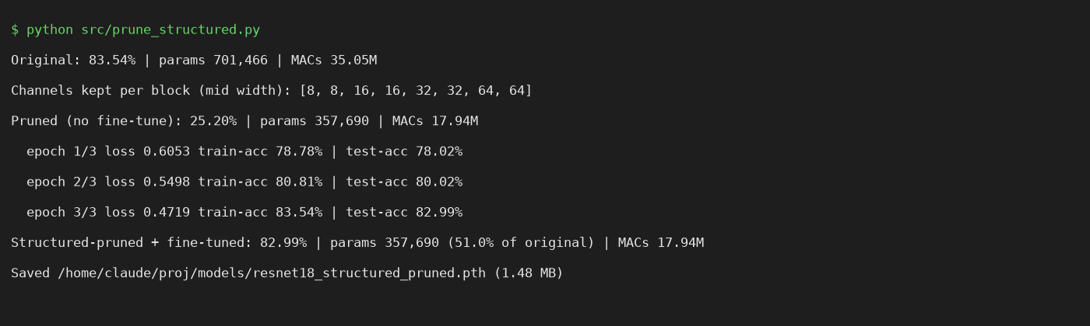
Figure 5 – Structured pruning output.

8. Inference pipeline
src/inference.py exposes one interface for all five models (fp32, ptq, qat, unstructured, structured): load_model(name) returns the right object (state dict, TorchScript INT8, or reconstructed pruned architecture), and the same preprocessing is used for every model. It can classify test-set samples or an arbitrary image file (resized to 32x32).
python src/inference.py --model all --n 5
python src/inference.py --model ptq --image my_image.png
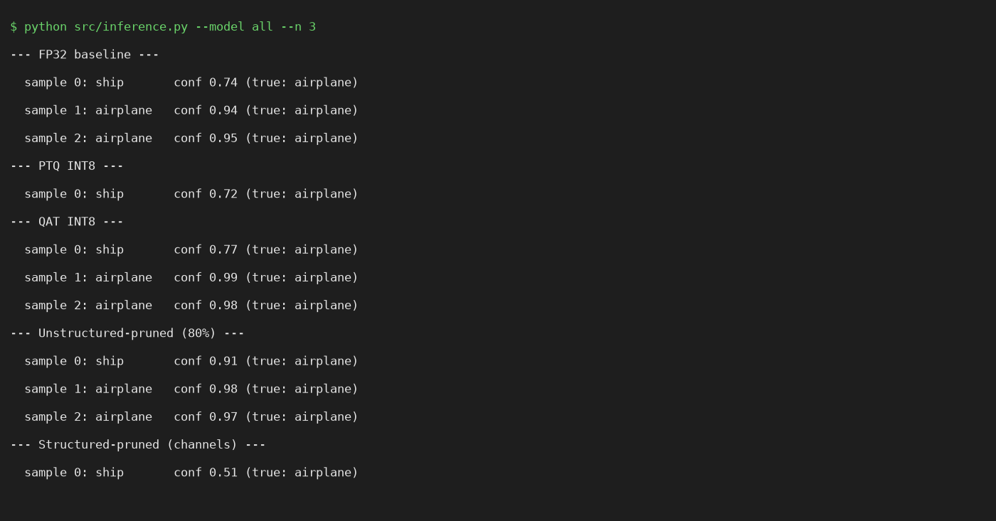
Figure 6 – Inference demo on the first three test images with all five models.

9. Benchmark results
src/benchmark.py evaluates all five models on the full CIFAR-10 test set with one thread, and writes results/benchmark_results.csv (summary) and results/per_sample_predictions.csv (prediction and confidence of every model for all 10,000 test images). Latency is the mean of 300 timed batch-1 runs after 50 warm-up runs.
Model | Acc. (%) | Size (MB) | Gzip (MB) | Non-zero params | MACs (M) | Latency (ms) | Speed-up
FP32 baseline | 83.54 | 2.856 | 2.621 | 701,466 | 35.05 | 1.433 | 1x
PTQ INT8 | 83.53 | 0.774 | 0.774 | 701,466 | 35.05 | 0.438 | 3.27x
QAT INT8 | 83.93 | 0.774 | 0.774 | 701,466 | 35.05 | 0.428 | 3.35x
Unstructured-pruned (80%) | 83.96 | 2.858 | 0.767 | 142,221 | 35.05 | 1.637 | 0.88x
Structured-pruned (channels) | 82.99 | 1.481 | 1.344 | 357,690 | 17.94 | 1.252 | 1.14x
Table 1 – PyTorch benchmark (single CPU thread). For INT8 models, parameter and MAC counts are those of the FP32 twin.
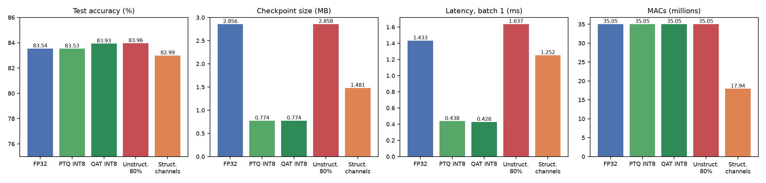
Figure 7 – Accuracy, size, latency and compute of the five models.
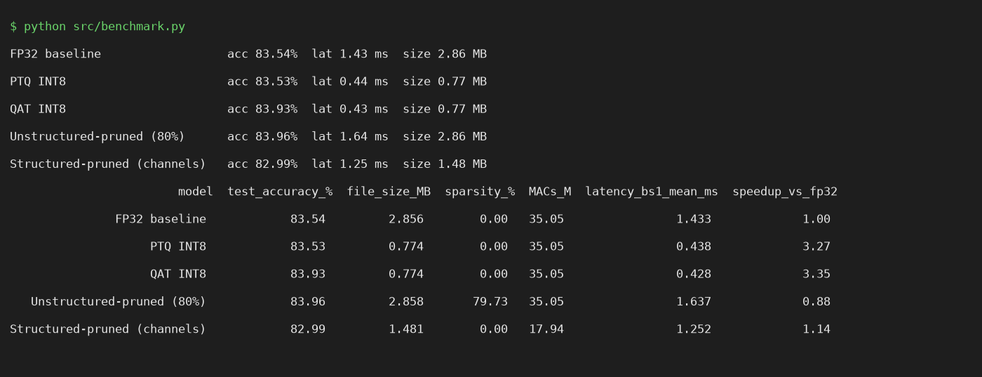
Figure 8 – Benchmark script output.

9.1 Agreement with the FP32 model
Using the per-sample CSV, the fraction of test images on which each model predicts the same class as FP32 is: PTQ 98.45%, QAT 94.98%, unstructured 92.94%, structured 91.37%. PTQ is almost a drop-in replacement; QAT, trained further, naturally deviates more while being slightly more accurate.

9.2 Discussion
- Quantization is the clear win here: about 3.7x smaller and about 3.3x faster on CPU with essentially no accuracy cost. QAT adds a small accuracy margin over PTQ for a few epochs of extra training.
- Unstructured pruning compresses storage, not runtime: 80% of the weights are zero, yet latency is slightly worse (1.64 ms vs 1.43 ms, within noise) because dense kernels still process zeros. It would pay off with sparse kernels, sparse storage formats or hardware support.
- Structured pruning reduces real work: half the MACs and parameters, a 1.48 MB checkpoint and 1.14x faster in PyTorch, for 0.55 points of accuracy. The speed-up is smaller than the MAC reduction because small convolutions are dominated by memory and framework overhead at this model size.
- Combining methods: structured pruning followed by INT8 quantization would stack the two benefits; this was not part of the assignment and was not run.

10. ONNX deployment
src/export_onnx.py writes five models to models/onnx/ (opset 13, dynamic batch axis), and src/onnx_inference.py runs them with ONNX Runtime on the CPU execution provider (1 thread).
- FP32, unstructured and structured models: exported directly with torch.onnx.export (BatchNorm folded).
- PTQ INT8: PyTorch eager INT8 modules cannot be exported to ONNX, so the FP32 ONNX graph is statically quantized with ONNX Runtime (QDQ format, per-channel INT8 weights, UINT8 activations, 500 training images for calibration). This is a separate quantization run from the PyTorch PTQ model, so its accuracy differs slightly (83.59%).
- QAT INT8: the fake-quantized QAT network is exported with its learned scales and zero-points as QuantizeLinear/DequantizeLinear nodes. The accuracy of 84.13% matches the QAT result.
ONNX model | Acc. (%) | Size (MB) | Latency (ms) | p95 (ms) | Throughput (img/s)
resnet18_fp32.onnx | 83.54 | 2.81 | 0.543 | 0.596 | 2230.2
resnet18_ptq_int8.onnx | 83.59 | 0.763 | 0.244 | 0.277 | 4598.4
resnet18_qat_int8.onnx | 84.13 | 2.903 | 1.42 | 1.485 | 785.6
resnet18_unstructured_pruned.onnx | 83.96 | 2.81 | 0.603 | 0.663 | 2239.7
resnet18_structured_pruned.onnx | 82.99 | 1.436 | 0.344 | 0.398 | 3191.9
Table 2 – ONNX Runtime CPU benchmark (results/onnx_benchmark_results.csv).
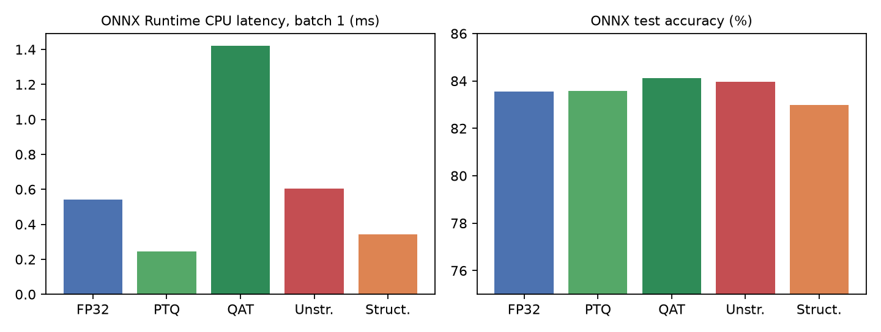
Figure 9 – ONNX Runtime latency and accuracy.
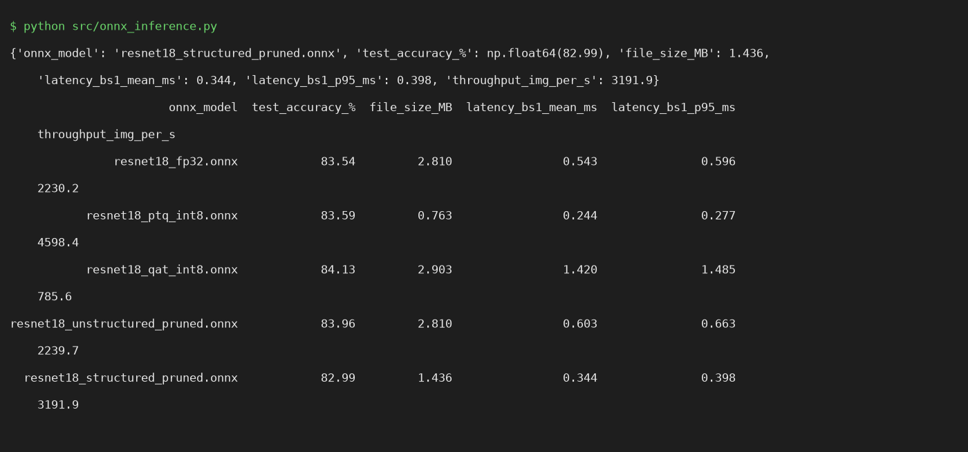
Figure 10 – ONNX benchmark output.
Observations: ONNX Runtime FP32 is faster than PyTorch FP32 (0.54 ms vs 1.43 ms). The PTQ ONNX model is the fastest (0.24 ms, 0.76 MB). The QAT ONNX file is large (2.90 MB) and slow (1.42 ms) because it keeps FP32 weights with explicit Q/DQ nodes, and ONNX Runtime had to be run with basic graph optimizations for this file: its extended QDQ fusion fails on the residual additions of this graph (a QLinearAdd scale/zero-point shape error). A fully fused INT8 ONNX QAT deployment would need converting the QAT weights through ONNX Runtime quantization tooling or another exporter. The PyTorch QAT TorchScript model (0.77 MB, 0.43 ms) is the practical INT8 QAT deliverable.

11. Conclusion
All required components were implemented and executed end to end: FP32 baseline, PTQ and QAT with INT8 checkpoints, unstructured and structured pruning with fine-tuning, a unified inference pipeline, automated benchmarking with CSV output, and ONNX export with CPU inference. On this setup, INT8 quantization gives the best size/latency trade-off, structured pruning gives a genuine reduction in compute, and unstructured pruning gives high sparsity that only helps with sparse-aware execution. Limitations to keep in mind are the reduced-width ResNet-18 and short training, the JPEG-based dataset mirror, and CPU-only measurements on a single machine.

