EduTrack Application

Introduction

This project focuses on the design and development of EduTrack, a Java-based personalized academic planner. Designed to enhance time management skills, reduce course-related stress, and improve study habits, EduTrack aims to help college students achieve higher grades. The motivation for this project arises from the need for a more effective academic planner, as poor time management is a significant factor contributing to academic failure. Through a structured engineering design process and rigorous testing methodologies, including boundary value testing, equivalence class testing, and use case testing, this project aims to deliver a robust and reliable solution to aid college students in managing their academic responsibilities more efficiently.

For a project to succeed, it must progress through several key stages: initiating, planning, executing, and closing. The initiating phase is crucial as it involves clearly defining the problem. Studies show that poor time management is the leading cause of subpar academic performance among college students. This research explores the project's problem by discussing and answering key questions.

Problem definition

**Reasons for Academic Failure in College Students**

1. **Lack of Time Management**: According to a study by the University of Minnesota, 87% of students face difficulties in managing their time effectively, leading to academic failure. [Source](https://www.tandfonline.com/doi/full/10.1080/00221546.2015.11777398)
2. **Poor Study Habits**: A survey by Cengage Learning found that 47% of college students struggle with ineffective study methods, impacting their academic performance. [Source](https://www.cengage.com/todays-learner/student-case-study/)
3. **Financial Stress**: According to a report by Georgetown University, 70% of students work while in college, leading to academic stress and failure due to divided attention. [Source](https://cew.georgetown.edu/cew-reports/workinglearners/)
4. **Mental Health Issues**: A study published in the Journal of American College Health found that 64% of college dropouts do so because of mental health issues like depression and anxiety. [Source](https://www.tandfonline.com/doi/abs/10.1080/07448481.2012.664266)
5. **Lack of Academic Support**: A report by Inside Higher Ed states that 55% of students feel they lack adequate academic support, leading to failure. [Source](https://www.insidehighered.com/news/2019/09/05/study-finds-students-lack-access-adequate-counseling-and-advising)

**Can Planning Be One of the Best Solutions?**

1. **Improves Time Management**: A study by the American Psychological Association found that students who use planning tools are 2x more likely to manage their time effectively. [Source](https://www.apa.org/pubs/journals/releases/xlm-a0035916.pdf)
2. **Enhances Study Habits**: According to a report by McGraw-Hill Education, 81% of students who used digital planning tools saw an improvement in their study habits. [Source](https://www.mheducation.com/highered/ideas/student-success/technology-study-habits.html)
3. **Reduces Stress**: A study in the Journal of Educational Psychology found that the use of planning tools reduced academic stress by 37%. [Source](https://psycnet.apa.org/record/2018-35570-001)

**Are There Statistics to Support This?**

Yes, a study by the Journal of College Student Retention found that students who used academic planning tools had a 21% higher retention rate compared to those who did not. [Source](https://journals.sagepub.com/doi/10.2190/CS.9.1.a)

Rationale

The need for this project arises from the challenges students face in managing their assignments and exams effectively. With multiple classes, tracking deadlines and setting reminders can be difficult using traditional methods, and schedule changes can become chaotic. EduTrack addresses this problem by providing a platform that can be updated in real time, keeping track of assignments and exam due dates, and delivering reminders. This not only boosts students' motivation but also leads to cost savings.

An economic study approach called Net Present Worth (NPW) was conducted to evaluate the value of a college student's studies in the present compared to the future worth. This approach aims to reduce expenditure relative to income, as illustrated in the Timing of Costs and Income diagram below.

Fig.-1 Timing of Costs and Income Diagram

Study terms and equations:

$$NPW=PW of benefits- PW of costs$$

NPW: Net Present Worth

PW: Present Worth

$$P=\frac{1}{F{\left(1+i\right)}^{n}}=F{\left(1+i\right)}^{-n}$$

P: Present of Now (starts form period 0 to the beginning of period 1 in the cash flow diagram)

F: Future amounts happened at the end period specified

i: interest rate

n: number of years

A: any event occurs e.g., deposit

Fig.-2 Cash Flow Diagram

**Study process:**

We are considering a case of a student who is receiving Student Loans from the Canadian government and uses that fund for five classes per semester.

Interest rate of Student Loans:

**Federal Student Loans:** (Sources: [Source-1](https://www.cbc.ca/news/business/canada-student-loans-repayment-tips-1.6858596), [Source-2](https://www.saskatchewan.ca/residents/education-and-learning/student-loans/after-you-apply/repay-your-student-loan))

* **Fixed Interest Rate**: The fixed interest rate is Prime Rate + 2%.
* **Floating Interest Rate**: The floating interest rate is Prime Rate + 0%.

**Provincial Student Loans:**

* The interest rate can vary depending on the province. Some provinces may offer interest-free loans, while others may have interest rates that are different from the federal rates.

**Example:**

Currently the Prime Rate is 7.2% ([Source-3](https://tools.canlearn.ca/cslgs-scpse/cln-cln/crp-lrc/af.nlindex-eng.do)), then:

* The fixed interest rate would be 9.2% (7.2% + 2%).
* The floating interest rate would be 7.2% (7.2% + 0%).

**Cost per semester:**

We are estimating the cost of five classes per semester at UoR for a Canadian/PR student as much as or close to $5000 (*self-experience*).

Now, we will calculate the cost of two years period in two cases: without failing courses and with failing courses.

The cost of failing free courses:

We are assuming the case of failing two courses per year.

*The fact is the course itself costs around $700 (self-experience).*

$$PW of benefits=\left[\left(\$5,000 ×6\right)\right]+\left[\left(\$5,000 ×6\right)\right]\left(P/F,9.2\%,2\right)$$

$≈\$30,000+\$25,158$ $$≈\$55,158$$

The cost with failing courses:

$$PW of cost=\left[\left(\$5,000 ×6\right)+\left(\$700×4\right)\right]+\left[\left(\$5,000 ×6\right)+\left(\$700×4\right)\right]\left(\frac{P}{F},9.2\%,2\right) \\ ≈\left[\$32,800\right]+\left[\$32,800\right]×\left(P/F,9.2\%,2\right) \\ ≈\$32,800+\$32,348 \\ ≈\$65,148$$

**Conclusion of the Study:**

$$NPW=PW of benefits- PW of costs$$

$$≈ \$55,158- \$65,148$$ $≈-\$9,990$

The impact (cost) of failing four courses per two years is $9,990, which equals to the value of the full two semesters cost. That is also without including the marginal costs, like transportation, communication, life expenses, and mental and emotional costs.

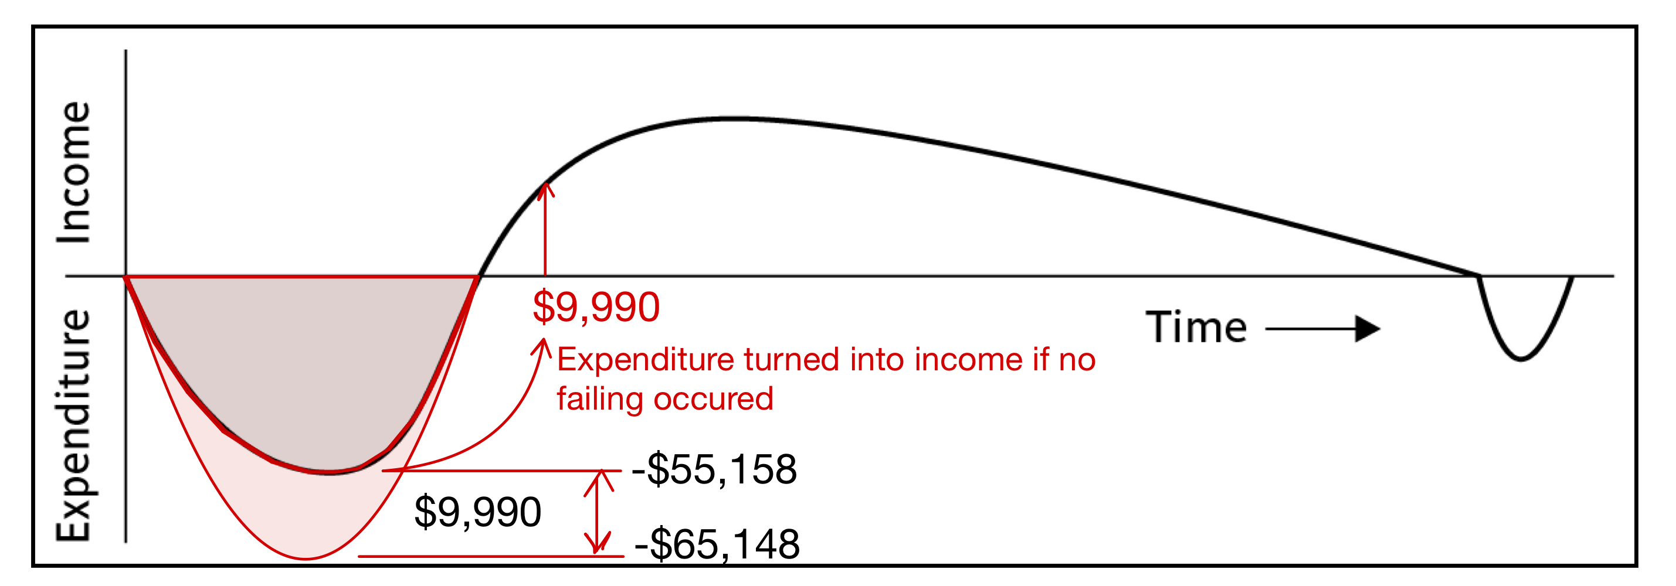

Fig.-3 Timing of Costs and Incomes (failing / failing free cases)

Overview Of Next Sections

The following sections will provide a comprehensive overview of the EduTrack project. We will discuss the various functions, objectives, and constraints involved in its development. This includes an examination of the chosen approach and the rationale behind it, as well as the project's features and its environmental, social, and economic impacts. We will detail how tasks were assigned to design, test, and validate the system, ensuring its reliability and user-friendliness. Additionally, we will present a project management chart that tracks the group's progress, based on an agile delivery approach.