Project Report:

# Members:

M. Bilal – 232118

M. Musa - 232084

Abdullah Mehmood – 232426

Introduction:  
The aim of this project was to develop a scheduler for SHOWDOWN, a one-to-one CTF and Hackathon competition played during the Pakistan Cybersecurty Challenge.

We used multiple languages and frameworks to bring our idea to life. Languages like HTML, CSS, Java Script, Node.js, C++ (add-ons) and Electron were part of the overall design.

# Task division among team members:

All three of us contributed on every aspect weather it was a code construction, flowchart making and report writing.

# References

* Youtube
* Github
* Chatgpt
* Node.js
* Stack overflow
* Cpp.com
* Microsoft.com
* Discord forms(chern)
* And many other forms

Classes:  
Multiple classes were used in our code. These include:

* **CTF_player** (name, role)
* **Team** (name, members, rank)
* **Match** (Team A, Team B, Winner, Loser)
* **CTFCompetition**

# Data Structures:

The data structures we used in our project were all coded from scratch and the pre-defined data structures were not used. They are:

* **Vector**
* **Queue**

# Design

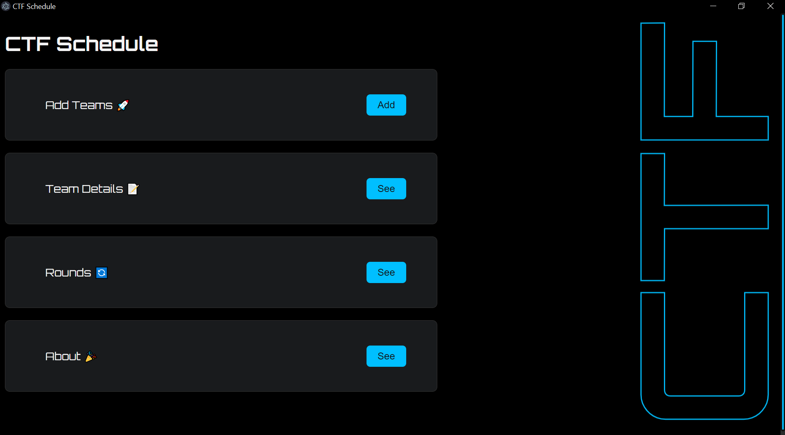

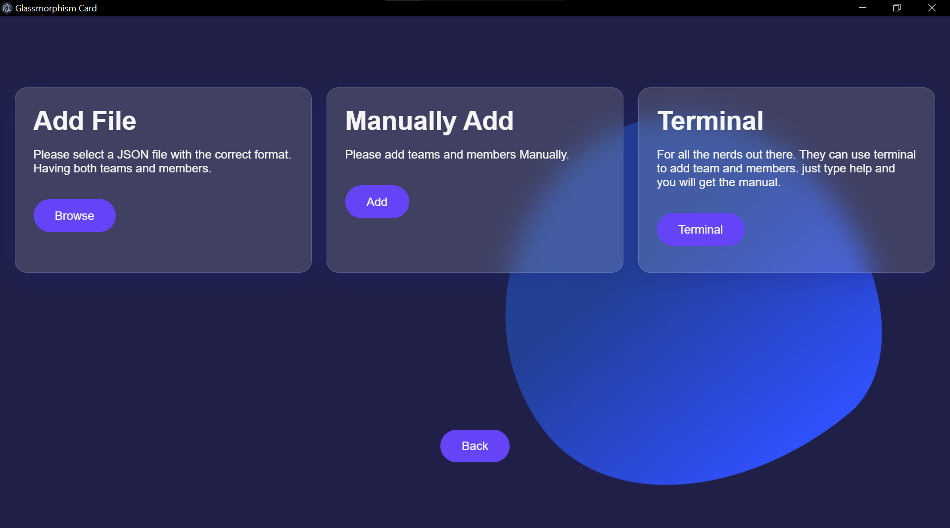

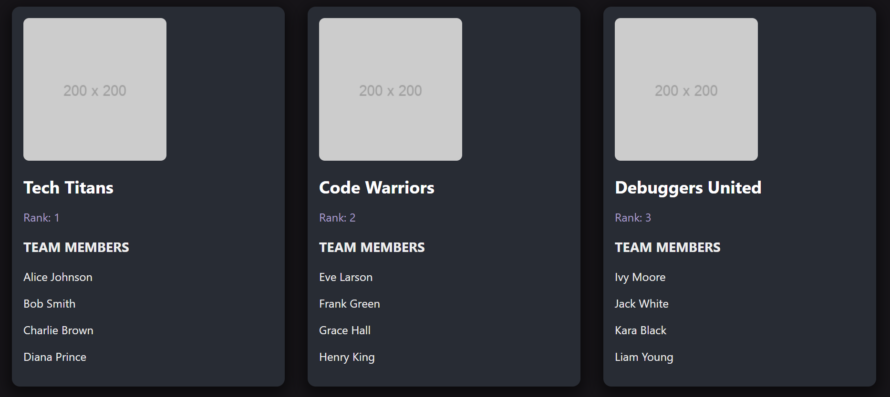

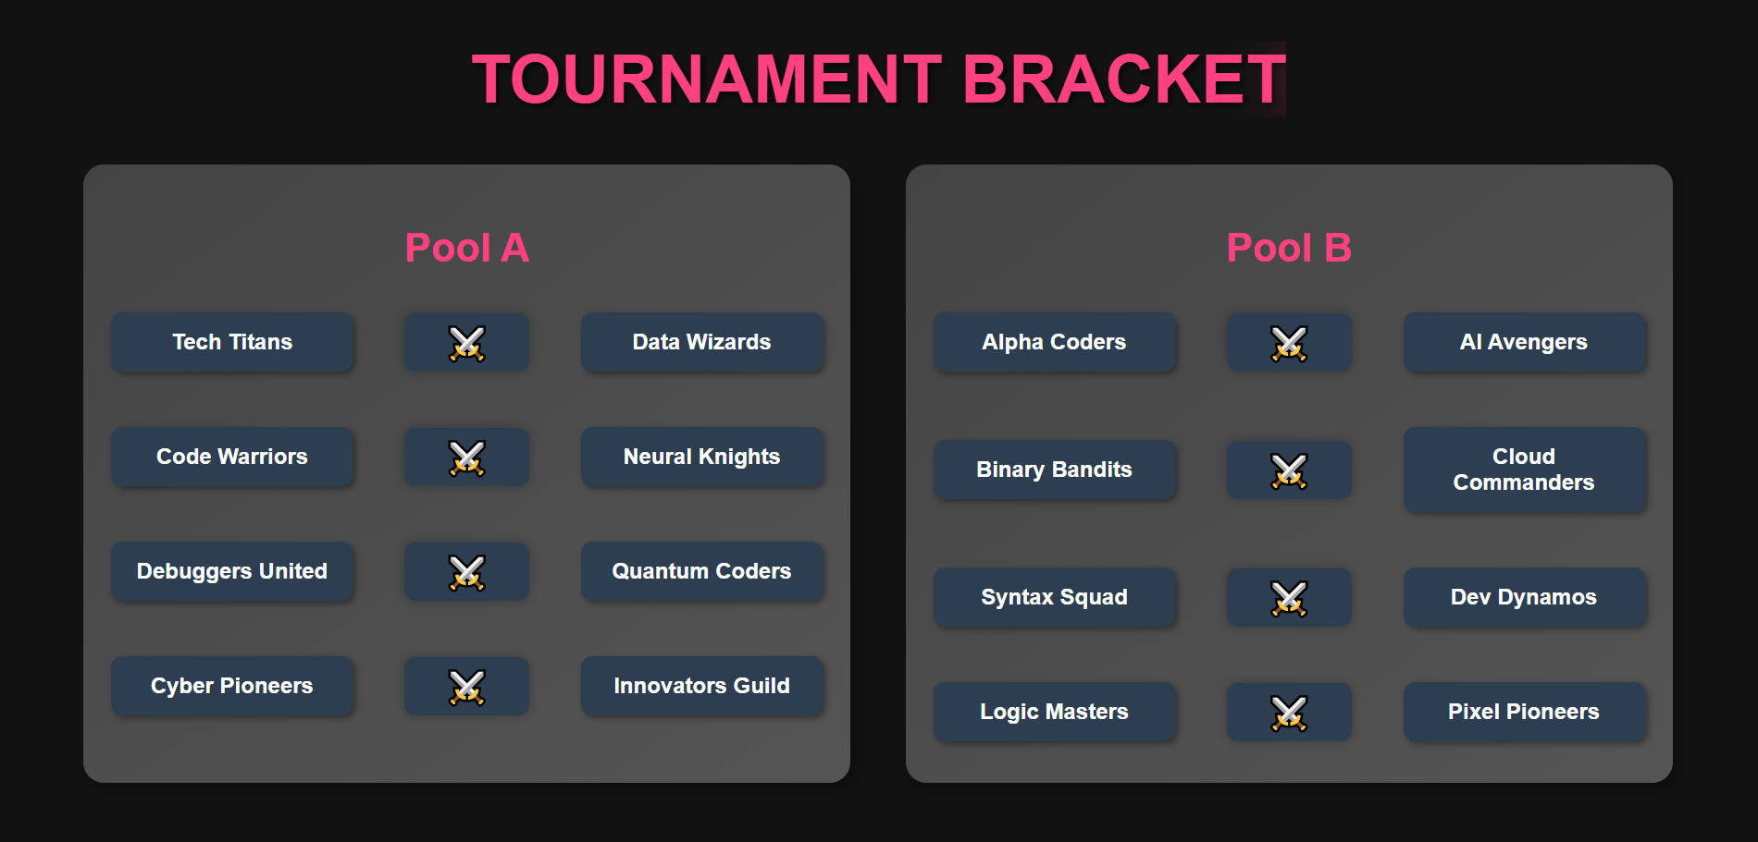

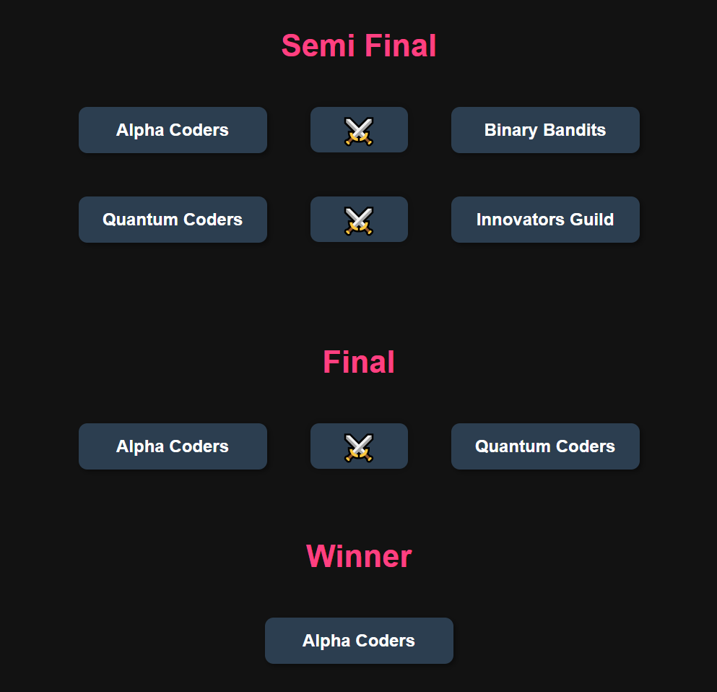

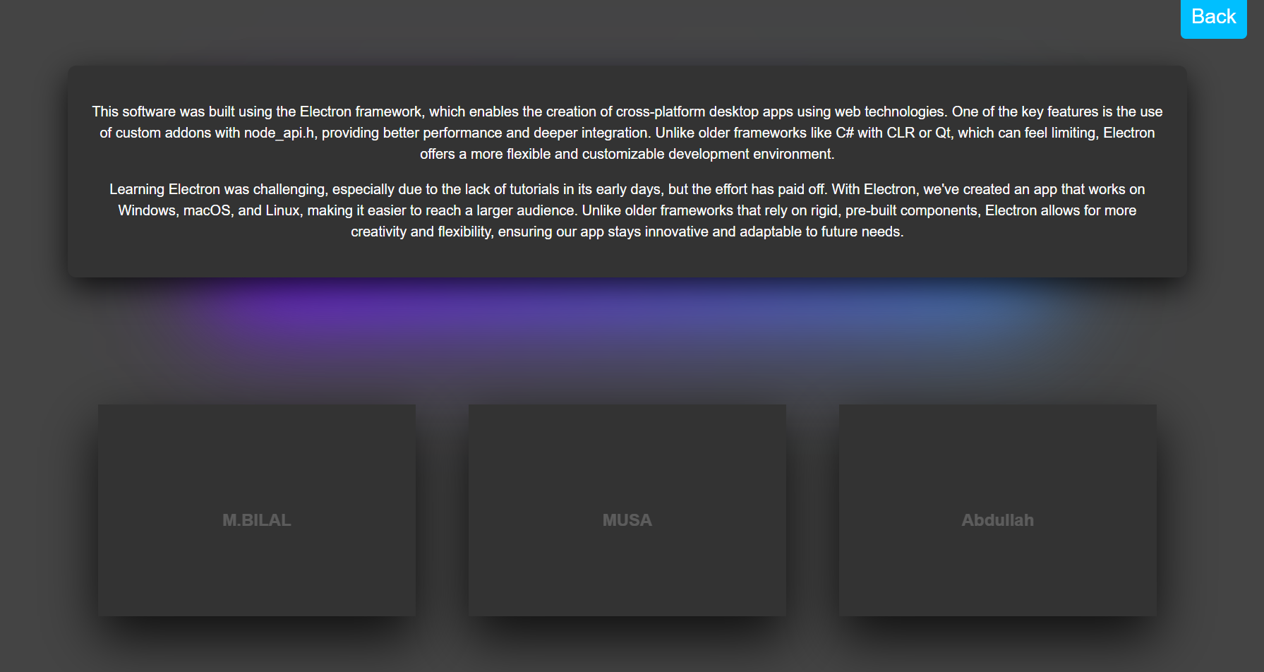

* CPP HEADER FILE

ADDON

* Main.js

ELECTRON mian file

* About page
* Main page
* Add team page
* Round page
* See team detail

# • Problems Faced:

* Yes, without a doubt, we had many difficulties. For example, when we first started, writing this kind of code proved to be difficult because we used ELECTRON which has a relatively amount of tutorials online. We took help from online resources (stack overflow and other forms) and investigated every aspect of Youtube to get our desired result.
* While making of the project, group work issues were faced. The group members could not cooperate with each other for some time which caused delay in the project .
* Time management also proved to be an issue.