**Title: Skin Disease Prediction Using Deep Learning Techniques**

# Introduction

Skin Disease is the one of the most important health problem world-wide, involving the major population groups and it effects millions of people(Gouda et al., 2022). They can be as simple as annoying and infections, to as deadly as melanoma, which could be fatal if not caught early(Mijwil, 2021). It's traditional that the diagnosis of skin diseases depend on necessarily skillful dermatologists, who observe the skin lesions, and support them with the laboratory hemorrhage tests(Jaiyeoba et al., 2024). However, this is manual and the nature of the process is slow, subjective and highly depends on the expertise of the professionals who are not always available in many areas such as the developing countries. Progress in artificial intelligence (AI) and in particular deep learning is transforming medical imaging. CNNs are one of the most effective models to perform image classification, even in medical tasks, as radiology, pathology and dermatology(Zhu et al., 2021). These classifiers are able to learn complex representations of the disease source by leveraging large datasets, and therefore, have been empirically shown to perform better.

# Project Overview

The goal of this project is the development and evaluation of deep convolutional neural networks (CNNs) for the classification of skin diseases from dermatoscopic images. The project will use a version of the DermNet dataset hosted on Kaggle, which consists more than 13,000 images across several diagnostic categories of skin disease, and pre-process the images to tackle issues such as class imbalance and variability in image quality. We will apply a wide range of deep learning models, from a simple CNN structure to the popular mod-els in this field (e.g., ResNet, DenseNet, EfficientNet).

# Research Aim

The aim of this study is to design, implement and evaluate deep learning models for effective recognition of skin diseases based on image data collected from the DermNet dataset. The main contribution of this study is to investigate different deep learning architectures, such as CNNs, and state-of-the-art models, and to find out the one that exhibits the best performance in terms of accuracy, precision, and generalization.

# Research Questions

* How accurately can deep learning models classify various skin diseases using image data from the DermNet dataset?
* Which deep learning architecture yields the best performance in skin disease prediction?
* What evaluation metrics are best suited to assess deep learning models for skin disease classification?

# Research Objectives

* To preprocess and augment the DermNet dataset to enhance model training and handle class imbalances.
* To implement and train several deep learning architectures, including baseline CNN, ResNet, DenseNet, and EfficientNet.
* To systematically evaluate model performance using metrics such as accuracy, precision, recall, F1-score, and area under the ROC curve (AUC-ROC).
* To analyze and compare the results to determine the most effective model architecture and evaluation strategy.
* To discuss the implications of the findings for clinical application and future research.

# Methodology

**Data Collection and Preparation**

The study will utilize the DermNet dataset on Kaggle, which includes upwards of 13,000 labeled images across multiple classes of skin diseases, including eczema, psoriasis, melanomas, and more. The diversity and size of the dataset is ideal for training deep learning models.

The first step involves data preprocessing, including:

* **Image resizing:** Standardizing all images to a fixed size (e.g., 224x224 pixels) for consistent input into neural networks.
* **Normalization:** Scaling pixel values to improve convergence during training.
* **Data augmentation:** Applying transformations such as rotation, flipping, zooming, and color jittering to artificially increase the dataset size and improve model robustness.
* **Handling class imbalance:** Techniques such as oversampling, undersampling, or class-weighting will be employed to address imbalanced representation across skin disease categories.

**Model Implementation**

* **Baseline CNN:** A straightforward convolutional neural network to establish a performance baseline.
* **ResNet (Residual Networks):** Known for its skip connections, ResNet addresses vanishing gradient problems and allows training of very deep networks.
* **DenseNet:** Uses dense connectivity to improve information flow and reduce parameters.
* **EfficientNet:** Balances network depth, width, and resolution for efficient and accurate modeling.

**Training and Validation**

* The dataset will be divided into the sets for 80% training and 20% testing, which is expected to provide an unbiased estimation of the model. Training will involve tuning of hyper-parameters - learning rate, batch size, optimization algorithm etc.
* Early stopping and model checkpointing will be utilized to avoid overfitting and store the best performing models.

# Evaluation Metrics

Given the multiclass classification setting and medical relevance, multiple metrics will be considered:

* **Accuracy:** Overall correct predictions percentage.
* **Precision and Recall:** To measure false positive and false negative rates, which are critical in medical diagnosis.
* **F1-score:** Harmonic mean of precision and recall, providing a balanced measure.
* Confusion matrices will also be used to visualize prediction errors and gain insights into class-specific performance.

# Importance of the Study

This study is important at the intersection of AI and medicine. By creating precise deep learning architecture models for skin diseases classification, it meets a significant demand for affordable diagnostic tools, particularly in underserved regions. The results will help to advance the scientific understanding of which architectures and evaluation schema are most effective for dermatological image classification.

# Project Plan

|  |  |
| --- | --- |
| **Week** | **Activities** |
| **Week 1** | Literature review, dataset acquisition |
| **Week 2** | Initial preprocessing of dataset |
| **Week 3** | Development of baseline CNN model |
| **Week 4** | Training and validation of baseline CNN model |
| **Week 5** | Implementation of ResNet architecture |
| **Week 6** | Implementation of DenseNet architecture |
| **Week 7** | Implementation of EfficientNet architecture |
| **Week 8** | Hyperparameter tuning for all advanced models |
| **Week 9** | Model evaluation and performance comparison |
| **Week 10** | Metric analysis and result interpretation |
| **Week 11** | Documentation and drafting final report |
| **Week 12** | Finalization of report and dissemination preparation |

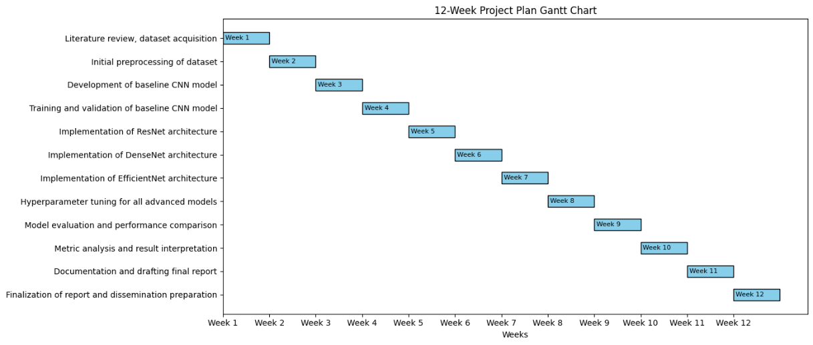

# Data Management Plan

The material in this project, beyond the parts used in this study, including all data and scripts, will be securely deposited in cloud storage services such as Google Drive and periodically backed up. For our data preprocessing and training scripts, we will use version control systems like GitHub to keep track of changes and share the workflow to make it easily reproducible. The project will adhere to all dataset licensing and ethical considerations, such that all data usage will be in accordance with requirements surrounding patient confidentiality and privacy.

# Ethical Considerations

Ethical integrity is paramount in medical AI research. The study will adhere to the following principles:

* **Informed Data Use:** Use only publicly available datasets with clear licensing and permission.
* **Patient Privacy:** Although the dataset is anonymized, no attempt will be made to re-identify individuals.
* **Bias Mitigation:** Address dataset imbalances and report any observed biases transparently.
* **Transparency:** Provide clear documentation of methods and results for peer review.
* **Clinical Responsibility:** Emphasize that AI tools are intended to assist, not replace, medical professionals.

# Conclusion

This proposal presents a proposal to use deep learning methods to build an automated classifier for skin disease classification based on the DermNet challenge dataset. Through the study of different model structures and testing modes, this study expects to find useful models for precise skin disease prediction. The potential influence of this work is significant because it may result in more accessible, reliable and global assistive diagnostic systems. In addition, the systematic assessment will offer information for further research and clinical practice.

# References

Gouda, W., Sama, N. U., Al-Waakid, G., Humayun, M., & Jhanjhi, N. Z. (2022). Detection of Skin Cancer Based on Skin Lesion Images Using Deep Learning. *Healthcare (Switzerland)*, *10*(7). https://doi.org/10.3390/healthcare10071183

Jaiyeoba, O., Ogbuju, E., Yomi, O. T., & Oladipo, F. (2024). Development of a Model to Classify Skin Diseases using Stacking Ensemble Machine Learning Techniques. *Journal of Computing Theories and Applications*, *2*(1), 22–38. https://doi.org/10.62411/jcta.10488

Mijwil, M. M. (2021). Skin cancer disease images classification using deep learning solutions. *Multimedia Tools and Applications*, *80*(17), 26255–26271. https://doi.org/10.1007/s11042-021-10952-7

Zhu, C. Y., Wang, Y. K., Chen, H. P., Gao, K. L., Shu, C., Wang, J. C., Yan, L. F., Yang, Y. G., Xie, F. Y., & Liu, J. (2021). A Deep Learning Based Framework for Diagnosing Multiple Skin Diseases in a Clinical Environment. *Frontiers in Medicine*, *8*. https://doi.org/10.3389/fmed.2021.626369